Supporting Information
2-Phenyl Substituted Benzimidazole Derivatives: Design, Synthesis, and Evaluation of Their Antiproliferative and Antimicrobial Activities
Ronak Haj Ersan^{1,2} · Burak Kuzu^{1,3} · Derya Yetkin⁴ · Mehmet Abdullah Alagoz⁵ · Aylin Dogen⁶ · Serdar Burmaoglu^{7 ✉} · Oztekin Algul^{1,8 ✉}
Detailed experimental procedures, characterization data, copies of ¹H and ¹³C NMR, molecular docking and ADMET properties for all compounds

Contents

Chemistry experimental procedure………………………………………………...…………..2
Copies of ¹H NMR spectra of the original and commercially available compounds………...14
Copies of ¹³C NMR spectra of the original and commercially available compounds…………26
Copies of LC-MS/MS spectra of the original compounds ……………………………………39
The docking scores of the compounds………………………………………………………...44
Physicochemical properties and estimated toxic properties of the synthesized compounds….46
References...…………………………………………………………………………………..49

MATERIALS AND METHODS
Chemistry
General
Commercial grade reagents and solvents were used without further purification. Melting points were measured with Mettler Toledo MP90 melting point device. IR Spectra: Perkin Elmer Spectrum One FT-IR spectrometer. ¹H-NMR and ¹³C-NMR Spectra: Bruker 400 spectrometer. Chemical shifts were reported in parts permillion (δ) relative to tetra methyl silane as an internal standard. Significant ¹H NMR data were tabulated in the following order: number of proton(s) and multiplicity (s, singlet; d, doublet; t, triplet; q, quartet; and m, multiplet); J values are in Hertz (Hz). Mass Spectra: Agilent Tecnologies 6460 Triple Quad LC-MS/MS.
General procedure for the synthesis of compounds
A mixture of 1,2-phenylenediamine derivative (13, 14 and 14) (1 eq) and the corresponding carboxylic acid derivatives (16, 17, 18, 19, 20, 36, 37, 38, 39, 40, 56, 57, 58, 59 and 60) (1.1 eq) was refluxed for a period of 15-27 hours in 5M hydrochloric acid. The reaction mixture was poured onto ice water and neutralized by mixing with NaHCO₃ till slightly basic pH (8–9) to get the precipitate. The resulting precipitate was filtered off and washed with cold water. Recrystallized with a suitable solvent. The resulting crystalline compounds were filtered and the vacuumed product was dried (Scheme 1-3).

Scheme 1. Synthesis route to the first group compounds

Scheme 2. Synthesis route to the second group compounds

Scheme 3. Synthesis route to the third group compounds
2-Benzyl-1H-benzo[d]imidazole (21)
General procedure was followed using 13 and 16 to afford compound 21 (0,41g, 66%) as a light yellow solid: m.p. 260-264 °C; ¹H NMR (400 MHz, CDCl₃) δ_{H} 7.54 (m, 2H, Ar-H); 7.35 (m, 2H, Ar-H), 7.29-7.32 (m, 3H, Ar-H), 7.24 (dd, 2H, J = 3.2 Hz, Ar-H), 4.29 (s, 2H, CH₂). The ¹H NMR spectrum is in agreement with reported data (Ben-David & Milstein, 2017).
2-(4-Methylbenzyl)-1H-benzo[d]imidazole (22)
General procedure was followed using 13 and 17 to afford compound 22 (0,32g, 49%) as a beige solid: m.p. 196-200 °C; ¹H NMR (400 MHz, CD₃OD) δ_{H} 12.23 (s, 1H, NH), 7.55–7.49 (m, 1H, Ar-H), 7.43–7.37 (m, 1H, Ar-H), 7.23–7.18 (m, 2H, Ar-H), 7.15–7.07 (m, 4H, Ar-H), 4.11 (s, 2H, CH₂), 2.26 (s, 3H, CH₃). The ¹H NMR spectrum is in agreement with reported data (Boggua, 2016).
4-((1H-benzo[d]imidazol-2-yl)methyl)phenol (23)
General procedure was followed using 13 and 18 to afford compound 23 (0.33g, 50%) as a light yellow solid: m.p. 264-266 °C (Boggua et al., 2016): IRv_{max}: 3258, 1511, 1440, 1250, 1027, 786, 736 cm⁻¹; ¹H NMR (400 MHz, DMSO-d₆) δ_{H} 12.23 (s, 1H, NH), 9.35 (s, 1H, OH), 7.50 (d, 2H, J = 1.4 Hz, Ar-H), 7.45-7.16 (m, 4H, Ar-H), 6.76-6.74 (m, 2H, Ar-H), 4.09 (s, 2H, -CH₂); ¹³C NMR (100 MHz, DMSO-d₆) δ_{C} 156.00, 154.12, 129.89, 127.71, 115.22, 34.16.
2-(4-Chlorobenzyl)-1H-benzo[d]imidazole (24)
General procedure was followed using 13 and 19 to afford compound 24 (0.45g, 62%) as a brown solid: m.p. 164-166 °C; ¹H NMR (400 MHz, DMSO-d₆) δ_{H} 12.26 (s, 1H, NH), 7.52 (s, 1H, Ar-H), 7.45–7.31 (m, 5H, Ar-H), 7.16–7.07 (m, 2H, Ar-H), 4.17 (s, 2H, -CH₂). The ¹H NMR spectrum is in agreement with reported data (Boggua et al., 2016).
2-(4-Fluorobenzyl)-1H-benzo[d]imidazole (25)
General procedure was followed using 13 and 20 to afford compound 25 (0.33g, 50%) as a white solid: m.p. 170-174 °C; ¹H NMR (400 MHz, DMSO-d₆) δ_{H} 12.26 (s, 1H, NH), 7.53 (s, 2 H, Ar-H), 7.39-7.34 (m, 2H, Ar-H), 7.17- 7.09 (m, 4H, Ar-H), 4.16 (s, 2H, -CH₂). The ¹H NMR spectrum is in agreement with reported data (Hruszkewycz et al., 2017).
2-Benzyl-6-chloro-1H-benzo[d]imidazole (26)
General procedure was followed using 14 and 16 to afford compound 26 (0.71g, 59%) as a grey solid: m.p. 169-173 °C; ¹H NMR (400 MHz, CD₃OD) δ_{H} 12.54–12.41 (m, 1H, NH), 7.62–7.35 (m, 2H, Ar-H), 7.34–7.29 (m, 4H, Ar-H), 7.29–7.20 (m, 1H, Ar-H), 7.18–7.10 (m, 1H, Ar-H), 4.17 (s, 2H, -CH₂). The ¹H NMR spectrum is in agreement with reported data (Boggua et al., 2016).
6-Chloro-2-(4-methylbenzyl)-1H-benzo[d]imidazole (27)
General procedure was followed using 14 and 17 to afford compound 27 (0.53g, 70%) as a light orange solid: m.p. 264-268 °C; ¹H NMR (400 MHz, CDCl₃) δ_{H} 10.52 (s, 1H, NH), 7.38 (s, 1H, Ar), 7.33 (d, 1H, J = 8.8 Hz, Ar-H), 7.14 (d, 1H, J = 8.8 Hz, Ar-H), 7.05-7.01 (m, 4H, Ar-H), 4.11 (s, 2H, -CH₂), 2.24 (s, 3H, -CH₂). The ¹H NMR spectrum is in agreement with reported data (Santos et al., 2013).
4-((6-Chloro-1H-benzo[d]imidazol-2-yl)methyl)phenol (28)
General procedure was followed using 14 and 18 to afford compound 28 (0.48g, 62%) as a brown solid: m.p. 178-182 °C; IRv_{max}: 3268, 3023, 2788, 1510, 1419, 801 cm⁻¹; ¹H NMR (400 MHz, CD₃OD) δ_{H} 7.55-7.41 (m, 2H, Ar-H), 7.23-7.11 (m, 3H, Ar-H), 6.82-6.71 (m, 2H, Ar-H), 4.14 (s, 2H, CH₂). ¹³C NMR (100 MHz, CD₃OD) δ_{C} 157.7, 130.9, 128.9, 123.7, 116.6, 35.35.
6-Chloro-2-(4-chlorobenzyl)-1H-benzo[d]imidazole (29)
General procedure was followed using 14 and 19 to afford compound 29 (0.77g, 56%) as a light grey solid: m.p. 147-151 °C; ¹H NMR (400 MHz, DMSO-d₆) δ_{H} 12.52 (s, 1H, Ar-H), 7.58–7.47 (m, 2H, Ar-H), 7.45–7.33 (m, 4H, Ar-H), 7.16 (td, 1H, J = 1.71, 8.54 Hz, Ar-H), 4.19 (s, 2H, -CH₂). The ¹H NMR spectrum is in agreement with reported data (Boggua et al., 2016).
6-Chloro-2-(4-fluorobenzyl)-1H-benzo[d]imidazole (30)
General procedure was followed using 14 and 20 to afford compound 30 (0.46g, 59%) as a beige solid: m.p. 202-206 °C: IRv_{max}: 3302, 2981, 2969, 1507, 1227, 799 cm⁻¹; ¹H NMR (400 MHz, DMSO-d₆) δ_{H} 7.73 (d, 1H, J = 1.9 Hz, Ar-H), 7.66 (d, 1H, J = 8.6 Hz, Ar-H), 7.50-7.43 (m, 2H, Ar-H), 7.37 (dd, 1H, J = 8.6, 1.9 Hz, Ar-H), 7.26-7.16 (m, 2H, Ar-H), 4.37 (s, 2H, CH₂). ¹³C NMR (100 MHz, DMSO-d₆) δ_{C} 162.6, 160.2, 154.5, 136.0, 133.7, 133.5, 131.6, 131.5, 131.1, 131.0, 127.8, 123.7, 115.6, 115.5, 115.4, 114.2, 32.6.
2-Benzyl-5,6-dichloro-1H-benzo[d]imidazole (31)
General procedure was followed using 15 and 16 to afford compound 31 (0.42g, 51%) as a shiny silver solid: m.p. 191-195 °C: IRv_{max}: 3209, 3064, 2981, 1532, 1444, 844 cm⁻¹; ¹H NMR (400 MHz, DMSO-d₆) δ_{H} 7.93 (s, 2H, Ar-H), 7.45-7.34 (m, 4H, Ar-H), 7.30 (ddd, 1H, J = 7.0, 3.8, 1.4 Hz, Ar-H), 4.37 (s, 2H, CH₂). ¹³C NMR (100 MHz, DMSO-d6) δ_{C} 155.9, 135.5, 135.0, 129.0, 128.7, 127.2, 125.8, 115.8, 33.6.
5,6-Dichloro-2-(4-methylbenzyl)-1H-benzo[d]imidazole (32)
General procedure was followed using 15 and 17 to afford compound 32 (1g, 69%) as a shiny silver solid: m.p. 181-185 °C; ¹H NMR (400 MHz, DMSO-d₆) δ_{H} 12.55 (s, 1H, NH); 7.70 (s, 2H, Ar-H); 7.19-7.10 (m, 4H, Ar-H); 4.11 (s, 2H, -CH₂); 2.23 (s, 3H, -CH₃). The ¹H NMR spectrum is in agreement with reported data (Mentese et al., 2013).
4-((5,6-Dichloro-1H-benzo[d]imidazol-2-yl)methyl)phenol (33)
General procedure was followed using 15 and 18 to afford compound 33 (0.45g, 52%) as a light purple solid: m.p. 243-247 °C: IRv_{max}: 3002, 2925, 2830, 1491,1446, 1310, 759 cm⁻¹; ¹H NMR (400 MHz, DMSO-d₆) δ_{H} 7.90 (s, 2H, Ar-H), 7.41 (td, 1H, J = 7.9, 6.3 Hz, Ar-H), 7.31-7.20 (m, 2H, Ar-H), 7.13 (td, 1H, J = 8.7, 2.6 Hz, Ar-H), 4.37 (s, 2H, CH₂). ¹³C NMR (100 MHz, DMSO-d₆) δ_{C} 163.4, 161.0, 155.5, 138.5, 135.9, 130.5, 125.3, 125.1, 116.0, 115.9, 115.8, 114.1, 113.8, 33.5.
5,6-Dichloro-2-(4-chlorobenzyl)-1H-benzo[d]imidazole (34)
General procedure was followed using 15 and 19 to afford compound 34 (0,48g, 52%) as a beige solid: m.p. 214-218 °C; ¹H NMR (400 MHz, DMSO-d₆) δ_{H} 12.60 (s, 1H, NH): 7.77-7.65 (m, 2H, Ar-H); 7.39-7.29 (m, 4H, Ar-H); 4.16 (s, 2H, -CH₂). The ¹H NMR spectrum is in agreement with reported data (Mentese et al., 2013).
5,6-Dichloro-2-(4-fluorobenzyl)-1H-benzo[d]imidazole (35)
General procedure was followed using 15 and 20 to afford compound 35 (0,76g, 52%) as a shiny light purple solid: m.p. 198-202 °C: IRv_{max}: 3054, 2941, 2732, 1509, 1231, 854 cm⁻¹; ¹H NMR (400 MHz, DMSO-d₆) δ_{H} 7.92 (s, 2H, Ar-H), 7.44 (dd, 2H, J = 7.4, 4.0 Hz, Ar-H), 7.21 (ddd, 2H, J = 8.9, 5.9, 2.5 Hz, Ar-H), 4.33 (s, 2H, CH₂). ¹³C NMR (100 MHz, DMSO-d₆) δ_{C} 156.1, 131.0, 130.9, 115.9, 115.8, 115.6, 115.5, 115.4, 115.3, 33.0.
2-Phenethyl-1H-benzo[d]imidazole (41)
General procedure was followed using 13 and 36 to afford compound 41 (0.35g, 32%) as a white solid: m.p. 189-203 °C; ¹H NMR (400 MHz, DMSO-d₆) δ_{H} 3.26 (dd, 2H, J = 7.3, 8.3 Hz), 3.51 (dd, 2H, J = 7.3, 8.3 Hz), 7.35-7.3 (m, 5H, Ar-H), 7.53-7.47 (m, 2H, -CH₂), 7.80-7.75 (m, 2H, -CH₂). The ¹H NMR spectrum is in agreement with reported data (Wang et al., 2006).
2-(4-Methylphenethyl)-1H-benzo[d]imidazole (42)
General procedure was followed using 13 and 37 to afford compound 42 (0.37g, 53%) as a shiny beige solid: m.p. 227-231 °C; ¹H NMR (400 MHz, CDCl₃) δ_{H} 7.45 (dd, J = 3.15, 5.97 Hz, 2H, Ar- H), 7.13-7.09 (m, 6H, Ar-H), 3.16-3.09 (m, 4H, CH₂), 2.02 (s, 3H, -CH₃). The ¹H NMR spectrum is in agreement with reported data (Chantler et al., 2004).
4-(2-(1H-benzo[d]imidazol-2-yl)ethyl)phenol (43)
General procedure was followed using 13 and 38 to afford compound 43 (0.40g, 57%) as a white solid: m.p. 264–266 °C: IRv_{max}: 3241, 3038, 2922, 1508, 1445, 1225, 821, 725 cm⁻¹; ¹H NMR (400 MHz, CD₃OD) δ_{H} 7.37 (bs, 2H, Ar-H), 7.10-7.00 (m, 2H, Ar-H), 6.92-6.86 (m, 2H, Ar-H), 6.60-6.53 (m, 2H, Ar-H), 3.01 (ddd, 2H, J = 8.3, 6.6, 1.8 Hz, CH₂), 2.96-2.89 (m, 2H, CH₂). ¹³C NMR (100 MHz, CD₃OD) δ_{C} 156.9, 156.3, 132.8, 130.3, 123.2, 116.3, 34.7, 32.3.
2-(4-chlorobenzyl)-1H-benzo[d]imidazole (44)
General procedure was followed using 13 and 39 to afford compound 44 (0.33g, 44%) as a white solid: m.p. 233–237 °C; ¹H NMR (400 MHz, DMSO-d₆) δ_{H} 12.2 (s,1H, NH), 7.52-7.48 (m,1H, Ar-H), 7.41-7.37 (m, 1H, Ar-H), 7.32-7.28 (m, 4H, Ar-H), 7.11-7.07 (m, 2H, Ar-H), 3.11 (s, 4H, -CH₂). The ¹H NMR spectrum is in agreement with reported data (Wena et al., 2012).
2-(4-fluorophenethyl)-1H-benzo[d]imidazole (45)
General procedure was followed using 13 and 40 to afford compound 45 (0.51g, 71%) as a beige solid: m.p. 189–193 °C; ¹H NMR (400 MHz, DMSO-d₆) δ_{H} 12.21 (s, 1H, NH), 7.53 (s, 2 H, Ar), 7.35-7.30 (m, 2H, Ar), 7.17- 7.08 (m, 4H, Ar), 4.1 (s, 4H, -CH₂). The ¹H NMR spectrum is in agreement with reported data (Chantler et al., 2004).
6-chloro-2-phenethyl-1H-benzo[d]imidazole (46)
General procedure was followed using 14 and 36 to afford compound 46 (0.53g, 69%) as a white solid: m.p. 282–286 °C; ¹H NMR (400 MHz, DMSO-d₆) δ_{H} 7.50–6.90 (m, 8H, Ar-H), 3.19 (s, 4H, CH₂). The ¹H NMR spectrum is in agreement with reported data (Oren et al., 2004).
6-chloro-2-(4-methylphenethyl)-1H-benzo[d]imidazole (47)
General procedure was followed using 14 and 37 to afford compound 47 (0.50g, 62%) as a light orange solid: m.p. 148–152 °C: IRv_{max}: 3171, 3013, 2923, 1512, 1290, 805 cm⁻¹; ¹H NMR (400 MHz, DMSO-d₆) δ_{H} 12.43 (s, 1H, NH), 7.54 (s, 1H, Ar-H), 7.49 (d, 1H, J = 8.3 Hz, Ar-H), 7.17-7.08 (m, 5H, Ar-H), 3.09 (dd, J = 5.0, 3.5 Hz, 4H, CH₂), 2.26 (s, 3H, CH₃). ¹³C NMR (100 MHz, DMSO-d₆) δ_{C} 157.4, 156.1, 137.8, 134.9, 128.8, 128.1, 125.4, 121.3, 32.6, 30.4, 20.4.
5(6)-Chloro-2-((4-hydroxyphenyl)ethyl)-1H-benzimidazole (48)
General procedure was followed using 14 and 38 to afford compound 48 (0.49g, 60%) as an orange solid: m.p. 206–210 °C: IRv_{max}: 3302, 3016, 2827, 1514, 1210, 817 cm⁻¹; ¹H NMR (400 MHz, CD₃OD) δ_{H} 7.67 (d, 1H, J = 2.0 Hz, Ar-H), 7.61 (d, 1H, J = 8.8 Hz, Ar-H), 7.46 (dd, 1H, J = 8.8 Hz, J = 2.0 Hz, Ar-H), 6.90 (d, 2H, J = 8.8 Hz, Ar-H), 6.60-6.56 (m, 2H, Ar-H), 3.21 (t, 2H, J = 3.3, 1.6 Hz, CH₂), 3.04 (t, 2H, J = 7.5 Hz, CH₂); ¹³C NMR (100 MHz, CD₃OD) δ_{C} 157.7, 156.4, 133.2, 133.1, 131.4, 130.3, 128.0, 116.7, 116.0, 114.8, 33.4, 30.2; LC-MS/MS (ESI+): m/z= 273.1 ([M+1]⁺).
5(6)-Chloro-2-((4-chlorophenyl)ethyl)-1H-benzimidazole (49)
General procedure was followed using 14 and 39 to afford compound 49 (0.46g, 53%) as a light yellow solid: m.p. 156–200 °C: IRv_{max}:3660, 2981, 1406, 1088, 820 cm⁻¹; ¹H NMR (400 MHz, CDCl₃) δ_{H} 7.54 (d, 1H, Ar-H), 7.36 (d, 1H, J = 8.8 Hz, Ar-H), 7.16-7.08 (m, 3H, Ar-H), 6.96-6.91 (d, 2H, J = 8.0 Hz, Ar-H), 3.12-3.03 (m, 4H, CH₂); ¹³C NMR (100 MHz, CD₃OD) δ_{C} 137.4, 131.5, 128.6, 127.8, 127.4, 125.5, 122.3, 114.4, 113.6, 32.5, 29.9; LC-MS/MS(ESI+) m/z= 291.0 ([M + 1]⁺).
5(6)-Chloro-2-((4-fluorophenyl)ethyl)-1H-benzimidazole (50)
General procedure was followed using 14 and 40 to afford compound 50 (0.40g, 49%) as a dark green solid: m.p. 262–266 °C: IRv_{max}: 3071, 2715, 1509, 1217, 806 cm⁻¹; ¹H NMR(400 MHz, DMSO-d₆) δ_{H} 7.88 (dd, 1H, J = 1.9, 0.4 Hz, Ar-H), 7.80 (dd, 1H, J = 8.7, 0.4 Hz, Ar-H), 7.55 (dd, 1H, J = 8.7 Hz, 1.9 Hz, Ar-H), 7.34 (t, 2H, J = 8.81 Hz, Ar-H), 7.13, (t, 2H, J = 8.81 Hz, Ar-H), 3.46 (t, 2H, J = 7.73 Hz, -CH₂), 3.27 (t, 2H, J = 7.73 Hz, -CH₂); ¹³C NMR (100 MHz, DMSO-d₆) δ_{C} 162.2, 159.8, 154.7, 135.4, 131.9, 130.1, 130.0, 129.7, 125.6, 115.4, 115.3, 113.6, 31.1, 28.2; LC-MS/MS (ESI+): m/z= 275.2 ([M+1]⁺).
5,6-dichloro-2-phenethyl-1H-benzo[d]imidazole (51)
General procedure was followed using 15 and 36 to afford compound 51 (0.34g, 40%) as a brown solid: m.p. 259–262 °C; ¹H NMR (400 MHz, CDCl₃) δ_{H} 8.06 (s, 2H, Ar-H), 7.26-7.21 (m, 5H, Ar-H), 3.42 (dd, 2H, J = 7.4, 8.2 Hz, -CH₂), 3.32 (dd, 2H, J = 7.4, 8.2 Hz, -CH₂). The ¹H NMR spectrum is in agreement with reported data (Wang et al., 2006).
5,6-dichloro-2-(4-methylbenzyl)-1H-benzo[d]imidazole (52)
General procedure was followed using 15 and 37 to afford compound 52 (0.54g, 59%) as a brown solid: m.p. 192–195 °C: IRv_{max}: 3083, 3002, 2914, 2845, 1444,1396, 865 cm⁻¹; ¹H NMR (400 MHz, DMSO- d₆) δ_{H} 12.56 (s, 1H, NH), 7.74 (s, 2H, Ar-H), 7.09 (dd, 4H, J = 19.6, 7.8 Hz, Ar-H), 3.35 (s, 2H, CH₂), 3.17-3.00 (m, 4H, CH₂), 2.24 (s, 3H, CH₃). ¹³C NMR (100 MHz, DMSO- d₆) δ_{C} 157.4, 137.6, 135.0, 128.9, 128.0, 123.5, 32.6, 30.4, 20.6.
5,6-Dichloro-2-((4-hydroxyphenyl)ethyl)-1H-benzimidazole (53)
General procedure was followed using 15 and 38 to afford compound 53 (0.65g, 71%) as a brown solid: m.p. 249-251 °C: IRv_{max}: 3366, 3142, 1449, 1243, 821 cm⁻¹; ¹H NMR (400 MHz, DMSO- d₆) δ_{H} 7.98 (s, 2H, Ar-H), 7.04 (d, 2H, J = 8.5 Hz, Ar-H), 6.69 (d, 2H, J = 8.5 Hz, Ar-H), 3.26 (t, 2H, J = 7.7 Hz, CH₂), 3.07 (t, 2H, J = 7.7 Hz, CH₂); ¹³C NMR (100 MHz, DMSO- d₆) δ_{C} 156.8, 155.9, 133.8, 129.8, 129.0, 126.3, 115.6, 115.3, 31.74, 29.5; LC-MS/MS (ESI+): m/z= 307.1 ([M+1]⁺).
5,6-Dichloro-2-((4-chlorophenyl)ethyl)-1H-benzimidazole (54)
General procedure was followed using 15 and 39 to afford compound 54 (0.59g, 61%) as a brown solid: m.p. 223-225 °C: IRv_{max}: 3076, 2605, 1406, 1098, 822 cm⁻¹; ¹H NMR (400 MHz, DMSO- d₆) δ_{H} 7.75 (s, 2H, Ar-H), 7.32 (d, 2H, J = 8.4 Hz, Ar-H), 7.26 (d, 2H, J = 8.4 Hz, Ar-H), 3.11 (s, 4H, CH₂); ¹³C NMR (100 MHz, DMSO-d₆) δ_{C} 157.1, 139.7, 130.7, 130.1, 128.2, 123.6, 32.2, 30.0; LC-MS/MS (ESI+): m/z= 325.1 ([M+1]⁺).
5,6-Dichloro-2-(4-fluorophenethyl)-1H-benzimidazole (55)
General procedure was followed using 15 and 40 to afford compound 55 (0.53g, 58%) as a light brown solid: m.p. 173-176 °C: IRv_{max}:3081, 2647, 1396, 1215, 824, 814 cm⁻¹; ¹H NMR (400 MHz, DMSO-d₆) δ_{H} 7.91 (s, 2H, Ar-H), 7.31 (td, 2H, J = 8.8, 2.2 Hz, Ar-H), 7.13 (td, 2H, J = 8.8, 2.2 Hz, Ar-H), 3.23 (t, 2H, J = 2.8 Hz, J = 14 Hz, CH₂), 3.14 (t, 2H, J = 2.8 Hz, J = 14 Hz, CH₂); ¹³C NMR (100 MHz, DMSO-d₆) δ_{C} 162.1, 159.7, 156.8, 136.2, 135.5, 130.1, 130.0, 125.3, 115.7, 115.2, 115.0, 31.8, 29.6; LC-MS/MS (ESI+): m/z= 309.1 ([M+1]⁺).
2-(phenoxymethyl)-1H-benzo[d]imidazole (61)
General procedure was followed using 13 and 56 to afford compound 61 (0.27g, 40%) as an orange solid: m.p. 158-162 °C; ¹H NMR (400 MHz, DMSO-d₆) δ_{H} 12.50 (bs,1H, –NH), 7.56-7.54 (m, 2H, Ar-H), 7.34-7.30 (m, 2H, Ar-H), 7.20-7.17 (m, 2H, Ar-H), 7.09 (d, 2H, J = 8.2 Hz, Ar-H), 6.99-6.96 (m, 1H, Ar-H), 5.31 (s, 2H, CH₂). The ¹H NMR spectrum is in agreement with reported data (Algul et al., 2005)
2-((p-tolyloxy)methyl)-1H-benzo[d]imidazole (62)
General procedure was followed using 13 and 57 to afford compound 62 (0.22g, 31%) as a white solid: m.p. 173-177 °C; ¹H NMR (400 MHz, CDCl₃) δ_{H} 9.70 (s, 1H, -NH), 7.73 (s, 1H, Ar-H), 7.41 (s, 1H, Ar-H), 7.26 (d, 2H, J = 5.75Hz, Ar-H), 7.06 (d, 2H, J = 8.25 Hz, Ar-H), 6.86 (d, 2H, J = 8.25 Hz, Ar- H), 5.34 (s, 2H, -CH₂), 2.27 (s, 3H, -CH₃). The ¹H NMR spectrum is in agreement with reported data (Manjunath et al., 2015).
2-((4-Hydroxyphenoxy)methyl)-1H-benzimidazole (63)
General procedure was followed using 13 and 58 to afford compound 63 (0.38g, 54%) as a shiny purple solid: m.p. 221-223 °C: IRv_{max}: 3081, 2647, 1396, 1215, 824, 814 cm⁻¹; ¹H NMR (400 MHz, CD₃OD) δ_{H} 7.46 (dd, 2H, J = 5.1, 3.1 Hz, Ar-H), 7.17-7.10 (m, 2H, Ar-H), 6.83-6.77 (m, 2H, Ar-H), 6.65-6.58 (m, 2H, Ar-H), 5.12 (s, 2H, CH₂); ¹³C NMR (100 MHz, CD₃OD) δ_{C} 153.3, 153.0, 152.5, 123.8, 117.3, 117.0, 65.9; LC-MS/MS (ESI+): m/z= 241.1 ([M+1]⁺).
2-((4-chlorophenoxy)methyl)-1H-benzo[d]imidazole (64)
General procedure was followed using 13 and 59 to afford compound 64 (0.41g, 53%) as a yellow solid: m.p. 195-199 °C; ¹H NMR (400 MHz, DMSO-d₆) δ_{H} 7.60–6.80 (m, 8H, Ar-H), 5.36 (s, 2H, CH₂). The ¹H NMR spectrum is in agreement with reported data (Oren et al., 2004).
2-((4-fluorophenoxy)methyl)-1H-benzo[d]imidazole (65)
General procedure was followed using 13 and 60 to afford compound 65 (0.45g, 63%) as a white solid: m.p. 147-151 °C: IRv_{max}: 3055, 309, 2841, 1503, 1197, 825 cm⁻¹; ¹H NMR (400 MHz, DMSO-d₆) δ_{H} 12.69 (s, 1H, NH), 7.57 (bs, 2 H, Ar-H), 7.39-6.98 (m, 6H, Ar-H), 5.32 (s, 2H, -CH₂). ¹³C NMR (100 MHz, DMSO-d₆) δ_{C} 158.1, 155.7, 154.3, 150.0, 121.9, 116.3, 116.0, 115.8, 64.4.
6-chloro-2-(phenoxymethyl)-1H-benzo[d]imidazole (66)
General procedure was followed using 14 and 56 to afford compound 66 (0.46g, 60%) as a grey solid: m.p. 133-137 °C; ¹H NMR (400 MHz, DMSO-d₆) δ_{H} 7.60–6.90 (m, 8H, Ar-H), 5.29 (s, 2H, CH₂). The ¹H NMR spectrum is in agreement with reported data (Oren et al., 2004).
6-chloro-2-((p-tolyloxy)methyl)-1H-benzo[d]imidazole (67)
General procedure was followed using 14 and 57 to afford compound 67 (0.49g, 60%) as a purple solid: m.p. 168-172 °C: IRv_{max}: 3053, 2981, 1511, 1232, 801, 752 cm⁻¹; ¹H NMR (400 MHz, CDCl₃) δ_{H} 7.41 (d, J = 8.2 Hz, 1H, Ar-H), 7.29 (bs, 1H, Ar), 7.01 (dd, J = 8.2, 1.1 Hz, 1H, Ar-H), 6.82 (qdd, 4H, J = 7.6, 6.9, 2.8 Hz, Ar-H), 5.21 (s, 2H, -CH₂), 2.38 (s, 3H, -CH₃); ¹³C NMR (100 MHz, CDCl₃) δ_{C} 159.1, 156.7, 153.9, 149.6, 132.9, 124.4, 116.2, 116.0, 115.9, 115.8, 65.0, 21.6.
5(6)-Chloro-2-((4-hydroxyphenoxy)methyl)-1H-benzimidazole (68)
General procedure was followed using 14 and 58 to afford compound 68 (0.33g, 41%) as a dark yellow solid: m.p. 195-197 °C: IRv_{max}: 3069, 2905, 1505, 1430, 1204, 814 cm⁻¹; ¹H NMR (400 MHz, CD₃OD) δ_{H} 7.46 (bs, 1H, Ar-H), 7.42 (d, 1H, J = 8.4 Hz, Ar-H), 7.13 (dd, 1H, J = 8.4, 2.0 Hz, Ar-H), 6.84-6.74 (m, 2H, Ar-H), 6.67-6.56 (m, 2H, Ar-H), 5.12 (s, 2H, CH₂); ¹³C NMR (100 MHz, CD₃OD) δ_{C} 154.0, 153.9, 153.4, 152.9, 124.2, 117.3, 117.0, 65.7; LC-MS/MS (ESI+): m/z= 275.1 ([M+1]⁺).
5-chloro-2-((4-chlorophenoxy)methyl)-1H-benzo[d]imidazole (69)
General procedure was followed using 14 and 59 to afford compound 69 (0.46g, 53%) as a yellow solid: m.p. 189-193 °C; ¹H NMR (400 MHz, DMSO-d₆) δ_{H} 7.70 6.90 (m, 7H, Ar-H), 5.29 (s, 2H, CH₂). The ¹H NMR spectrum is in agreement with reported data (Oren et al., 2004).
5-chloro-2-((4-fluorophenoxy)methyl)-1H-benzo[d]imidazole (70)
General procedure was followed using 14 and 60 to afford compound 70 (0.40g, 49%) as a dark green solid: m.p. 224-228 °C: IRv_{max}: 3061, 2815, 1559, 1217, 808 cm⁻¹; ¹H NMR (400 MHz, DMSO-d₆) δ_{H} 7.77 (d, 1H, J = 1.5 Hz, Ar-H), 7.70 (d, 1H, J = 8.7 Hz, Ar-H), 7.39 (dd, 1H, J = 8.7, 1.5 Hz, Ar-H), 7.25-7.10 (m, 4H, Ar-H), 5.47 (s, 2H, CH₂). ¹³C NMR (100 MHz, DMSO-d₆) δ_{C} 155.9, 153.8, 151.2, 136.3, 134.0, 128.0, 124.0, 116.5, 116.4, 116.1, 116.0, 115.9, 114.6, 63.2.
5,6-dichloro-2-(phenoxymethyl)-1H-benzo[d]imidazole (71)
General procedure was followed using 15 and 56 to afford compound 71 (0.39g, 45%) as a light orange solid: m.p. 234-237 °C: IRv_{max}: 3562, 3099, 2969, 1585, 1217, 864, 749 cm⁻¹; ¹H NMR (400 MHz, DMSO-d₆) δ_{H} 7.83 (s,1H, Ar-H), 7.37-7.30 (m, 2H, Ar-H), 7.13-7.08 (m, 2H, Ar-H), 7.00 (ddd, 1H, J = 8.3, 2.0, 1.0 Hz, Ar-H), 5.34 (s, 2H, CH₂). ¹³C NMR (100 MHz, DMSO-d₆) δ_{C} 157.9, 154.4, 153.5, 129.6, 124.2, 123.4, 121.3, 114.8, 63.7.
5,6-dichloro-2-((p-tolyloxy)methyl)-1H-benzo[d]imidazole (72)
General procedure was followed using 15 and 57 to afford compound 72 (0.5g, 55%) as a purple solid: m.p. 168-172 °C: IRv_{max}: 3061, 3031, 2919, 1507, 1225, 808 cm⁻¹; ¹H NMR (400 MHz, DMSO-d₆) δ_{H} 12.98 (s, 1H, NH), 7.84 (s, 2H, Ar-H), 7.13 (d, 2H, J = 8.6 Hz, Ar-H), 7.01-6.96 (m, 2H, Ar-H), 5.31 (s, 2H, CH₂), 2.25 (s, 3H, CH₃); ¹³C NMR (100 MHz, DMSO-d₆) δ_{C} 155.7, 155.2, 130.1, 129.9, 124.4, 14.7, 63.7, 20.0.
5,6-Dichloro-2-((4-hydroxyphenoxy)methyl)-1H-benzimidazole (73)
General procedure was followed using 15 and 58 to afford compound 73 (0.63g, 68%) as a purple solid: m.p. 252-254 °C: IRv_{max}: 3069, 2905, 1505, 1430, 1204, 814 cm⁻¹; ¹H NMR (400 MHz, CD₃OD) δ_{H} 7.72 (s, 2H, Ar-H), 6.91 (d, 2H, J = 9.0 Hz, Ar-H), 6.74 (d, 2H, J = 9.0 Hz, Ar-H), 5.25 (s, 2H, CH₂); ¹³C NMR (100 MHz, CD₃OD) δ_{C} 155.3, 153.4, 152.8, 139.0, 138.97, 138.92, 127.6, 117.4, 117.2, 117.0, 65.7; LC-MS/MS (APCI) m/z= 309.01 (M⁺).
5,6-dichloro-2-((4-chlorophenoxy)methyl)-1H-benzo[d]imidazole (74)
General procedure was followed using 15 and 59 to afford compound 74 (0.54g, 55%) as a dark brown solid: m.p. 188-192 °C: IRv_{max}: 3030, 2971, 1445,1231, 1049, 819 cm⁻¹; ¹H NMR (400 MHz, DMSO-d₆) δ_{H} 11.04 (s, 1H, NH), 7.85 (bs, 2H, Ar-H), 7.42-7.34 (m, 2H, Ar-H), 7.16-7.09 (m, 2H, Ar-H), 5.36 (s, 2H, CH₂). ¹³C NMR (100 MHz, DMSO-d₆) δ_{C} 156.7, 152.7, 129.4, 125.2, 116.7, 63.9.
5,6-dichloro-2-((4-fluorophenoxy)methyl)-1H-benzo[d]imidazole (75)
General procedure was followed using 15 and 60 to afford compound 75 (0.51g, 55%) as a brown solid: m.p. 236-240 °C: IRv_{max}: 3018, 2855, 1445, 1369,1284, 858, 632 cm⁻¹; ¹H NMR (400 MHz, DMSO-d₆) δ_{H} 12.65 (s, 1H, NH), 7.77 (bs, 2H, Ar-H), 7.44-7.33 (m, 4H, Ar-H), 4.21 (s, 2H, CH₂).¹³C NMR (100 MHz, DMSO-d₆) δ_{C} 156.1, 136.0, 131.4, 130.7, 128.4, 34.0
¹H NMR spectrum of 4-((1H-benzo[d]imidazol-2-yl)methyl)phenol (23)
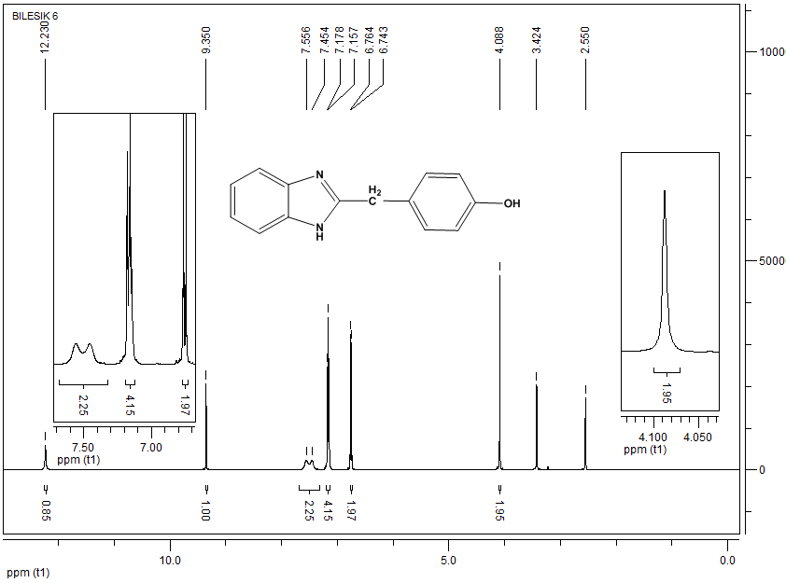
¹H NMR spectrum of 4-((6-chloro-1H-benzo[d]imidazol-2-yl)methyl)phenol (28)

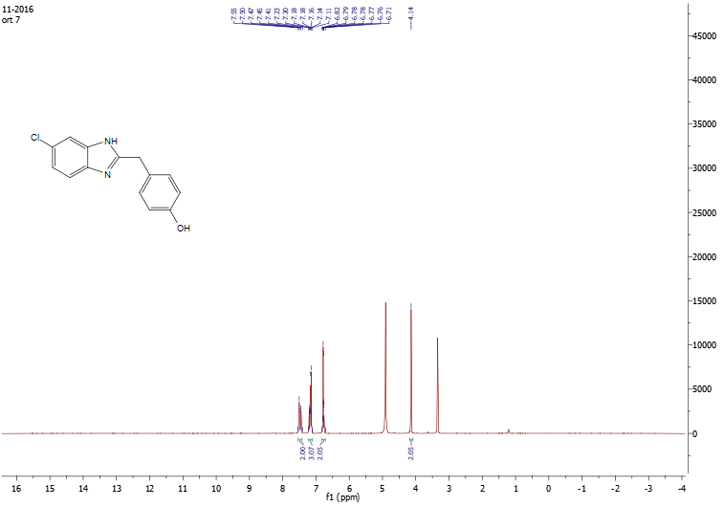
¹H NMR spectrum of 6-chloro-2-(4-fluorobenzyl)-1H-benzo[d]imidazole (30)
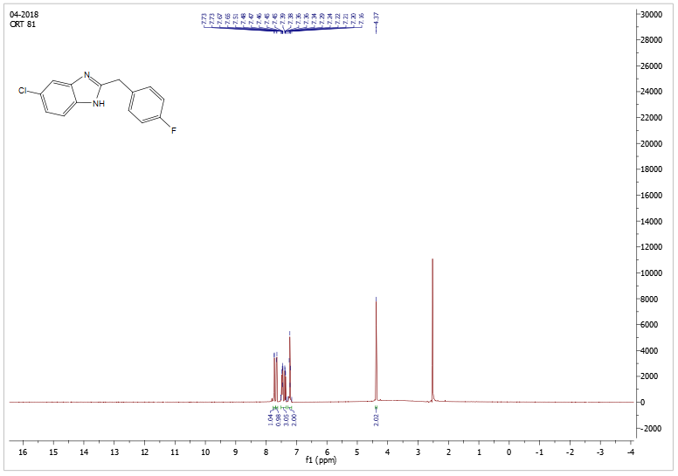
¹H NMR spectrum of 2-benzyl-5,6-dichloro-1H-benzo[d]imidazole (31)
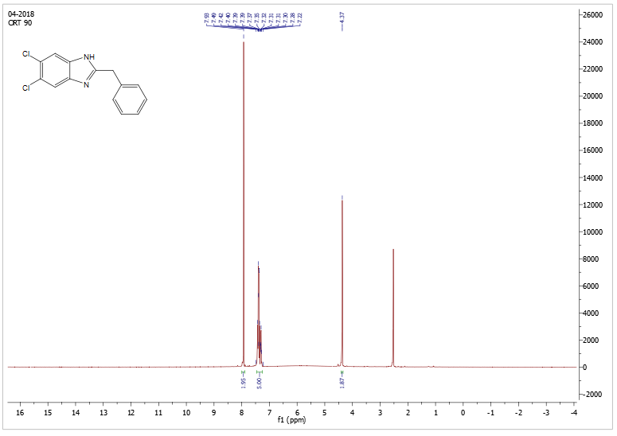

¹H NMR spectrum of 4-((5,6-dichloro-1H-benzo[d]imidazol-2-yl)methyl)phenol (33)
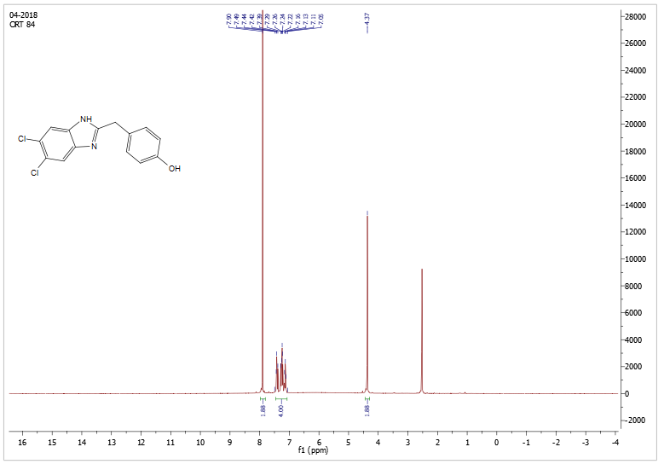
¹H NMR spectrum of 5,6-dichloro-2-(4-fluorobenzyl)-1H-benzo[d]imidazole (35)
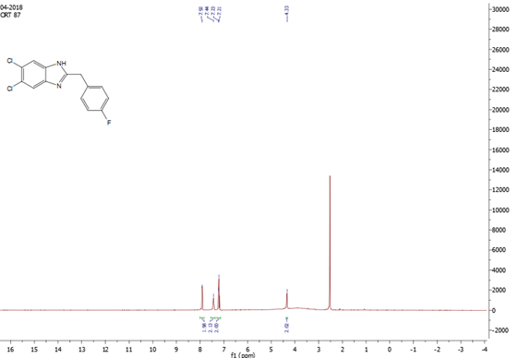

¹H NMR spectrum of 4-(2-(1H-benzo[d]imidazol-2-yl)ethyl)phenol (43)
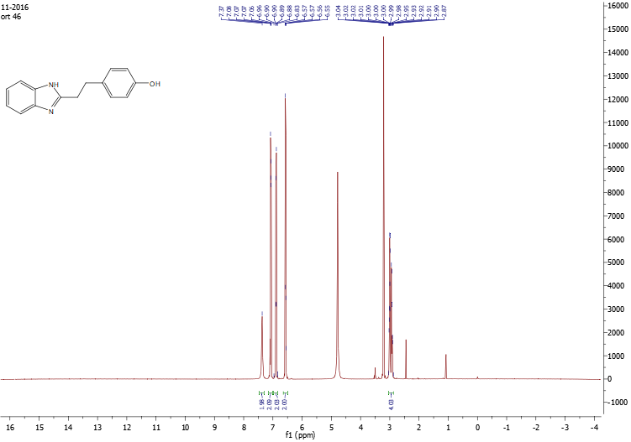
¹H NMR spectrum of 6-chloro-2-(4-methylphenethyl)-1H-benzo[d]imidazole (47)

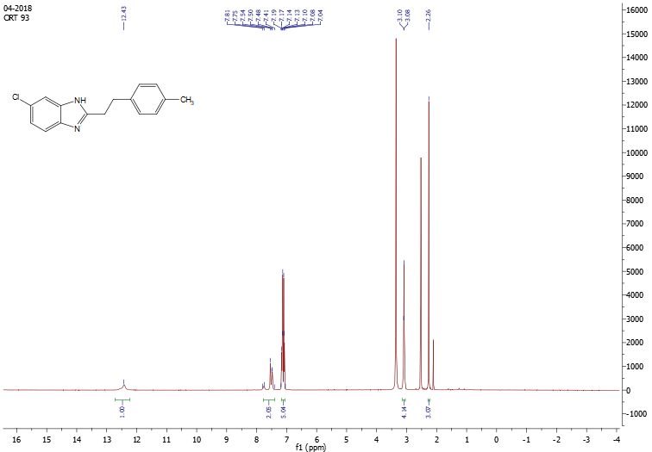

¹H NMR spectrum of 5(6)-Chloro-2-((4-hydroxyphenyl)ethyl)-1H-benzimidazole (48)
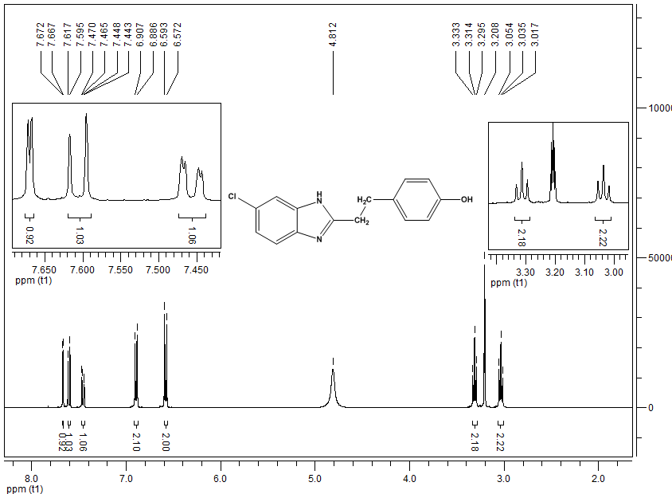
¹H NMR spectrum of 5(6)-Chloro-2-((4-chlorophenyl)ethyl)-1H-benzimidazole (49)
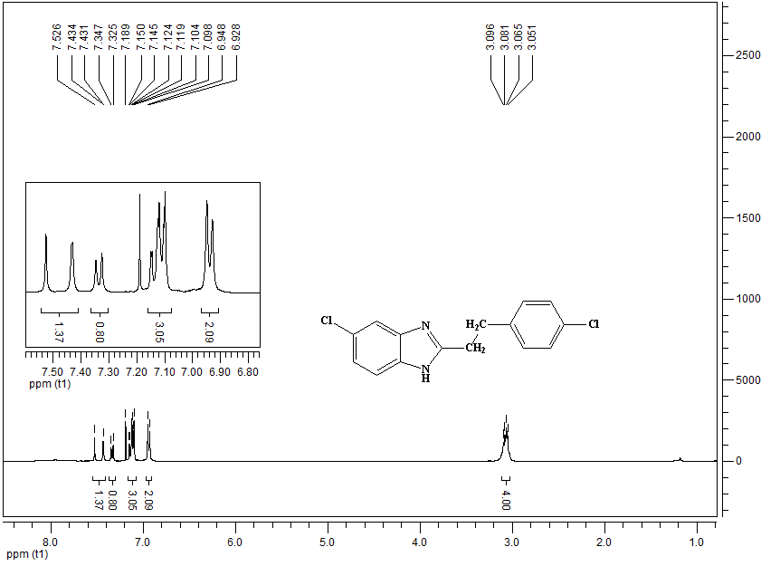

¹H NMR spectrum of 5(6)-Chloro-2-((4-fluorophenyl)ethyl)-1H-benzimidazole (50)
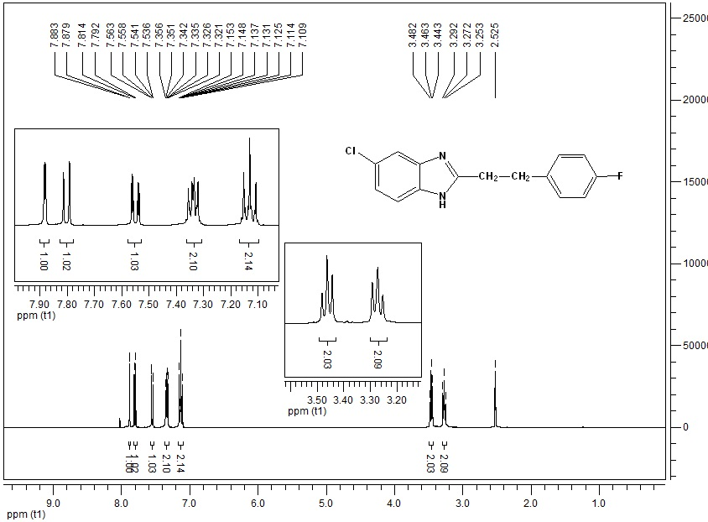
¹H NMR spectrum of 5,6-dichloro-2-(4-methylbenzyl)-1H-benzo[d]imidazole (52)
, 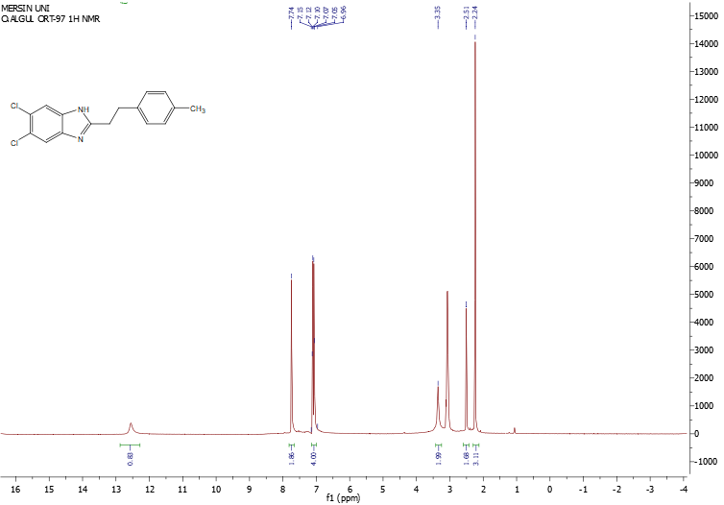

¹H NMR spectrum of 5,6-Dichloro-2-((4-hydroxyphenyl)ethyl)-1H-benzimidazole (53)
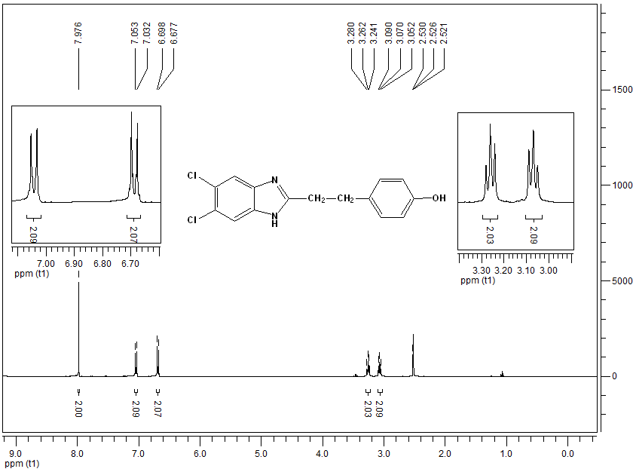
¹H NMR spectrum of 5,6-Dichloro-2-((4-chlorophenyl)ethyl)-1H-benzimidazole (54)
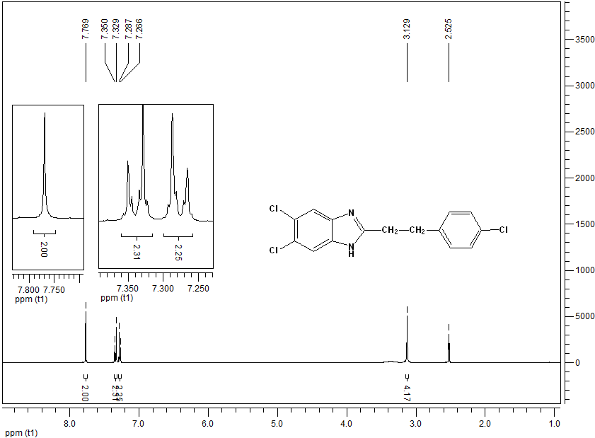

¹H NMR spectrum of 5,6-Dichloro-2-((4-fluorophenyl)ethyl)-1H-benzimidazole (55)
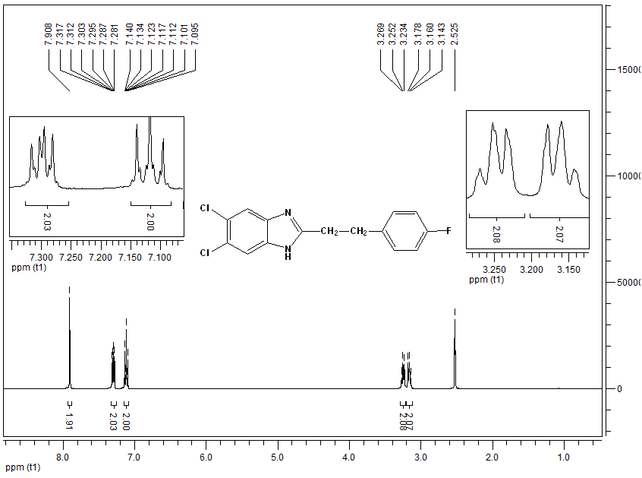
¹H NMR spectrum of 2-((4-Hydroxyphenoxy)methyl)-1H-benzimidazole (63)
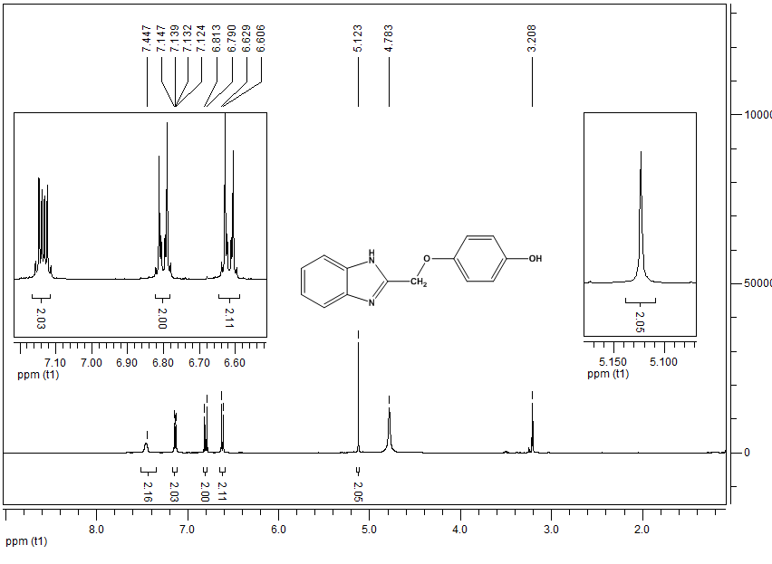

¹H NMR spectrum of 2-((4-fluorophenoxy)methyl)-1H-benzo[d]imidazole (65)
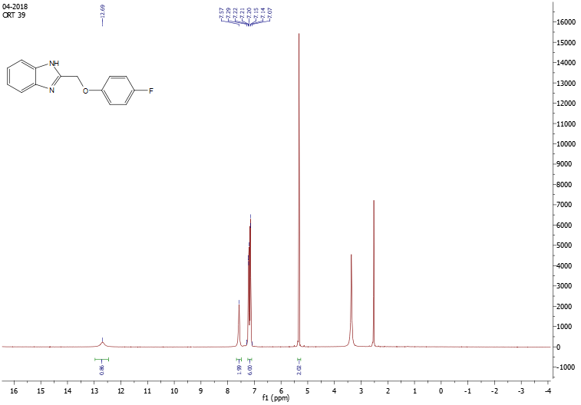
¹H NMR spectrum of 6-chloro-2-((p-tolyloxy)methyl)-1H-benzo[d]imidazole (67)
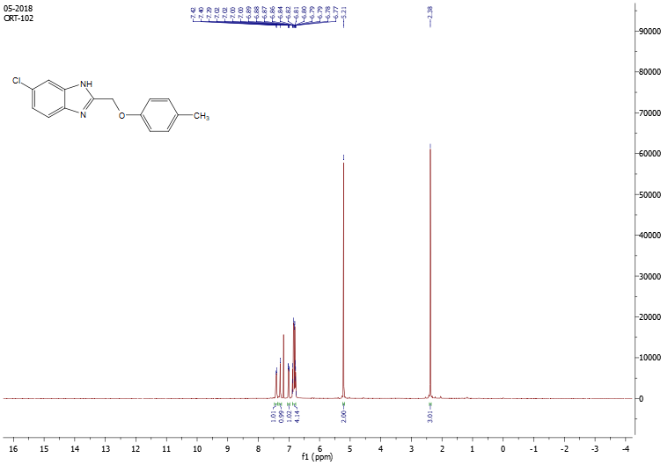

¹H NMR spectrum of 5(6)-Chloro-2-((4-hydroxyphenoxy)methyl)-1H-benzimidazole (68)
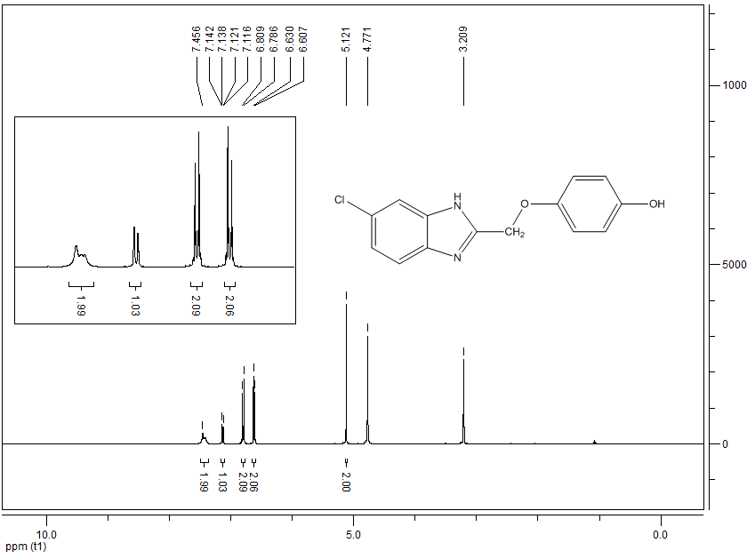
¹H NMR spectrum of 5-chloro-2-((4-fluorophenoxy)methyl)-1H-benzo[d]imidazole (70)
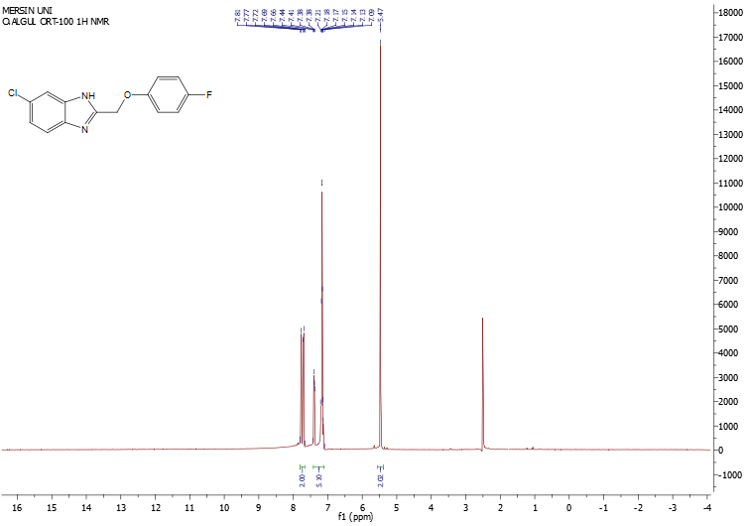

¹H NMR spectrum of 5,6-dichloro-2-(phenoxymethyl)-1H-benzo[d]imidazole (71)
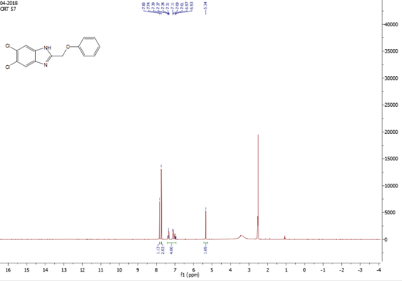

¹H NMR spectrum of 5,6-dichloro-2-((p-tolyloxy)methyl)-1H-benzo[d]imidazole (72)
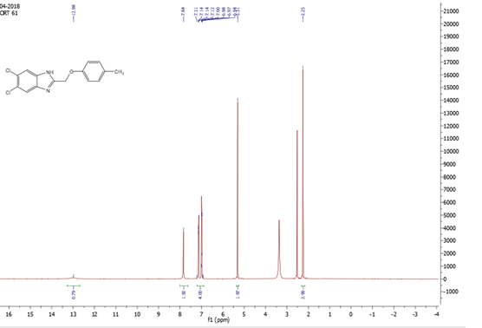

¹H NMR spectrum of 5,6-Dichloro-2-((4-hydroxyphenoxy)methyl)-1H-benzimidazole (73)
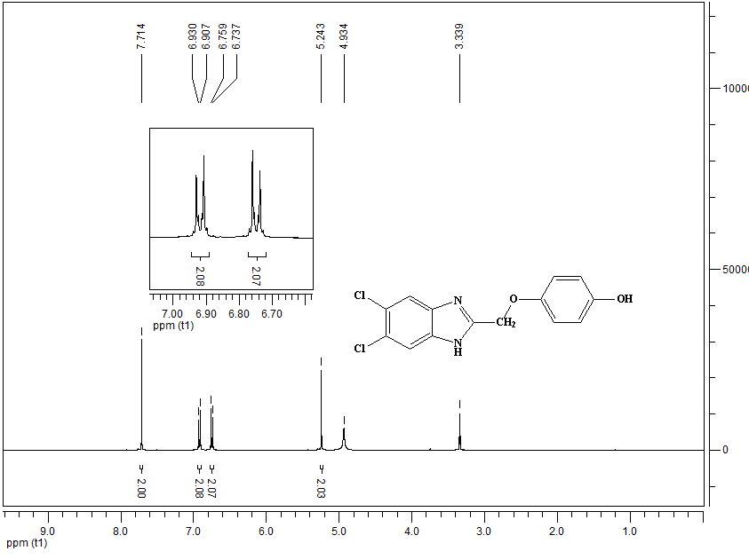
¹H NMR spectrum of 5,6-dichloro-2-((4-chlorophenoxy)methyl)-1H-benzo[d]imidazole (74)
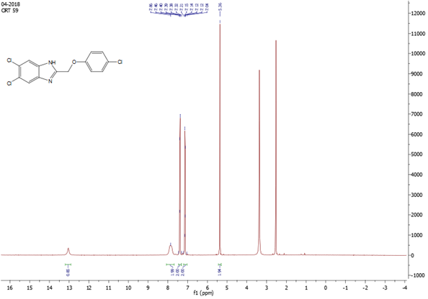
¹H NMR spectrum of 5,6-dichloro-2-((4-fluorophenoxy)methyl)-1H-benzo[d]imidazole (75)
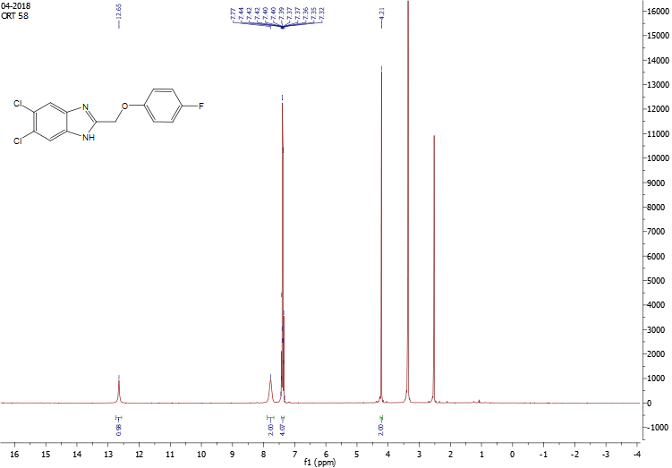
¹³C NMR spectrum of 4-((1H-benzo[d]imidazol-2-yl)methyl)phenol (23)
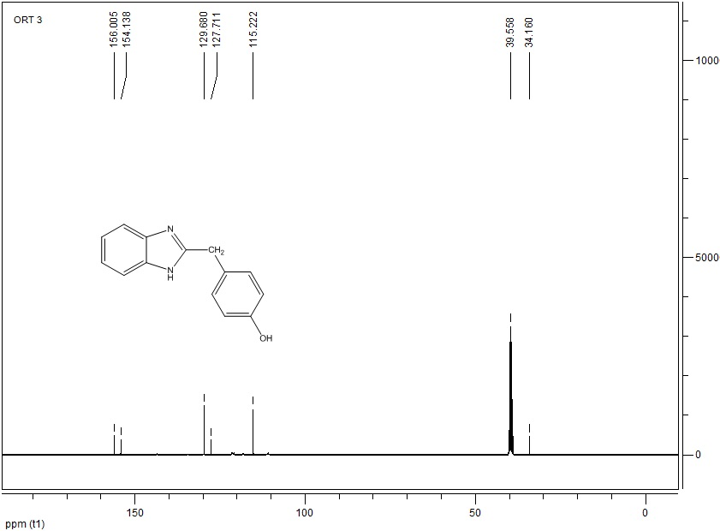

¹³C NMR spectrum of 4-((6-chloro-1H-benzo[d]imidazol-2-yl)methyl)phenol (28)
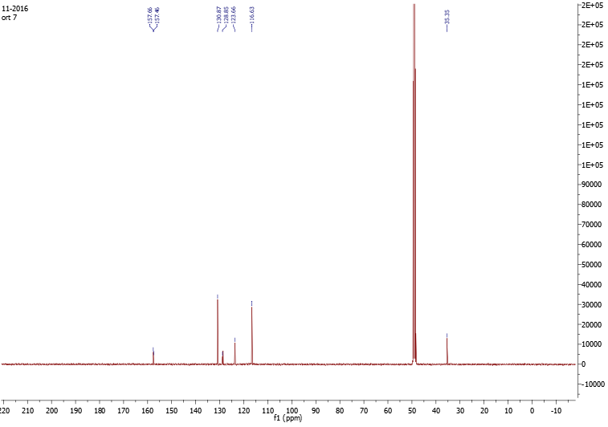
¹³C NMR spectrum of 6-chloro-2-(4-fluorobenzyl)-1H-benzo[d]imidazole (30)
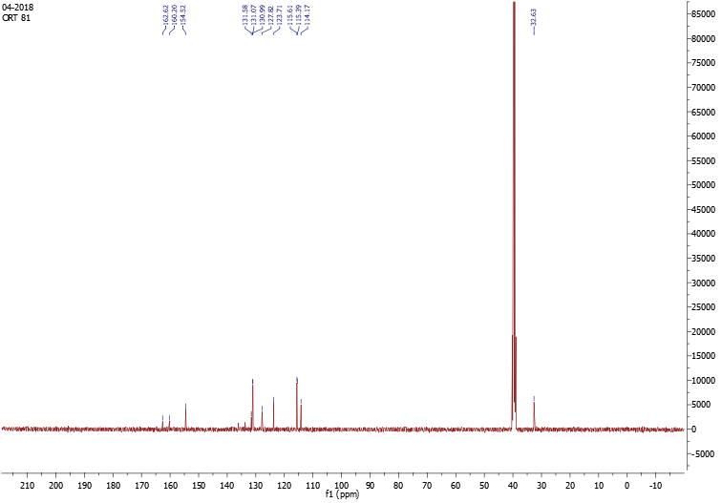

¹³C NMR spectrum of 2-benzyl-5,6-dichloro-1H-benzo[d]imidazole (31)
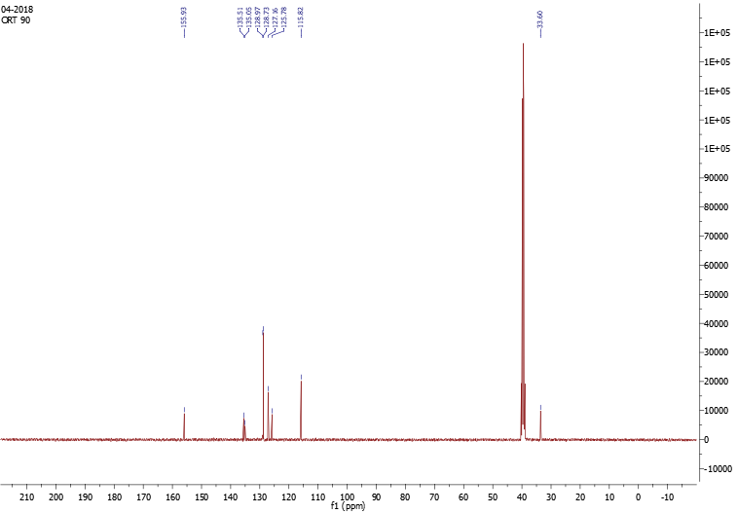
¹³C NMR spectrum of 4-((5,6-dichloro-1H-benzo[d]imidazol-2-yl)methyl)phenol (33)
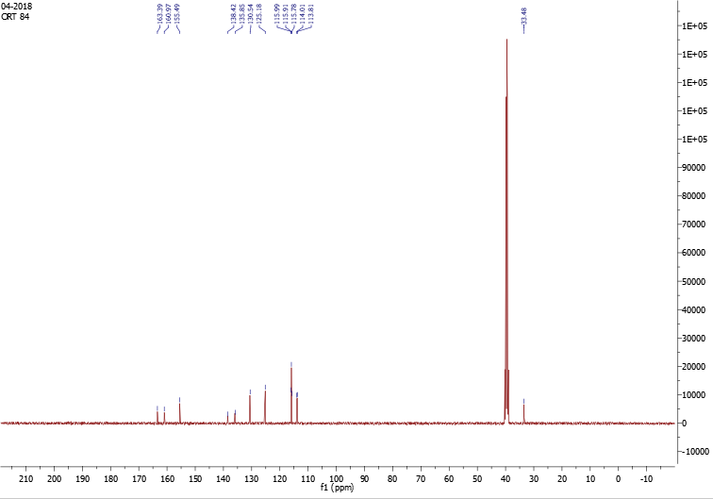

¹³C NMR spectrum of 5,6-dichloro-2-(4-fluorobenzyl)-1H-benzo[d]imidazole (35)
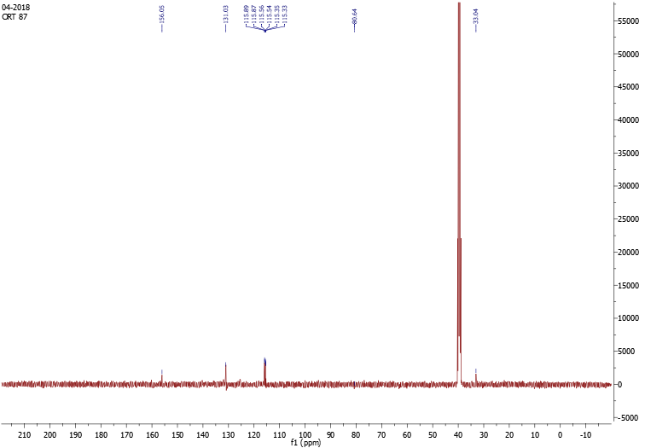
¹³C NMR spectrum of 4-(2-(1H-benzo[d]imidazol-2-yl)ethyl)phenol (43)

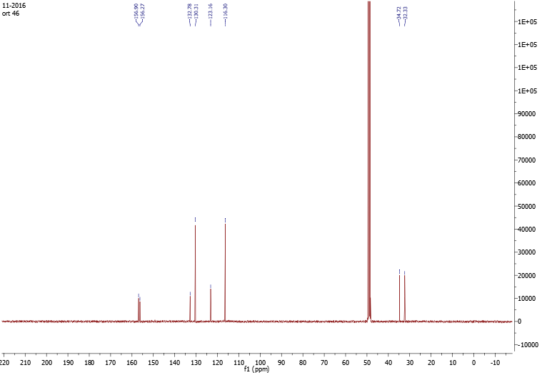

¹³C NMR spectrum of 6-chloro-2-(4-methylphenethyl)-1H-benzo[d]imidazole (47)
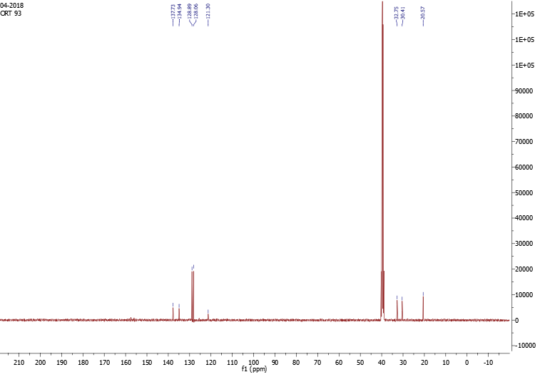
¹³C NMR spectrum of 5(6)-Chloro-2-((4-hydroxyphenyl)ethyl)-1H-benzimidazole (48)
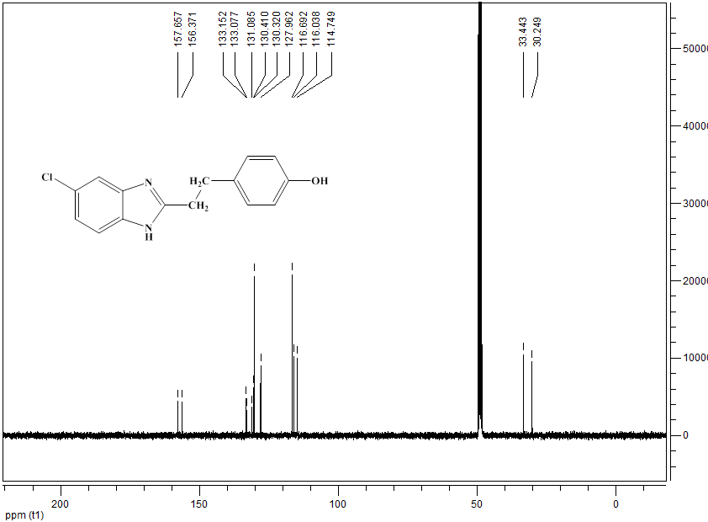

¹³C NMR spectrum of 5(6)-Chloro-2-((4-chlorophenyl)ethyl)-1H-benzimidazole (49)
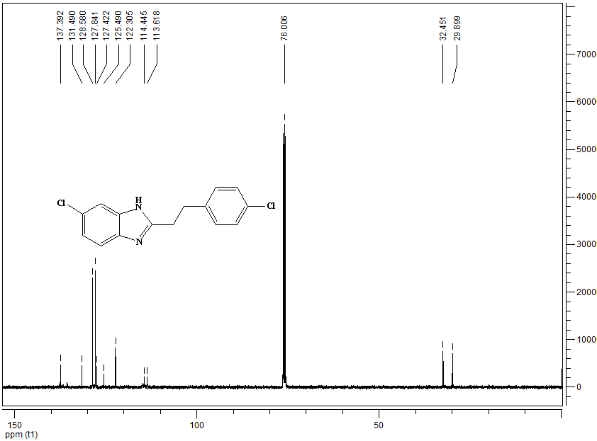
¹³C NMR spectrum of 5(6)-Chloro-2-((4-fluorophenyl)ethyl)-1H-benzimidazole (50)
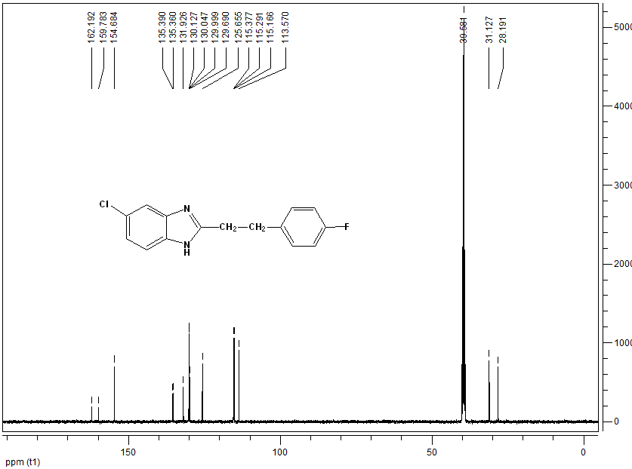

¹³C NMR spectrum of 5,6-dichloro-2-(4-methylbenzyl)-1H-benzo[d]imidazole (52)
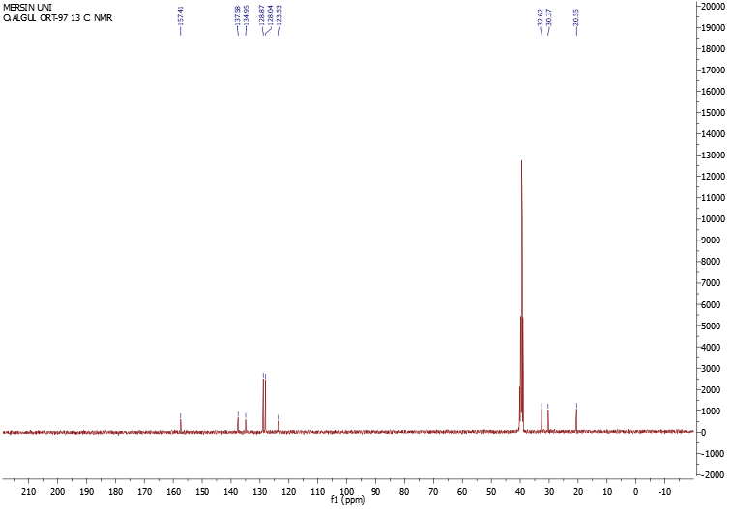
¹³C NMR spectrum of 5,6-Dichloro-2-((4-hydroxyphenyl)ethyl)-1H-benzimidazole (53)
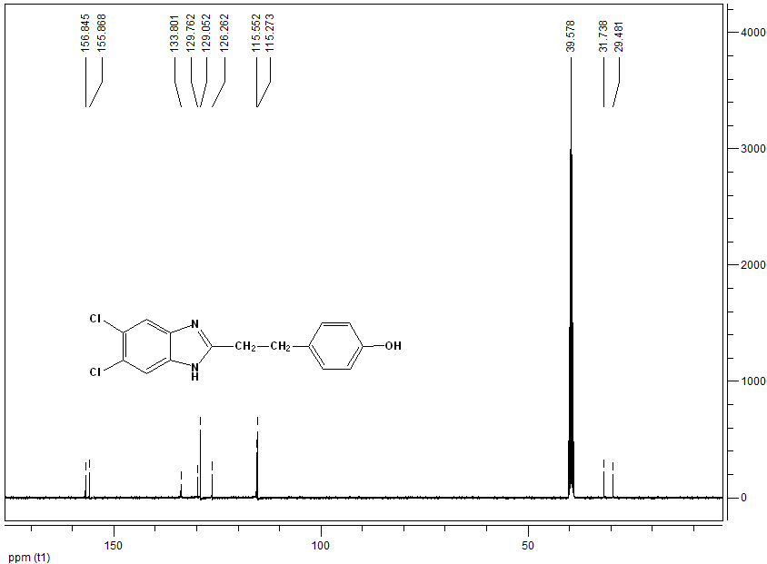

¹³C NMR spectrum of 5,6-Dichloro-2-((4-chlorophenyl)ethyl)-1H-benzimidazole (54)
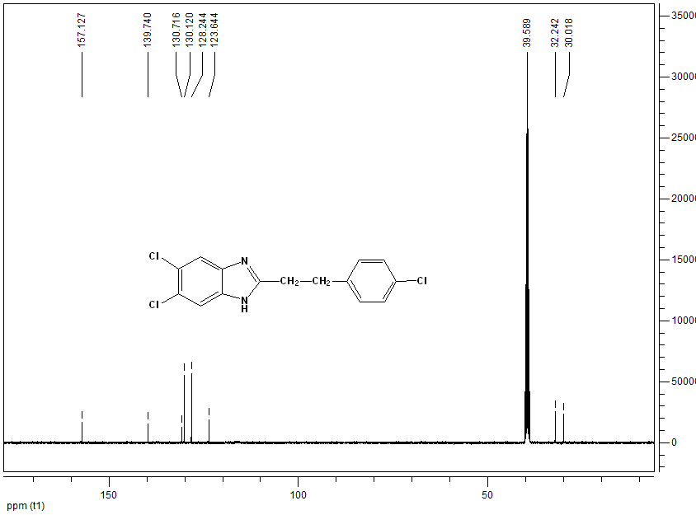
¹³C NMR spectrum of 5,6-Dichloro-2-((4-fluorophenyl)ethyl)-1H-benzimidazole (55)
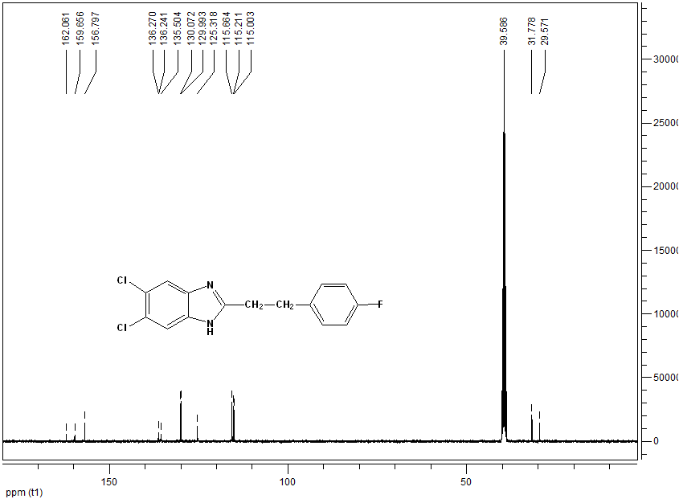
¹³C NMR spectrum of 2-((4-Hydroxyphenoxy)methyl)-1H-benzimidazole (63)
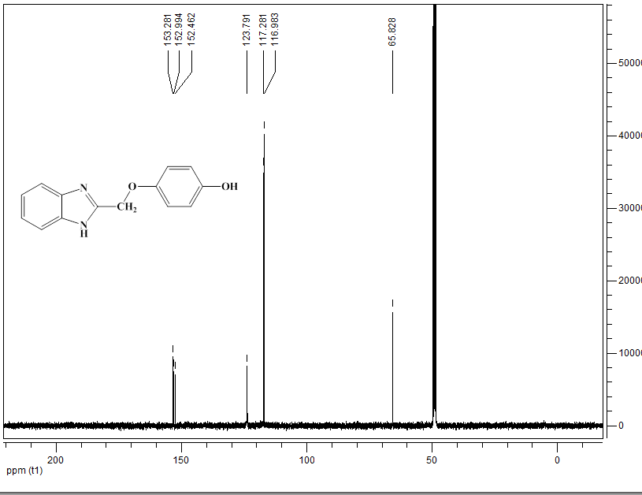
¹³C NMR spectrum of 2-((4-fluorophenoxy)methyl)-1H-benzo[d]imidazole (65)
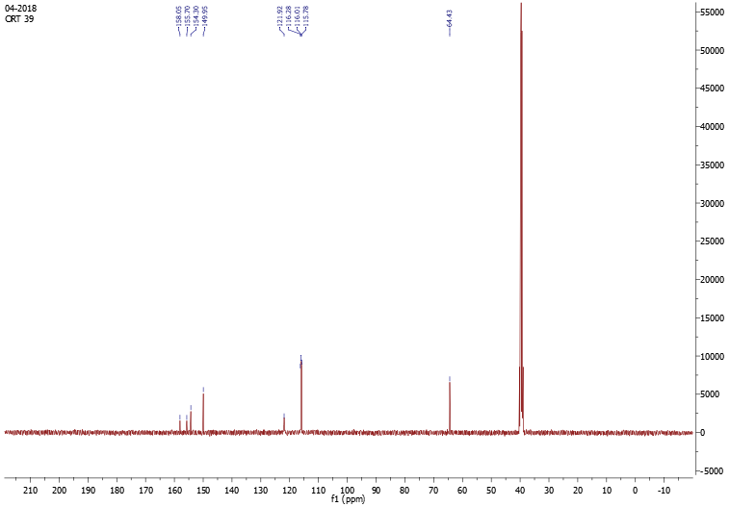
¹³C NMR spectrum of 6-chloro-2-((p-tolyloxy)methyl)-1H-benzo[d]imidazole (67)
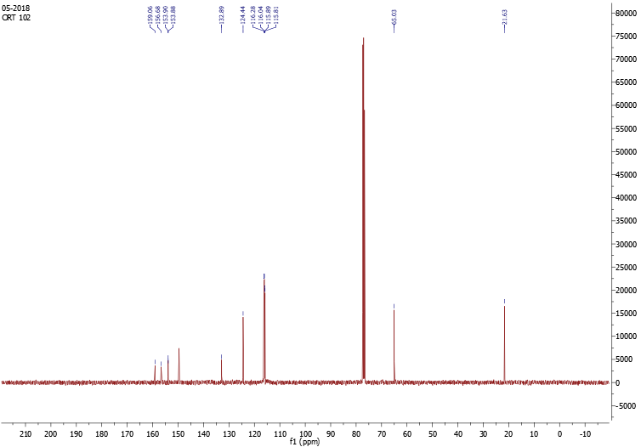
¹³C NMR spectrum of 5(6)-Chloro-2-((4-hydroxyphenoxy)methyl)-1H-benzimidazole (68)
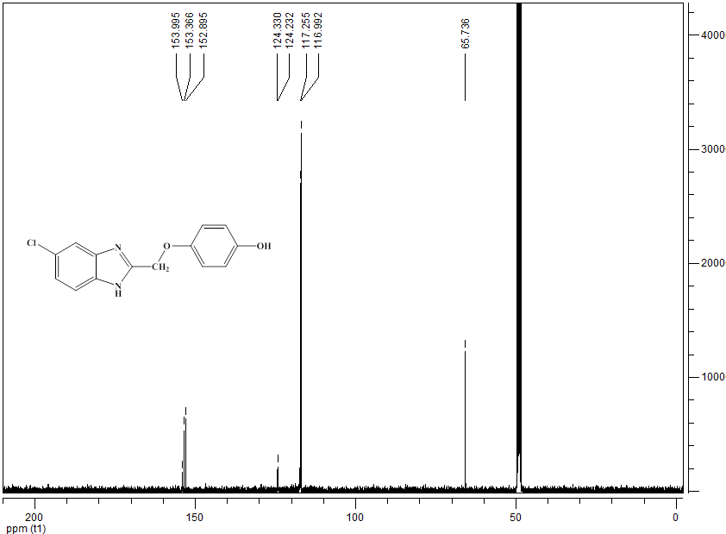
¹³C NMR spectrum of 5-chloro-2-((4-fluorophenoxy)methyl)-1H-benzo[d]imidazole (70)
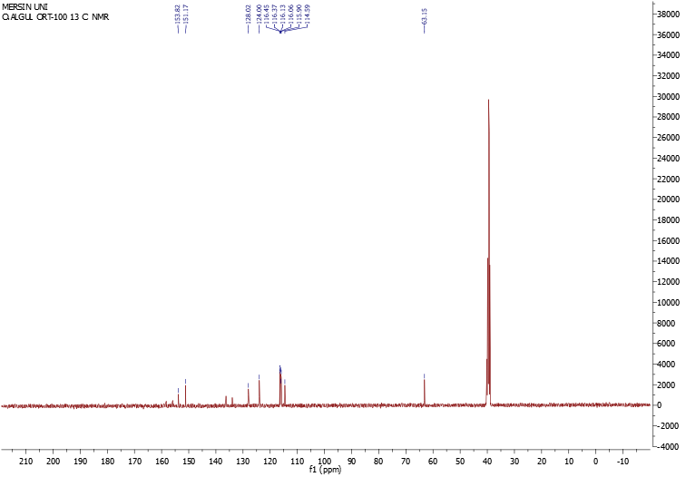
¹³C NMR spectrum of 5,6-dichloro-2-(phenoxymethyl)-1H-benzo[d]imidazole (71)
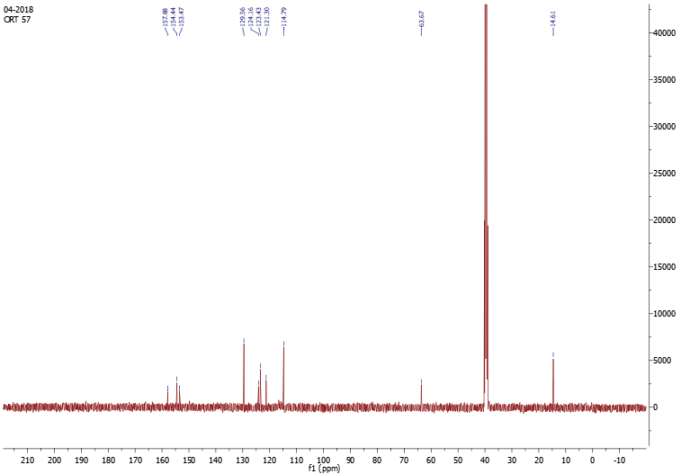

¹³C NMR spectrum of 5,6-dichloro-2-((p-tolyloxy)methyl)-1H-benzo[d]imidazole (72)
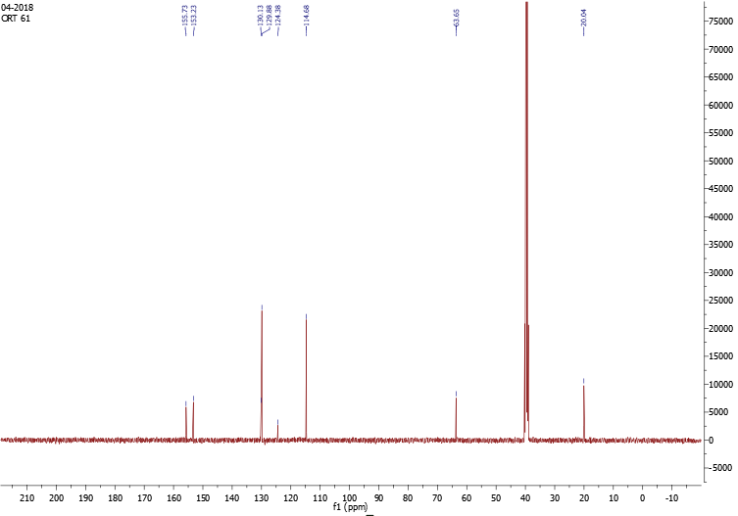
¹³C NMR spectrum of 5,6-Dichloro-2-((4-hydroxyphenoxy)methyl)-1H-benzimidazole (73)
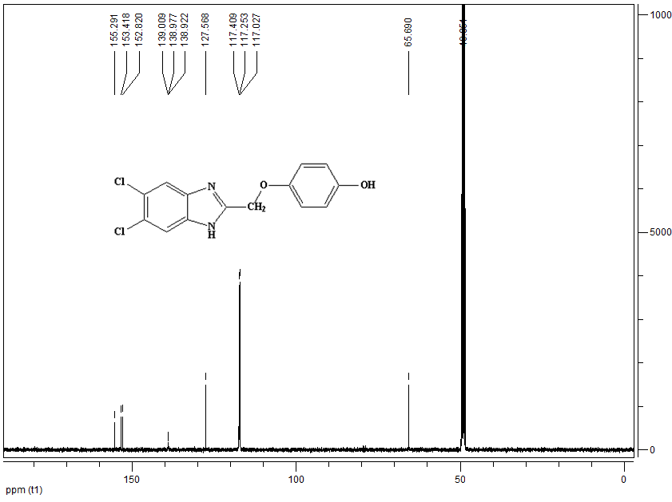
¹³C NMR spectrum of 5,6-dichloro-2-((4-chlorophenoxy)methyl)-1H-benzo[d]imidazole (74)
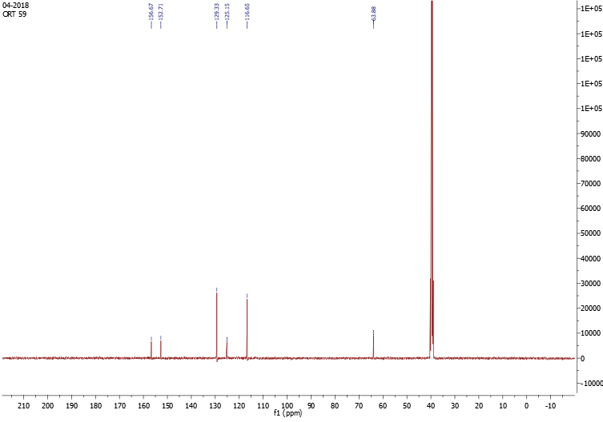
¹³C NMR spectrum of 5,6-dichloro-2-((4-fluorophenoxy)methyl)-1H-benzo[d]imidazole (75)
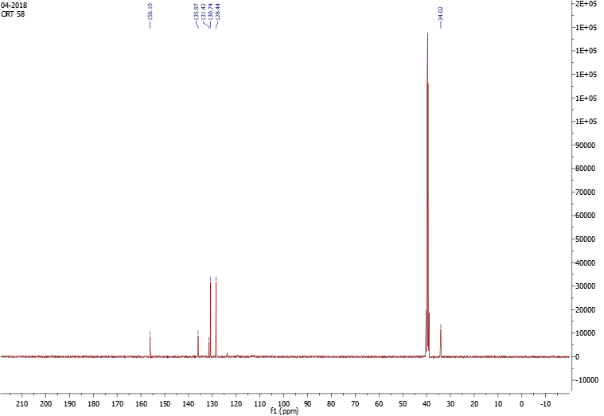
LC-MS/MS spectrum of 5(6)-Chloro-2-((4-hydroxyphenyl)ethyl)-1H-benzimidazole (48)
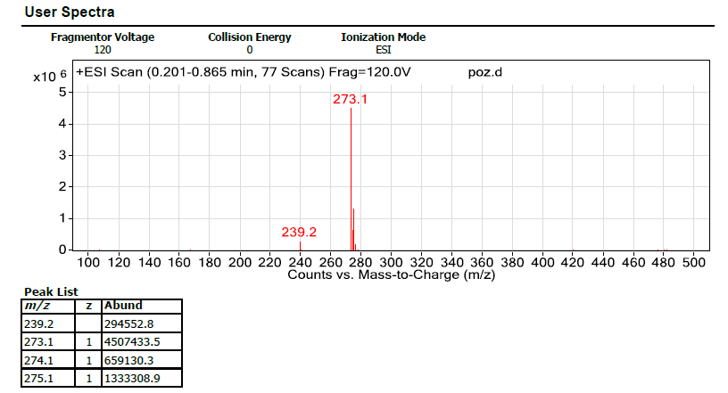
LC-MS/MS spectrum of 5(6)-Chloro-2-((4-chlorophenyl)ethyl)-1H-benzimidazole (49)
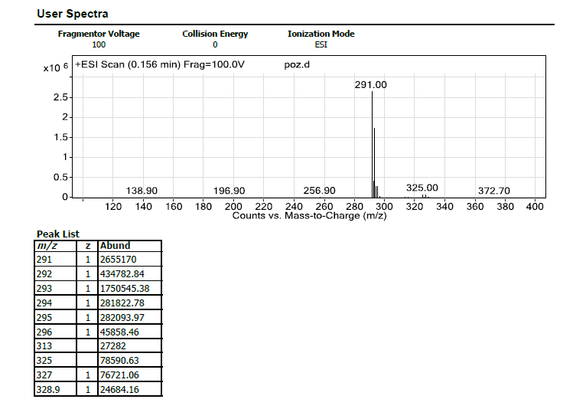

LC-MS/MS spectrum of 5(6)-Chloro-2-((4-fluorophenyl)ethyl)-1H-benzimidazole (50)
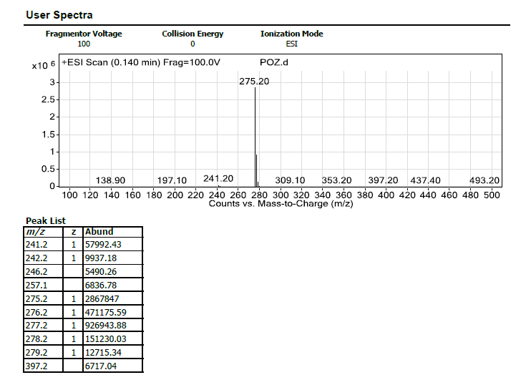
LC-MS/MS spectrum of 5,6-Dichloro-2-((4-hydroxyphenyl)ethyl)-1H-benzimidazole (53)
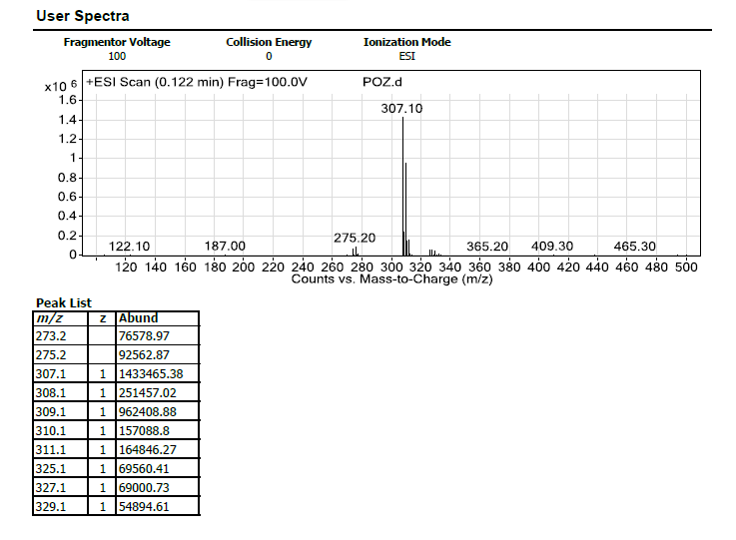

LC-MS/MS spectrum of 5,6-Dichloro-2-((4-chlorophenyl)ethyl)-1H-benzimidazole (54)
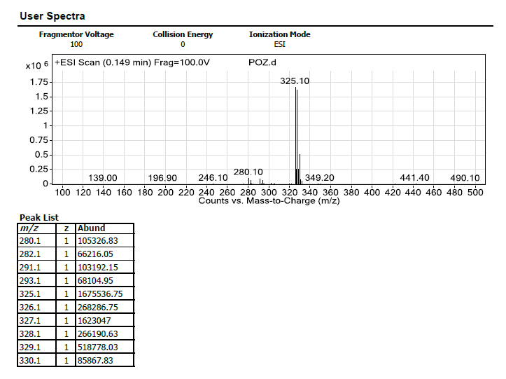
LC-MS/MS spectrum of 5,6-Dichloro-2-((4-fluorophenyl)ethyl)-1H-benzimidazole (55)
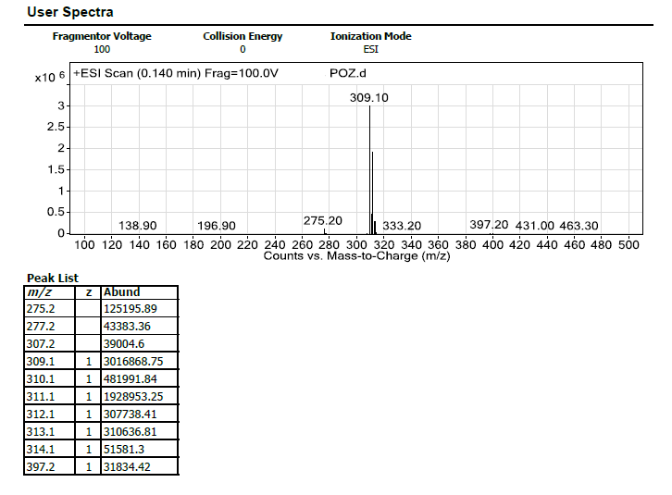
LC-MS/MS spectrum of 2-((4-Hydroxyphenoxy)methyl)-1H-benzimidazole (63)
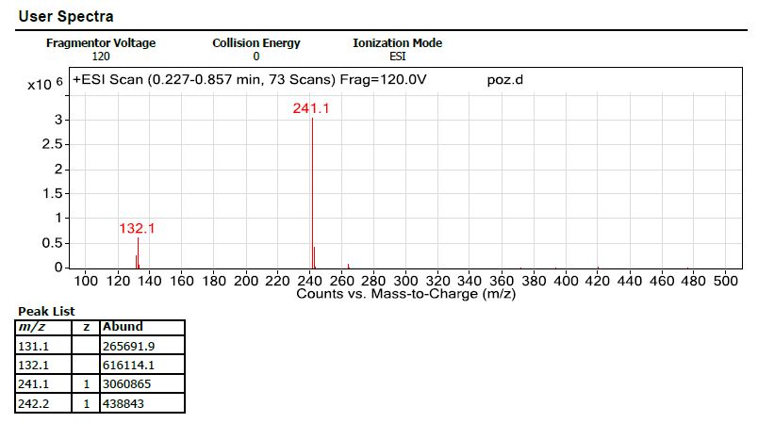
LC-MS/MS spectrum of 5(6)-Chloro-2-((4-hydroxyphenoxy)methyl)-1H-benzimidazole (68)
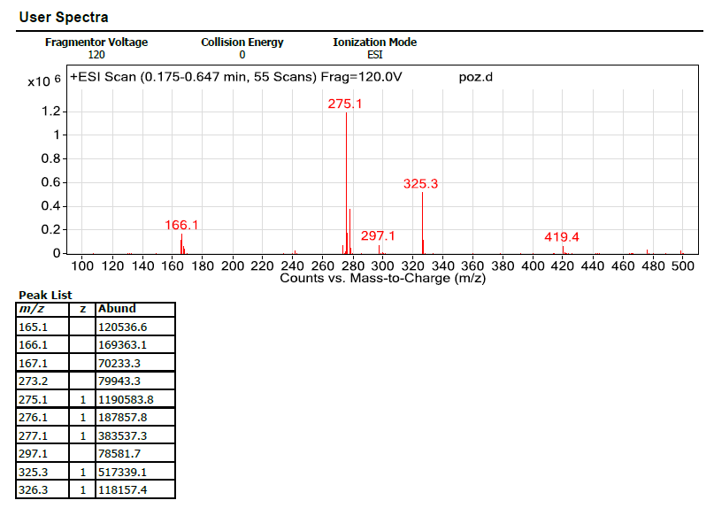
LC-MS/MS spectrum of 5,6-Dichloro-2-((4-hydroxyphenoxy)methyl)-1H-benzimidazole (73)
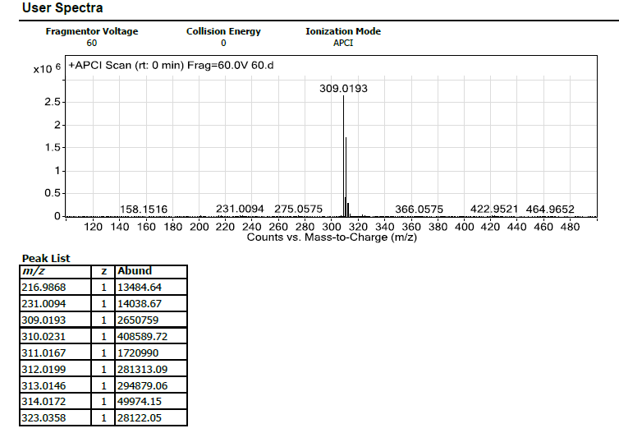

Table S1. Docking scores of compounds (kcal/mol) against potential target proteins
Compounds | 1SA0 | 4V24 | 3RCD | 2D0T | Compounds | 1SA0 | 4V24 | 3RCD | 2D0T
21 | -6,340 | -7,380 | -6,041 | -5,891 | 51 | -6,680 | -7,609 | -5,276 | -5,069
22 | -6,108 | -7,005 | -4,786 | -4,434 | 52 | -6,506 | -7,520 | -4,926 | -4,257
23 | -6,024 | -6,703 | -5,659 | -5,294 | 53 | -6,844 | -8,160 | -5,402 | -6,103
24 | -6,323 | -6,917 | -5,136 | -4,762 | 54 | -6,874 | -8,557 | -6,102 | -6,615
25 | -5,916 | -7,067 | -5,212 | -5,207 | 55 | -6,342 | -7,457 | -5,030 | -4,676
26 | -6,409 | -6,991 | -6,113 | -5,161 | 61 | -6,232 | -6,332 | -5,046 | -5,220
27 | -6,905 | -7,634 | -6,059 | -6,978 | 62 | -6,880 | -8,532 | -6,084 | -6,615
28 | -6,454 | -7,230 | -5,546 | -4,750 | 63 | -7,080 | -8,019 | -5,986 | -5,754
29 | -6,555 | -7,600 | -5,174 | -4,564 | 64 | -6,691 | -8,032 | -4,666 | -5,058
30 | -6,220 | -7,212 | -6,547 | -6,381 | 65 | -5,154 | -6,768 | -5,266 | -6,242
31 | -5,974 | -7,063 | -5,185 | -5,062 | 66 | -5,385 | -6,581 | -5,018 | -4,052
32 | -6,345 | -6,890 | -5,063 | -4,619 | 67 | -6,696 | -7,589 | -4,858 | -5,194
33 | -7,077 | -7,197 | -6,216 | -6,492 | 68 | -6,280 | -7,654 | -4,047 | -4,575
34 | -5,970 | -7,292 | -5,269 | -5,145 | 69 | -6,710 | -6,565 | -4,812 | -5,003
35 | -6,377 | -7,272 | -5,658 | -5,798 | 70 | -7,206 | -6,775 | -4,056 | -5,647
41 | -5,661 | -6,560 | -4,659 | -4,474 | 71 | -6,726 | -7,823 | -6,042 | -6,584
42 | -6,974 | -7,577 | -5,714 | -6,258 | 72 | -6,807 | -7,518 | -6,468 | -5,655
43 | -6,933 | -8,424 | -6,421 | -6,879 | 73 | -7,050 | -7,542 | -5,416 | -5,120
44 | -6,460 | -5,523 | -4,483 | -4,298 | 74 | -6,720 | -7,806 | -5,969 | -5,358
45 | -6,777 | -7,729 | -5,760 | -5,806 | 75 | -6,237 | -5,655 | -5,569 | -5,022
46 | -5,642 | -6,808 | -6,091 | -6,378 | CN2 * | -7,041 | - | - | -
47 | -6,455 | -6,142 | -5,022 | -5,199 | PF-543* | - | -9,078 | - | -
48 | -5,611 | -6,704 | -5,665 | -4,308 | TAK-285* | - | - | -6,481 | -
49 | -6,990 | -8,312 | -6,080 | -6,726 | PIM* | - | - | - | -6,004
50 | -6,409 | -7,338 | -4,712 | -5,101
*=Ligand in protein co-crystal structure

Table S2. Some predicted ADME, toxicological, and drug-like properties.
Compound | mol MW | logP | volume | PSA | Qplog HERG | QPP Caco | Qplog Khsa | Percent Human Oral Absorption | Rule of Five | Rule Of Three | Druglikeness Score | Mutagenic | Tumorigenic | Irritant
21 | 208,26 | 3,52 | 749,51 | 27,55 | -5,35 | 4855,75 | 0,27 | 100 | 0 | 0 | 0,021 | none | none | none
22 | 222,29 | 3,83 | 808,35 | 27,55 | -5,31 | 4855,75 | 0,43 | 100 | 0 | 0 | -0,053 | none | none | none
23 | 224,26 | 2,84 | 772,61 | 50,20 | -5,25 | 1465,18 | 0,06 | 100 | 0 | 0 | -0,004 | none | none | none
24 | 242,71 | 4,06 | 793,73 | 27,54 | -5,31 | 4859,25 | 0,39 | 100 | 0 | 0 | 0,100 | none | none | none
25 | 226,25 | 3,76 | 765,64 | 27,54 | -5,25 | 4859,71 | 0,31 | 100 | 0 | 0 | -1,319 | none | none | none
26 | 242,71 | 4,06 | 794,06 | 27,53 | -5,32 | 4864,23 | 0,39 | 100 | 0 | 0 | 0,100 | none | none | none
27 | 256,73 | 4,33 | 852,91 | 27,53 | -5,27 | 4864,23 | 0,55 | 100 | 0 | 0 | 0,035 | none | none | none
28 | 258,71 | 3,22 | 817,17 | 50,19 | -5,21 | 1467,74 | 0,17 | 100 | 0 | 0 | 0,085 | none | none | none
29 | 277,15 | 4,56 | 838,29 | 27,52 | -5,28 | 4867,73 | 0,51 | 100 | 0 | 0 | 0,100 | none | none | none
30 | 260,70 | 4,30 | 810,20 | 27,52 | -5,22 | 4868,19 | 0,43 | 100 | 0 | 0 | -1,240 | none | none | none
31 | 277,15 | 4,51 | 833,64 | 27,53 | -5,25 | 4866,19 | 0,50 | 100 | 0 | 0 | 0,100 | none | none | none
32 | 291,18 | 4,76 | 892,48 | 27,53 | -5,19 | 4866,19 | 0,66 | 100 | 0 | 0 | 0,035 | none | none | none
33 | 293,15 | 3,65 | 856,74 | 50,19 | -5,14 | 1468,33 | 0,28 | 100 | 0 | 0 | 0,085 | none | none | none
34 | 311,60 | 4,95 | 877,86 | 27,52 | -5,20 | 4869,69 | 0,62 | 100 | 0 | 1 | 0,100 | none | none | none
35 | 295,14 | 4,69 | 849,77 | 27,52 | -5,14 | 4870,15 | 0,54 | 100 | 0 | 0 | -1,240 | none | none | none
41 | 222,29 | 3,87 | 810,98 | 27,86 | -5,77 | 4164,15 | 0,39 | 100 | 0 | 0 | -1,029 | none | none | none
42 | 236,32 | 4,18 | 869,82 | 27,86 | -5,71 | 4164,15 | 0,55 | 100 | 0 | 0 | -1,103 | none | none | none
43 | 238,29 | 3,09 | 834,08 | 50,52 | -5,66 | 1256,50 | 0,17 | 100 | 0 | 0 | -1,054 | none | none | none
44 | 256,73 | 4,41 | 855,20 | 27,86 | -5,71 | 4163,72 | 0,51 | 100 | 0 | 0 | -0,950 | none | none | none
45 | 240,28 | 4,11 | 827,11 | 27,86 | -5,66 | 4163,52 | 0,44 | 100 | 0 | 0 | -2,369 | none | none | none
46 | 256,73 | 4,41 | 855,53 | 27,85 | -5,72 | 4171,20 | 0,51 | 100 | 0 | 0 | -0,950 | none | none | none
47 | 270,76 | 4,73 | 914,38 | 27,85 | -5,65 | 4171,20 | 0,68 | 100 | 0 | 0 | -1,015 | none | none | none
48 | 272,73 | 3,56 | 878,63 | 50,51 | -5,61 | 1258,63 | 0,29 | 100 | 0 | 0 | -0,965 | none | none | none
49 | 291,18 | 4,87 | 899,76 | 27,85 | -5,66 | 4170,62 | 0,64 | 100 | 0 | 0 | -0,950 | none | none | none
50 | 274,73 | 4,61 | 871,67 | 27,85 | -5,61 | 4170,56 | 0,56 | 100 | 0 | 0 | -2,290 | none | none | none
51 | 291,18 | 4,80 | 895,11 | 27,85 | -5,64 | 4173,12 | 0,62 | 100 | 0 | 0 | -0,950 | none | none | none
52 | 305,21 | 5,11 | 953,95 | 27,85 | -5,56 | 4173,12 | 0,79 | 100 | 1 | 1 | -1,015 | none | none | none
53 | 307,18 | 3,99 | 918,21 | 50,50 | -5,52 | 1259,20 | 0,39 | 100 | 0 | 0 | -0,965 | none | none | none
54 | 325,62 | 5,30 | 939,33 | 27,85 | -5,57 | 4172,69 | 0,75 | 100 | 1 | 1 | -0,950 | none | none | none
55 | 309,17 | 5,04 | 911,24 | 27,85 | -5,52 | 4172,48 | 0,67 | 100 | 1 | 1 | -2,290 | none | none | none
61 | 224,26 | 3,34 | 778,89 | 35,56 | -5,81 | 3636,50 | 0,17 | 100 | 0 | 0 | -0,508 | none | none | none
62 | 238,29 | 3,65 | 837,74 | 35,56 | -5,75 | 3636,50 | 0,33 | 100 | 0 | 0 | -0,535 | none | none | high
63 | 240,26 | 2,57 | 802,00 | 58,22 | -5,70 | 1097,28 | -0,02 | 96 | 0 | 0 | -0,460 | none | none | none
64 | 258,71 | 3,85 | 823,18 | 35,56 | -5,75 | 3636,50 | 0,29 | 100 | 0 | 0 | -0,398 | none | none | none
65 | 242,25 | 3,58 | 795,10 | 35,56 | -5,70 | 3636,50 | 0,21 | 100 | 0 | 0 | -1,848 | none | none | none
66 | 258,71 | 3,85 | 823,45 | 35,55 | -5,76 | 3642,50 | 0,29 | 100 | 0 | 0 | -0,398 | none | none | none
67 | 272,73 | 4,17 | 882,30 | 35,55 | -5,69 | 3642,50 | 0,45 | 100 | 0 | 0 | -0,423 | none | none | high
68 | 274,71 | 3,06 | 846,55 | 58,20 | -5,65 | 1099,09 | 0,09 | 100 | 0 | 0 | -0,350 | none | none | none
69 | 293,15 | 4,34 | 867,74 | 35,54 | -5,70 | 3642,50 | 0,41 | 100 | 0 | 0 | -0,398 | none | none | none
70 | 276,70 | 4,08 | 839,66 | 35,54 | -5,65 | 3642,50 | 0,33 | 100 | 0 | 0 | -1,738 | none | none | none
71 | 293,15 | 4,26 | 863,02 | 35,55 | -5,68 | 3644,22 | 0,40 | 100 | 0 | 0 | -0,398 | none | none | none
72 | 307,18 | 4,60 | 921,87 | 35,55 | -5,60 | 3644,22 | 0,56 | 100 | 0 | 0 | -0,423 | none | none | high
73 | 309,15 | 3,48 | 886,12 | 58,20 | -5,56 | 1099,61 | 0,19 | 100 | 0 | 0 | -0,350 | none | none | none
74 | 327,60 | 4,76 | 907,31 | 35,54 | -5,61 | 3644,22 | 0,52 | 100 | 0 | 1 | -0,398 | none | none | none
75 | 311,14 | 4,50 | 879,23 | 35,54 | -5,56 | 3644,22 | 0,44 | 100 | 0 | 0 | -1,738 | none | none | none

PSA: Van der Waals surface area of polar nitrogen and oxygen atoms and carbonyl carbon atoms (7.0 – 200.0).Volume: Total solvent-accessible volume in cubic angstroms using a probe with a 1.4 Å Radius (500,0 – 2000,0). QPlogHERG: Predicted IC₅₀ value for blockage of HERG K+ channels (concern below –5). QPPCaco: Predicted apparent Caco-2 cell permeability in nm/sec. Caco2 cells are a model for the gut-blood barrier. QikProp predictions are for non-active transport (<25 poor, >500 great). QPlogKhsa: Prediction of binding to human serum albumin (–1.5 – 1.5). Percent Human Oral Absorption: Predicted human oral absorption on 0 to 100% scale (>80% is high <25% is poor). Rule Of Five: Number of violations of Lipinski’s rule of five . The rules are: mol_MW < 500, QPlogPo/w < 5, donorHB ≤ 5, accptHB ≤ 10. Compounds that satisfy these rules are considered druglike (The “five” refers to the limits, which are multiples of 5). Rule Of Three: Number of violations of Jorgensen’s rule of three. The three rules are: QPlogS > -5.7, QP PCaco > 22 nm/s, Primary Metabolites < 7. Compounds with fewer (and preferably no) violations of these rules are more likely to be orally available.

References:
Algul, O., Ozcelik, B., Abbasoglu, U., & Gumus, F. (2005). Synthesis, Characterization and Genotoxicity of Platinum(II)Complexes With Subtituted Benzimidazole Ligands. Turkish Journal of Chemistry, 29, 607 – 615.
Ben-David, Y.,&Milstein D.(2017). Direct Synthesis of Benzimidazoles by Dehydrogenative Coupling of Aromatic Diamines and Alcohols Catalyzed by Cobalt Prosenjit Daw. ACS Catalysis, 7, 7456-7460.
Boggua,P., Venkateswararaoa, E., Manickam, M., Kwak, D., Kim, Y., & Jung, S.H. (2016). Exploration of 2-benzylbenzimidazole scaffold as novel inhibitor of NF-kB. Bioorganic & Medicinal Chemistry, 24, 1872–1878.
Chantler, T., Perrin, V. L., Donkor, R. E., Cawthorne, R. S., & Bowen, R. D. (2004). Proximity effects in the electron impact mass spectra of 2-substituted benzazoles. International Journal of Mass Spectrometry, 236, 65–80.
Hruszkewycz, D. P., Miles, K. C., Thiel O. R., & Stahl S. S. (2017). Co/NHPI-mediated aerobic oxygenation of benzylic C–H bonds in pharmaceutically relevant molecules. Chemical Science, 8, 1282.
Manjunath, G., Mahesh, M.,Bheemaraju, G, &Ramana, P. V.(2015). Synthesis and antimicrobial activity of novel pyrazolone and pyrazole analogues containing benzimidazole moiety. Journal of Pharmaceutical, Biological and Chemical Sciences, 6 (4), 704-716.
Mentese, E., Doğan, I. S., &Kahveci, B. (2013). Green Protocol: Solvent- And Catalyst-Free Synthesis of Benzimidazole Derivatives Via Microwave Technique. Chemistry of Heterocyclic Compounds, 49, 1136-1140.
Oren, I.Y., Yalcin, I., Sener, E. A., & Ucarturk, N. (2004). Synthesis and structure–activity relationships of new antimicrobial active multisubstituted benzazole derivatives. European Journal of Medicinal Chemistry, 39, 291–298.
Santos, A. D., Kaïm L. E., & Grimaud, L. (2013). Metal-free aerobic oxidation of benzazole derivatives. Organic & Biomolecular Chemistry, 11, 3282.
Wang,Y., Sarris, K., Sauer D. R., & Djuric, S. W. (2006). A simple and eﬃcient one step synthesis of benzoxazoles and benzimidazoles from carboxylic acids. Tetrahedron Letters, 47, 4823–4826.
Wena, X., El Bakalib, J., Poulain, R. D., & Deprez, B. (2012). Efﬁcient propylphosphonic anhydride (T3P) mediated synthesis of benzothiazoles, benzoxazoles and benzimidazoles. Tetrahedron Letters, 53, 2440–2443.

