Supporting Information

Monitoring and imaging pH in biofilms utilizing a fluorescent polymeric nanosensor
Charlotte Kromer^{1,2}, Karin Schwibbert³, Ashish K. Gadicherla⁴, Dorothea Thiele³, Nithiya Nirmalananthan-Budau⁵, Peter Laux¹, Ute Resch-Genger⁵*, Andreas Luch^{1,2}, Harald R. Tschiche¹*
$${ratio}_{FI}=d+\left(\frac{a-d}{1+{\left(\frac{pH}{c}\right)}^{b}}\right)$$
Supporting Equation S1. Curve fitting for pH calibration.

Supporting Table S2. Parameters used for the inverse estimation.
Parameter | Estimate | Std. Error
a | 0.13383 | 0.01005
b | 0.71996 | 0.01539
c | 7.16552 | 0.05673
d | 0.68475 | 0.05915

The thickness of the biofilm was determined after 24 h growth time and 2 times washing steps with RB-buffer (Supporting Table S3). For the measurements, the focus plane of the CLSM was placed at the lower end of the biofilm in BF mode and a z-stack was recorded until reaching the minimum or maximum upper end. Three measurement points were recorded for each biological replicate. After a growth period of 24 hours, the E. coli biofilms had a uniform thickness and colonized the entire Ibidi glass slide without gaps.

To visualize the structure and viability of the biofilm, a live/dead staining was performed using the BacLight kit (Thermo Fisher Scientific). Supporting Figure S3 shows the top and side view of a CLSM image obtained from a live/dead stained biofilm. A dense and homogeneous biofilm uniformly colonizes the slide. The high number of living bacteria (green) shows the high viability of the biofilm with is not altered when PS NP are incubated into the biofilm for 24 hours.
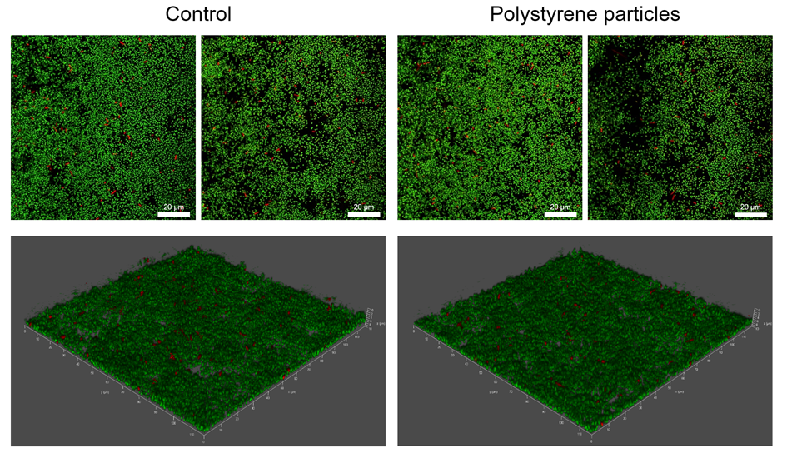
Supporting Figure S3 CLSM image of a live/dead stained biofilm. The green SYTO®9 stain represents living cells, the red propidium iodide stain represents dead cells. Left: biofilm grown without nanoparticles for 24 h. Right: biofilm incubated with 1 mg/ml polystyrene nanoparticles for 24 hours.

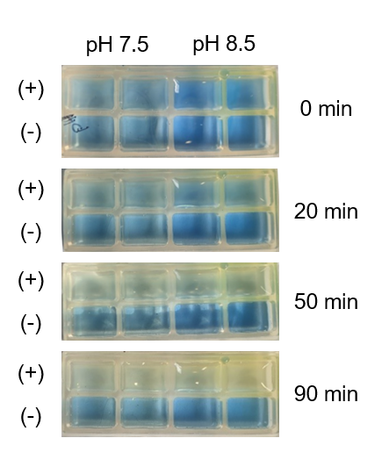
Supporting Figure S4 Test for metabolic activity of E. coli biofilms in terms of acidification of growth media. Bromothymol blue was used as pH indicator solution. The upper row samples (+) were inoculated with glucose, the lower row samples (-) were control samples without glucose. The change of color from blue to yellow, indicates acidification of the samples containing glucose.

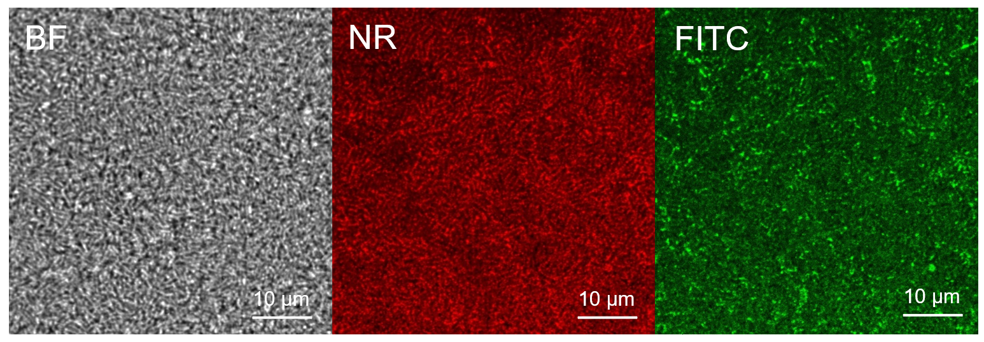
Supporting Figure S5 CLSM images of the biofilm in bright field (BF) and fluorescence mode (NR and FITC). In BF mode the dense biofilm composed of rod-shaped E. coli is visible. The NR fluorescence image shows the highest fluorescence signals in extracellular regions, indicating that the nanosensor is not taken up by the bacteria.

