MiRNA-mediated Changes in DNA Methylation Affect the Expression of Genes Involved in the Thickness of Pod Canopy Trait in Brassica napus
Zhiyou Chen^{1, 2, 3, 4}, Ledong Jia^{1, 2}, Yuanyuan Wan^{1, 2}, Jinqi Ma^{1, 2}, Kun Lu^{1, 2, 3, 4}, Cunmin Qu^{1, 2, 3, 4}*, Jiana Li^{1, 2, 3, 4}*
- College of Agronomy and Biotechnology, Southwest University, Chongqing 400715, China
- Academy of Agricultural Sciences, Southwest University, Chongqing 400715, China
- Engineering Research Center of South Upland Agriculture, Ministry of Education, Chongqing 400715, China
- State Cultivation Base of Crop Stress Biology for Southern Mountainous Land of Southwest University, Chongqing 400715, China
* Correspondence: drqucunmin@swu.edu.cn (C.Q.); ljn1950@swu.edu.cn (J.L.)

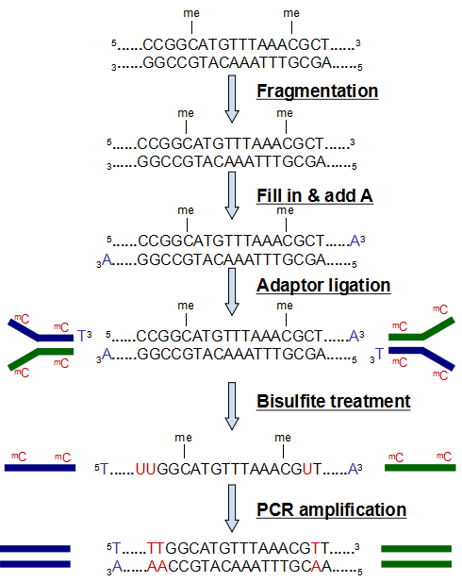
Supplementary figure 1. Library construction flowchart
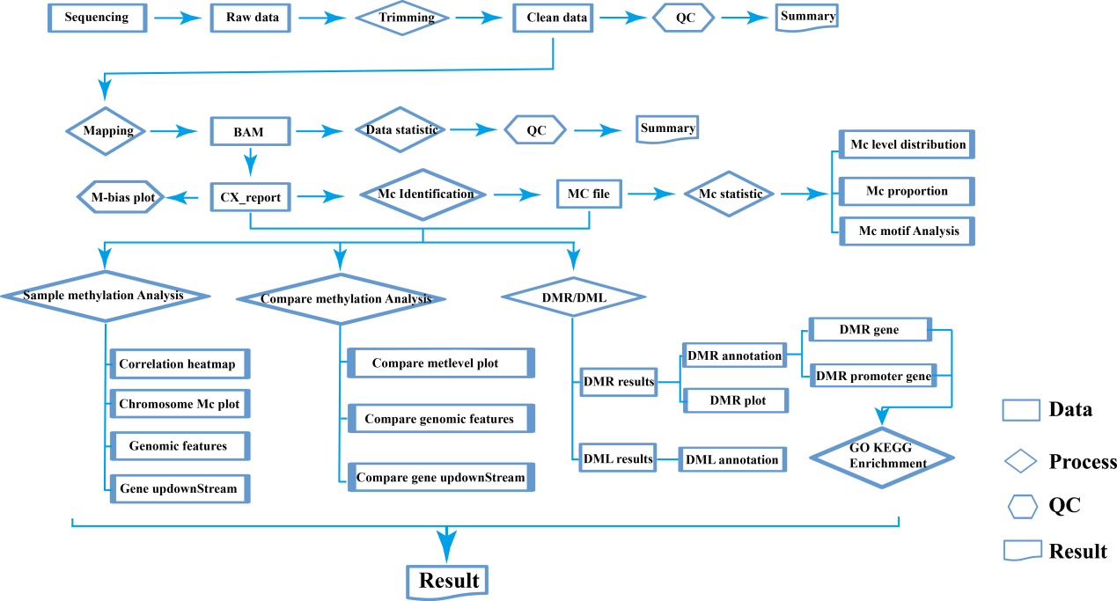
Supplementary figure 2. The process of biological information analysis
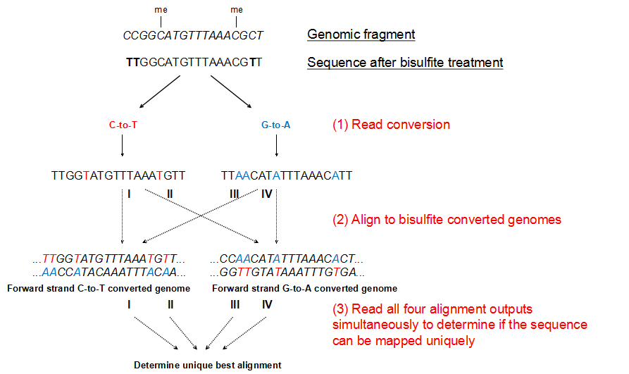
Supplementary figure 3. The basic idea of Bismark comparison
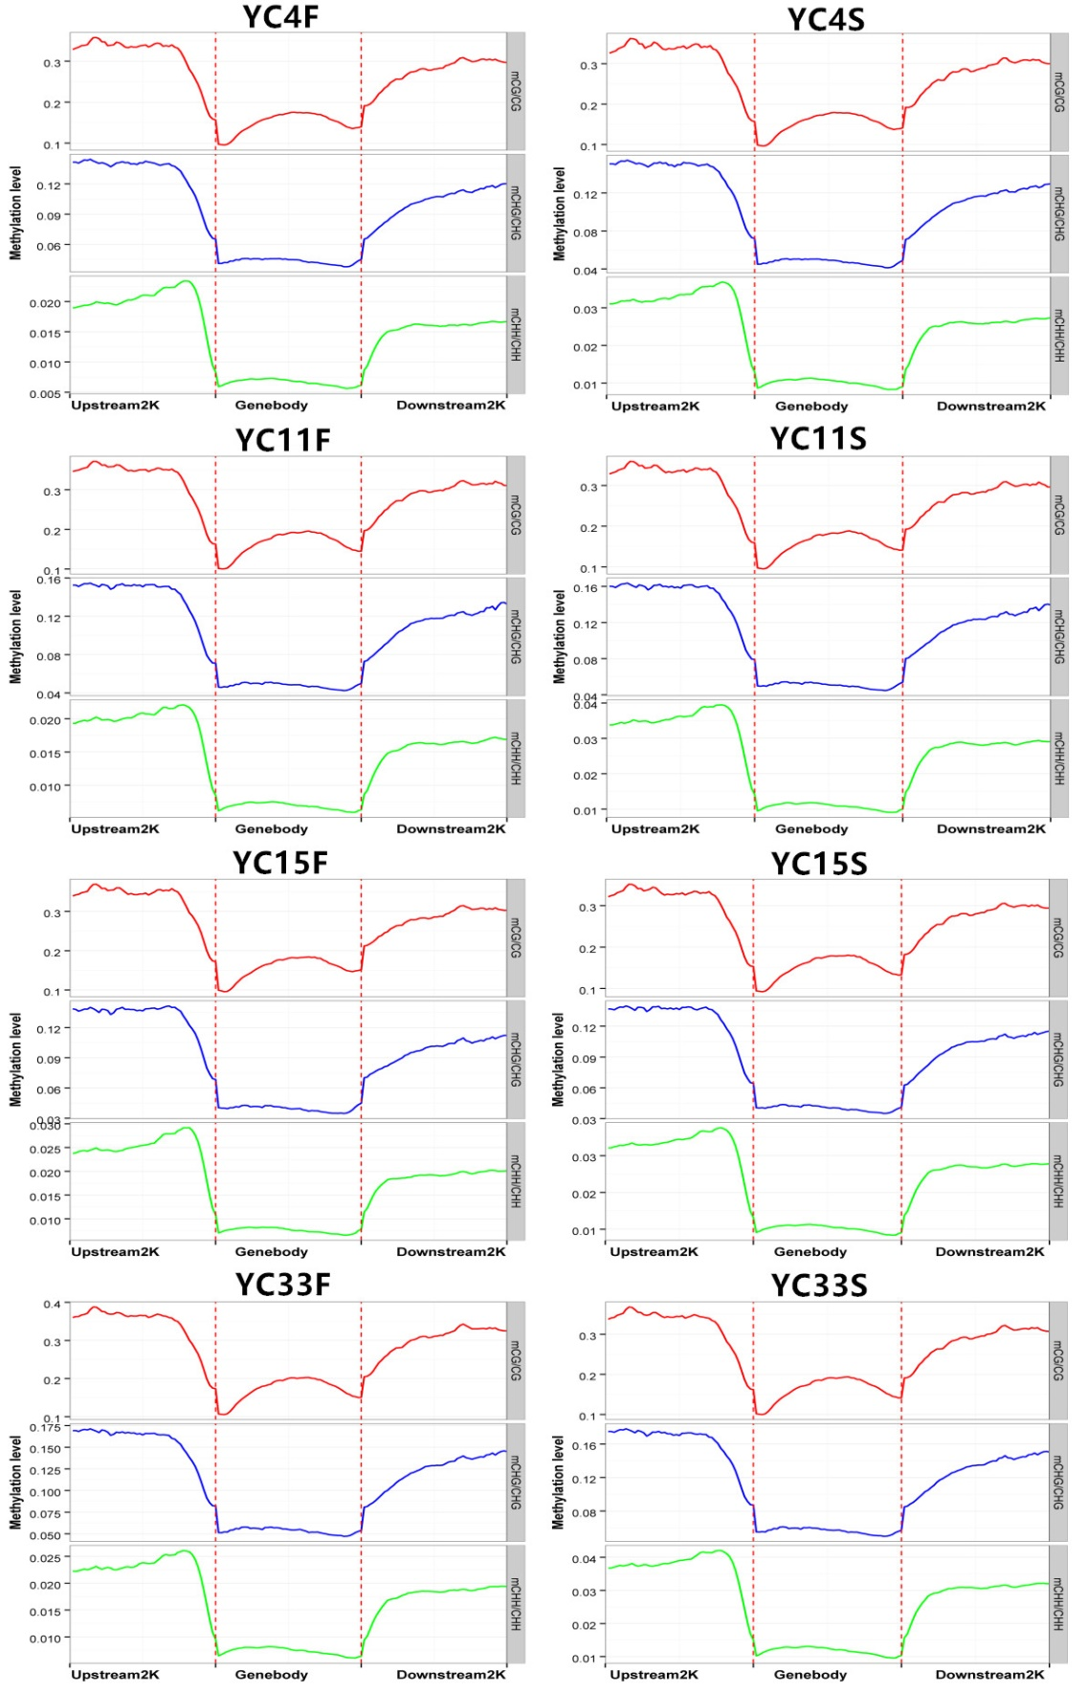
Supplementary figure 4. The distribution of sample methylation levels 2K upstream and downstream of the genebody. The abscissa represents different regions and the ordinate represents methylation levels. Each region of each gene was equally divided into 50 bins, and then the C-site levels of the corresponding bins of all regions were averaged, and the different colors represent different sequence contexts (CpG, CHG, CHH).
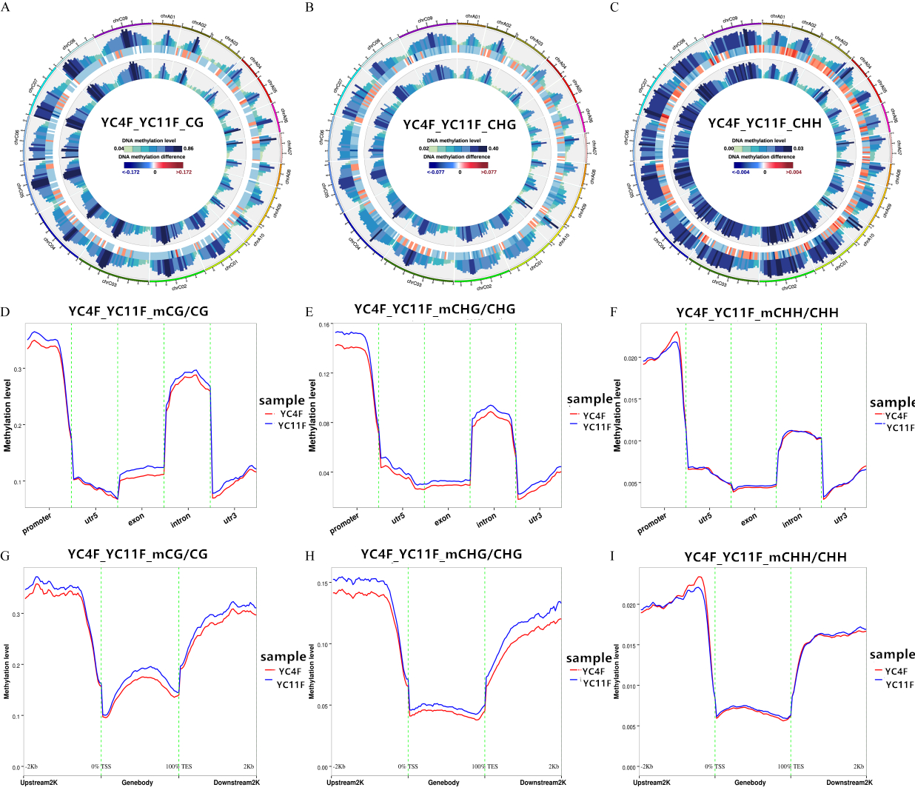
Supplementary Figure 5. Comparison of the overall level of methylation between the two groups of materials. AC, from the outside to the inside, said: methylation level of treatment group, methylation level difference between sample groups, methylation level of control group; internal scale: DNA methylation level indicates methylation level The DNA methylation difference indicates the degree of methylation level difference between samples; DF, the abscissa represents different genomic components, and the ordinate represents methylation level. Each region of each gene is equally divided into 20 bins, and then the C-site levels of the corresponding bins of all regions are averaged, different colors represent groups; GI, abscissa represents different regions, and ordinate represents A The level of basicization. Each region of each gene was equally divided into 50 bins, and then the C-site levels of the corresponding bins of all regions were averaged, with different colors representing the groups.
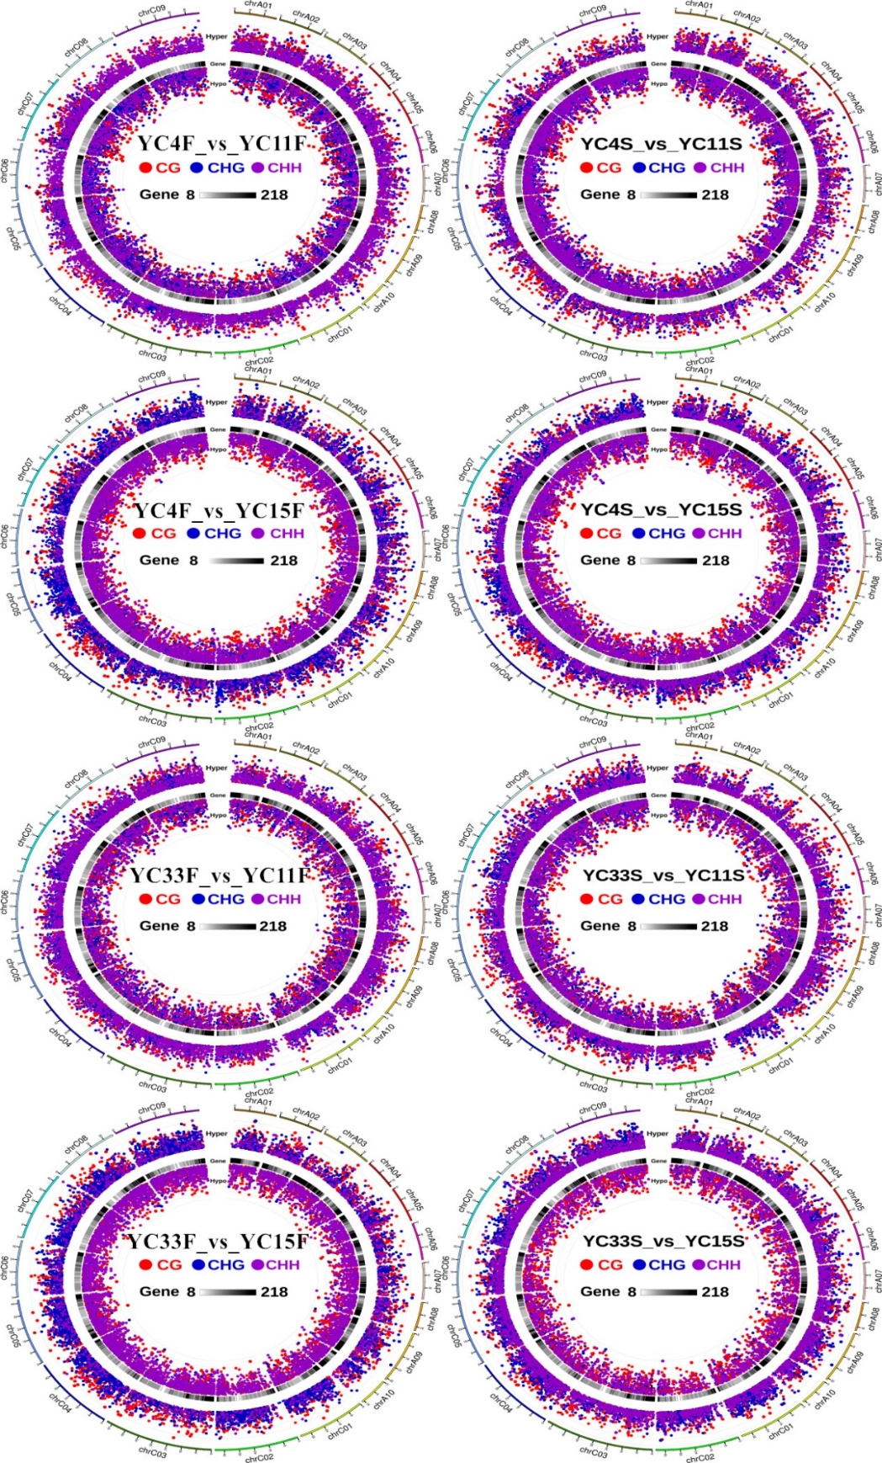
Supplementary Figure 6. Sequence Environment (CG/CHG/CHH) DMR overall Circos display. Graphical display, from the outside to the inside: (1) Hyper DMR statistic log5 ( |areaStat|). The higher the outward dot is, the more significant the position difference is. The CG sequence DMR is red circle, CHG is blue circle, CHH is purple circle; (2) gene density heat map (color indicates see scale); (3) Hypo The DMR statistic is log5( |areaStat|). The higher the inward dot is, the more significant the position difference is. The CG sequence DMR is red circle, CHG is blue circle, and CHH is purple circle.
Supplementary Table 1. Changes of methylation in promoter region affect gene expression
Gene_id | Sites | Methylation_change | Gene_expression | Comparison with Arabidopsis genes
BnaC04g17440D | common | hypermethylation | down | -
BnaC04g55380D | common | hypermethylation | down | microtubule-associated protein 65-4 (MAP65-4)
BnaCnng64040D | common | hypermethylation | down | Lipase family protein
BnaCnng10140D | common | hypermethylation | down | -
BnaC04g27680D | common | hypermethylation | down | -
BnaC05g36710D | common | hypermethylation | down | myb family transcription factor
BnaC06g03310D | common | hypermethylation | down | -
BnaAnng09670D | common | hypermethylation | down | SWELLMAP 1 (SMP1)
BnaAnng30250D | common | hypermethylation | down | -
BnaCnng72240D | common | hypermethylation | down | -
BnaA07g07800D | common | hypermethylation | down | -
BnaCnng50740D | common | hypermethylation | down | RNA-directed DNA polymerase (reverse transcriptase)-related family protein
BnaA10g28170D | common | hypermethylation | down | Alba DNA/RNA-binding protein
BnaA09g02000D | common | hypermethylation | down | succinate dehydrogenase 2-2 (SDH2-2)
BnaCnng25160D | common | hypermethylation | down | -
BnaC08g03460D | common | hypermethylation | down | FUNCTIONS IN: sequence-specific DNA binding transcription factor activity
BnaC03g70780D | common | hypermethylation | down | auxin associated family protein
BnaC01g12960D | common | hypermethylation | down | NITRATE TRANSPORTER 1.8 (NRT1.8)
BnaA05g21120D | common | hypermethylation | down | PIF1 helicase
BnaC03g65070D | flower bud | hypermethylation | down | -
BnaA09g27840D | flower bud | hypermethylation | down | -
BnaC09g52660D | flower bud | hypermethylation | down | -
BnaC03g25740D | flower bud | hypermethylation | down | -
BnaA09g11170D | flower bud | hypermethylation | down | pentatricopeptide (PPR) repeat-containing protein
BnaC04g28000D | flower bud | hypermethylation | down | -
BnaCnng72230D | flower bud | hypermethylation | down | -
BnaC04g46510D | stem apex | hypermethylation | down | Prefoldin chaperone subunit family protein
BnaC02g22110D | stem apex | hypermethylation | down | -
BnaC02g22120D | stem apex | hypermethylation | down | Spc97 / Spc98 family of spindle pole body (SBP) component
BnaC03g53050D | common | hypomethlation | up | ubiquitin-conjugating enzyme 32 (UBC32)
BnaC04g48480D | common | hypomethlation | up | alpha/beta-Hydrolases superfamily protein
BnaUnng05080D | common | hypomethlation | up | -
BnaC03g69480D | common | hypomethlation | up | -
BnaA04g14930D | common | hypomethlation | up | S-locus lectin protein kinase family protein
BnaA05g26660D | common | hypomethlation | up | cystatin B (CYSB)
BnaA06g09210D | common | hypomethlation | up | IQ-domain 28 (IQD28)
BnaC09g37800D | common | hypomethlation | up | Galactose oxidase/kelch repeat superfamily protein
BnaA10g07880D | common | hypomethlation | up | T-complex protein 1 alpha subunit (TCP-1)
BnaAnng28000D | common | hypomethlation | up | Nucleic acid-binding, OB-fold-like protein
BnaC07g41590D | common | hypomethlation | up | novel interactor of JAZ (NINJA)
BnaC07g18250D | common | hypomethlation | up | Ca(2)-dependent phospholipid-binding protein (Copine) family
BnaCnng56050D | common | hypomethlation | up | Pyridoxal phosphate (PLP)-dependent transferases superfamily protein
BnaC03g09180D | common | hypomethlation | up | -
BnaUnng03990D | common | hypomethlation | up | -
BnaA06g22170D | common | hypomethlation | up | -
BnaC03g09160D | common | hypomethlation | up | -
BnaC09g30490D | flower bud | hypomethlation | up | TBP-associated factor 15B (TAF15b)
BnaC05g38320D | flower bud | hypomethlation | up | -
BnaC08g48020D | stem apex | hypomethlation | up | unknown protein
BnaC09g25570D | stem apex | hypomethlation | up | -
BnaC06g02510D | stem apex | hypomethlation | up | -
BnaCnng57630D | stem apex | hypomethlation | up | -
Supplementary Table 2. Genes used for methylation validation
Chromosome | start | end | length | Context | Gene_id | region | Methylation | Materials
chrC04 | 28932484 | 28933278 | 795 | CG | BnaC04g27680D | promoter | hypermethylation | YC4F/YC11F
chrC05 | 35959735 | 35961483 | 1749 | CG | BnaC05g36710D | promoter | hypermethylation | YC4F/YC11F
chrC06 | 3994751 | 3995435 | 685 | CG | BnaC06g03310D | promoter | hypermethylation | YC4F/YC11F
chrA07 | 8074819 | 8075354 | 536 | CHG | BnaA07g07800D | promoter | hypermethylation | YC4F/YC11F
chrC08 | 3215209 | 3217065 | 1857 | CG | BnaC08g03460D | promoter | hypermethylation | YC4F/YC11F
chrCnn_random | 63802915 | 63803399 | 485 | CG | BnaCnng64040D | promoter | hypermethylation | YC4F/YC1FF
chrC03 | 60388542 | 60389391 | 850 | CG | BnaC03g70780D | promoter | hypermethylation | YC4F/YC11F
chrA05 | 16370918 | 16372104 | 1187 | CHG | BnaA05g21120D | promoter | hypermethylation | YC4F/YC11F
chrC03 | 54554408 | 54555203 | 796 | CG | BnaC03g65070D | promoter | hypermethylation | YC4F/YC11F
chrA09 | 20870973 | 20871783 | 811 | CG | BnaA09g27840D | promoter | hypermethylation | YC4F/YC11F
chrC03 | 14444574 | 14445925 | 1352 | CG | BnaC03g25740D | promoter | hypermethylation | YC4F/YC11F
chrA09 | 5783775 | 5784177 | 403 | CHG | BnaA09g11170D | promoter | hypermethylation | YC4F/YC11F
chrC04 | 29430769 | 29431783 | 1015 | CG | BnaC04g28000D | promoter | hypermethylation | YC4F/YC11F
chrC04 | 47080059 | 47080491 | 433 | CHG | BnaC04g48480D | promoter | hypomethylation | YC4F/YC11F
chrC03 | 59224107 | 59224481 | 375 | CHG | BnaC03g69480D | promoter | hypomethylation | YC4F/YC11F
chrA04 | 12508634 | 12509001 | 368 | CHG | BnaA04g14930D | promoter | hypomethylation | YC4F/YC11F
chrA05 | 19453849 | 19454171 | 323 | CHG | BnaA05g26660D | promoter | hypomethylation | YC4F/YC11F
chrA10 | 6400443 | 6401340 | 898 | CG | BnaA10g07880D | promoter | hypomethylation | YC4F/YC11F
chrC09 | 33390641 | 33391416 | 776 | CG | BnaC09g30490D | promoter | hypomethylation | YC4F/YC11F
chrC03 | 4369774 | 4371039 | 1266 | CG | BnaC03g09180D | promoter | hypomethylation | YC4F/YC11F

