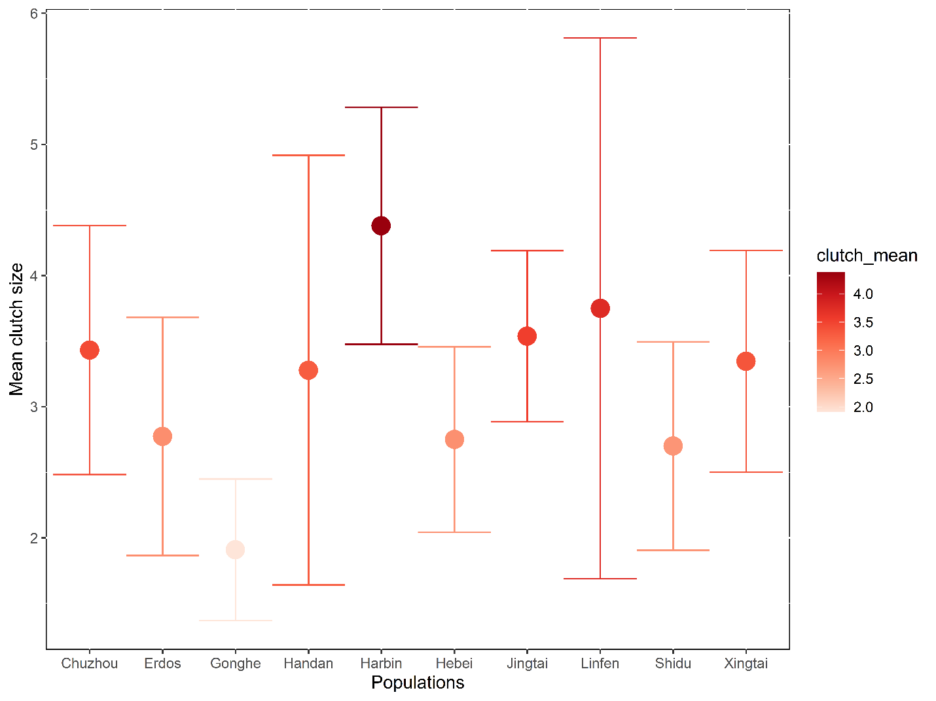
FIGURE S1; Population differences in mean ± s.d. clutch size of E. argus lizards from ten populations from China. Red gradient colour depicts the clutch size, with females from Gonghe having the smallest clutch size, while the Harbin population have the largest clutch size.

Table S1; Results for parameters estimates of linear mixed effects models on clutch size of different lizard populations: a) table shows results of latitude model; b) table shows results of a climate model. Habitat types along latitudinal gradients being compared to the arid habitat
Factors | Estimate | SE | z-value | p-value
- Latitude model
Latitude | 0.014 | 0.006 | 2.479 | 0.013
Grassland | -0.007 | 0.129 | -0.058 | 0.954
Farmland | -0.141 | 0.162 | -0.869 | 0.385
Semiarid | -0.216 | 0.136 | -1.592 | 0.111
- Climate model
PC1 | -0.163 | 0.067 | -2.445 | 0.015
PC2 | 0.225 | 0.084 | 2.691 | 0.007
Grassland | -0.747 | 0.276 | -2.704 | 0.007
Farmland | -0.684 | 0.238 | -2.875 | 0.004
Semiarid | -0.496 | 0.138 | -3.607 | 0.0003

