Supplementary Information

Switchable Topological Phase Transition and Novel Non-linear Optical Properties in ReC₂H Monolayer
Chunmei Zhang^{1#*}, Hanqi Pi^{2#}, Liqin Zhou^{2#}, Si Li¹, Jian Zhou³, Aijun Du⁴, Hongming Weng^{2,5}*
¹School of Physics, Northwest University, Xi’an 710069, China
²Beijing National Laboratory for Condensed Matter Physics and Institute of Physics, Chinese Academy of Sciences, Beijing 100190, China
³Center for Alloy Innovation and Design, State Key Laboratory for Mechanical Behavior of Materials, Xi’an Jiaotong University, Xi’an, China.
⁴ School of Chemistry and Physics, Queensland University of Technology, Gardens Point Campus, Brisbane, QLD 4001, Australia
⁵Songshan Lake Materials Laboratory, Dongguan, Guangdong 523808, China
C. Z, H. P. and L. Z. contribute equally to this work.

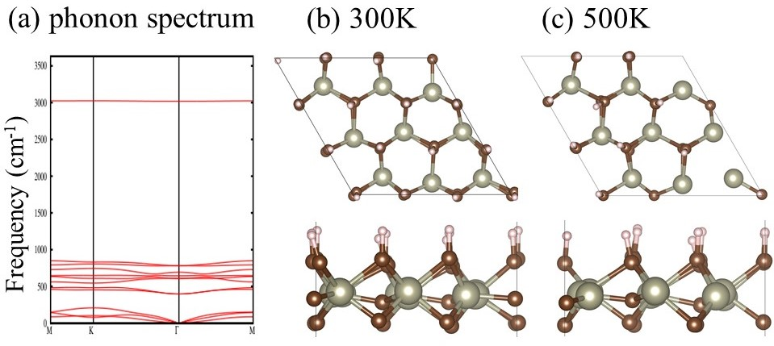
Figure s1 phonon spectrum of ReC₂H monolayer. AIMD of the ReC₂H monolayers with time running for 10 ps under 300K and 500K, respectively.
We first obtain the band structure of ReC₂H without SOC by GGA and plot it along the high-symmetry directions in Fig. 1d, which indicates that ReC₂H monolayer is a small bandgap semiconductor. While we impose tensile biaxial strain, a clear band inversion features near the fermi level around K (1/3, 1/3, 0) point. The bandgap closes first and reopens which brings about topological phase transition, and a Z2 indicator reveal the changes (Fig. s2).
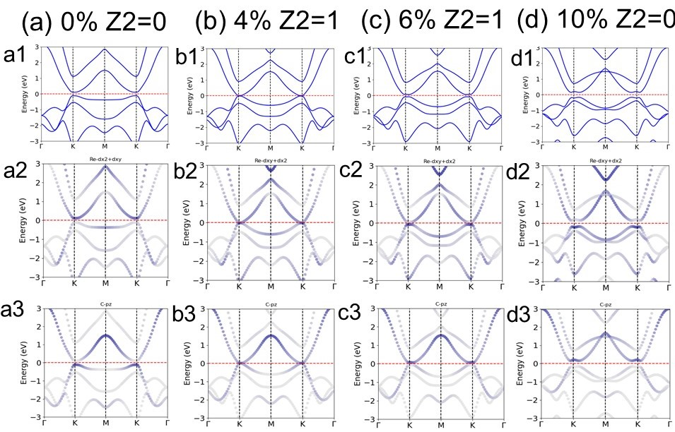
Fig. s2 band structure without SOC of strained ReC₂H monolayer.
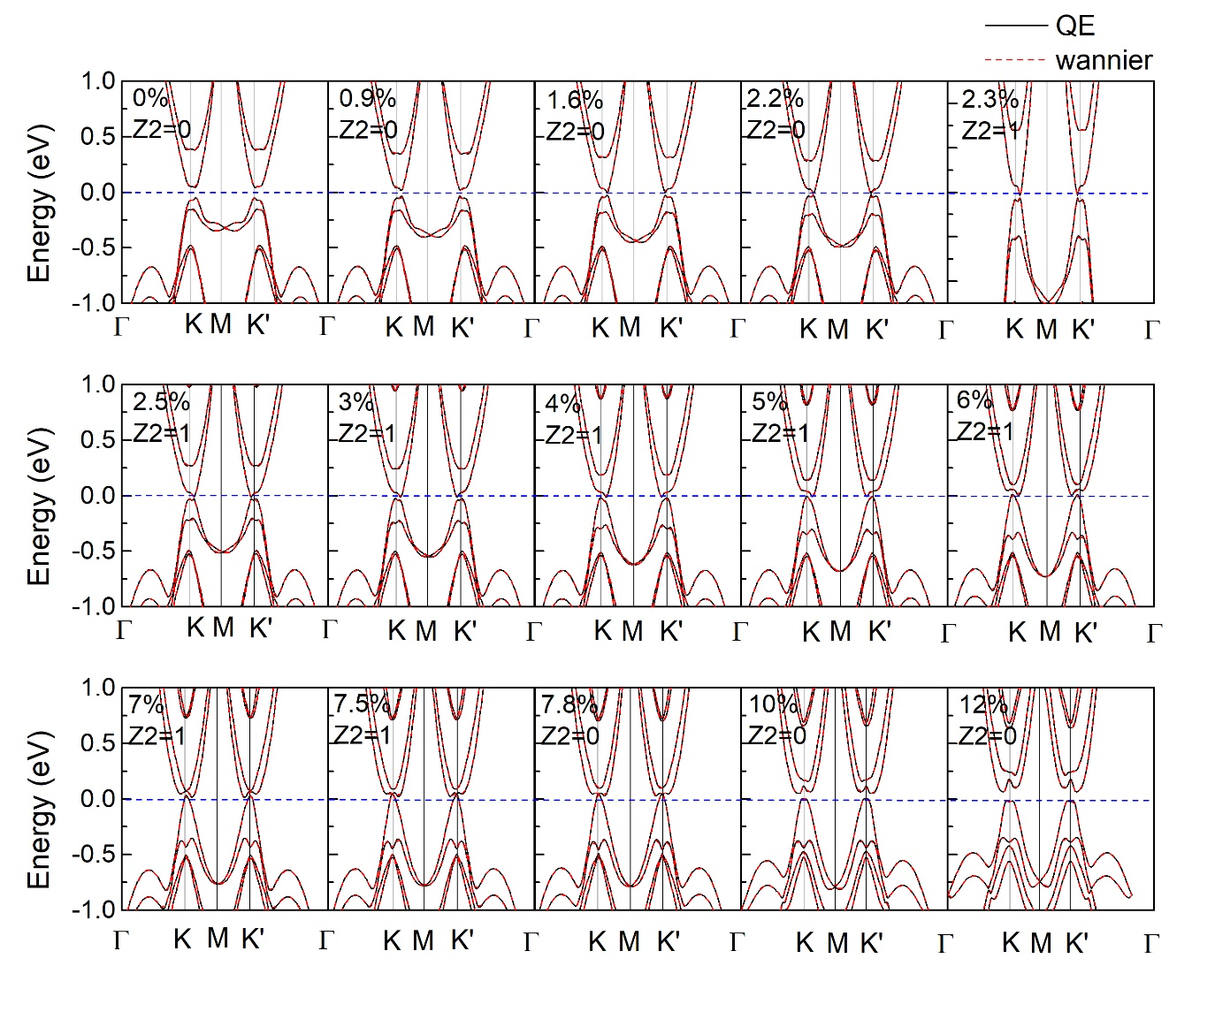
Figure s3 whole band structure along $Γ-K-M-K^{'}-Γ$ and Z₂ changes of strained ReC₂H monolayer with strain in the range of 0%-12%.
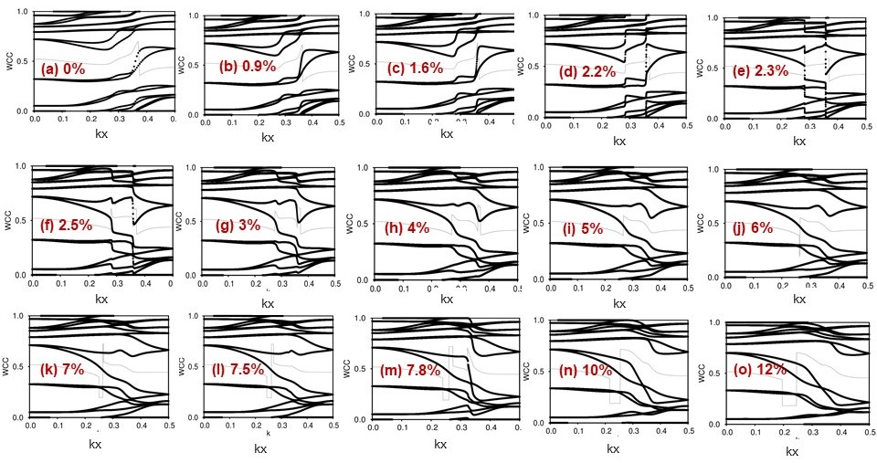
Figure s4 (a-o) The evolution lines of WCCs along K_{Z}=0 plane for strained ReC₂H monolayer. For the 2.3%-7.5% strained ReC₂H monolayer, the evolution lines cross the reference line with odd number of times indicating ReC₂H is a topological insulator. While an even number of times crossing for 0%-2.2% and 7.8%-12% strained ReC₂H indicating the trivial insulator character.
Table s1 Matrices of the representations of the little group at K point.
The point group at K point is C3, and there are three symmetry operations in three classes, which is E, C3, and C3-. E is unit operation, C3 represents 120-degree clockwise rotation, C3- represents 120-degree counterclockwise rotation. in the table, e=exp(2*$π$*i/3).
 | E | C3 | C3-
GM1 | 1 | 1 | 1
GM2 | 1 | e | e*
GM3 | 1 | e* | e
GM4 | 1 | - e* | -e
GM5 | 1 | -e | - e*
GM6 | 1 | -1 | -1

Zigzag edge state of 1D projection for the 2D BZ for strained ReC₂H monolayer.
Resembling armchair edge state, the Dirac cones for the edge state of 0.9% and 10% strained ReC₂H monolayers connect valence band only, finally making the system topologically trivial. On the contrary, two helical edge states protected by time-reversal symmetry are visible clearly for 4% strained ReC₂H monolayers.
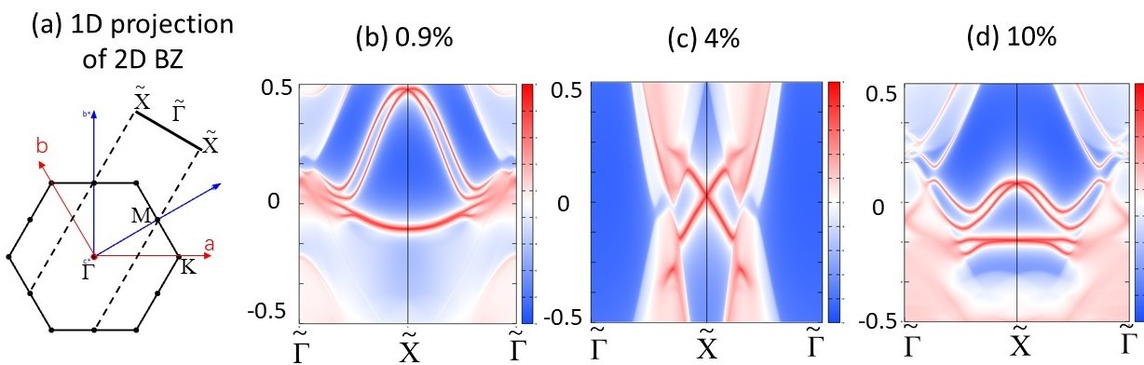
Figure s5, (a) The 1D projection of the 2D BZ onto the Zigzag edge. The edge state for for (b) 0.9%, (c) 4%, and (d) 10% strained ReC₂H monolayer along the Zigzag edge.
Nonlinear optical property
Across the first TPT, the incident light with the small photon energy same with the bandgap at transition point can only pump electron transition between the lowest valence and conduction band. Thus, for the first TPT, the possible reason that more bands incorporated when calculating the shift current distribution in BZ might eliminate the contribution of sign change is excluded.
Table s2. The shift current peak position corresponding to the bands transition.

Energy (eV) | The second highest valence band at K point | VBM at K point | CBM at K point | The second lowest conduction band at K point | peak position of σ^{yyy}
0% | -0.15 | -0.07 | 0.05 | 0.39 | 0.13
0.9% | -0.17 | -0.05 | 0.04 | 0.35 | 0.09
1.6% | -0.19 | -0.04 | 0.03 | 0.31 | 0.08
2.2% | -0.2 | -0.035 | 0.03 | 0.28 | 0.07
2.3% | -0.21 | -0.035 | 0.03 | 0.28 | 0.07
2.5% | -0.22 | -0.03 | 0.03 | 0.27 | 0.07
3% | -0.25 | -0.025 | 0.027 | 0.24 | 0.065
4% | -0.3 | -0.02 | 0.03 | 0.18 | 0.065
5% | -0.35 | -0.007 | 0.04 | 0.14 | 0.06
7% | -0.43 | 0.32 | 0.55 | 0.77 | 0.065
7.5% | -0.45 | 0.045 | 0.05 | 0.09 | 0.055
7.8% | -0.45 | 0.04 | 0.05 | 0.1 | 0.08/0.175
10% | -0.45 | -0.0 | 0.11 | 0.17 | 0.08
12% | -0.38 | -0.025 | 0.175 | 0.24 | 0.12

Explanation for Figure 4
We also notice the sign flipping of the shift vector at the point ky=0.5, kx=0.310 in Fig. 4d
It can be explained that the orbital wavefunction at point kx=0.031, ky=0.5 would be affected by the band inversion at generic moment. Meanwhile, the absorption rate at this point is small. Thus, the sign reversal at Ky=0.5 is accidental. However, the shift vector flipping sign at a single singularity point generates no effect to the whole shift current, as the shift current is determined by the transition intensity by its associated shift vector, and then sum over bands and k points.
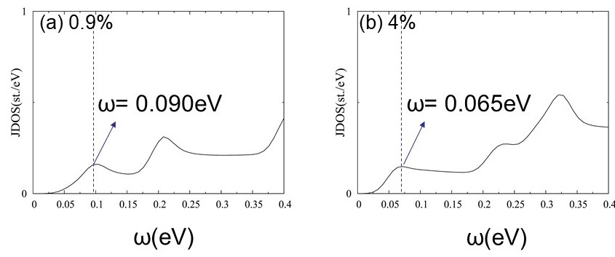
Figure s5, JDOS for 0.9% and 4% strained ReC₂H monolayer. The first peak emerges at the photon energy same as bandgap at K point.
Table s3, the orbital component weight analyses around TPT point. As the orbital contribution from Re_s, p orbitals and C_s orbitals are very small, we only show contributions from Re_d and C_p orbitals.
The first phase transition (near the phase transition point)
orbital | 0.9%VBM | 0.9%CBM | 2.2%VBM | 2.2%CBM | 2.3%VBM | 2.3%CBM | 4%VBM | 4%CBM
Re_d | 0.349 | 0.258 | 0.380 | 0.242 | 0.380 | 0.242 | 0.356 | 0.270
C_p | 0.295 | 0.318 | 0.283 | 0.328 | 0.282 | 0.327 | 0.281 | 0.315

The first phase transition (at K point)
orbital | 0.9%VBM | 0.9%CBM | 2.2%VBM | 2.2%CBM | 2.3%VBM | 2.3%CBM | 4%VBM | 4%CBM
Re_d | 0.197 | 0.282 | 0.203 | 0.301 | 0.203 | 0.294 | 0.215 | 0.276
C_p | 0.343 | 0.333 | 0.345 | 0.317 | 0.344 | 0.317 | 0.338 | 0.320

The second phase transition (at K point)
 | 7%VBM | 7%CBM | 7.8%VBM | 7.8%CBM | 9%VBM | 9%CBM | 10%VBM | 10%CBM
C_p | 0.323 | 0.182 | 0.176 | 0.319 | 0.168 | 0.312 | 0.164 | 0.305
Re_d | 0.237 | 0.659 | 0.664 | 0.243 | 0.673 | 0.251 | 0.679 | 0.258

¹ L. Z. Tan and A. M. Rappe, Phys. Rev. Lett. 116, 237402 (2016).

