Supplementary information 1
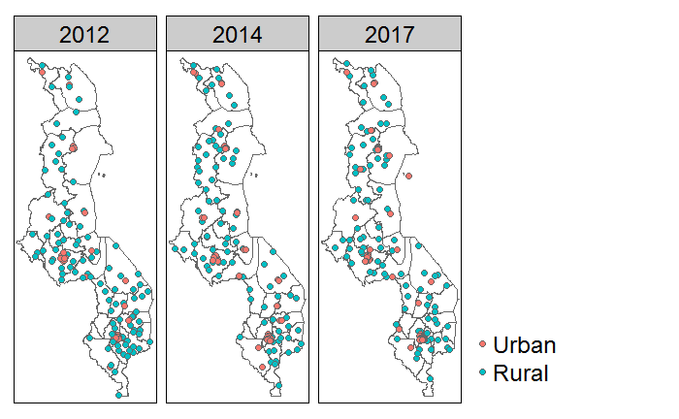
Household cluster for each MIS round, with colours indicating household locations in urban or rural area.

Supplementary information 2
Detailed description of the insecticide-treated net calculations
indicator | Unit of analysis | Calculation
Household ownership | Cluster of households | ${\hat{p}}_{h}$ $= \frac{x_{b}}{x_{t}}$  ${\hat{p}}_{h}$ = household ownership  $x_{b}$ = sum of household with at least one ITNs  $x_{t}$ = sum of households surveyed
Household access | Cluster of households | Step 1  $${\hat{p}}_{p}= \frac{x_{c}}{x_{t}}$$  ${\hat{p}}_{p}$ = proportion of population with access to 1 ITNs per 2 people  $x_{c}$ = total number of ITNs in household  $x_{t}$ = total number of household members that slept in the household the previous night, including visitors  Step 2  ${\hat{p}}_{p}$ < 0.5, $x_{d}$ is 0  ${\hat{p}}_{p}$ ≥ 0.5, $x_{d}$ is 1  ${\hat{p}}_{p}$ = proportion of population with access to 1 ITNs per 2 people  $x_{d}$ = households with full household access to ITNs, excluding households without a sleeping person  Step 3  ${\hat{p}}_{a}$ $= \frac{{sum(x}_{d})}{x_{u}}$  ${\hat{p}}_{a}$ = household access  $x_{d}$ = households with full household access to ITNs  $x_{u}$ = total number of households surveyed in the cluster, excluding households without a sleeping person
Population access | population | Step 1  $x_{e}$ > $x_{t}$, adjust $x_{e}$ = $x_{t}$  $x_{e}$ = Potential ITN user, calculated by total number of ITNs * 1.64, with the assumption that one ITN provided protection for 1.64 people[55]  $x_{t}$ = total number of household members that slept in the household the previous night, including visitors  Step 2  $${\hat{p}}_{q}= \frac{sum(x_{e})}{x_{t}}$$  ${\hat{p}}_{q}$ = population access  $x_{e}$ = Potential ITN user  $x_{t}$ = total number of household members that slept in the household the previous night, including visitors
ITN use | population | ${\hat{p}}_{r}$ $= \frac{x_{g}}{x_{t}}$  ${\hat{p}}_{r}$ = ITN use  $x_{g}$ = sum of number of people who slept under an ITN the night before, sum(hml11_1 to hml11_7)  $x_{t}$ = total number of household members that slept in the household the previous night, including visitors (hv013)

Supplementary information 3
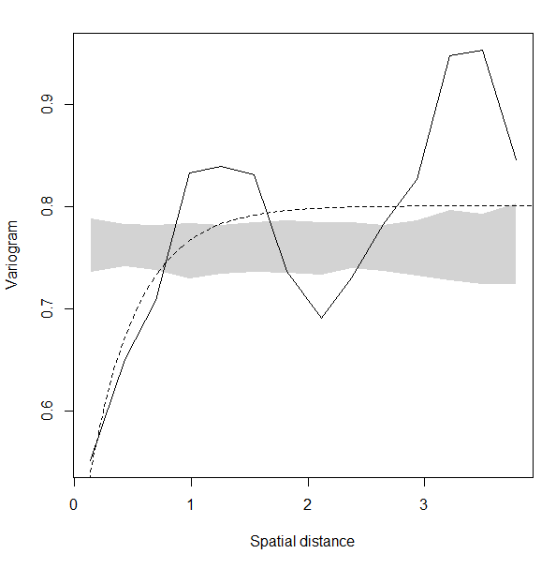
Spatial dependence in the variance is shown by the variogram. The grey shaded areas are the Monte Carlo envelopes of the simulated variance, which is obtained by randomly assigning childhood malaria prevalence values at the different geographical locations and calculating the empirical variogram.

Supplementary information 4

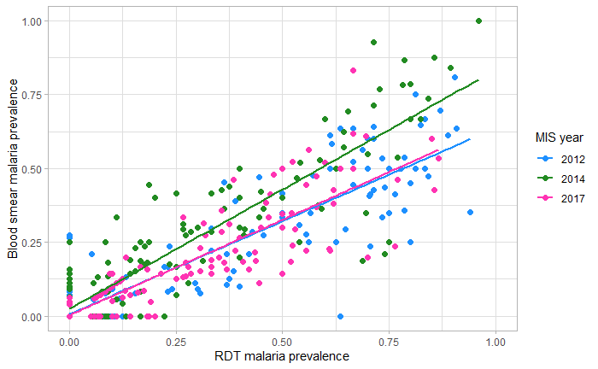

Malaria prevalence comparison between RDT and blood smears.

Supplementary information 5
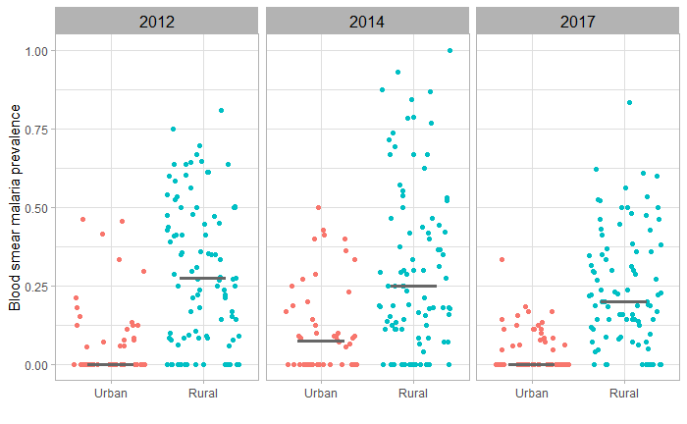
Blood smear malaria prevalence in urban and rural areas for 2012, 2014 and 2017 with median.

Supplementary information 6
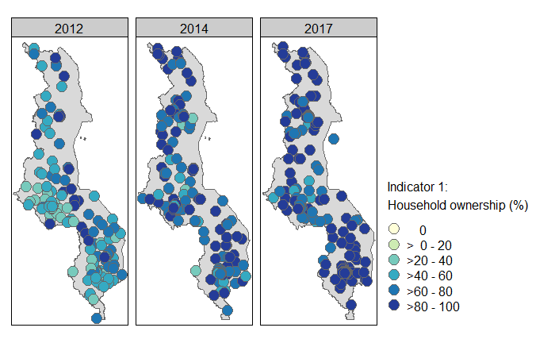
A

B
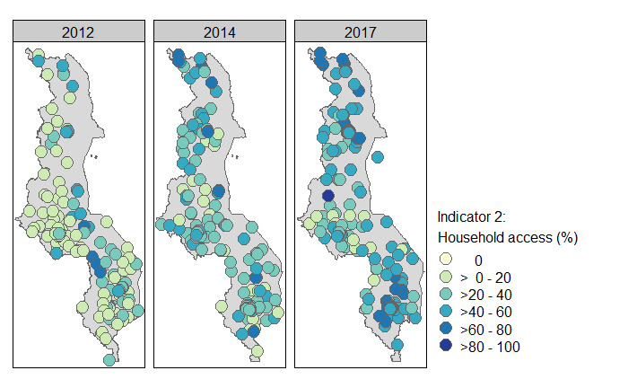
C
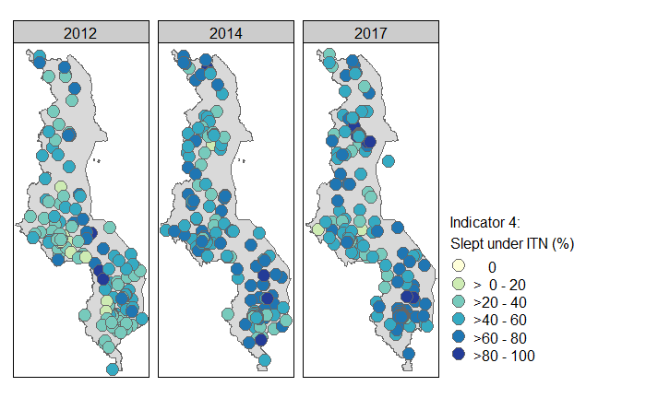

Insecticide treated net indicators from 2012, 2014 and 2017. A) Household ownership, B) household access, C) population that slept under an insecticide treated net (ITN) the night before the survey.

Supplementary information 7

Year | Population access | ITN use
2012 | 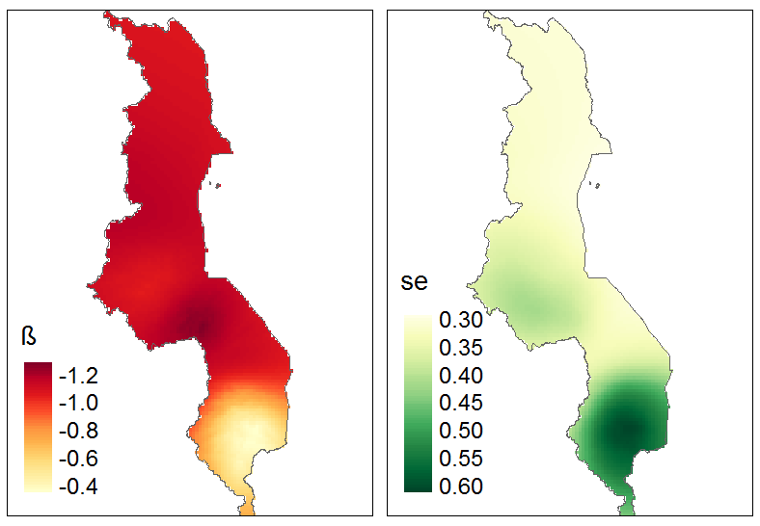 | 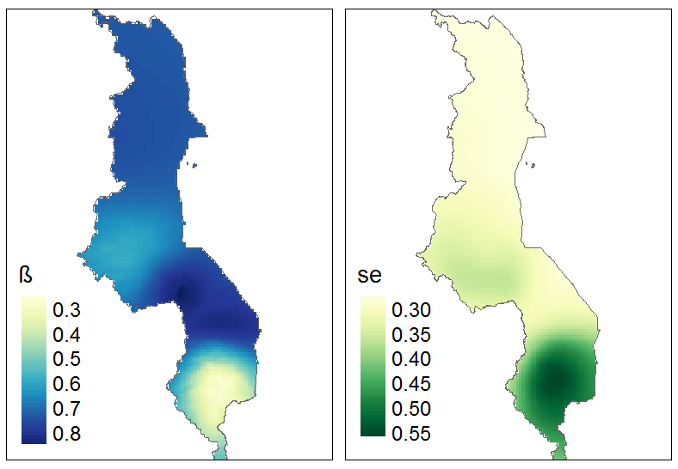
2014 | 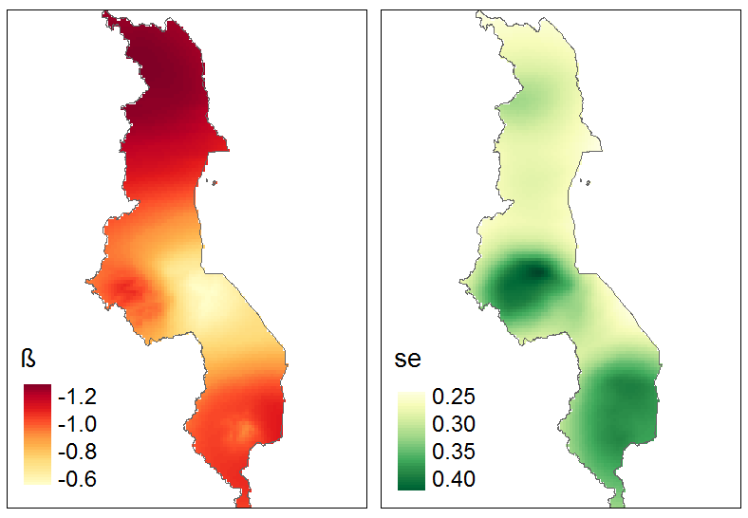 | 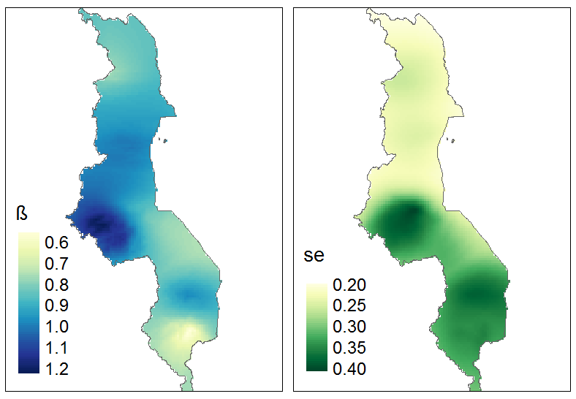
2017 | 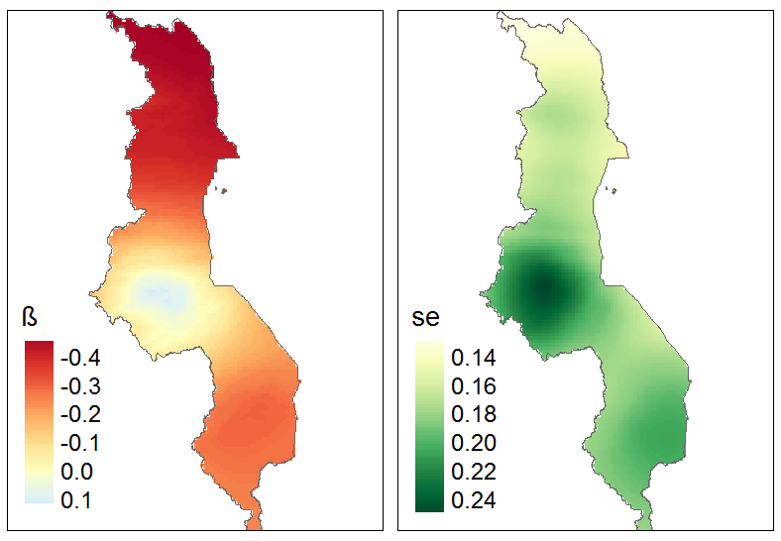 | 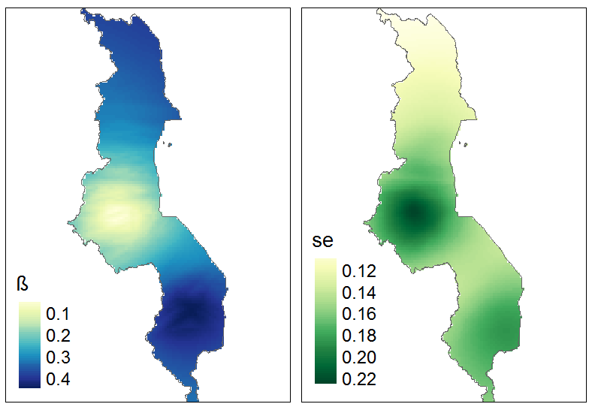
The geographically weighted regression analysis results with β the estimated coefficient range and the standard error (se).

