Auxiliary rapid identification of pathogenic and antagonistic microorganisms for Coptis chinensis root rot by high-throughput sequencing

Hailang Liao ^{1,2}, Ling Huang ^{1,2}, Na Li ^{1,2}, Wenjia Ke ^{1,2}, Yiqing Xiang ^{1,2} and Yuntong Ma ^{1,2,3,} *

¹ State Key Laboratory Breeding Base of Systematic Research, Development and Utilization of Chinese Medicine Resources, Chengdu University of Traditional Chinese Medicine, Chengdu 611137, China
² Department of Pharmacy, Chengdu University of Traditional Chinese Medicine, Chengdu 611137, China
³ The Engineering and Technology Research Center for the Protection and Development of Yalian Resourcesin Sichuan Province, Meishan 620360, Sichuan, China
* Correspondence: mayuntong@cdutcm.edu.cn; Tel.: +86-139-8059-8196

Supplementary Information
Supplementary Information Fig. S1-S8
Supplementary Information Table S1-S6

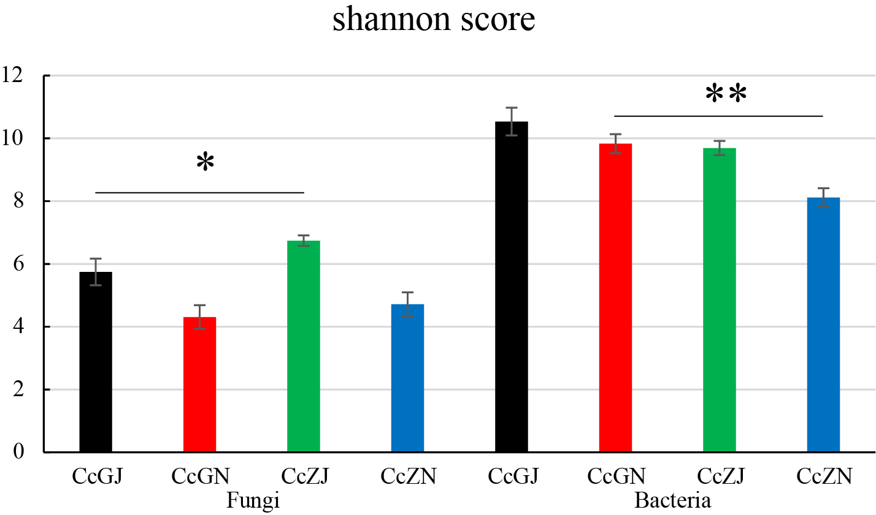
Figure S1 α Diversity in the rhizosphere and the endospheree of Normal and Diseased C. chinensis. *: 0.01＜p≤0.05; **: p≤0.01.

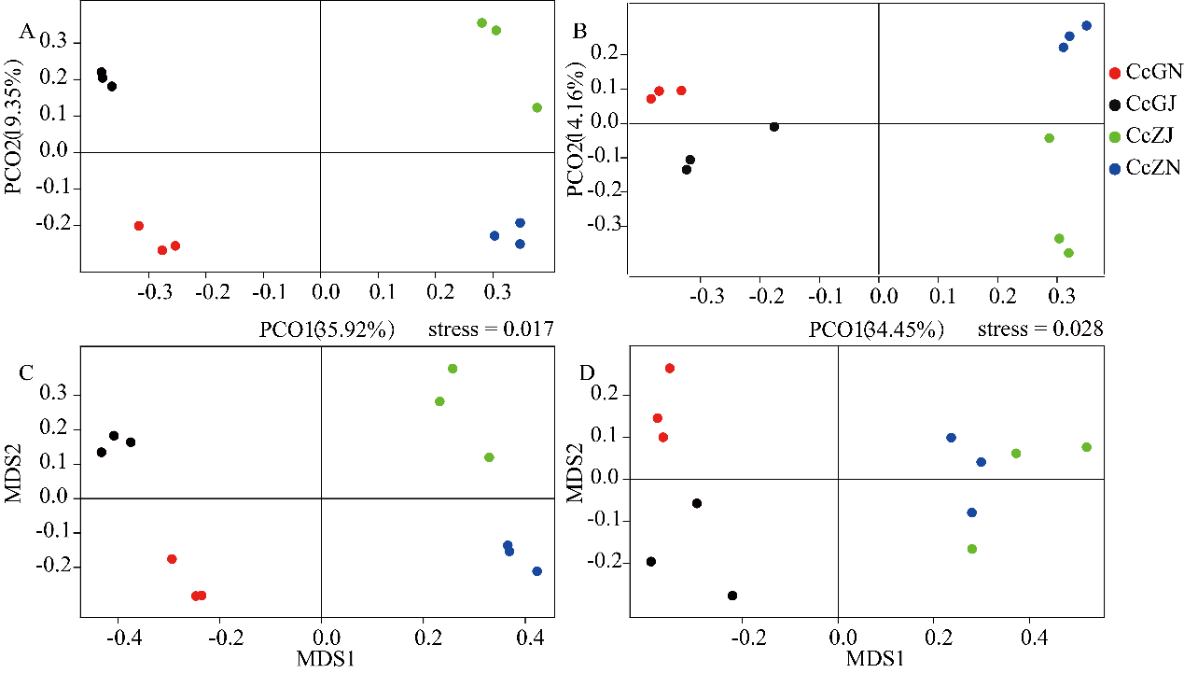
Figure S2 Analysis of the Microbiome Sample Distance in the rhizosphere and the endospheree of Normal and Diseased C. chinensis. A: Principal Coordinate Analysis (PCoA) based on the Bray Curtis distance of bacteria between samples; B: Principal Coordinate Analysis (PCoA) based on the fungal Bray Curtis distance between samples. The root microbiome of C. chinensis was separated on the first axis of PcoA (PCo1) according to whether it was diseased or not, and the second axis (PCo2) was separated according to niche, with significant differences between groups (PERMANOVA, P<0.001); C: Non-metric multidimensional scaling analysis (NMDS) based on the Bray Curtis distance of bacteria between samples. The root microbiome of C. chinensis is separated on the first axis of PcoA (MDS1) according to whether it is diseased or not, and the second axis is separated according to niche, stress=0.017<0.1; D: Non-metric multidimensional scaling analysis (NMDS) based on the Bray Curtis distance of bacteria between samples. The root microbiome of C. chinensis is separated on the first axis of NMDS (MDS1) according to whether it is diseased or not, stress=0.028<0.1.

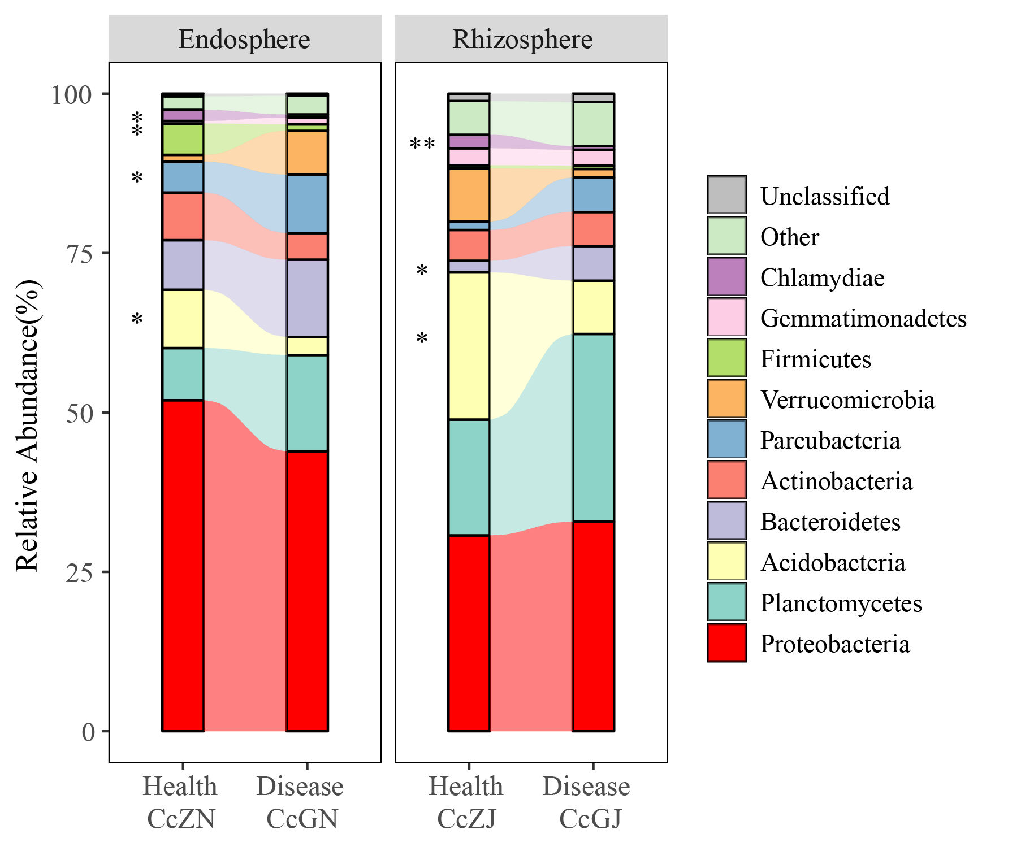
Figure S3 Stacked shock map of bacteria distribution in the rhizosphere and the endospheree of health and diseased C. chinensis. *:0.01<P≤0.05; **: P≤0.01（Welch\'s t test）.

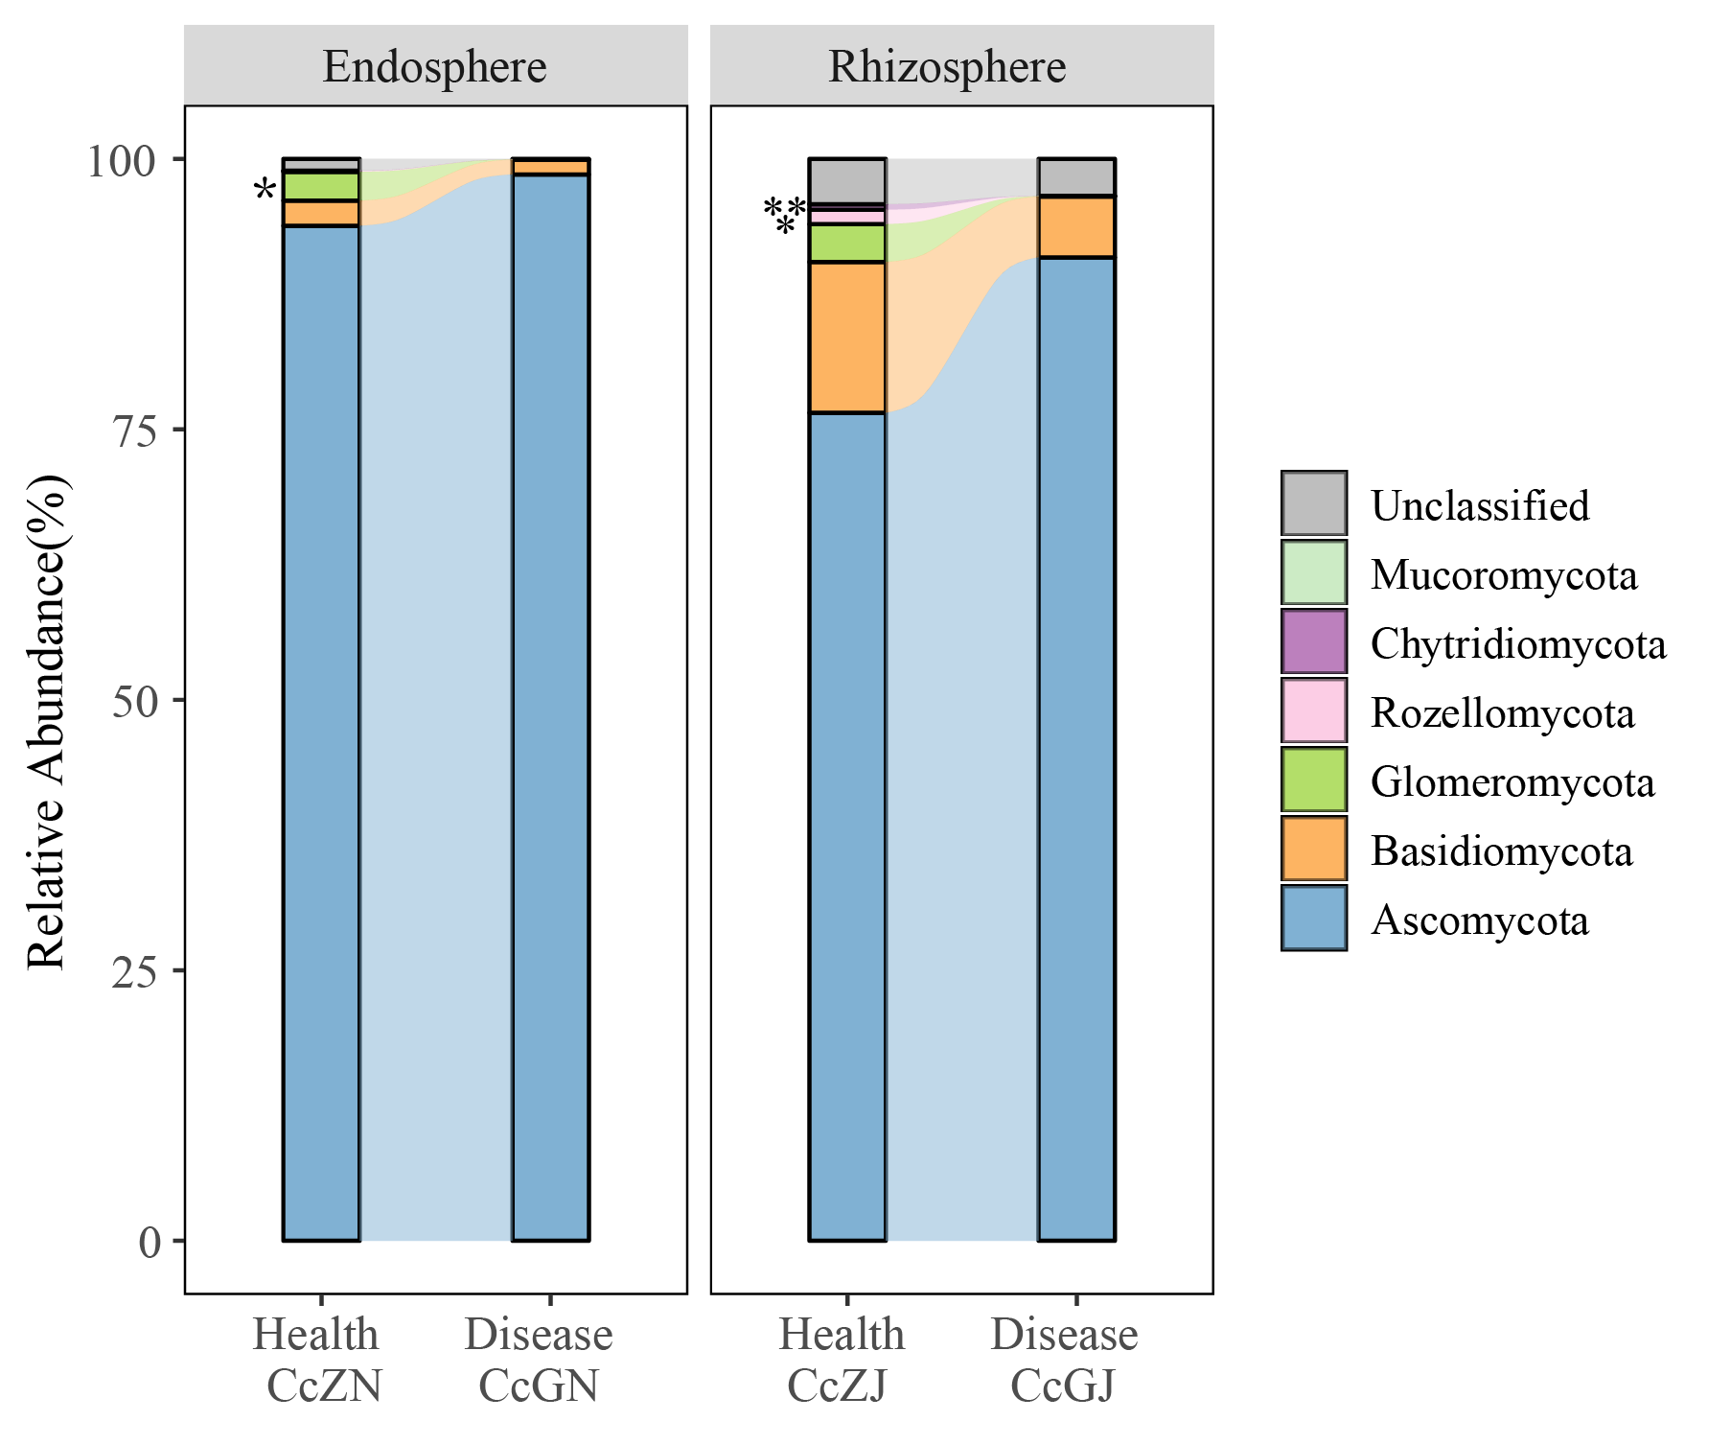
Figure S4 Stacked shock map of fungi in the rhizosphere and the endospheree of normal and diseased C. chinensis. *:0.01<P≤0.05; **: P≤0.01（Welch\'s t test）

Figure S5 Analysis of indicator species of bacteria in the rhizosphere and the endosphere of health and diseased C. chinensis

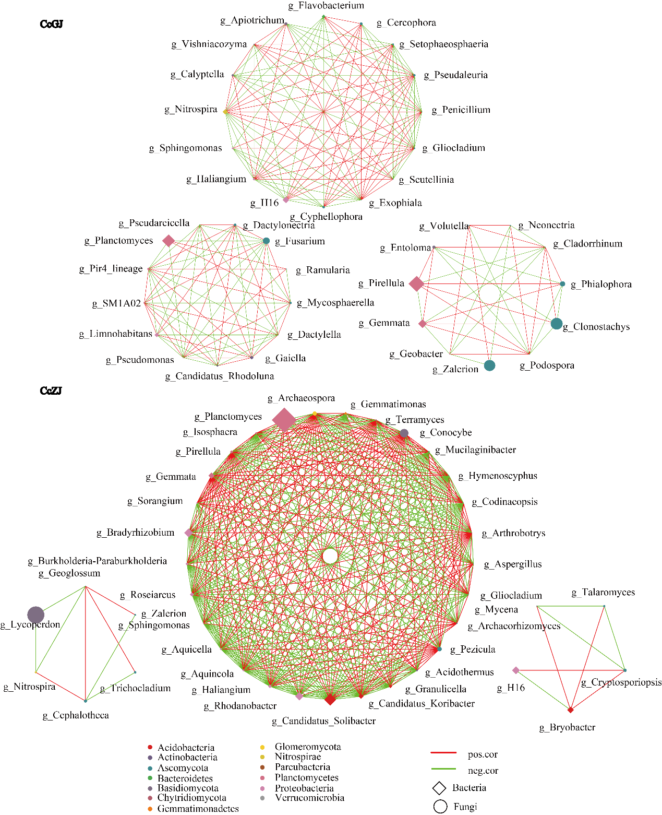
Figure S6 Microbial network in the rhizosphere of health and diseased C. chinensis

Figure S7 Phylogenetic tree based on ITS and EF1-α RNA sequences

Figure S8 Phylogenetic tree based on 16s RNA sequences

Table S1 Bacterial data pre-processing statistics and quality control
Sample Name | Raw PE | Clean PE | Raw Tags | Clean Tags | Effective Tags | Effective Ratio (%)
CcZJ-1 | 147051 | 143301 | 143164 | 142298 | 135640 | 92.24
CcZJ-2 | 124267 | 121075 | 120918 | 120123 | 119265 | 95.97
CcZJ-3 | 119689 | 116160 | 116041 | 115198 | 114837 | 95.95
CcGJ-1 | 109032 | 106155 | 105881 | 105033 | 104366 | 95.72
CcGJ-2 | 113682 | 110485 | 110273 | 109481 | 107116 | 94.22
CcGJ-3 | 117284 | 114211 | 113734 | 112890 | 112191 | 95.66
CcZN-1 | 109786 | 106819 | 106721 | 106110 | 105642 | 96.23
CcZN-2 | 132217 | 129044 | 128915 | 128338 | 127527 | 96.45
CcZN-3 | 116135 | 112773 | 112677 | 112116 | 111659 | 96.15
CcGN-1 | 112608 | 109339 | 109219 | 108507 | 107439 | 95.41
CcGN-2 | 123894 | 120379 | 120284 | 119413 | 117387 | 94.75
CcGN-3 | 111588 | 108350 | 108253 | 107486 | 105944 | 94.94

Table S2 Bacteria tags detailed information table
SampleID | Tags Number | Total length | Max length | Min length | N50 | N90
CcZJ-1 | 135640 | 61368839 | 476 | 331 | 453 | 441
CcZJ-2 | 119265 | 54156109 | 476 | 352 | 455 | 441
CcZJ-3 | 114837 | 52421083 | 476 | 337 | 463 | 441
CcGJ-1 | 104366 | 47806361 | 476 | 342 | 463 | 441
CcGJ-2 | 107116 | 48918474 | 476 | 353 | 462 | 442
CcGJ-3 | 112191 | 51376553 | 476 | 354 | 463 | 441
CcZN-1 | 105642 | 47581022 | 470 | 434 | 443 | 441
CcZN-2 | 127527 | 56948936 | 472 | 332 | 443 | 441
CcZN-3 | 111659 | 50020192 | 474 | 302 | 443 | 441
CcGN-1 | 107439 | 48748262 | 474 | 315 | 459 | 441
CcGN-2 | 117387 | 53619024 | 476 | 434 | 461 | 441
CcGN-3 | 105944 | 48210867 | 476 | 332 | 461 | 441

Table S3 Statistics table of the number of OTUs and tags of different bacterial samples
SampleID | Total Tags | Unique Tags | Taxon Tags | Unclassified Tags | Singleton Tags | OTUs
CcZJ-1 | 135640 | 108361 | 118011 | 0 | 17629 | 5766
CcZJ-2 | 119265 | 98336 | 109246 | 0 | 10019 | 5480
CcZJ-3 | 114837 | 91253 | 105165 | 0 | 9672 | 4538
CcGJ-1 | 104366 | 89453 | 96629 | 0 | 7737 | 5744
CcGJ-2 | 107116 | 81200 | 100439 | 0 | 6677 | 4608
CcGJ-3 | 112191 | 92808 | 104342 | 0 | 7849 | 5457
CcZN-1 | 105642 | 52224 | 102563 | 0 | 3079 | 2047
CcZN-2 | 127527 | 47860 | 125660 | 0 | 1867 | 1442
CcZN-3 | 111659 | 47250 | 109298 | 0 | 2361 | 1833
CcGN-1 | 107439 | 69708 | 101890 | 0 | 5549 | 3637
CcGN-2 | 117387 | 82155 | 110068 | 0 | 7319 | 4177
CcGN-3 | 105944 | 76807 | 98632 | 0 | 7312 | 4347

Table S4 Fungal data preprocessing statistics and quality control
Sample Name | Raw PE | Clean PE | Raw Tags | Clean Tags | Effective Tags | Effective Ratio (%)
CcZJ-1 | 170375 | 168700 | 168191 | 160078 | 160078 | 93.96
CcZJ-2 | 167581 | 165659 | 165023 | 144136 | 144136 | 86.01
CcZJ-3 | 143746 | 142000 | 140131 | 126468 | 126468 | 87.98
CcGJ-1 | 189725 | 187732 | 186870 | 176516 | 176516 | 93.04
CcGJ-2 | 189590 | 187225 | 183677 | 168323 | 168323 | 88.78
CcGJ-3 | 160955 | 159292 | 158521 | 151073 | 151073 | 93.86
CcZN-1 | 190589 | 189160 | 188973 | 188760 | 188760 | 99.04
CcZN-2 | 177353 | 175882 | 175733 | 175572 | 175572 | 99.00
CcZN-3 | 162109 | 160642 | 160493 | 160088 | 160088 | 98.75
CcGN-1 | 188370 | 186815 | 186653 | 186159 | 186159 | 98.83
CcGN-2 | 236245 | 233984 | 233523 | 232232 | 232232 | 98.30
CcGN-3 | 174149 | 172624 | 172469 | 172072 | 172072 | 98.81

Table S5 Fungus tags details
SampleID | Tags Number | Total length | Max length | Min length | N50 | N90
CcZJ-1 | 160078 | 59083526 | 399 | 226 | 385 | 327
CcZJ-2 | 144136 | 51976503 | 399 | 223 | 374 | 328
CcZJ-3 | 126468 | 44961272 | 399 | 204 | 359 | 326
CcGJ-1 | 176516 | 62071085 | 399 | 204 | 340 | 327
CcGJ-2 | 168323 | 59926179 | 399 | 233 | 351 | 329
CcGJ-3 | 151073 | 54536271 | 399 | 237 | 377 | 327
CcZN-1 | 188760 | 72183831 | 399 | 271 | 385 | 382
CcZN-2 | 175572 | 67284639 | 399 | 271 | 385 | 382
CcZN-3 | 160088 | 61027759 | 399 | 271 | 385 | 382
CcGN-1 | 186159 | 69879071 | 399 | 274 | 385 | 338
CcGN-2 | 232232 | 81186225 | 398 | 268 | 338 | 333
CcGN-3 | 172072 | 64450722 | 397 | 263 | 385 | 338

Table S6 Statistics of OTUs and tags of different fungal samples
SampleID | Total Tags | Unique Tags | Taxon Tags | Unclassified Tags | Singleton Tags | OTUs
CcZJ-1 | 160078 | 39280 | 158240 | 0 | 1838 | 1037
CcZJ-2 | 144136 | 44328 | 142356 | 0 | 1780 | 961
CcZJ-3 | 126468 | 37820 | 125239 | 0 | 1229 | 720
CcGJ-1 | 176516 | 48235 | 174646 | 0 | 1870 | 886
CcGJ-2 | 168323 | 45221 | 166644 | 0 | 1679 | 751
CcGJ-3 | 151073 | 39277 | 149791 | 0 | 1282 | 730
CcZN-1 | 188760 | 33266 | 187663 | 0 | 1097 | 410
CcZN-2 | 175572 | 34919 | 174343 | 0 | 1229 | 455
CcZN-3 | 160088 | 32742 | 158625 | 0 | 1463 | 441
CcGN-1 | 186159 | 39215 | 184063 | 0 | 2096 | 399
CcGN-2 | 232232 | 59824 | 223363 | 0 | 8869 | 459
CcGN-3 | 172072 | 39076 | 169682 | 0 | 2390 | 381

