Supporting information
Supplementary Excel 1. Taxonomy, annotations, glycosyl hydrolase and peptidase data.
Supplementary Table 1. Sequencing data and alignment information.
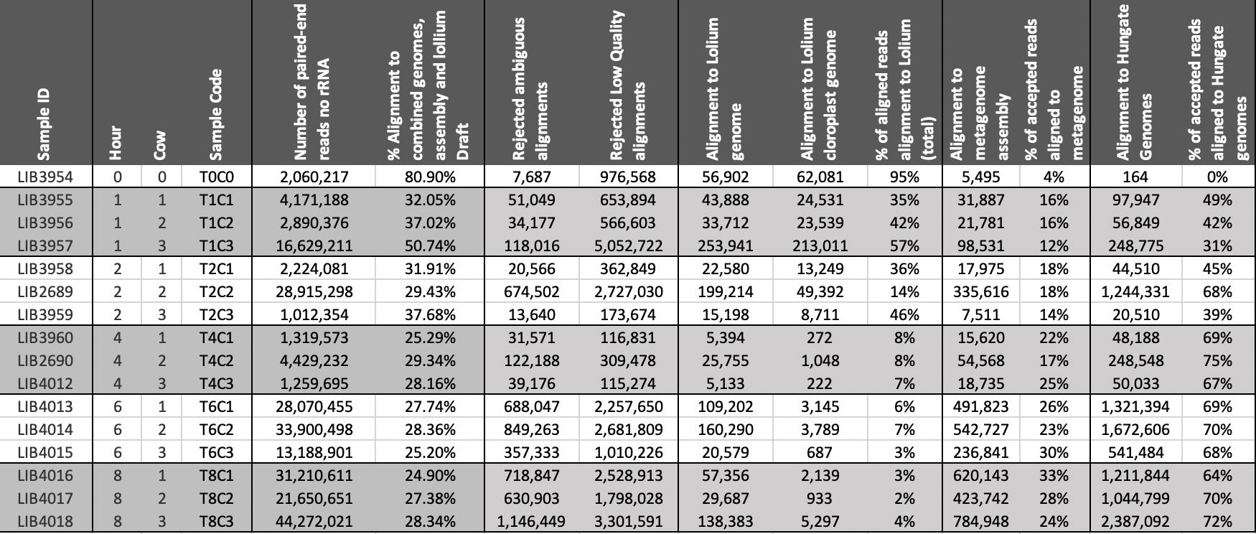

Supplementary Table 1. Parameters used for identification of putative keystone taxonomic families within the primary colonising sub-microbiome

Taxonomic Family | Transitivity diff | Density  Diff | Modularity  diff | AvePathLen  diff | CentraEigen  diff | Transitivity rank | Density rank | Modularity  rank | AvePathLen  Rank | CentraEige  rank | Sum of Ranks | Overall  rank
Burkholderiaceae | -0.024494 | -0.020256 | 0.015984 | 0.032821 | 0.021189 | 1 | 4 | 2 | 5 | 3 | 15 | 1
Enterobacteriaceae | -0.024494 | -0.020256 | 0.015984 | 0.032821 | 0.021189 | 1 | 4 | 2 | 5 | 3 | 15 | 1
Rhizobiaceae | -0.024379 | -0.02359 | 0.01706 | 0.036154 | 0.009229 | 3 | 1 | 1 | 3 | 10 | 18 | 3
Coriobacteriaceae | -0.015592 | -0.02359 | 0.006752 | 0.059487 | 0.022978 | 7 | 1 | 8 | 1 | 2 | 19 | 4
Mycobacteriaceae | -0.014053 | -0.02359 | 0.007012 | 0.052821 | 0.02674 | 8 | 1 | 7 | 2 | 1 | 19 | 4
Micrococcaceae | -0.016009 | -0.016923 | 0.007491 | 0.029487 | 0.013453 | 6 | 6 | 6 | 7 | 6 | 31 | 6
Chlamydiaceae | -0.019243 | -0.01359 | 0.012857 | 0.026154 | 0.013337 | 4 | 8 | 4 | 9 | 7 | 32 | 7
Tolypothrichaceae | -0.018521 | -0.016923 | 0.00409 | 0.029487 | 0.018468 | 5 | 6 | 9 | 7 | 5 | 32 | 7
Alcaligenaceae | -0.010044 | -0.006923 | 0.009796 | 0.016154 | 0.005689 | 9 | 12 | 5 | 13 | 13 | 52 | 9
Paenibacillaceae | 0.001343 | -0.010256 | -0.004116 | 0.036154 | 0.008043 | 12 | 11 | 15 | 3 | 12 | 53 | 10
Oscillospiraceae | -0.003048 | -0.01359 | -0.005123 | 0.026154 | 0.009432 | 11 | 8 | 19 | 9 | 9 | 56 | 11
Endomicrobiaceae | 0.002282 | -0.01359 | -0.004751 | 0.026154 | 0.011805 | 14 | 8 | 18 | 9 | 8 | 57 | 12
Rhodobacteraceae | -0.005755 | -0.006923 | 0.003426 | 0.016154 | 0.003935 | 10 | 12 | 11 | 13 | 14 | 60 | 13
Acidaminococcaceae | 0.002327 | -0.000256 | 0.000301 | 0.009487 | -0.003262 | 15 | 15 | 12 | 16 | 16 | 74 | 14
Rhodospirillaceae | 0.012461 | -0.00359 | -0.008242 | 0.009487 | 0.009013 | 19 | 14 | 20 | 16 | 11 | 80 | 15
Eggerthellaceae | 0.025436 | 0.00641 | 0.003864 | 0.019487 | -0.010651 | 23 | 18 | 10 | 12 | 19 | 82 | 16
Vibrionaceae | 0.013247 | -0.000256 | -0.010974 | 0.012821 | -0.007602 | 20 | 15 | 21 | 15 | 18 | 89 | 17
Cystobacterineae | 0.008595 | 0.029744 | -0.002998 | -0.053846 | -0.020321 | 18 | 20 | 14 | 18 | 20 | 90 | 18
Mycoplasmataceae | 0.002432 | 0.033077 | -0.001472 | -0.090513 | -0.024176 | 16 | 21 | 13 | 20 | 22 | 92 | 19
Bradyrhizobiaceae | 0.004063 | 0.033077 | -0.004188 | -0.080513 | -0.023399 | 17 | 21 | 16 | 19 | 21 | 94 | 20
Moraxellaceae | 0.00162 | 0.033077 | -0.004188 | -0.097179 | -0.024603 | 13 | 21 | 16 | 22 | 23 | 95 | 21
Prevotellaceae | 0.013657 | -0.000256 | -0.019919 | -0.090948 | -0.000608 | 21 | 15 | 23 | 21 | 15 | 95 | 21
Fusobacteriaceae | 0.019971 | 0.013077 | -0.0158 | -0.112687 | -0.004507 | 22 | 19 | 22 | 23 | 17 | 103 | 23

Supplementary Table 2. Parameters used for identification of putative keystone taxonomic families within the secondary colonising sub-microbiome
Taxonomic Family | Transitivity  diff | Density_diff | Modularity diff | AvePathLen diff | CentraEigen diff | Transitivity  rank | Density  rank | Modularity rank | AvePathLe  rank | CentraEigen  rank | Sum of Ranks | Overall  rank
Flammeovirgaceae | -0.014005 | -0.018696 | 0.014439 | 0.028116 | 0.01926 | 3 | 2 | 4 | 4 | 1 | 14 | 1
Cyclobacteriaceae | -0.014005 | -0.018696 | 0.014439 | 0.028116 | 0.01926 | 3 | 2 | 4 | 4 | 1 | 14 | 1
Cytophagaceae | -0.011396 | -0.022319 | 0.017428 | 0.035362 | 0.009304 | 6 | 1 | 1 | 3 | 10 | 21 | 3
Methanomassiliicoccaceae | -0.009152 | -0.018696 | 0.017285 | 0.028116 | 0.018052 | 11 | 2 | 2 | 4 | 3 | 22 | 4
Marinilabiliaceae | -0.014153 | -0.015072 | 0.011473 | 0.024493 | 0.016052 | 1 | 6 | 7 | 8 | 5 | 27 | 6
Porphyromonadaceae | -0.009152 | -0.018696 | 0.017285 | 0.028116 | 0.018052 | 11 | 2 | 2 | 4 | 3 | 22 | 4
Prolixibacteraceae | -0.014153 | -0.015072 | 0.011473 | 0.024493 | 0.016052 | 1 | 6 | 7 | 8 | 5 | 27 | 6
Flavobacteriaceae | -0.011175 | -0.011449 | 0.011056 | 0.02087 | 0.012697 | 7 | 8 | 9 | 10 | 7 | 41 | 8
Rikenellaceae | -0.013054 | -0.011449 | 0.008529 | 0.017246 | 0.011517 | 5 | 8 | 10 | 12 | 8 | 43 | 9
Leptospiraceae | -0.00186 | -0.011449 | 0.013789 | 0.02087 | 0.009772 | 13 | 8 | 6 | 10 | 9 | 46 | 10
Odoribacteraceae | -0.010633 | -0.007826 | 0.005608 | 0.002754 | 0.0069 | 8 | 11 | 12 | 14 | 11 | 56 | 11
Chitinophagaceae | -0.010633 | -0.007826 | 0.005608 | 0.002754 | 0.0069 | 8 | 11 | 12 | 14 | 11 | 56 | 11
Hymenobacteraceae | -0.010633 | -0.007826 | 0.005608 | 0.002754 | 0.0069 | 8 | 11 | 12 | 14 | 11 | 56 | 11
Bacteroidaceae | 0.019921 | -0.007826 | -0.011817 | 0.042609 | 0.001475 | 23 | 11 | 20 | 2 | 14 | 70 | 14
Thermoanaerobacterales_Family_III._Incertae_Sedis | 0.002956 | -0.00058 | 0.007369 | 0.006377 | -0.000265 | 17 | 16 | 11 | 13 | 16 | 73 | 15
Crocinitomicaceae | -0.001744 | -0.00058 | 0.004897 | -0.004493 | -0.000448 | 14 | 16 | 15 | 17 | 17 | 79 | 17
Erysipelotrichaceae | 0.026539 | -0.004203 | -0.024449 | 0.071594 | -0.004232 | 25 | 15 | 22 | 1 | 18 | 81 | 18
Sphingobacteriaceae | -0.000644 | -0.00058 | 0.004897 | -0.004493 | 0.000134 | 15 | 16 | 15 | 17 | 15 | 78 | 16
Planococcaceae | 0.017221 | 0.013913 | 0.003455 | -0.018986 | -0.015404 | 21 | 19 | 17 | 21 | 19 | 97 | 19
Bacillaceae | 0.022093 | 0.013913 | -0.016117 | -0.004493 | -0.018293 | 24 | 19 | 21 | 17 | 20 | 101 | 20
Lachnospiraceae | 0.00129 | 0.046522 | -0.005391 | -0.124058 | -0.030446 | 16 | 25 | 18 | 24 | 25 | 108 | 21
Methanosarcinaceae | 0.005323 | 0.042899 | -0.010627 | -0.062464 | -0.028312 | 18 | 24 | 19 | 23 | 24 | 108 | 21
Clostridiaceae | 0.009588 | 0.028406 | -0.03207 | -0.037101 | -0.022385 | 19 | 22 | 25 | 22 | 21 | 109 | 23
Streptococcaceae | 0.018462 | 0.021159 | -0.030901 | -0.008116 | -0.024021 | 22 | 21 | 24 | 20 | 22 | 109 | 23
Acholeplasmataceae | 0.009662 | 0.032029 | -0.027285 | -0.182029 | -0.024282 | 20 | 23 | 23 | 25 | 23 | 114 | 25

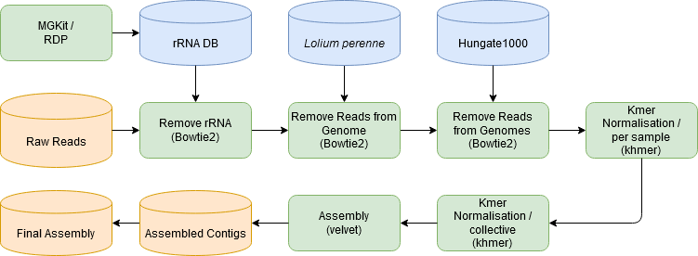
Supplementary Figure 1. Flow chart detailing the methodology used to assemble the raw reads into contigs for further analysis. In green the software used, in blue the public data used and in orange the study data.

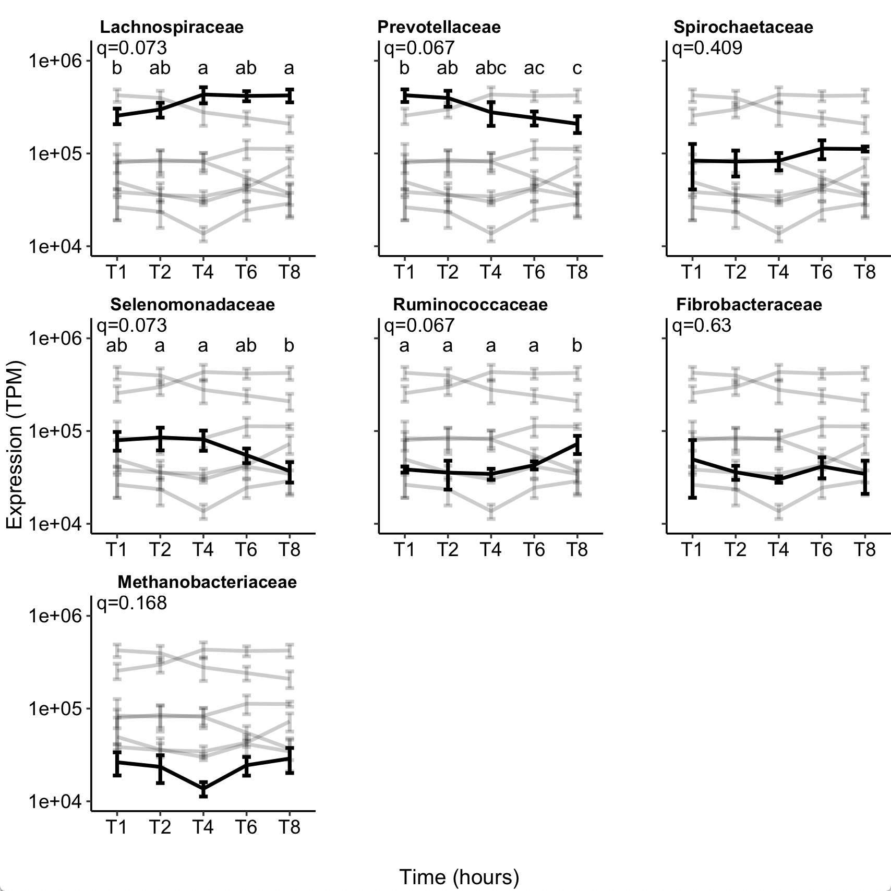
Supplementary Figure 2. Number of expressed sequencing reads (Transcripts per million, TPM), shown using a log scale, for each prokaryotic taxonomic family colonising perennial ryegrass incubated in the rumen over time. The seven taxonomic families representing 95% of the gene expression data from all timepoints are shown (i.e. T1 represents 1 hour of rumen incubation). The black lines shows the data for the representative family named above the plot, and fainter greyscale lines represent the data for the other families in order to show overall proportion of the highlighted family compared with all other dominant families.
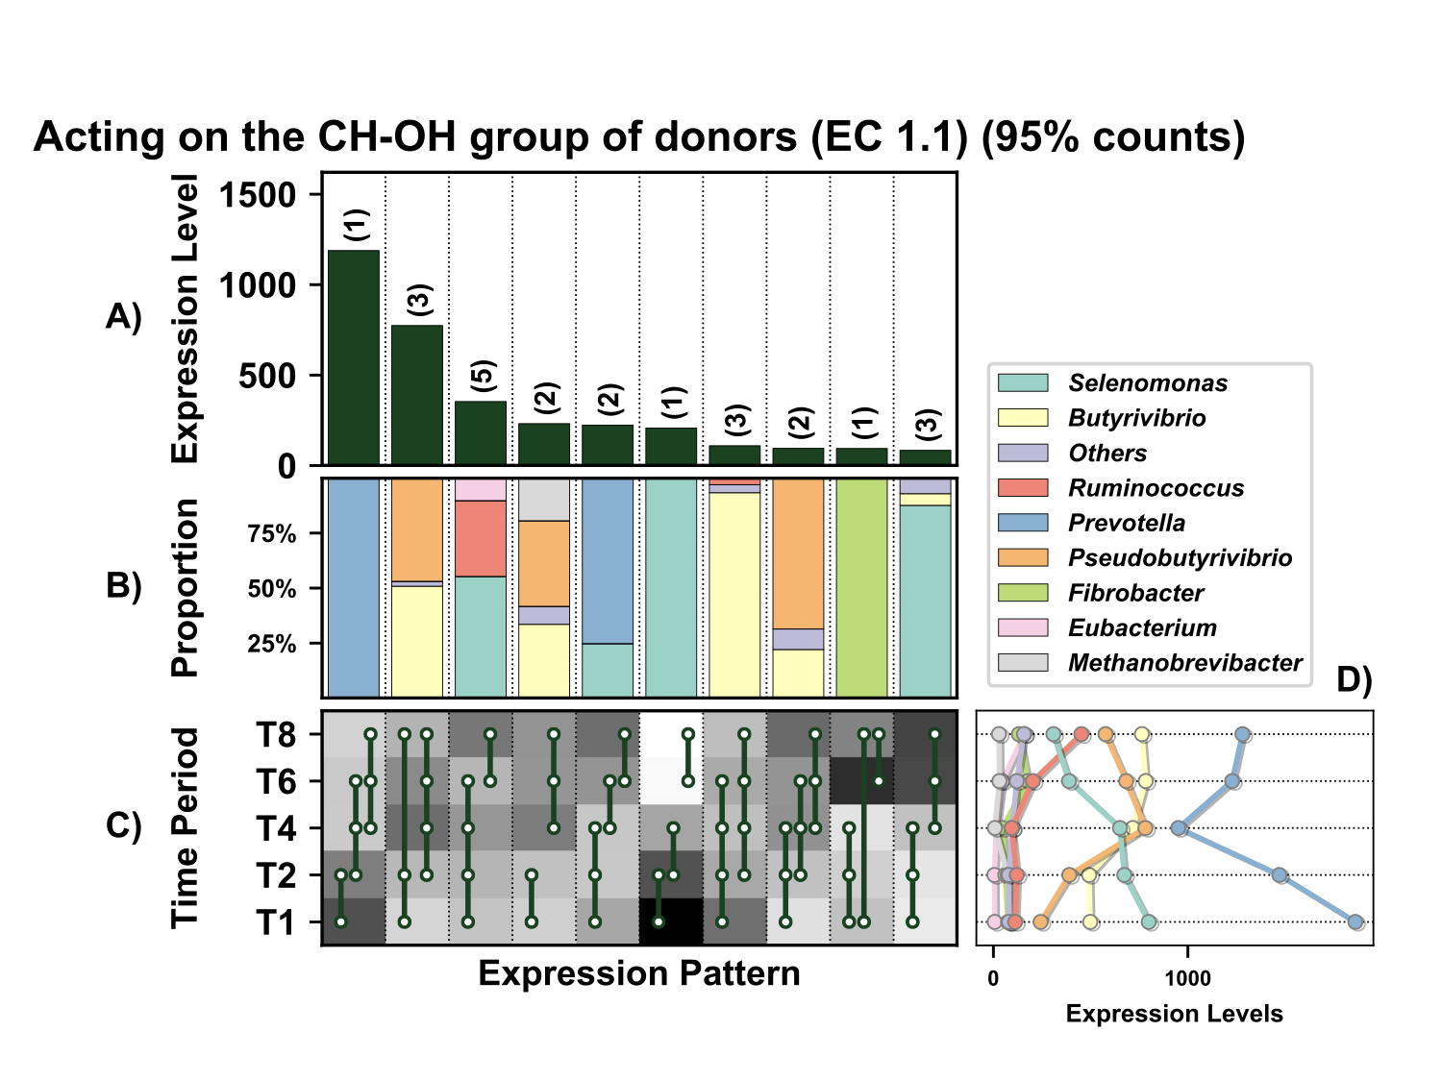
Supplementary Figure 3. Temporal expression of the top 95% most highly expressed genes acting on the CH-OH group of donors (EC 1.1) with a significant interaction with time expressed by prokaryotes attached to fresh perennial ryegrass incubated in situ within the rumen. Each column represents a set of genes that showed the same differential expression (DE) pattern (denoted as expression pattern on x axis). A) Summed expression of all genes acting on the CH-OH group of donors with the same DE pattern, in brackets the number of genes with the same DE pattern. B) The proportion of taxonomic genera contributing to the expression level for each DE pattern. C) Visual representation of the DE patterns for each set of genes across the timepoints sampled; The heatmap represents the level of expression for each timepoint (Low = White, High = Black); The lines and dots represent the specific DE pattern shared by all genes in this set where the timepoints connected by line and dots were not significantly different from each other. D) The level of expression of genes acting on the CH-OH group of donors across each timepoint.
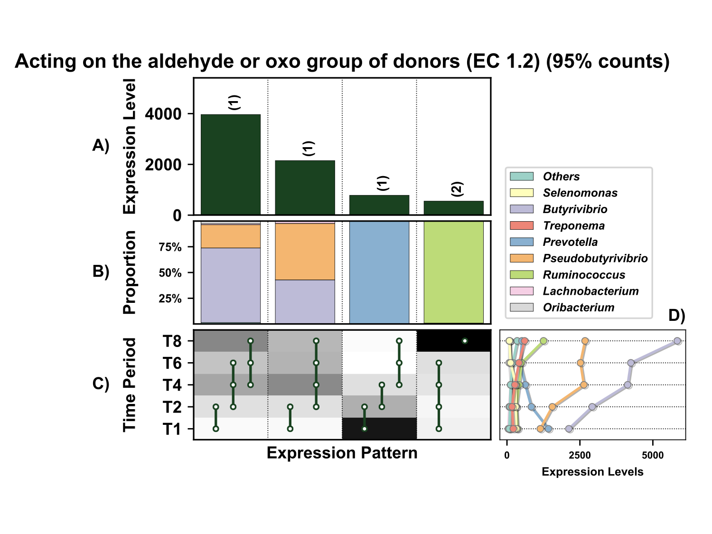
Supplementary Figure 4. Temporal expression of the top 95% most highly expressed genes acting on the aldehyde or oxo group of donors (EC 1.2) with a significant interaction with time expressed by prokaryotes attached to fresh perennial ryegrass incubated in situ within the rumen. Each column represents a set of genes that showed the same differential expression (DE) pattern (denoted as expression pattern on x axis). A) Summed expression of all genes acting on the aldehyde or oxo group of donors with the same DE pattern, in brackets the number of genes with the same DE pattern. B) The proportion of taxonomic genera contributing to the expression level for each DE pattern. C) Visual representation of the DE patterns for each set of genes across the timepoints sampled; The heatmap represents the level of expression for each timepoint (Low = White, High = Black); The lines and dots represent the specific DE pattern shared by all genes in this set where the timepoints connected by line and dots were not significantly different from each other. D) The level of expression of genes acting on the aldehyde or oxo group of donors across each timepoint.

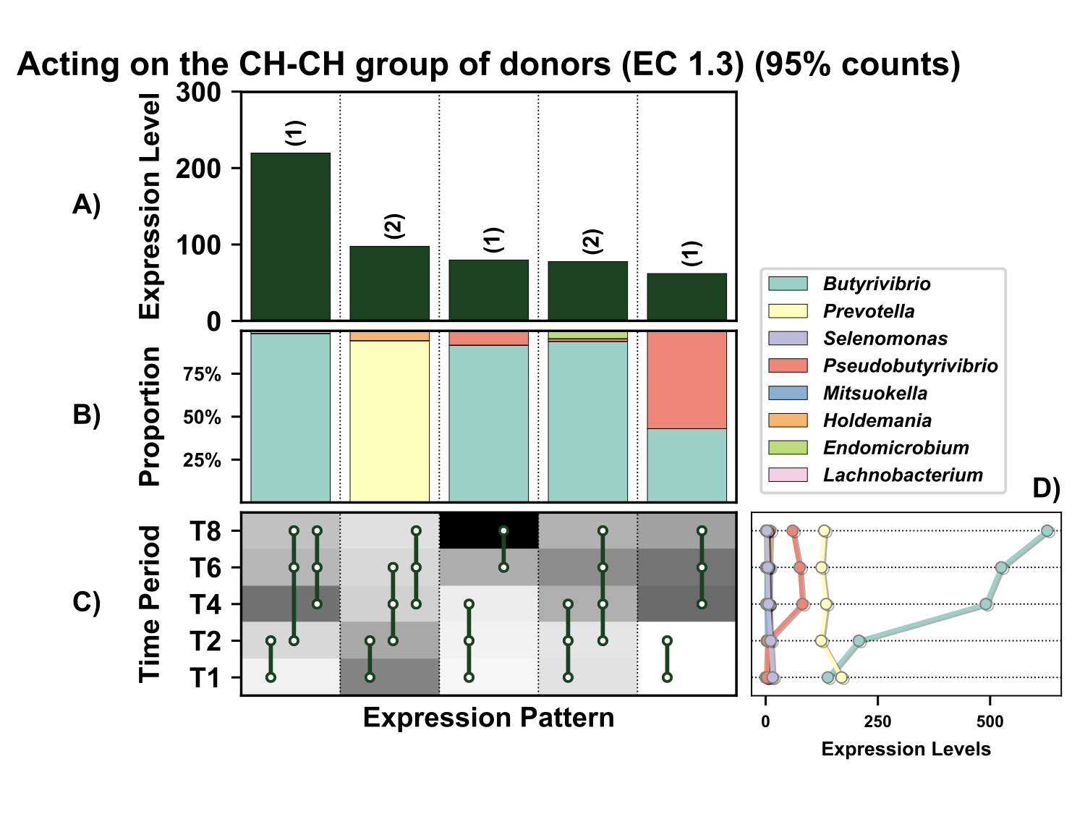
Supplementary Figure 5. Temporal expression of the top 95% most highly expressed genes acting on the CH-CH group of donors (EC 1.3) with a significant interaction with time expressed by prokaryotes attached to fresh perennial ryegrass incubated in situ within the rumen. Each column represents a set of genes that showed the same differential expression (DE) pattern (denoted as expression pattern on x axis). A) Summed expression of all genes acting on the CH-CH group of donors with the same DE pattern, in brackets the number of genes with the same DE pattern. B) The proportion of taxonomic genera contributing to the expression level for each DE pattern. C) Visual representation of the DE patterns for each set of genes across the timepoints sampled; The heatmap represents the level of expression for each timepoint (Low = White, High = Black); The lines and dots represent the specific DE pattern shared by all genes in this set where the timepoints connected by line and dots were not significantly different from each other. D) The level of expression of genes acting on the CH-CH group of donors across each timepoint.

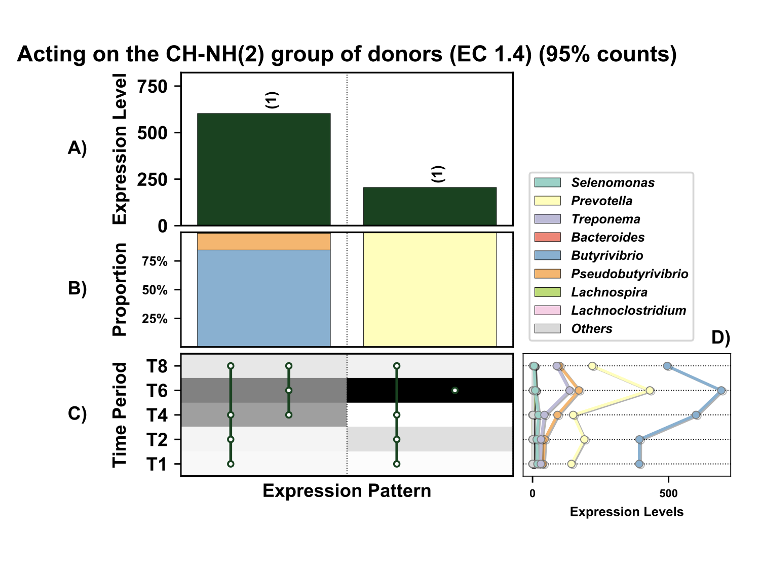Figure 6. Temporal expression the top 95% most highly expressed genes acting on the CH-NH₂ group of donors (EC 1.4) with a significant interaction with time expressed by prokaryotes attached to fresh perennial ryegrass incubated in situ within the rumen. Each column represents a set of genes that showed the same differential expression (DE) pattern (denoted as expression pattern on x axis). A) Summed expression of all genes acting on the CH-NH₂ group of donors with the same DE pattern, in brackets the number of genes with the same DE pattern. B) The proportion of taxonomic genera contributing to the expression level for each DE pattern. C) Visual representation of the DE patterns for each set of genes across the timepoints sampled; The heatmap represents the level of expression for each timepoint (Low = White, High = Black); The lines and dots represent the specific DE pattern shared by all genes in this set where the timepoints connected by line and dots were not significantly different from each other. D) The level of expression of genes acting on the CH-NH₂ group of donors across each timepoint.

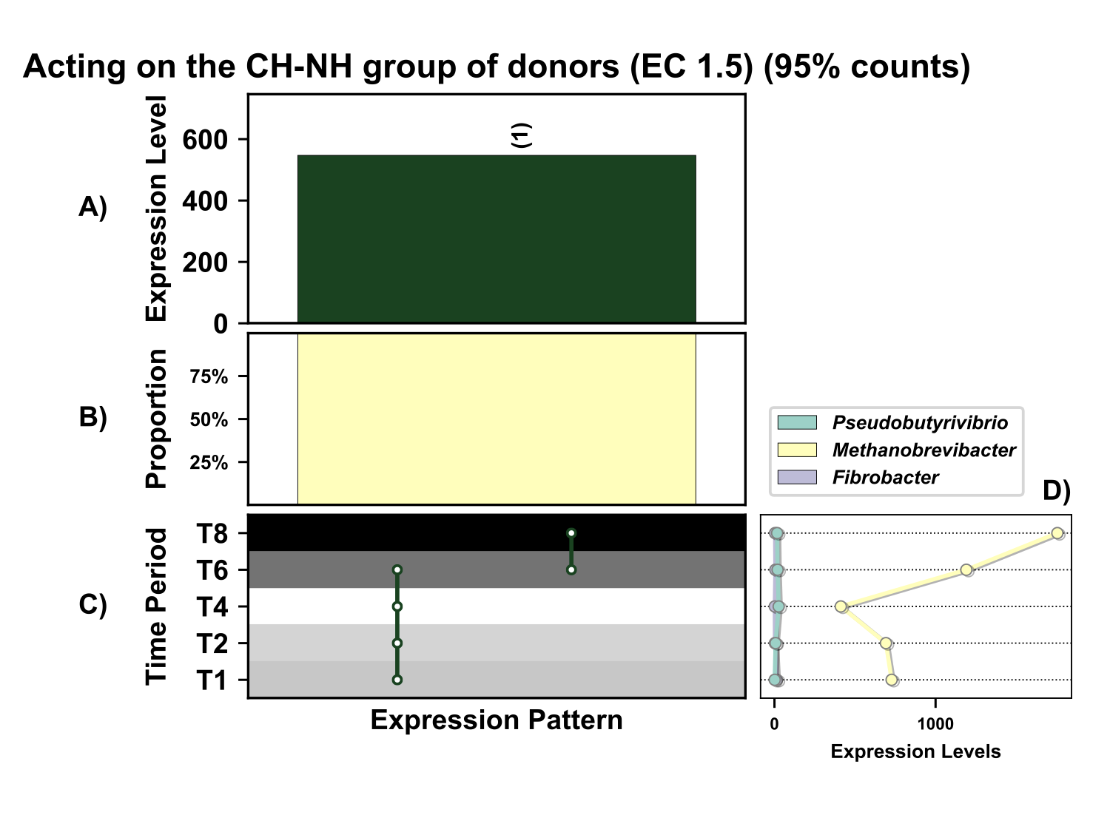Supplementary Figure 7. Temporal expression of genes the top 95% most highly expressed genes acting on the CH-NH group of donors (EC 1.5) with a significant interaction with time expressed by prokaryotes attached to fresh perennial ryegrass incubated in situ within the rumen. Each column represents a set of genes that showed the same differential expression (DE) pattern (denoted as expression pattern on x axis). A) Summed expression of all glycosylases with the same DE pattern, in brackets the number of genes with the same DE pattern. B) The proportion of taxonomic genera contributing to the expression level for each DE pattern. C) Visual representation of the DE patterns for each set of genes across the timepoints sampled; The heatmap represents the level of expression for each timepoint (Low = White, High = Black); The lines and dots represent the specific DE pattern shared by all genes in this set where the timepoints connected by line and dots were not significantly different from each other. D) The level of expression of genes acting on the CH-NH group of donors across each timepoint.

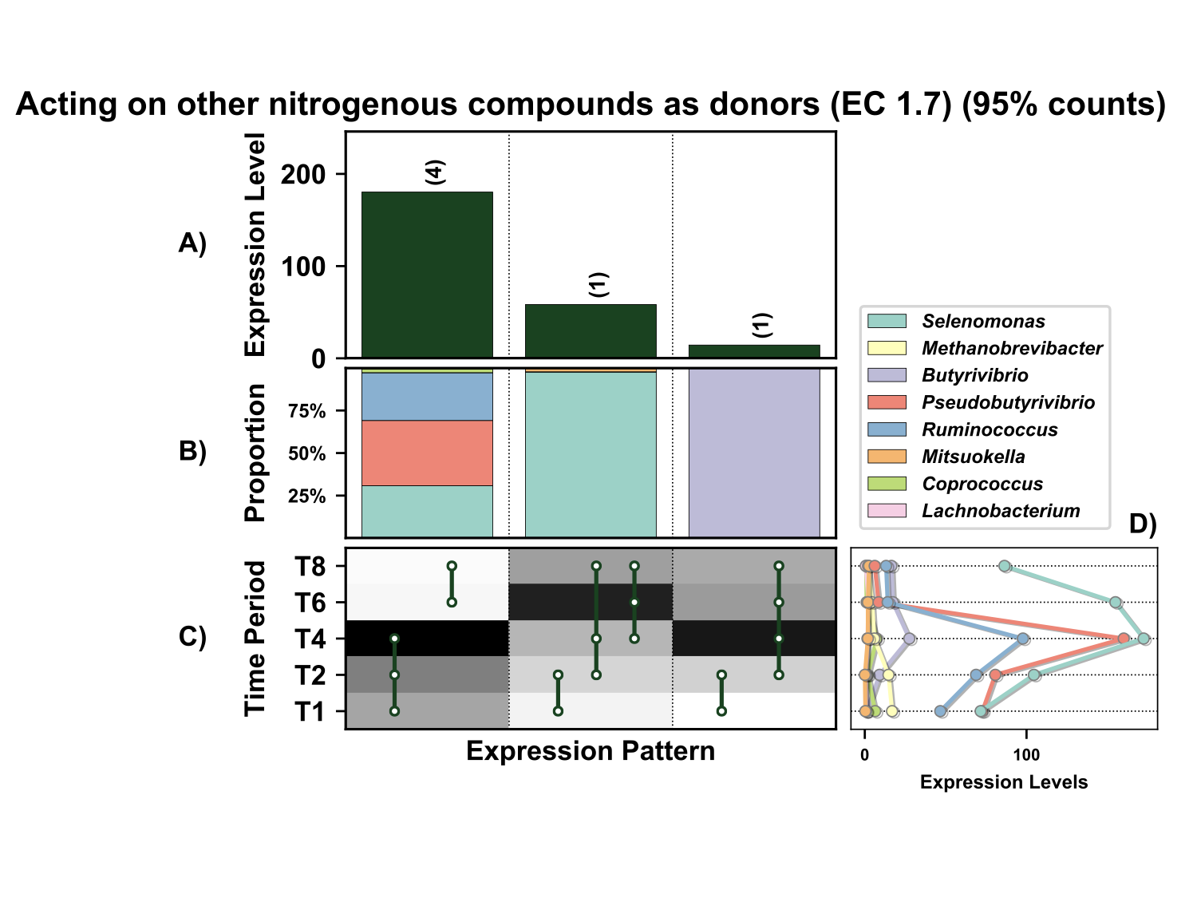Supplementary Figure 8. Temporal expression of the top 95% most highly expressed genes acting on other nitrogenous compounds as donors (EC 1.7) with a significant interaction with time expressed by prokaryotes attached to fresh perennial ryegrass incubated in situ within the rumen. Each column represents a set of genes that showed the same differential expression (DE) pattern (denoted as expression pattern on x axis). A) Summed expression of all glycosylases with the same DE pattern, in brackets the number of genes with the same DE pattern. B) The proportion of taxonomic genera contributing to the expression level for each DE pattern. C) Visual representation of the DE patterns for each set of genes across the timepoints sampled; The heatmap represents the level of expression for each timepoint (Low = White, High = Black); The lines and dots represent the specific DE pattern shared by all genes in this set where the timepoints connected by line and dots were not significantly different from each other. D) The level of expression of genes acting on other nitrogenous compounds as donors across each timepoint.

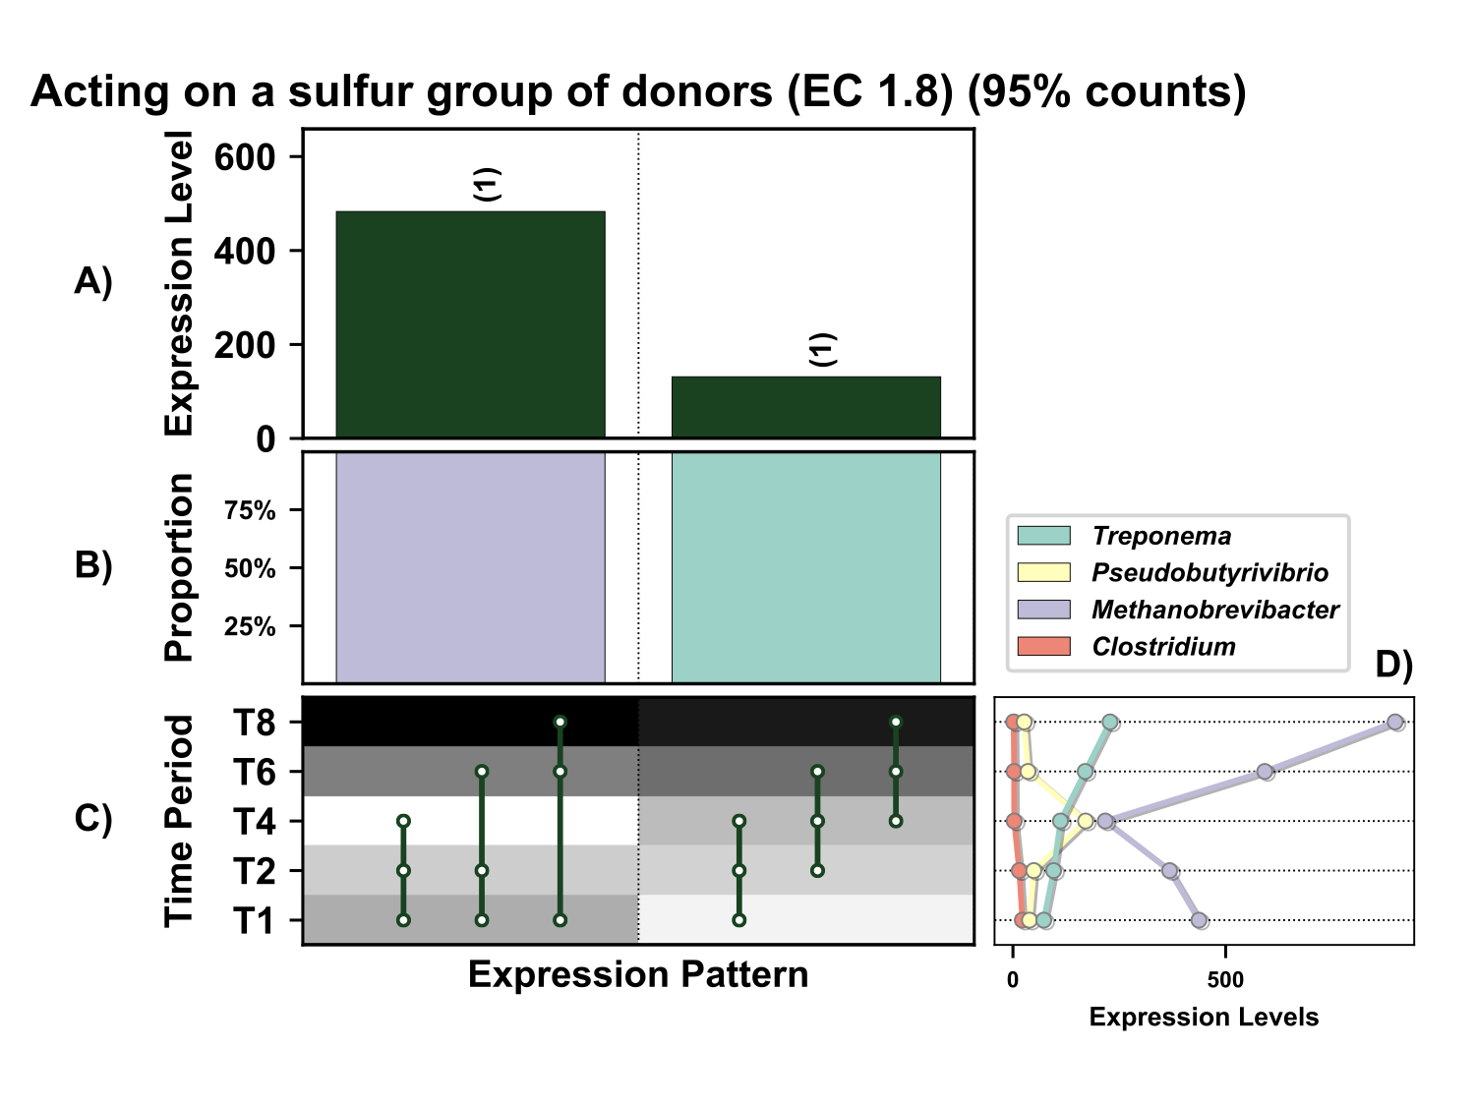Supplementary Figure 9. Temporal expression of the top 95% most highly expressed genes acting on a sulfur group of donors (EC 1.8) with a significant interaction with time expressed by prokaryotes attached to fresh perennial ryegrass incubated in situ within the rumen. Each column represents a set of genes that showed the same differential expression (DE) pattern. A) Summed expression of all genes acting on a sulfur group of donors with the same DE pattern, in brackets the number of genes with the same DE pattern. B) The proportion of taxonomic genera contributing to the expression level for each DE pattern. C) Visual representation of the DE patterns for each set of genes across the timepoints sampled; The heatmap represents the level of expression for each timepoint (Low = White, High = Black); The lines and dots represent the specific DE pattern shared by all genes in this set where the timepoints connected by line and dots were not significantly different from each other. D) The level of expression of genes acting on a sulfur group of donors across each timepoint.

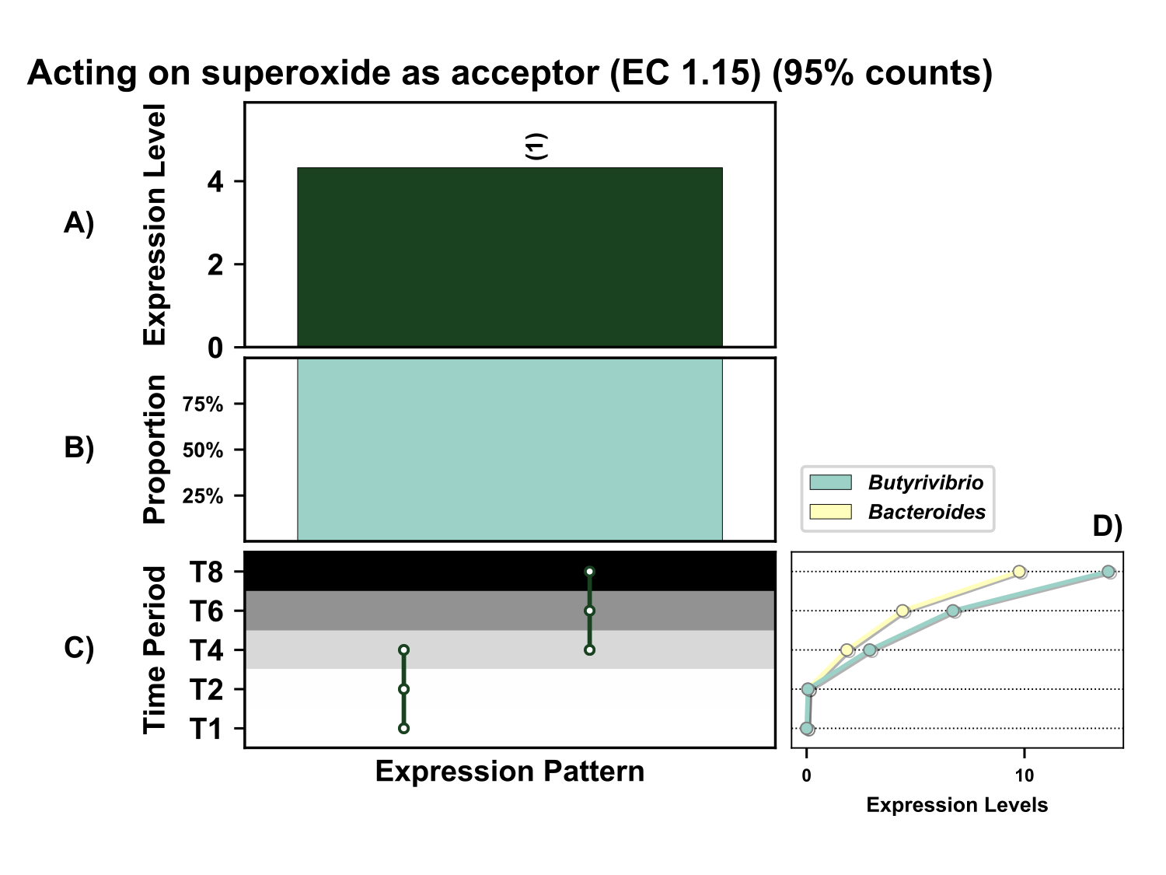
Supplementary Figure 10. Temporal expression of the top 95% most highly expressed genes acting on superoxide radicals as acceptors (EC 1.15) with a significant interaction with time expressed by prokaryotes attached to fresh perennial ryegrass incubated in situ within the rumen. Each column represents a set of genes that showed the same differential expression (DE) pattern (denoted as expression pattern on x axis). A) Summed expression of all genes acting on superoxide radicals as acceptors with the same DE pattern, in brackets the number of genes with the same DE pattern. B) The proportion of taxonomic genera contributing to the expression level for each DE pattern. C) Visual representation of the DE patterns for each set of genes across the timepoints sampled; The heatmap represents the level of expression for each timepoint (Low = White, High = Black); The lines and dots represent the specific DE pattern shared by all genes in this set where the timepoints connected by line and dots were not significantly different from each other. D) The level of expression of genes acting on the superoxide radicals as acceptors across each timepoint.

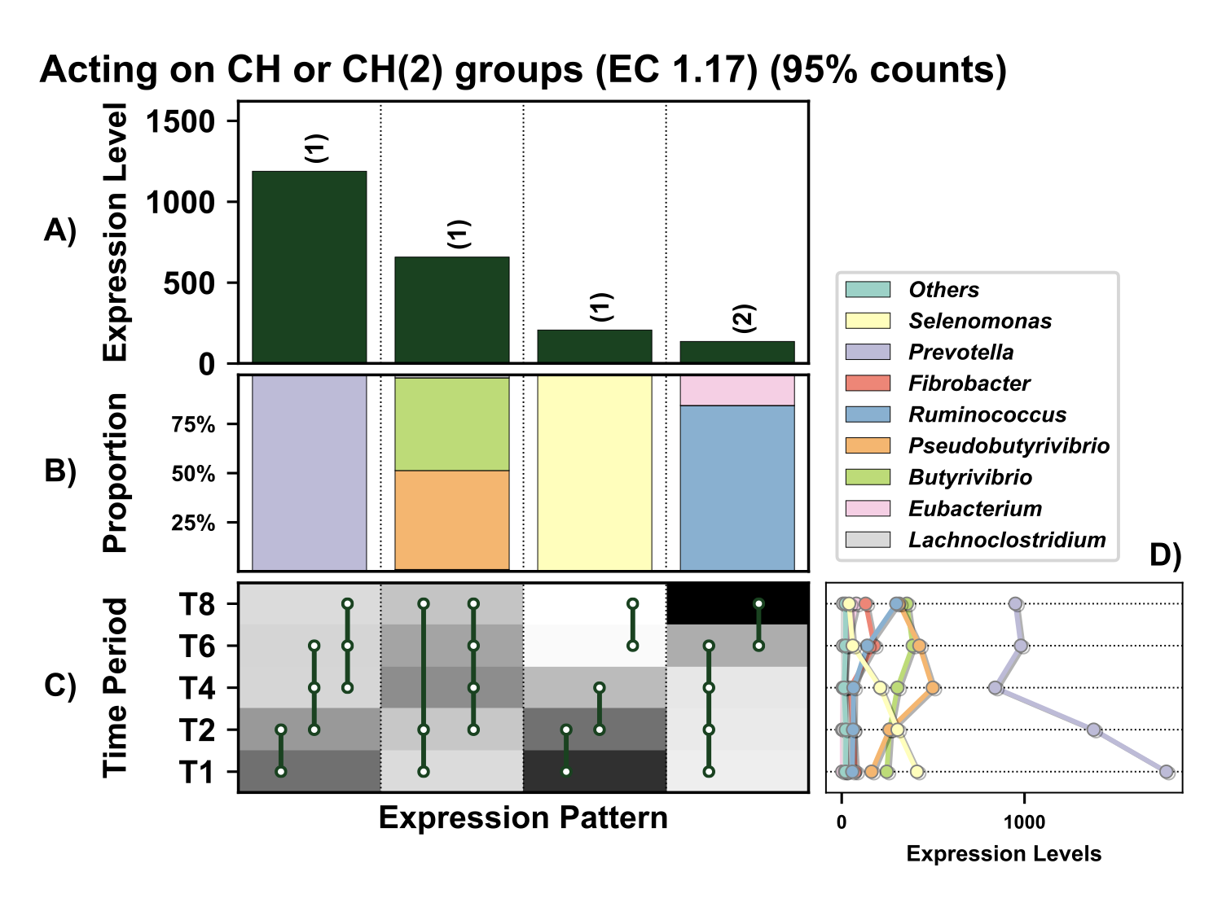
Supplementary Figure 11. Temporal expression of the top 95% most highly expressed genes acting on the CH or CH₂ groups (EC 1.17) with a significant interaction with time expressed by prokaryotes attached to fresh perennial ryegrass incubated in situ within the rumen. Each column represents a set of genes that showed the same differential expression (DE) pattern (denoted as expression pattern on x axis). A) Summed expression of all genes acting on the CH or CH₂ groups with the same DE pattern, in brackets the number of genes with the same DE pattern. B) The proportion of taxonomic genera contributing to the expression level for each DE pattern. C) Visual representation of the DE patterns for each set of genes across the timepoints sampled; The heatmap represents the level of expression for each timepoint (Low = White, High = Black); The lines and dots represent the specific DE pattern shared by all genes in this set where the timepoints connected by line and dots were not significantly different from each other. D) The level of expression of genes acting on the CH or CH₂ groups across each timepoint.

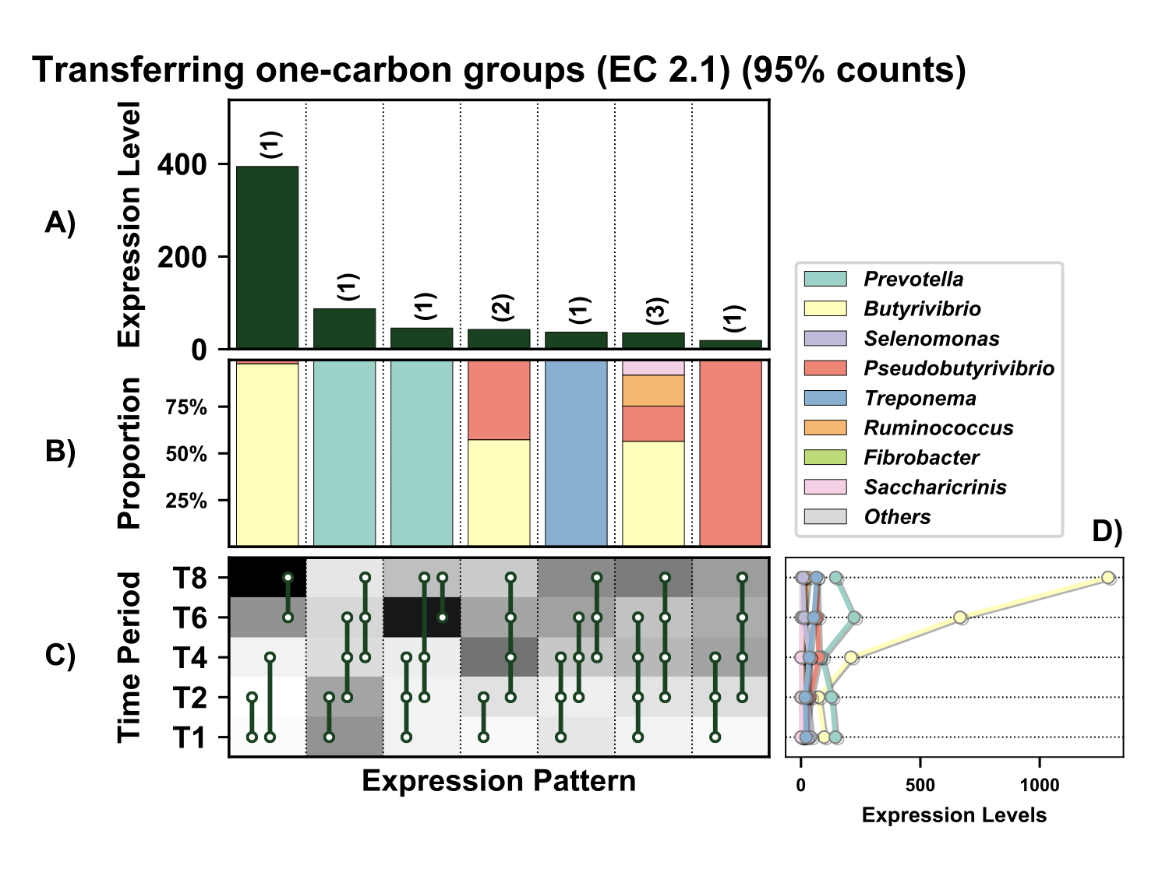

Supplementary Figure 12. Temporal expression of the top 95% most highly expressed genes involved in transfer one-carbon groups, Methylase (EC 2.1) with a significant interaction with time expressed by prokaryotes attached to fresh perennial ryegrass incubated in situ within the rumen. Each column represents a set of genes that showed the same differential expression (DE) pattern (denoted as expression pattern on x axis). A) Summed expression of all glycosylases with the same DE pattern, in brackets the number of genes with the same DE pattern. B) The proportion of taxonomic genera contributing to the expression level for each DE pattern. C) Visual representation of the DE patterns for each set of genes across the timepoints sampled; The heatmap represents the level of expression for each timepoint (Low = White, High = Black); The lines and dots represent the specific DE pattern shared by all genes in this set where the timepoints connected by line and dots were not significantly different from each other. D) The level of expression of genes involved in transfer one-carbon groups, Methylase across each timepoint.

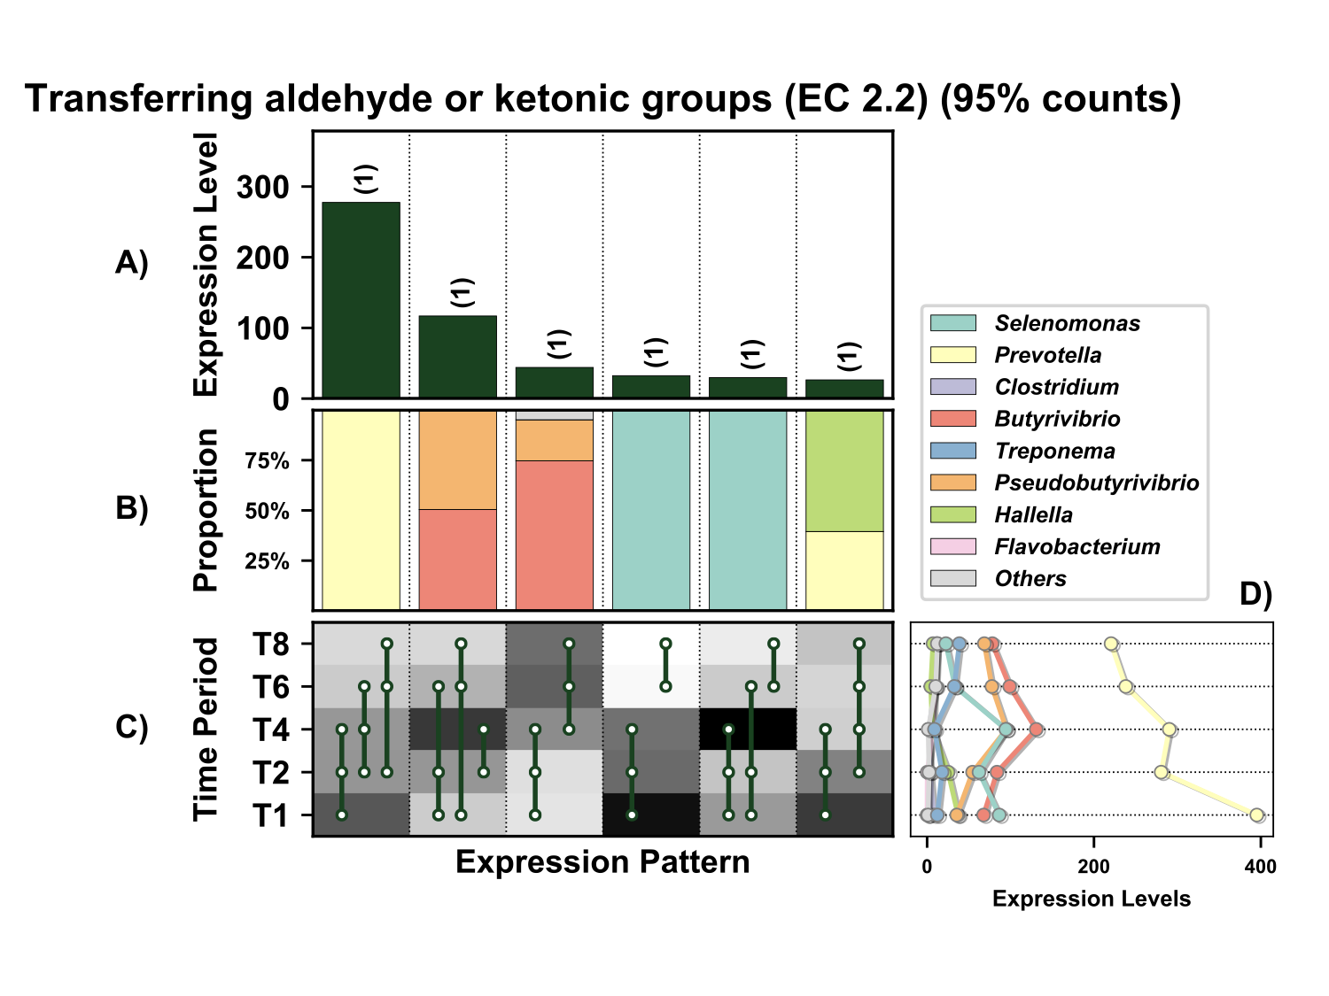

Supplementary Figure 13. Temporal expression of the top 95% most highly expressed genes involved in transfer aldehyde or ketone groups (EC 2.2) with a significant interaction with time expressed by prokaryotes attached to fresh perennial ryegrass incubated in situ within the rumen. Each column represents a set of genes that showed the same differential expression (DE) pattern (denoted as expression pattern on x axis). A) Summed expression of all genes involved in transfer aldehyde or ketone groups with the same DE pattern, in brackets the number of genes with the same DE pattern. B) The proportion of taxonomic genera contributing to the expression level for each DE pattern. C) Visual representation of the DE patterns for each set of genes across the timepoints sampled; The heatmap represents the level of expression for each timepoint (Low = White, High = Black); The lines and dots represent the specific DE pattern shared by all genes in this set where the timepoints connected by line and dots were not significantly different from each other. D) The level of expression of genes involved in transfer aldehyde or ketone groups across each timepoint.

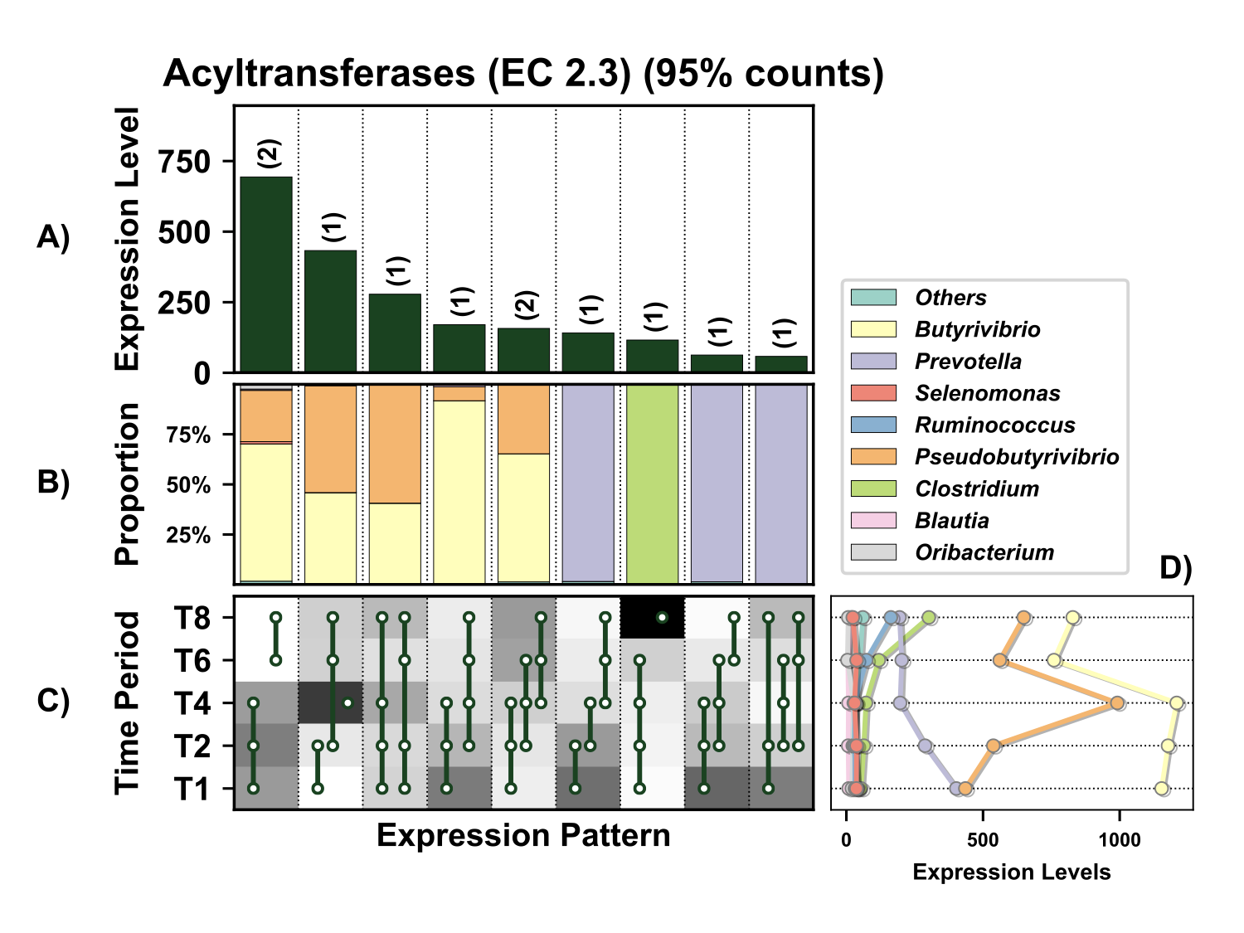

Supplementary Figure 14. Temporal expression of the top 95% most highly expressed acyltransferases (EC 2.3) with a significant interaction with time expressed by prokaryotes attached to fresh perennial ryegrass incubated in situ within the rumen. Each column represents a set of genes that showed the same differential expression (DE) pattern (denoted as expression pattern on x axis). A) Summed expression of all acyltransferases with the same DE pattern, in brackets the number of genes with the same DE pattern. B) The proportion of taxonomic genera contributing to the expression level for each DE pattern. C) Visual representation of the DE patterns for each set of genes across the timepoints sampled; The heatmap represents the level of expression for each timepoint (Low = White, High = Black); The lines and dots represent the specific DE pattern shared by all genes in this set where the timepoints connected by line and dots were not significantly different from each other. D) The level of expression of acyltransferases across each timepoint.

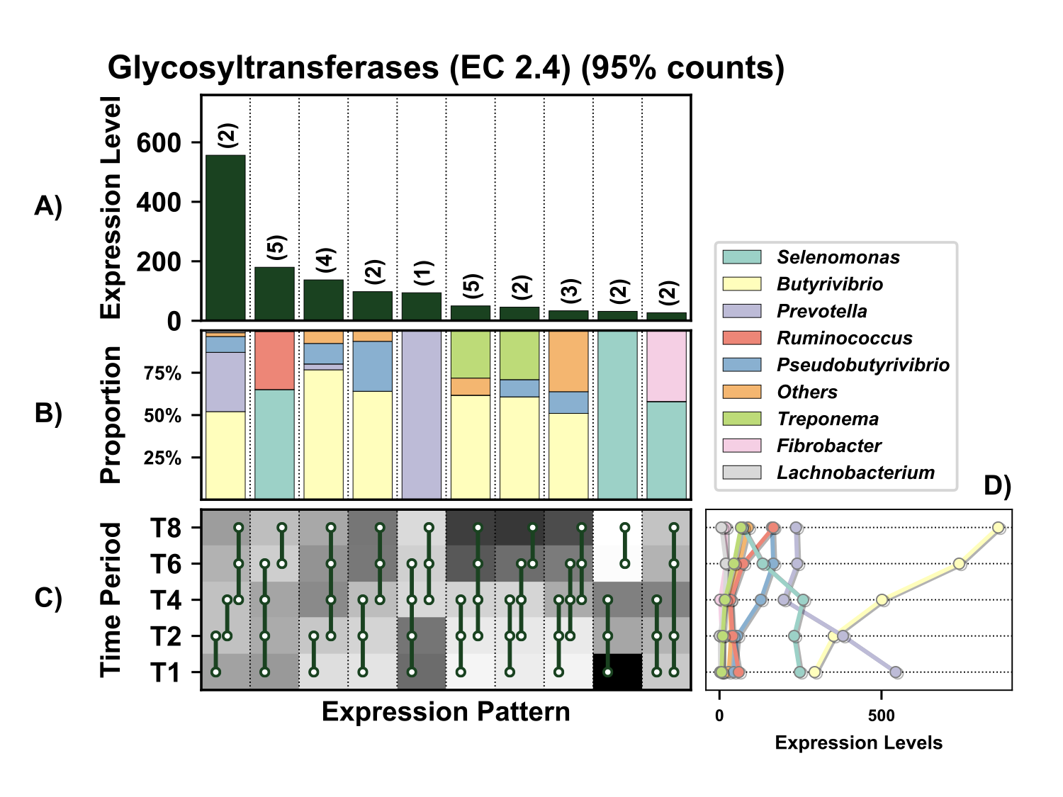

Supplementary Figure 15. Temporal expression of the top 95% most highly expressed glycosyltransferases (EC 2.4) with a significant interaction with time expressed by prokaryotes attached to fresh perennial ryegrass incubated in situ within the rumen. Each column represents a set of genes that showed the same differential expression (DE) pattern (denoted as expression pattern on x axis). A) Summed expression of all glycosylases with the same DE pattern, in brackets the number of genes with the same DE pattern. B) The proportion of taxonomic genera contributing to the expression level for each DE pattern. C) Visual representation of the DE patterns for each set of genes across the timepoints sampled; The heatmap represents the level of expression for each timepoint (Low = White, High = Black); The lines and dots represent the specific DE pattern shared by all genes in this set where the timepoints connected by line and dots were not significantly different from each other. D) The level of expression of glycosyltransferases across each timepoint.

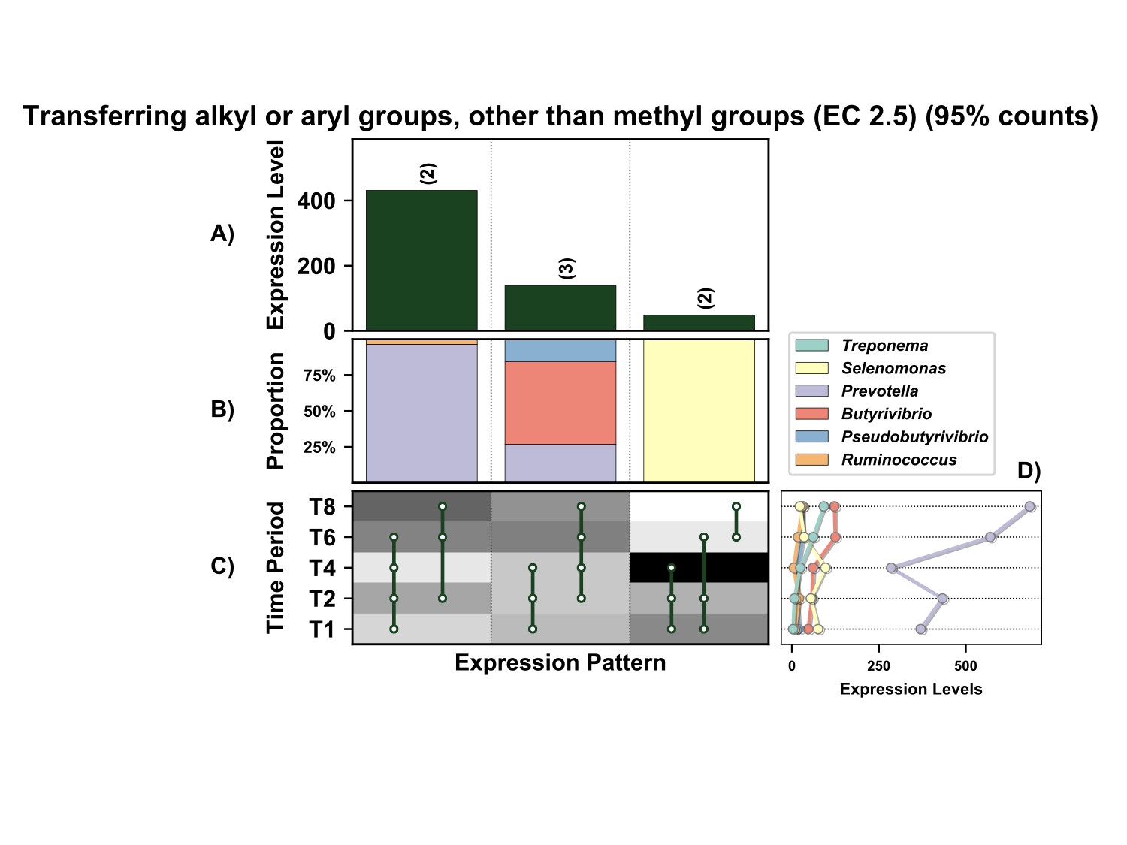Supplementary Figure 16. Temporal expression of the top 95% most highly expressed genes acting on transfer alkyl or aryl groups, other than methyl groups (EC 2.5) with a significant interaction with time expressed by prokaryotes attached to fresh perennial ryegrass incubated in situ within the rumen. Each column represents a set of genes that showed the same differential expression (DE) pattern (denoted as expression pattern on x axis). A) Summed expression of all glycosylases with the same DE pattern, in brackets the number of genes with the same DE pattern. B) The proportion of taxonomic genera contributing to the expression level for each DE pattern. C) Visual representation of the DE patterns for each set of genes acting on transfer alkyl or aryl groups, other than methyl groups across the timepoints sampled; The heatmap represents the level of expression for each timepoint (Low = White, High = Black); The lines and dots represent the specific DE pattern shared by all genes in this set where the timepoints connected by line and dots were not significantly different from each other. D) The level of expression of genes acting on transfer alkyl or aryl groups, other than methyl groups across each timepoint.

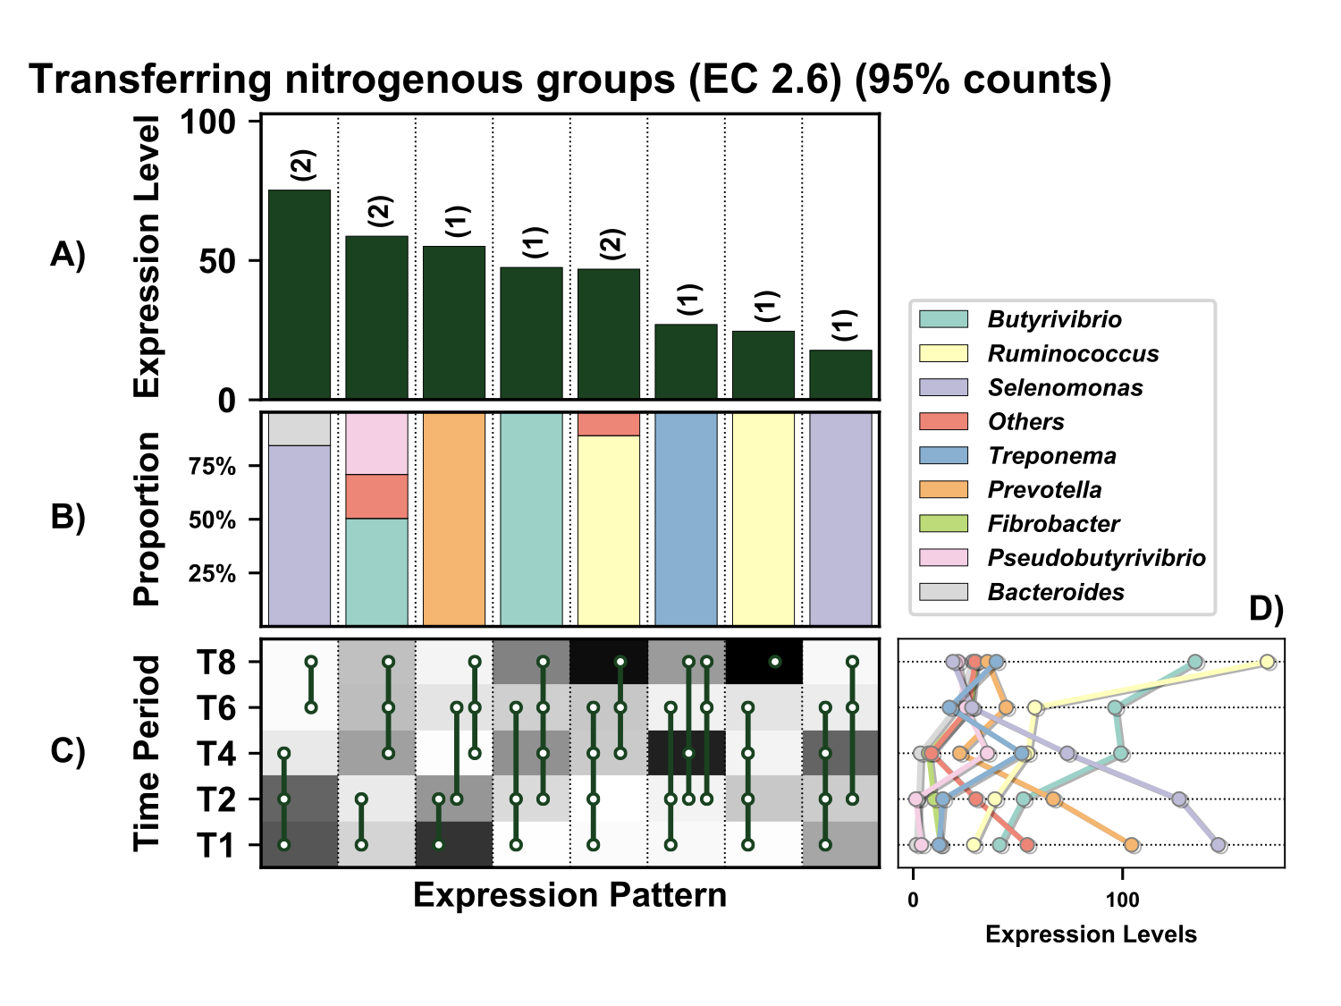

Supplementary Figure 17. Temporal expression of the top 95% most highly expressed genes involved in transfer of nitrogenous groups (EC 2.6) with a significant interaction with time expressed by prokaryotes attached to fresh perennial ryegrass incubated in situ within the rumen. Each column represents a set of genes that showed the same differential expression (DE) pattern (denoted as expression pattern on x axis). A) Summed expression of all genes involved in transfer of nitrogenous groups with the same DE pattern, in brackets the number of genes with the same DE pattern. B) The proportion of taxonomic genera contributing to the expression level for each DE pattern. C) Visual representation of the DE patterns for each set of genes across the timepoints sampled; The heatmap represents the level of expression for each timepoint (Low = White, High = Black); The lines and dots represent the specific DE pattern shared by all genes in this set where the timepoints connected by line and dots were not significantly different from each other. D) The level of expression of genes involved in transfer of nitrogenous groups across each timepoint.

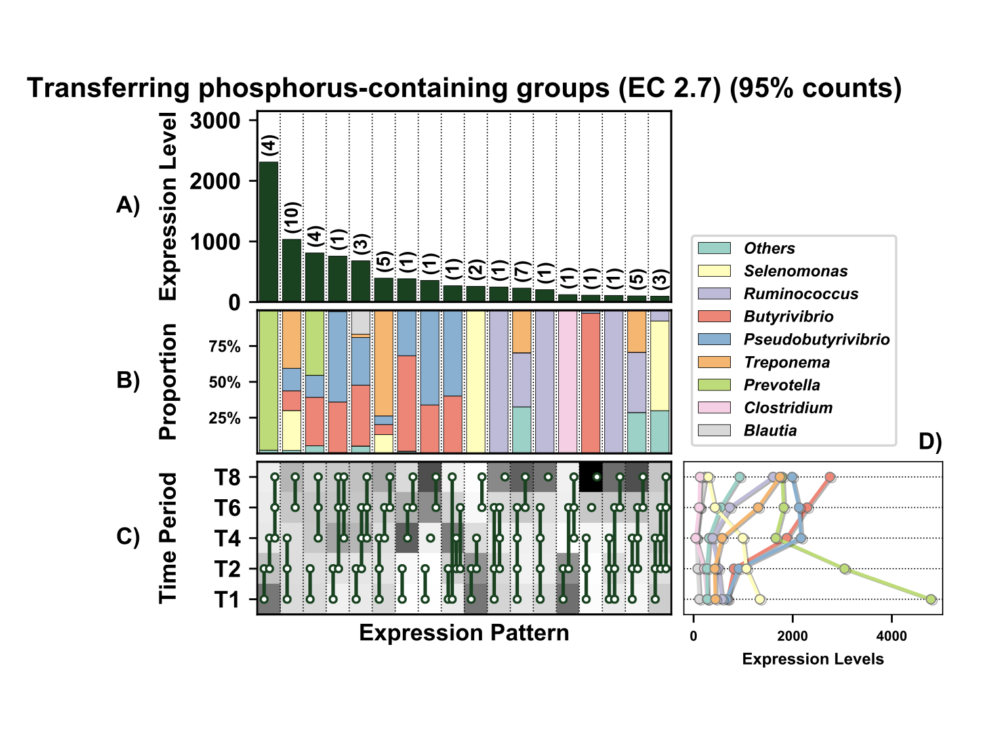

Supplementary Figure 18. Temporal expression of the top 95% most highly expressed genes involved in transfer of phosphorus-containing groups (EC 2.7) with a significant interaction with time expressed by prokaryotes attached to fresh perennial ryegrass incubated in situ within the rumen. Each column represents a set of genes that showed the same differential expression (DE) pattern (denoted as expression pattern on x axis). A) Summed expression of all genes involved in transfer of phosphorus-containing groups with the same DE pattern, in brackets the number of genes with the same DE pattern. B) The proportion of taxonomic genera contributing to the expression level for each DE pattern. C) Visual representation of the DE patterns for each set of genes across the timepoints sampled; The heatmap represents the level of expression for each timepoint (Low = White, High = Black); The lines and dots represent the specific DE pattern shared by all genes in this set where the timepoints connected by line and dots were not significantly different from each other. D) The level of expression of genes involved in transfer of phosphorus-containing groups across each timepoint.

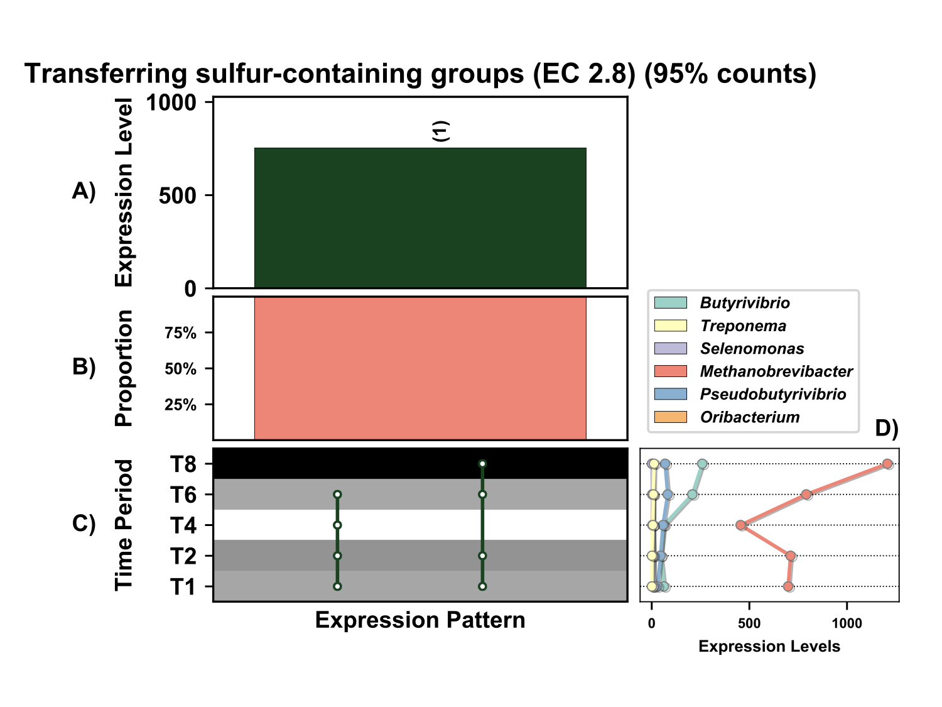

Supplementary Figure 19. Temporal expression of the top 95% most highly expressed genes involved in transfer of transfer sulfur-containing groups (EC 2.8) with a significant interaction with time expressed by prokaryotes attached to fresh perennial ryegrass incubated in situ within the rumen. Each column represents a set of genes that showed the same differential expression (DE) pattern (denoted as expression pattern on x axis). A) Summed expression of all glycosylases with the same DE pattern, in brackets the number of genes with the same DE pattern. B) The proportion of taxonomic genera contributing to the expression level for each DE pattern. C) Visual representation of the DE patterns for each set of genes across the timepoints sampled; The heatmap represents the level of expression for each timepoint (Low = White, High = Black); The lines and dots represent the specific DE pattern shared by all genes in this set where the timepoints connected by line and dots were not significantly different from each other. D) The level of expression of genes involved in transfer of transfer sulfur-containing groups across each timepoint.

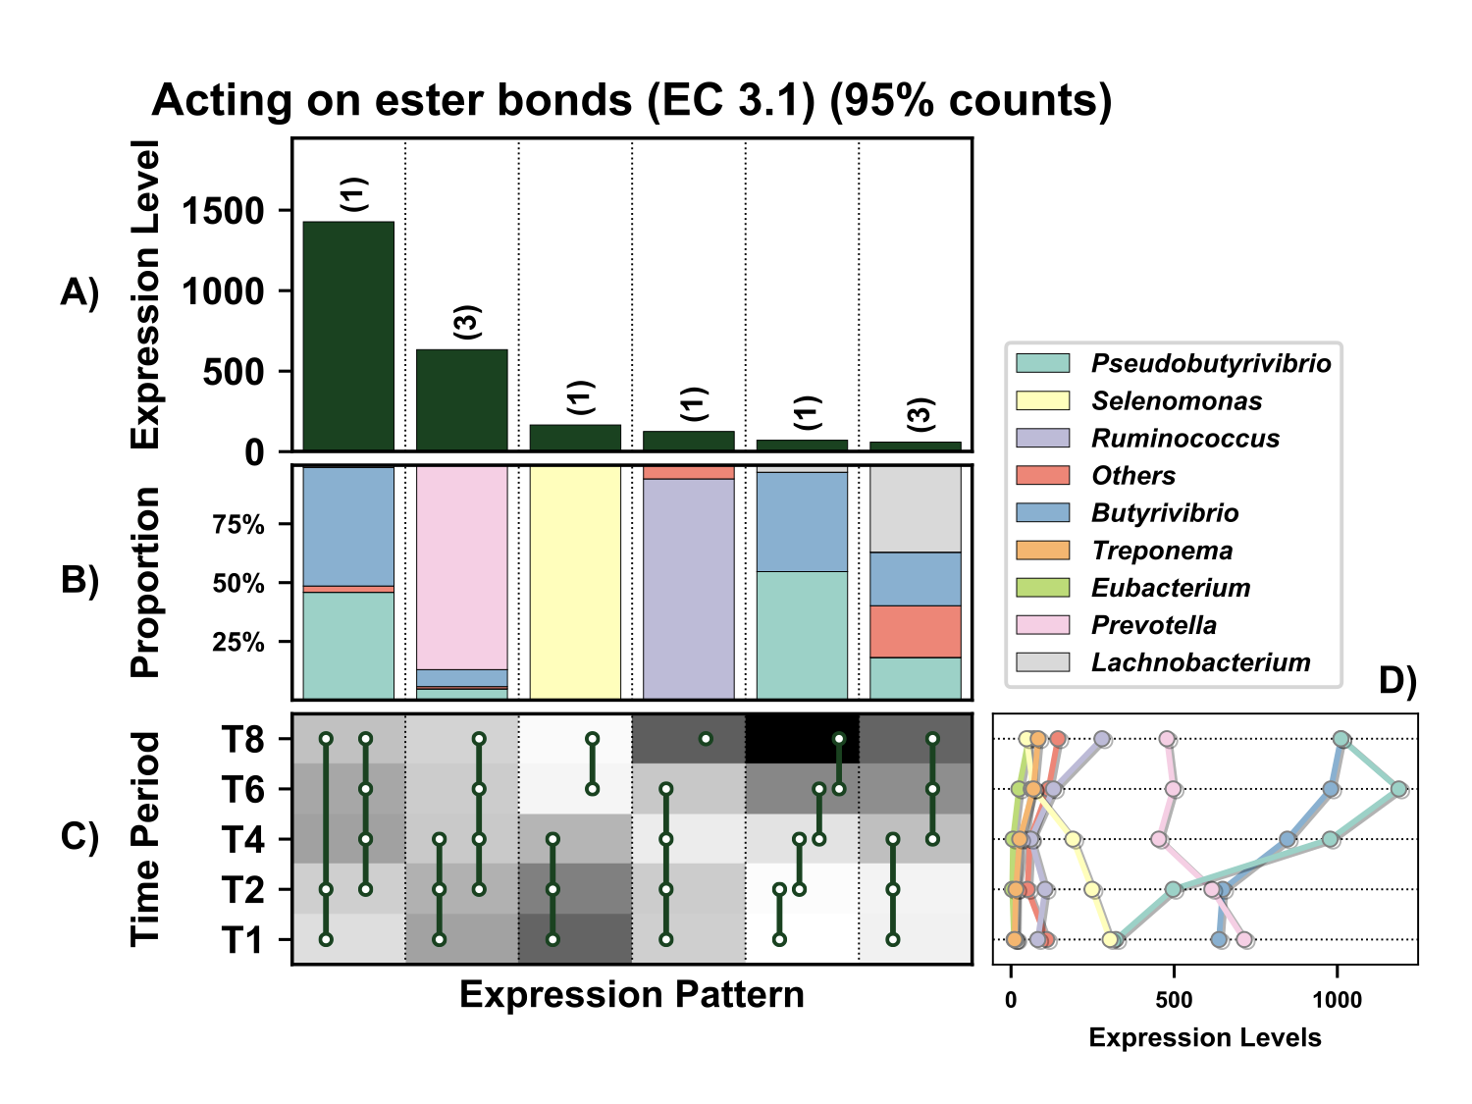

Supplementary Figure 20. Temporal expression of the top 95% most highly expressed genes acting on ester bonds (EC 3.1) with a significant interaction with time expressed by prokaryotes attached to fresh perennial ryegrass incubated in situ within the rumen. Each column represents a set of genes that showed the same differential expression (DE) pattern (denoted as expression pattern on x axis). A) Summed expression of all genes acting on ester bonds with the same DE pattern, in brackets the number of genes with the same DE pattern. B) The proportion of taxonomic genera contributing to the expression level for each DE pattern. C) Visual representation of the DE patterns for each set of genes across the timepoints sampled; The heatmap represents the level of expression for each timepoint (Low = White, High = Black); The lines and dots represent the specific DE pattern shared by all genes in this set where the timepoints connected by line and dots were not significantly different from each other. D) The level of expression of genes acting on ester bonds across each timepoint.

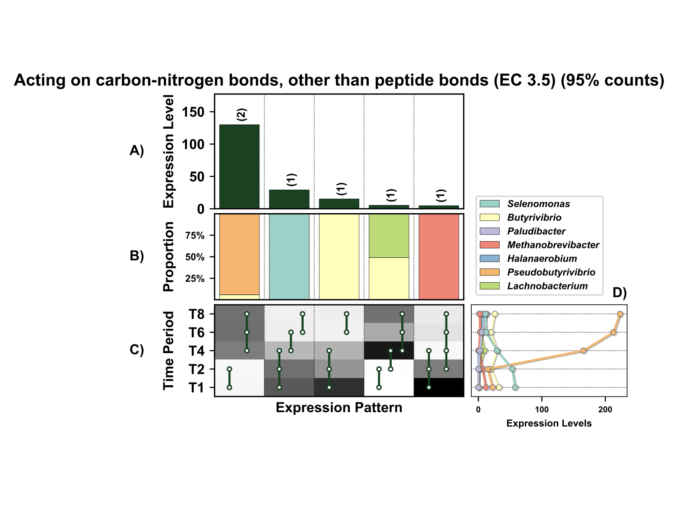
Supplementary Figure 21. Temporal expression of the top 95% most highly expressed genes acting on carbon-nitrogen bonds, other than peptide bonds (EC 3.5) with a significant interaction with time expressed by prokaryotes attached to fresh perennial ryegrass incubated in situ within the rumen. Each column represents a set of genes that showed the same differential expression (DE) pattern (denoted as expression pattern on x axis). A) Summed expression of all genes acting on carbon-nitrogen bonds, other than peptide bonds with the same DE pattern, in brackets the number of genes with the same DE pattern. B) The proportion of taxonomic genera contributing to the expression level for each DE pattern. C) Visual representation of the DE patterns for each set of genes across the timepoints sampled; The heatmap represents the level of expression for each timepoint (Low = White, High = Black); The lines and dots represent the specific DE pattern shared by all genes in this set where the timepoints connected by line and dots were not significantly different from each other. D) The level of expression of genes acting on carbon-nitrogen bonds, other than peptide bonds across each timepoint.

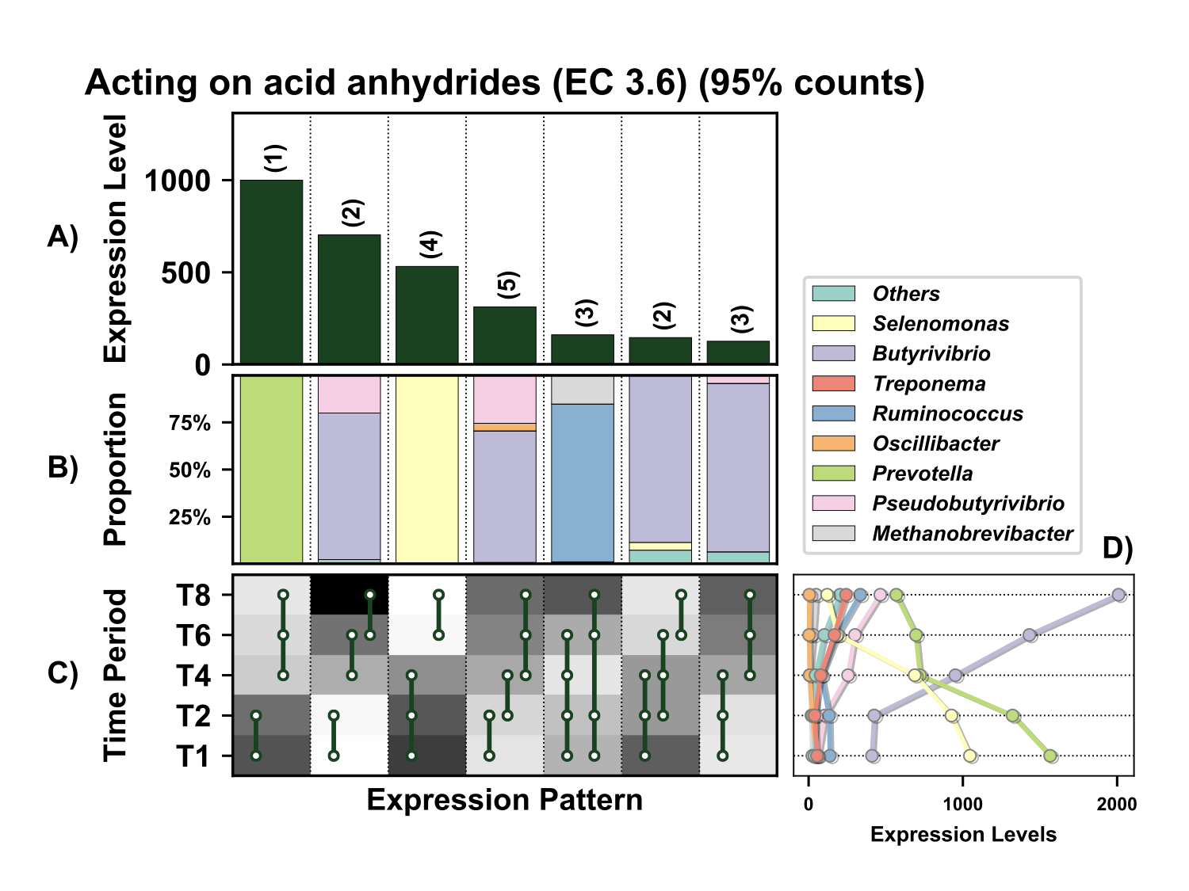

Supplementary Figure 22. Temporal expression of the top 95% most highly expressed genes acting on acid anhydrides (EC 3.6) with a significant interaction with time expressed by prokaryotes attached to fresh perennial ryegrass incubated in situ within the rumen. Each column represents a set of genes that showed the same differential expression (DE) pattern (denoted as expression pattern on x axis). A) Summed expression of all genes with the same DE pattern, in brackets the number of genes with the same DE pattern. B) The proportion of taxonomic genera contributing to the expression level for each DE pattern. C) Visual representation of the DE patterns for each set of genes across the timepoints sampled; The heatmap represents the level of expression for each timepoint (Low = White, High = Black); The lines and dots represent the specific DE pattern shared by all genes in this set where the timepoints connected by line and dots were not significantly different from each other. D) The level of expression of genes acting on acid anhydrides across each timepoint.

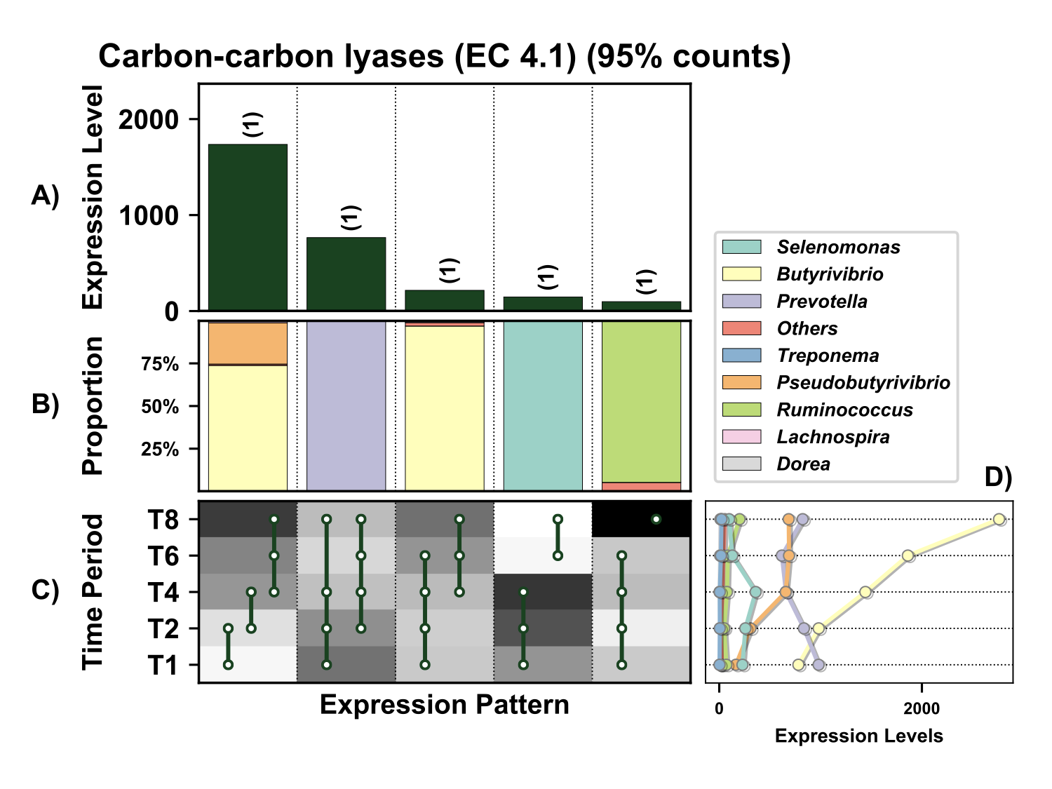

Supplementary Figure 23. Temporal expression of the top 95% most highly expressed genes acting on the carbon-carbon lyases (EC 4.1) with a significant interaction with time expressed by prokaryotes attached to fresh perennial ryegrass incubated in situ within the rumen. Each column represents a set of genes that showed the same differential expression (DE) pattern (denoted as expression pattern on x axis). A) Summed expression of all genes acting on the carbon-carbon lyases with the same DE pattern, in brackets the number of genes with the same DE pattern. B) The proportion of taxonomic genera contributing to the expression level for each DE pattern. C) Visual representation of the DE patterns for each set of genes across the timepoints sampled; The heatmap represents the level of expression for each timepoint (Low = White, High = Black); The lines and dots represent the specific DE pattern shared by all genes in this set where the timepoints connected by line and dots were not significantly different from each other. D) The level of expression of genes acting on the carbon-carbon lyases across each timepoint.

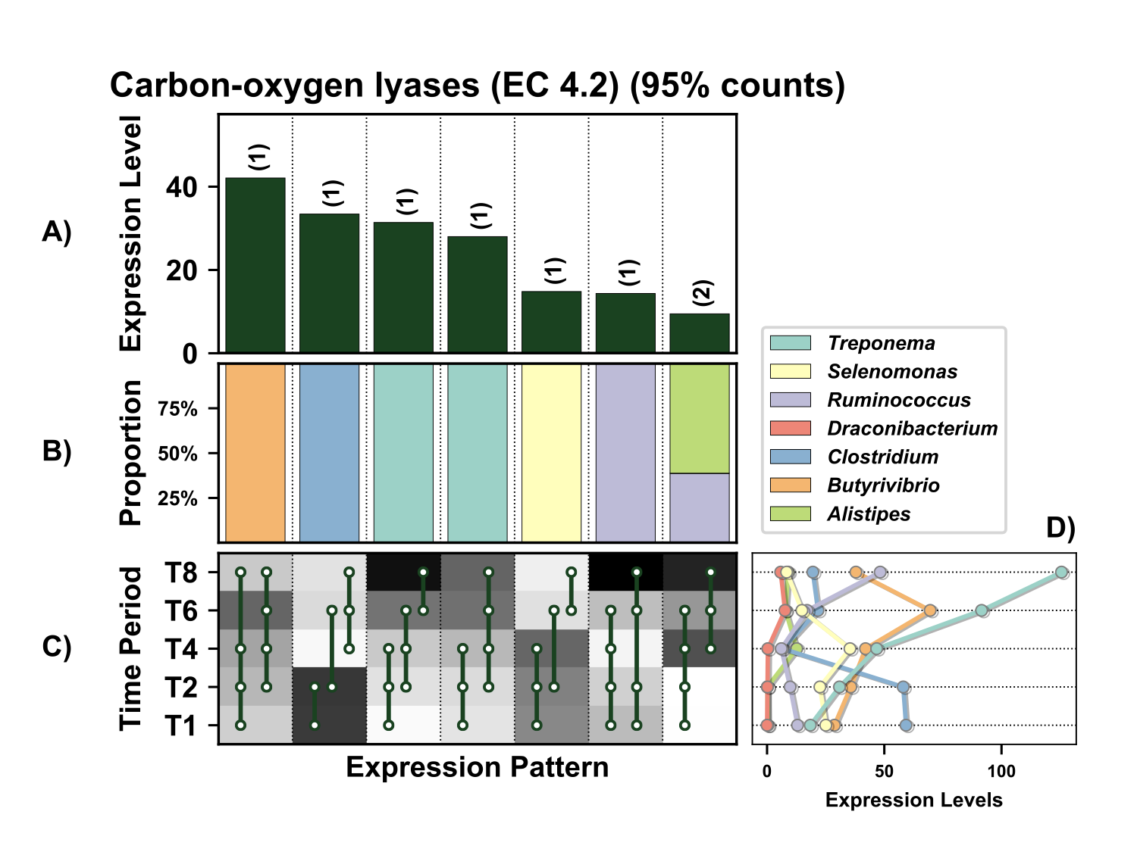

Supplementary Figure 24. Temporal expression of the top 95% most highly expressed carbon-oxygen lyases (EC 4.2) with a significant interaction with time expressed by prokaryotes attached to fresh perennial ryegrass incubated in situ within the rumen. Each column represents a set of genes that showed the same differential expression (DE) pattern (denoted as expression pattern on x axis). A) Summed expression of all genes with the same DE pattern, in brackets the number of genes with the same DE pattern. B) The proportion of taxonomic genera contributing to the expression level for each DE pattern. C) Visual representation of the DE patterns for each set of genes across the timepoints sampled; The heatmap represents the level of expression for each timepoint (Low = White, High = Black); The lines and dots represent the specific DE pattern shared by all genes in this set where the timepoints connected by line and dots were not significantly different from each other. D) The level of expression of carbon-oxygen lyases across each timepoint.

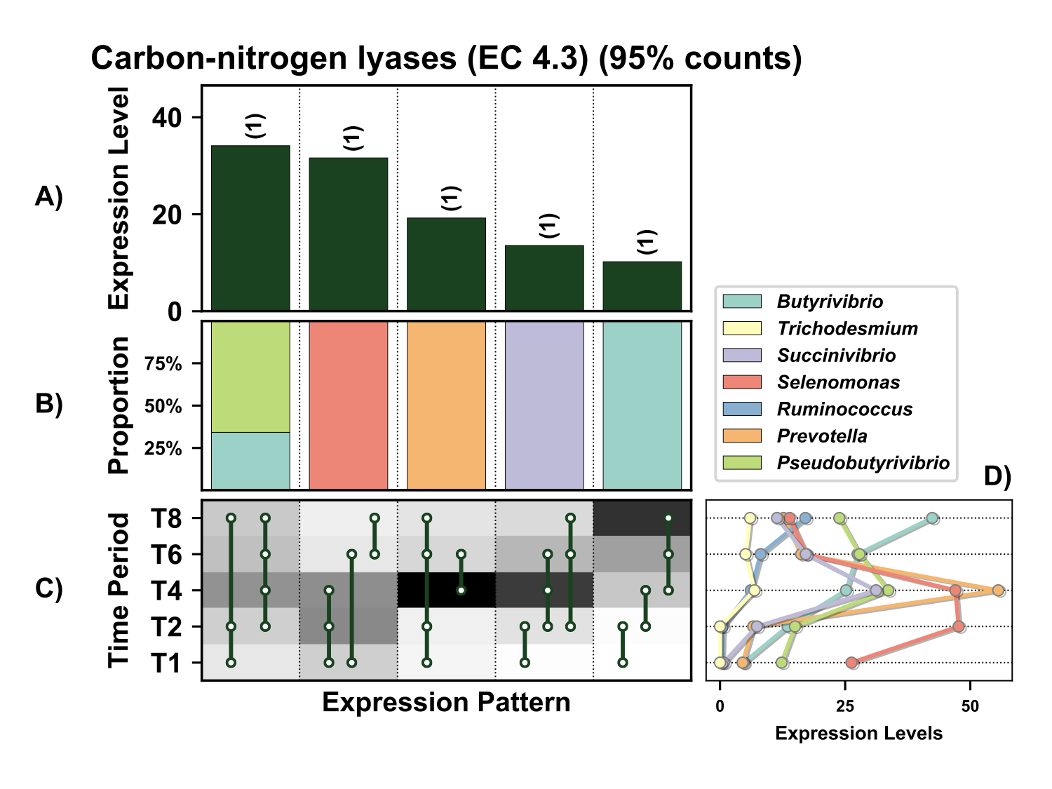

Supplementary Figure 25. Temporal expression of the top 95% most highly expressed carbon-nitrogen lyases (EC 4.3) with a significant interaction with time expressed by prokaryotes attached to fresh perennial ryegrass incubated in situ within the rumen. Each column represents a set of genes that showed the same differential expression (DE) pattern (denoted as expression pattern on x axis). A) Summed expression of all carbon-nitrogen lyases with the same DE pattern, in brackets the number of genes with the same DE pattern. B) The proportion of taxonomic genera contributing to the expression level for each DE pattern. C) Visual representation of the DE patterns for each set of genes across the timepoints sampled; The heatmap represents the level of expression for each timepoint (Low = White, High = Black); The lines and dots represent the specific DE pattern shared by all genes in this set where the timepoints connected by line and dots were not significantly different from each other. D) The level of expression of carbon-nitrogen lyases across each timepoint.

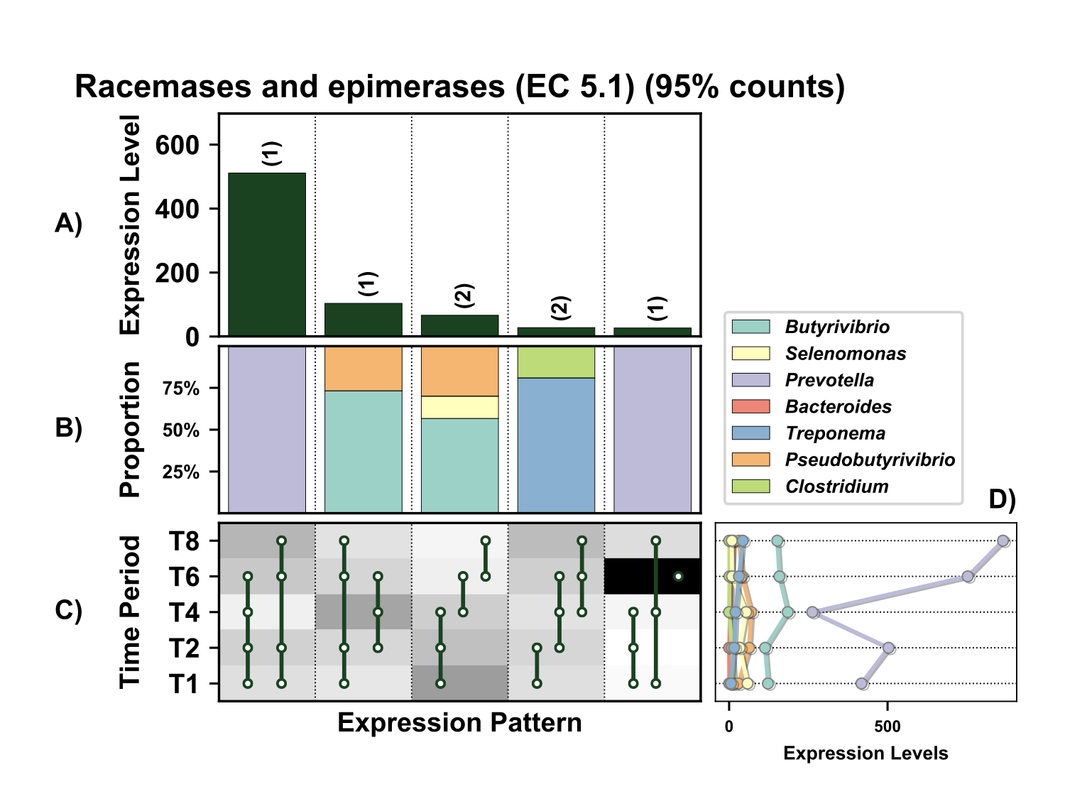

Supplementary Figure 26. Temporal expression of the top 95% most highly expressed racemases and epimerases (EC 5.1) with a significant interaction with time expressed by prokaryotes attached to fresh perennial ryegrass incubated in situ within the rumen. Each column represents a set of genes that showed the same differential expression (DE) pattern (denoted as expression pattern on x axis). A) Summed expression of all glycosylases with the same DE pattern, in brackets the number of genes with the same DE pattern. B) The proportion of taxonomic genera contributing to the expression level for each DE pattern. C) Visual representation of the DE patterns for each set of genes across the timepoints sampled; The heatmap represents the level of expression for each timepoint (Low = White, High = Black); The lines and dots represent the specific DE pattern shared by all genes in this set where the timepoints connected by line and dots were not significantly different from each other. D) The level of expression of racemases and epimerases across each timepoint.

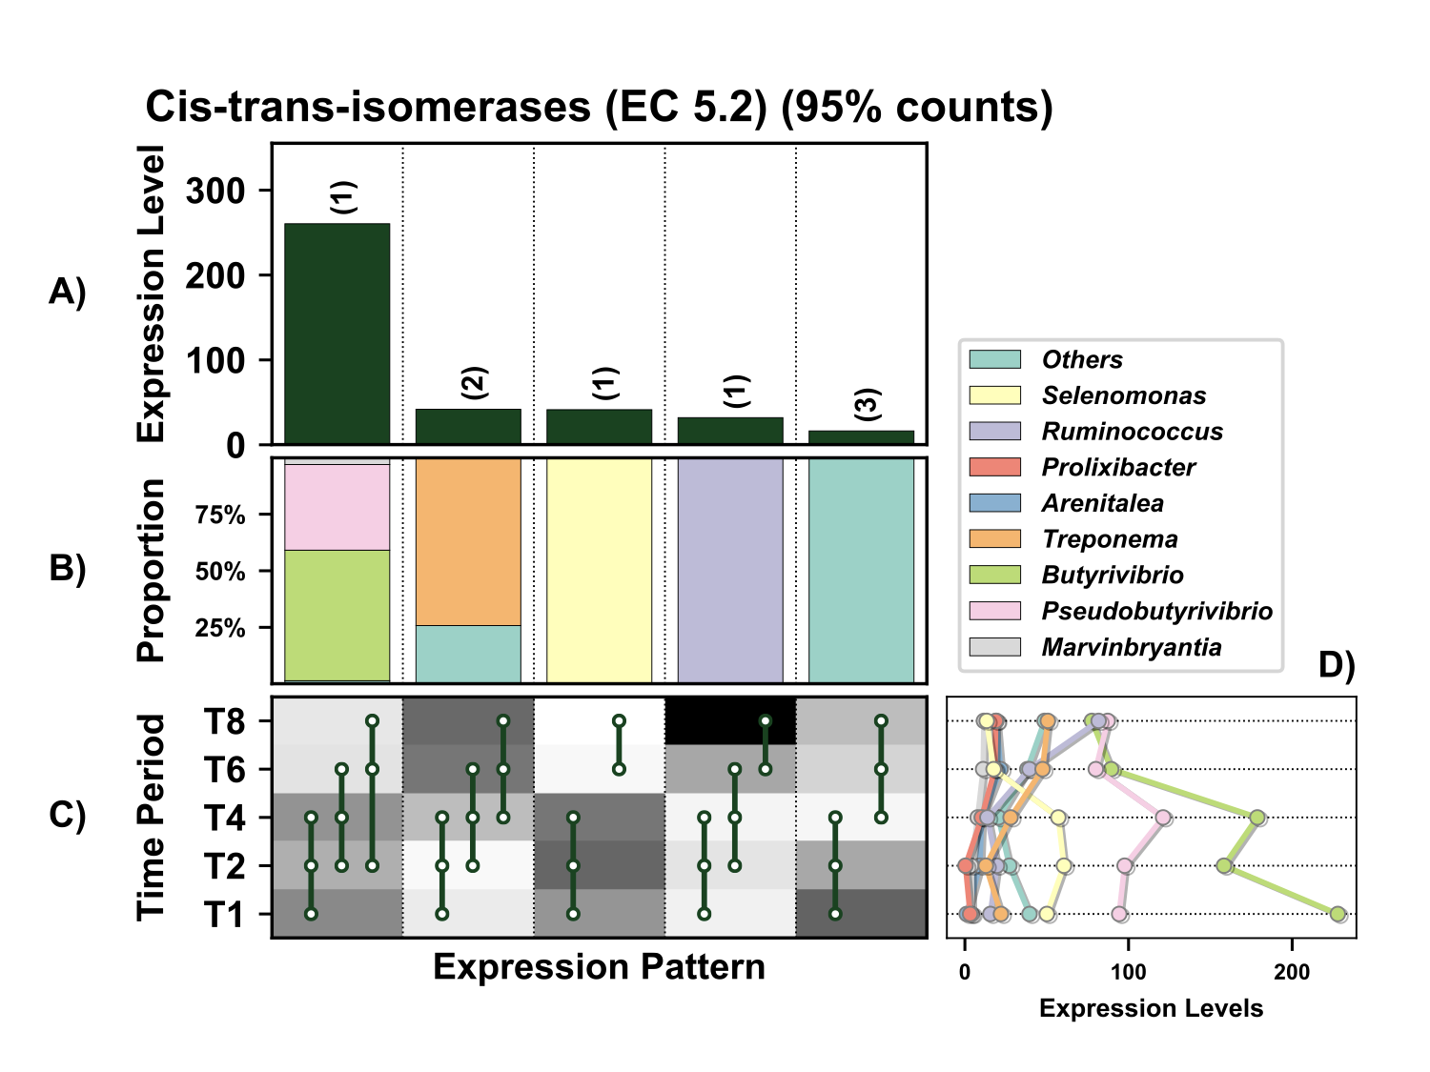
Figure 27. Temporal expression of the top 95% most highly expressed cis-trans-isomerase genes (EC 5.2) with a significant interaction with time expressed by prokaryotes attached to fresh perennial ryegrass incubated in situ within the rumen. Each column represents a set of genes that showed the same differential expression (DE) pattern (denoted as expression pattern on x axis). A) Summed expression of all cis-trans-isomerase genes with the same DE pattern, in brackets the number of genes with the same DE pattern. B) The proportion of taxonomic genera contributing to the expression level for each DE pattern. C) Visual representation of the DE patterns for each set of genes across the timepoints sampled; The heatmap represents the level of expression for each timepoint (Low = White, High = Black); The lines and dots represent the specific DE pattern shared by all genes in this set where the timepoints connected by line and dots were not significantly different from each other. D) The level of expression of cis-trans-isomerase genes across each timepoint.

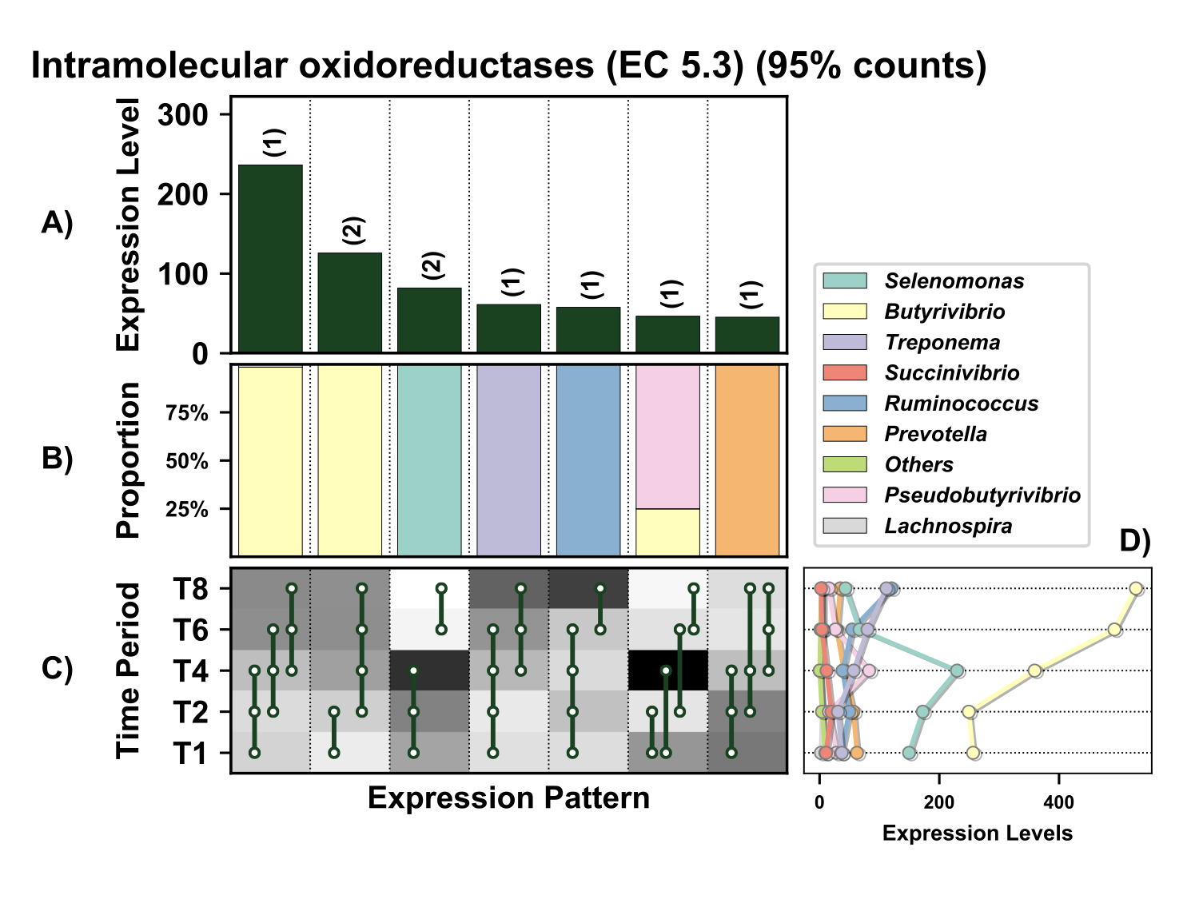

Supplementary Figure 28. Temporal expression of the top 95% most highly expressed intramolecular oxidoreductases (EC 5.3) with a significant interaction with time expressed by prokaryotes attached to fresh perennial ryegrass incubated in situ within the rumen. Each column represents a set of genes that showed the same differential expression (DE) pattern (denoted as expression pattern on x axis). A) Summed expression of all intramolecular oxidoreductases with the same DE pattern, in brackets the number of genes with the same DE pattern. B) The proportion of taxonomic genera contributing to the expression level for each DE pattern. C) Visual representation of the DE patterns for each set of genes across the timepoints sampled; The heatmap represents the level of expression for each timepoint (Low = White, High = Black); The lines and dots represent the specific DE pattern shared by all genes in this set where the timepoints connected by line and dots were not significantly different from each other. D) The level of expression of intramolecular oxidoreductases across each timepoint.

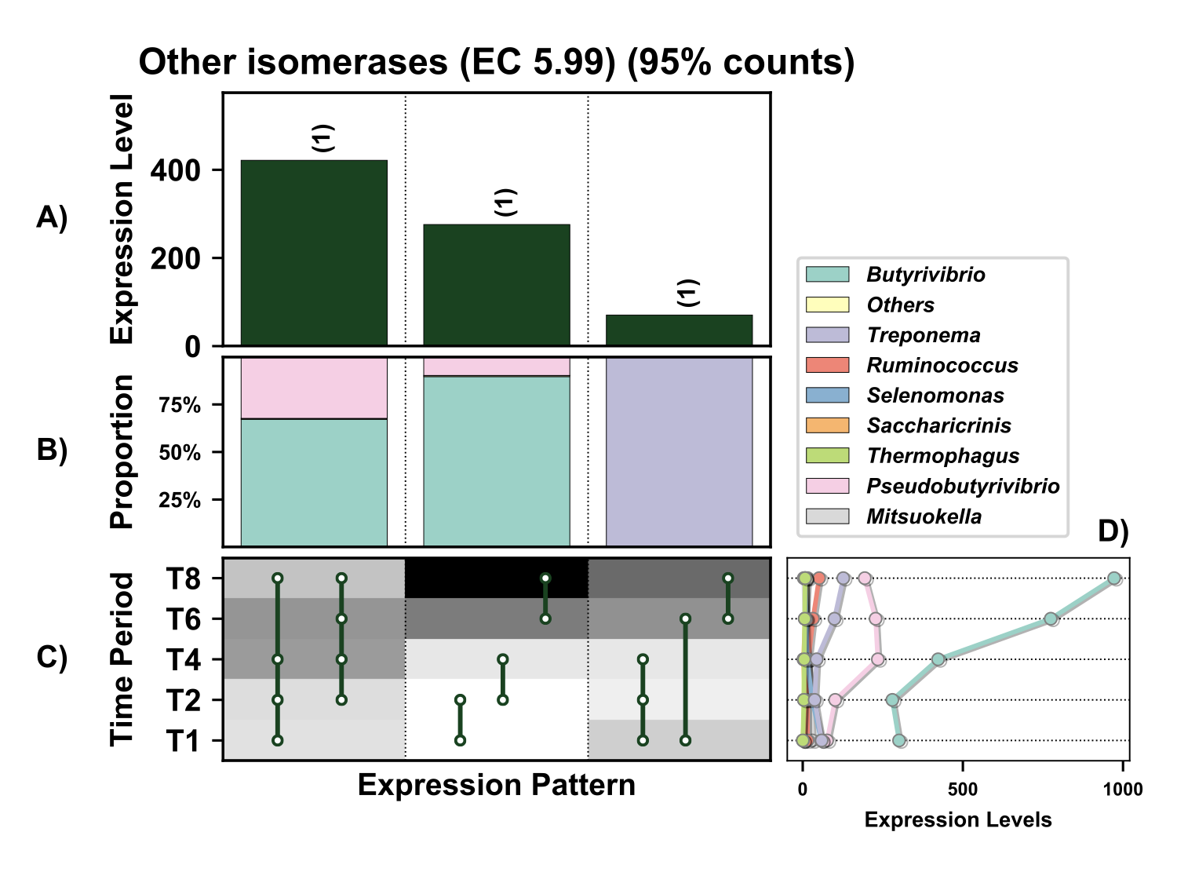

Supplementary Figure 29. Temporal expression of the top 95% most highly expressed other isomerases (EC 5.99) with a significant interaction with time expressed by prokaryotes attached to fresh perennial ryegrass incubated in situ within the rumen. Each column represents a set of genes that showed the same differential expression (DE) pattern (denoted as expression pattern on x axis). A) Summed expression of all other isomerases with the same DE pattern, in brackets the number of genes with the same DE pattern. B) The proportion of taxonomic genera contributing to the expression level for each DE pattern. C) Visual representation of the DE patterns for each set of genes across the timepoints sampled; The heatmap represents the level of expression for each timepoint (Low = White, High = Black); The lines and dots represent the specific DE pattern shared by all genes in this set where the timepoints connected by line and dots were not significantly different from each other. D) The level of expression other isomerases across each timepoint.

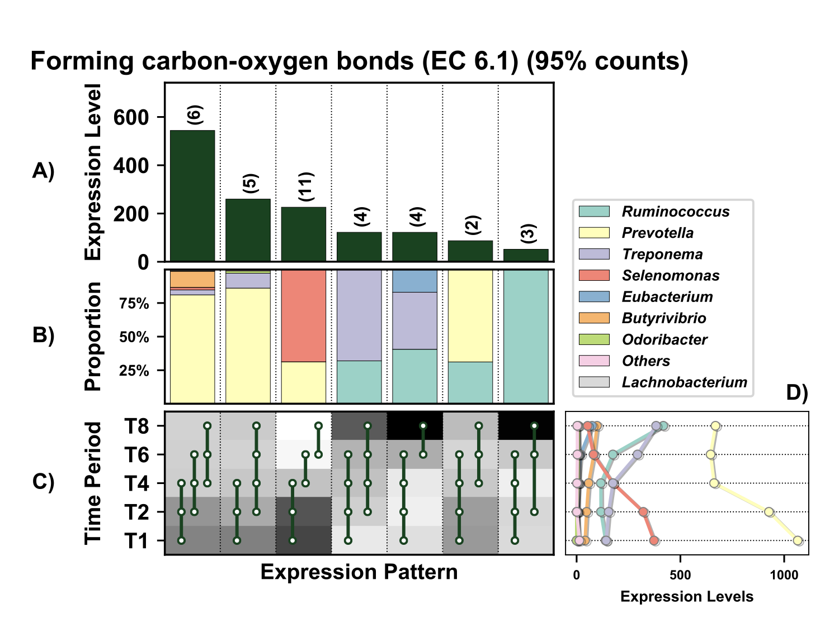

Supplementary Figure 30. Temporal expression of genes involved in formation of carbon-oxygen bonds (EC 6.1) within the top 95% of expressed by prokaryotes attached to fresh perennial ryegrass incubated in situ within the rumen. Each column represents a set of genes that showed the same differential expression (DE) pattern (denoted as expression pattern on x axis). A) Summed expression of all genes involved in formation of carbon-oxygen bonds with the same DE pattern, in brackets the number of genes with the same DE pattern. B) The proportion of taxonomic genera contributing to the expression level for each DE pattern. C) Visual representation of the DE patterns for each set of genes across the timepoints sampled; The heatmap represents the level of expression for each timepoint (Low = White, High = Black); The lines and dots represent the specific DE pattern shared by all genes in this set where the timepoints connected by line and dots were not significantly different from each other. D) The level of expression of genes involved in formation of carbon-oxygen bonds across each timepoint.

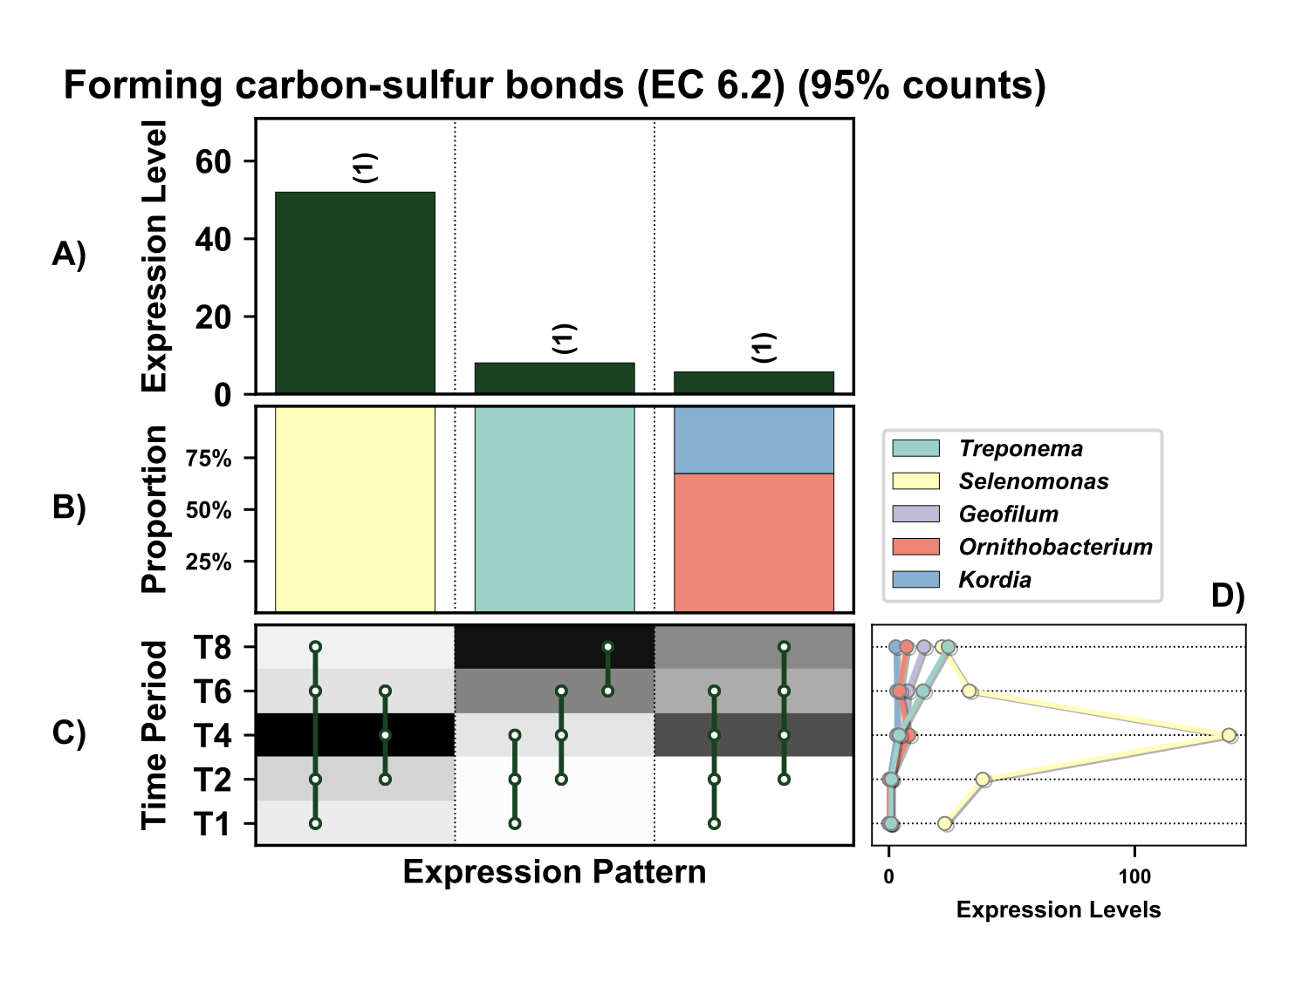

Supplementary Figure 31. Temporal expression of the top 95% most highly expressed genes involved in the formation of carbon-sulfur bonds (EC 6.2) with a significant interaction with time expressed by prokaryotes attached to fresh perennial ryegrass incubated in situ within the rumen. Each column represents a set of genes that showed the same differential expression (DE) pattern (denoted as expression pattern on x axis). A) Summed expression of all genes involved in the formation of carbon-sulfur bonds with the same DE pattern, in brackets the number of genes with the same DE pattern. B) The proportion of taxonomic genera contributing to the expression level for each DE pattern. C) Visual representation of the DE patterns for each set of genes across the timepoints sampled; The heatmap represents the level of expression for each timepoint (Low = White, High = Black); The lines and dots represent the specific DE pattern shared by all genes in this set where the timepoints connected by line and dots were not significantly different from each other. D) The level of expression of genes across each timepoint.
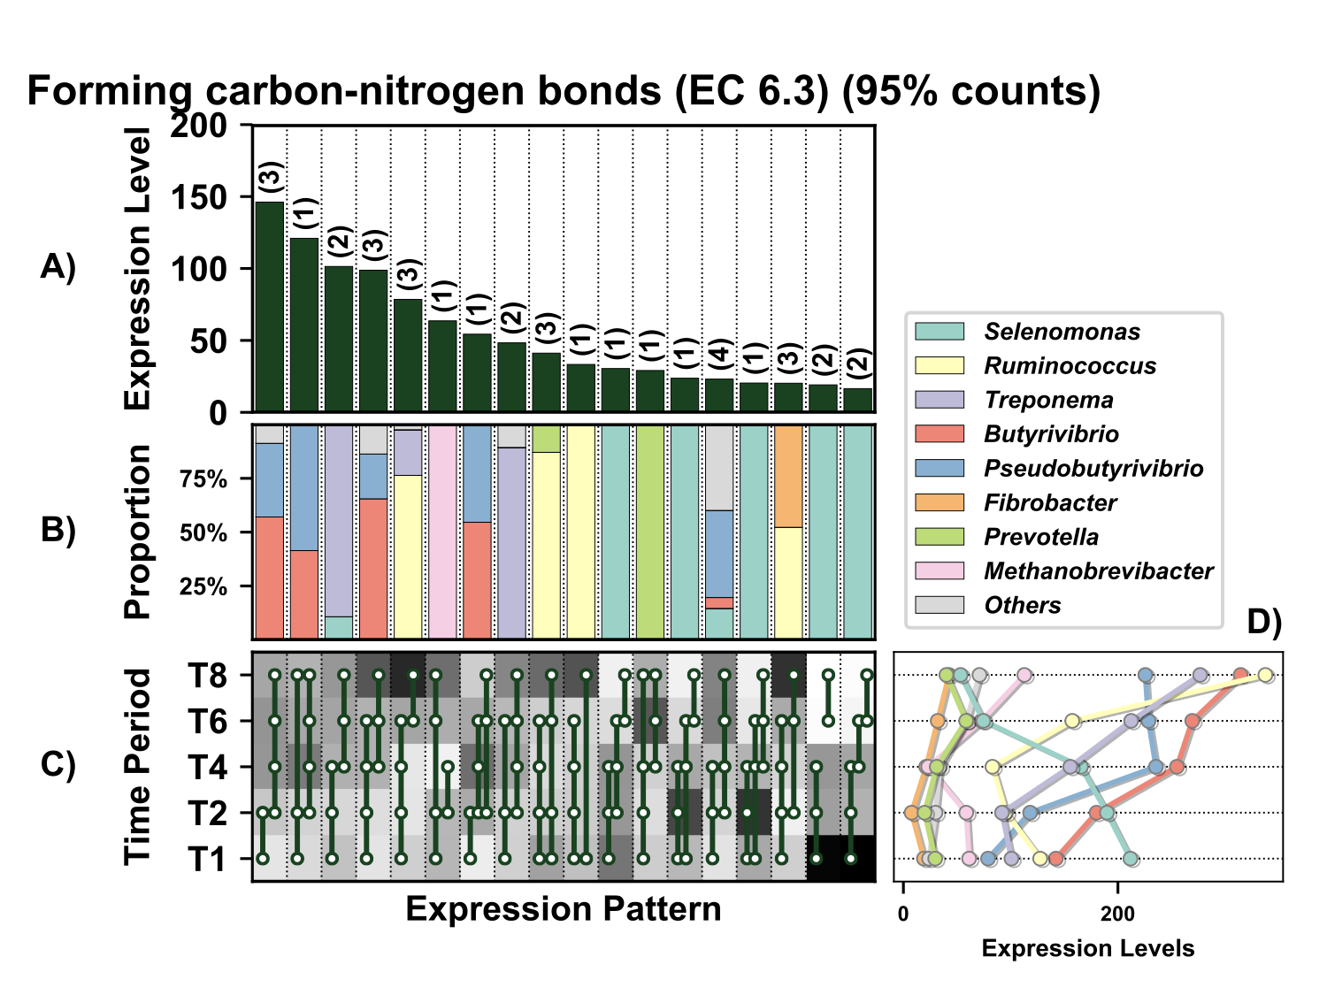

Supplementary Figure 32. Temporal expression of the top 95% most highly expressed genes involved in formation of carbon-nitrogen bonds (EC 6.3) with a significant interaction with time expressed by prokaryotes attached to fresh perennial ryegrass incubated in situ within the rumen. Each column represents a set of genes that showed the same differential expression (DE) pattern (denoted as expression pattern on x axis). A) Summed expression of all glycosylases with the same DE pattern, in brackets the number of genes with the same DE pattern. B) The proportion of taxonomic genera contributing to the expression level for each DE pattern. C) Visual representation of the DE patterns for each set of genes across the timepoints sampled; The heatmap represents the level of expression for each timepoint (Low = White, High = Black); The lines and dots represent the specific DE pattern shared by all genes in this set where the timepoints connected by line and dots were not significantly different from each other. D) The level of expression of genes involved in formation of carbon-nitrogen bonds across each timepoint.

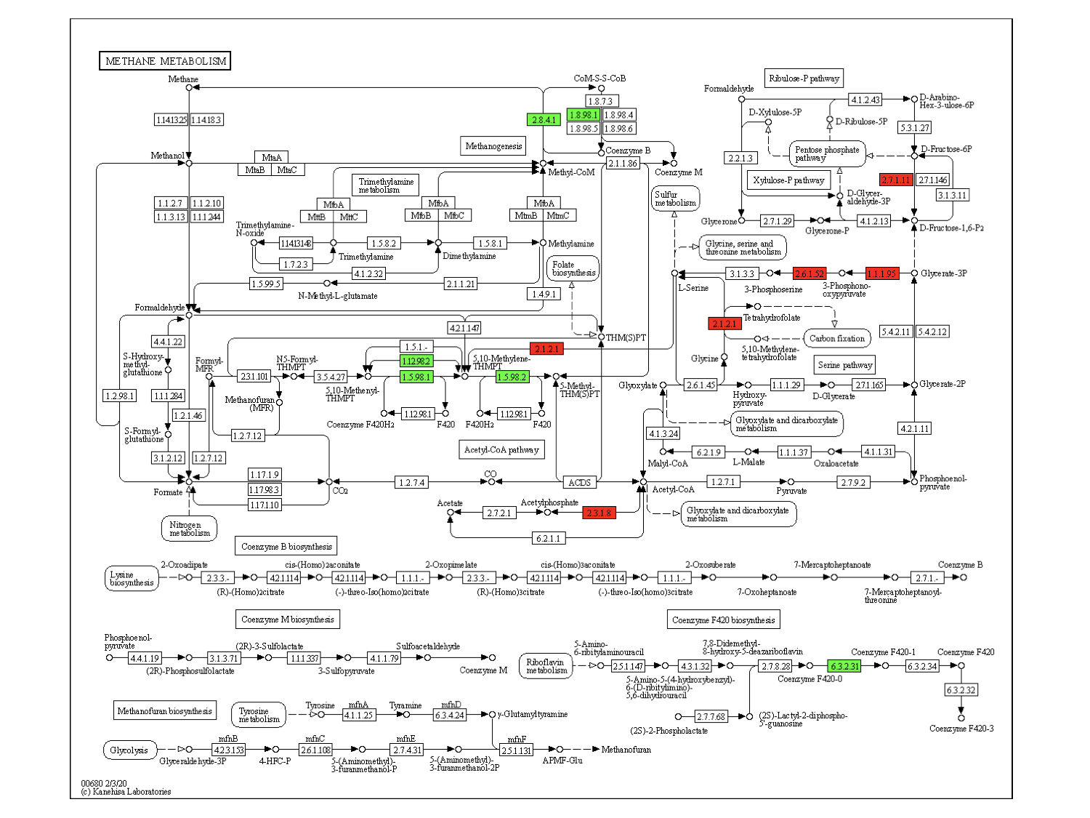

Supplementary Figure 33. Enzyme classifications involved in the KEGG methane metabolism pathway that contribute to data presented in Figure 3. The genera Methanobrevibacter (green) and Butyrivibrio (red) were dominated in terms of methane metabolism.

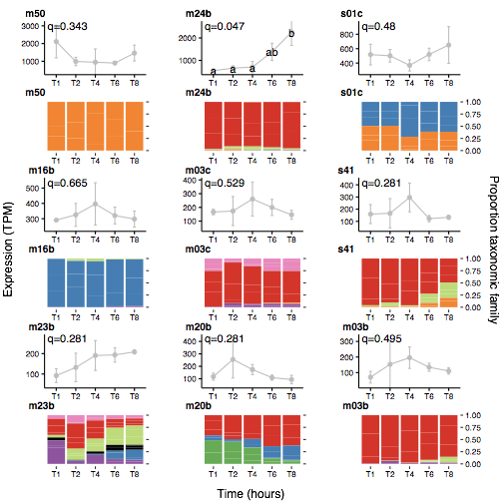
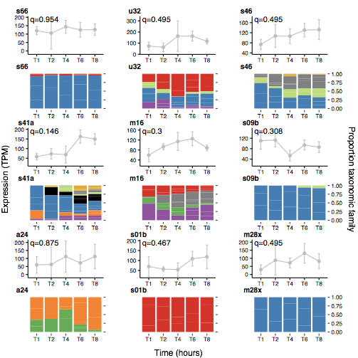

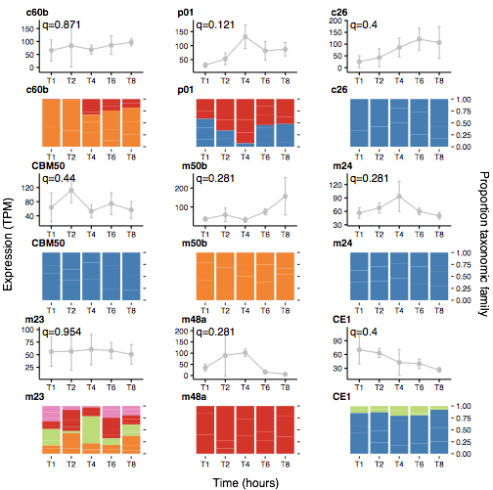
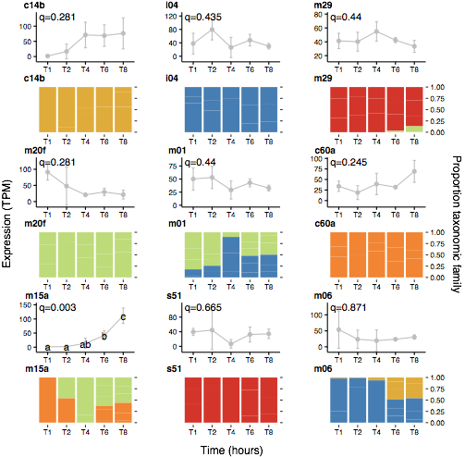
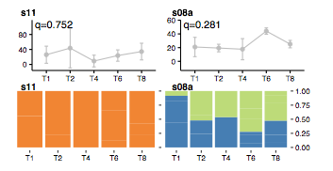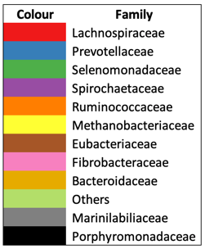
Time(hours)
Supplementary Figure 34. Temporal expression of all peptidases within the top 95% of expressed genes by perennial ryegrass attached bacteria within the rumen (Top figure) and their taxonomic origins (Figure below expression data).

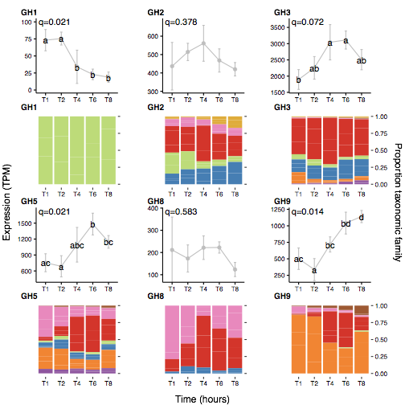
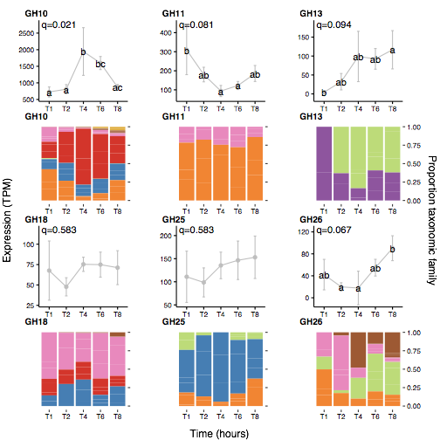

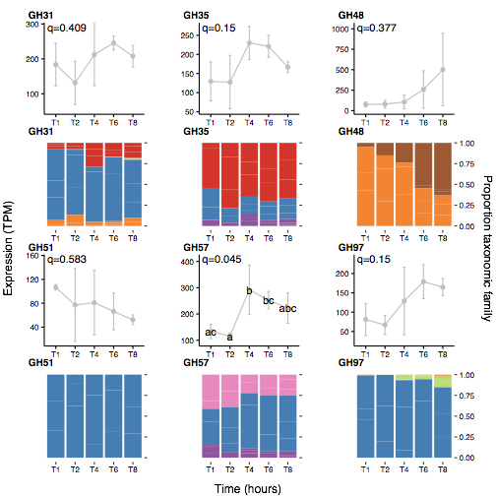

Supplementary Figure 35. Temporal expression of all carbohydrate active enzymes (CAZYmes also known as glycosyl hydrolases (GHs)) within the top 95% of expressed genes by perennial ryegrass attached bacteria within the rumen (Top figure) and their taxonomic origins (Figure below expression data).

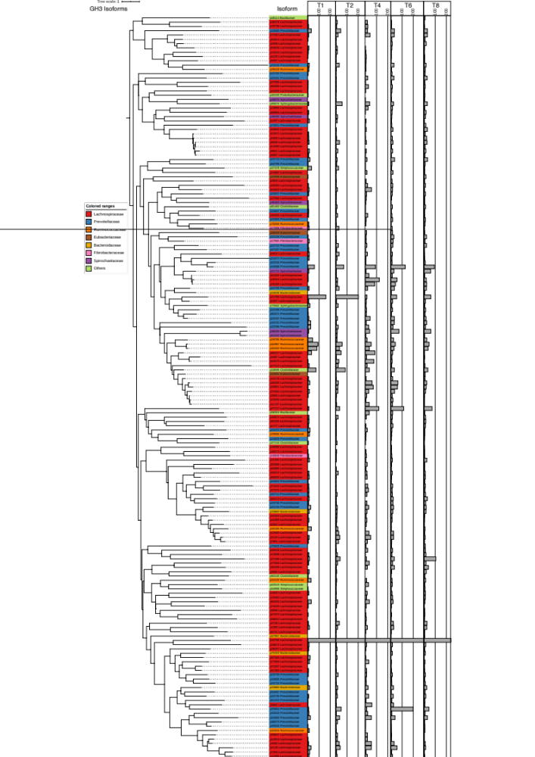

Supplementary Figure 36. Phylogenetic relationships and temporal expression of glycosyl hydrolase family 3 isoforms and their associated taxonomic origins.

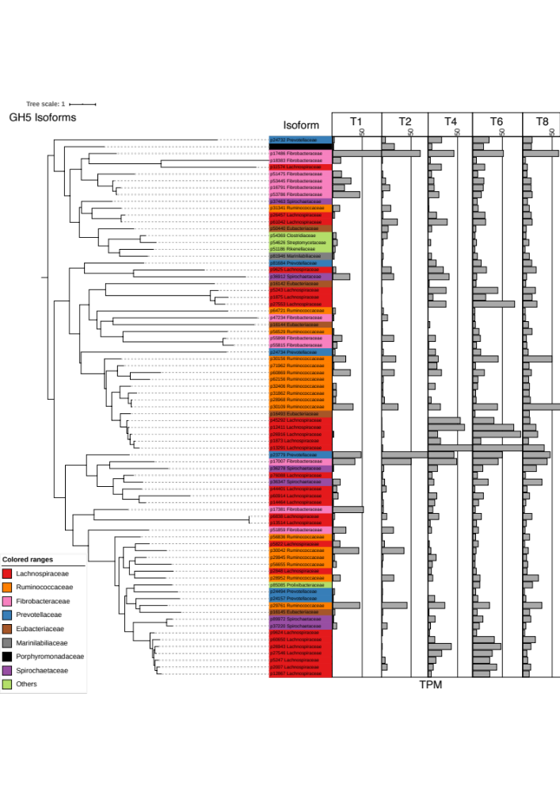
Supplementary Figure 37. Phylogenetic relationships and temporal expression of glycosyl hydrolase family 5 isoforms and their taxonomic origins.

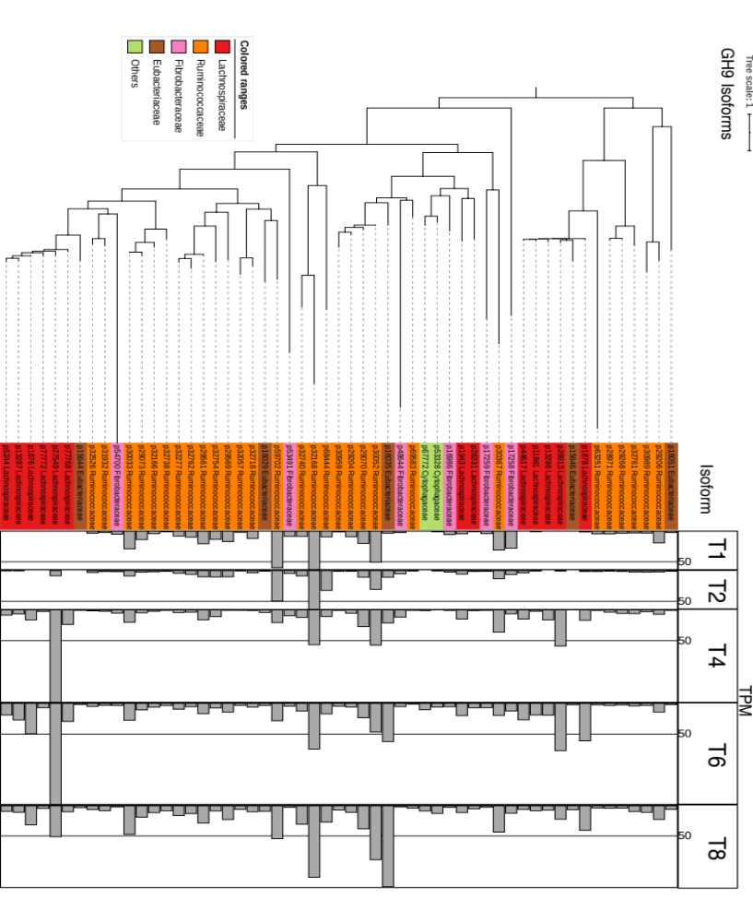

Supplementary Figure 38. Phylogenetic relationships and temporal expression of glycosyl hydrolase family 9 isoforms and their taxonomic origins.

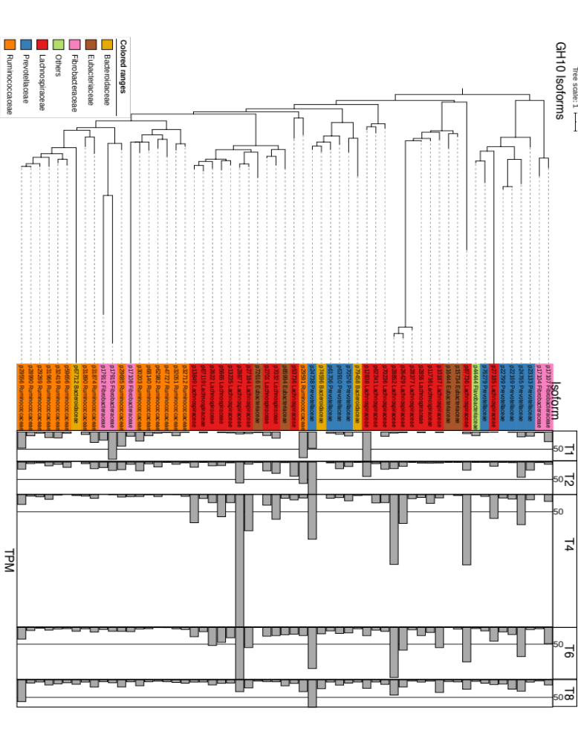

Supplementary Figure 39. Phylogenetic relationships and temporal expression of glycosyl hydrolase family 10 isoforms and their taxonomic origins.

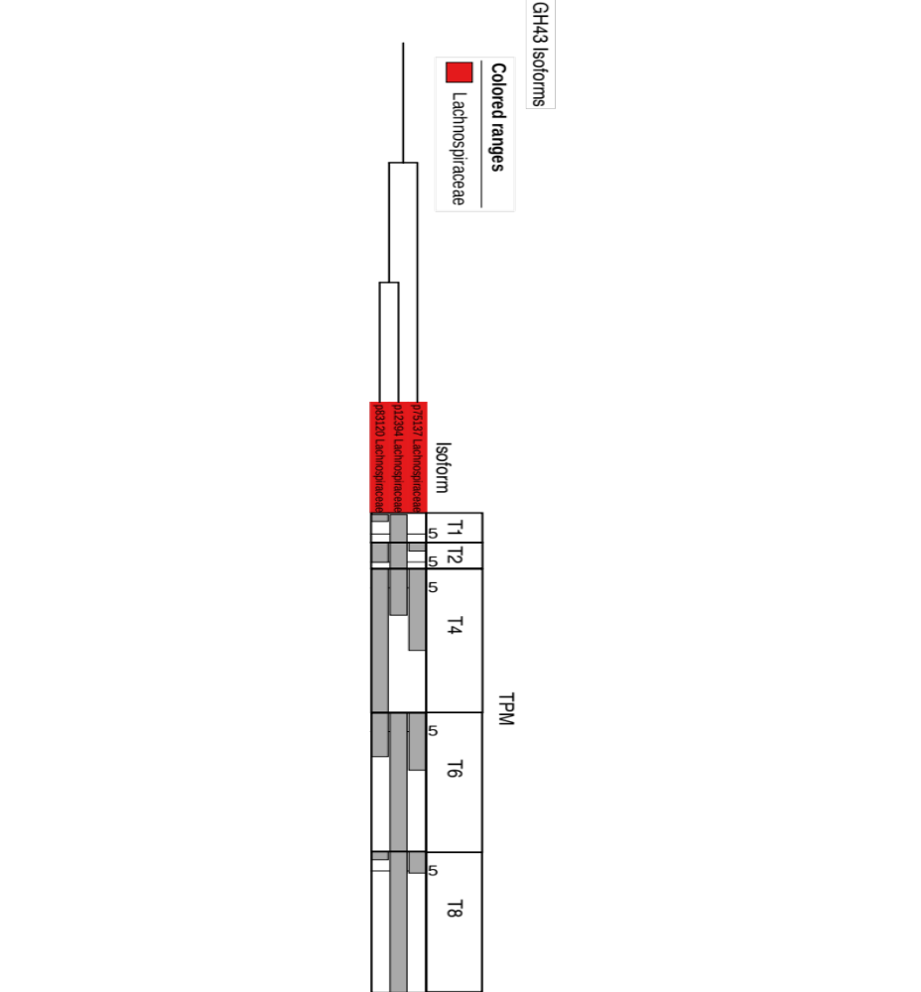
Supplementary Figure 40. Phylogenetic relationships and temporal expression of glycosyl hydrolase family 43 isoforms and their taxonomic origins.

