Transient increase in atherosclerotic plaque macrophage content following Streptococcus pneumoniae pneumonia – Supplementary data

Supplementary figures

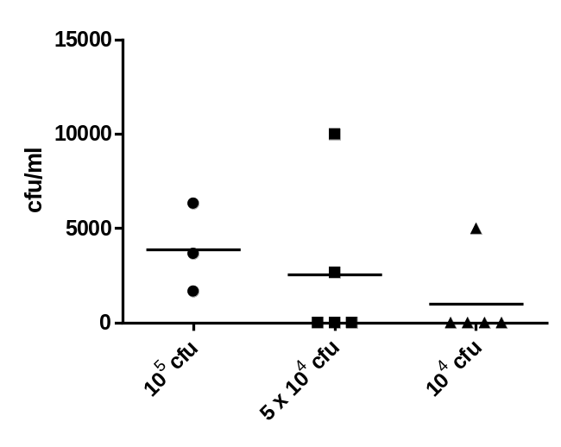
Supplementary Figure 1. Blood viable bacterial counts in male, Western diet fed ApoE^{-/-} mice 24 hours after intranasal instillation of serotype 4 S. pneumoniae. Bacteria in blood following infection with 10⁵, 5 x 10⁴ or 10⁴ cfu serotype 4 pneumococci demonstrating consistent bacteremia following the 10⁵ cfu dose (n=3-5).

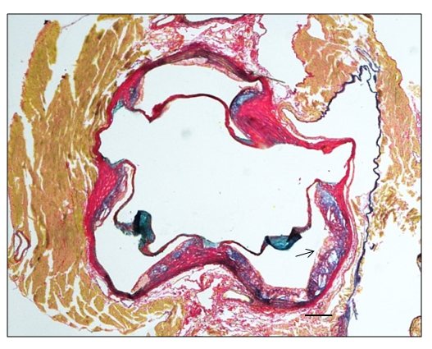
Supplementary Figure 2. Aortic sinus following 8 weeks of Western diet feeding. Representative image of Miller’s Elastin/Modified Van Gieson stained aortic sinus section from a male ApoE^{-/-} mouse fed Western diet for 8 wks. Arrow points to advanced atheromatous lesion. (x40 magnification, scale bar 100 µm).

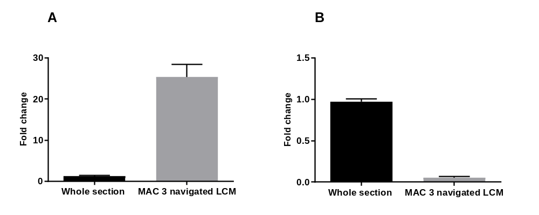
Supplementary Figure 3. Enrichment of lesion macrophage RNA following LCM
qPCR analysis comparing expression of macrophage-specific marker CD68 (A) and smooth muscle marker ACTA2 (B) in LCM isolated plaque macrophage RNA compared with RNA extracted from whole aortic sinus sections (normalised to cyclophilin A), n=4.

Supplementary methods
Immunohistochemistry
Aortic sinus sections were dewaxed in xylene, before rehydration through graded alcohols to water. Endogenous peroxidases were blocked with hydrogen peroxide (30% v/v; Sigma-Aldrich, UK) and sections were then incubated in a solution of 0.1% w/v milk buffer (commercially available Marvel skimmed milk powder) in PBS for 30 minutes to block non-specific binding of the secondary antibody. An antigen retrieval step was performed if necessary, after which sections were incubated with primary antibody overnight at 4°C or for 1 hour at room temperature. Binding of the primary antibody to the target antigen was identified indirectly by incubating sections with biotinylated secondary antibody (1:200 dilution in PBS) for 30 minutes at room temperature, followed by avidin-biotinylated enzyme complexes with horseradish peroxidase (HRP) (Vectastain ABC-HRP kit , Vector Labs, UK) and finally the HRP substrate SigmaFAS 3,3′- diaminobenzidine tetrahydrochloride (DAB) (Sigma-Aldrich). Sections were counterstained with Carazzi’s haematoxylin, dehydrated through graded alcohols into xylene and finally mounted under coverslips with DPX. Antibodies used for immunohistochemistry are summarised in Supplementary Table 1.

Primary antibody | Secondary antibody | Antigen retrieval | Dilution | Incubation
MAC-3 (rat anti- mouse; BD Biosciences 553322) | Biotinylated anti-rat IgG (Vector Laboratories BA-9400) | Citrate buffer | 1:500 | Overnight at 4°C
α-smooth muscle actin (mouse monoclonal anti-human M0851, Dako) | Biotinylated anti-mouse IgG (Vector Laboratories BA-9200) | None | 1:150 | 1 hour at RT
Ki67 (rabbit monoclonal, Abcam, ab1667) | Biotinylated anti-rabbit IgG (Vector Laboratories BA-1000) | Citrate buffer | 1:200 | Overnight at 4°C

Supplementary Table 1. Antibodies used for immunohistochemistry.

MAC-3 immunostaining of cryo-sections
Immunohistochemical staining for the macrophage marker MAC-3 was performed on every 5th aortic sinus cryo-section to be used as guide slides to direct LCM of plaque macrophages on the remaining Toluidine blue stained cryo-sections. Sections were fixed in ice cold acetone for 10 minutes, then rinsed in 3 changes of PBS followed by incubation for 10 minutes with Bloxall (Vector Laboratories, UK), an endogenous peroxidase and alkaline phosphatase blocking solution, before rinsing again in 3 changes of PBS. Slides were incubated in 4% v/v rabbit serum (Vector Laboratories) in PBS for 15 minutes then incubated in primary antibody (rat anti-mouse MAC-3 (BD Biosciences 550292) 1:200 dilution in 4% rabbit serum) for 1 hour at room temperature, then rinsed in 3 changes of PBS. Sections were incubated in secondary antibody (biotinylated rabbit anti-rat IgG mouse adsorbed antibody (Vector Laboratories, BA-4001) 1:200 dilution in 4% rabbit serum) for 15 minutes, followed by Vectastain ABC-HRP and then DAB before counterstaining with Carazzi’s haematoxylin and dehydration through graded alcohols into xylene and finally mounted under coverslips with DPX.

Gene | Primer (Life Technologies, UK)
18S | Mm03928990_g1
Ppia (Cyclophilin A) | Mm02342430_g1
CD68 | Mm03047343_m1
Acta 2 (smooth muscle actin) | Mm01204962_gH
Itch | Mm00492683_m1
Anapc1 | Mm01336123_m1
Huwe1 | Mm00615533_m1

Supplementary Table 2. mRNA qPCR assay primers

Affymetrix probe  ID | Gene Symbol | Log2 Fold change | p value | Gene name
17484100 | zinc finger, RAN-binding domain containing 1 | -1.85063 | 0.004772 | Zranb1
17391480 | anaphase promoting complex subunit 1 | -1.8085 | 0.009954 | Anapc1
17538773 | HECT, UBA and WWE domain containing 1 | -1.77086 | 0.008573 | Huwe1
17359961 | golgi-specific brefeldin A-resistance factor 1 | -1.68328 | 0.005597 | Gbf1
17221250 | ADP-ribosylation factor guanine nucleotide-exchange factor 1(brefeldin A-inhibited) | 1.642493 | 0.001327 | Arfgef1
17300371 | predicted gene 20521 | -1.61363 | 0.018606 | Gm20521
17300185 | olfactory receptor 204 | -1.58533 | 0.019681 | Olfr204
17221233 | ADP-ribosylation factor guanine nucleotide-exchange factor 1(brefeldin A-inhibited) | 1.554567 | 0.025784 | Arfgef1
17378318 | itchy, E3 ubiquitin protein ligase | -1.48962 | 0.006535 | Itch
17206483 | small nucleolar RNA, H/ACA box 28 | -1.48322 | 0.016768 | Snora28
17359926 | golgi-specific brefeldin A-resistance factor 1 | -1.47904 | 0.000368 | Gbf1
17324680 | discs, large homolog 1 (Drosophila) | -1.44446 | 0.00436 | Dlg1
17202517 | olfactory receptor 1313 | -1.42432 | 0.017611 | Olfr1313
17206727 | ankyrin repeat domain 17 | -1.35285 | 0.008902 | Ankrd17
17290927 | zinc finger with KRAB and SCAN domains 3 | -1.33248 | 0.005763 | Zkscan3
17359948 | golgi-specific brefeldin A-resistance factor 1 | -1.32392 | 0.02368 | Gbf1
17308472 | exportin 7 | 1.301569 | 0.003501 | Xpo7
17219478 | coatomer protein complex subunit alpha | -1.28481 | 0.014817 | Copa
17200103 | coatomer protein complex, subunit gamma 1 | 1.269288 | 0.008141 | Copg1
17449547 | ankyrin repeat domain 17 | -1.23804 | 0.032238 | Ankrd17
17403846 | vomeronasal 1 receptor 12 | -1.22049 | 0.018813 | Vmn1r12
17458948 | olfactory receptor 1504 | -1.21671 | 0.005725 | Olfr1504
17202979 | olfactory receptor 1135 | 1.194902 | 0.009684 | Olfr1135
17221253 | ADP-ribosylation factor guanine nucleotide-exchange factor 1(brefeldin A-inhibited) | -1.18669 | 0.013091 | Arfgef1
17341696 | 3-phosphoinositide dependent protein kinase 1 | -1.17206 | 0.000454 | Pdpk1
17348452 | RIO kinase 3 | -1.1686 | 0.007253 | Riok3
17484102 | zinc finger, RAN-binding domain containing 1 | -1.16181 | 0.028292 | Zranb1
17202919 | calnexin | -1.1541 | 0.006838 | Canx
17220754 | angel homolog 2 (Drosophila) | -1.13319 | 0.030408 | Angel2
17391446 | anaphase promoting complex subunit 1 | -1.13013 | 0.013971 | Anapc1
17308463 | exportin 7 | -1.11946 | 0.040084 | Xpo7
17207455 | apolipoprotein L 7c | 1.111031 | 0.030042 | Apol7c
17219451 | coatomer protein complex subunit alpha | -1.05955 | 0.042363 | Copa
17359958 | golgi-specific brefeldin A-resistance factor 1 | -1.02617 | 0.014976 | Gbf1
17341704 | 3-phosphoinositide dependent protein kinase 1 | 1.02562 | 0.003371 | Pdpk1
17238667 | C-type lectin domain family 4, member e | -1.00679 | 0.006966 | Clec4e

Supplementary Table 3. Differentially expressed genes (unpaired t test <0.05) in plaque macrophages in S. pneumoniae infected mice as compared to mock infected mice.

KEGG category | KEGG subcategory | KEGG pathway | Adjusted p value | Genes
Genetic Information processing | Folding, sorting and degradation | Ubiquitin mediated proteolysis | 0.011337 | Anapc1, Huwe1, Itch
Cellular processes | Transport and catabolism | Endocytosis | 0.030526 | Anapc1, Huwe1, Itch
Human diseases | Infectious diseases:viral | HTLV-I infection | 0.030526 | Canx, Dlg1, Anapc1

Supplementary Table 4. KEGG pathways, and their categories, altered by pneumococcal infection in plaque macrophages.

