Table S1. The cis-acting elements present in the promoter region of the TaSRG
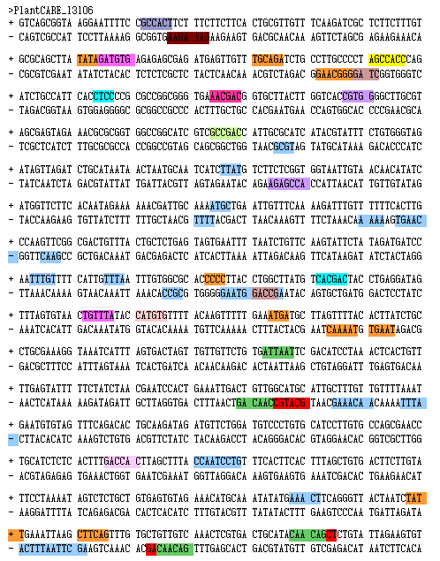

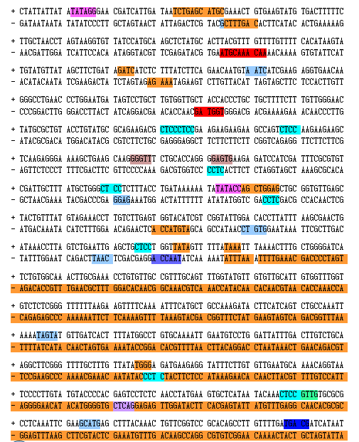

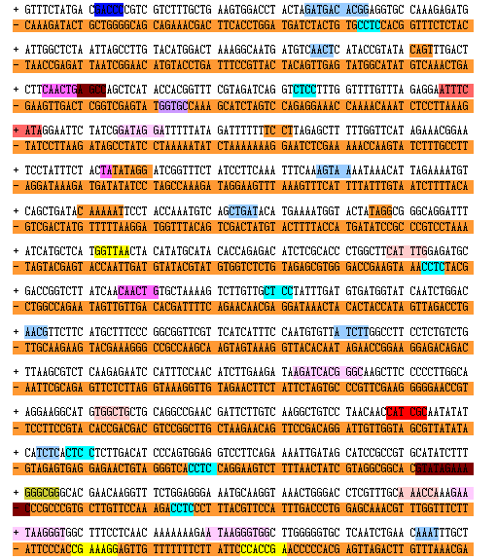

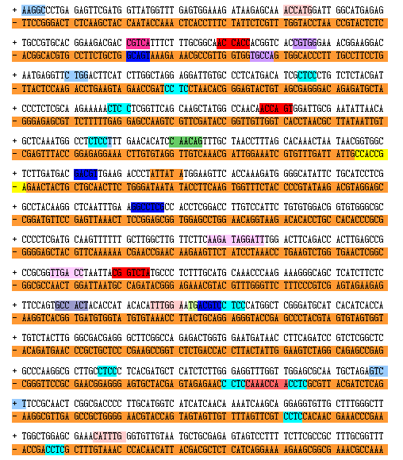

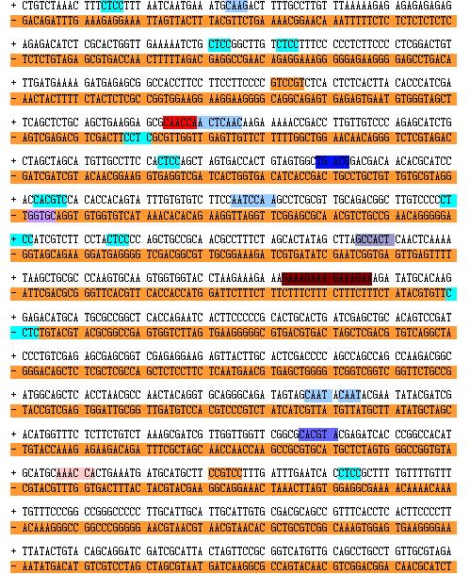

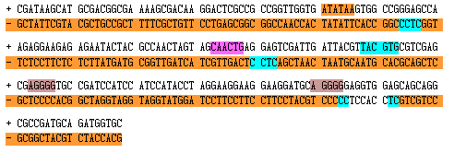
A Box AAGAA-motif ABRE ABRE3a ABRE4 ARE ATTATA-BOX BOX4 CAAT BOX CAT BOX CCAAT-BOX CCGTCC-motif
CCGTCC-Box CGTCA-motif DRE core DRE1 ERE1 GBOX
GATA-motif GC-repeat GT1- MOTİF MBS MYB MYB recognation site MYB-like sequence MYC MYB MYB binding site O2 site RY element STRE element SP1 TATA-box TGA element

Table S2. The cis-acting elements present in the promoter region of the TaCP
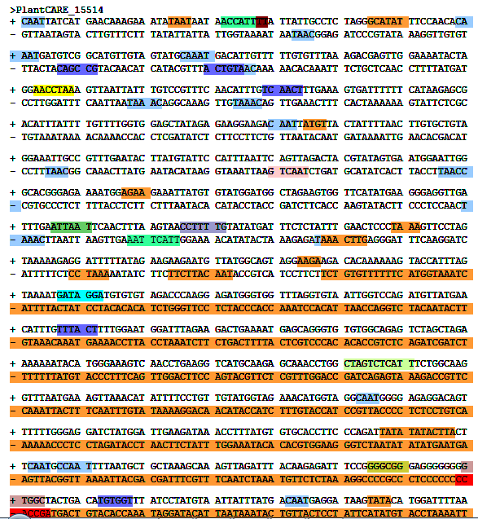

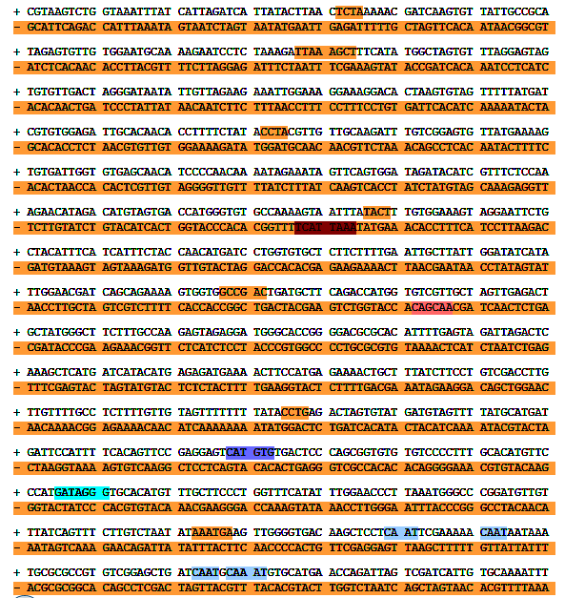

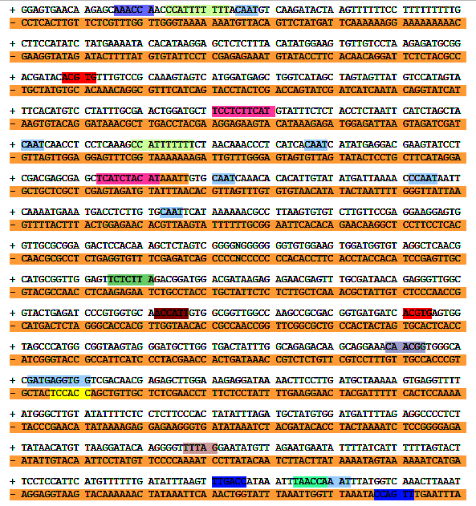

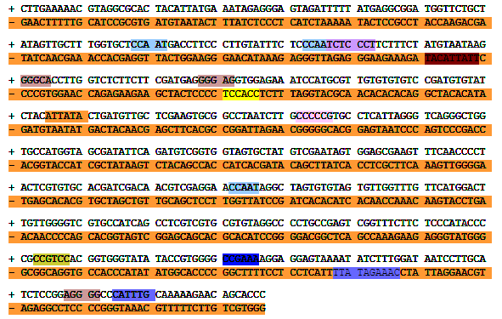

A Box AAGAA-motif ABRE ACE ARE ATCT-motif
ATTATABOX BOX4 CAAT BOX CCAAT BOX CCGTCC-motif
CCGTCC-box DRE core ERE F-box G-box G-box GATA-motif Gc-motif LTR MRE MYB MYB recognation site MYB-like sequence MYC Myb Myb binding siteMYC O2 site P-box STRE SP1 TATA-box TCATCA-element TCCC-motif TGA-element
W box WRE3WUN-motif box S chs-CMA1a circadian

Table S3. The cis-acting elements present in the promoter region of the Sal1

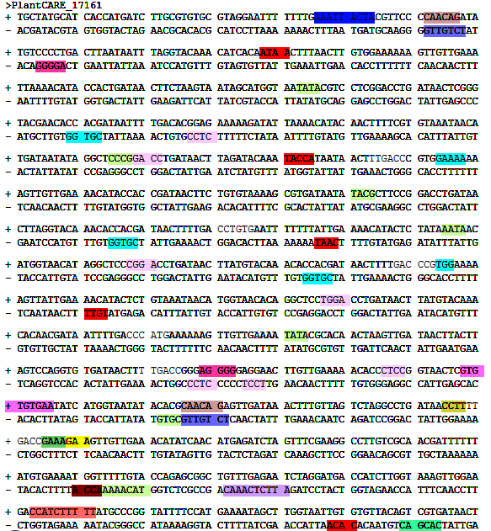

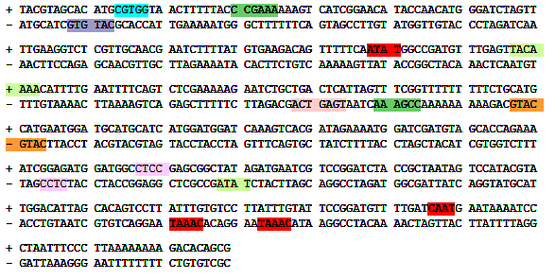
AAGAA-motif ARE CAAT-box G-box GARE-motif GCN4-motif
GT1-motif LTR MYB MYC Myb-binding site P-box RY-elemet STRE TATA-box TC- repeats TCA-element WUN-motif

Table S4. The cis-acting elements present in the promoter region of the Era1

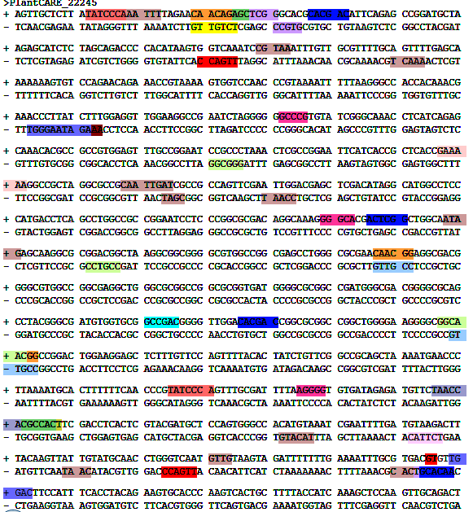

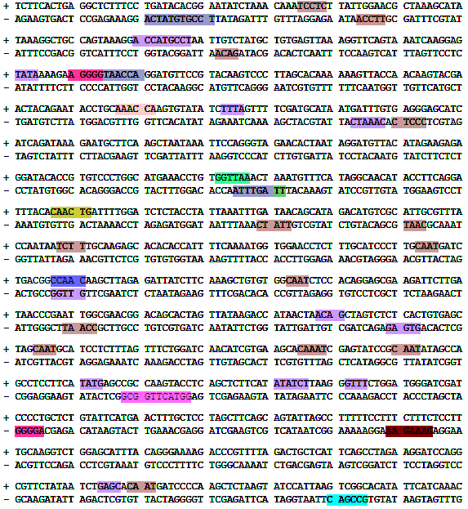

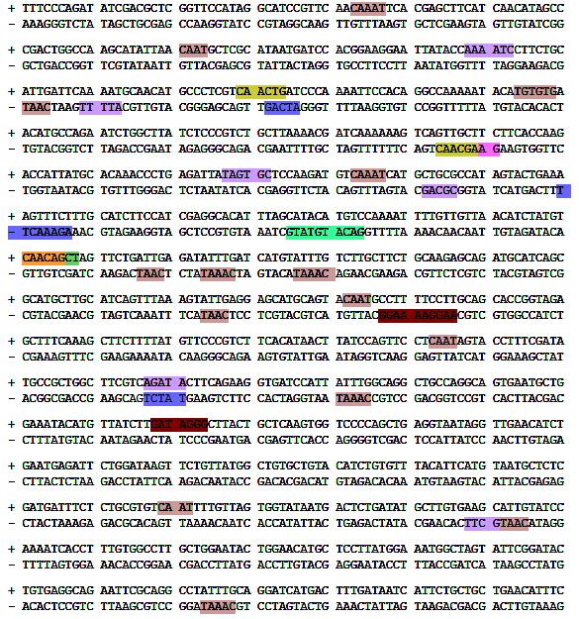

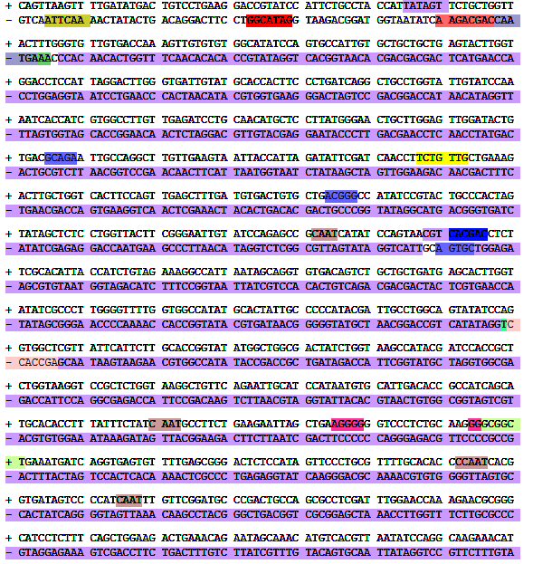

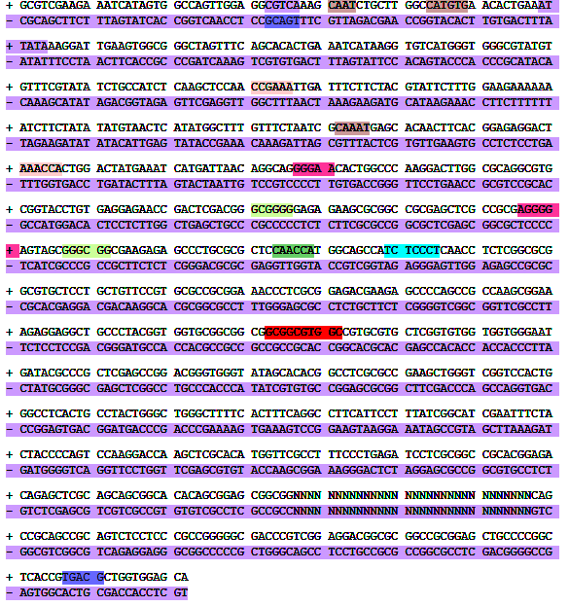

A Box AAGAA-motif ABRE ACE AE-box ARE AT-element
AT-TATA-box Box4 BoxII-like sequence CAAT-BOX CAT-box
CCAAT-box CCGTCC motif CCGTCC-box CGTCA-motif CTAG-motif DRE coreERE G-box GARE-motif GATA-motif GC-motif
GT1-motif I-box LTRMBS MYBMYB recognation site MYB-like sequence MYC Myb Myb-binding site STRE Sp1 TATA-box TATC-box TCCC-motif TCT-motif W box WRE3 as-1 box S motif I

Table S5. The cis-acting elements present in the promoter region of the TdPIP1

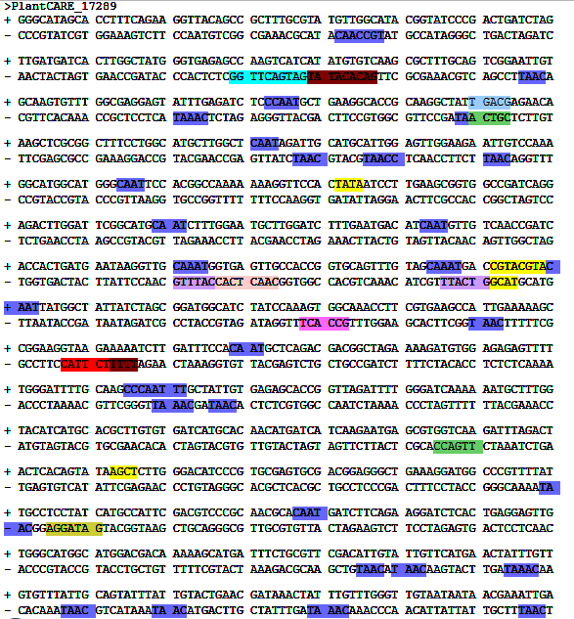

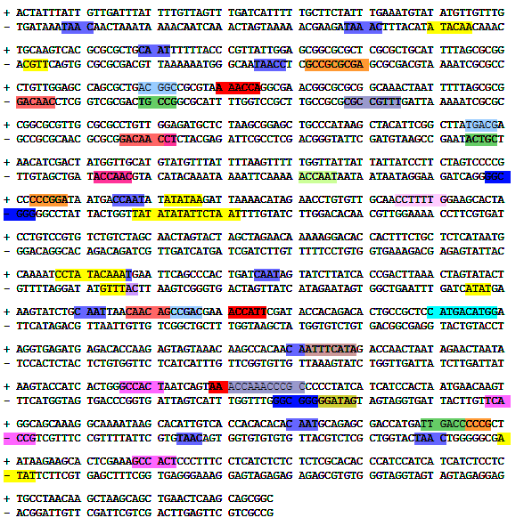
ABRE ACE ARE AT-TATA-box CAAT-box CARE CAT-box
CGTCA-motif DRE core E2Fb ERE GATA-motif GC-motif
MYB MYB- like sequenceMYC Myb-binding site O2 site
P-box Sp1 TATA-box TC-rich repeats TCT-motif TGACG-motif W boxas-1 chs-Unit 1

