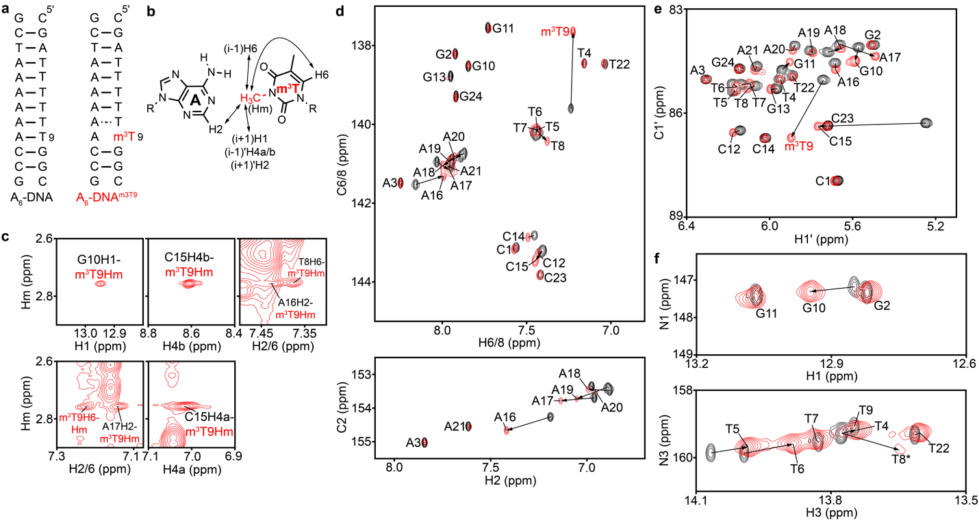
Extended Data Fig. 1. NMR spectra of A₆-DNA and A₆-DNA^{m3T9}. (a) The A₆-DNA and A₆-DNA^{m3T9} duplexes. Solid and dashed lines denote stable and labile Watson-Crick bps, respectively. (b) Chemical structure of the A-m³T bp with observed NOE connectivities (see panel c) indicated using arrows. i-1, i and i+1 denote the residue preceding m³T (T8), the m³T residue itself and the residue after m³T (G10) in the 5' to 3' direction. (i-1)', i' and (i+1)' denote the residue preceding the adenine complementary to m³T (C15), the adenine itself, and the residue following it (A17) in the 5' to 3' direction. (c) Regions of the 2D [¹H, ¹H] NOESY spectra of A₆-DNA^{m3T9} showing cross peaks between the N³-methyl protons (Hm) of m³T9 with imino, amino and aromatic protons of neighboring bases. (d-f) Overlays of 2D [¹³C, ¹H] HSQC spectra of the aromatic (d) and C1' regions (e), and 2D [¹⁵N, ¹H] HMQC spectra of the imino region (f) of A₆-DNA (black) and A₆-DNA^{m3T9} (red) in NMR buffer (15 mM sodium phosphate, 25 mM sodium chloride, 0.1 mM EDTA) at pH 6.8 and 25 °C.
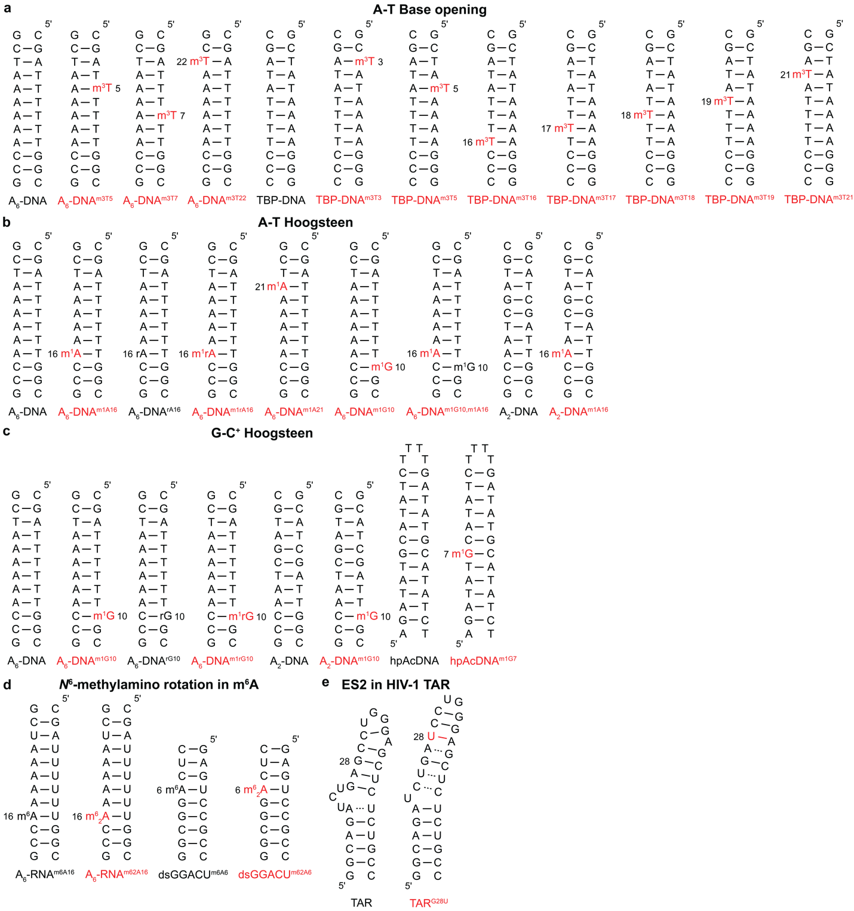
Extended Data Fig. 2. DNA and RNA constructs used to measure conformational penalties associated with (a) base opening of A-T bps, (b) A-T and (c) G-C⁺ Hoogsteen bps, (d) methylamino rotation in N⁶-methyl adenine (m⁶A) and (e) formation of a minor conformation (ES2)¹ in HIV-1 TAR, using delta-Melt. Modifications or mutations used to bias the conformation towards that the minor conformation of the unmodified molecule are indicated in red. Solid and dashed lines denote stable bps, and labile bps or mismatches, respectively. All nucleotides are unlabeled. m¹A, m¹G, m³T and m⁶₂A denote N¹-methyl adenine, N¹-methyl guanine, N³-methyl thymine and N⁶,N⁶-dimethyl adenine, respectively. All nucleotides in DNA and RNA have deoxyribose and ribose sugars respectively, apart from rA/rG/m¹rA/m¹rG in DNA, which have a ribose sugar.
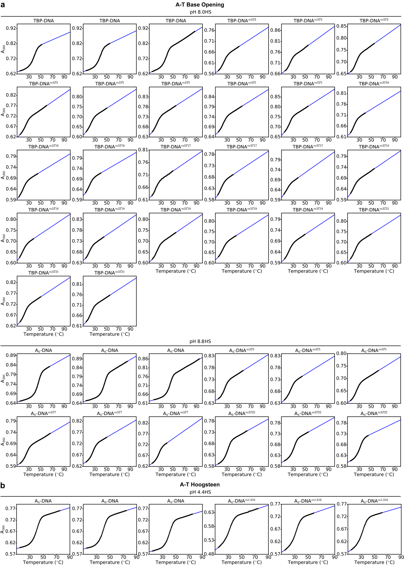
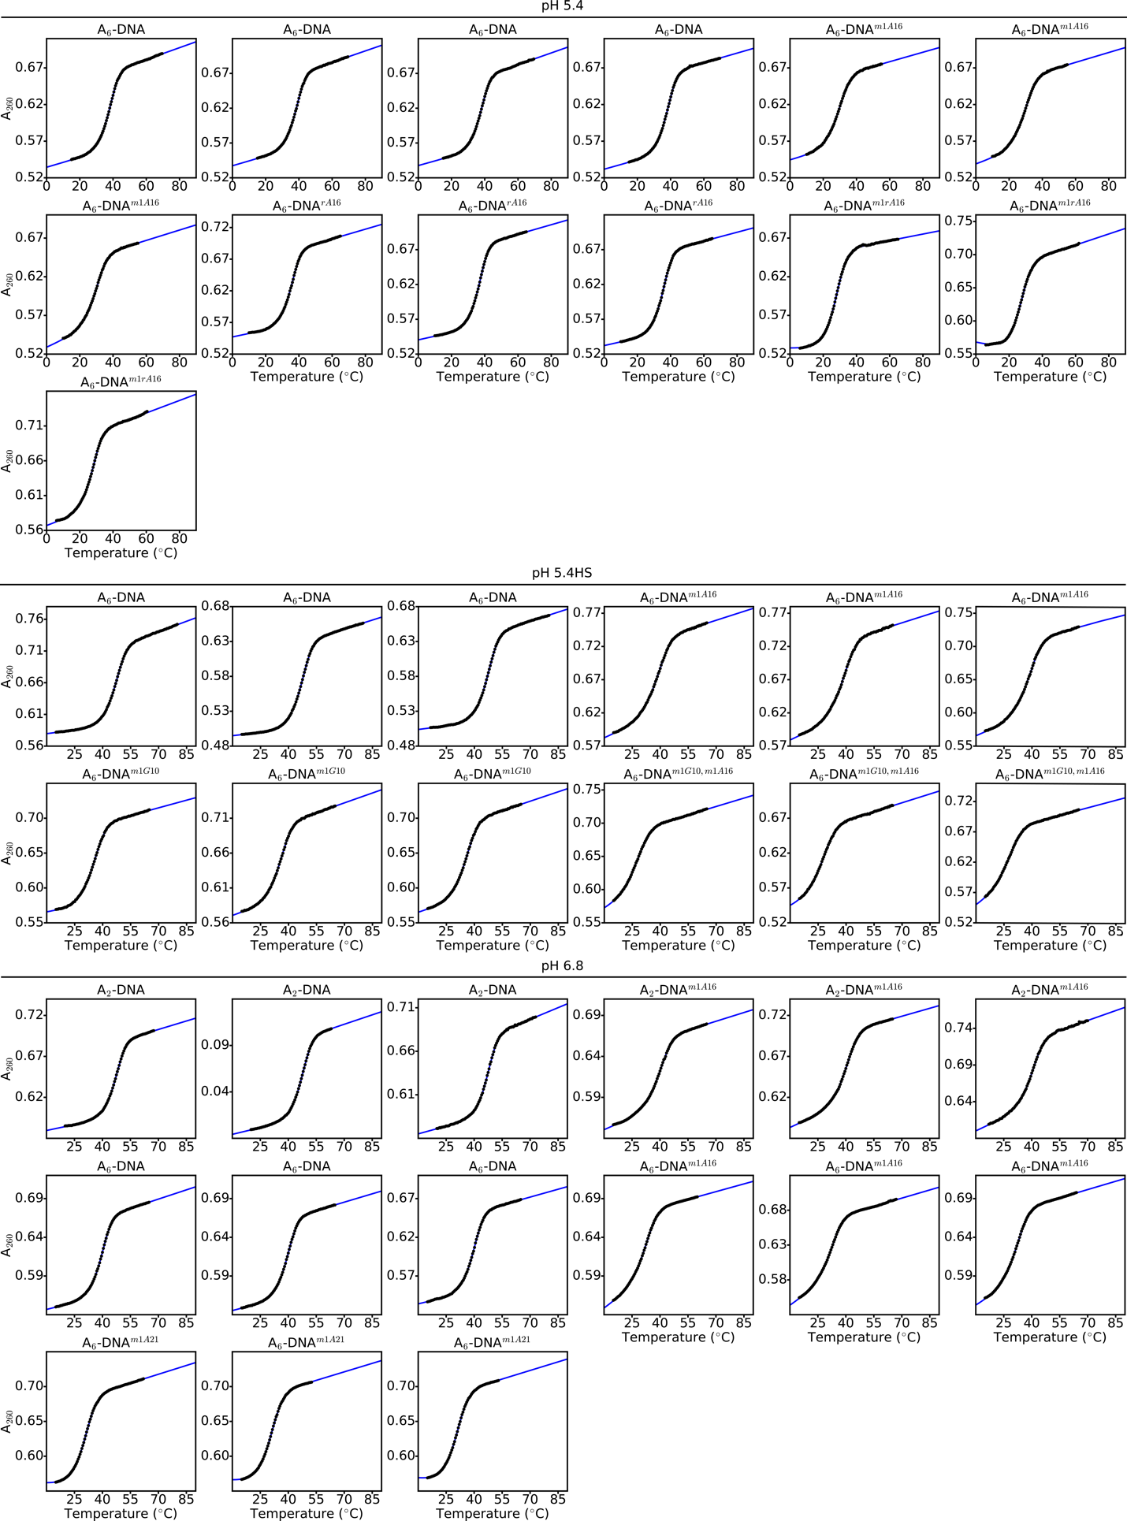
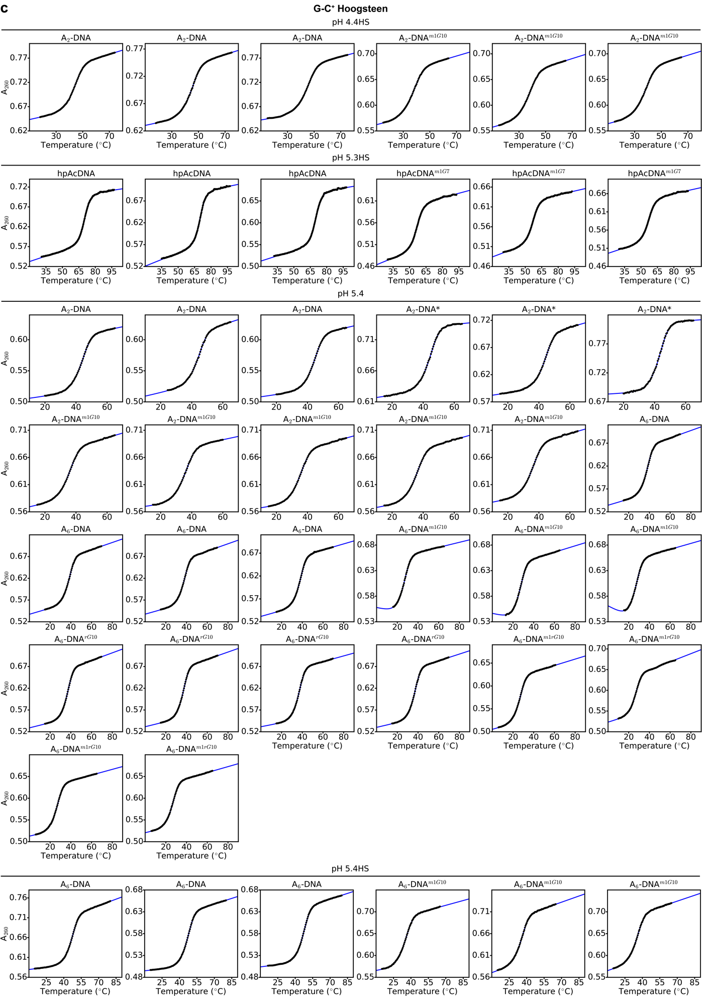
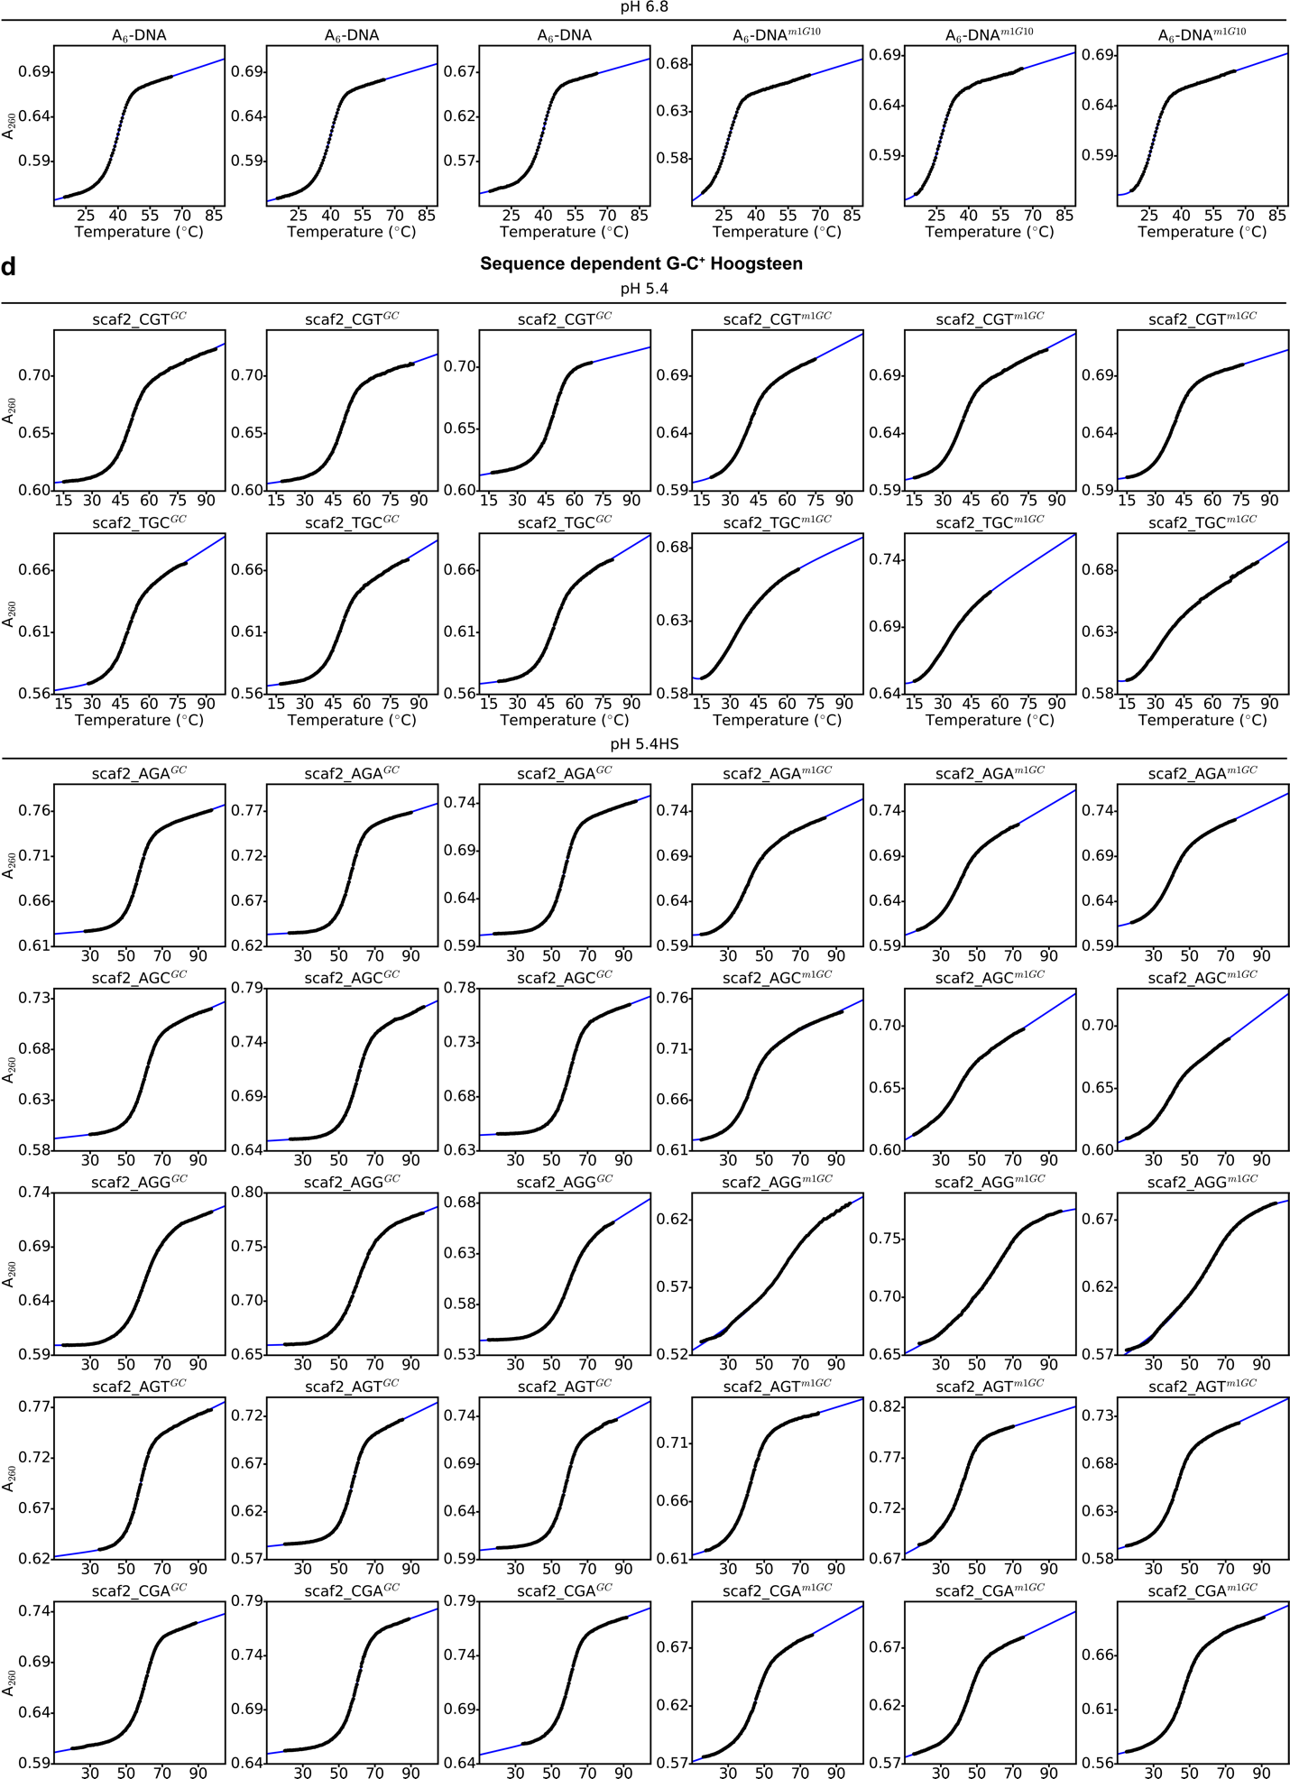
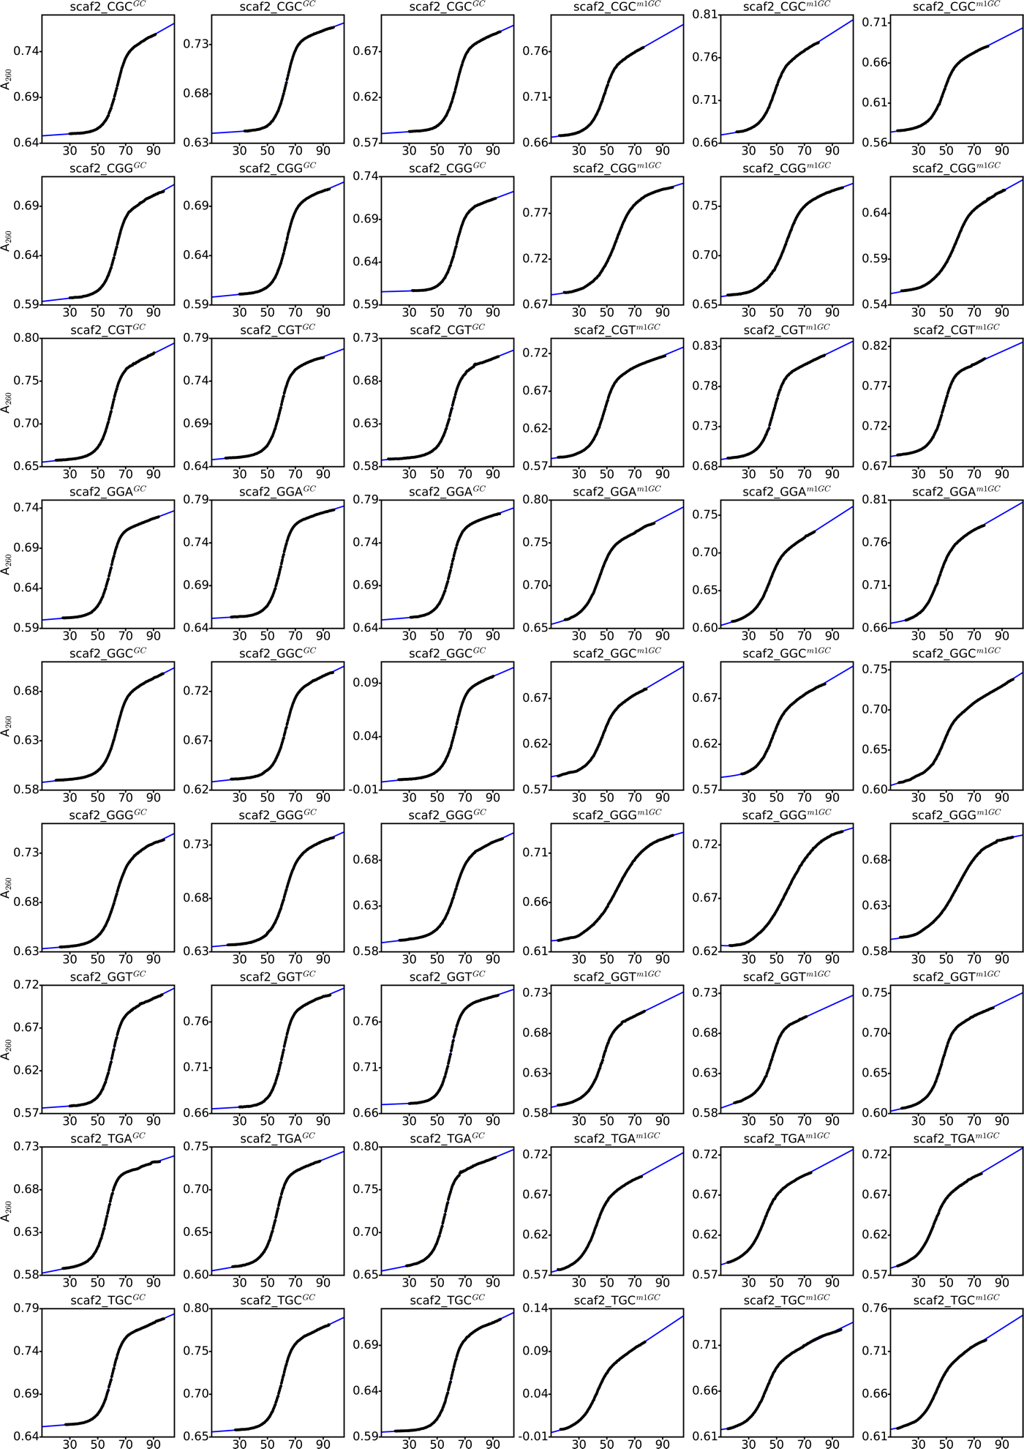
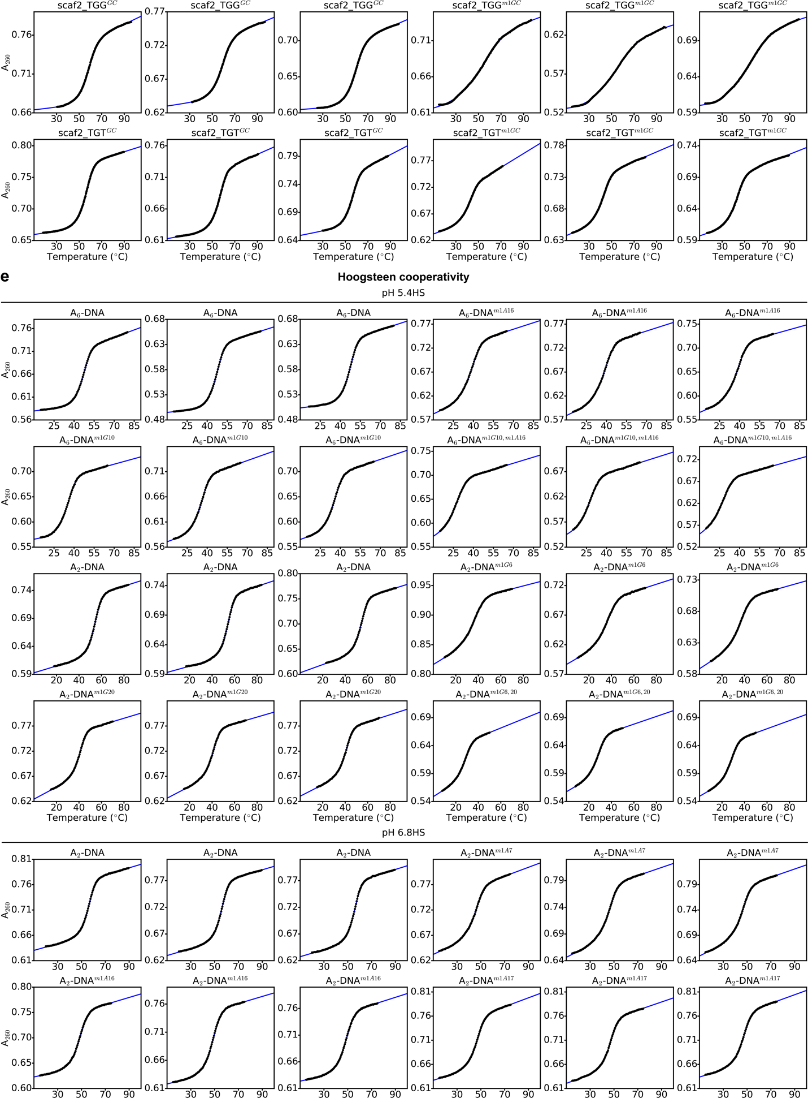
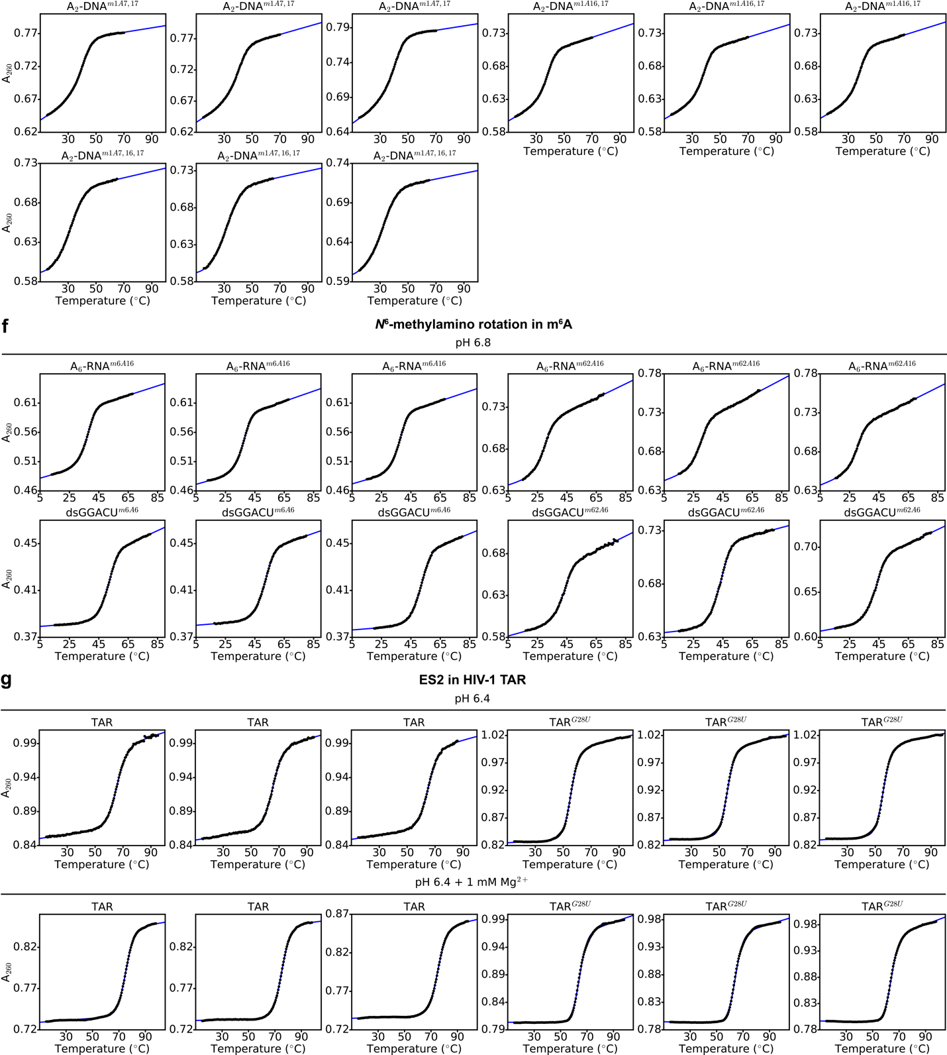
Extended Data Fig. 3. UV melting curves (black lines) for DNA and RNA constructs used in this study, along with fits of the data assuming a two-state model (blue lines) used in delta-Melt to estimate conformational penalties involving the (a) A-T base opened state, (b) A-T Hoogsteen bp, (c) G-C⁺ Hoogsteen bp, (d) sequence dependent G-C⁺ Hoogsteen bps, (e) Hoogsteen bp cooperativity, (f) N⁶-methylamino rotation in N⁶-methyl adenine (m⁶A) and (g) formation of a minor conformation (ES2)¹ in HIV-1 TAR. The name of the constructs (Extended Data Fig. 2) and buffer conditions are highlighted above the melts. A₂₆₀ refers to the absorbance at 260nm. HS denotes high salt (> 25mM NaCl, Methods).
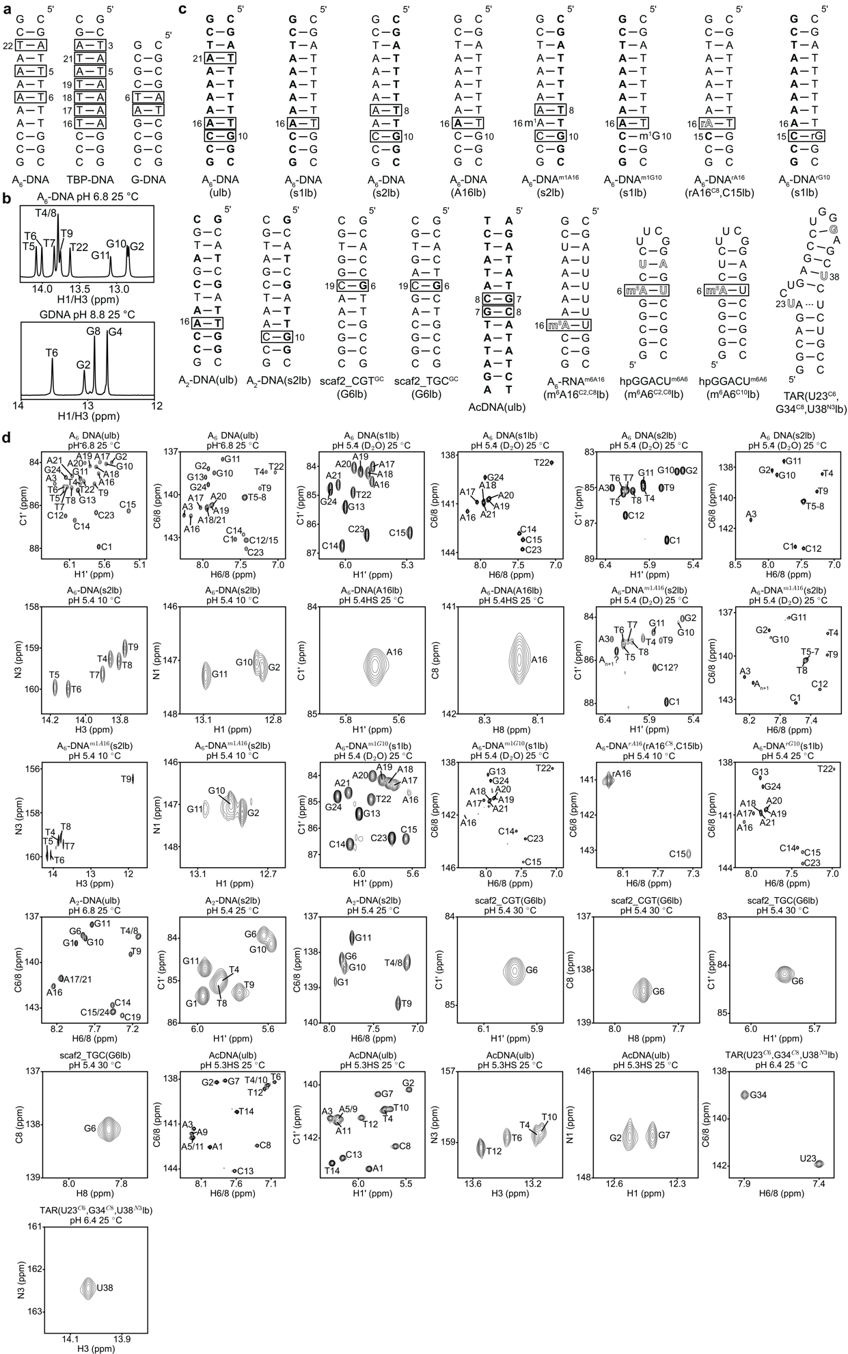
Extended Data Fig. 4. Representative NMR spectra of the DNA and RNA constructs used for NMR measurements. (a) DNA constructs used for imino proton exchange measurements. (b) Representative ¹H 1D spectra of the imino region of A₆-DNA and GDNA. Spectra for TBP-DNA have been reported previously². (c) Isotope labeled DNA and RNA constructs used for R_{1ρ} and CEST measurements. Solid and dashed lines denote stable and labile Watson-Crick bps respectively. (d) Representative 2D [¹³C/¹⁵N, ¹H] HSQC spectra of the isotope labeled DNA and RNA constructs. HS refers to high salt (> 25mM NaCl, Methods). Squares in panels a and c denote sites at which A-T base opening and Hoogsteen bps were monitored using imino proton exchange and R_{1ρ}/CEST, respectively. ¹³C, ¹⁵N uniformly labeled (A, C, T and G) nucleotides are denoted in bold while atom-specifically ¹³C/¹⁵N nucleotides are indicated using outlines. All other nucleotides are unlabeled. m¹A, m¹G, and m⁶A denote N¹-methyl adenine, N¹-methyl guanine and N⁶-methyl adenine, respectively. All nucleotides in DNA and RNA have deoxyribose and ribose sugars respectively, apart from rA/rG in DNA, which have a ribose sugar. The A and U nucleotides in hpGGACU^{m6A6}(m⁶A6^{C2,C8}lb) are site-specifically ¹³C labeled at C2 and C8, and ¹⁵N labeled at N3, respectively. Spectra for A₆-RNA^{m6A16}(m⁶A16^{C2,C8}lb), hpGGACU^{m6A6}(m⁶A6^{C2,C8}lb) and hpGGACU^{m6A6}(m⁶A6^{C10}lb) were reported in another study (Liu et al., Manuscript under preparation).
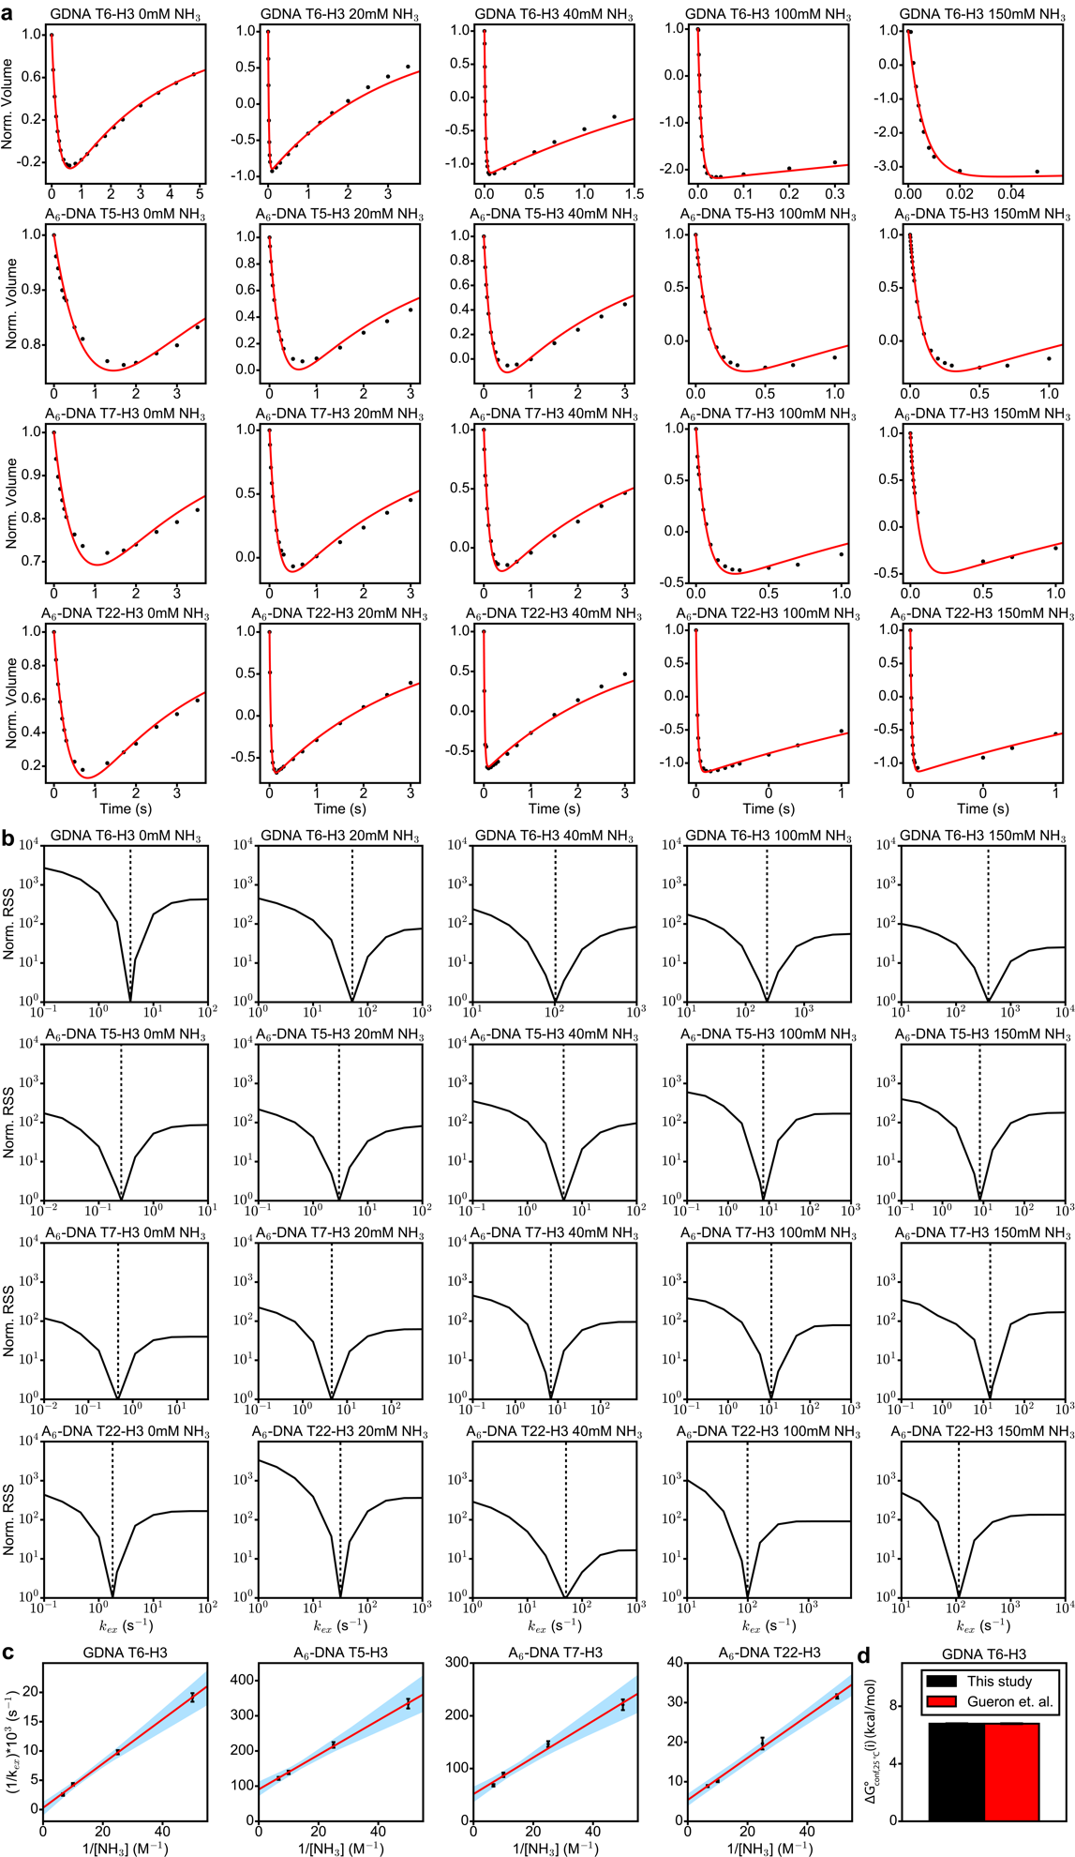
Extended Data Fig. 5. Imino proton exchange measurements on DNA. (a) Recovery of longitudinal imino proton magnetization post inversion. Shown is the normalized volume of the imino proton as a function of relaxation delay, computed as described in Methods. Experimental data points are in black and a fit to the data to Equation 2 is in red (Methods). (b) Quality of fit for the inversion recovery curves as a function of changing the net imino proton exchange rate k_{ex}. RSS denotes the residual sum of squares and was computed as described in the Methods. Dashed line denotes the value of k_{ex} obtained from the fitting. (c) Variation of the inverse of the exchange rate with the inverse of the effective ammonia concentration. Data points are in black and a linear fit of the data to Equation 5 (black line) was computed as described in the Methods. Error bars for k_{ex} were obtained from the fitting error of the inversion recovery curves in (a), as described in Methods. Blue shaded region denotes the family of lines obtained from iterative linear regression fits of the data using a Monte-Carlo sampling protocol (Methods). (d) Comparison of the conformational penalty for opening of the A5-T6 bp obtained from imino-proton exchange measurements in this study and those reported by Gueron et al³. Buffer conditions for the measurements along with the summary of the obtained exchange parameters are given in Supplementary Tables 2-4.
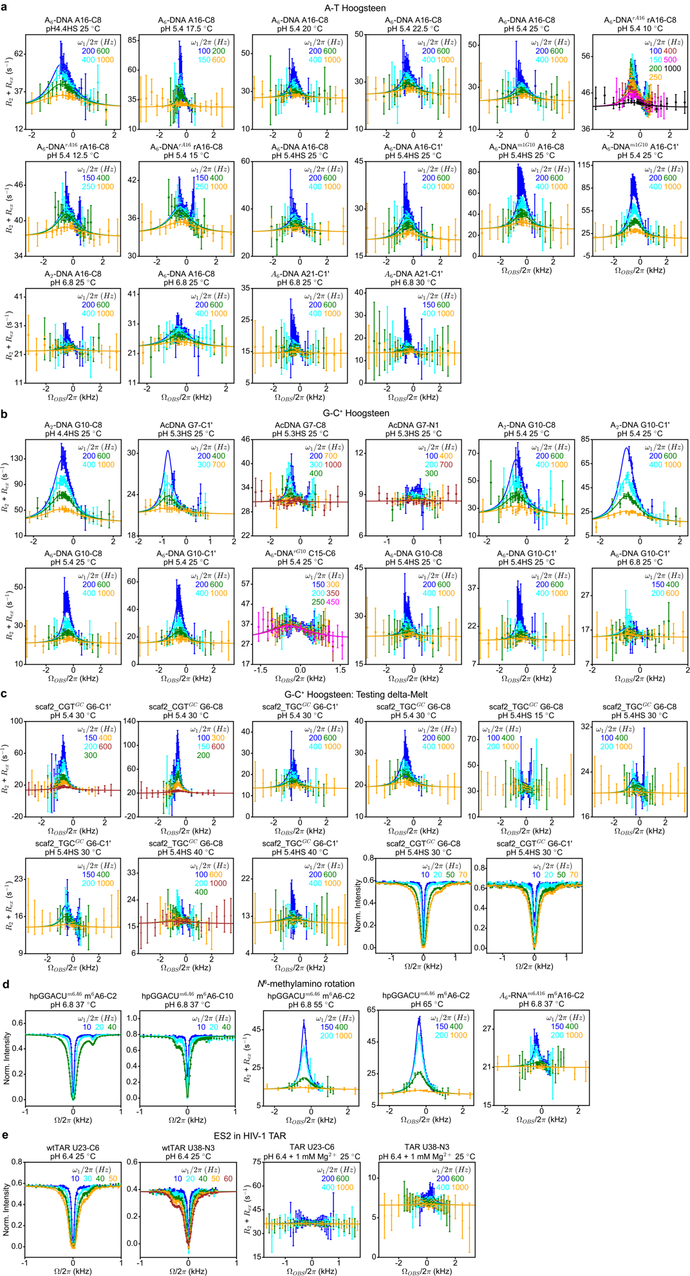
Extended Data Fig. 6. Off-resonance R_{1ρ} relaxation dispersion and CEST profiles probing (a) A-T and (b-c) G-C⁺ Hoogsteen bp formation, (d) methylamino rotation in N⁶-methyl adenine (m⁶A) and (e) formation of a minor conformation (ES2)¹ in HIV-1 TAR. HS refers to high salt (> 25mM NaCl, Methods). Secondary structures and labeling schemes for the constructs used for the above measurements are provided in Extended Data Fig. 4 and Supplementary Table 5. RF powers for R_{1ρ} and CEST are color coded. Two-state individual/shared fits (Supplementary Table 7, Methods) of the data to the Bloch-McConnell equations is shown as solid lines. Error bars for the R_{1ρ} and CEST data were obtained using a Monte-Carlo based approach as described in the Methods. Error bars for the CEST intensities are smaller than the data points.

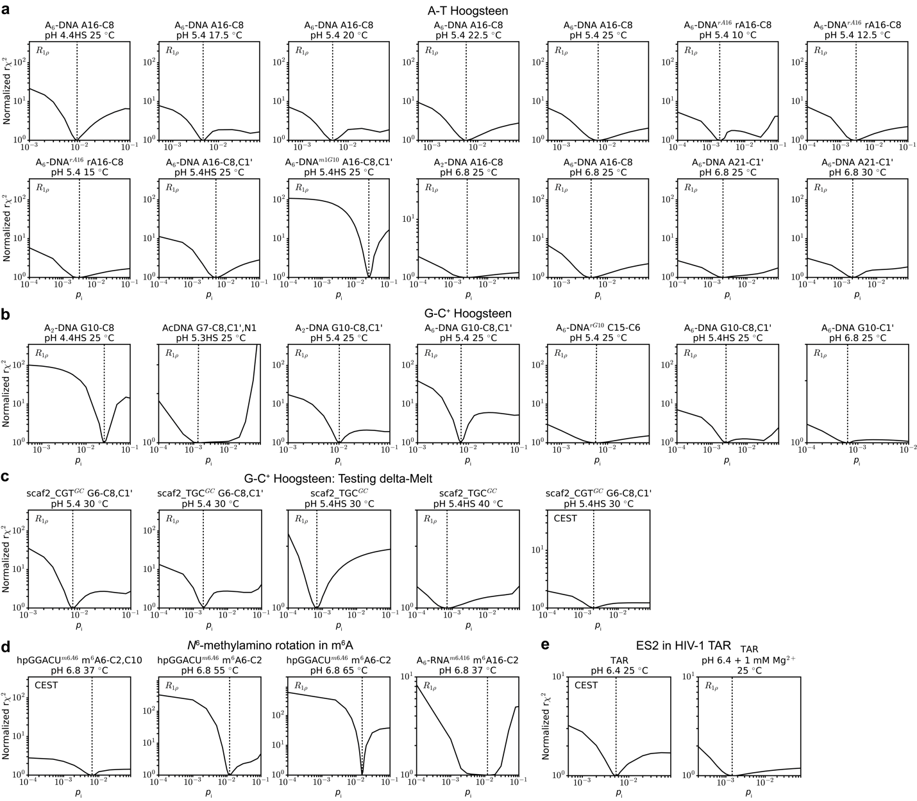
Extended Data Fig. 7. Dependence of fit quality of the measured R_{1ρ} or CEST data on the value of p_{i}, the population of the i^{th} minor conformation. Shown is the normalized reduced ${}^{2}$ ($r^{2}$) as a function of fixing p_{i} to different values when fitting R_{1ρ} or CEST profiles probing (a) A-T and (b-c) G-C⁺ Hoogsteen bp formation, (d) methylamino rotation in N⁶-methyl adenine (m⁶A) and (e) formation of a minor conformation (ES2)¹ in HIV-1 TAR. HS refers to high salt (> 25mM NaCl, Methods). The absolute r${}^{2}$ values obtained from fitting the R_{1ρ} or CEST profiles were normalized such that r${}^{2}$= 1 for the best fit. The values of p_{i} obtained from free fitting the R_{1ρ} or CEST profiles are indicated using a dashed line.
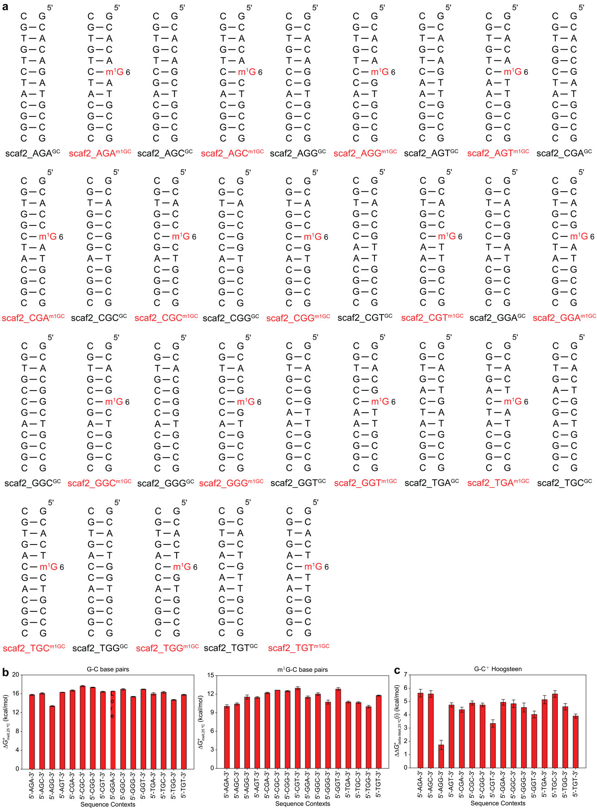
Extended Data Fig. 8. Measuring sequence dependent conformational penalties for G-C⁺ Hoogsteen bp formation using delta-Melt. (a) Duplexes used in the UV melting experiments. m¹G (red) denotes N¹-methyl guanine. All nucleotides are unlabeled and have deoxyribose sugars. (b) Bar plots of the energy for melting ($G_{melt,25 C}^{}$ at 25 °C) of G-C (left) and m¹G-C (right) containing duplexes as a function of sequence. (c) Bar plot of the conformational penalty for the Watson-Crick to Hoogsteen transition obtained using delta-Melt ($G_{delta-Melt,25 C}^{}(i)$ at 25 °C) as a function of sequence. Buffer conditions for the measurements are given in Supplementary Table 1. Error bars for $G_{melt}^{}$ and $G_{delta-Melt}^{}(i)$ were obtained by propagating the error in UV melting measurements as described in Methods.
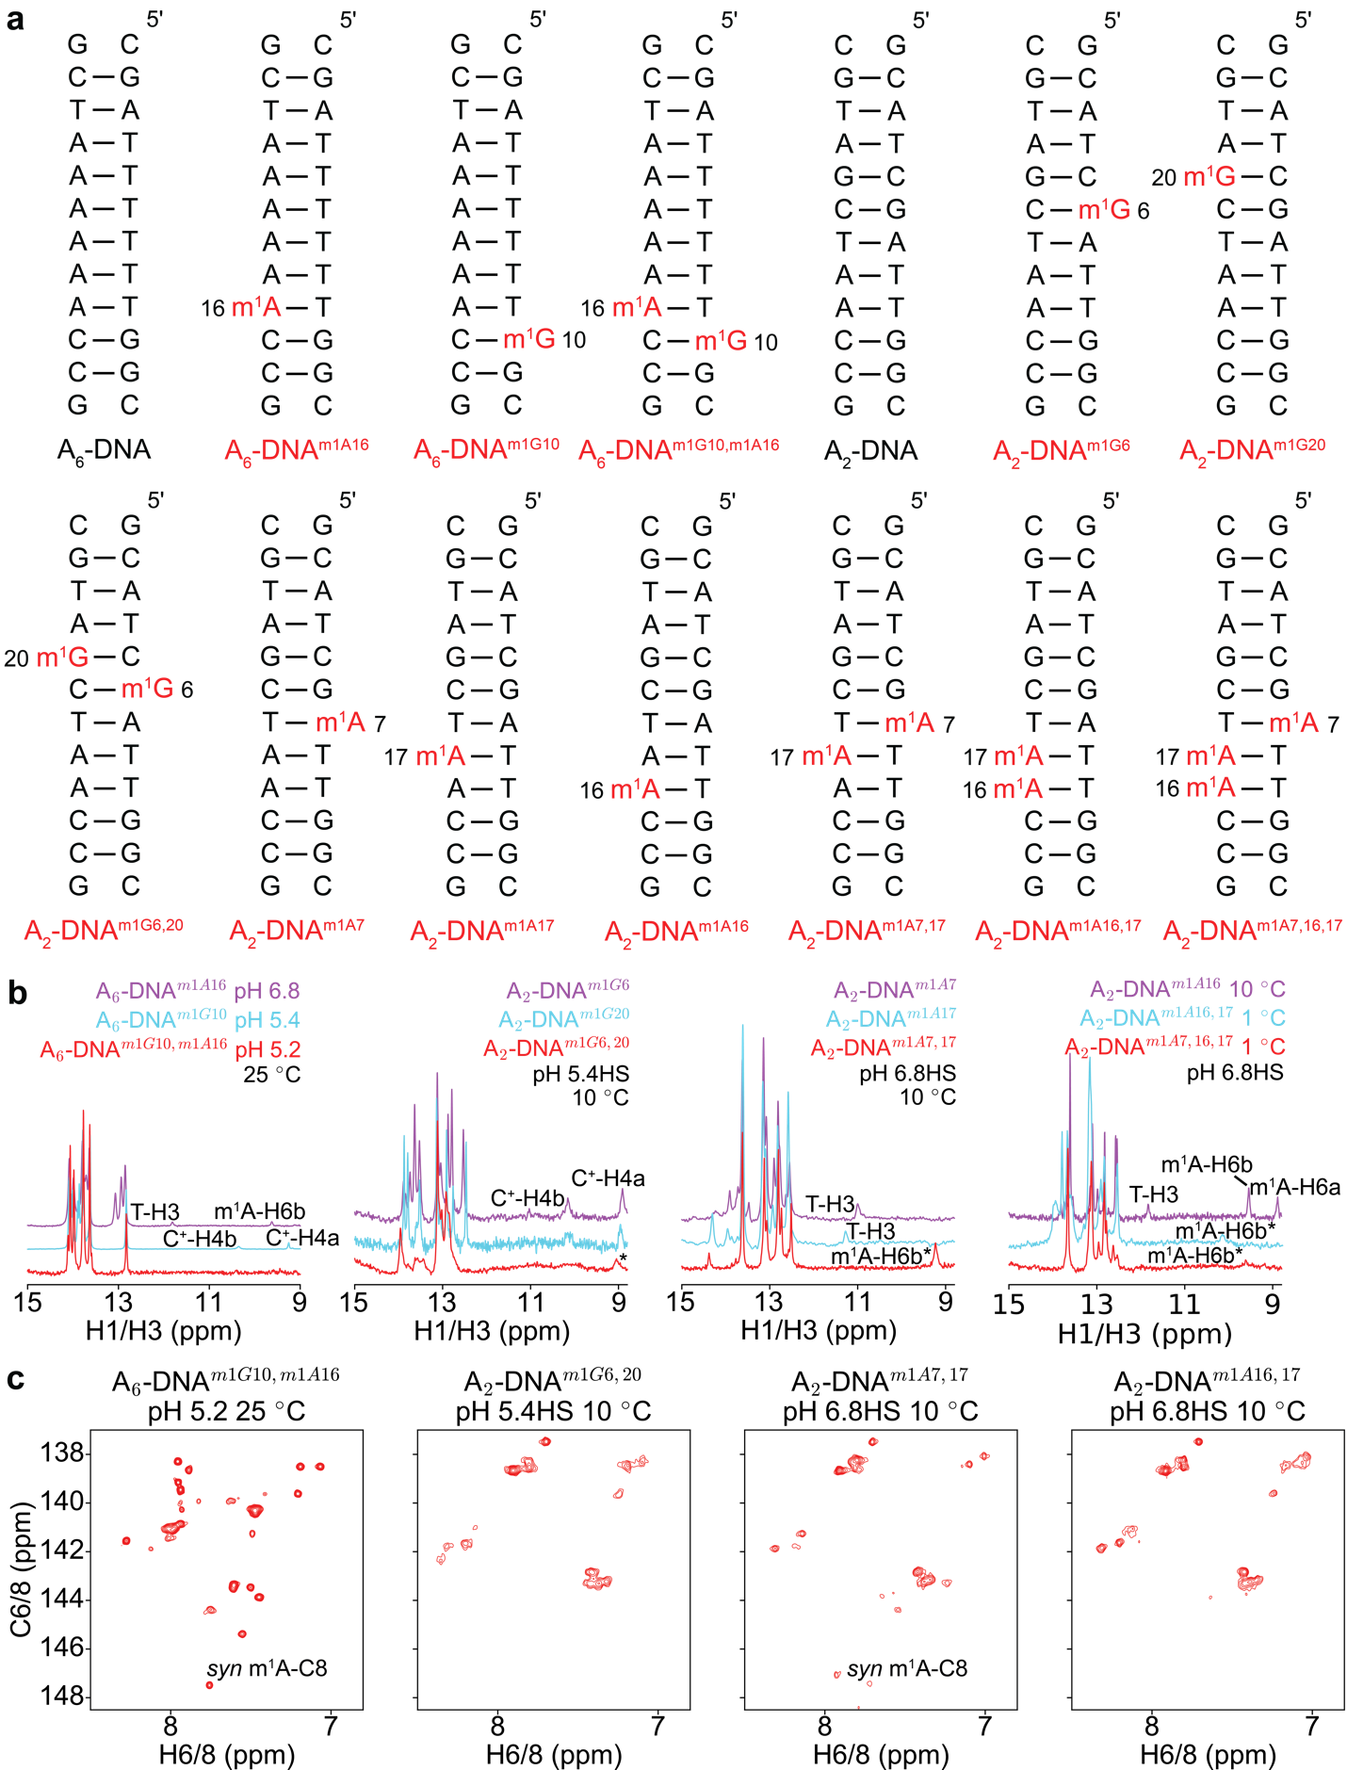
Extended Data Fig. 9. (a) Duplexes used to examine cooperativity of Hoogsteen bp formation using delta-Melt. m¹A and m¹G (red) denote N¹-methyl adenine and guanine respectively. All nucleotides are unlabeled. (b) Overlay of ¹H 1D spectra of the imino region of the duplexes with single and tandem N¹-methylated purines. Hoogsteen signatures such as the upfield shifted thymine imino proton (T-H3) and downfield shifted amino protons of m¹A (m¹A-H6b and m¹A-H6a) in m¹A-T Hoogsteen bps, and downfield shifted cytosine amino protons in m¹G-C⁺ Hoogsteen bps (C⁺-H4b and C⁺-H4a)⁴ are indicated. (c) 2D [¹³C, ¹H] HSQC spectra of the aromatic region of DNA constructs with tandem N¹-methylated purines. The downfield shifted m¹A-C8 resonance characteristic of a syn conformation of m¹A in an m¹A-T Hoogsteen bp is indicated⁵. The singly methylated duplexes show NMR signatures of Hoogsteen bp formation in the ¹H 1D spectra, while the tandem doubly methylated duplexes only show Hoogsteen signatures either in the ¹H 1D or 2D spectra in some cases. The absence of Hoogsteen signatures is likely due to exchange broadening of the resonances. HS corresponds to high salt (> 25 mM NaCl, Methods). In addition to NaCl, the buffers used for NMR measurements contained 15 mM sodium phosphate, 0.1 mM EDTA in a 90% H₂O:10% D₂O mixture. * denotes tentative or unknown assignments.
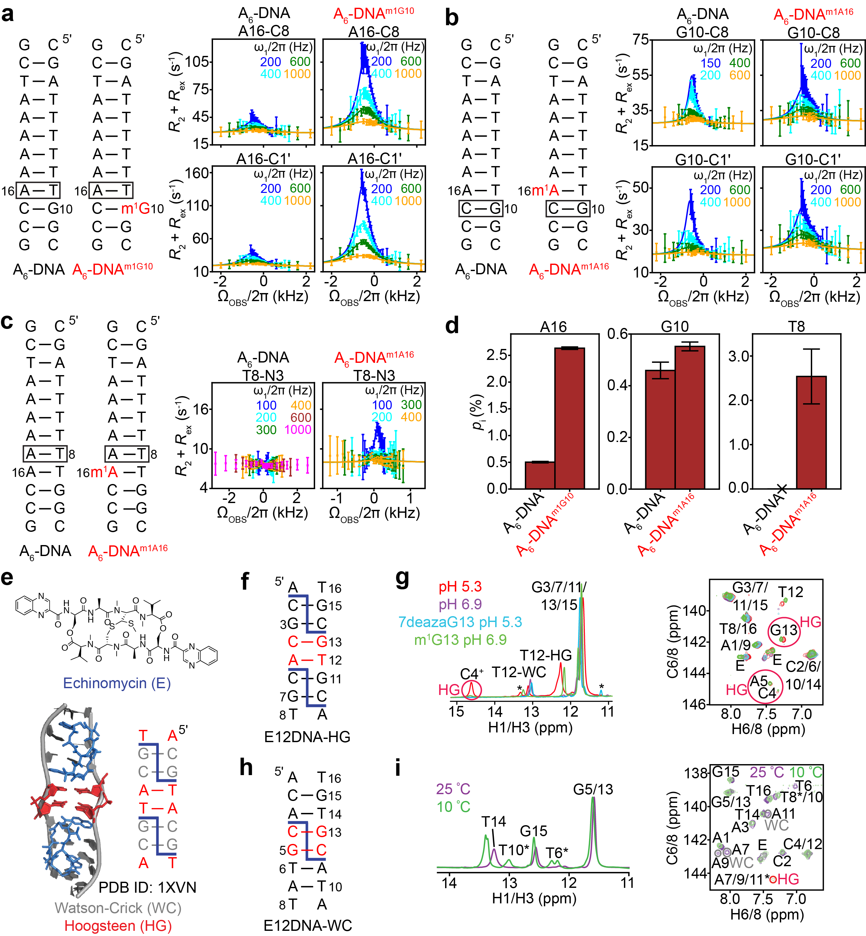
Extended Data Fig. 10. NMR measurements providing evidence for the cooperative formation of Hoogsteen bps. Shown in panels a, b and c are the duplexes with and without preformed Hoogsteen bps induced by N¹-methyl adenine/guanine (m¹A/m¹G) (left) along with off-resonance R_{1ρ} relaxation dispersion profiles for the indicated nuclei (right). Sites which were probed for Hoogsteen bp formation using NMR are indicated with a box on the duplex. RF powers for R_{1ρ} profiles are color coded. Two-state individual/shared fits (Supplementary Table 7, Materials and Methods) of the data to the Bloch-McConnell equations is shown as solid lines. Error bars for the R_{1ρ} data were obtained from a Monte-Carlo based approach as described in the Materials and Methods. (d) Comparison of the population of the transient Hoogsteen bp (p_{i}) obtained from NMR measurements in panels a, b and c, for samples with and without preformed Hoogsteen bps. Error bars for p_{i} were obtained using a Monte-Carlo scheme as described in Methods. ‘x’ denotes a flat R_{1ρ} profile from which p_{i} could not be obtained. p_{i} is higher next to a preformed Hoogsteen bp, suggesting that Hoogsteen bps form cooperatively in DNA. (e) Chemical structure of echinomycin (top) and structure of Echinomycin bound DNA (bottom, PDB ID: 1XVN). Watson-Crick and Hoogsteen bps in the Echinomycin-DNA complex are shown in gray and red, respectively, while Echinomycin is shown using blue sticks. Also shown is the secondary structure of Echinomycin bound DNA, with Echinomycin indicated using blue dashed lines. (f and h) Secondary structures of the duplexes used for NMR measurements in the presence of bound Echinomycin (blue dashes). (g and i) Overlay of the imino region of the ¹H 1D spectra (g, left) and ¹H 1D imino SOFAST spectra (i, left), and overlay of the aromatic region of the 2D [¹³C, ¹H] HSQC spectra (right). The E12DNA-HG Echinomycin complex shows NMR signatures of tandem G13-C4/A5-T12 Hoogsteen bp formation at pH 5.4 (red circles) that are both lost on moving to high pH (purple), which destabilizes G-C⁺ Hoogsteen bps. Substitution of G13 with 7-deaza guanine which is known to destabilize G-C⁺ Hoogsteen bps⁶ even at pH 5.4 via loss of a hydrogen bond, also results in loss of tandem Hoogsteen bp signatures (cyan). Furthermore, stabilization of the G-C⁺ Hoogsteen bp at pH 6.8 by substitution of G13 with m¹G (green), results in persistence of tandem Hoogsteen bp signatures (red circles). Thus, destabilization of the G13-C4⁺ Hoogsteen bp also destabilizes the A5-T12 Hoogsteen bp, suggesting that Hoogsteen bps form cooperatively. The E12DNA-WC Echinomycin complex shows NMR signatures (red circles) of cooperative formation of tandem A11-T6/A7-T10/A9-T8 Hoogsteen bps at low temperature (10 °C), that are absent at high temperature (25 °C). * denotes tentative or unknown assignments. R_{1ρ} measurements in panels a, b and c were performed in a buffer containing 15 mM sodium phosphate, 25 mM sodium chloride, 0.1 mM EDTA at pH 5.4 (at 25 ºC in 100% D₂O for panels a and b, and at 10 ºC 90% H₂O:10% D₂O for panel c). Echinomycin measurements were performed in a 90% H₂O:10% D₂O buffer containing 15 mM sodium phosphate, 125 mM sodium chloride, 0.1 mM EDTA, at the indicated pH.
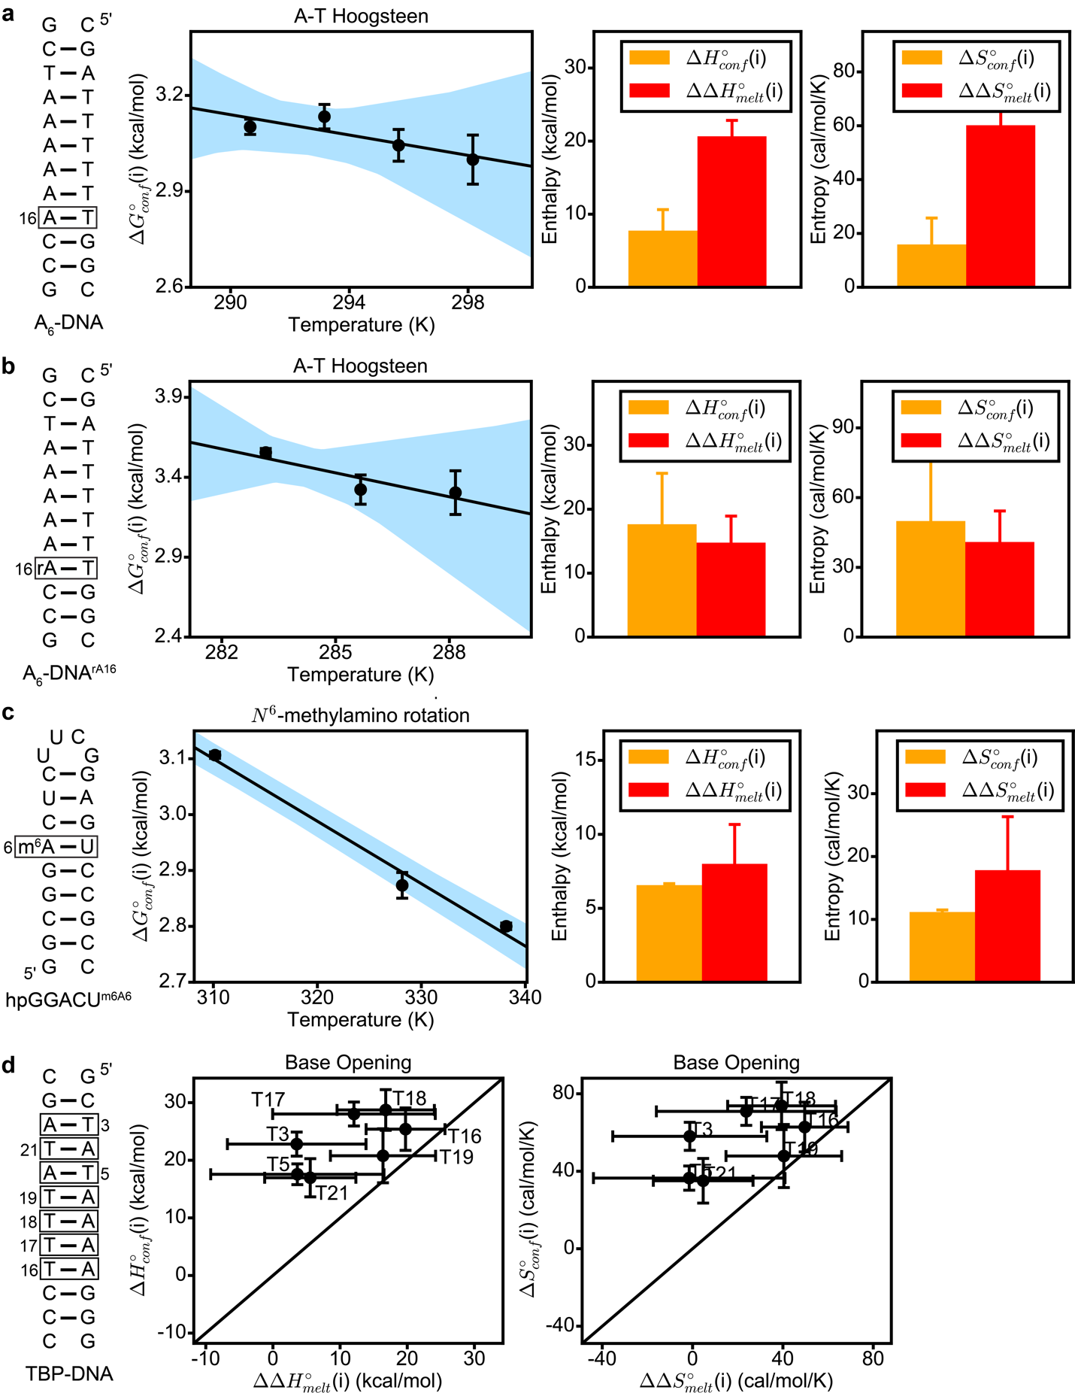
Extended Data Fig. 11. Comparison of the entropy and enthalpy of conformational changes in nucleic acids from delta-Melt and NMR. Shown in panels a, b and c are the secondary structure of the construct used for NMR measurements with the position of interest enclosed by a box, temperature dependence of the NMR derived free energies for the conformational change, and comparison of the enthalpy and entropy values obtained from NMR and that obtained from UV melting measurements (Methods). Shown in panel d is a correlation plot of the enthalpy and entropy values for base opening in TBP DNA obtained using imino proton exchange NMR measurements in Chen et al.², and UV melting measurements in this study. Black line denotes y=x. Error bars for the thermodynamic parameters obtained from NMR and UV melting experiments were obtained as described in Methods. Blue shaded region in panels a, b and c denotes estimate of error of linear regression obtained as described in Methods. Buffer conditions for panels a, b and c are summarized in Supplementary Tables 4 and 7.

Supplementary Table 1. Thermodynamic parameters obtained from UV melting experiments

Construct | pH | [NaCl] (mM) | [MgCl₂]  (mM) | C_{t} (μm) | T_{m} (°C) | $H_{melt}^{}$ (kcal/mol) | $S_{melt}^{}$ (cal/mol/K) | $G_{melt, 25C}^{}$ (kcal/mol)
A-T Base Opening
TBP-DNA | 8.0 | 100 | 0 | 3 | 38.0±0.2 | 84.0±5.6 | 243.2±18.2 | 11.5±0.2
TBP-DNA^{m3T3} | 8.0 | 100 | 0 | 3 | 23.5±0.7 | 80.4±8.7 | 244.5±28.8 | 7.5±0.2
TBP-DNA^{m3T5} | 8.0 | 100 | 0 | 3 | 22.8±0.9 | 80.3±11.6 | 244.7±38.3 | 7.4±0.2
TBP-DNA^{m3T16} | 8.0 | 100 | 0 | 3 | 18.5±0.3 | 64.2±1.7 | 193.6±5.9 | 6.5±0.1
TBP-DNA^{m3T17} | 8.0 | 100 | 0 | 3 | 18.8±1.5 | 71.9±10.7 | 219.5±35.4 | 6.5±0.2
TBP-DNA^{m3T18} | 8.0 | 100 | 0 | 3 | 18.3±0.6 | 67.2±4.6 | 203.8±15.4 | 6.4±0.1
TBP-DNA^{m3T19} | 8.0 | 100 | 0 | 3 | 21.3±0.7 | 67.6±5.5 | 202.8±18.0 | 7.1±0.1
TBP-DNA^{m3T21} | 8.0 | 100 | 0 | 3 | 22.5±0.6 | 78.4±3.8 | 238.5±12.4 | 7.3±0.1
A₆-DNA | 8.8 | 100 | 0 | 3 | 44.9±0.4 | 94.5±1.7 | 270.6±5.4 | 13.9±0.2
A₆-DNA^{m3T5} | 8.8 | 100 | 0 | 3 | 24.6±0.6 | 74.5±2.8 | 223.4±9.2 | 7.9±0.2
A₆-DNA^{m3T7} | 8.8 | 100 | 0 | 3 | 25.3±0.6 | 80.8±6.9 | 244.2±22.8 | 8.0±0.2
A₆-DNA^{m3T22} | 8.8 | 100 | 0 | 3 | 30.6±0.1 | 81.7±3.2 | 242.4±10.3 | 9.5±0.1
A-T Hoogsteen
A₆-DNA | 4.4 | 150 | 0 | 3 | 39.7±0.3 | 85.0±0.9 | 244.9±2.6 | 12.0±0.1
A₆-DNA^{m1A16} | 4.4 | 150 | 0 | 3 | 31.9±0.1 | 71.8±1.0 | 208.6±3.3 | 9.6±0.1
A₆-DNA | 5.4 | 25 | 0 | 3 | 37.6±0.2 | 91.1±1.6 | 266.5±5.3 | 11.7±0.1
A₆-DNA^{m1A16} | 5.4 | 25 | 0 | 3 | 29.3±0.2 | 70.5±1.4 | 206.4±4.6 | 9.0±0.1
A₆-DNA^{rA16} | 5.4 | 25 | 0 | 3 | 35.5±0.6 | 89.8±1.4 | 264.2±3.9 | 11.0±0.2
A₆-DNA^{m1rA16} | 5.4 | 25 | 0 | 3 | 27.0±0.5 | 75.0±3.9 | 223.3±12.8 | 8.4±0.1
A₆-DNA | 5.4 | 150 | 0 | 3 | 46.6±0.1 | 93.2±0.2 | 264.8±0.6 | 14.3±0.1
A₆-DNA^{m1A16} | 5.4 | 150 | 0 | 3 | 38.3±0.1 | 73.5±0.7 | 209.4±2.3 | 11.1±0.1
A₆-DNA^{m1G10} | 5.4 | 150 | 0 | 3 | 35.1±0.2 | 80.4±2.4 | 234.0±7.6 | 10.6±0.1
A₆-DNA^{m1G10,m1A16} | 5.4 | 150 | 0 | 3 | 27.4±0.2 | 68.9±0.5 | 202.7±1.4 | 8.5±0.1
A₂-DNA | 6.8 | 25 | 0 | 3 | 47.0±0.1 | 102.4±1.2 | 293.1±3.9 | 15.0±0.1
A₂-DNA^{m1A16} | 6.8 | 25 | 0 | 3 | 40.0±0.2 | 81.9±1.7 | 234.8±5.3 | 11.9±0.1
A₆-DNA | 6.8 | 25 | 0 | 3 | 39.4±0.1 | 95.2±0.6 | 277.9±1.8 | 12.3±0.1
A₆-DNA^{m1A16} | 6.8 | 25 | 0 | 3 | 32.2±0.2 | 78.6±2.2 | 230.7±7.0 | 9.8±0.1
A₆-DNA^{m1A21} | 6.8 | 25 | 0 | 3 | 30.0±0.1 | 75.9±0.7 | 223.6±2.1 | 9.2±0.1
G-C⁺ Hoogsteen
A₂-DNA | 4.4 | 150 | 0 | 3 | 44.2±0.4 | 76.9±2.7 | 215.6±8.6 | 12.6±0.1
A₂-DNA^{m1G10} | 4.4 | 150 | 0 | 3 | 37.3±0.2 | 70.1±1.1 | 199.1±3.6 | 10.7±0.1
hpAcDNA | 5.3 | 125 | 0 | 3 | 70.1±0.1 | 83.4±1.6 | 242.9±4.6 | 10.9±0.2
hpAcDNA^{m1G7} | 5.3 | 125 | 0 | 3 | 57.0±0.1 | 68.8±1.0 | 208.5±3.2 | 6.7±0.1
A₂-DNA | 5.4 | 25 | 0 | 3 | 43.8±0.3 | 90.6±1.6 | 259.2±4.8 | 13.3±0.2
A₂-DNA* | 5.4 | 25 | 0 | 3 | 43.6±0.5 | 90.0±1.5 | 257.5±4.9 | 13.2±0.2
A₂-DNA^{m1G10} | 5.4 | 25 | 0 | 3 | 35.3±0.2 | 81.1±1.8 | 236.4±6.0 | 10.7±0.1
A₆-DNA | 5.4 | 25 | 0 | 3 | 37.6±0.2 | 91.1±1.6 | 266.5±5.3 | 11.7±0.1
A₆-DNA^{m1G10} | 5.4 | 25 | 0 | 3 | 26.0±0.1 | 73.9±1.7 | 220.4±5.5 | 8.2±0.1
A₆-DNA^{rG10} | 5.4 | 25 | 0 | 3 | 36.5±0.1 | 92.8±1.8 | 273.1±5.8 | 11.4±0.1
A₆-DNA^{m1rG10} | 5.4 | 25 | 0 | 3 | 26.4±0.1 | 83.5±3.7 | 252.0±12.4 | 8.3±0.1
A₆-DNA | 5.4 | 150 | 0 | 3 | 46.6±0.1 | 93.2±0.2 | 264.8±0.6 | 14.3±0.1
A₆-DNA^{m1G10} | 5.4 | 150 | 0 | 3 | 35.1±0.2 | 80.4±2.4 | 234.0±7.6 | 10.6±0.1
A₆-DNA | 6.8 | 25 | 0 | 3 | 39.4±0.1 | 95.2±0.6 | 277.9±1.8 | 12.3±0.1
A₆-DNA^{m1G10} | 6.8 | 25 | 0 | 3 | 26.0±0.5 | 78.9±6.5 | 237.0±21.2 | 8.2±0.2
Sequence dependent G-C⁺ Hoogsteen
scaf2_CGT^{GC} | 5.4 | 25 | 0 | 3 | 48.6±0.2 | 72.4±3.7 | 198.5±11.5 | 13.2±0.3
scaf2_CGT^{m1GC} | 5.4 | 25 | 0 | 3 | 38.0±0.2 | 59.0±2.2 | 163.0±7.0 | 10.4±0.1
scaf2_TGC^{GC} | 5.4 | 25 | 0 | 3 | 47.1±0.2 | 68.4±1.3 | 187.1±4.3 | 12.7±0.1
scaf2_TGC^{m1GC} | 5.4 | 25 | 0 | 3 | 20.6±2.0 | 27.7±3.4 | 67.5±11.0 | 7.6±0.1
scaf2_AGA^{GC} | 5.4 | 150 | 0 | 3 | 55.9±0.2 | 83.4±0.7 | 226.8±1.9 | 15.8±0.1
scaf2_AGA^{m1GC} | 5.4 | 150 | 0 | 3 | 37.8±0.5 | 50.7±4.6 | 136.4±14.4 | 10.0±0.3
scaf2_AGC^{GC} | 5.4 | 150 | 0 | 3 | 59.1±0.2 | 79.4±1.2 | 212.3±3.5 | 16.1±0.2
scaf2_AGC^{m1GC} | 5.4 | 150 | 0 | 3 | 38.5±1.6 | 57.4±2.6 | 157.5±9.2 | 10.4±0.2
scaf2_AGG^{GC} | 5.4 | 150 | 0 | 3 | 57.9±0.5 | 54.8±1.6 | 139.0±4.8 | 13.4±0.1
scaf2_AGG^{m1GC} | 5.4 | 150 | 0 | 3 | 61.0±0.6 | 33.4±2.8 | 73.3±8.4 | 11.5±0.3
scaf2_AGT^{GC} | 5.4 | 150 | 0 | 3 | 56.5±0.1 | 87.7±0.5 | 239.4±1.5 | 16.3±0.1
scaf2_AGT^{m1GC} | 5.4 | 150 | 0 | 3 | 41.8±0.1 | 66.1±2.5 | 183.3±7.9 | 11.5±0.1
scaf2_CGA^{GC} | 5.4 | 150 | 0 | 3 | 59.3±0.2 | 85.0±1.4 | 229.1±4.3 | 16.7±0.1
scaf2_CGA^{m1GC} | 5.4 | 150 | 0 | 3 | 45.0±0.6 | 67.8±3.4 | 186.4±10.9 | 12.2±0.1
scaf2_CGC^{GC} | 5.4 | 150 | 0 | 3 | 62.7±0.1 | 86.4±1.5 | 230.4±4.6 | 17.6±0.1
scaf2_CGC^{m1GC} | 5.4 | 150 | 0 | 3 | 46.7±0.1 | 69.4±0.4 | 190.2±1.3 | 12.6±0.1
scaf2_CGG^{GC} | 5.4 | 150 | 0 | 3 | 62.3±0.2 | 84.6±1.0 | 225.6±3.1 | 17.4±0.1
scaf2_CGG^{m1GC} | 5.4 | 150 | 0 | 3 | 54.8±0.5 | 50.2±1.6 | 126.5±5.0 | 12.5±0.1
scaf2_CGT^{GC} | 5.4 | 150 | 0 | 3 | 58.9±0.3 | 83.2±1.8 | 224.1±5.8 | 16.4±1.1
scaf2_CGT^{m1GC} | 5.4 | 150 | 0 | 3 | 46.9±0.1 | 73.4±3.6 | 202.7±11.3 | 13.0±0.2
scaf2_GGA^{GC} | 5.4 | 150 | 0 | 3 | 58.8±0.4 | 84.7±1.1 | 228.4±3.7 | 16.6±0.1
scaf2_GGA^{m1GC} | 5.4 | 150 | 0 | 3 | 43.3±0.2 | 61.4±2.8 | 167.5±8.7 | 11.5±0.2
scaf2_GGC^{GC} | 5.4 | 150 | 0 | 3 | 62.2±0.1 | 81.2±1.5 | 215.6±4.4 | 17.0±0.2
scaf2_GGC^{m1GC} | 5.4 | 150 | 0 | 3 | 45.7±0.7 | 62.7±2.1 | 170.0±6.4 | 12.0±0.2
scaf2_GGG^{GC} | 5.4 | 150 | 0 | 3 | 61.5±0.1 | 68.3±0.7 | 177.3±2.2 | 15.4±0.1
scaf2_GGG^{m1GC} | 5.4 | 150 | 0 | 3 | 54.3±1.1 | 31.0±2.6 | 67.9±7.7 | 10.7±0.3
scaf2_GGT^{GC} | 5.4 | 150 | 0 | 3 | 59.6±0.3 | 86.7±0.4 | 234.0±1.5 | 17.0±0.1
scaf2_GGT^{m1GC} | 5.4 | 150 | 0 | 3 | 46.0±0.1 | 74.2±3.4 | 206.0±10.7 | 12.8±0.2
scaf2_TGA^{GC} | 5.4 | 150 | 0 | 3 | 55.5±0.5 | 86.6±1.8 | 236.7±5.3 | 16.0±0.3
scaf2_TGA^{m1GC} | 5.4 | 150 | 0 | 3 | 39.9±0.5 | 58.4±1.3 | 159.9±3.8 | 10.7±0.1
scaf2_TGC^{GC} | 5.4 | 150 | 0 | 3 | 59.1±0.2 | 81.7±1.5 | 219.4±4.5 | 16.3±0.2
scaf2_TGC^{m1GC} | 5.4 | 150 | 0 | 3 | 40.7±0.2 | 54.1±2.6 | 145.7±8.2 | 10.6±0.1
scaf2_TGG^{GC} | 5.4 | 150 | 0 | 3 | 58.0±0.3 | 68.0±1.4 | 178.6±4.5 | 14.7±0.1
scaf2_TGG^{m1GC} | 5.4 | 150 | 0 | 3 | 49.6±1.0 | 26.7±1.7 | 56.1±5.1 | 10.0±0.2
scaf2_TGT^{GC} | 5.4 | 150 | 0 | 3 | 55.7±0.1 | 84.1±1.3 | 229.0±4.1 | 15.8±0.1
scaf2_TGT^{m1GC} | 5.4 | 150 | 0 | 3 | 42.1±0.5 | 70.8±3.3 | 197.8±10.9 | 11.8±0.1
Hoogsteen Cooperativity
A₆-DNA | 5.4 | 150 | 0 | 3 | 46.6±0.1 | 93.2±0.2 | 264.8±0.6 | 14.3±0.1
A₆-DNA^{m1G10} | 5.4 | 150 | 0 | 3 | 35.1±0.2 | 80.4±2.4 | 234.0±7.6 | 10.6±0.1
A₆-DNA^{m1A16} | 5.4 | 150 | 0 | 3 | 38.3±0.1 | 73.5±0.7 | 209.4±2.3 | 11.1±0.1
A₆-DNA^{m1G10,m1A16} | 5.4 | 150 | 0 | 3 | 27.4±0.2 | 68.9±0.5 | 202.7±1.4 | 8.5±0.1
A₂-DNA | 5.4 | 150 | 0 | 3 | 53.9±0.2 | 96.3±0.9 | 267.7±2.7 | 16.4±0.1
A₂-DNA^{m1G6} | 5.4 | 150 | 0 | 3 | 36.7±0.2 | 60.6±0.9 | 168.8±3.0 | 10.2±0.1
A₂-DNA^{m1G20} | 5.4 | 150 | 0 | 3 | 40.7±0.1 | 89.6±2.1 | 258.7±6.8 | 12.4±0.1
A₂-DNA^{m1G6,20} | 5.4 | 150 | 0 | 3 | 28.2±0.1 | 74.3±1.5 | 220.0±5.1 | 8.7±0.1
A₂-DNA | 6.8 | 150 | 0 | 3 | 55.6±0.1 | 99.8±0.6 | 277.0±1.8 | 17.2±0.1
A₂-DNA^{m1A7} | 6.8 | 150 | 0 | 3 | 45.9±0.2 | 76.3±0.9 | 212.5±2.8 | 12.9±0.1
A₂-DNA^{m1A16} | 6.8 | 150 | 0 | 3 | 48.0±0.1 | 80.4±0.5 | 223.6±1.6 | 13.7±0.1
A₂-DNA^{m1A17} | 6.8 | 150 | 0 | 3 | 46.5±0.1 | 82.2±1.9 | 230.3±5.9 | 13.5±0.1
A₂-DNA^{m1A7,17} | 6.8 | 150 | 0 | 3 | 40.2±0.1 | 71.8±0.7 | 202.4±2.4 | 11.4±0.1
A₂-DNA^{m1A16,17} | 6.8 | 150 | 0 | 3 | 38.0±0.1 | 86.4±0.6 | 251.1±1.9 | 11.6±0.1
A₂-DNA^{m1A7,16,17} | 6.8 | 150 | 0 | 3 | 30.2±0.5 | 46.7±1.5 | 127.3±4.8 | 8.7±0.1
N⁶-methylamino rotation in m⁶A
A₆-RNA^{m6A16} | 6.8 | 25 | 0 | 3 | 37.0±0.1 | 94.0±0.6 | 276.4±2.1 | 11.6±0.1
A₆-RNA^{m62A16} | 6.8 | 25 | 0 | 3 | 29.4±0.3 | 80.9±3.9 | 240.6±12.7 | 9.1±0.1
dsGGACU^{m6A6} | 6.8 | 25 | 0 | 3 | 51.2±0.2 | 88.2±1.2 | 245.1±3.7 | 15.1±0.1
dsGGACU^{m62A6} | 6.8 | 25 | 0 | 3 | 42.5±0.2 | 80.2±2.4 | 227.3±7.6 | 12.4±0.1
ES2 in HIV-1 TAR
TAR | 6.4 | 25 | 0 | 3 | 65.2±0.2 | 62.8±1.1 | 185.5±3.2 | 7.5±0.1
TAR^{G28U} | 6.4 | 25 | 0 | 3 | 55.6±0.1 | 77.1±0.8 | 234.6±2.3 | 7.2±0.1
TAR | 6.4 | 25 | 1 | 3 | 75.0±0.1 | 72.6±1.3 | 208.4±3.8 | 10.4±0.2
TAR^{G28U} | 6.4 | 25 | 1 | 3 | 64.0±0.1 | 78.8±1.1 | 233.8±3.2 | 9.1±0.1

[NaCl] and [MgCl₂] denote the concentration of sodium and magnesium chloride used in the buffers, respectively, C_{t} denotes the concentration of the double stranded/hairpin species at the start of the melting measurement, T_{m} is the melting temperature,$H_{melt}^{}$ and $S_{melt}^{}$ denote the enthalpy and entropy of unfolding, respectively, $G_{melt,25 C}^{}$ denotes the free energy of unfolding at 25 °C and m⁶A denotes N⁶-methyl adenine. * indicates melts conducted in 90% H₂O:10% D₂O solvent. Secondary structures of samples are given in Extended Data Fig. 2, 8 and 9. Buffer compositions for each sample are indicated under the ‘Buffer preparation’ section of the methods. Errors for thermodynamic quantities were obtained based on multiple UV melting experiments, as described in Methods.

Supplementary Table 2. Summary of the relaxation delay times used in the imino proton exchange experiments
Nucleus | [NH₃]  (M) | Delay (s)
GDNA  T6-H3  pH 8.8, 25 °C | 0 | 0.0, 0.05, 0.1, 0.15, 0.2, 0.25, 0.3, 0.4, 0.5, 0.6, 0.8, 1.0, 1.2, 1.5, 1.8, 2.1, 2.4, 3.0, 3.6, 4.2, 4.8
GDNA  T6-H3  pH 8.8, 25 °C | 0.02 | 0.0, 0.005, 0.01, 0.02, 0.03, 0.04, 0.05, 0.1, 0.2, 0.3, 0.5, 0.7, 1.0, 1.3, 1.6, 2.0, 2.5, 3.0, 3.5
GDNA  T6-H3  pH 8.8, 25 °C | 0.04 | 0.0, 0.002, 0.004, 0.006, 0.008, 0.01, 0.015, 0.02, 0.025, 0.03, 0.04, 0.05, 0.1, 0.2, 0.3, 0.5, 0.7, 1.0, 1.3
GDNA  T6-H3  pH 8.8, 25 °C | 0.1 | 0.0, 0.001, 0.002, 0.003, 0.004, 0.005, 0.006, 0.008, 0.01, 0.015, 0.02, 0.03, 0.04, 0.05, 0.1, 0.2, 0.3
GDNA  T6-H3  pH 8.8, 25 °C | 0.15 | 0.0, 0.001, 0.002, 0.003, 0.004, 0.005, 0.006, 0.008, 0.01, 0.02, 0.05
A₆-DNA  T5-H3  pH 8.8, 25 °C | 0 | 0.0, 0.05, 0.1, 0.15, 0.2, 0.25, 0.3, 0.5, 0.7, 1.3, 1.7, 2.0, 2.5, 3.0, 3.5
A₆-DNA  T5-H3  pH 8.8, 25 °C | 0.02 | 0.0, 0.01, 0.03, 0.05, 0.07, 0.1, 0.15, 0.2, 0.25, 0.3, 0.5, 0.7, 1.0, 1.5, 2.0, 2.5, 3.0
A₆-DNA  T5-H3  pH 8.8, 25 °C | 0.04 | 0.0, 0.01, 0.03, 0.05, 0.07, 0.1, 0.15, 0.2, 0.25, 0.3, 0.5, 0.7, 1.0, 1.5, 2.0, 2.5, 3.0
A₆-DNA  T5-H3  pH 8.8, 25 °C | 0.1 | 0.0, 0.01, 0.015, 0.02, 0.03, 0.05, 0.07, 0.1, 0.15, 0.2, 0.25, 0.3, 0.5, 0.7, 1.0
A₆-DNA  T5-H3  pH 8.8, 25 °C | 0.15 | 0.0, 0.002, 0.004, 0.006, 0.008, 0.01, 0.013, 0.016, 0.02, 0.025, 0.03, 0.05, 0.07, 0.1, 0.15, 0.2, 0.25, 0.3, 0.5, 0.7, 1.0
A₆-DNA  T7-H3  pH 8.8, 25 °C | 0 | 0.0, 0.05, 0.1, 0.15, 0.2, 0.25, 0.3, 0.5, 0.7, 1.3, 1.7, 2.0, 2.5, 3.0, 3.5
A₆-DNA  T7-H3  pH 8.8, 25 °C | 0.02 | 0.0, 0.01, 0.03, 0.05, 0.07, 0.1, 0.15, 0.2, 0.25, 0.3, 0.5, 0.7, 1.0, 1.5, 2.0, 2.5, 3.0
A₆-DNA  T7-H3  pH 8.8, 25 °C | 0.04 | 0.0, 0.01, 0.03, 0.05, 0.07, 0.1, 0.15, 0.2, 0.25, 0.3, 0.5, 0.7, 1.0, 1.5, 2.0, 2.5, 3.0
A₆-DNA  T7-H3  pH 8.8, 25 °C | 0.1 | 0.0, 0.01, 0.015, 0.02, 0.03, 0.05, 0.07, 0.1, 0.15, 0.2, 0.25, 0.3, 0.5, 0.7, 1.0
A₆-DNA  T7-H3  pH 8.8, 25 °C | 0.15 | 0.0, 0.002, 0.004, 0.006, 0.008, 0.01, 0.013, 0.016, 0.02, 0.025, 0.03, 0.05, 0.5, 0.7, 1.0
A₆-DNA  T22-H3  pH 8.8, 25 °C | 0 | 0.0, 0.05, 0.1, 0.15, 0.2, 0.25, 0.3, 0.5, 0.7, 1.3, 1.7, 2.0, 2.5, 3.0, 3.5
A₆-DNA  T22-H3  pH 8.8, 25 °C | 0.02 | 0.0, 0.01, 0.03, 0.05, 0.07, 0.1, 0.15, 0.2, 0.25, 0.3, 0.5, 0.7, 1.0, 1.5, 2.0, 2.5, 3.0
A₆-DNA  T22-H3  pH 8.8, 25 °C | 0.04 | 0.0, 0.01, 0.03, 0.05, 0.07, 0.1, 0.15, 0.2, 0.25, 0.3, 0.5, 0.7, 1.0, 1.5, 2.0, 2.5, 3.0
A₆-DNA  T22-H3  pH 8.8, 25 °C | 0.1 | 0.0, 0.01, 0.015, 0.02, 0.03, 0.05, 0.07, 0.1, 0.15, 0.2, 0.25, 0.3, 0.5, 0.7, 1.0
A₆-DNA  T22-H3  pH 8.8, 25 °C | 0.15 | 0.0, 0.002, 0.004, 0.006, 0.008, 0.01, 0.013, 0.016, 0.02, 0.025, 0.03, 0.05, 0.5, 0.7, 1.0

Summary of the relaxation delay times used in the imino proton exchange experiments. [NH₃] denotes the effective ammonia concentration in the buffer. Secondary structures of the DNA constructs used for the imino proton exchange measurements are given in Extended Data Fig. 4.

Supplementary Table 3. Kinetic parameters obtained from imino proton exchange experiments.
Construct | pH | Temperature  (°C) | Residue | [NH₃]  (M) | R_{1w}  (s⁻¹) | E | R_{1n}  (s⁻¹) | k_{ex}  (s⁻¹)
GDNA | 8.8 | 25 | 6 | 0.00 | 0.31 | 1.88 | 4.71±0.07 | 3.81±0.05
GDNA | 8.8 | 25 | 6 | 0.02 | 0.34 | 1.86 | 49.68±2.11 | 52.25±2.00
GDNA | 8.8 | 25 | 6 | 0.04 | 0.34 | 1.82 | 85.31±3.57 | 102.16±3.72
GDNA | 8.8 | 25 | 6 | 0.10 | 0.33 | 1.96 | 140.76±8.43 | 232.07±11.90
GDNA | 8.8 | 25 | 6 | 0.15 | 0.33 | 1.93 | 172.90±19.87 | 389.55±32.27
A₆-DNA | 8.8 | 25 | 5 | 0.00 | 0.35 | 1.90 | 1.19±0.07 | 0.26±0.01
A₆-DNA | 8.8 | 25 | 5 | 0.02 | 0.33 | 1.85 | 4.53±0.23 | 2.99±0.12
A₆-DNA | 8.8 | 25 | 5 | 0.04 | 0.33 | 1.78 | 6.28±0.28 | 4.60±0.17
A₆-DNA | 8.8 | 25 | 5 | 0.10 | 0.33 | 1.95 | 9.69±0.42 | 7.19±0.25
A₆-DNA | 8.8 | 25 | 5 | 0.15 | 0.32 | 1.93 | 11.07±0.47 | 8.19±0.28
A₆-DNA | 8.8 | 25 | 7 | 0.00 | 0.35 | 1.90 | 1.99±0.14 | 0.47±0.03
A₆-DNA | 8.8 | 25 | 7 | 0.02 | 0.33 | 1.85 | 6.43±0.36 | 4.53±0.21
A₆-DNA | 8.8 | 25 | 7 | 0.04 | 0.33 | 1.78 | 8.96±0.40 | 6.83±0.25
A₆-DNA | 8.8 | 25 | 7 | 0.10 | 0.33 | 1.95 | 14.38±0.81 | 11.35±0.54
A₆-DNA | 8.8 | 25 | 7 | 0.15 | 0.32 | 1.93 | 17.60±0.68 | 14.66±0.49
A₆-DNA | 8.8 | 25 | 22 | 0.00 | 0.35 | 1.90 | 2.93±0.09 | 1.79±0.05
A₆-DNA | 8.8 | 25 | 22 | 0.02 | 0.33 | 1.85 | 33.43±0.63 | 31.67±0.56
A₆-DNA | 8.8 | 25 | 22 | 0.04 | 0.33 | 1.78 | 51.76±4.16 | 50.86±3.87
A₆-DNA | 8.8 | 25 | 22 | 0.10 | 0.33 | 1.95 | 88.40±2.11 | 98.78±2.19
A₆-DNA | 8.8 | 25 | 22 | 0.15 | 0.32 | 1.93 | 100.14±3.65 | 112.38±3.27

Kinetic parameters obtained from imino proton exchange experiments. [NH₃] denotes the effective ammonia concentration in the buffer, R_{1w} and R_{1n} are the longitudinal relaxation rate constants of water and the thymine imino proton, respectively, E denotes the efficiency of inversion of the shaped pulse in the NMR experiment (Methods) and k_{ex} denotes the exchange rate of the thymine imino proton with water. Errors for R_{1n} and k_{ex} were set to be equal to the standard error of the fit and were computed as described in Methods. Secondary structures of the constructs are given in Extended Data Fig. 4.

Supplementary Table 4. Summary of exchange parameters obtained from fitting the imino proton exchange data as a function of ammonia concentration in GDNA and A₆-DNA

Construct | pH | Temperature  (°C) | Residue | p_{i} | ΔGº_{conf,25ºC}(i)  (kcal/mol) | τ_{open} (s)
GDNA | 8.8 | 25 | 6 | (1.06±0.05)*10⁻⁵ | 6.79±0.03 | (2.96±2.73)*10⁻⁴
A₆-DNA | 8.8 | 25 | 5 | (8.14±0.54)*10⁻⁷ | 8.31±0.04 | (9.10±0.53)*10⁻²
A₆-DNA | 8.8 | 25 | 7 | (1.15±0.08)*10⁻⁶ | 8.10±0.04 | (5.16±0.39)*10⁻²
A₆-DNA | 8.8 | 25 | 22 | (7.53±0.20)*10⁻⁶ | 7.00±0.02 | (5.40±0.40)*10⁻³

p_{i} denotes the population of the base open state. ΔGº_{conf,25 ºC}(i) denotes the conformational penalty for opening the bp at 25 °C. τ_{open} denotes the inverse of the rate consant for opening of the bp. Errors of the exchange parameters were computed using a Monte-Carlo based approach as described in Methods. Buffer used for the measurements was composed of 10 mM sodium phosphate, 100 mM sodium chloride, 1 mM EDTA and 1 mM triethanolamine (TEOA) in 95% H₂O:5% D₂O.

Supplementary Table 5. Summary of the experimental conditions and labeling schemes used for collecting the R_{1ρ} and CEST data in this study

Construct | pH | Temp  (°C) | [NaCl]  (mM) | [MgCl₂]  (mM) | H₂O:  D₂O | Nucleus | Spectrometer  (MHz) | Expt. | Labeling
A-T Hoogsteen
A₆-DNA | 4.4 | 25 | 150 | 0 | 90:10 | A16-C8 | 700 | R_{1ρ} | A₆-DNA(s1lb)
A₆-DNA | 5.4 | 17.5 | 25 | 0 | 90:10 | A16-C8 | 600 | R_{1ρ} | A₆-DNA(A16lb)
A₆-DNA | 5.4 | 20 | 25 | 0 | 90:10 | A16-C8 | 600 | R_{1ρ} | A₆-DNA(A16lb)
A₆-DNA | 5.4 | 22.5 | 25 | 0 | 90:10 | A16-C8 | 600 | R_{1ρ} | A₆-DNA(A16lb)
A₆-DNA | 5.4 | 25 | 25 | 0 | 90:10 | A16-C8 | 600 | R_{1ρ} | A₆-DNA(A16lb)
A₆-DNA^{rA16} | 5.4 | 10 | 25 | 0 | 90:10 | rA16-C8 | 600 | R_{1ρ} | A₆-DNA^{rA16}  (rA16^{C8},C15lb)
A₆-DNA^{rA16} | 5.4 | 12.5 | 25 | 0 | 90:10 | rA16-C8 | 600 | R_{1ρ} | A₆-DNA^{rA16} (rA16^{C8},C15lb)
A₆-DNA^{rA16} | 5.4 | 15 | 25 | 0 | 90:10 | rA16-C8 | 600 | R_{1ρ} | A₆-DNA^{rA16} (rA16^{C8},C15lb)
A₆-DNA | 5.4 | 25 | 150 | 0 | 90:10 | A16-C8,C1' | 600 | R_{1ρ} | A₆-DNA(A16lb)
A₆-DNA^{m1G10} | 5.4 | 25 | 150 | 0 | 90:10 | A16-C8,C1' | 600 | R_{1ρ} | A₆-DNA^{m1G10}(s1lb)
A₂-DNA | 6.8 | 25 | 25 | 0 | 90:10 | A16-C8 | 600 | R_{1ρ} | A₂-DNA(ulb)
A₆-DNA | 6.8 | 25 | 25 | 0 | 90:10 | A16-C8 | 700 | R_{1ρ} | A₆-DNA(ulb)
A₆-DNA | 6.8 | 25 | 25 | 0 | 90:10 | A21-C1' | 600 | R_{1ρ} | A₆-DNA(ulb)
A₆-DNA | 6.8 | 30 | 25 | 0 | 90:10 | A21-C1' | 600 | R_{1ρ} | A₆-DNA(ulb)
G-C⁺ Hoogsteen
A₂-DNA | 4.4 | 25 | 150 | 0 | 90:10 | G10-C8 | 700 | R_{1ρ} | A₂-DNA(s2lb)
AcDNA | 5.3 | 25 | 125 | 0 | 90:10 | G7-C1',C8,N1 | 700 | R_{1ρ} | AcDNA(ulb)
A₂-DNA | 5.4 | 25 | 25 | 0 | 90:10 | G10-C8,C1' | 700 | R_{1ρ} | A₂-DNA(s2lb)
A₆-DNA | 5.4 | 25 | 25 | 0 | 90:10 | G10-C8,C1' | 600 | R_{1ρ} | A₆-DNA(s2lb)
A₆-DNA^{rG10} | 5.4 | 25 | 25 | 0 | 90:10 | C15-C6 | 700 | R_{1ρ} | A₆-DNA^{rG10} (s1lb)
A₆-DNA | 5.4 | 25 | 150 | 0 | 90:10 | G10-C8,C1' | 600 | R_{1ρ} | A₆-DNA(s2lb)
A₆-DNA | 6.8 | 25 | 25 | 0 | 90:10 | G10-C1' | 700 | R_{1ρ} | A₆-DNA(ulb)
G-C⁺ Hoogsteen: Testing delta-Melt
Scaf2_  CGT^{GC} | 5.4 | 30 | 25 | 0 | 90:10 | G6-C8,C1' | 600 | R_{1ρ} | Scaf2_CGT^{GC}  (G6lb)
Scaf2_  TGC^{GC} | 5.4 | 30 | 25 | 0 | 90:10 | G6-C8,C1' | 600 | R_{1ρ} | Scaf2_TGC^{GC}  (G6lb)
Scaf2_  TGC^{GC} | 5.4 | 15 | 150 | 0 | 90:10 | G6-C8 | 600 | R_{1ρ} | Scaf2_TGC^{GC}  (G6lb)
Scaf2_  TGC^{GC} | 5.4 | 30 | 150 | 0 | 90:10 | G6-C8,C1' | 600 | R_{1ρ} | Scaf2_TGC^{GC}  (G6lb)
Scaf2_  TGC^{GC} | 5.4 | 40 | 150 | 0 | 90:10 | G6-C8,C1' | 600 | R_{1ρ} | Scaf2_TGC^{GC}  (G6lb)
Scaf2_  CGT^{GC} | 5.4 | 30 | 150 | 0 | 90:10 | G6-C8,C1' | 600 | CEST | Scaf2_CGT^{GC}  (G6lb)
Hoogsteen Cooperativity
A₆-DNA | 5.4 | 25 | 25 | 0 | 0:100 | A16-C8,C1' | 700 | R_{1ρ} | A₆-DNA(s1lb)
A₆-DNA | 5.4 | 25 | 25 | 0 | 0:100 | G10-C8,C1' | 700 | R_{1ρ} | A₆-DNA(s2lb)
A₆-DNA^{m1A16} | 5.4 | 25 | 25 | 0 | 0:100 | G10-C8,C1' | 700 | R_{1ρ} | A₆-DNA^{m1A16}(s2lb)
A₆-DNA^{m1G10} | 5.4 | 25 | 25 | 0 | 0:100 | A16-C8,C1' | 700 | R_{1ρ} | A₆-DNA^{m1G10}(s1lb)
A₆-DNA | 5.4 | 10 | 25 | 0 | 90:10 | T8-N3 | 700 | R_{1ρ} | A₆-DNA(s2lb)
A₆-DNA^{m1A16} | 5.4 | 10 | 25 | 0 | 90:10 | T8-N3 | 700 | R_{1ρ} | A₆-DNA^{m1A16}(s2lb)
N⁶-methylamino rotation in m⁶A
hpGGACU^{m6A6} | 6.8 | 37 | 25 | 0 | 90:10 | m⁶A6-C2 | 600 | CEST | hpGGACU^{m6A6} (m⁶A6^{C2,C8}lb)
hpGGACU^{m6A6} | 6.8 | 37 | 25 | 0 | 90:10 | m⁶A6-C10 | 600 | CEST | hpGGACU^{m6A6}  (m⁶A6^{C10}lb)
hpGGACU^{m6A6} | 6.8 | 55 | 25 | 0 | 90:10 | m⁶A6-C2 | 600 | R_{1ρ} | hpGGACU^{m6A6}  (m⁶A6^{C2,C8}lb)
hpGGACU^{m6A6} | 6.8 | 65 | 25 | 0 | 90:10 | m⁶A6-C2 | 600 | R_{1ρ} | hpGGACU^{m6A6}  (m⁶A6^{C2,C8}lb)
A₆-RNA^{m6A16} | 6.8 | 37 | 25 | 0 | 90:10 | m⁶A16-C2 | 600 | R_{1ρ} | A₆-RNA^{m6A16}  (m⁶A16^{C2,C8}lb)
ES2 in HIV-1 TAR
TAR | 6.4 | 25 | 25 | 0 | 90:10 | U23-C6, U38-N3 | 600 | CEST | TAR(U23^{C6}, G34^{C8},U38^{N3}lb)
TAR | 6.4 | 25 | 25 | 1 | 90:10 | U23-C6, U38-N3 | 600 | R_{1ρ} | TAR(U23^{C6}, G34^{C8},U38^{N3}lb)

[NaCl] and [MgCl₂] denote the concentration of sodium and magnesium chloride used in the buffers, respectively, H₂O:D₂O denotes the ratio of H₂O and D₂O in the buffer and m⁶A denotes N⁶-methyl adenine.

Supplementary Table 6. List of spin-lock powers (ω₁/2π, in Hz) and offsets (Ω/2π, in Hz) used in off-resonance ¹³C/¹⁵N R_{1ρ} and CEST experiments
Nucleus | [ω₁/2π (Hz)] {Ω/2π (Hz)}
A-T Hoogsteen
A₆-DNA  A16-C8  pH 4.4HS  25 °C  (R_{1ρ}) | [150, 200, 250, 300, 400, 500, 600, 700, 900, 1000, 1200, 1400, 1600, 2000, 2500] {0}  [200], {-600.0, -400.0, -300.0, -200.0, -150.0, -100.0, -50.0, 50.0, 100.0, 150.0, 200.0, 200.0, 250.0, 300.0, 350.0, 400.0, 450.0, 500.0, 550.0, 600.0}  [400], {-1200.0, -1000.0, -850.0, -700.0, -550.0, -400.0, -250.0, -100.0, -50.0, 50.0, 100.0, 150.0, 200.0, 200.0, 250.0, 300.0, 350.0, 400.0, 450.0, 500.0, 650.0, 800.0}  [600], {-1600.0, -1200.0, -800.0, -600.0, -400.0, -200.0, -100.0, 50.0, 100.0, 150.0, 200.0, 200.0, 250.0, 300.0, 350.0, 400.0, 500.0, 600.0, 800.0, 1000.0, 1200.0, 1600.0}  [1000], {-1600.0, -1000.0, -700.0, -400.0, -100.0, 50.0, 150.0, 200.0, 200.0, 250.0, 350.0, 500.0, 800.0, 1100.0, 1400.0, 2000.0}
A₆-DNA  A16-C8  pH 5.4  17.5 °C  (R_{1ρ}) | [100, 150, 200, 250, 300, 400, 500, 600, 700, 900, 1000, 1200, 1600, 2000, 2500, 3000] {0}  [100], {-375.0, -225.0, -125.0, -25.0, 75.0, 125.0, 175.0, 225.0, 275.0, 295.0, 315.0, 335.0, 355.0, 375.0, 395.0, 435.0, 455.0, 475.0, 525.0, 575.0}  [150], {-625.0, -375.0, -225.0, -125.0, -25.0, 75.0, 125.0, 175.0, 225.0, 275.0, 295.0, 315.0, 335.0, 355.0, 375.0, 395.0, 415.0, 435.0, 455.0, 475.0, 525.0, 575.0, 675.0, 775.0, 875.0}  [200], {-625.0, -425.0, -225.0, -125.0, -25.0, 75.0, 125.0, 175.0, 225.0, 275.0, 295.0, 315.0, 335.0, 355.0, 375.0, 395.0, 415.0, 435.0, 455.0, 475.0, 525.0, 575.0, 625.0, 675.0, 775.0, 875.0, 975.0, 1175.0}  [600], {-2625.0, -2225.0, -1825.0, -1425.0, -1025.0, -625.0, -425.0, -225.0, -25.0, 75.0, 175.0, 275.0, 305.0, 335.0, 355.0, 375.0, 395.0, 415.0, 445.0, 475.0, 575.0, 675.0, 775.0, 975.0, 1175.0, 1375.0, 1775.0, 2175.0, 2575.0, 2975.0, 3375.0}
A₆-DNA  A16-C8  pH 5.4  20.0 °C  (R_{1ρ}) | [150, 200, 250, 300, 400, 500, 600, 700, 900, 1000, 1200, 1600, 2000, 2500, 3000] {0}  [200], {-625.0, -425.0, -225.0, -125.0, -25.0, 75.0, 125.0, 175.0, 225.0, 275.0, 315.0, 345.0, 375.0, 405.0, 435.0, 475.0, 525.0, 575.0, 625.0, 675.0, 775.0}  [400], {-1225.0, -825.0, -625.0, -425.0, -225.0, -75.0, 75.0, 175.0, 225.0, 275.0, 315.0, 345.0, 375.0, 405.0, 435.0, 475.0, 525.0, 575.0, 675.0, 825.0, 975.0, 1175.0, 1375.0, 1575.0}  [600], {-2225.0, -1825.0, -1425.0, -1025.0, -625.0, -425.0, -225.0, -25.0, 75.0, 175.0, 275.0, 305.0, 335.0, 375.0, 415.0, 445.0, 475.0, 575.0, 675.0, 775.0, 975.0, 1175.0, 1375.0, 1775.0, 2175.0}  [1000], {-3125.0, -2625.0, -2025.0, -1425.0, -825.0, -525.0, -225.0, 75.0, 225.0, 325.0, 375.0, 425.0, 525.0, 675.0, 975.0, 1275.0, 1575.0, 2175.0, 2775.0, 3375.0}
A₆-DNA  A16-C8  pH 5.4  22.5 °C  (R_{1ρ}) | [100, 150, 200, 250, 300, 400, 500, 600, 700, 900, 1000, 1200, 1600, 2000, 2500, 3000] {0}  [200], {-625.0, -425.0, -225.0, -125.0, -25.0, 75.0, 125.0, 175.0, 225.0, 275.0, 315.0, 345.0, 375.0, 405.0, 435.0, 475.0, 525.0, 575.0, 625.0, 675.0, 775.0}  [400], {-1225.0, -825.0, -625.0, -425.0, -225.0, -75.0, 75.0, 175.0, 225.0, 275.0, 315.0, 345.0, 375.0, 405.0, 435.0, 475.0, 525.0, 575.0, 675.0, 825.0, 975.0, 1175.0, 1375.0, 1575.0}  [600], {-2225.0, -1825.0, -1425.0, -1025.0, -625.0, -425.0, -225.0, -25.0, 75.0, 175.0, 275.0, 305.0, 335.0, 375.0, 415.0, 445.0, 475.0, 575.0, 675.0, 775.0, 975.0, 1175.0, 1375.0, 1775.0, 2175.0}  [1000], {-3125.0, -2625.0, -2025.0, -1425.0, -825.0, -525.0, -225.0, 75.0, 225.0, 325.0, 375.0, 425.0, 525.0, 675.0, 975.0, 1275.0, 1575.0, 2175.0, 2775.0, 3375.0}
A₆-DNA  A16-C8  pH 5.4  25 °C  (R_{1ρ}) | [150, 200, 250, 300, 400, 500, 600, 700, 900, 1000, 1200, 1600, 2000, 2500, 3000] {0}  [200], {-625.0, -225.0, -125.0, -25.0, 75.0, 125.0, 175.0, 225.0, 275.0, 315.0, 345.0, 375.0, 405.0, 435.0, 475.0, 525.0, 575.0, 625.0, 675.0, 775.0}  [400], {-1225.0, -825.0, -625.0, -425.0, -225.0, -75.0, 75.0, 175.0, 225.0, 275.0, 315.0, 345.0, 375.0, 405.0, 435.0, 475.0, 525.0, 575.0, 675.0, 825.0, 975.0, 1175.0, 1375.0, 1575.0}  [600], {-2225.0, -1825.0, -1425.0, -1025.0, -625.0, -425.0, -225.0, -25.0, 75.0, 175.0, 275.0, 305.0, 335.0, 375.0, 415.0, 445.0, 475.0, 575.0, 675.0, 775.0, 975.0, 1175.0, 1375.0, 1775.0, 2175.0}  [1000], {-3125.0, -2625.0, -2025.0, -1425.0, -825.0, -525.0, -225.0, 75.0, 225.0, 325.0, 375.0, 425.0, 525.0, 675.0, 975.0, 1275.0, 1575.0, 2175.0, 2775.0, 3375.0}
A₆-DNA^{rA16}  rA16-C8  pH 5.4  10 °C  (R_{1ρ}) | [100, 150, 200, 250, 300, 350, 400, 500, 600, 700, 800, 1000, 1200, 1400, 1600, 1800, 2000, 2500, 3000, 3500] {0}  [100], {-360.0, -300.0, -240.0, -180.0, -120.0, -90.0, -60.0, -30.0, 30.0, 60.0, 90.0, 120.0, 150.0, 180.0, 210.0, 240.0, 270.0, 300.0, 330.0, 360.0}  [150], {-500.0, -480.0, -450.0, -420.0, -400.0, -360.0, -350.0, -300.0, -300.0, -250.0, -240.0, -200.0, -180.0, -150.0, -120.0, -100.0, -60.0, -50.0, 50.0, 60.0, 100.0, 120.0, 150.0, 180.0, 200.0, 240.0, 250.0, 300.0, 300.0, 350.0, 360.0, 390.0, 400.0, 420.0, 450.0, 450.0, 480.0, 500.0, 510.0, 540.0}  [200], {-600.0, -540.0, -480.0, -420.0, -360.0, -300.0, -270.0, -240.0, -180.0, -120.0, -60.0, 60.0, 120.0, 180.0, 240.0, 270.0, 300.0, 360.0, 390.0, 420.0, 450.0, 480.0, 510.0, 540.0, 570.0, 600.0, 630.0, 660.0}  [250], {-720.0, -720.0, -660.0, -600.0, -600.0, -540.0, -480.0, -450.0, -420.0, -400.0, -360.0, -350.0, -300.0, -300.0, -240.0, -200.0, -180.0, -150.0, -120.0, -100.0, -60.0, -50.0, 50.0, 60.0, 100.0, 120.0, 150.0, 180.0, 200.0, 240.0, 300.0, 300.0, 350.0, 360.0, 400.0, 420.0, 450.0, 450.0, 480.0, 510.0, 540.0, 570.0, 600.0, 600.0, 630.0, 660.0, 720.0, 720.0}  [400], {-1200.0, -1000.0, -800.0, -700.0, -600.0, -500.0, -400.0, -300.0, -200.0, -100.0, 100.0, 200.0, 300.0, 400.0, 500.0, 600.0, 700.0, 800.0, 1000.0, 1200.0}  [500], {-1600.0, -1400.0, -1200.0, -1000.0, -800.0, -600.0, -500.0, -400.0, -300.0, -200.0, -100.0, 100.0, 200.0, 300.0, 400.0, 440.0, 480.0, 520.0, 560.0, 600.0, 640.0, 800.0, 1000.0, 1200.0, 1400.0, 1600.0}  [1000], {-3000.0, -2400.0, -1800.0, -1400.0, -1100.0, -800.0, -600.0, -400.0, -200.0, -100.0, 100.0, 200.0, 400.0, 600.0, 800.0, 1100.0, 1400.0, 1800.0, 2400.0, 3000.0}
A₆-DNA^{rA16}  rA16-C8  pH 5.4  12.5 °C  (R_{1ρ}) | [100, 150, 200, 250, 300, 350, 400, 500, 600, 700, 800, 1000, 1200, 1400, 1600, 1800, 2000, 2500, 3000, 3500] {0}  [150], {-500.0, -450.0, -400.0, -350.0, -300.0, -250.0, -200.0, -150.0, -100.0, -50.0, 50.0, 100.0, 150.0, 200.0, 250.0, 300.0, 350.0, 400.0, 450.0, 500.0}  [250], {-720.0, -600.0, -450.0, -400.0, -350.0, -300.0, -200.0, -150.0, -100.0, -50.0, 50.0, 100.0, 150.0, 200.0, 300.0, 350.0, 400.0, 450.0, 600.0, 720.0}  [400], {-1200.0, -1000.0, -800.0, -700.0, -600.0, -500.0, -400.0, -300.0, -200.0, -100.0, 100.0, 200.0, 300.0, 400.0, 500.0, 600.0, 700.0, 800.0, 1000.0, 1200.0}  [1000], {-3000.0, -2400.0, -1800.0, -1400.0, -1100.0, -800.0, -600.0, -400.0, -200.0, -100.0, 100.0, 200.0, 400.0, 600.0, 800.0, 1100.0, 1400.0, 1800.0, 2400.0, 3000.0}
A₆-DNA^{rA16}  rA16-C8  pH 5.4  15 °C  (R_{1ρ}) | [100, 150, 200, 250, 300, 350, 400, 500, 600, 700, 800, 1000, 1200, 1400, 1600, 1800, 2000, 2500, 3000, 3500] {0}  [150], {-500.0, -450.0, -400.0, -350.0, -300.0, -250.0, -200.0, -150.0, -100.0, -50.0, 50.0, 100.0, 150.0, 200.0, 250.0, 300.0, 350.0, 400.0, 450.0, 500.0}  [250], {-720.0, -600.0, -450.0, -400.0, -350.0, -300.0, -200.0, -150.0, -100.0, -50.0, 50.0, 100.0, 150.0, 200.0, 300.0, 350.0, 400.0, 450.0, 600.0, 720.0}  [400], {-1200.0, -1000.0, -800.0, -700.0, -600.0, -500.0, -400.0, -300.0, -200.0, -100.0, 100.0, 200.0, 300.0, 400.0, 500.0, 600.0, 700.0, 800.0, 1000.0, 1200.0}  [1000], {-3000.0, -2400.0, -1800.0, -1400.0, -1100.0, -800.0, -600.0, -400.0, -200.0, -100.0, 100.0, 200.0, 400.0, 600.0, 800.0, 1100.0, 1400.0, 1800.0, 2400.0, 3000.0}
A₆-DNA  A16-C8  pH 5.4HS  25 °C  (R_{1ρ}) | [150, 200, 250, 300, 400, 500, 600, 700, 900, 1000, 1200, 1400, 1600, 2000, 2500, 3000] {0}  [200], {-500.0, -300.0, -200.0, -100.0, 50.0, 100.0, 150.0, 200.0, 220.0, 240.0, 260.0, 280.0, 300.0, 320.0, 340.0, 360.0, 380.0, 450.0, 500.0, 600.0, 700.0}  [400], {-900.0, -700.0, -500.0, -300.0, -150.0, 100.0, 150.0, 200.0, 220.0, 240.0, 260.0, 280.0, 300.0, 320.0, 340.0, 360.0, 380.0, 400.0, 450.0, 500.0, 600.0, 750.0, 900.0, 1100.0}  [600], {-1500.0, -1100.0, -700.0, -500.0, -300.0, -100.0, 100.0, 200.0, 230.0, 260.0, 280.0, 300.0, 320.0, 340.0, 370.0, 400.0, 500.0, 600.0, 700.0, 900.0, 1100.0, 1300.0, 1700.0, 2100.0}  [1000], {-3200.0, -2100.0, -1500.0, -900.0, -600.0, -300.0, 150.0, 250.0, 300.0, 350.0, 450.0, 600.0, 900.0, 1200.0, 1500.0, 2100.0}
A₆-DNA  A16-C1'  pH 5.4HS  25 °C  (R_{1ρ}) | [150, 200, 250, 300, 400, 500, 600, 700, 900, 1000, 1200, 1400, 1600, 2000, 2500, 3000] {0}  [200], {-600.0, -400.0, -200.0, -100.0, 100.0, 150.0, 200.0, 250.0, 300.0, 320.0, 340.0, 360.0, 380.0, 400.0, 420.0, 440.0, 460.0, 480.0, 500.0, 550.0, 600.0, 650.0, 700.0}  [400], {-800.0, -600.0, -400.0, -200.0, -50.0, 100.0, 200.0, 250.0, 300.0, 320.0, 340.0, 360.0, 380.0, 400.0, 420.0, 440.0, 460.0, 480.0, 500.0, 550.0, 600.0, 700.0, 850.0, 1000.0, 1200.0, 1400.0}  [600], {-1400.0, -1000.0, -600.0, -400.0, -200.0, 100.0, 200.0, 300.0, 330.0, 360.0, 380.0, 400.0, 420.0, 440.0, 470.0, 500.0, 600.0, 700.0, 800.0, 1000.0, 1200.0, 1400.0, 1800.0}  [1000], {-3100.0, -2600.0, -2000.0, -1400.0, -800.0, -500.0, -200.0, 100.0, 250.0, 350.0, 400.0, 450.0, 550.0, 700.0, 1000.0, 1300.0, 1600.0, 2200.0, 2800.0, 3400.0}
A₆-DNA^{m1G10}  A16-C8  pH 5.4HS  25 °C  (R_{1ρ}) | [150, 200, 250, 300, 400, 500, 600, 700, 900, 1000, 1200, 1400, 1600, 2000, 2500, 3000] {0}  [200], {-600.0, -400.0, -200.0, -100.0, 100.0, 150.0, 200.0, 250.0, 300.0, 320.0, 340.0, 360.0, 380.0, 400.0, 420.0, 440.0, 460.0, 480.0, 500.0, 550.0, 600.0, 650.0, 700.0}  [400], {-1200.0, -800.0, -600.0, -400.0, -200.0, -50.0, 100.0, 200.0, 250.0, 300.0, 320.0, 340.0, 360.0, 380.0, 400.0, 420.0, 440.0, 460.0, 480.0, 500.0, 550.0, 600.0, 700.0, 850.0, 1000.0, 1200.0, 1400.0}  [600], {-1800.0, -1400.0, -1000.0, -600.0, -400.0, -200.0, 100.0, 200.0, 300.0, 330.0, 360.0, 380.0, 400.0, 420.0, 440.0, 470.0, 500.0, 600.0, 700.0, 800.0, 1000.0, 1200.0, 1400.0, 1800.0}  [1000], {-3100.0, -2600.0, -2000.0, -1400.0, -800.0, -500.0, -200.0, 100.0, 250.0, 350.0, 400.0, 450.0, 550.0, 700.0, 1000.0, 1300.0, 1600.0, 2200.0, 2800.0, 3400.0}
A₆-DNA^{m1G10}  A16-C1'  pH 5.4HS  25 °C  (R_{1ρ}) | [200, 250, 300, 400, 500, 600, 700, 900, 1000, 1200, 1400, 1600, 2000, 2500, 3000] {0}  [200], {-600.0, -400.0, -200.0, -100.0, 100.0, 150.0, 200.0, 250.0, 300.0, 320.0, 340.0, 360.0, 380.0, 400.0, 420.0, 440.0, 460.0, 480.0, 500.0, 550.0, 600.0, 650.0, 700.0}  [400], {-1200.0, -800.0, -600.0, -400.0, -200.0, -50.0, 100.0, 200.0, 250.0, 300.0, 320.0, 340.0, 360.0, 380.0, 400.0, 420.0, 440.0, 460.0, 480.0, 500.0, 550.0, 600.0, 700.0, 850.0, 1000.0, 1200.0, 1400.0}  [600], {-1800.0, -1400.0, -1000.0, -600.0, -400.0, -200.0, 100.0, 200.0, 300.0, 330.0, 360.0, 380.0, 400.0, 420.0, 440.0, 470.0, 500.0, 600.0, 700.0, 800.0, 1000.0, 1200.0, 1400.0, 1800.0}  [1000], {-3100.0, -2600.0, -2000.0, -1400.0, -800.0, -500.0, -200.0, 100.0, 250.0, 350.0, 400.0, 450.0, 550.0, 700.0, 1000.0, 1300.0, 1600.0, 2200.0, 2800.0, 3400.0}
A₂-DNA  A16-C8  pH 6.8  25 °C  (R_{1ρ}) | [100, 150, 200, 250, 300, 400, 500, 600, 700, 900, 1000, 1200, 1400, 1600, 2000, 2500, 3000] {0}  [200], {-700.0, -500.0, -300.0, -200.0, -100.0, 50.0, 100.0, 150.0, 200.0, 220.0, 240.0, 260.0, 280.0, 300.0, 320.0, 340.0, 360.0, 380.0, 400.0, 450.0, 500.0, 550.0, 600.0, 700.0}  [400], {-1300.0, -900.0, -700.0, -500.0, -300.0, -150.0, 100.0, 150.0, 200.0, 220.0, 240.0, 260.0, 280.0, 300.0, 320.0, 340.0, 360.0, 380.0, 400.0, 450.0, 500.0, 600.0, 750.0, 900.0, 1100.0, 1300.0}  [600], {-1900.0, -1500.0, -1100.0, -700.0, -500.0, -300.0, -100.0, 100.0, 200.0, 230.0, 260.0, 280.0, 300.0, 320.0, 340.0, 370.0, 400.0, 500.0, 600.0, 700.0, 900.0, 1100.0, 1300.0, 1700.0, 2100.0}  [1000], {-3200.0, -2700.0, -2100.0, -1500.0, -900.0, -600.0, -300.0, 150.0, 250.0, 300.0, 350.0, 450.0, 600.0, 900.0, 1200.0, 1500.0, 2100.0, 2700.0, 3300.0}
A₆-DNA  A16-C8  pH 6.8  25 °C  (R_{1ρ}) | [150, 200, 250, 300, 400, 500, 600, 700, 900, 1000, 1200, 1400, 1600, 2000, 2500] {0}  [200], {-600.0, -400.0, -200.0, -100.0, 50.0, 100.0, 150.0, 200.0, 250.0, 300.0, 400.0, 400.0, 450.0, 500.0, 550.0}  [400], {-1200.0, -1000.0, -800.0, -650.0, -500.0, -350.0, -200.0, -50.0, 100.0, 150.0, 200.0, 250.0, 300.0, 350.0, 400.0, 400.0, 450.0, 500.0, 550.0, 600.0, 650.0, 700.0, 850.0, 1000.0, 1150.0}  [600], {-1800.0, -1400.0, -600.0, -400.0, -200.0, 100.0, 200.0, 250.0, 300.0, 350.0, 400.0, 400.0, 450.0, 500.0, 550.0, 600.0, 700.0, 800.0, 1000.0, 1400.0, 1800.0}  [1000], {-2000.0, -1400.0, -800.0, -500.0, -200.0, 100.0, 250.0, 350.0, 400.0, 400.0, 450.0, 550.0, 700.0, 1000.0, 1300.0, 1600.0, 2200.0}
A₆-DNA  A21-C1'  pH 6.8  25 °C  (R_{1ρ}) | [200, 250, 300, 400, 500, 600, 700, 900, 1000, 1200, 1400, 1600, 2000, 2500, 3000] {0}  [200], {-600.0, -400.0, -200.0, -100.0, 100.0, 150.0, 200.0, 250.0, 300.0, 320.0, 340.0, 360.0, 380.0, 400.0, 420.0, 440.0, 460.0, 480.0, 500.0, 550.0, 600.0, 650.0, 700.0}  [400], {-1200.0, -800.0, -600.0, -400.0, -200.0, -50.0, 100.0, 200.0, 250.0, 300.0, 320.0, 340.0, 360.0, 380.0, 400.0, 420.0, 440.0, 460.0, 480.0, 500.0, 550.0, 600.0, 700.0, 850.0, 1000.0, 1200.0, 1400.0}  [600], {-1800.0, -1400.0, -1000.0, -600.0, -400.0, -200.0, 100.0, 200.0, 300.0, 330.0, 360.0, 380.0, 400.0, 420.0, 440.0, 470.0, 500.0, 600.0, 700.0, 800.0, 1000.0, 1200.0, 1400.0, 1800.0}  [1000], {-3100.0, -2600.0, -2000.0, -1400.0, -800.0, -500.0, -200.0, 100.0, 250.0, 350.0, 400.0, 450.0, 550.0, 700.0, 1000.0, 1300.0, 1600.0, 2200.0, 2800.0, 3400.0}
A₆-DNA  A21-C1'  pH 6.8  30 °C  (R_{1ρ}) | [200, 250, 300, 400, 500, 600, 700, 900, 1000, 1200, 1400, 1600, 2000, 2500, 3000] {0}  [150], {-625.0, -375.0, -225.0, -125.0, -25.0, 175.0, 225.0, 275.0, 295.0, 315.0, 335.0, 355.0, 375.0, 395.0, 415.0, 435.0, 455.0, 475.0, 525.0, 575.0, 625.0, 675.0}  [400], {-1625.0, -1225.0, -825.0, -625.0, -425.0, -225.0, -75.0, 75.0, 175.0, 225.0, 275.0, 295.0, 315.0, 335.0, 355.0, 375.0, 395.0, 415.0, 435.0, 455.0, 475.0, 525.0, 575.0, 675.0, 825.0, 975.0, 1175.0, 1375.0, 1575.0, 1975.0}  [600], {-2625.0, -2225.0, -1825.0, -1425.0, -1025.0, -625.0, -425.0, -225.0, -25.0, 75.0, 175.0, 275.0, 305.0, 335.0, 355.0, 375.0, 395.0, 415.0, 445.0, 475.0, 575.0, 675.0, 775.0, 975.0, 1175.0, 1375.0, 1775.0, 2175.0, 2575.0, 2975.0}  [1000], {-3125.0, -2625.0, -2025.0, -1425.0, -825.0, -525.0, -225.0, 75.0, 225.0, 325.0, 375.0, 425.0, 525.0, 675.0, 975.0, 1275.0, 1575.0, 2175.0, 2775.0, 3375.0}
G-C⁺ Hoogsteen
A₂-DNA  G10-C8  pH 4.4HS  25 °C  (R_{1ρ}) | [150, 200, 250, 300, 400, 500, 600, 700, 900, 1000, 1200, 1400, 1600, 2000, 2500] {0}  [200], {-600.0, -400.0, -200.0, -100.0, 50.0, 100.0, 150.0, 200.0, 250.0, 300.0, 350.0, 400.0, 400.0, 450.0, 500.0, 550.0, 600.0}  [400], {-1200.0, -1000.0, -800.0, -650.0, -500.0, -350.0, -200.0, -50.0, 100.0, 150.0, 200.0, 250.0, 300.0, 350.0, 400.0, 400.0, 450.0, 500.0, 550.0, 600.0, 650.0, 700.0, 850.0, 1000.0, 1150.0}  [600], {-1800.0, -1400.0, -1000.0, -600.0, -400.0, -200.0, 100.0, 200.0, 250.0, 300.0, 350.0, 400.0, 400.0, 450.0, 500.0, 550.0, 600.0, 700.0, 800.0, 1000.0, 1200.0, 1400.0, 1800.0}  [1000], {-2000.0, -1400.0, -800.0, -500.0, -200.0, 100.0, 250.0, 350.0, 400.0, 400.0, 450.0, 550.0, 700.0, 1000.0, 1300.0, 1600.0, 2200.0}
AcDNA  G7-C1'  pH 5.3HS  25 °C  (R_{1ρ}) | [150, 200, 250, 300, 400, 500, 700, 900, 1200, 1600, 2000, 2400] {0}  [200], {-600.0, -500.0, -400.0, -300.0, -200.0, -100.0, -50.0, 50.0, 100.0, 150.0, 200.0, 250.0, 300.0, 350.0, 400.0, 500.0, 550.0, 600.0}  [300], {-800.0, -600.0, -400.0, -300.0, -200.0, -100.0, 100.0, 200.0, 300.0, 400.0, 500.0, 600.0, 700.0, 800.0, 900.0}  [400], {-800.0, -600.0, -400.0, -300.0, -200.0, -100.0, 100.0, 200.0, 300.0, 400.0, 500.0, 600.0, 700.0, 800.0, 900.0, 1100.0}  [700], {-900.0, -700.0, -500.0, -300.0, -200.0, -100.0, 100.0, 200.0, 300.0, 400.0, 500.0, 600.0, 700.0, 800.0, 900.0, 1100.0, 1300.0, 1500.0, 1700.0}
AcDNA  G7-C8  pH 5.3HS  25 °C  (R_{1ρ}) | [200, 250, 300, 400, 500, 600, 700, 800, 900, 1000, 1200, 1400, 1800, 2200, 2600, 3000] {0}  [200], {-600.0, -500.0, -400.0, -300.0, -200.0, -100.0, 50.0, 100.0, 200.0, 250.0, 300.0, 350.0, 400.0, 450.0, 500.0, 600.0}  [300], {-900.0, -800.0, -700.0, -600.0, -500.0, -400.0, -300.0, -200.0, -100.0, 100.0, 200.0, 300.0, 400.0, 500.0, 600.0, 700.0, 800.0, 900.0}  [400], {-1000.0, -800.0, -500.0, -300.0, -200.0, -100.0, 100.0, 200.0, 300.0, 400.0, 500.0, 600.0, 700.0, 800.0, 900.0, 1000.0, 1200.0}  [700], {-1700.0, -1200.0, -800.0, -600.0, -400.0, -200.0, 100.0, 200.0, 300.0, 400.0, 500.0, 600.0, 700.0, 800.0, 900.0, 1000.0, 1200.0, 1400.0, 1600.0, 2000.0}  [1000], {-2500.0, -2000.0, -1600.0, -1000.0, -600.0, -400.0, -200.0, 100.0, 200.0, 300.0, 400.0, 500.0, 600.0, 700.0, 800.0, 900.0, 1100.0, 1300.0, 1500.0, 1800.0, 2000.0, 2600.0, 3000.0}
AcDNA  G7-N1  pH 5.3HS  25 °C  (R_{1ρ}) | [100, 150, 200, 250, 300, 400, 500, 600, 700, 900, 1200, 1600] {0}  [100], {-350.0, -300.0, -250.0, -200.0, -150.0, -100.0, -50.0, 50.0, 100.0, 150.0, 200.0, 250.0, 300.0}  [200], {-600.0, -500.0, -400.0, -350.0, -300.0, -200.0, -150.0, -100.0, -50.0, 50.0, 100.0, 150.0, 200.0, 300.0, 400.0}  [300], {-900.0, -800.0, -700.0, -600.0, -500.0, -400.0, -300.0, -200.0, -100.0, 100.0, 200.0, 300.0, 400.0, 500.0, 600.0, 800.0}  [400], {-1100.0, -900.0, -800.0, -700.0, -600.0, -500.0, -400.0, -300.0, -200.0, -100.0, 100.0, 200.0, 300.0, 400.0, 500.0, 700.0}  [700], {-1600.0, -1300.0, -1000.0, -800.0, -600.0, -500.0, -400.0, -300.0, -200.0, -100.0, 100.0, 200.0, 300.0, 400.0, 600.0, 800.0, 1000.0, 1300.0}
A₂-DNA  G10-C8  pH 5.4  25 °C  (R_{1ρ}) | [150, 200, 250, 300, 400, 500, 600, 700, 900, 1000, 1400, 1600, 2000, 2500] {0}  [200], {-600.0, -400.0, -200.0, -100.0, 50.0, 100.0, 150.0, 200.0, 250.0, 300.0, 350.0, 400.0, 400.0, 450.0, 550.0}  [400], {-1200.0, -1000.0, -800.0, -650.0, -500.0, -350.0, -200.0, -50.0, 100.0, 150.0, 250.0, 300.0, 350.0, 400.0, 400.0, 450.0, 500.0, 550.0, 600.0, 650.0, 700.0, 850.0, 1150.0}  [600], {-1800.0, -600.0, -400.0, -200.0, 100.0, 200.0, 250.0, 300.0, 350.0, 400.0, 400.0, 450.0, 500.0, 550.0, 600.0, 700.0, 800.0, 1000.0, 1200.0, 1400.0, 1800.0}  [1000], {-2000.0, -1400.0, -800.0, -500.0, -200.0, 100.0, 250.0, 350.0, 400.0, 400.0, 450.0, 550.0, 700.0, 1000.0, 1300.0, 2200.0}
A₂-DNA  G10-C1'  pH 5.4  25 °C  (R_{1ρ}) | [150, 200, 250, 300, 400, 500, 600, 700, 900, 1000, 1200, 1400, 1600, 2000, 2500] {0}  [200], {-600.0, -400.0, -200.0, -100.0, 50.0, 100.0, 150.0, 200.0, 250.0, 300.0, 350.0, 400.0, 400.0, 450.0, 550.0}  [400], {-1200.0, -1000.0, -800.0, -650.0, -500.0, -350.0, -200.0, -50.0, 100.0, 150.0, 200.0, 250.0, 300.0, 350.0, 400.0, 400.0, 450.0, 500.0, 550.0, 600.0, 650.0, 700.0, 850.0, 1000.0, 1150.0}  [600], {-1800.0, -1400.0, -600.0, -400.0, -200.0, 100.0, 200.0, 250.0, 300.0, 350.0, 400.0, 400.0, 450.0, 500.0, 550.0, 600.0, 700.0, 800.0, 1000.0, 1400.0}  [1000], {-2000.0, -1400.0, -800.0, -500.0, 100.0, 250.0, 350.0, 400.0, 400.0, 450.0, 550.0, 700.0, 1000.0, 1300.0, 1600.0, 2200.0}
A₆-DNA  G10-C8  pH 5.4  25 °C  (R_{1ρ}) | [100, 150, 200, 250, 300, 400, 500, 600, 700, 900, 1000, 1200, 1400, 1600, 2000, 2500, 3000] {0}  [200], {-600.0, -400.0, -200.0, -100.0, 100.0, 150.0, 200.0, 250.0, 300.0, 320.0, 340.0, 360.0, 380.0, 400.0, 420.0, 440.0, 460.0, 480.0, 500.0, 550.0, 600.0, 650.0, 700.0}  [400], {-1200.0, -800.0, -600.0, -400.0, -200.0, -50.0, 100.0, 200.0, 250.0, 300.0, 320.0, 340.0, 360.0, 380.0, 400.0, 420.0, 440.0, 460.0, 480.0, 500.0, 550.0, 600.0, 700.0, 850.0, 1200.0, 1400.0}  [600], {-1800.0, -1400.0, -1000.0, -600.0, -400.0, -200.0, 100.0, 200.0, 300.0, 330.0, 360.0, 380.0, 400.0, 420.0, 440.0, 470.0, 500.0, 600.0, 700.0, 800.0, 1000.0, 1200.0, 1400.0, 1800.0}  [1000], {-3100.0, -2600.0, -2000.0, -1400.0, -800.0, -500.0, -200.0, 100.0, 250.0, 350.0, 400.0, 450.0, 550.0, 700.0, 1000.0, 1300.0, 1600.0, 2200.0, 2800.0, 3400.0}
A₆-DNA  G10-C1'  pH 5.4  25 °C  (R_{1ρ}) | [150, 200, 250, 300, 400, 500, 600, 700, 900, 1000, 1200, 1400, 1600, 2000, 2500, 3000] {0}  [200], {-600.0, -400.0, -200.0, -100.0, 100.0, 150.0, 200.0, 250.0, 300.0, 320.0, 340.0, 360.0, 380.0, 400.0, 420.0, 440.0, 460.0, 480.0, 500.0, 550.0, 600.0, 650.0, 700.0}  [400], {-1200.0, -800.0, -600.0, -400.0, -200.0, -50.0, 100.0, 200.0, 250.0, 300.0, 320.0, 340.0, 360.0, 380.0, 400.0, 420.0, 440.0, 460.0, 480.0, 500.0, 550.0, 600.0, 700.0, 850.0, 1000.0, 1200.0, 1400.0}  [600], {-1800.0, -1400.0, -1000.0, -600.0, -400.0, -200.0, 100.0, 200.0, 300.0, 330.0, 360.0, 380.0, 400.0, 420.0, 440.0, 470.0, 500.0, 600.0, 700.0, 800.0, 1000.0, 1200.0, 1400.0, 1800.0}  [1000], {-3100.0, -2600.0, -2000.0, -1400.0, -800.0, -500.0, -200.0, 100.0, 250.0, 350.0, 400.0, 450.0, 550.0, 700.0, 1000.0, 1300.0, 1600.0, 2200.0, 2800.0, 3400.0}
A₆-DNA^{rG10}  C15-C6  pH 5.4  25 °C  (R_{1ρ}) | [200, 250, 300, 350, 400, 500, 600, 700, 800, 900, 1000, 1200, 1400, 1600, 1800, 2000, 2500, 3000, 3500] {0}  [150], {-522.0, -464.0, -406.0, -348.0, -290.0, -232.0, -174.0, -116.0, -58.0, 10.0, 58.0, 116.0, 174.0, 232.0, 290.0, 348.0, 406.0, 464.0, 522.0}  [200], {-702.0, -624.0, -546.0, -468.0, -390.0, -312.0, -234.0, -156.0, -78.0, -10.0, 10.0, 78.0, 156.0, 234.0, 312.0, 390.0, 468.0, 546.0, 624.0, 702.0}  [250], {-873.0, -776.0, -679.0, -582.0, -485.0, -388.0, -291.0, -194.0, -97.0, -10.0, 10.0, 97.0, 194.0, 291.0, 388.0, 485.0, 582.0, 679.0, 776.0, 873.0}  [300], {-1053.0, -936.0, -819.0, -702.0, -585.0, -468.0, -351.0, -234.0, -117.0, -10.0, 10.0, 117.0, 234.0, 351.0, 468.0, 585.0, 702.0, 819.0, 936.0, 1053.0}  [350], {-1224.0, -1088.0, -952.0, -816.0, -680.0, -544.0, -408.0, -272.0, -136.0, -10.0, 10.0, 136.0, 272.0, 408.0, 544.0, 680.0, 816.0, 952.0, 1088.0, 1224.0}  [450], {-1575.0, -1400.0, -1225.0, -1050.0, -875.0, -700.0, -525.0, -350.0, -175.0, -10.0, 10.0, 175.0, 350.0, 525.0, 700.0, 875.0, 1050.0, 1225.0, 1400.0, 1575.0}
A₆-DNA  G10-C8  pH 5.4HS  25 °C  (R_{1ρ}) | [100, 150, 200, 250, 300, 400, 500, 600, 700, 900, 1000, 1200, 1400, 1600, 2000, 2500, 3000] {0}  [200], {-600.0, -400.0, -200.0, -100.0, 100.0, 150.0, 200.0, 250.0, 300.0, 320.0, 340.0, 360.0, 380.0, 400.0, 420.0, 440.0, 480.0, 500.0, 550.0, 600.0, 650.0, 700.0}  [400], {-1200.0, -800.0, -600.0, -400.0, -200.0, -50.0, 100.0, 200.0, 250.0, 300.0, 320.0, 340.0, 360.0, 380.0, 400.0, 420.0, 440.0, 460.0, 480.0, 500.0, 550.0, 600.0, 700.0, 850.0, 1000.0, 1400.0}  [600], {-1800.0, -1400.0, -1000.0, -600.0, -400.0, -200.0, 100.0, 200.0, 300.0, 330.0, 360.0, 380.0, 400.0, 420.0, 440.0, 470.0, 500.0, 600.0, 700.0, 800.0, 1000.0, 1200.0, 1400.0, 1800.0}  [1000], {-3100.0, -2600.0, -2000.0, -1400.0, -800.0, -500.0, -200.0, 100.0, 250.0, 350.0, 400.0, 450.0, 550.0, 700.0, 1000.0, 1300.0, 1600.0, 2200.0, 2800.0, 3400.0}
A₆-DNA  G10-C1'  pH 5.4HS  25 °C  (R_{1ρ}) | [150, 200, 250, 300, 400, 500, 600, 700, 900, 1000, 1200, 1400, 1600, 2000, 2500, 3000] {0}  [200], {-600.0, -400.0, -200.0, -100.0, 100.0, 150.0, 200.0, 250.0, 300.0, 320.0, 340.0, 360.0, 380.0, 400.0, 420.0, 440.0, 460.0, 480.0, 500.0, 550.0, 600.0, 650.0, 700.0}  [400], {-1200.0, -800.0, -600.0, -400.0, -200.0, -50.0, 100.0, 200.0, 250.0, 300.0, 320.0, 340.0, 360.0, 380.0, 400.0, 420.0, 440.0, 460.0, 480.0, 500.0, 550.0, 600.0, 700.0, 850.0, 1200.0, 1400.0}  [600], {-1400.0, -600.0, -400.0, -200.0, 100.0, 200.0, 300.0, 330.0, 360.0, 380.0, 400.0, 420.0, 440.0, 470.0, 500.0, 600.0, 700.0, 800.0, 1000.0, 1200.0, 1400.0, 1800.0}  [1000], {-3100.0, -2600.0, -2000.0, -1400.0, -800.0, -500.0, -200.0, 100.0, 250.0, 350.0, 400.0, 450.0, 550.0, 700.0, 1000.0, 1300.0, 1600.0, 2200.0, 2800.0, 3400.0}
A₆-DNA  G10-C1'  pH 6.8  25 °C  (R_{1ρ}) | [150, 200, 250, 300, 400, 500, 600, 700, 900, 1000, 1200, 1400, 1600, 2000, 2500] {0}  [150], {-300.0, -100.0, 60.0, 120.0, 160.0, 200.0, 240.0, 280.0, 320.0, 400.0, 400.0}  [200], {-200.0, -100.0, 50.0, 150.0, 250.0, 300.0, 350.0, 400.0, 400.0, 450.0, 500.0, 550.0, 600.0}  [400], {-1200.0, -1000.0, -800.0, -650.0, -500.0, -350.0, -200.0, -50.0, 100.0, 150.0, 200.0, 250.0, 300.0, 350.0, 400.0, 400.0, 450.0, 500.0, 550.0, 600.0, 650.0, 700.0, 850.0, 1000.0, 1150.0}  [600], {-1800.0, -1400.0, -1000.0, -600.0, -400.0, -200.0, 100.0, 200.0, 250.0, 300.0, 350.0, 400.0, 400.0, 450.0, 500.0, 550.0, 600.0, 700.0, 800.0, 1000.0, 1200.0, 1400.0, 1800.0}
G-C⁺ Hoogsteen: Testing delta-Melt
scaf2_CGT^{GC}  G6-C1'  pH 5.4  30 °C  (R_{1ρ}) | [150, 200, 250, 300, 400, 500, 600, 700, 900, 1000, 1200, 1400, 1600, 2000, 2500, 3000] {0}  [150], {-400.0, -150.0, 100.0, 200.0, 300.0, 350.0, 400.0, 450.0, 500.0, 520.0, 540.0, 560.0, 580.0, 600.0, 620.0, 640.0, 660.0, 680.0, 700.0, 750.0, 800.0, 850.0, 900.0, 1000.0, 1100.0, 1200.0, 1350.0}  [200], {-400.0, -200.0, 100.0, 200.0, 300.0, 350.0, 400.0, 450.0, 500.0, 520.0, 540.0, 560.0, 580.0, 600.0, 620.0, 640.0, 660.0, 680.0, 700.0, 750.0, 800.0, 850.0, 900.0, 1000.0, 1100.0, 1200.0, 1400.0, 1600.0}  [300], {-400.0, -200.0, 100.0, 200.0, 300.0, 350.0, 400.0, 450.0, 500.0, 520.0, 540.0, 560.0, 580.0, 600.0, 620.0, 640.0, 660.0, 680.0, 700.0, 750.0, 800.0, 850.0, 900.0, 1000.0, 1100.0, 1200.0, 1600.0}  [400], {-1400.0, -1000.0, -600.0, -400.0, -200.0, 150.0, 300.0, 400.0, 450.0, 500.0, 520.0, 540.0, 560.0, 580.0, 600.0, 620.0, 640.0, 660.0, 680.0, 700.0, 750.0, 800.0, 900.0, 1050.0, 1200.0, 1400.0, 1600.0, 1800.0, 2200.0, 2600.0}  [600], {-2400.0, -2000.0, -1600.0, -1200.0, -800.0, -400.0, -200.0, 200.0, 300.0, 400.0, 500.0, 530.0, 560.0, 580.0, 600.0, 620.0, 640.0, 670.0, 700.0, 800.0, 900.0, 1000.0, 1200.0, 1400.0, 1600.0, 2000.0, 2400.0, 2800.0}
scaf2_CGT^{GC}  G6-C8  pH 5.4  30 °C  (R_{1ρ}) | [100, 150, 200, 250, 300, 400, 500, 600, 700, 900, 1000, 1200, 1400, 1600, 2000, 2500, 3000] {0}  [100], {-400.0, -150.0, 100.0, 200.0, 300.0, 350.0, 400.0, 450.0, 500.0, 520.0, 540.0, 560.0, 580.0, 600.0, 620.0, 640.0, 660.0, 680.0, 700.0, 750.0, 800.0, 850.0, 900.0, 1000.0}  [150], {-400.0, -150.0, 100.0, 200.0, 300.0, 350.0, 400.0, 450.0, 500.0, 520.0, 540.0, 560.0, 580.0, 600.0, 620.0, 640.0, 660.0, 680.0, 700.0, 750.0, 800.0, 850.0, 900.0, 1000.0, 1100.0, 1200.0, 1350.0}  [200], {-400.0, -200.0, 100.0, 200.0, 300.0, 350.0, 400.0, 450.0, 500.0, 520.0, 540.0, 560.0, 580.0, 600.0, 620.0, 640.0, 660.0, 680.0, 700.0, 750.0, 800.0, 850.0, 900.0, 1000.0, 1100.0, 1200.0, 1400.0, 1600.0}  [300], {-400.0, -200.0, 100.0, 200.0, 300.0, 350.0, 400.0, 450.0, 500.0, 520.0, 540.0, 560.0, 580.0, 600.0, 620.0, 640.0, 660.0, 680.0, 700.0, 750.0, 800.0, 850.0, 900.0, 1000.0, 1100.0, 1200.0, 1400.0, 1600.0}  [600], {-2000.0, -1600.0, -1200.0, -800.0, -400.0, -200.0, 200.0, 300.0, 400.0, 500.0, 530.0, 560.0, 580.0, 600.0, 620.0, 640.0, 670.0, 700.0, 800.0, 900.0, 1000.0, 1200.0, 1400.0, 1600.0, 2000.0, 2400.0, 2800.0, 3200.0}
scaf2_TGC^{GC}  G6-C1'  pH 5.4  30 °C  (R_{1ρ}) | [200, 250, 300, 400, 500, 600, 700, 900, 1000, 1200, 1400, 1600, 2000, 2500, 3000] {0}  [200], {-600.0, -400.0, -200.0, -100.0, 100.0, 150.0, 200.0, 250.0, 300.0, 320.0, 340.0, 360.0, 380.0, 400.0, 420.0, 440.0, 460.0, 480.0, 500.0, 550.0, 600.0, 650.0, 700.0}  [400], {-1200.0, -800.0, -600.0, -400.0, -200.0, -50.0, 100.0, 200.0, 250.0, 300.0, 320.0, 340.0, 360.0, 380.0, 400.0, 420.0, 440.0, 460.0, 480.0, 500.0, 550.0, 600.0, 700.0, 850.0, 1000.0, 1200.0, 1400.0}  [600], {-1800.0, -1400.0, -1000.0, -600.0, -400.0, -200.0, 100.0, 200.0, 300.0, 330.0, 360.0, 380.0, 400.0, 420.0, 440.0, 470.0, 500.0, 600.0, 700.0, 800.0, 1000.0, 1200.0, 1800.0}  [1000], {-2600.0, -2000.0, -1400.0, -800.0, -500.0, -200.0, 100.0, 250.0, 350.0, 400.0, 450.0, 550.0, 700.0, 1000.0, 1300.0, 1600.0, 2200.0, 2800.0, 3400.0}
scaf2_TGC^{GC}  G6-C8  pH 5.4  30 °C  (R_{1ρ}) | [100, 150, 200, 250, 300, 400, 500, 600, 700, 900, 1000, 1200, 1400, 1600, 2000, 2500, 3000] {0}  [200], {-600.0, -400.0, -200.0, -100.0, 100.0, 150.0, 200.0, 250.0, 300.0, 320.0, 360.0, 380.0, 400.0, 420.0, 440.0, 460.0, 480.0, 500.0, 550.0, 600.0, 650.0, 700.0}  [400], {-800.0, -600.0, -400.0, -200.0, -50.0, 100.0, 200.0, 250.0, 300.0, 320.0, 340.0, 360.0, 380.0, 400.0, 420.0, 440.0, 460.0, 480.0, 500.0, 550.0, 600.0, 700.0, 850.0, 1000.0}  [600], {-1000.0, -600.0, -400.0, -200.0, 100.0, 200.0, 300.0, 330.0, 360.0, 380.0, 400.0, 420.0, 440.0, 470.0, 500.0, 600.0, 700.0, 800.0, 1000.0, 1200.0, 1400.0, 1800.0}  [1000], {-3100.0, -2600.0, -2000.0, -1400.0, -800.0, -500.0, -200.0, 100.0, 250.0, 350.0, 400.0, 450.0, 550.0, 700.0, 1000.0, 1300.0, 1600.0, 2200.0, 2800.0, 3400.0}
scaf2_TGC^{GC}  G6-C8  pH 5.4HS  15 °C  (R_{1ρ}) | [150, 200, 250, 300, 400, 500, 600, 700, 900, 1000, 1200, 1400, 1600, 2000, 2500, 3000] {0}  [100], {-400.0, -300.0, -250.0, -200.0, -150.0, -100.0, -60.0, -30.0, 30.0, 60.0, 100.0, 150.0, 200.0, 250.0, 300.0, 400.0}  [200], {-800.0, -600.0, -500.0, -400.0, -300.0, -250.0, -200.0, -150.0, -100.0, -60.0, -30.0, 30.0, 60.0, 100.0, 150.0, 200.0, 250.0, 300.0, 400.0, 500.0, 600.0, 800.0}  [400], {-1600.0, -1200.0, -1000.0, -800.0, -600.0, -450.0, -300.0, -200.0, -150.0, -100.0, -60.0, -30.0, 30.0, 60.0, 100.0, 150.0, 200.0, 300.0, 450.0, 600.0, 800.0, 1000.0, 1200.0, 1600.0}  [1000], {-3500.0, -3000.0, -2400.0, -1800.0, -1200.0, -900.0, -600.0, -300.0, -150.0, -50.0, 50.0, 150.0, 300.0, 600.0, 900.0, 1200.0, 1800.0, 2400.0, 3000.0, 3500.0}
scaf2_TGC^{GC}  G6-C8  pH 5.4HS  30 °C  (R_{1ρ}) | [100, 150, 200, 250, 300, 400, 500, 600, 700, 900, 1000, 1200, 1600, 2000, 2500, 3000] {0}  [100], {-350.0, -300.0, -250.0, -200.0, -150.0, -120.0, -90.0, -60.0, -30.0, 30.0, 60.0, 90.0, 120.0, 150.0, 200.0, 250.0, 300.0}  [200], {-600.0, -500.0, -400.0, -350.0, -300.0, -250.0, -200.0, -150.0, -100.0, -60.0, -30.0, 30.0, 60.0, 100.0, 150.0, 200.0, 250.0, 300.0, 350.0, 400.0, 500.0, 600.0}  [400], {-1200.0, -1000.0, -800.0, -600.0, -500.0, -400.0, -300.0, -200.0, -150.0, -100.0, -50.0, 50.0, 100.0, 150.0, 200.0, 300.0, 400.0, 500.0, 600.0, 800.0, 1000.0, 1200.0}  [1000], {-3500.0, -3000.0, -2400.0, -1800.0, -1200.0, -900.0, -600.0, -300.0, -150.0, -50.0, 50.0, 150.0, 300.0, 600.0, 900.0, 1200.0, 1800.0, 2400.0, 3000.0, 3500.0}
scaf2_TGC^{GC}  G6-C1'  pH 5.4HS  30 °C  (R_{1ρ}) | [150, 200, 250, 300, 400, 500, 600, 700, 900, 1000, 1200, 1400, 1600, 2000, 2500, 3000] {0}  [150], {-500.0, -450.0, -400.0, -350.0, -300.0, -250.0, -200.0, -150.0, -100.0, -60.0, -30.0, 30.0, 60.0, 100.0, 150.0, 200.0, 250.0, 300.0, 350.0, 400.0, 450.0, 500.0}  [200], {-600.0, -500.0, -400.0, -350.0, -300.0, -250.0, -200.0, -150.0, -100.0, -60.0, -30.0, 30.0, 60.0, 100.0, 150.0, 200.0, 250.0, 300.0, 350.0, 400.0, 500.0, 600.0}  [400], {-1200.0, -1000.0, -800.0, -600.0, -500.0, -400.0, -300.0, -200.0, -150.0, -100.0, -50.0, 50.0, 100.0, 150.0, 200.0, 300.0, 400.0, 500.0, 600.0, 800.0, 1000.0, 1200.0}  [1000], {-3500.0, -3000.0, -2400.0, -1800.0, -1200.0, -900.0, -600.0, -300.0, -150.0, -50.0, 50.0, 150.0, 300.0, 600.0, 900.0, 1200.0, 1800.0, 2400.0, 3000.0, 3500.0}
scaf2_TGC^{GC}  G6-C8  pH 5.4HS  40 °C  (R_{1ρ}) | [100, 150, 200, 250, 300, 400, 500, 600, 700, 900, 1000, 1200, 1400, 1600, 2000, 2500, 3000] {0}  [100], {-300.0, -200.0, -150.0, -100.0, -60.0, -30.0, 30.0, 60.0, 100.0, 150.0, 200.0, 250.0, 300.0}  [200], {-600.0, -500.0, -400.0, -300.0, -250.0, -200.0, -150.0, -100.0, -60.0, -30.0, 30.0, 60.0, 100.0, 150.0, 200.0, 250.0, 300.0, 350.0, 400.0, 450.0, 500.0, 520.0, 540.0, 560.0, 580.0, 600.0, 620.0, 640.0, 660.0, 680.0, 700.0}  [400], {-1200.0, -1000.0, -800.0, -600.0, -450.0, -300.0, -200.0, -150.0, -100.0, -60.0, -30.0, 30.0, 60.0, 100.0, 150.0, 200.0, 300.0, 400.0, 450.0, 500.0, 520.0, 540.0, 560.0, 580.0, 600.0, 620.0, 640.0, 660.0, 680.0, 700.0, 750.0, 800.0, 900.0, 1000.0, 1050.0, 1200.0, 1400.0}  [600], {-2000.0, -1600.0, -1200.0, -800.0, -400.0, -200.0, 200.0, 300.0, 400.0, 500.0, 530.0, 560.0, 580.0, 600.0, 620.0, 640.0, 670.0, 700.0, 800.0, 900.0, 1000.0, 1200.0, 1400.0, 1600.0, 2000.0}  [1000], {-3500.0, -3000.0, -2400.0, -1800.0, -1200.0, -900.0, -600.0, -300.0, -150.0, -50.0, 50.0, 150.0, 300.0, 450.0, 550.0, 600.0, 650.0, 750.0, 900.0, 1200.0, 1500.0, 1800.0, 2400.0, 3000.0, 3500.0}
scaf2_TGC^{GC}  G6-C1'  pH 5.4HS  40 °C  (R_{1ρ}) | [150, 200, 250, 300, 400, 500, 600, 700, 900, 1000, 1200, 1400, 1600, 2000, 2500, 3000] {0}  [200], {-500.0, -100.0, 100.0, 200.0, 250.0, 300.0, 400.0, 420.0, 440.0, 460.0, 480.0, 500.0, 540.0, 560.0, 580.0, 650.0, 700.0}  [400], {-1100.0, -700.0, -500.0, -300.0, -100.0, 50.0, 200.0, 300.0, 350.0, 400.0, 420.0, 440.0, 460.0, 480.0, 500.0, 520.0, 540.0, 560.0, 580.0, 600.0, 650.0, 700.0, 800.0, 950.0, 1100.0, 1300.0}  [600], {-2100.0, -1700.0, -1300.0, -900.0, -500.0, -300.0, -100.0, 100.0, 200.0, 300.0, 400.0, 430.0, 460.0, 480.0, 500.0, 520.0, 540.0, 570.0, 600.0, 700.0, 800.0, 900.0, 1100.0, 1300.0, 1500.0, 1900.0}  [1000], {-3500.0, -3000.0, -2500.0, -1900.0, -1300.0, -700.0, -400.0, -100.0, 200.0, 350.0, 450.0, 500.0, 550.0, 650.0, 800.0, 1100.0, 1400.0, 1700.0, 2300.0, 3500.0}
scaf2_CGT^{GC}  G6-C8  pH 5.4HS  30 °C  (CEST) | [10.0], {-1500.0, -1442.1, -1384.2, -1326.3, -1268.4, -1210.5, -1152.6, -1094.7, -1036.8, -978.9, -921.1, -863.2, -805.3, -747.4, -689.5, -631.6, -573.7, -515.8, -457.9, -400.0, -400.0, -383.5, -367.1, -350.6, -334.2, -317.7, -301.3, -284.8, -268.4, -251.9, -235.4, -219.0, -202.5, -186.1, -169.6, -153.2, -136.7, -120.3, -103.8, -87.3, -70.9, -54.4, -38.0, -21.5, -5.1, 11.4, 27.8, 44.3, 60.8, 77.2, 93.7, 110.1, 126.6, 143.0, 159.5, 175.9, 192.4, 208.9, 225.3, 241.8, 258.2, 274.7, 291.1, 307.6, 324.1, 340.5, 357.0, 373.4, 389.9, 406.3, 422.8, 439.2, 455.7, 472.2, 488.6, 505.1, 521.5, 538.0, 554.4, 570.9, 587.3, 603.8, 620.3, 636.7, 653.2, 669.6, 686.1, 702.5, 719.0, 735.4, 751.9, 768.4, 784.8, 800.0, 801.3, 817.7, 834.2, 836.8, 850.6, 867.1, 873.7, 883.5, 900.0, 910.5, 947.4, 984.2, 1021.1, 1057.9, 1094.7, 1131.6, 1168.4, 1205.3, 1242.1, 1278.9, 1315.8, 1352.6, 1389.5, 1426.3, 1463.2, 1500.0}  [20.0], {-1500.0, -1442.1, -1384.2, -1326.3, -1268.4, -1210.5, -1152.6, -1094.7, -1036.8, -978.9, -921.1, -863.2, -805.3, -747.4, -689.5, -631.6, -573.7, -515.8, -457.9, -400.0, -400.0, -383.5, -367.1, -350.6, -334.2, -317.7, -301.3, -284.8, -268.4, -251.9, -235.4, -219.0, -202.5, -186.1, -169.6, -153.2, -136.7, -120.3, -103.8, -87.3, -70.9, -54.4, -38.0, -21.5, -5.1, 11.4, 27.8, 44.3, 60.8, 77.2, 93.7, 110.1, 126.6, 143.0, 159.5, 175.9, 192.4, 208.9, 225.3, 241.8, 258.2, 274.7, 291.1, 307.6, 324.1, 340.5, 357.0, 373.4, 389.9, 406.3, 422.8, 439.2, 455.7, 472.2, 488.6, 505.1, 521.5, 538.0, 554.4, 570.9, 587.3, 603.8, 620.3, 636.7, 653.2, 669.6, 686.1, 702.5, 719.0, 735.4, 751.9, 768.4, 784.8, 800.0, 801.3, 817.7, 834.2, 836.8, 850.6, 867.1, 873.7, 883.5, 900.0, 910.5, 947.4, 984.2, 1021.1, 1057.9, 1094.7, 1131.6, 1168.4, 1205.3, 1242.1, 1278.9, 1315.8, 1352.6, 1389.5, 1426.3, 1463.2, 1500.0}  [50.0], {-1500.0, -1442.1, -1384.2, -1326.3, -1268.4, -1210.5, -1152.6, -1094.7, -1036.8, -978.9, -921.1, -863.2, -805.3, -747.4, -689.5, -631.6, -573.7, -515.8, -457.9, -400.0, -400.0, -383.5, -367.1, -350.6, -334.2, -317.7, -301.3, -284.8, -268.4, -251.9, -235.4, -219.0, -202.5, -186.1, -169.6, -153.2, -136.7, -120.3, -103.8, -87.3, -70.9, -54.4, -38.0, -21.5, -5.1, 11.4, 27.8, 44.3, 60.8, 77.2, 93.7, 110.1, 126.6, 143.0, 159.5, 175.9, 192.4, 208.9, 225.3, 241.8, 258.2, 274.7, 291.1, 307.6, 324.1, 340.5, 357.0, 373.4, 389.9, 406.3, 422.8, 439.2, 455.7, 472.2, 488.6, 505.1, 521.5, 538.0, 554.4, 570.9, 587.3, 603.8, 620.3, 636.7, 653.2, 669.6, 686.1, 702.5, 719.0, 735.4, 751.9, 768.4, 784.8, 800.0, 801.3, 817.7, 834.2, 836.8, 850.6, 867.1, 873.7, 883.5, 900.0, 910.5, 947.4, 984.2, 1021.1, 1057.9, 1094.7, 1131.6, 1168.4, 1205.3, 1242.1, 1278.9, 1315.8, 1352.6, 1389.5, 1426.3, 1463.2, 1500.0}  [70.0], {-1500.0, -1442.1, -1384.2, -1326.3, -1268.4, -1210.5, -1152.6, -1094.7, -1036.8, -978.9, -921.1, -863.2, -805.3, -747.4, -689.5, -631.6, -573.7, -515.8, -457.9, -400.0, -400.0, -383.5, -367.1, -350.6, -334.2, -317.7, -301.3, -284.8, -268.4, -251.9, -235.4, -219.0, -202.5, -186.1, -169.6, -153.2, -136.7, -120.3, -103.8, -87.3, -70.9, -54.4, -38.0, -21.5, -5.1, 11.4, 27.8, 44.3, 60.8, 77.2, 93.7, 110.1, 126.6, 143.0, 159.5, 175.9, 192.4, 208.9, 225.3, 241.8, 258.2, 274.7, 291.1, 307.6, 324.1, 340.5, 357.0, 373.4, 389.9, 406.3, 422.8, 439.2, 455.7, 472.2, 488.6, 505.1, 521.5, 538.0, 554.4, 570.9, 587.3, 603.8, 620.3, 636.7, 653.2, 669.6, 686.1, 702.5, 719.0, 735.4, 751.9, 768.4, 784.8, 800.0, 801.3, 817.7, 834.2, 836.8, 850.6, 867.1, 873.7, 883.5, 900.0, 910.5, 947.4, 984.2, 1021.1, 1057.9, 1094.7, 1131.6, 1168.4, 1205.3, 1242.1, 1278.9, 1315.8, 1352.6, 1389.5, 1426.3, 1463.2, 1500.0}
scaf2_CGT^{GC}  G6-C1'  pH 5.4HS  30 °C  (CEST) | [10.0], {-1500.0, -1442.1, -1384.2, -1326.3, -1268.4, -1210.5, -1152.6, -1094.7, -1036.8, -978.9, -921.1, -863.2, -805.3, -747.4, -689.5, -631.6, -573.7, -515.8, -457.9, -400.0, -400.0, -383.5, -367.1, -350.6, -334.2, -317.7, -301.3, -284.8, -268.4, -251.9, -235.4, -219.0, -202.5, -186.1, -169.6, -153.2, -136.7, -120.3, -103.8, -87.3, -70.9, -54.4, -38.0, -21.5, -5.1, 11.4, 27.8, 44.3, 60.8, 77.2, 93.7, 110.1, 126.6, 143.0, 159.5, 175.9, 192.4, 208.9, 225.3, 241.8, 258.2, 274.7, 291.1, 307.6, 324.1, 340.5, 357.0, 373.4, 389.9, 406.3, 422.8, 439.2, 455.7, 472.2, 488.6, 505.1, 521.5, 538.0, 554.4, 570.9, 587.3, 603.8, 620.3, 636.7, 653.2, 669.6, 686.1, 702.5, 719.0, 735.4, 751.9, 768.4, 784.8, 800.0, 801.3, 817.7, 834.2, 836.8, 850.6, 867.1, 873.7, 883.5, 900.0, 910.5, 947.4, 984.2, 1021.1, 1057.9, 1094.7, 1131.6, 1168.4, 1205.3, 1242.1, 1278.9, 1315.8, 1352.6, 1389.5, 1426.3, 1463.2, 1500.0}  [20.0], {-1500.0, -1442.1, -1384.2, -1326.3, -1268.4, -1210.5, -1152.6, -1094.7, -1036.8, -978.9, -921.1, -863.2, -805.3, -747.4, -689.5, -631.6, -573.7, -515.8, -457.9, -400.0, -400.0, -383.5, -367.1, -350.6, -334.2, -317.7, -301.3, -284.8, -268.4, -251.9, -235.4, -219.0, -202.5, -186.1, -169.6, -153.2, -136.7, -120.3, -103.8, -87.3, -70.9, -54.4, -38.0, -21.5, -5.1, 11.4, 27.8, 44.3, 60.8, 77.2, 93.7, 110.1, 126.6, 143.0, 159.5, 175.9, 192.4, 208.9, 225.3, 241.8, 258.2, 274.7, 291.1, 307.6, 324.1, 340.5, 357.0, 373.4, 389.9, 406.3, 422.8, 439.2, 455.7, 472.2, 488.6, 505.1, 521.5, 538.0, 554.4, 570.9, 587.3, 603.8, 620.3, 636.7, 653.2, 669.6, 686.1, 702.5, 719.0, 735.4, 751.9, 768.4, 784.8, 800.0, 801.3, 817.7, 834.2, 836.8, 850.6, 867.1, 873.7, 883.5, 900.0, 910.5, 947.4, 984.2, 1021.1, 1057.9, 1094.7, 1131.6, 1168.4, 1205.3, 1242.1, 1278.9, 1315.8, 1352.6, 1389.5, 1426.3, 1463.2, 1500.0}  [50.0], {-1500.0, -1442.1, -1384.2, -1326.3, -1268.4, -1210.5, -1152.6, -1094.7, -1036.8, -978.9, -921.1, -863.2, -805.3, -747.4, -689.5, -631.6, -573.7, -515.8, -457.9, -400.0, -400.0, -383.5, -367.1, -350.6, -334.2, -317.7, -301.3, -284.8, -268.4, -251.9, -235.4, -219.0, -202.5, -186.1, -169.6, -153.2, -136.7, -120.3, -103.8, -87.3, -70.9, -54.4, -38.0, -21.5, -5.1, 11.4, 27.8, 44.3, 60.8, 77.2, 93.7, 110.1, 126.6, 143.0, 159.5, 175.9, 192.4, 208.9, 225.3, 241.8, 258.2, 274.7, 291.1, 307.6, 324.1, 340.5, 357.0, 373.4, 389.9, 406.3, 422.8, 439.2, 455.7, 472.2, 488.6, 505.1, 521.5, 538.0, 554.4, 570.9, 587.3, 603.8, 620.3, 636.7, 653.2, 669.6, 686.1, 702.5, 719.0, 735.4, 751.9, 768.4, 784.8, 800.0, 801.3, 817.7, 834.2, 836.8, 850.6, 867.1, 873.7, 883.5, 900.0, 910.5, 947.4, 984.2, 1021.1, 1057.9, 1094.7, 1131.6, 1168.4, 1205.3, 1242.1, 1278.9, 1315.8, 1352.6, 1389.5, 1426.3, 1463.2, 1500.0}  [70.0], {-1500.0, -1442.1, -1384.2, -1326.3, -1268.4, -1210.5, -1152.6, -1094.7, -1036.8, -978.9, -921.1, -863.2, -805.3, -747.4, -689.5, -631.6, -573.7, -515.8, -457.9, -400.0, -400.0, -383.5, -367.1, -350.6, -334.2, -317.7, -301.3, -284.8, -268.4, -251.9, -235.4, -219.0, -202.5, -186.1, -169.6, -153.2, -136.7, -120.3, -103.8, -87.3, -70.9, -54.4, -38.0, -21.5, -5.1, 11.4, 27.8, 44.3, 60.8, 77.2, 93.7, 110.1, 126.6, 143.0, 159.5, 175.9, 192.4, 208.9, 225.3, 241.8, 258.2, 274.7, 291.1, 307.6, 324.1, 340.5, 357.0, 373.4, 389.9, 406.3, 422.8, 439.2, 455.7, 472.2, 488.6, 505.1, 521.5, 538.0, 554.4, 570.9, 587.3, 603.8, 620.3, 636.7, 653.2, 669.6, 686.1, 702.5, 719.0, 735.4, 751.9, 768.4, 784.8, 800.0, 801.3, 817.7, 834.2, 836.8, 850.6, 867.1, 873.7, 883.5, 900.0, 910.5, 947.4, 984.2, 1021.1, 1057.9, 1094.7, 1131.6, 1168.4, 1205.3, 1242.1, 1278.9, 1315.8, 1352.6, 1389.5, 1426.3, 1463.2, 1500.0}
Hoogsteen Cooperativity
A₆-DNA  A16-C8  pH 5.4 (D₂O) 25 °C  (R_{1ρ}) | [150, 200, 250, 300, 400, 500, 600, 700, 900, 1000, 1200, 1400, 1600, 2000, 2500] {0}  [200], {-600.0, -400.0, -300.0, -200.0, -150.0, -100.0, -50.0, 50.0, 100.0, 150.0, 200.0, 200.0, 250.0, 300.0, 350.0, 400.0, 450.0, 500.0, 550.0, 600.0}  [400], {-1200.0, -1000.0, -850.0, -700.0, -550.0, -400.0, -250.0, -100.0, -50.0, 50.0, 100.0, 150.0, 200.0, 200.0, 250.0, 300.0, 350.0, 400.0, 450.0, 500.0, 650.0, 800.0, 950.0, 1100.0}  [600], {-1600.0, -1200.0, -800.0, -600.0, -400.0, -200.0, -100.0, 50.0, 100.0, 150.0, 200.0, 200.0, 250.0, 300.0, 350.0, 400.0, 500.0, 600.0, 800.0, 1000.0, 1200.0, 1600.0}  [1000], {-2200.0, -1600.0, -1000.0, -700.0, -400.0, -100.0, 50.0, 150.0, 200.0, 200.0, 250.0, 350.0, 500.0, 800.0, 1100.0, 1400.0, 2000.0}
A₆-DNA  A16-C1'  pH 5.4 (D₂O) 25 °C  (R_{1ρ}) | [150, 200, 250, 300, 400, 500, 600, 700, 900, 1000, 1200, 1400, 1600, 2000, 2500] {0}  [200], {-600.0, -400.0, -300.0, -200.0, -150.0, -100.0, -50.0, 50.0, 100.0, 150.0, 200.0, 200.0, 250.0, 300.0, 350.0, 400.0, 450.0, 500.0, 550.0, 600.0}  [400], {-1200.0, -1000.0, -850.0, -700.0, -550.0, -400.0, -250.0, -100.0, -50.0, 50.0, 100.0, 150.0, 200.0, 200.0, 250.0, 300.0, 350.0, 400.0, 450.0, 500.0, 650.0, 800.0, 950.0, 1100.0}  [600], {-1600.0, -1200.0, -800.0, -600.0, -400.0, -200.0, -100.0, 50.0, 100.0, 150.0, 200.0, 200.0, 250.0, 300.0, 350.0, 400.0, 500.0, 600.0, 800.0, 1000.0, 1200.0, 1600.0}  [1000], {-2200.0, -1600.0, -1000.0, -700.0, -400.0, -100.0, 50.0, 150.0, 200.0, 200.0, 250.0, 350.0, 500.0, 800.0, 1100.0, 1400.0, 2000.0}
A₆-DNA  G10-C8  pH 5.4 (D₂O) 25 °C  (R_{1ρ}) | [150, 200, 250, 300, 400, 500, 600, 700, 900, 1000, 1200, 1400, 1600, 2000, 2500] {0}  [150], {-300.0, -100.0, 60.0, 120.0, 160.0, 200.0, 240.0, 280.0, 320.0, 360.0, 400.0, 400.0, 440.0}  [200], {-600.0, -400.0, -200.0, -100.0, 50.0, 100.0, 150.0, 200.0, 250.0, 300.0, 350.0, 400.0, 400.0, 450.0, 500.0, 550.0, 600.0}  [400], {-1200.0, -1000.0, -800.0, -650.0, -500.0, -350.0, -200.0, -50.0, 100.0, 150.0, 200.0, 250.0, 300.0, 350.0, 400.0, 400.0, 450.0, 500.0, 550.0, 600.0, 650.0, 700.0, 850.0, 1000.0, 1150.0}  [600], {-1800.0, -1400.0, -1000.0, -600.0, -400.0, -200.0, 100.0, 200.0, 250.0, 300.0, 350.0, 400.0, 400.0, 450.0, 500.0, 550.0, 600.0, 700.0, 800.0, 1000.0, 1200.0, 1400.0, 1800.0}
A₆-DNA  G10-C1'  pH 5.4 (D₂O) 25 °C  (R_{1ρ}) | [150, 200, 250, 300, 400, 500, 600, 700, 900, 1000, 1200, 1400, 1600, 2000, 2500] {0}  [200], {-600.0, -400.0, -200.0, -100.0, 50.0, 100.0, 150.0, 200.0, 250.0, 300.0, 350.0, 400.0, 400.0, 450.0, 500.0, 550.0, 600.0}  [400], {-1200.0, -1000.0, -800.0, -650.0, -500.0, -350.0, -200.0, -50.0, 100.0, 150.0, 200.0, 250.0, 300.0, 350.0, 400.0, 400.0, 450.0, 500.0, 550.0, 600.0, 650.0, 700.0, 850.0, 1000.0, 1150.0}  [600], {-1800.0, -1400.0, -1000.0, -600.0, -400.0, -200.0, 100.0, 200.0, 250.0, 300.0, 350.0, 400.0, 400.0, 450.0, 500.0, 550.0, 600.0, 700.0, 800.0, 1000.0, 1200.0, 1400.0, 1800.0}  [1000], {-2000.0, -1400.0, -800.0, -500.0, -200.0, 100.0, 250.0, 350.0, 400.0, 400.0, 450.0, 550.0, 700.0, 1000.0, 1300.0, 1600.0, 2200.0}
A₆-DNA^{m1A16}  G10-C8  pH 5.4 (D₂O)  25 °C  (R_{1ρ}) | [150, 200, 250, 300, 400, 500, 600, 700, 900, 1000, 1200, 1400, 1600, 2000, 2500] {0}  [200], {-600.0, -400.0, -300.0, -200.0, -150.0, -100.0, -50.0, 50.0, 100.0, 150.0, 200.0, 200.0, 250.0, 300.0, 350.0, 400.0, 450.0, 500.0, 550.0, 600.0}  [400], {-1200.0, -1000.0, -850.0, -700.0, -550.0, -400.0, -250.0, -100.0, -50.0, 50.0, 100.0, 150.0, 200.0, 200.0, 250.0, 300.0, 350.0, 400.0, 450.0, 500.0, 650.0, 800.0, 950.0, 1100.0}  [600], {-1600.0, -1200.0, -800.0, -600.0, -400.0, -200.0, -100.0, 50.0, 100.0, 150.0, 200.0, 200.0, 250.0, 300.0, 350.0, 400.0, 500.0, 600.0, 800.0, 1000.0, 1200.0, 1600.0}  [1000], {-2200.0, -1600.0, -1000.0, -700.0, -400.0, -100.0, 50.0, 150.0, 200.0, 200.0, 250.0, 350.0, 500.0, 800.0, 1100.0, 1400.0, 2000.0}
A₆-DNA^{m1A16}  G10-C1'  pH 5.4 (D₂O)  25 °C  (R_{1ρ}) | [150, 200, 250, 300, 400, 500, 600, 700, 900, 1000, 1200, 1400, 1600, 2000, 2500] {0}  [200], {-600.0, -400.0, -300.0, -200.0, -150.0, -100.0, -50.0, 50.0, 100.0, 150.0, 200.0, 200.0, 250.0, 300.0, 350.0, 400.0, 450.0, 500.0, 550.0, 600.0}  [400], {-1200.0, -1000.0, -850.0, -700.0, -550.0, -400.0, -250.0, -100.0, -50.0, 50.0, 100.0, 150.0, 200.0, 200.0, 250.0, 300.0, 350.0, 400.0, 450.0, 500.0, 650.0, 800.0, 950.0, 1100.0}  [600], {-1600.0, -1200.0, -800.0, -600.0, -400.0, -200.0, -100.0, 50.0, 100.0, 150.0, 200.0, 200.0, 250.0, 300.0, 350.0, 400.0, 500.0, 600.0, 800.0, 1000.0, 1200.0, 1600.0}  [1000], {-2200.0, -1600.0, -1000.0, -700.0, -400.0, -100.0, 50.0, 150.0, 200.0, 200.0, 250.0, 350.0, 500.0, 800.0, 1100.0, 1400.0, 2000.0}
A₆-DNA^{m1G10}  A16-C8  pH 5.4 (D₂O)  25 °C  (R_{1ρ}) | [150, 200, 250, 300, 400, 500, 600, 700, 900, 1000, 1200, 1400, 1600, 2000, 2500] {0}  [200], {-600.0, -300.0, -200.0, -150.0, -100.0, -50.0, 50.0, 100.0, 150.0, 200.0, 200.0, 250.0, 300.0, 350.0, 400.0, 450.0, 500.0, 550.0, 600.0}  [400], {-1200.0, -1000.0, -850.0, -700.0, -550.0, -400.0, -250.0, -100.0, -50.0, 50.0, 100.0, 150.0, 200.0, 200.0, 250.0, 300.0, 350.0, 400.0, 450.0, 500.0, 650.0, 800.0, 950.0, 1100.0}  [600], {-1600.0, -1200.0, -800.0, -600.0, -400.0, -200.0, -100.0, 50.0, 100.0, 150.0, 200.0, 200.0, 250.0, 300.0, 350.0, 400.0, 500.0, 600.0, 800.0, 1000.0, 1200.0, 1600.0}  [1000], {-2200.0, -1600.0, -1000.0, -700.0, -400.0, -100.0, 50.0, 150.0, 200.0, 200.0, 250.0, 350.0, 500.0, 800.0, 1100.0, 1400.0, 2000.0}
A₆-DNA^{m1G10}  A16-C1'  pH 5.4 (D₂O)  25 °C  (R_{1ρ}) | [150, 200, 250, 300, 400, 500, 600, 700, 900, 1000, 1200, 1400, 1600, 2000, 2500] {0}  [200], {-600.0, -400.0, -300.0, -200.0, -150.0, -100.0, -50.0, 50.0, 100.0, 150.0, 200.0, 200.0, 250.0, 300.0, 350.0, 400.0, 450.0, 500.0, 550.0, 600.0}  [400], {-1200.0, -1000.0, -850.0, -700.0, -550.0, -400.0, -250.0, -100.0, -50.0, 50.0, 100.0, 150.0, 200.0, 200.0, 250.0, 300.0, 350.0, 400.0, 450.0, 500.0, 650.0, 800.0, 950.0, 1100.0}  [600], {-1600.0, -1200.0, -800.0, -600.0, -400.0, -200.0, -100.0, 50.0, 100.0, 150.0, 200.0, 200.0, 250.0, 300.0, 350.0, 400.0, 500.0, 600.0, 800.0, 1000.0, 1200.0, 1600.0}  [1000], {-2200.0, -1600.0, -1000.0, -700.0, -400.0, -100.0, 50.0, 150.0, 200.0, 200.0, 250.0, 350.0, 500.0, 800.0, 1100.0, 1400.0, 2000.0}
A₆-DNA  T8-N3  pH 5.4 10 °C  (R_{1ρ}) | [100, 150, 200, 250, 300, 400, 500, 600, 700, 900, 1000, 1200, 1400, 1600, 2000, 2500] {0} [100, 150, 200, 250, 300, 400, 500, 600, 700, 900, 1000, 1200, 1400, 1600, 2000, 2500] {0}  [100], {-290.0, -260.0, -230.0, -200.0, -200.0, -170.0, -140.0, -110.0, -80.0, -50.0, 50.0, 100.0, 150.0, 200.0, 250.0, 300.0}  [200], {-600.0, -550.0, -500.0, -450.0, -400.0, -350.0, -300.0, -250.0, -200.0, -200.0, -150.0, -100.0, -50.0, 50.0, 100.0, 150.0, 200.0, 300.0, 400.0, 600.0}  [300], {-800.0, -700.0, -600.0, -550.0, -500.0, -450.0, -400.0, -350.0, -300.0, -250.0, -200.0, -200.0, -150.0, -100.0, -50.0, 50.0, 100.0, 150.0, 200.0, 300.0, 400.0, 600.0, 800.0}  [400], {-1100.0, -950.0, -800.0, -650.0, -500.0, -450.0, -400.0, -350.0, -300.0, -250.0, -200.0, -200.0, -150.0, -100.0, -50.0, 50.0, 100.0, 250.0, 400.0, 550.0, 700.0, 850.0, 1000.0, 1200.0}  [600], {-1600.0, -1200.0, -1000.0, -800.0, -600.0, -500.0, -400.0, -350.0, -300.0, -250.0, -200.0, -200.0, -150.0, -100.0, -50.0, 100.0, 200.0, 400.0, 600.0, 800.0, 1200.0, 1600.0}  [1000], {-2600.0, -2000.0, -1400.0, -1100.0, -800.0, -500.0, -350.0, -250.0, -200.0, -200.0, -150.0, -50.0, 100.0, 400.0, 700.0, 1000.0, 1600.0, 2200.0, 2800.0}
A₆-DNA^{m1A16}  T8-N3  pH 5.4 10 °C  (R_{1ρ}) | [100, 150, 200, 250, 300, 400, 500, 600, 700, 900, 1000, 1200, 1400, 1600, 2000, 2500] {0}  [100], {-290.0, -260.0, -230.0, -200.0, -200.0, -170.0, -140.0, -110.0, -80.0, -50.0, 50.0, 100.0, 150.0, 200.0, 250.0, 300.0}  [200], {-600.0, -550.0, -500.0, -450.0, -400.0, -350.0, -300.0, -250.0, -200.0, -200.0, -150.0, -100.0, -50.0, 50.0, 100.0, 150.0, 200.0, 300.0, 400.0, 600.0}  [300], {-800.0, -700.0, -600.0, -550.0, -500.0, -450.0, -400.0, -350.0, -300.0, -250.0, -200.0, -200.0, -150.0, -100.0, -50.0, 50.0, 100.0, 150.0, 200.0, 300.0, 400.0, 600.0, 800.0}  [400], {-800.0, -650.0, -500.0, -450.0, -400.0, -350.0, -300.0, -250.0, -200.0, -200.0, -150.0, -100.0, -50.0, 50.0, 100.0, 250.0, 400.0, 550.0, 700.0, 850.0, 1000.0, 1200.0}
N⁶-methylamino rotation in m⁶A
hpGGACU^{m6A6}  m⁶A6-C2  pH 6.8  37 °C  (CEST) | [10.0], {-1000.0, -922.2, -844.4, -766.7, -688.9, -611.1, -533.3, -455.6, -377.8, -300.0, -300.0, -290.7, -281.4, -272.1, -262.8, -253.4, -244.1, -234.8, -225.5, -216.2, -206.9, -197.6, -188.3, -179.0, -169.7, -160.3, -151.0, -141.7, -132.4, -123.1, -113.8, -104.5, -95.2, -85.9, -76.6, -67.2, -57.9, -48.6, -39.3, -30.0, 30.0, 39.6, 49.2, 58.8, 68.4, 78.0, 87.6, 97.1, 106.7, 116.3, 125.9, 135.5, 145.1, 154.7, 164.3, 173.9, 183.5, 193.1, 202.7, 212.2, 221.8, 231.4, 241.0, 250.6, 260.2, 269.8, 279.4, 289.0, 298.6, 308.2, 317.8, 327.3, 336.9, 346.5, 356.1, 365.7, 375.3, 384.9, 394.5, 404.1, 413.7, 423.3, 432.9, 442.4, 452.0, 461.6, 471.2, 480.8, 490.4, 500.0, 500.0, 555.6, 611.1, 666.7, 722.2, 777.8, 833.3, 888.9, 944.4, 1000.0}  [20.0], {-1000.0, -922.2, -844.4, -766.7, -688.9, -611.1, -533.3, -455.6, -377.8, -300.0, -300.0, -290.7, -281.4, -272.1, -262.8, -253.4, -244.1, -234.8, -225.5, -216.2, -206.9, -197.6, -188.3, -179.0, -169.7, -160.3, -151.0, -141.7, -132.4, -123.1, -113.8, -104.5, -95.2, -85.9, -76.6, -67.2, -57.9, -48.6, -39.3, -30.0, 30.0, 39.6, 49.2, 58.8, 68.4, 78.0, 87.6, 97.1, 106.7, 116.3, 125.9, 135.5, 145.1, 154.7, 164.3, 173.9, 183.5, 193.1, 202.7, 212.2, 221.8, 231.4, 241.0, 250.6, 260.2, 269.8, 279.4, 289.0, 298.6, 308.2, 317.8, 327.3, 336.9, 346.5, 356.1, 365.7, 375.3, 384.9, 394.5, 404.1, 413.7, 423.3, 432.9, 442.4, 452.0, 461.6, 471.2, 480.8, 490.4, 500.0, 500.0, 555.6, 611.1, 666.7, 722.2, 777.8, 833.3, 888.9, 944.4, 1000.0}  [40.0], {-1000.0, -922.2, -844.4, -766.7, -688.9, -611.1, -533.3, -455.6, -377.8, -300.0, -300.0, -290.7, -281.4, -272.1, -262.8, -253.4, -244.1, -234.8, -225.5, -216.2, -206.9, -197.6, -188.3, -179.0, -169.7, -160.3, -151.0, -141.7, -132.4, -123.1, -113.8, -104.5, -95.2, -85.9, -76.6, -67.2, -57.9, -48.6, -39.3, -30.0, 30.0, 39.6, 49.2, 58.8, 68.4, 78.0, 87.6, 97.1, 106.7, 116.3, 125.9, 135.5, 145.1, 154.7, 164.3, 173.9, 183.5, 193.1, 202.7, 212.2, 221.8, 231.4, 241.0, 250.6, 260.2, 269.8, 279.4, 289.0, 298.6, 308.2, 317.8, 327.3, 336.9, 346.5, 356.1, 365.7, 375.3, 384.9, 394.5, 404.1, 413.7, 423.3, 432.9, 442.4, 452.0, 461.6, 471.2, 480.8, 490.4, 500.0, 500.0, 555.6, 611.1, 666.7, 722.2, 777.8, 833.3, 888.9, 944.4, 1000.0}
hpGGACU^{m6A6}  m⁶A6-C10  pH 6.8  37 °C  (CEST) | [10.0], {-1000.0, -922.2, -844.4, -766.7, -688.9, -611.1, -533.3, -455.6, -377.8, -300.0, -300.0, -290.7, -281.4, -272.1, -262.8, -253.4, -244.1, -234.8, -225.5, -216.2, -206.9, -197.6, -188.3, -179.0, -169.7, -160.3, -151.0, -141.7, -132.4, -123.1, -113.8, -104.5, -95.2, -85.9, -76.6, -67.2, -57.9, -48.6, -39.3, -30.0, 30.0, 39.6, 49.2, 58.8, 68.4, 78.0, 87.6, 97.1, 106.7, 116.3, 125.9, 135.5, 145.1, 154.7, 164.3, 173.9, 183.5, 193.1, 202.7, 212.2, 221.8, 231.4, 241.0, 250.6, 260.2, 269.8, 279.4, 289.0, 298.6, 308.2, 317.8, 327.3, 336.9, 346.5, 356.1, 365.7, 375.3, 384.9, 394.5, 404.1, 413.7, 423.3, 432.9, 442.4, 452.0, 461.6, 471.2, 480.8, 490.4, 500.0, 500.0, 555.6, 611.1, 666.7, 722.2, 777.8, 833.3, 888.9, 944.4, 1000.0}  [20.0], {-1000.0, -922.2, -844.4, -766.7, -688.9, -611.1, -533.3, -455.6, -377.8, -300.0, -300.0, -290.7, -281.4, -272.1, -262.8, -253.4, -244.1, -234.8, -225.5, -216.2, -206.9, -197.6, -188.3, -179.0, -169.7, -160.3, -151.0, -141.7, -132.4, -123.1, -113.8, -104.5, -95.2, -85.9, -76.6, -67.2, -57.9, -48.6, -39.3, -30.0, 30.0, 39.6, 49.2, 58.8, 68.4, 78.0, 87.6, 97.1, 106.7, 116.3, 125.9, 135.5, 145.1, 154.7, 164.3, 173.9, 183.5, 193.1, 202.7, 212.2, 221.8, 231.4, 241.0, 250.6, 260.2, 269.8, 279.4, 289.0, 298.6, 308.2, 317.8, 327.3, 336.9, 346.5, 356.1, 365.7, 375.3, 384.9, 394.5, 404.1, 413.7, 423.3, 432.9, 442.4, 452.0, 461.6, 471.2, 480.8, 490.4, 500.0, 500.0, 555.6, 611.1, 666.7, 722.2, 777.8, 833.3, 888.9, 944.4, 1000.0}  [40.0], {-1000.0, -922.2, -844.4, -766.7, -688.9, -611.1, -533.3, -455.6, -377.8, -300.0, -300.0, -290.7, -281.4, -272.1, -262.8, -253.4, -244.1, -234.8, -225.5, -216.2, -206.9, -197.6, -188.3, -179.0, -169.7, -160.3, -151.0, -141.7, -132.4, -123.1, -113.8, -104.5, -95.2, -85.9, -76.6, -67.2, -57.9, -48.6, -39.3, -30.0, 30.0, 39.6, 49.2, 58.8, 68.4, 78.0, 87.6, 97.1, 106.7, 116.3, 125.9, 135.5, 145.1, 154.7, 164.3, 173.9, 183.5, 193.1, 202.7, 212.2, 221.8, 231.4, 241.0, 250.6, 260.2, 269.8, 279.4, 289.0, 298.6, 308.2, 317.8, 327.3, 336.9, 346.5, 356.1, 365.7, 375.3, 384.9, 394.5, 404.1, 413.7, 423.3, 432.9, 442.4, 452.0, 461.6, 471.2, 480.8, 490.4, 500.0, 500.0, 555.6, 611.1, 666.7, 722.2, 777.8, 833.3, 888.9, 944.4, 1000.0}
hpGGACU^{m6A6}  m⁶A6-C2  pH 6.8  55 °C  (R_{1ρ}) | [150, 200, 250, 300, 400, 500, 600, 700, 900, 1000, 1200, 1600, 2000, 2500] {0}  [150], {-400.0, -340.0, -280.0, -240.0, -200.0, -160.0, -120.0, -80.0, -40.0, 40.0, 80.0, 120.0, 160.0, 200.0, 240.0, 280.0, 340.0, 400.0}  [200], {-600.0, -500.0, -400.0, -350.0, -300.0, -250.0, -200.0, -150.0, -100.0, -50.0, 50.0, 100.0, 150.0, 200.0, 250.0, 300.0, 350.0, 400.0, 500.0, 600.0}  [400], {-1200.0, -1050.0, -900.0, -600.0, -450.0, -300.0, -250.0, -200.0, -150.0, -100.0, -50.0, 50.0, 100.0, 150.0, 200.0, 250.0, 300.0, 450.0, 600.0, 750.0, 900.0, 1050.0, 1200.0}  [1000], {-2400.0, -1800.0, -1200.0, -900.0, -600.0, -300.0, -150.0, -50.0, 50.0, 150.0, 300.0, 600.0, 900.0, 1200.0, 1800.0, 2400.0}
hpGGACU^{m6A6}  m⁶A6-C2  pH 6.8  65 °C  (R_{1ρ}) | [150, 200, 250, 400, 500, 600, 700, 900, 1000, 1200, 1400, 1600, 2000, 2500] {0}  [150], {-400.0, -340.0, -280.0, -240.0, -200.0, -160.0, -120.0, -80.0, -40.0, 40.0, 80.0, 120.0, 200.0, 240.0, 280.0, 340.0, 400.0}  [200], {-600.0, -500.0, -400.0, -350.0, -300.0, -250.0, -200.0, -150.0, -100.0, -50.0, 50.0, 100.0, 150.0, 200.0, 250.0, 300.0, 350.0, 400.0, 500.0, 600.0}  [400], {-1200.0, -1050.0, -900.0, -750.0, -600.0, -450.0, -300.0, -250.0, -200.0, -150.0, -100.0, -50.0, 50.0, 100.0, 150.0, 200.0, 250.0, 300.0, 450.0, 600.0, 750.0, 900.0, 1050.0, 1200.0}  [1000], {-2400.0, -1800.0, -1200.0, -900.0, -600.0, -300.0, -150.0, -50.0, 50.0, 150.0, 300.0, 600.0, 900.0, 1200.0, 1800.0, 2400.0}
A₆-RNA^{m6A16}  m⁶A16-C2  pH 6.8  37 °C  (R_{1ρ}) | [150, 200, 250, 300, 400, 500, 600, 700, 900, 1000, 1200, 1400, 1600, 2000, 2500] {0}  [150], {-400.0, -340.0, -280.0, -240.0, -200.0, -160.0, -120.0, -80.0, -40.0, 40.0, 80.0, 120.0, 160.0, 200.0, 240.0, 280.0, 340.0, 400.0}  [200], {-600.0, -500.0, -400.0, -350.0, -300.0, -250.0, -200.0, -150.0, -100.0, -50.0, 50.0, 100.0, 150.0, 200.0, 250.0, 300.0, 350.0, 400.0, 500.0, 600.0}  [400], {-1200.0, -1050.0, -900.0, -750.0, -600.0, -450.0, -300.0, -250.0, -200.0, -150.0, -100.0, -50.0, 50.0, 100.0, 150.0, 200.0, 250.0, 300.0, 450.0, 600.0, 750.0, 900.0, 1050.0, 1200.0}  [1000], {-2400.0, -1800.0, -1200.0, -900.0, -600.0, -300.0, -150.0, -50.0, 50.0, 150.0, 300.0, 600.0, 900.0, 1200.0, 1800.0, 2400.0}
ES2 in HIV-1 TAR
TAR  U23-C6  pH 6.4  25 °C  (CEST) | [10.0], {-1000.0, -922.2, -844.4, -766.7, -688.9, -611.1, -533.3, -455.6, -377.8, -300.0, -300.0, -289.9, -279.7, -269.6, -259.5, -249.4, -239.2, -229.1, -219.0, -208.9, -198.7, -188.6, -178.5, -168.4, -158.2, -148.1, -138.0, -127.8, -117.7, -107.6, -97.5, -87.3, -77.2, -67.1, -57.0, -46.8, -36.7, -26.6, -16.5, -6.3, 3.8, 13.9, 24.1, 34.2, 44.3, 54.4, 64.6, 74.7, 84.8, 94.9, 105.1, 115.2, 125.3, 135.4, 145.6, 155.7, 165.8, 175.9, 186.1, 196.2, 206.3, 216.5, 226.6, 236.7, 246.8, 257.0, 267.1, 277.2, 287.3, 297.5, 307.6, 317.7, 327.8, 338.0, 348.1, 358.2, 368.4, 378.5, 388.6, 398.7, 408.9, 419.0, 429.1, 439.2, 449.4, 459.5, 469.6, 479.7, 489.9, 500.0, 500.0, 555.6, 611.1, 666.7, 722.2, 777.8, 833.3, 888.9, 944.4, 1000.0}  [20.0], {-1000.0, -922.2, -844.4, -766.7, -688.9, -611.1, -533.3, -455.6, -377.8, -300.0, -300.0, -289.9, -279.7, -269.6, -259.5, -249.4, -239.2, -229.1, -219.0, -208.9, -198.7, -188.6, -178.5, -168.4, -158.2, -148.1, -138.0, -127.8, -117.7, -107.6, -97.5, -87.3, -77.2, -67.1, -57.0, -46.8, -36.7, -26.6, -16.5, -6.3, 3.8, 13.9, 24.1, 34.2, 44.3, 54.4, 64.6, 74.7, 84.8, 94.9, 105.1, 115.2, 125.3, 135.4, 145.6, 155.7, 165.8, 175.9, 186.1, 196.2, 206.3, 216.5, 226.6, 236.7, 246.8, 257.0, 267.1, 277.2, 287.3, 297.5, 307.6, 317.7, 327.8, 338.0, 348.1, 358.2, 368.4, 378.5, 388.6, 398.7, 408.9, 419.0, 429.1, 439.2, 449.4, 459.5, 469.6, 479.7, 489.9, 500.0, 500.0, 555.6, 611.1, 666.7, 722.2, 777.8, 833.3, 888.9, 944.4, 1000.0}  [30.0], {-1000.0, -922.2, -844.4, -766.7, -688.9, -611.1, -533.3, -455.6, -377.8, -300.0, -300.0, -289.9, -279.7, -269.6, -259.5, -249.4, -239.2, -229.1, -219.0, -208.9, -198.7, -188.6, -178.5, -168.4, -158.2, -148.1, -138.0, -127.8, -117.7, -107.6, -97.5, -87.3, -77.2, -67.1, -57.0, -46.8, -36.7, -26.6, -16.5, -6.3, 3.8, 13.9, 24.1, 34.2, 44.3, 54.4, 64.6, 74.7, 84.8, 94.9, 105.1, 115.2, 125.3, 135.4, 145.6, 155.7, 165.8, 175.9, 186.1, 196.2, 206.3, 216.5, 226.6, 236.7, 246.8, 257.0, 267.1, 277.2, 287.3, 297.5, 307.6, 317.7, 327.8, 338.0, 348.1, 358.2, 368.4, 378.5, 388.6, 398.7, 408.9, 419.0, 429.1, 439.2, 449.4, 459.5, 469.6, 479.7, 489.9, 500.0, 500.0, 555.6, 611.1, 666.7, 722.2, 777.8, 833.3, 888.9, 944.4, 1000.0}  [40.0], {-1000.0, -922.2, -844.4, -766.7, -688.9, -611.1, -533.3, -455.6, -377.8, -300.0, -300.0, -289.9, -279.7, -269.6, -259.5, -249.4, -239.2, -229.1, -219.0, -208.9, -198.7, -188.6, -178.5, -168.4, -158.2, -148.1, -138.0, -127.8, -117.7, -107.6, -97.5, -87.3, -77.2, -67.1, -57.0, -46.8, -36.7, -26.6, -16.5, -6.3, 3.8, 13.9, 24.1, 34.2, 44.3, 54.4, 64.6, 74.7, 84.8, 94.9, 105.1, 115.2, 125.3, 135.4, 145.6, 155.7, 165.8, 175.9, 186.1, 196.2, 206.3, 216.5, 226.6, 236.7, 246.8, 257.0, 267.1, 277.2, 287.3, 297.5, 307.6, 317.7, 327.8, 338.0, 348.1, 358.2, 368.4, 378.5, 388.6, 398.7, 408.9, 419.0, 429.1, 439.2, 449.4, 459.5, 469.6, 479.7, 489.9, 500.0, 500.0, 555.6, 611.1, 666.7, 722.2, 777.8, 833.3, 888.9, 944.4, 1000.0}
TAR  U38-N3  pH 6.4  25 °C  (CEST) | [10.0], {-800.0, -766.7, -733.3, -700.0, -666.7, -633.3, -600.0, -566.7, -533.3, -500.0, -500.0, -489.9, -479.7, -469.6, -459.5, -449.4, -439.2, -429.1, -419.0, -408.9, -398.7, -388.6, -378.5, -368.4, -358.2, -348.1, -338.0, -327.8, -317.7, -307.6, -297.5, -287.3, -277.2, -267.1, -257.0, -246.8, -236.7, -226.6, -216.5, -206.3, -196.2, -186.1, -175.9, -165.8, -155.7, -145.6, -135.4, -125.3, -115.2, -105.1, -94.9, -84.8, -74.7, -64.6, -54.4, -44.3, -34.2, -24.1, -13.9, -3.8, 6.3, 16.5, 26.6, 36.7, 46.8, 57.0, 67.1, 77.2, 87.3, 97.5, 107.6, 117.7, 127.8, 138.0, 148.1, 158.2, 168.4, 178.5, 188.6, 198.7, 208.9, 219.0, 229.1, 239.2, 249.4, 259.5, 269.6, 279.7, 289.9, 300.0, 300.0, 333.3, 366.7, 400.0, 433.3, 466.7, 500.0, 533.3, 566.7, 600.0}  [20.0], {-800.0, -766.7, -733.3, -700.0, -666.7, -633.3, -600.0, -566.7, -533.3, -500.0, -500.0, -489.9, -479.7, -469.6, -459.5, -449.4, -439.2, -429.1, -419.0, -408.9, -398.7, -388.6, -378.5, -368.4, -358.2, -348.1, -338.0, -327.8, -317.7, -307.6, -297.5, -287.3, -277.2, -267.1, -257.0, -246.8, -236.7, -226.6, -216.5, -206.3, -196.2, -186.1, -175.9, -165.8, -155.7, -145.6, -135.4, -125.3, -115.2, -105.1, -94.9, -84.8, -74.7, -64.6, -54.4, -44.3, -34.2, -24.1, -13.9, -3.8, 6.3, 16.5, 26.6, 36.7, 46.8, 57.0, 67.1, 77.2, 87.3, 97.5, 107.6, 117.7, 127.8, 138.0, 148.1, 158.2, 168.4, 178.5, 188.6, 198.7, 208.9, 219.0, 229.1, 239.2, 249.4, 259.5, 269.6, 279.7, 289.9, 300.0, 300.0, 333.3, 366.7, 400.0, 433.3, 466.7, 500.0, 533.3, 566.7, 600.0}  [30.0], {-800.0, -766.7, -733.3, -700.0, -666.7, -633.3, -600.0, -566.7, -533.3, -500.0, -500.0, -489.9, -479.7, -469.6, -459.5, -449.4, -439.2, -429.1, -419.0, -408.9, -398.7, -388.6, -378.5, -368.4, -358.2, -348.1, -338.0, -327.8, -317.7, -307.6, -297.5, -287.3, -277.2, -267.1, -257.0, -246.8, -236.7, -226.6, -216.5, -206.3, -196.2, -186.1, -175.9, -165.8, -155.7, -145.6, -135.4, -125.3, -115.2, -105.1, -94.9, -84.8, -74.7, -64.6, -54.4, -44.3, -34.2, -24.1, -13.9, -3.8, 6.3, 16.5, 26.6, 36.7, 46.8, 57.0, 67.1, 77.2, 87.3, 97.5, 107.6, 117.7, 127.8, 138.0, 148.1, 158.2, 168.4, 178.5, 188.6, 198.7, 208.9, 219.0, 229.1, 239.2, 249.4, 259.5, 269.6, 279.7, 289.9, 300.0, 300.0, 333.3, 366.7, 400.0, 433.3, 466.7, 500.0, 533.3, 566.7, 600.0}  [40.0], {-800.0, -766.7, -733.3, -700.0, -666.7, -633.3, -600.0, -566.7, -533.3, -500.0, -500.0, -489.9, -479.7, -469.6, -459.5, -449.4, -439.2, -429.1, -419.0, -408.9, -398.7, -388.6, -378.5, -368.4, -358.2, -348.1, -338.0, -327.8, -317.7, -307.6, -297.5, -287.3, -277.2, -267.1, -257.0, -246.8, -236.7, -226.6, -216.5, -206.3, -196.2, -186.1, -175.9, -165.8, -155.7, -145.6, -135.4, -125.3, -115.2, -105.1, -94.9, -84.8, -74.7, -64.6, -54.4, -44.3, -34.2, -24.1, -13.9, -3.8, 6.3, 16.5, 26.6, 36.7, 46.8, 57.0, 67.1, 77.2, 87.3, 97.5, 107.6, 117.7, 127.8, 138.0, 148.1, 158.2, 168.4, 178.5, 188.6, 198.7, 208.9, 219.0, 229.1, 239.2, 249.4, 259.5, 269.6, 279.7, 289.9, 300.0, 300.0, 333.3, 366.7, 400.0, 433.3, 466.7, 500.0, 533.3, 566.7, 600.0}  [50.0], {-800.0, -766.7, -733.3, -700.0, -666.7, -633.3, -600.0, -566.7, -533.3, -500.0, -500.0, -489.9, -479.7, -469.6, -459.5, -449.4, -439.2, -429.1, -419.0, -408.9, -398.7, -388.6, -378.5, -368.4, -358.2, -348.1, -338.0, -327.8, -317.7, -307.6, -297.5, -287.3, -277.2, -267.1, -257.0, -246.8, -236.7, -226.6, -216.5, -206.3, -196.2, -186.1, -175.9, -165.8, -155.7, -145.6, -135.4, -125.3, -115.2, -105.1, -94.9, -84.8, -74.7, -64.6, -54.4, -44.3, -34.2, -24.1, -13.9, -3.8, 6.3, 16.5, 26.6, 36.7, 46.8, 57.0, 67.1, 77.2, 87.3, 97.5, 107.6, 117.7, 127.8, 138.0, 148.1, 158.2, 168.4, 178.5, 188.6, 198.7, 208.9, 219.0, 229.1, 239.2, 249.4, 259.5, 269.6, 279.7, 289.9, 300.0, 300.0, 333.3, 366.7, 400.0, 433.3, 466.7, 500.0, 533.3, 566.7, 600.0}
TAR  U23-C6  pH 6.4 + 1 mM Mg²⁺  25 °C  (R_{1ρ}) | [200], {-800.0, -700.0, -600.0, -540.0, -480.0, -420.0, -390.0, -360.0, -330.0, -300.0, -270.0, -240.0, -210.0, -180.0, -150.0, -120.0, -90.0, -60.0, -30.0, 30.0, 60.0, 90.0, 120.0, 150.0, 180.0, 210.0, 240.0, 270.0, 300.0, 330.0, 360.0, 390.0, 420.0, 480.0, 540.0, 600.0, 700.0, 800.0}  [400], {-1500.0, -1200.0, -1000.0, -900.0, -800.0, -700.0, -600.0, -550.0, -500.0, -450.0, -400.0, -350.0, -300.0, -250.0, -200.0, -150.0, -100.0, -50.0, 50.0, 100.0, 150.0, 200.0, 250.0, 300.0, 350.0, 400.0, 450.0, 500.0, 550.0, 600.0, 700.0, 800.0, 900.0, 1000.0, 1200.0, 1500.0}  [600], {-1600.0, -1400.0, -1200.0, -1000.0, -800.0, -650.0, -550.0, -450.0, -375.0, -300.0, -225.0, -150.0, -75.0, 75.0, 150.0, 225.0, 300.0, 375.0, 450.0, 550.0, 650.0, 800.0, 1000.0, 1200.0, 1400.0, 1600.0}  [1000], {-1700.0, -1500.0, -1300.0, -1100.0, -900.0, -700.0, -500.0, -400.0, -300.0, -200.0, -100.0, 100.0, 200.0, 300.0, 400.0, 500.0, 700.0, 900.0, 1100.0, 1300.0, 1500.0, 1700.0}
TAR  U38-N3  pH 6.4 + 1 mM Mg²⁺  25 °C  (R_{1ρ}) | [200], {-500.0, -400.0, -350.0, -300.0, -250.0, -225.0, -200.0, -180.0, -160.0, -140.0, -120.0, -100.0, -80.0, -60.0, -40.0, -20.0, 20.0, 40.0, 60.0, 80.0, 100.0, 120.0, 140.0, 160.0, 180.0, 200.0, 225.0, 250.0, 300.0, 350.0, 400.0, 500.0}  [400], {-1000.0, -800.0, -700.0, -600.0, -500.0, -400.0, -350.0, -300.0, -250.0, -210.0, -180.0, -150.0, -120.0, -90.0, -60.0, -30.0, 30.0, 60.0, 90.0, 120.0, 150.0, 180.0, 210.0, 250.0, 300.0, 350.0, 400.0, 500.0, 600.0, 700.0, 800.0, 1000.0}  [600], {-1600.0, -1400.0, -1200.0, -1000.0, -800.0, -600.0, -500.0, -400.0, -300.0, -240.0, -200.0, -160.0, -120.0, -80.0, -40.0, 40.0, 80.0, 120.0, 160.0, 200.0, 240.0, 300.0, 400.0, 500.0, 600.0, 800.0, 1000.0, 1200.0, 1400.0, 1600.0}  [1000], {-3000.0, -2500.0, -2000.0, -1500.0, -1300.0, -1100.0, -900.0, -700.0, -600.0, -500.0, -400.0, -300.0, -200.0, -100.0, 100.0, 200.0, 300.0, 400.0, 500.0, 600.0, 700.0, 900.0, 1100.0, 1300.0, 1500.0, 2000.0, 2500.0, 3000.0}  [100, 150, 200, 250, 300, 350, 400, 450, 500, 600, 700, 800, 900, 1000, 1200, 1400, 1600, 1800, 2000] {0}

Ω = ω_{RF} - ω_{OBS}, where ω_{OBS} is the Larmor frequency of the observed resonance and ω_{RF} is the angular frequency of the RF field. m⁶A denotes N⁶-methyl adenine. Secondary structures of the constructs are given in Extended Data Fig. 4.

Supplementary Table 7. Exchange parameters obtained from fitting R_{1ρ}/CEST relaxation dispersion data

Nucleus | p_{i} (%) | k_{ex} (s⁻¹) | Δω_{i-Major} (ppm) | R₁ (s⁻¹) | R₂ (s⁻¹) | Red. χ²
A-T Hoogsteen
A₆-DNA A16-C8  pH 4.4HS 25 °C (R_{1ρ}) | 0.888±0.043 | 3709±218 | 3.35±0.11 | 0.73±0.16 | 26.23±0.47 | 0.19
A₆-DNA A16-C8  pH 5.4 17.5 °C (R_{1ρ}) | 0.463±0.019 | 1515±120 | 2.83±0.10 | 2.66±0.07 | 28.83±0.19 | 0.24
A₆-DNA A16-C8  pH 5.4 20 °C (R_{1ρ}) | 0.459±0.030 | 2025±171 | 2.89±0.13 | 2.30±0.08 | 26.49±0.19 | 0.33
A₆-DNA A16-C8  pH 5.4 22.5 °C (R_{1ρ}) | 0.559±0.047 | 3068±219 | 2.77±0.13 | 2.96±0.07 | 24.64±0.22 | 0.22
A₆-DNA A16-C8  pH 5.4 25 °C (R_{1ρ}) | 0.629±0.081 | 3652±302 | 2.62±0.17 | 2.98±0.08 | 23.33±0.28 | 0.30
A₆-DNA^{rA16}  rA16-C8  pH 5.4 10 °C  (R_{1ρ}) | 0.180±0.008 | 2547±213 | 3.79±0.14 | 1.64±0.03 | 42.08±0.13 | 0.43
A₆-DNA^{rA16}  rA16-C8  pH 5.4 12.5 °C (R_{1ρ}) | 0.286±0.046 | 4398±438 | 2.96±0.28 | 1.65±0.04 | 37.25±0.17 | 0.37
A₆-DNA^{rA16}  rA16-C8  pH 5.4 15 °C (R_{1ρ}) | 0.311±0.074 | 5173±577 | 2.91±0.37 | 1.84±0.04 | 33.59±0.21 | 0.54
A₆-DNA  A16-C8,C1' pH 5.4HS 25 °C (R_{1ρ}) | 0.498±0.038 | 3430±170 | 2.44±0.11  2.88±0.12 | 2.28±0.08  1.93±0.06 | 30.26±0.17  19.99±0.16 | 0.17
A₆-DNA^{m1G10}  A16-C8,C1'  pH 5.4HS 25 °C (R_{1ρ}) | 2.460±0.041 | 2357±37 | 2.48±0.03  3.00±0.03 | 2.51±0.12  1.27±0.11 | 25.49±0.23  18.15±0.20 | 0.08
A₂-DNA A16-C8  pH 6.8 25 °C (R_{1ρ}) | 0.252±0.086 | 3169±554 | 2.09±0.36 | 2.17±0.06 | 22.12±0.17 | 0.21
A₆-DNA A16-C8  pH 6.8 25 °C (R_{1ρ}) | 0.441±0.058 | 3770±315 | 2.32±0.15 | 1.78±0.06 | 23.03±0.21 | 0.13
A₆-DNA A21-C1'  pH 6.8 25 °C (R_{1ρ}) | 0.204±0.029 | 1099±263 | 2.86±0.20 | 1.67±0.07 | 14.44±0.12 | 0.20
A₆-DNA A21-C1'  pH 6.8 30 °C (R_{1ρ}) | 0.205±0.019 | 1484±199 | 2.94±0.20 | 2.21±0.06 | 13.34±0.12 | 0.21
G-C⁺ Hoogsteen
A₂-DNA G10-C8  pH 4.4HS 25 °C (R_{1ρ}) | 2.586±0.052 | 3003±91 | 3.26±0.04 | 0.56±0.21 | 30.87±0.56 | 0.17
AcDNA  G7-C1',C8,N1  pH 5.3HS 25 °C (R_{1ρ}) | 0.137±0.036 | 549±166 | 4.36±0.17  3.88±0.35  -2.39±0.26 | 1.23±0.04  1.35±0.06  2.03±0.02 | 21.17±0.06  30.42±0.08  8.52±0.03 | 0.79
A₂-DNA  G10-C8,C1'  pH 5.4 25 °C (R_{1ρ}) | 1.014±0.024 | 2340±134 | 3.11±0.11  3.87±0.07 | 1.14±0.37  1.19±0.19 | 25.18±0.53  15.78±0.39 | 0.90
A₆-DNA  G10-C8,C1'  pH 5.4 25 °C (R_{1ρ}) | 0.717±0.010 | 1766±44 | 2.97±0.03  3.66±0.05 | 1.98±0.05  1.87±0.06 | 20.85±0.09  15.12±0.12 | 0.11
A₆-DNA^{rG10}  C15-C6  pH 5.4 25 °C (R_{1ρ}) | 0.577±0.105 | 4949±526 | 2.44±0.28 | 1.88±0.06 | 29.71±0.37 | 0.42
A₆-DNA G10-C8,C1' pH 5.4HS  25 °C (R_{1ρ}) | 0.251±0.012 | 1321±108 | 2.91±0.09  3.49±0.12 | 2.22±0.05  1.72±0.06 | 23.69±0.08  16.45±0.09 | 0.11
A₆-DNA G10-C1'  pH 6.8 25 °C (R_{1ρ}) | 0.063±0.015 | 2069±1036 | 3.04±0.53 | 1.55±0.10 | 14.89±0.21 | 0.32
G-C⁺ Hoogsteen: Testing delta-Melt
scaf2_CGT^{GC}  G6-C8,C1'  pH 5.4 30 °C  (R_{1ρ}) | 0.736±0.015 | 680±19 | 3.76±0.02  3.91±0.02 | 2.84±0.03  2.23±0.03 | 19.73±0.06  13.36±0.06 | 0.16
scaf2_TGC^{GC}  G6-C8,C1'  pH 5.4 30 °C  (R_{1ρ}) | 0.196±0.005 | 2528±137 | 4.27±0.11  4.12±0.12 | 2.82±0.05  2.39±0.06 | 19.25±0.08  13.37±0.11 | 0.16
scaf2_TGC^{GC}  G6-C8,C1'  pH 5.4HS 30 °C  (R_{1ρ}) | 0.069±0.005 | 2177±355 | 3.20±0.33  4.11±0.32 | 2.49±0.04  2.16±0.03 | 20.21±0.08  13.93±0.08 | 0.23
scaf2_TGC^{GC}  G6-C8,C1'  pH 5.4HS 40 °C  (R_{1ρ})* | 0.071±0.019 | 6571±1566 | 4.27  4.12 | 2.68±0.04  2.38±0.05 | 16.02±0.22  11.27±0.20 | 0.25
scaf2_CGT^{GC}  G6-C8,C1'  pH 5.4HS 30 °C  (CEST) | 0.203±0.002 | 490±12 | 3.78±0.01  3.93±0.02 | 2.68±0.01  2.27±0.01 | 19.16±0.03  12.43±0.07 | 13.63
Hoogsteen Cooperativity
A₆-DNA A16-C8,C1' pH 5.4  (D₂O) 25 °C (R_{1ρ}) | 0.503±0.014 | 2909±117 | 2.72±0.06  3.29±0.07 | 1.48±0.08  1.41±0.07 | 27.86±0.16  18.17±0.16 | 0.11
A₆-DNA G10-C8,C1' pH 5.4  (D₂O) 25 °C (R_{1ρ}) | 0.459±0.032 | 794±75 | 3.04±0.05  3.57±0.07 | 1.37±0.06  1.19±0.06 | 27.53±0.09  18.22±0.08 | 0.15
A₆-DNA^{m1A16}  G10-C8,C1'  pH 5.4 (D₂O)  25 °C (R_{1ρ}) | 0.552±0.017 | 2388±122 | 2.93±0.09  3.03±0.08 | 1.25±0.12  1.08±0.09 | 28.74±0.22  20.62±0.19 | 0.17
A₆-DNA^{m1G10}  A16-C8, C1'  pH 5.4 (D₂O)  25 °C (R_{1ρ}) | 2.634±0.023 | 1950±33 | 2.59±0.02  3.16±0.02 | 1.00±0.16  0.75±0.14 | 30.43±0.25  20.02±0.22 | 0.14
A₆-DNA^{m1A16}  T8-N3 pH 5.4  10 °C (R_{1ρ}) | 2.539±0.619 | 282±76 | -1.27±0.08 | 1.47±0.03 | 7.98±0.04 | 0.14
N⁶-methylamino rotation in m⁶A
hpGGACU^{m6A6}  m⁶A6-C2,C10  pH 6.8 37 °C (CEST) | 0.643±0.006 | 192±5 | 2.78±0.01  -1.56±0.01 | 3.30±0.01  1.24±0.01 | 18.38±0.04  4.55±0.05 | 25.91
hpGGACU^{m6A6}  m⁶A6-C2  pH 6.8 55 °C (R_{1ρ}) | 1.205±0.042 | 534±24 | 2.63±0.02 | 4.45±0.02 | 13.71±0.04 | 0.23
hpGGACU^{m6A6}  m⁶A6-C2  pH 6.8 65 °C (R_{1ρ}) | 1.526±0.013 | 1187±16 | 2.56±0.01 | 4.90±0.03 | 11.91±0.05 | 0.23
A₆-RNA^{m6A16}  m⁶A16-C2  pH 6.8 37 °C (R_{1ρ}) | 1.203±0.580 | 99±56 | 1.84±0.08 | 4.55±0.03 | 21.02±0.03 | 0.38
ES2 in HIV-1 TAR
TAR  U23-C6, U38-N3  pH 6.4 25 °C  (CEST) | 0.532±0.003 | 397±5 | 2.06±0.01  -5.20±0.01 | 2.71±0.01  3.15±0.01 | 30.36±0.07  8.14±0.03 | 15.32
TAR  U23-C6, U38-N3  pH 6.4 + 1 mM Mg²⁺ 25 °C  (R_{1ρ}) | 0.145±0.020 | 1636±234 | 2.05±0.26  -4.34±0.42 | 2.89±0.07  2.03±0.03 | 36.02±0.13  6.58±0.05 | 0.26

p_{i} denotes the population of the i^{th} minor conformation, k_{ex} the exchange rate (sum of forward and backward rate constants) between the major and i^{th} minor conformation, Δω_{i-Major} = ω_{i} - ω_{Major}, where ω_{i} and ω_{Major} are the Larmor frequencies of the spin in the i^{th} minor conformation and the major conformation, R₁ and R₂ are the longitudinal and transverse spin relaxation rate constants, respectively, and m⁶A denotes N⁶-methyl adenine. * denotes data for which Δω was fixed during fitting (Methods). Errors in the exchange parameters were obtained using a Monte-Carlo scheme as described in Methods.

Supplementary Table 8. Sequence contexts used for testing the predictive power of delta-Melt
Sequence  Context | Sample | Nuclei | pH | [NaCl]  (mM) | Temperature  (°C)
1 | scaf2_CGT^{GC} | G6-C1',C8 | 5.4 | 25 | 30
2 | scaf2_CGT^{GC} | G6-C1',C8 | 5.4 | 150 | 30
3 | scaf2_TGC^{GC} | G6-C1',C8 | 5.4 | 25 | 30
4 | scaf2_TGC^{GC} | G6-C1',C8 | 5.4 | 150 | 30
5 | scaf2_TGC^{GC} | G6-C1',C8 | 5.4 | 150 | 40
6 | scaf2_TGC^{GC} | G6-C8 | 5.4 | 150 | 15

Sequence context refers to the context numbers in Fig. 2g in the main text. Secondary structure of samples are given in Extended Data Fig. 4. Nuclei denotes the atoms on which R_{1ρ} experiments were performed and [NaCl] denotes the concentration of sodium chloride used in the buffer for the measurements.

Supplementary Table 9. Base pair steps used for estimating the cooperativity of Hoogsteen bp formation using delta-Melt
Bp step | Sample | HG1 | HG2 | HG3 | pH | [NaCl]  (mM) | Temperature  (°C)
1 | A₆-DNA^{m1G10,m1A16} | G10-C15 | A16-T9 | - | 5.4 | 150 | 25
2 | A₂-DNA^{m1G6,20} | G6-C19 | G20-C5 | - | 5.4 | 150 | 25
3 | A₂-DNA^{m1A16,17} | A16-T9 | A17-T8 | - | 6.8 | 150 | 25
4 | A₂-DNA^{m1A7,17} | A7-T18 | A17-T8 | - | 6.8 | 150 | 25
5 | A₂-DNA^{m1A7,16,17} | A7-T18 | A16-T9 | A17-T8 | 6.8 | 150 | 25

Bp step refers to the step numbers in Fig. 2h in the main text. Secondary structure of samples are given in Extended Data Fig. 9. HG1, HG2 and HG3 denote the bp steps at which the cooperativity of Hoogsteen bp formation was examined using delta-Melt (Methods). [NaCl] denotes the concentration of sodium chloride used in the buffer for the measurements.

Supplementary Note 1: Offset $c(i)$ for different types of nucleic acid conformational dynamics
For the applications of delta-Melt to study conformational penalties in DNA and RNA in this study, we have assumed that $c(i)$ is independent of sequence and physiological conditions. Although this is supported by the current data, it remains possible that NMR and UV measurements of conformational penalties in additional sequence and/or physiological conditions could reveal that there are certain sequences that have different $c(i)$ values. In such cases, sequence specific calibrations to NMR data would have to be performed to extract conformational thermodynamics from delta-Melt, assuming offsets are independent of physiological conditions and vice versa. Nevertheless, delta-Melt could still be used in such cases to characterize the influence of changes in physiological conditions such as pH, buffer composition and temperature on conformational thermodynamics for a given sequence, and vice versa.
For A-T base opening, the $c(i)$ is ~ 2.4 kcal/mol (Fig. 2b). This indicates that N³-methylation of thymine in single strand DNA is less thermodynamically favorable relative to N³-methylation of an unmodified open A-T bp in duplex DNA. This could be due to the fact that a methyl group in a base open state would enjoy more stacking interactions relative to a single strand, given that the A-m³T bp is stacked within the helix (Extended Data Fig. 1). However, we cannot entirely rule out that the large magnitude of $c(i)$ arises from over-estimation of the base catalyst accessibility factor $α$. Although $α$ is typically assumed to be 1 when interpreting imino proton exchange data³, if $α$ was truly a smaller number than one, it would lead to a reduction in $ΔG_{conf}^{○}(i)$ measured by NMR imino exchange experiment, leading to an increase in $c(i)$.
For Watson-Crick to Hoogsteen transition of A-T and G-C bps, $c(i)$ is close to zero (-0.1 to 0.3 kcal/mol) (Fig. 2d, f), suggesting energetic differences of purine N¹-methylation in single-stranded states and unmodified Hoogsteen bps in duplex DNA is small. Sequence specific $c(i)$ values could contribute to the deviation of ~0.8 kcal/mol between the delta-Melt- and NMR-derived conformational penalties for the Watson-Crick to Hoogsteen transition of G6 in scaf2_TGC^{GC} at pH 5.4 high salt (150mM NaCl) and 30 °C (Fig. 2g, sequence context 4). Although only 1 out of the 7 measurements used for establishing calibration curves is in the same tri-nucleotide step (5'-TGC-3', Fig. 2f), we cannot entirely rule out that the deviation of ~0.8 kcal/mol could also be caused due to the poorly defined nature of the relaxation dispersion curves (see ‘Analysis of R_{1ρ} data’ section). Given that all these forms of methylation (m¹A, m¹G and m³T) occur naturally as forms of damage⁷, delta-Melt provides insights into the relative thermodynamic propensities of single- versus double-stranded DNA to undergo damage.
For m⁶A N⁶-methylamino group rotation, the $c(i)$ is around 0.7 kcal/mol (Fig. 3b). This implies that N⁶-methylation of syn m⁶A in single strand RNA is less thermodynamically favorable relative to N⁶-methylation of an m⁶A(syn)-U bp in duplex RNA.

Supplementary Note 2: Prospective use of delta-Melt to identify novel minor conformations in nucleic acids
All the applications of delta-Melt in this study are on modes of conformational dynamics in nucleic acids that have been previously characterized using NMR. Nevertheless, delta-Melt can be used to prospectively identify novel minor conformations in nucleic acids by first performing UV melts with and without modifications or mutations. The caveat in such cases would be that determination of the true energetics of formation of such minor conformation i would require subsequent NMR measurements given that $c(i)$ is unknown.

Supplementary Note 3: Comparison of enthalpy and entropy from NMR and delta-Melt
Comparison of $ΔH_{conf}^{○}(i)$ and $ΔS_{conf}^{○}(i)$ values obtained from temperature dependent NMR experiments with $ΔΔH_{melt}^{○}(i)$ and $ΔΔS_{melt}^{○}(i)$ values from delta-Melt show that in some cases, the agreement is better than others (Extended Data Fig. 11). This could be due to systematic errors in estimation of enthalpies and entropies in UV melting measurements due to the assumption of a heat capacity of zero i.e., neglecting the temperature dependence of the enthalpy and entropy⁸. These errors are compensatory in nature such that estimate of free energies from UV melting is accurate⁸. Nevertheless, we cannot rule out that deviations in enthalpies and entropies from delta-melt and NMR are also due to process and/or sequence specific non-zero $c_{Enthalpy}(i)$ and $c_{Entropy}(i)$ values (Methods, Extended Data Fig. 11).

References
1. Lee, J., Dethoff, E.A. & Al-Hashimi, H.M. Invisible RNA state dynamically couples distant motifs. Proc Natl Acad Sci U S A 111, 9485-9490 (2014).
2. Chen, C. & Russu, I.M. Sequence-dependence of the energetics of opening of at basepairs in DNA. Biophys J 87, 2545-2551 (2004).
3. Gueron, M., Kochoyan, M. & Leroy, J.L. A single mode of DNA base-pair opening drives imino proton exchange. Nature 328, 89-92 (1987).
4. Nikolova, E.N. et al. Transient Hoogsteen base pairs in canonical duplex DNA. Nature 470, 498-502 (2011).
5. Nikolova, E.N. in Chemical Biology, Vol. PhD (University of Michigan, 2011).
6. Nikolova, E.N., Gottardo, F.L. & Al-Hashimi, H.M. Probing transient Hoogsteen hydrogen bonds in canonical duplex DNA using NMR relaxation dispersion and single-atom substitution. J Am Chem Soc 134, 3667-3670 (2012).
7. Christmann, M., Poos, W.P. & Kaina, B. in Chromosomal Alterations. (ed. G.n.O.a. Vijayalaxmi) 99-121 (Springer, 2007).
8. Schroeder, S.J. & Turner, D.H. Optical melting measurements of nucleic acid thermodynamics. Methods Enzymol 468, 371-387 (2009).

