Supplementary data
Table. S1 The negative results of strains BT175^{T} and BT728^{T} in API 20NE and API ZYM test.
Negative characteristics of BT175^{T}
API 20NE:
Reduction of nitrates (NO₃) to nitrite (NO₂⁻), reduction of nitrates (NO₃) to nitrogen (N₂), indole production on tryptophan, glucose fermentation, arginine dihydrolase, urease, gelatin hydrolysis, β-galactosidase, D-glucose, L-arabinose, D-mannose, D-mannitol, N-acetyl-D-glucosamine, D-maltose, potassium gluconate, capric acid, adipic acid, malic acid, trisodium citrate, and phenylacetic acid.
Enzyme activities (API ZYM):
Lipase (C14), trypsin, α-galactosidase, β-galactosidase, β-glucuronidase, α-glucosidase, β-glucosidase, α-mannosidase, and α-fucosidase.
Negative characteristics of BT728^{T}
API 20NE:
Reduction of nitrates (NO₃) to nitrite (NO₂⁻), reduction of nitrates (NO₃) to nitrogen (N₂), indole production on tryptophan, glucose fermentation, arginine dihydrolase, urease, D-glucose, L-arabinose, D-mannose, D-mannitol, N-acetyl-D-glucosamine, potassium gluconate, capric acid, adipic acid, malic acid, trisodium citrate, and phenylacetic acid.
Enzyme activities (API ZYM):
Trypsin, α-chymotrypsin, α-galactosidase, α-mannosidase, and α-fucosidase.

Table S2. The percentage of ortho–ANI and digital DDH values between the genome sequences of the BT175^{T} and BT728^{T} strain and related Hymenobacter species
Taxon name | BT175^{T} |  | BT728^{T}
Taxon name | ANI (%) | DDH (%) | ANI (%) | DDH (%)
Hymenobacter persicinus | 77.8 | 22.3 | 76.5 | 21.6
Hymenobacter russus | 75.9 | 21.8 | 76.9 | 23.0
Hymenobacter rigui | 75.5 | 21.9 | 83.8 | 27.3
Hymenobacter perfusus | 75.8 | 22.0 | 80.9 | 24.6
Hymenobacter swuensis | 75.7 | 21.8 | 80.6 | 23.8
Hymenobacter daecheongensis | 77.5 | 22.3 | 76.4 | 21.6
Hymenobacter aquaticus | 78.2 | 22.5 | 76.8 | 22.0
Hymenobacter elongatus | 76.8 | 22.1 | 75.3 | 21.1
Hymenobacter metallicola | 77.4 | 22.4 | 75.8 | 21.9
Hymenobacter chitinivorans | 77.8 | 22.3 | 76.2 | 21.5
Table. S3. Cellular fatty acid profiles of strains BT175^{T} and BT728^{T} and closely related species.
Fatty acids | 1 | 2 | 3 | 4 | 5 | 6 | 7 | 8 | 9
Saturated
10:0 | - | 2.6 | - | - | - | - | - | - | -
12:0 | - | 1.4 | - | - | - | - | - | - | -
13:0 iso | tr | 1.5 | - | - | - | - | - | tr | tr
13:0 anteiso | - | 1.5 | - | - | - | - | - | - | -
15:0 iso | 10.2 | 19.6 | 19.9 | 12.6 | 20.5 | 34.8 | 20.3 | 19.4 | 26.6
15:0 anteiso | 9.3 | 7.3 | 11.2 | 10.4 | 11.5 | 5.9 | 10.5 | 19.8 | 17.5
15:0 2OH | tr | - | - | 13.0 | - | - | - | 1.0 | tr
15:0 iso 3OH | 2.4 | 6.4 | 4.0 | 4.0 | tr | - | - | 2.1 | 2.1
16:0 | 1.1 | 5.0 | - | 1.4 | tr | - | 3.3 | 1.7 | 2.1
16:0 iso | 3.3 | - | - | 1.5 | tr | - | - | 1.4 | 1.9
17:0 iso | 2.3 | - | 2.2 | - | - | - | - | - | -
17:0 anteiso | 1.2 | - | - | 1.4 | - | - | - | 1.5 | 2.7
17:0 iso 3OH | - | 8.6 | 5.0 | 7.1 | 7.2 | - | - | 3.6 | 4.9
18:0 | - | 2.5 | - | tr | - | - | - | - | tr
Unsaturated
15:1 iso G | - | 1.6 | - | - | - | - | - | tr | tr
16:1 iso H | 7.7 | - | 1.9 | 2.5 | 1.3 | - | 1.2 | 1.3 | 1.4
16:1 ω5c | 4.5 | 4.2 | 12.5 | 10.5 | 6.2 | - | 13.4 | 9.7 | 9.8
17:1 ω6c | 1.8 | - | - | tr | - | - | - | - | -
Hydroxy
17:0 iso 3OH | 3.9 | - | - | - | - | 3.1 | 4.7 | 5.0 | -
1 | 1.2 | 2.9 | 1.6 | 1.0 | 3.0 | - | 1.2 | 1.6 | tr
3 | 8.5 | 15.1 | 19.7 | 19.5 | 15.7 | 14.4 | 18.5 | 11.1 | 8.1
4 | 34.2 | 16.9 | 17.8 | 15.9 | 22.0 | - | 12.2 | 12.4 | 7.8
9 | 3.8 | - | - | tr | - | - | - | tr | tr
Taxa: 1, strain BT175^{T}; 2, strain BT728^{T} ; 3, H. persicinus 1-3-3-3^{T} (Ten et al. 2019); 4, H. knuensis 16F7C-2^{T} (Ten et al. 2017); 5, H. daejeonensis PB105^{T} (Jin et al. 2018); 6, H. rigui WPCB131^{T} (Baik et al. 2006); 7, H. metallilatus 9PBR-2^{T} (Feng et al. 2019); 8, H. perfusus A1-12^{T} (Chung et al. 2010); 9, H. swuensis DY53^{T} (Lee et al. 2014). Data of strains BT175^{T} and BT728^{T} were obtained in this study. Those of reference strains were obtained from previous results. -, not detected; TR, trace amount (<1%). For unsaturated fatty acids, the double bond location was presented by counting the number from the methyl (ω) end of the carbon chain. -, trace (< 1%) or not detected. Summed feature 1 comprised 15:1 iso H and 13:0 3OH; summed feature 3 comprised 16:1 ω6c and 16:1 ω7c; summed feature 4 comprised 17:1 iso I and 17:1 anteiso B; Summed Feature 9 comprised 17:1 iso ω9c and 16:0 10-methyl.
Fig. S1 Transmission electron micrograph of strains BT175^{T} (a) and BT728^{T} (b).
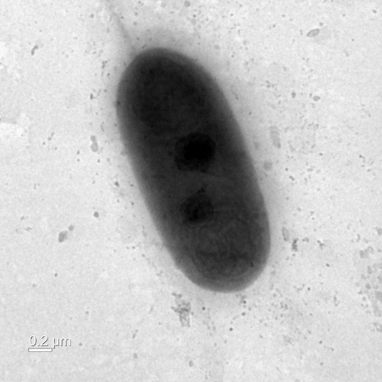
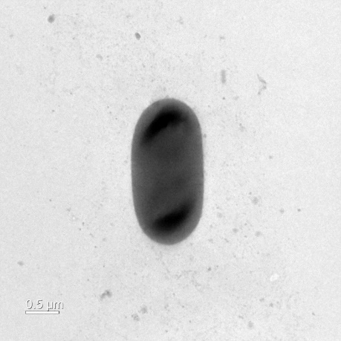
(a) (b)
Fig. S2. Maximum-Parsimony phylogenetic tree based on 16S rRNA gene sequences, showing the relationships of strains BT175^{T} and BT728^{T} with closely related validly published species. Bootstrap values (> 70%) based on 1,000 replications are shown at the branch nodes. Flexibacter elegans IFO 15055^{T} were used as an outgroup.
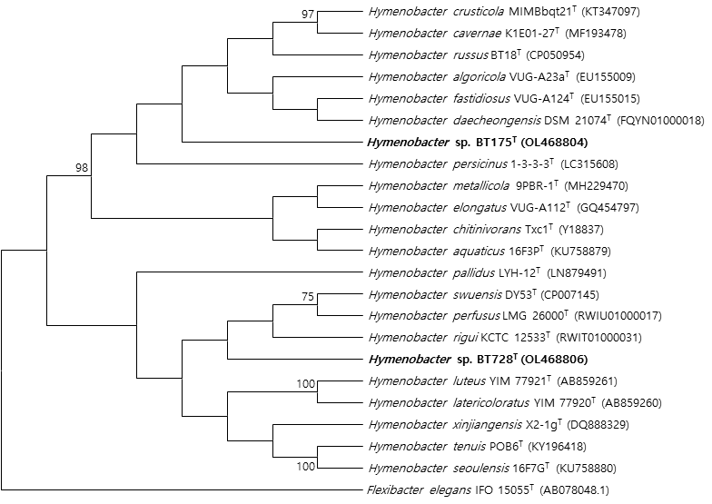

Fig. S3. Maximum-Likelihood phylogenetic tree based on 16S rRNA gene sequences showing the relationships of strains BT175^{T} and BT728^{T} with closely related validly published species. Bootstrap values (> 70%) based on 1,000 replications are shown at the branch nodes. Bar, 0.020 substitutions per nucleotide position. Flexibacter elegans IFO 15055^{T} were used as an outgroup.
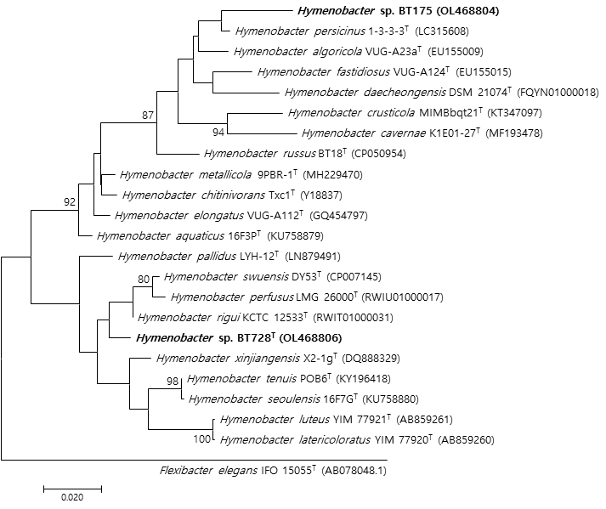

Fig. S4. Polar lipid profile of strain BT175^{T} after two-dimensional chromatography.
(a) total lipids; (b) phospholipids; (c) aminolipids; (d) glycolipids.
Abbreviations: L₁-L₆, unknown lipids; PL₁-PL₂, an unknown phospholipid; APL₁-APL₂, unknown aminophospholipids; PE, an unknown phosphatidylethanolamine.
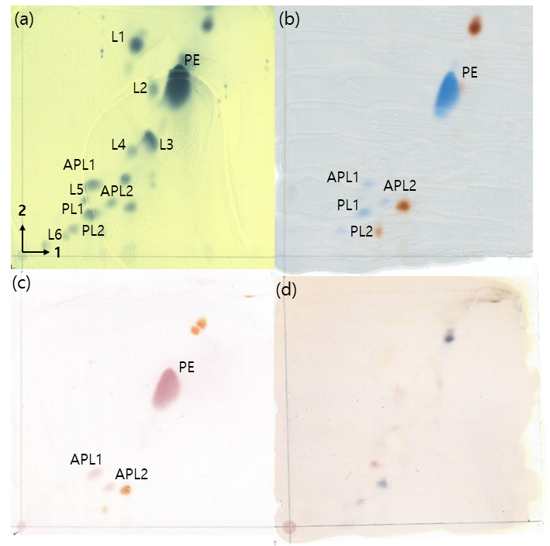
Fig. S5. Polar lipid profile of strain BT728^{T} after two-dimensional chromatography.
(a) total lipids; (b) phospholipids; (c) aminolipids; (d) glycolipids.
Abbreviations: L₁-L₄, unknown lipids; APL₁-APL₂, unknown aminophospholipids; PE, an unknown phosphatidylethanolamine.
