Supplemental Figure 1 The level of blood glucose in each group. ** P < 0.05 compared with control, HFD and HFD+5 mg/Kg QUE groups.

Supplemental Figure 2 The level of triglycerides in each group. ** P < 0.05 compared with control, HFD and HFD+5 mg/Kg QUE groups.

Supplemental Figure 3 The level of serum insulin in each group. ** P < 0.05 compared with control, HFD and HFD+5mg/Kg QUE groups.

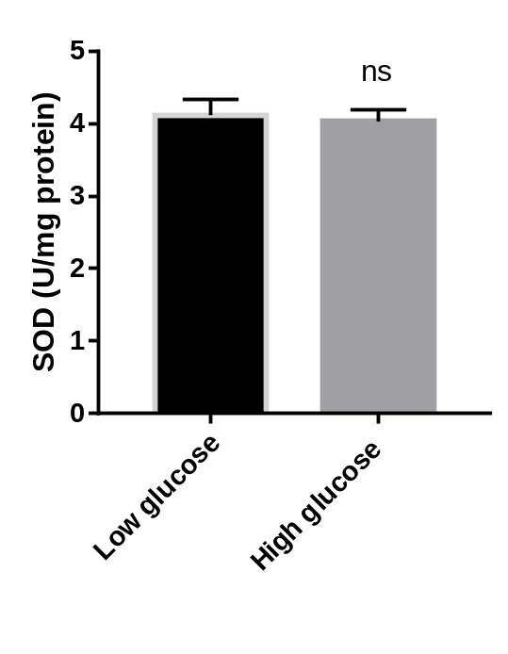
Supplemental Figure 4 Supplemental Figure S6 C2C12 cells were cultured in normal DMEM medium (1g/L glucose, low glucose) and DMEM medium with glucose concentration of 4.5g/L for 24 hours respectively, and the levels of SOD were detected.

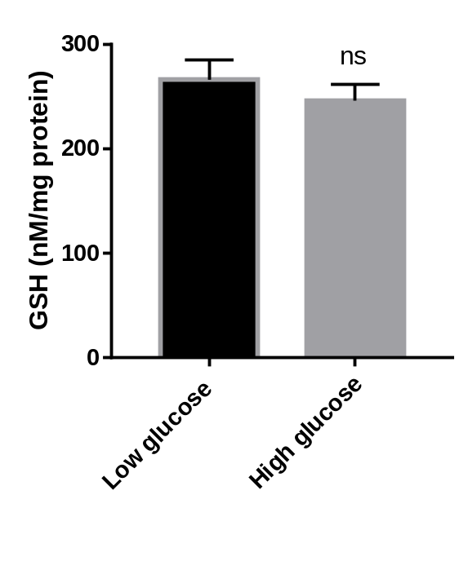
Supplemental Figure 5 Supplemental Figure S6 C2C12 cells were cultured in normal DMEM medium (1g/L glucose, low glucose) and DMEM medium with glucose concentration of 4.5g/L for 24 hours respectively, and the levels of GSH were detected.

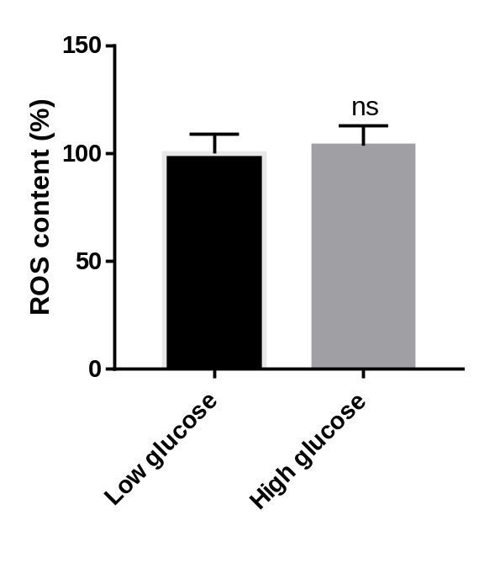
Supplemental Figure 6 C2C12 cells were cultured in normal DMEM medium (1g/L glucose, low glucose) and DMEM medium with glucose concentration of 4.5g/L for 24 hours respectively, and the levels of ROS were detected.

