Supplementary table S1: Characteristics of residents, MLST analysis and reasons for event or censoring in Kaplan Meier analysis per nursing home

 | Nursing home A | Nursing home B | Total
Resident characteristics
Male, n (%) | 51 (44,7) | 11 (36,7) | 62 (43.1)
Female, n (%) | 63 (55,3) | 19 (63,3) | 82 (56.9)
Age on day of first ESBL-EC positive rectal swab (years), median (IQR) | 82 (75 – 88) | 80 (71 – 85) | 82 (75 – 87)
MLST E. coli strains
ESBL-ST131, n (%) | 67 (58,8) | 17 (43,3) | 84 (58.3)
ESBL-non-ST131, n (%) | 47 (41,2) | 13 (56,7) | 60 (41.7)
Reasons for event of censoring in Kaplan Meier analysis
Loss of colonisation (event), n (%) | 52 (45.6) | 14 (46.7) | 66 (45.8)
Acquisition of other strain type (event), n (%) | 5 (4.4) | 1 (3.3) | 6 (4.2)
Still ESBL-EC positive at end of study (censored), n (%) | 2 (1.8) | 5 (16.7) | 7 (4.9)
Discharged in study period (censored), n (%) | 7 (6.1) | 2 (6.7) | 9 (6.3)
Deceased in study period (censored), n (%) | 48 (42.1) | 8 (26.7) | 56 (38.9)

Supplementary table S2: Characteristics of residents, MLST analysis and reasons for event or censoring in Kaplan Meier analysis per group (ESBL-ST131 and ESBL-non-ST131)
 | ESBL-ST131 | ESBL-non-ST131 | Total
Resident characteristics
Male n (%) | 36 (42.9) | 26 (43.3) | 62 (43.1)
Female, n (%) | 48 (57.1) | 34 (56.7) | 82 (56.9)
Age on day of first ESBL-EC positive rectal swab, median (IQR) | 82 (76 – 88) | 81 (72 – 86) | 82 (75 – 87)
Nursing home
Nursing home A, n (%) | 67 (58,8) | 17 (43,3) | 144 (100)
Nursing home B, n (%) | 17 (43,3) | 13 (56,7) | 30 (100)
Reasons for event of censoring in Kaplan Meier analysis
Loss of colonisation (event), n (%) | 28 (46.7) | 38 (45.2) | 66 (45.8)
Acquisition of other strain type (event), n (%) | 5 (8.3) | 1 (1.2) | 6 (4.2)
Still ESBL-EC positive at end of study (censored), n (%) | 2 (3.3) | 5 (6.0) | 7 (4.9)
Discharged in study period (censored), n (%) | 6 (10.0) | 3 (3.6) | 9 (6.3)
Deceased in study period (censored), n (%) | 19 (31.7) | 37 (44.0) | 56 (38.9)

Supplementary table S3: Mediation duration of colonisation in months stratified for females and males by ST131 group and log- rank test.

 | Median duration of carriage (months) | Log-rank test
ESBL-non-ST131
Female (n = 34) | 7.9 (1.4 – 14.4) | 0.992
Male (n = 26) | 11.2 (6.8 – 15.6) | 0.992
ESBL-ST131
Female (n = 48) | 25.7 (0.6 – 50.8) | 0.013
Male (n = 36) | 8.1 (5.9 – 10.3) | 0.013

Supplementary figure S4 Kaplan-Meier curve of survival probability of residents colonised with ESBL-non-ST131 by gender

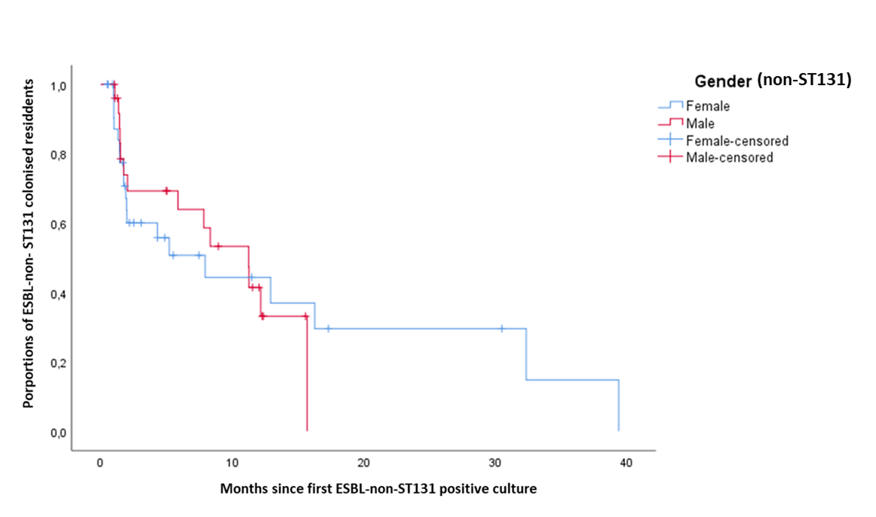

Supplementary figure S5 Kaplan-Meier curve of survival probability of residents colonised with ESBL-ST131 by gender
