Can Ecological Groups be Classified Quantitatively? A Model-Based Evaluation of the Ecological Grouping of Benthic Polychaete Species
GiSeop Lee¹², HongYeon Cho¹², Sunyoung Kim³, SangPil Yoon³, and SoHyun Park ³*

¹Marine Bigdata Center, Korea Institute of Ocean Science and Technology, Busan, 49111, South Korea
²University of Science and Technology, Daejeon, 34113, South Korea.
³Marine Environment Research Division, National Institute of Fisheries Science, Busan 46083, South Korea.

*Corresponding author: SoHyun Park (jing5678@naver.com)

Supplementary Information

Supporting Text 1
Original Text of the Public Notice^{[20]} (NIFS, 2020)
Regulations on Methods, Procedures, etc. for Evaluating Fishing Ground Environment 2020-15 [Korean Literature]

[Attached Table 1] <Created August 14, 2014>
Fishing Ground Environment Evaluation method (related to Article 3-2 (4))
1. After measuring the evaluation items for the environmental evaluation of fishing grounds, the score is calculated based on the following criteria.
Score  Evaluation Items | 1 point | 2 points | 3 points | 4 points
Total Organic Carbon  (TOC; mg/g dry) | ≤10.00 | 10.01–17.00 | 17.01–25.00 | ≥25.01
Benthic Health Index (BHI) | ≥71 | 51–70 | 26–50 | ≤25 or less
2. The Fishing Ground Environment Evaluation Index is calculated by adding the TOC and BHI scores calculated in accordance with subparagraph 1(above, author notation).
3. According to the Fishing Ground Environment Evaluation Index, the classes of fishing grounds subject to the fishing ground environment evaluation are determined as follows.
Class | Class 1 | Class 2 | Class 3 | Class 4
Fishing Ground Environment  Evaluation Index | 2–3 points | 4–5 points | 6–7 points | 8 points

[Appendix 3]
BHI Calculation Method

1. The benthic health index (BHI) is calculated using the equation provided below. The table below the equation is used for the benthic species corresponding to each group used in the calculation. When a species occurs that has not been presented in the table, a lower group among the species belonging to the same genus is selected; if there is no other species belonging to the same genus, the BHI is calculated as for Group 1.
BHI = 25((4×N₁ + 2.68×N₂ + 1.36×N₃ + 0.04×N₄) /N_{total})
where N is the number of individuals in each group
Group 1: Species that occur at low frequencies and densities or occur at high densities in low organic matter concentrations
Group 2: Species with an even distribution regardless of the organic matter concentration
Group 3: Species that occur at high densities in relatively high organic matter concentrations
Group 4: Species that occur in high organic matter concentrations or occur at high densities in sea areas where dead zones seasonally occur.

0 is assigned if benthic organisms that do not occur

2. List of species by polychaete group
EGs | Family | Species | In Korean
1 | Amphinomidae | Amphinome rostrata | 부리양목갯지렁이
 |  | Amphinomidae sp.
 | Aphroditidae | Aphrodita aculeata | 가시고슴도치갯지렁이
 |  | Aphrodita japonica | 갈고리고슴도치갯지렁이
 | Apistobranchidae | Apistobranchus tubergi
 | Arabellidae | Arabellidae unid.
 | Arenicolidae | Arenicola brasiliensis | 작은검은갯지렁이
 | Capitellidae | Heteromastus filiformis
 |  | Mediomastus californiensis
 |  | Notomastus latericeus | 가는버들갯지렁이
 | Chaetopteridae | Mesochaetopterus minuta | 모래무지날개갯지렁이
 | Chrysopetalidae | Bhawania goodei | 갈색비늘갯지렁이
 | Cossuridae | Cossuridae sp.
 | Eunicidae | Eunice antennata | 고리털갯지렁이
 |  | Eunice sp.
 |  | Lysidice collaris | 노란솜털갯지렁이
 |  | Lysidise sp.
 |  | Marphysa sanguinea | 바위털갯지렁이
 | Flabelligeridae | Brada villosa | 황금더덕갯지렁이
 | Glyceridae | Glycera capitata | 큰머리미갑갯지렁이
 |  | Glycera convoluta | 긴아가미미갑갯지렁이
 |  | Glycera dentribranchia | 다발아가미미갑갯지렁이
 |  | Glycera onomichiensis | 오노미치미갑갯지렁이
 |  | Hemipodus yenourensis | 반다리미갑갯지렁이
 | Goniadidae | Goniada japonica | 큰갈매기고리갯지렁이
 |  | Goniada maculata | 작은갈매기고리갯지렁이
 | Hesionidae | Hesiospina similis | 고리수염갯지렁이
 |  | Podarkeopsis sp.
 | Heterospionidae | Heterospio similis
 |  | Heterospio sinica
 | Lacydoniidae | Paralacydonia paradoxa | 은갯지렁이
 | Lumbrineridae | Lumbrineris latreilli
 |  | Lumbrineris sp.
 |  | Ninoe palmata
 | Magelonidae | Magelona koreana
 |  | Magelona sp.
 | Maldanidae | Asychis disparidentata | 톱수슬대나무갯지렁이
 |  | Asychis pigmentata | 점박이대나무갯지렁이
 |  | Clymenella koellikeri | 띠대나무갯지렁이
 |  | Euclymene oerstedi
 |  | Euclymene uncinata
 |  | Maldane cristata | 민숭대나무갯지렁이
 |  | Maldanidae sp.
 |  | Microclymene propecaudata | 꼬마대나무갯지렁이
1 | Nephtyidae | Aglaophamus lobatus
 |  | Aglaophamus tepens
 |  | Micronephtys sphaerocirrata orientalis | 꼬마백금갯지렁이
 | Nereidae | Ceratonereis mirabilis | 등수염창갯지렁이
 |  | Leonnates persica
 |  | Neanthes flava
 |  | Nectoneanthes oxypoda | 넓적발참갯지렁이
 |  | Nereidae sp.
 |  | Nereis pelagica | 원참갯지렁이
 |  | Nereis sinensis
 |  | Perineris caltrifera
 |  | Tambalagamia fauveli | 쌍수염참갯지렁이
 | Onuphidae | Nothria shirikishinaiensis | 실집갯지렁이
 | Opheliidae | Polyopthalmus pictus | 무늬요정갯지렁이
 | Orbiniidae | Haploscoloplos elongatus | 갓모갯지렁이
 |  | Scoloplos rubra
 | Paraonidae | Aedicira pacifica
 |  | Aricidea horokoshii
 |  | Aricidea jeffreysii
 |  | Aricidea sp.
 |  | Cirrophorus branchiatus
 |  | Paraonidae sp.
 | Pectinariidae | Cistenides okudai | 곤봉빗갯지렁이
 | Phyllodocidae | Anaitides chinensis | 중국부채발갯지렁이
 |  | Anaitides koreana | 한국부채발갯지렁이
 |  | Anaitides sp.
 |  | Eulalia sp.
 |  | Mysta ornata | 혹부채발갯지렁이
 |  | Notophyllum splendens
 | Pilargiidae | Ancistrosyllis groenlandica
 |  | Cabira pilargiformis japonica
 |  | Pilargis berkeleyae
 | Pisionidae | Pisione sp.
 | Poecilochaetidae | Poecilochaetus sp.
 | Polynoidae | Halosydnopsis pilosa | 가는혹비늘갯지렁이
 |  | Lepidasthenia maculata | 날씬긴비늘갯지렁이
 |  | Lepidonotinae sp.
 |  | Lepidonotus dentatus | 이예뿐이비늘갯지렁이
 |  | Lepidonotus helotypus | 송곳예쁜이비늘갯지렁이
 |  | Perolepis stylolepis | 벌거숭이비늘갯지렁이
 |  | Polynoella levisetosa | 작은비늘갯지렁이
 | Polyodontidae | Polyodontes melanonotus
 | Questidae | Questidae sp.
 | Sabellariidae | Idanthyrsus armatus | 양면울타리갯지렁이
 |  | Lygdamis giardi | 홈울타리갯지렁이
1 | Sabellidae | Chone sp.
 |  | Myxicola infundibulum | 깔때기꽃갯지렁이
 |  | Pseudopotamilla occelata
 | Scalibregmidae | Scalibregma inflaum | 수염구더기갯지렁이
 |  | Scalibregmidae sp.
 | Sigalionidae | Sigalionidae sp.
 |  | Sthenelais fusca | 갈색뱀고랑비늘갯지렁이
 | Sphaerodoridae | Sphaerodoridae sp.
 |  | Sphaerodorum gracile
 | Spionidae | Dipolydora socialis
 |  | Malacoceros indicus
 |  | Minuspio elongata
 |  | Minuspio membranacea
 |  | Paraprionospio cordifolia
 |  | Prionospio depauperata
 |  | Prionospio paradisea
 |  | Pseudopolydora kempi
 |  | Scolelepis variegata
 |  | Spio borealis | 달걀얼굴갯지렁이
 |  | Spio filicornis | 혹달걀얼굴갯지렁이
 |  | Spio martinensis
 |  | Spio sp.
 |  | Spiophanes sp.
 | Sternaspidae | Sternaspis scutata | 오뚜기갯지렁이
 | Syllidae | Exogone sp.
 |  | Exogone verugera | 짧은더듬이달걀발갯지렁이
 | Terebellidae | Amphitrite cirrata | 실꽃유령갯지렁이
 |  | Amphitrite edwardsii | 에드워드꽃유령갯지렁이
 |  | Pista sp.
 |  | Terebella punctata | 점고목유령갯지렁이
 |  | Terebella sp.
 | Trichobranchidae | Trichobranchus glacialis | 여섯조름털갯지렁이
 | Trochochaetidae | Trochochaetidae sp.
2 | Ampharetidae | Amage auricula | 뿔사슴갯지렁이
 |  | Ampharete arctica | 작은사슴갯지렁이
 |  | Amphicteis gunneri | 큰사슴갯지렁이
 |  | Amphisamytha japonica | 고리사슴갯지렁이
 |  | Isolda pulchella
 |  | Melinna elisabethae | 황금뿔사슴갯지렁이
 | Amphitritidae | Amphitritinae spp.
 | Arabellidae | Drilonereis filum
 | Arenicolidae | Abarenicola pacifica | 큰검은갯지렁이
 | Capitellidae | Leiochrides sp.
 | Chrysopetalidae | Chrysopetalum occidentale | 황금비늘갯지렁이
 | Cirratulidae | Chaetozone sp.
 |  | Chaetozone spinosa | 긴털바퀴실타래갯지렁이
2 |  | Tharyx spp.
 | Flabelligeridae | Brada villosa capensis
 |  | Flabelligeridae sp.
 | Glyceridae | Glycera alba | 짧은아가미미갑갯지렁이
 |  | Glycera chirori | 치로리미갑갯지렁이
 | Goniadidae | Glycinde gurjanovae
 | Hesionidae | Hesionides sp.
 |  | Micropodarke dubia | 작은수염갯지렁이
 |  | Ophiodromus pugettensis | 뱀수염갯지렁이
 | Lumbrineridae | Lumbrineris cruzensis
 |  | Lumbrineris heteropoda | 긴다리송곳갯지렁이
 |  | Lumbrineris japonica | 참송곳갯지렁이
 |  | Ninoe japonica
 | Magelonidae | Magelona japonica | 양손갯지렁이
 | Maldanidae | Clymenella koreana | 한국대나무갯지렁이
 |  | Praxillella affinis | 꼬리대나무갯지렁이
 | Nephtyidae | Inermonephtys gallardi
 |  | Nephtys oligobranchia | 광염백금갯지렁이
 |  | Nephtys polybranchia | 남방백금갯지렁이
 | Nereidae | Neanthes japonica | 참갯지렁이
 |  | Nectoneanthes multignatha
 |  | Nereis longior | 길쭉참갯지렁이
 |  | Platynereis bicanaliculata | 두점참갯지렁이
 | Onuphidae | Diopatra sugokai | 털보집갯지렁이
 | Opheliidae | Ammotrypane aulogaster | 매끈요정갯지렁이
 |  | Armandia simodaensis | 둥근보석요정갯지렁이
 |  | Travisia pupa | 번데기요정갯지렁이
 | Orbiniidae | Naineris lavigata | 모자갯지렁이
 |  | Phylo felix
 |  | Scoloplos armiger | 삼각모자갯지렁이
 | Oweniidae | Myriochele oculata | 관버섯갯지렁이
 |  | Owenia gomsoni
 | Paraonidae | Aricidea assimilis
 |  | Cirrophorus furcatus
 |  | Paraonis glacilis japonica
 | Pectinariidae | Lagis bocki | 잎빗갯지렁이
 | Phyllodocidae | Anaitides maculata | 네모부채발갯지렁이
 |  | Eteone longa | 작은부채발갯지렁이
 |  | Eumida sanguinea | 심장부채발갯지렁이
 |  | Genetyllis castanea | 납작수염부채발갯지렁이
 |  | Phyllodocidae sp.
 | Polynoidae | Halosydna brevisetosa | 짧은미륵비늘갯지렁이
 |  | Harmothoe imbricata | 옆눈비늘갯지렁이
 |  | Harmothoinae spp.
 |  | Polynoidae sp.
 | Sabellidae | Chone teres | 빛꽃갯지렁이
2 |  | Sabellidae sp.
 | Scalibregmidae | Oncoscolex pacificus borealis | 민구더기 갯지렁이
 | Sigalionidae | Sthenolepis japonica | 큰모래고랑비늘갯지렁이
 | Spionidae | Aonides oxycephala
 |  | Laonice cirrata | 납작얼굴갯지렁이
 |  | Minuspio japonica
 |  | Polydora spp.
 |  | Prionospio membranacea
 |  | Prionospio saccifera
 |  | Pseudopolydora paucibranchiata | 둥근선녀얼굴갯지렁이
 |  | Rhynchospio tuberculata
 |  | Scolelepis sp.
 |  | Spiophanes kroeyeri
 | Syllidae | Syllidae spp.
 | Terebellidae | Amaeana occidentalis
 |  | Loimia medusa | 괴물유령갯지렁이
 |  | Pista cristata | 총채유령갯지렁이
 |  | Pista quadrilobata
 |  | Terebellidae spp.
 |  | Thelepus setosus | 마당비유령갯지렁이
 |  | Thelepus sp.
 | Trichobranchidae | Terebellides japonica
3 | Sabellidae | Euchone alicaudata | 홈꽃갯지렁이
 | Cirratulidae | Aphelochaeta monilaris
 |  | Chaetozone setosa | 솜털바퀴실타래갯지렁이
 |  | Cirratulidae sp.
 |  | Cirratulus cirratus | 가는실타래갯지렁이
 |  | Cirriformia tentaculata | 명주실타래갯지렁이
 | Lumbrineridae | Lumbrineris longifolia
 | Nereidae | Neanthes caudata | 둥근얼굴참갯지렁이
 |  | Neanthes succinea | 두줄박이참갯지렁이
 | Opheliidae | Armandia lanceolata | 침보석요정갯지렁이
 | Paraonidae | Aricidea neosuecica nipponica
 | Pilargiidae | Sigambra tentaculata
 | Spionidae | Aquilaspio krusadensis
 |  | Minuspio multibranchiata
 |  | Paraprionospio coora
 | Terebellidae | Amphitrite oculata | 눈꽃유령갯지렁이
 |  | Thelepus toyamaensis | 짧은사리비유령갯지렁이
4 | Capitellidae | Capitella capitata | 등가시버들갯지렁이
 | Chaetopteridae | Spiochaetopterus koreana
 | Dorvilleidae | Dorvillea rudolphi
 | Spionidae | Minuspio pulchra
 |  | Paraprionospio patiens

Supporting Text 2
Ellipse Fitting Details
The optimal elliptic parameter fitting method is a more robust algorithm for singular matrices compared to the method proposed by Fitzgibbon et al.^{[30]}. Hence, this was proposed as a method for singular matrices that occur when the coordinates used for estimation are in almost identical elliptical orbits^{[31]}.

The shape of an ellipse can be expressed as a quadratic polynomial function as follows:

$$f\left(x,y\right)=β_{20}x^{2}+β_{11}xy+β_{02}y^{2}+β_{10}x+β_{01}y+β_{00}=0$$

where the discriminant that satisfies the ellipticity condition is $β_{11}^{2}-4β_{20}β_{02}<0$. The previous equation can be expressed as a vector for the data to be fit, as follows:

$f\left(X\right)=X∙β=0$

where the coefficient matrices $β$ and $X$ are as follows, and each is divided into two regions:
$β=\left[\begin{matrix}β_{1}|⋮β_{2}\end{matrix}\right]$ $X=\left[\begin{matrix}X_{1}|X_{2}\end{matrix}\right]$

For the above equations, the coefficients of the elliptic equation fitted to $\begin{matrix}x_{i}\end{matrix}, \begin{matrix}y_{i}\end{matrix}$ are calculated as follows. The input information required for calculation are the $\begin{matrix}X[6×n]\end{matrix}$,$C[6×6]$ matrices, and $C_{1}[3×3]$ is the constraint matrix of the elliptic equation.
$C=\left[\begin{matrix}C_{1} & 0 \\ 0 & 0\end{matrix}\right]$, $C_{1}=\left[\begin{matrix}0 & 0 & 2 \\ 0 & -1 & 0 \\ 2 & 0 & 0\end{matrix}\right]$, $0=\left[\begin{matrix}0 & 0 & 0 \\ 0 & 0 & 0 \\ 0 & 0 & 0\end{matrix}\right]$
$X_{1}=\left[\begin{matrix}x_{1}^{2} & x_{1}y_{1} & y_{1}^{2} \\ ⋮ & ⋮ & ⋮ \\ x_{i}^{2} & x_{i}y_{i} & y_{i}^{2} \\ ⋮ & ⋮ & ⋮ \\ x_{n}^{2} & x_{n}y_{n} & y_{n}^{2}\end{matrix}\right]$, $X_{2}=\left[\begin{matrix}x_{1} & y_{1} & 1 \\ ⋮ & ⋮ & ⋮ \\ x_{i} & y_{i} & 1 \\ ⋮ & ⋮ & ⋮ \\ x_{n} & y_{n} & 1\end{matrix}\right]$
The calculation process for the coefficient matrix $β$ is as follows. First, a scatter matrix $S[6×6]$ is configured.
$S=\left[\begin{matrix}S_{1} & S_{2} \\ S_{2}^{T} & S_{3}\end{matrix}\right]$

where $S_{1}=X_{1}^{T}X_{1}\left[3×3\right]$, $S_{2}=X_{1}^{T}X_{2}[3×3]$, and $S_{3}=X_{2}^{T}X_{2}[3×3]$, and $C_{1}$, $S_{1}$, $S_{2}$, and $S_{3}$ are used to calculate the reduced scatter matrix $M[3×3]$ as follows:
$M=C_{1}^{-1}\left(S_{1}-S_{2}S_{3}^{-1}S_{2}^{T}\right)$

Next, the eigenvalues and eigenvectors of matrix $M$ are obtained as follows:
$Mν=λν$

As matrix $M$ is $[3×3]$, three eigenvalues and three eigenvectors are obtained as follows:

$λ_{1}ν_{1}$, $λ_{2}ν_{2}$, $λ_{3}ν_{3}$

Here, the eigenvalues are typically calculated as two negative numbers and one positive number, and the eigenvector for one positive eigenvalue is $β_{1}$. $β_{1}$. This is used to calculate $β_{2}$ as follows:

$β_{2}=S_{3}^{-1}S_{2}^{T}β_{1}$

After estimating the ellipse parameter $β$, it is converted back into a meaningful value in the data space.

The center coordinates of the ellipse ($x_{c},y_{c}$) are calculated as follows^{[S1]}:
$2β_{20}x_{c}+β_{11}y_{c}+β_{10}=0$
$β_{11}x_{c}+2β_{02}y_{c}+β_{01}=0$

$\left[\begin{matrix}2β_{20} & β_{11} \\ β_{11} & 2β_{02}\end{matrix}\right]\left[\begin{matrix}x_{c} \\ y_{c}\end{matrix}\right]=\left[\begin{matrix}-β_{10} \\ -β_{01}\end{matrix}\right]$
$\left[\begin{matrix}x_{c} \\ y_{c}\end{matrix}\right]={\left[\begin{matrix}2β_{20} & β_{11} \\ β_{11} & 2β_{02}\end{matrix}\right]}^{-1}\left[\begin{matrix}-β_{10} \\ -β_{01}\end{matrix}\right]$

The major and minor axes are calculated as follows:
$D=2\left(β_{20}β_{01}^{2}+β_{02}β_{10}^{2}+β_{00}β_{11}^{2}-β_{11}β_{10}β_{01}-4β_{20}β_{02}β_{00}\right)$
$d_{1}=β_{11}^{2}-4β_{20}β_{02}$, $d_{2}=\sqrt{{\left(β_{20}-β_{02}\right)}^{2}+β_{11}^{2}}$, $d_{3}=β_{20}+β_{02}$
$R={\left[\sqrt{\frac{D}{d_{1}\left(d_{2}-d_{3}\right)}},\sqrt{-\frac{D}{d_{1}\left(d_{2}+d_{3}\right)}}\right]}^{T}={\left[\begin{matrix}R_{1} & R_{2}\end{matrix}\right]}^{T}$

In $R_{1}$ and $R_{2}$, the larger value is the length of the major axis, and the smaller value is the length of the minor axis. The oblateness is a variable derived from the major-to-minor axis ratio.

References
S1 Pu, J., Zheng, B., Leader, J. K., & Gur, D. An ellipse‐fitting based method for efficient registration of breast masses on two mammographic views. Med. Phys. 35, 487-494 (2008).
Supplementary Figures
Supplementary Figure 1. Representative examples of species for fitting the results of elliptic equations. Blue and light blue areas indicate are hull bags and hull loops, respectively. The red lines are ellipses fitted with the least-squares method. TOC: total organic carbon.

Cabira pilargiformis japonica (Group 1) | Thelepus sp.(Group 2)
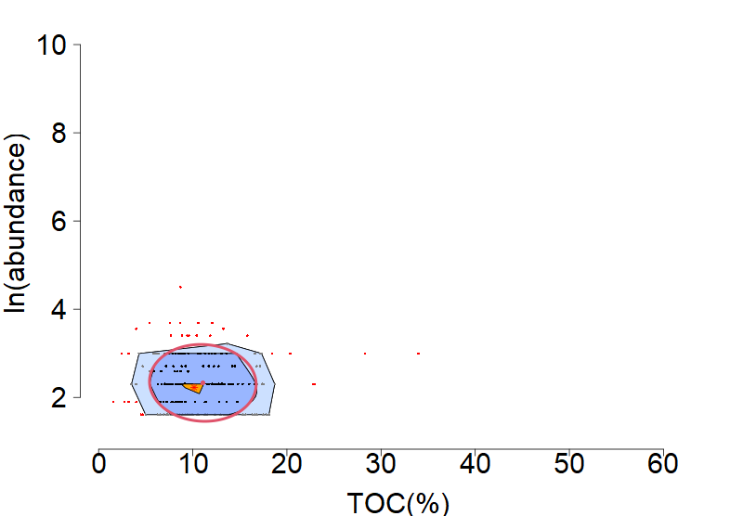 | 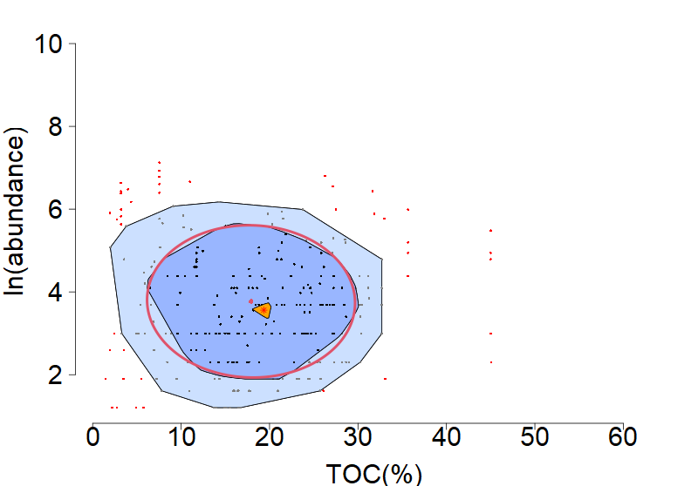
Lumbrineris longifolia (Group 3) | Paraprionospio patiens (Group 4)
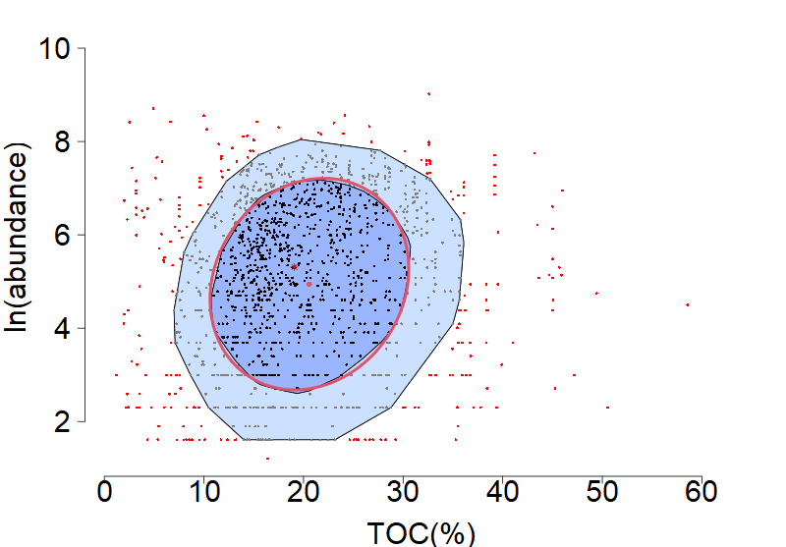 | 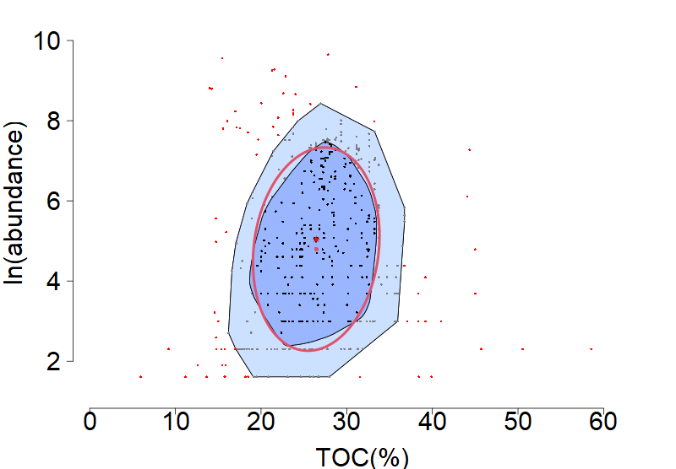

Supplementary Figure 2. Examples of TOC (x-axis)-abundance (y-axis) images generated using 2D kernel density. Group 4 was not used in the classification models. TOC: total organic carbon.

Cabira pilargiformis japonica (Group 1) | Thelepus sp. (Group 2)
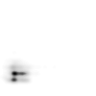 | 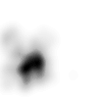
Lumbrineris longifolia (Group 3) | Paraprionospio patiens (Group 4)
 | 

Supplementary Figure 3. CNN model training and validation results for a specific subset of the data, including Group 4. The classification accuracy is approximately 78%. CNN: convolutional neural network.

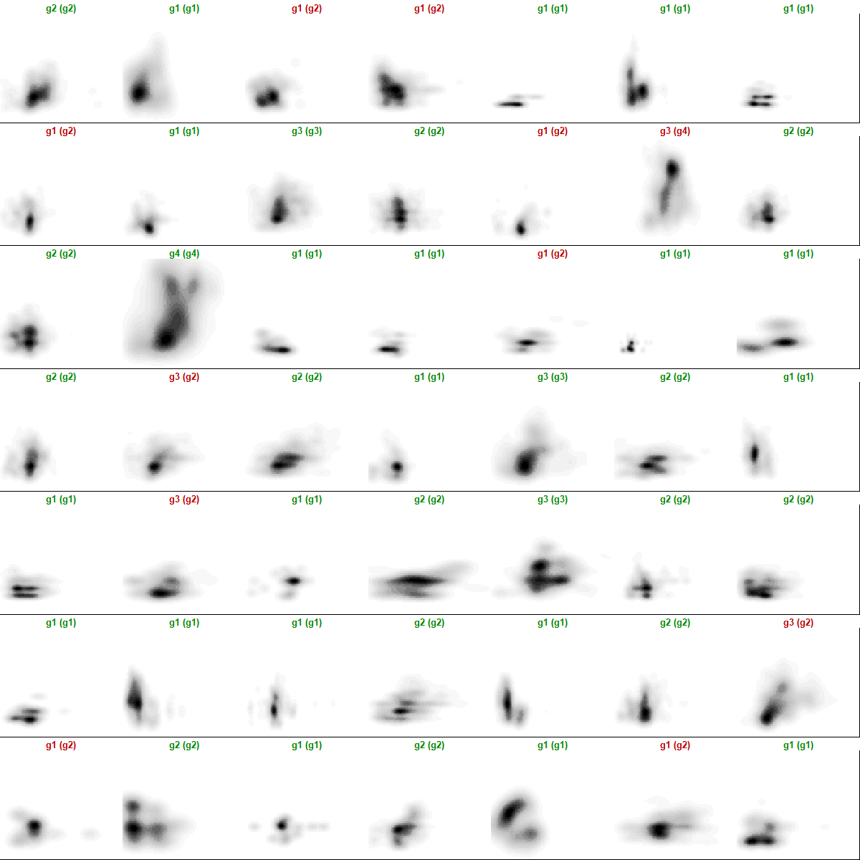

Supplementary Figure 4. Comparison of EG classifications in South Korea, EU, and USA with those in this study using the AHC, ABDT, and CNN models. EU: European Union; EG: environmental grade; AHC: agglomerative hierarchical clustering; ABDT: adaptive boosting decision tree; CNN: convolutional neural network.
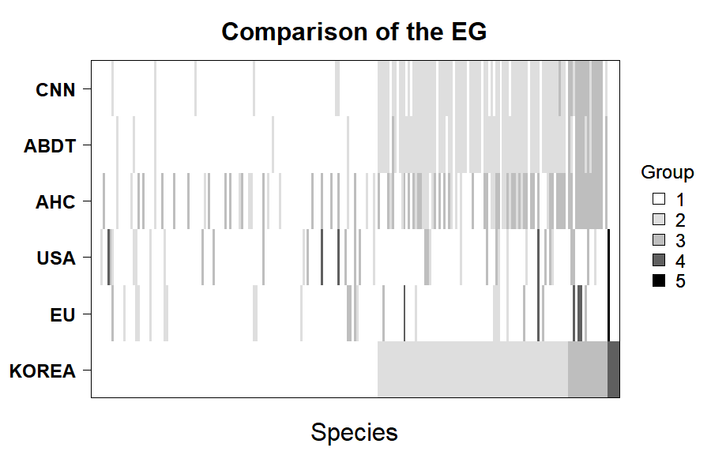

Supplementary Table 1. Confusion matrix corresponding to Figure S3 (classification results for a specific subset of the data).
KDE2D-CNN  NIFS notice | 1 | 2 | 3 | 4
1 | 20 | 0 | 0 | 0
2 | 7 | 14 | 3 | 0
3 | 0 | 0 | 3 | 0
4 | 0 | 0 | 1 | 1

