Authors details:
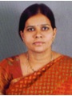
Dr. Rama Devi Boddu 1 completed her Ph.D. from JNTUH College of Engineering, Hyderabad, and Telangana, India in April 2016. At present, she is working as a Professor, in the department of ECE at Kakatiya Institute of Technology and Science-Warangal (KITSW), Telangana, India. She authored 40 publications, 2 books, and filed 3 patents. Her research area is wireless communication and networks.

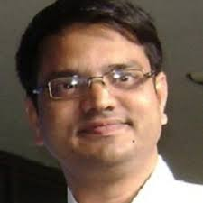
Dr. Ashoka Reddy Komalla – He completed Ph.D. in 2002 from IITM, India. At present Dr. Reddy working as Principal, KITSW. He published 3 books, more than 100 articles in reputed journals and conferences, and filed 3 patents. His research area is signal processing and instrumentation.

