Appendix

Degree of Balance
 | Remifentanil Use
 | No | Yes
Gender | 1.15 | 1.49
Age | 62.04 | 61.19
Body Mass Index (BMI) | 24.92 | 25.17
Type of Operation (Visceral, Gynaecological, Urological) | 1.36 | 1.44
ASA | 2.38 | 2.32
Operation Risk (Low, Medium, High) | 1.69 | 1.57
Preoperative Hemoglobin (mg/dL) | 12.38 | 12.44
History of Ischemic Heart Disease | 1.11 | 1.10
History of Cerebrovascular Accident | 1.03 | 1.03
Duration of Surgery (min) | 211.30 | 238.17
Preoperative Creatinine (μmol/L) | 93.01 | 91.88

Plot histograms of the estimated propensity scores by treatment status
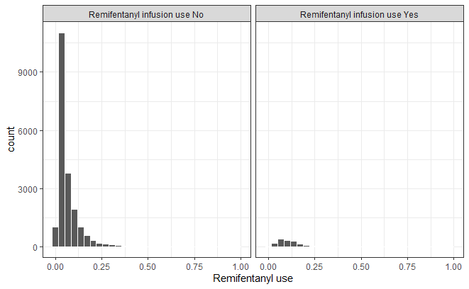

Summary of Balance for All Data
 | Means Treated | Means Control | Std. Mean Diff. | Var. Ratio | eCDF Mean | eCDF Max
Distance | 0.1201 | 0.0643 | 0.7955 | 1.1451 | 0.2871 | 0.4997
Gender | 0.4989 | 0.4707 | 0.0565 |  | 0.0283 | 0.0283
Age | 61.1420 | 59.0567 | 0.1543 | 0.8105 | 0.0249 | 0.0811
Body Mass Index (BMI) | 25.1852 | 31.1624 | -0.9279 | 0.0000 | 0.0112 | 0.0312
Type of Operation (Visceral, Gynaecological, Urological) | 1.4483 | 1.6073 | -0.2112 | 0.7582 | 0.0530 | 0.0949
ASA Class | 2.3199 | 2.1469 | 0.2955 | 0.8333 | 0.0297 | 0.0981
Operation Risk (Low, Medium, High) | 2.5141 | 2.0358 | 0.8491 | 0.7137 | 0.1595 | 0.3070
Preoperative Hemoglobin (mg/dL) | 12.4453 | 12.7744 | -0.1627 | 0.9890 | 0.0237 | 0.0871
Urgency of Surgery | 1.0620 | 1.1385 | -0.3170 | 0.4878 | 0.0382 | 0.0765
History of Ischemic Heart Disease | 0.1045 | 0.1036 | 0.0029 |  | 0.0009 | 0.0009
History of Cerebrovascular Accident | 0.0337 | 0.0340 | -0.0018 |  | 0.0003 | 0.0003
Operation Duration (minutes) | 237.8449 | 133.2820 | 0.8413 | 1.0557 | 0.1918 | 0.4682
Preoperative Creatinine (μmol/L) | 92.1431 | 99.0727 | -0.0698 | 0.7678 | 0.0078 | 0.0498

Summary of Balance for Matched Data
 | Means Treated | Means Control | Std. Mean Diff. | Var. Ratio | eCDF Mean | eCDF Max | Std. Pair Dist.
Distance | 0.1201 | 0.1201 | 0.0001 | 0.9997 | 0.0000 | 0.0027 | 0.0004
Gender | 0.4989 | 0.5218 | -0.0457 |  | 0.0229 | 0.0229 | 0.9859
Age | 61.1420 | 60.9924 | 0.0111 | 0.9087 | 0.0100 | 0.0305 | 1.0926
Body Mass Index (BMI) | 25.1852 | 25.0679 | 0.0182 | 0.9277 | 0.0072 | 0.0223 | 0.9167
Type of Operation (Visceral, Gynaecological, Urological) | 1.4483 | 1.3765 | 0.0954 | 1.0846 | 0.0239 | 0.0560 | 0.8255
ASA Class | 2.3199 | 2.3417 | -0.0372 | 0.8383 | 0.0107 | 0.0348 | 0.9607
Operation Risk (Low, Medium, High) | 2.5141 | 2.5751 | -0.1082 | 1.0619 | 0.0203 | 0.0544 | 0.4249
Preoperative Hemoglobin (mg/dL) | 12.4453 | 12.4129 | 0.0160 | 0.9970 | 0.0038 | 0.0163 | 1.1225
Urgency of Surgery | 1.0620 | 1.0724 | -0.0428 | 0.8667 | 0.0052 | 0.0103 | 0.4307
History of Ischemic Heart Disease | 0.1045 | 0.1110 | -0.0213 |  | 0.0065 | 0.0065 | 0.5906
History of Cerebrovascular Accident | 0.0337 | 0.0348 | -0.0060 |  | 0.0011 | 0.0011 | 0.3556
Operation Duration (minutes) | 237.8449 | 217.0696 | 0.1672 | 0.8093 | 0.0456 | 0.1366 | 0.7874
Preoperative Creatinine (μmol/L) | 92.1431 | 93.0550 | -0.0092 | 0.9774 | 0.0026 | 0.0152 | 0.6241

Percent Balance Improvement
 | Standard Mean Difference | Variance Ratio | eCDF Mean | eCDF Max
Distance | 100.0 | 99.8 | 100.0 | 99.5
Gender | 19.1 |  | 19.1 | 19.1
Age | 92.8 | 54.4 | 60.0 | 62.4
Body Mass Index (BMI) | 98.0 | 99.3 | 35.8 | 28.5
Type of Operation (Visceral, Gynaecological, Urological) | 54.8 | 70.7 | 54.8 | 40.9
ASA Class | 87.4 | 3.2 | 64.0 | 64.5
Operation Risk (Low, Medium, High) | 87.3 | 82.2 | 87.3 | 82.3
Preoperative Hemoglobin (mg/dL) | 90.2 | 72.8 | 83.8 | 81.2
Urgency of Surgery | 86.5 | 80.1 | 86.5 | 86.5
History of Ischemic Heart Disease | -640.6 |  | -640.6 | -640.6
History of Cerebrovascular Accident | -242.7 |  | -242.7 | -242.7
Operation Duration (minutes) | 80.1 | -290.6 | 76.2 | 70.8
Preoperative Creatinine (μmol/L) | 86.8 | 91.4 | 66.6 | 69.4

Sample Sizes
 | Control | Treated
All | 25169 | 1838
Matched | 1838 | 1838
Unmatched | 23331 | 0
Discarded | 0 | 0

Empirical Quantile-Quantile (eQQ) Plots
Gender  Age  BMI  Type of operation  ASA Class  Operation risk  Preoperative Hemoglobin (mg/dL)  Urgency of Surgery  History of Ischemic Heart Disease  History of Cerebrovascular Accident  Operation Duration (minutes)  Preoperative Creatinine (μmol/L) | 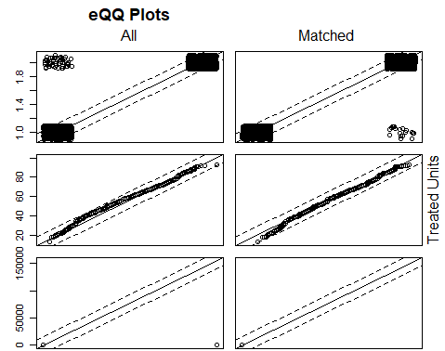  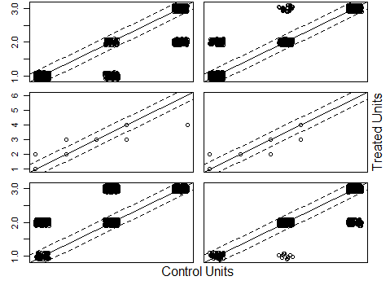  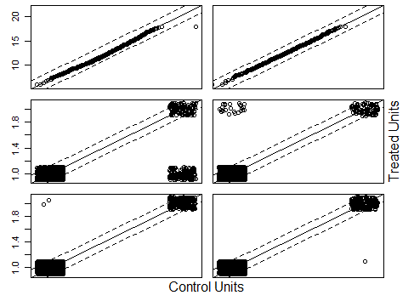  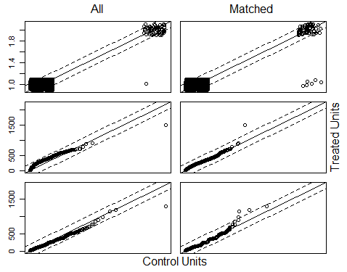

Propensity Score Plots
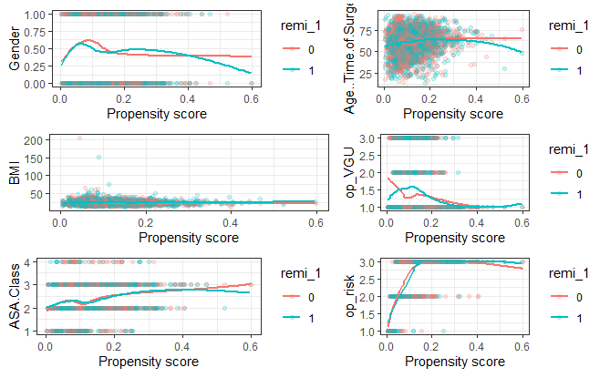
Legend for Propensity Score Plots
Label | Variable
Gender | Gender
Age.. Time.of.Surgery | Age
BMI | Body Mass Index
ASA.Class | American Society of Anesthesiology (ASA) class
op_VGU | Type of Operation (Visceral, Gynecological, Urological)
op_risk | Operation Risk (Low, Intermediate, High)
remi_1 | Remifentanil infusion given intraoperatively

