Supporting Information
DFT Study of the Structural, Electronic, Bonding Nature, NBO Analysis, and Thermodynamic Properties of Halogenated (F, Cl, Br) and Heteroatom (O, N, S) doped Cyclopropane
Emmanuel I. Ubana¹, Hitler Louis^{1*}, Obieze C. Enudi¹, Moses M. Edim^{1&2}, Prince David, Idante P. Samuel¹, and Benedict I. Ita¹
¹Computational and Bio-Simulation Research Group, University of Calabar, Calabar, Nigeria
²Department of Chemistry, Faculty of Physical Sciences, Cross River University of Technology, Calabar, Nigeria
*Corresponding author’s email: louismuzong@gmail.com;

TABLE S1: bond order of c3, c3f, c3cl, c3br, c3n, c3o, c3s obtained from multiwavefunction program.
C3
BOND ORDER | VALUE
C1 ; C2 | 0.695
C1 ; C3 | 0.701
C1 ; H4 | 0.819
C1 ; H5 | 0.819
C2 ; C3 | 0.699
C2 ; H6 | 0.818
C2 ; H7 | 0.818
C3 ; H8 | 0.818
C3 ; H9 | 0.818
C3F
BOND ORDER | VALUE
C1 ; C2 | 0.626
C1 ; C3 | 0.809
C1 ; H4 | 0.814
C1 ; H5 | 0.811
C2 ; C3 | 0.809
C2 ; H6 | 0.814
C2 ; H7 | 0.811
C3 ; H8 | 0.841
C3 ; F9 | 0.11
C3Cl
BOND ORDER | VALUE
C1 ; C2 | 0.661
C1 ; C3 | 0.734
C1 ; H4 | 0.815
C1 ; H5 | 0.818
C2 ; C3 | 0.735
C2 ; H6 | 0.815
C2 ; H7 | 0.818
C3 ; H8 | 0.833
C3 ; Cl9 | 0.447
C3Br
BOND ORDER | VALUE
C1 ; C2 | 0.663
C1 ; C3 | 0.729
C1 ; H4 | 0.817
C1 ; H5 | 0.819
C2 ; C3 | 0.73
C2 ; H6 | 0.817
C2 ; H7 | 0.819
C3 ; H8 | 0.832
C3 ; Br9 | 0.312
C3N
BOND ORDER | VALUE
C1 ; C2 | 0.77
C1 ; H3 | 0.826
C1 ; H4 | 0.836
C1 ; N7 | 0.47
C2 ; H5 | 0.826
C2 ; H6 | 0.836
C2 ; N7 | 0.472
N7 ; H8 | 0.685
C3O
BOND ORDER | VALUE
C1 ; C2 | 0.805
C1 ; H3 | 0.823
C1 ; H4 | 0.823
C1 ; O7 | 0.207
C2 ; H5 | 0.824
C2 ; H6 | 0.824
C2 ; O7 | 0.206
C3S
BOND ORDER | VALUE
C1 ; C2 | 0.97
C1 ; H3 | 0.834
C1 ; H4 | 0.834
C1 ; S7 | 0.34
C2 ; H5 | 0.834
C2 ; H6 | 0.834
C2 ; S7 | 0.34

Table S2: Energy, wave lengths, and orbital contribution in electronic transition of C3, C3F, C3Cl, C3Br, C3N, C3O, C3S
CYCLOPROPANE
EXCITED STATE | WAVE LENGTH (nm) | ENERGY (eV) | OSCILLATOR STRENGTH | MAJOR CONTRIBUTIONS
S0-S1 12->13 | 172.39 | 7.191 | 0.0009 | 99.17%(HOMO)-LUMO+1)
S0-S2 11->13 | 172.37 | 7.1928 | 0.0009 | 99.17%(HOMO-1)-(LUMO+1)
S0-S3 12->14 | 163.46 | 7.5848 | 0 | 98.79%(HOMO)-(LUMO+3)
F-CYCLOPROPANE
EXCITED STATE | WAVE LENGTH (nm) | ENERGY (eV) | OSCILLATOR STRENGTH | MAJOR CONTRIBUTIONS
S0-S1 16->17 | 175.51 | 7.0643 | 0.005 | 97.66%(HOMO)-(LUMO+1)
S0-S2 15-17 | 167.47 | 7.4032 | 0.0014 | 97.96%(HOMO-1)-(LUMO+1)
S0-S3 16-18 | 166.03 | 7.4675 | 0.0137 | 96.19%(HOMO)-(LUMO+2)
Cl-CYCLOPROPANE
EXCITED STATE | WAVE LENGTH (nm) | ENERGY (eV) | OSCILLATOR STRENGTH | MAJOR CONTRIBUTIONS
S0-S1 20-21 | 189.74 | 6.5344 | 0 | 3.33%(HOMO)-(LUMO+1)
20-22 |  |  |  | 94.11%(HOMO)-(LUMO+2)
S0-S2 20-21 | 186.34 | 6.6538 | 0.0148 | 94.69%(HOMO)-(LUMO+1)
20-22 |  |  |  | 3.1%(HOMO)-(LUMO+2)
S0-S3 19-21 | 178.03 | 6.9641 | 0.0032 | 3.66%(HOMO-1)-(LUMO+1)
19-22 |  |  |  | 94.22%(HOMO-1)-(LUMO+2)
Br-CYCLOPROPANE
EXCITED STATE | WAVE LENGTH (nm) | ENERGY (eV) | OSCILLATOR STRENGTH | MAJOR CONTRIBUTIONS
S0-S1 29-30 | 222.18 | 5.5804 | 0.0002 | 99.09%(HOMO)-(LUMO+1)
S0-S2 28-30 | 210.01 | 5.9037 | 0.0023 | 98.97%(HOMO-1)-(LUMO+1)
S0-S3 29-31 | 194.26 | 6.3824 | 0.0255 | 97.16%(HOMO)-(LUMO+1)
N-CYCLOPROPANE
EXCITED STATE | WAVE LENGTH (nm) | ENERGY (eV) | OSCILLATOR STRENGTH | MAJOR CONTRIBUTIONS
S0-S1 12-13 | 214.18 | 5.7889 | 0.0014 | 94.90%(HOMO)-(LUMO+1)
12-14 |  |  |  | 3.57%(HOMO)-(LUMO+2)
S0-S2 12-13 | 195.18 | 6.3522 | 0.0241 | 3.81%(HOMO)-(LUMO+1)
12-14 |  |  |  | 95.30%(HOMO)-(LUMO+2)
S0-S3 12-15 | 189.11 | 6.556 | 0.00348 | 99%(HOMO)-(LUMO+3)
O-CYCLOPROPANE
EXCITED STATE | WAVE LENGTH (nm) | ENERGY (eV) | OSCILLATOR STRENGTH | MAJOR CONTRIBUTIONS
S0-S1 12-13 | 185.81 | 6.6728 | 0.0273 | 99.23%(HOMO)-(LUMO+1)
S0-S2 12-16 | 173.71 | 7.1373 | 0.0049 | 98.78%(HOMO)-(LUMO+4)
S0-S3 12-14 | 172.56 | 7.1849 | 0 | 98.22%(HOMO)-(LUMO+2)
S-CYCLOPROPANE
EXCITED STATE | WAVE LENGTH (nm) | ENERGY (eV) | OSCILLATOR STRENGTH | MAJOR CONTRIBUTIONS
S0-S1 16-17 | 264.94 | 4.6797 | 0 | 94.93%(HOMO)-(LUMO+1)
16-12 |  |  |  | 4.826%(HOMO)-(LUMO-4)
S0-S2 16-18 | 233.69 | 5.3055 | 0.0002 | 99.18%(HOMO)-(LUMO+2)
S0-S3 16-19 | 218.66 | 5.6701 | 0.0312 | 99.13%(HOMO)-(LUMO+3)

TABLE S3: Local reactivity descriptors of C3, C3F, C3Cl, C3Br, C3N, C3O, C3S obtained at B3LYP functional with 6-311++G(d,p) basis set.
C3
Atom q(N) q(N+1) q(N-1) f- f+ f0 CDD
1(C ) -0.0743 -0.1741 0.1312 0.2056 0.0998 0.1527 -0.1058
2(C ) -0.0743 -0.1741 0.1327 0.2070 0.0998 0.1534 -0.1072
3(C ) -0.0743 -0.1741 0.0411 0.1154 0.0998 0.1076 -0.0157
4(H ) 0.0371 -0.0796 0.1168 0.0796 0.1168 0.0982 0.0371
5(H ) 0.0371 -0.0796 0.1168 0.0796 0.1168 0.0982 0.0371
6(H ) 0.0371 -0.0796 0.1170 0.0798 0.1168 0.0983 0.0370
7(H ) 0.0371 -0.0796 0.1170 0.0798 0.1168 0.0983 0.0370
8(H ) 0.0371 -0.0796 0.1137 0.0765 0.1168 0.0966 0.0402
9(H ) 0.0371 -0.0796 0.1137 0.0765 0.1168 0.0966 0.0402
C3F
Atom q(N) q(N+1) q(N-1) f- f+ f0 CDD
1(C ) -0.0795 -0.1754 0.0593 0.1389 0.0959 0.1174 -0.0430
2(C ) -0.0778 -0.1735 0.0524 0.1302 0.0957 0.1130 -0.0346
3(C ) 0.0690 -0.0392 0.2375 0.1685 0.1082 0.1384 -0.0603
4(H ) 0.0407 -0.0917 0.1189 0.0782 0.1324 0.1053 0.0542
5(H ) 0.0461 -0.0548 0.1145 0.0684 0.1009 0.0846 0.0325
6(H ) 0.0412 -0.0935 0.1186 0.0774 0.1347 0.1061 0.0574
7(H ) 0.0458 -0.0528 0.1133 0.0675 0.0986 0.0831 0.0311
8(H ) 0.0461 -0.1080 0.1183 0.0722 0.1541 0.1131 0.0818
9(F ) -0.1317 -0.2112 0.0671 0.1987 0.0795 0.1391 -0.1192
C3Cl
Atom q(N) q(N+1) q(N-1) f- f+ f0 CDD
1(C ) -0.0698 -0.1395 0.0294 0.0993 0.0697 0.0845 -0.0296
2(C ) -0.0688 -0.1424 0.0258 0.0946 0.0736 0.0841 -0.0209
3(C ) 0.0021 -0.1166 0.1098 0.1078 0.1187 0.1132 0.0109
4(H ) 0.0444 -0.0195 0.1074 0.0630 0.0639 0.0634 0.0009
5(H ) 0.0462 -0.0258 0.0951 0.0489 0.0720 0.0604 0.0231
6(H ) 0.0446 -0.0195 0.1068 0.0622 0.0640 0.0631 0.0018
7(H ) 0.0460 -0.0265 0.0945 0.0485 0.0725 0.0605 0.0240
8(H ) 0.0506 -0.0086 0.1029 0.0523 0.0592 0.0557 0.0069
9(Cl) -0.0953 -0.5017 0.3282 0.4235 0.4064 0.4150 -0.0171
C3Br
Atom q(N) q(N+1) q(N-1) f- f+ f0 CDD
1(C ) -0.0688 -0.1319 0.0148 0.0836 0.0631 0.0734 -0.0206
2(C ) -0.0679 -0.1348 0.0126 0.0804 0.0670 0.0737 -0.0135
3(C ) -0.0188 -0.1372 0.0652 0.0840 0.1184 0.1012 0.0344
4(H ) 0.0443 -0.0128 0.1010 0.0567 0.0572 0.0569 0.0005
5(H ) 0.0455 -0.0142 0.0869 0.0414 0.0597 0.0506 0.0183
6(H ) 0.0445 -0.0129 0.1005 0.0560 0.0574 0.0567 0.0014
7(H ) 0.0454 -0.0147 0.0865 0.0411 0.0601 0.0506 0.0189
8(H ) 0.0511 -0.0086 0.0966 0.0455 0.0597 0.0526 0.0143
9(Br) -0.0754 -0.5329 0.4358 0.5112 0.4575 0.4844 -0.0537
C3N
Atom q(N) q(N+1) q(N-1) f- f+ f0 CDD
1(C ) -0.0314 -0.1310 0.0842 0.1156 0.0996 0.1076 -0.0160
2(C ) -0.0311 -0.1392 0.0890 0.1201 0.1081 0.1141 -0.0121
3(H ) 0.0336 -0.0553 0.1092 0.0756 0.0889 0.0823 0.0133
4(H ) 0.0403 -0.0320 0.1196 0.0793 0.0723 0.0758 -0.0070
5(H ) 0.0358 -0.0620 0.1092 0.0733 0.0978 0.0856 0.0245
6(H ) 0.0422 -0.0279 0.1183 0.0761 0.0701 0.0731 -0.0060
7(N ) -0.2051 -0.3243 0.1545 0.3597 0.1192 0.2394 -0.2405
8(H ) 0.1156 -0.2283 0.2159 0.1002 0.3440 0.2221 0.2437
C3O
Atom q(N) q(N+1) q(N-1) f- f+ f0 CDD
1(C ) 0.0071 -0.1466 0.1230 0.1159 0.1537 0.1348 0.0378
2(C ) 0.0090 -0.1688 0.1275 0.1185 0.1778 0.1482 0.0593
3(H ) 0.0462 -0.0707 0.1323 0.0861 0.1170 0.1015 0.0309
4(H ) 0.0462 -0.0707 0.1323 0.0861 0.1170 0.1015 0.0309
5(H ) 0.0489 -0.0677 0.1302 0.0813 0.1166 0.0989 0.0354
6(H ) 0.0489 -0.0677 0.1302 0.0813 0.1166 0.0989 0.0354
7(O ) -0.2065 -0.4078 0.2245 0.4309 0.2013 0.3161 -0.2296
C3S
Atom q(N) q(N+1) q(N-1) f- f+ f0 CDD
1(C ) -0.0499 -0.1743 0.0251 0.0749 0.1245 0.0997 0.0495
2(C ) -0.0464 -0.1828 0.0316 0.0780 0.1364 0.1072 0.0584
3(H ) 0.0463 -0.0247 0.1087 0.0624 0.0710 0.0667 0.0087
4(H ) 0.0463 -0.0247 0.1087 0.0624 0.0710 0.0667 0.0087
5(H ) 0.0480 -0.0244 0.1079 0.0599 0.0724 0.0661 0.0125
6(H ) 0.0480 -0.0244 0.1079 0.0599 0.0724 0.0661 0.0125
7(S ) -0.0925 -0.5448 0.5101 0.6026 0.4523 0.5274 -0.1503

Table S4: Optimized coordina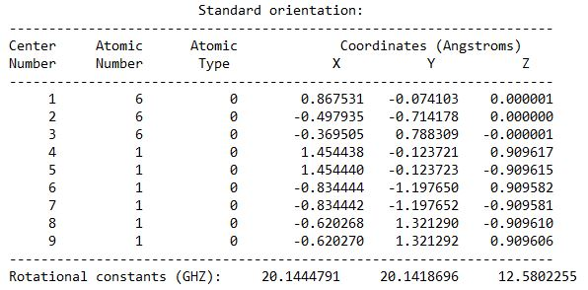tes of Cyclopropane

Figure S2: Optimized coordinates of F-Cycloprpane
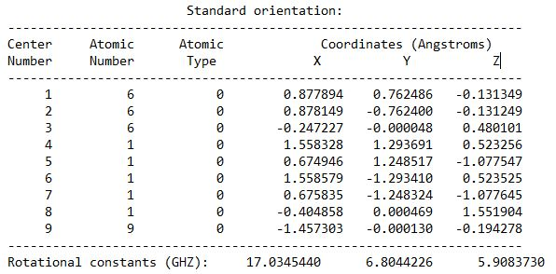

Table S5: Optimized coordinates of Cl-Cyclopropane
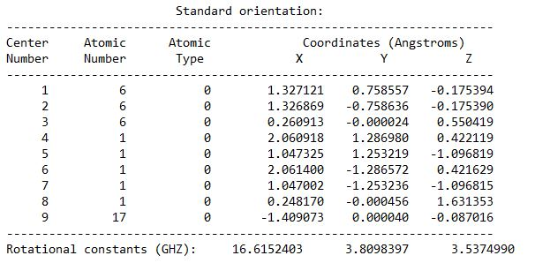
Figure S4: Optimized coordinates of Br-Cycloprpane
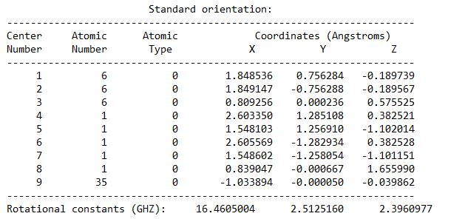
Table S6: Optimized coordinates of N-Cyclopropane
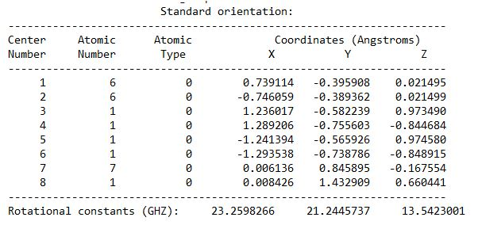

Table S7: Optimized coordinates of O-Cyclopropane
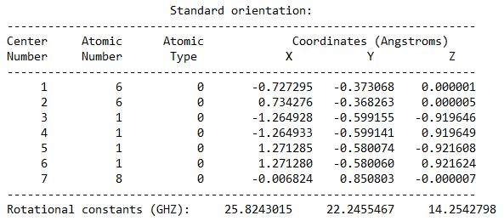

Table S8: Optimized coordinates of S-Cyclopropane
