Supplementary note: Caloric restriction and refeeding response

We observe APOA4, APOC1, SPP2, TTR changing in CR, which are proteins that have been proven sensitive to caloric restriction and refeeding and describe these transitions best (Extended Data Fig. 3). Also, there is APOC2 showing a negative correlation with leptin and insulin levels. A closer look at TSH reveals a correlation with GC and CR1, while for fT4 (free T4) we observe a strong positive correlation with SERPINF2 and a negative with IGHG1 (Figure 1H). It is plausible these changes represent the acute response of the hypothalamic-pituitary-thyoid axis to caloric restriction. Additionally, leptin, glucose and insulin correlate with the proteomic response (Figure 1H). SPP2, an insulin-sensitive, bone morphogenetic protein^{1,2}, is found to correlate at most negative levels with glucose. Further, APOA4, APOC2 are in line with previous reports^{3,4}. Additionally, SERPINA4 correlates with both insulin and leptin levels. TSH shows negative correlations with complement factors (CR1). For fT4 we see correlations for immunoglobulin heavy chains and SERPINF2 (alpha-2-antiplasmin)⁵.
Apart from the dominating proteins, the differential expression analysis pointed to further proteins that decrease under CR and increase under RF while others behave in reverse fashion. In fact, many differentially expressed proteins are responsive to both negative and positive energy balance (Extended Data Fig. 3). Among other apolipoproteins we detect APOB, which belongs to the TGR (triglyceride-rich lipoproteins)^{6,7} being increased under CR and decreased under RF while the HDL-related APOA1⁶ decreases under CR. The above indicate a triglyceride-based metabolism during CR. The data obtained by shifting the diet to caloric restriction and refeeding extend our knowledge on physiological adaptation, complementing the insights that Harney et al.⁸ provided on the triglyceride regulation after intermittent fasting. APOC2 concentration increased during caloric restriction and decreased again after refeeding. Whereas, APOC1 and APOA4 changed in the reverse direction during those conditions (Fig. 1e, Extended Data Fig. 3).
Apolipoproteins’ role is to maintain and regulate the assembly, structure and metabolism of lipoprotein particles⁹. Through binding to membrane receptors, apolipoproteins regulate enzymatic activity. APOC1, APOC2 and APOE genes are located within the same gene cluster of chromosome 19¹⁰. APOC1 is part of the chylomicrons (CM), VLDLs and HDLs¹¹ and has been extensively related to lipid metabolism in various ways. Its role on HDL metabolism is to inhibit CETP^{12,13} and activate LCAT¹². Its main role though, is the direct or indirect inhibition of LPL (lipoprotein lipase)^{14,15} by preventing it from binding to the lipid/water interface of the lipoprotein particles^{16,17} and thus being involved mostly with VLDL-TG metabolic regulation. It is also involved in lipoprotein remnants (CM, VLDL) uptake by the possible inhibition and blockade of receptors involved in the clearance, such as LPR1¹⁸, LDLR¹⁹ or VLDLR¹⁵. APOC2 is mainly expressed in the liver and the intestine¹⁶ and is important for LPL’s activity^{7,20}. When present in intermediate concentrations, it binds to the lipoprotein membrane and activates LPL and, most importantly, competes with APOC1 and APOC3 and prevents their function²¹.
APOA4 is mainly synthesised in the liver and, at a smaller amount, in the intestine, where it plays an important role in intestinal lipid absorption²². It binds CMs and HDLs, maybe gets displaced by APOC2 and modulates LPL activity, but not when APOC2 is present²³. Then, APOA4 rapidly dissociates from the chylomicrons when hydrolysis occurs²². Furthermore, it activates LCAT that converts cholesterol to cholesterol (more hydrophobic) and enables the easiest formation of HDL particles²⁴. Additionally, it regulates the transport of long-chain fatty acids to chylomicrons²⁵ suggesting another role in the formation of lipoproteins and not their lipolysis. APOA4 follows leptin, insulin and glucose in concentration fluctuations as we see it correlating with diagnostic measurements (Fig. 2e), which are in direct proportion to stored fat, something that is confirmed by the results of this study too. APOA4’s production in the small intestine when there is an active lipid absorption and the causing reduction of gastric motility²⁶ suggest its role as a fat-induced signal of satiety in order to regulate food intake²⁷.
Our results with APOC1, APOC2 and APOA4 suggest their interactions during the response with acute caloric restriction (Fig. 1e, Extended Data Fig. 6a). APOC2’s increase during caloric restriction might lead to the activation of LPL and the inhibition of APOC1 which is then detected at a decreased level. Instead, during refeeding an increase in the APOC1 concentration might lead to an inhibition of LPL and the prevention of the hydrolysis of the lipoprotein particles. APOA4 follows the same concentration trend and could be correlated with an antagonistic APOC2 role (Fig. 1e, Extended Data Fig. 6a). Additionally, APOA4 is required for the formation of lipoprotein particles, which has a specific role in regulating food intake. The above results are consistent with an increased fatty acid oxidation during caloric restriction and the decrease of triglycerides in circulation when refeeding. Contrary to our observations Harney et al.⁸ observed increased APOA4 after intermittent fasting, but other mass spectrometry based investigations by Geyer et al.³ and Bruderer et al.⁴ both report a decrease of APOA4 upon weight loss (negative energy balance) and a reinstatement with weight maintenance, in accordance with our results. Sphingolipids, which are building blocks of lipoproteins, are also increased during caloric restriction. The above suggest that healthy male individuals’ metabolism is regulated towards the hydrolysis of triglyceride rich lipoproteins (TGL-rich) in acute caloric restriction that may lead to the necessary usage of fatty acids to cover energetic demands of the organism.
ΤTR (transthyretin) has been reported for its role in transporting thyroid hormones in plasma and cerebrospinal fluid²⁷. Also, it is associated with retinol transport via binding with RBP. Interestingly, it has been associated with malnutrition^{28,29} and our results suggest that TTR concentration is significantly decreasing during caloric restriction and increasing in refeeding. Additionally, TTR has been correlated with triglyceride levels and insulin resistance^{30,31}. Our results confirm this relation with the triglyceride levels decreasing in caloric restriction to be used for covering energetic demands and increasing in refeeding for storage purposes, following the TTR concentration trend.
SPP2, a protein that emerges with many correlations with the metabolome and the physiome (Fig. 1g, 1h), is poorly characterised, with mostly known that it has a cystatin-like domain that could serve as a thiol protease inhibitor. It is also part of the fetuin mineral complex that serves the calcification process by carrying insoluble calcium and phosphate³². Via that complex it could inhibit BMP-2 and increase inflammation³³. Its homology with fetuin-A, a free fatty acid carrier in the circulation³⁴ and its responsiveness to caloric intake changes in this study, could support further examination of its role.
Recent literature highlights the role of APOM against insulin resistance by carrying S1P on HDL and activating insulin signalling pathways^{35,36}. LPA is constantly higher (P<0.05) in diabetic compared to non-diabetic individuals of the cohort in an association with diabetes that has been reported³⁷. This effect becomes slightly higher in T60 (P<0.001) and T120 (P<0.01). APOC1, APOM and LPA abundances are different in diseased conditions, proving the importance of apolipoproteins to describe metabolic homeostasis (Fig. 3d).

Extended Data Figures Legends

Extended Data Fig. 1. Data quality of the proteomic data acquisition in the CR study (a) and Ely (b) studies proteomic profiling, while the acquisition of GS data has been reported previously³⁸. Coefficient of variation (CV) values in both studies demonstrate that the biological signal (samples) is much higher than the technical variability (QC - quality controls). The numbers of proteins and precursors that are detected in the CR study are higher than those detected in the Ely study, because of the different proteomic method used (Methods)

Extended Data Fig. 2. Partial least squares discriminant analysis (PLS-DA) of proteomes and metabolomes, respectively, in the CR study. At the metabolome, PLS-DA separates baseline (BS), caloric restriction (CR), and refeeding (RF), while at the proteome CR from BS and RF, respectively.

Extended Data Fig. 3. Differentially abundant plasma proteins (Wilcoxon test, p<0.05) upon acute CR in a controlled environment. 22 proteins are decreased during CR and increased in RF, 13 proteins are increased in CR and decreased in RF, three proteins decrease in CR and remain decreased and ITIH3 increased and remained increased. Nomenclature baseline (BS), caloric restriction (CR), and refeeding (RF),

Extended Data Fig. 4. Individual-specific differential protein abundance. After a Wilcoxon test (p<0.01) we identified 192 commonly shared proteins that were differentially abundant between each individual and at least one of the other nine individuals. Examples include proteins of the complement cascade (i.e. C1R, C4, C8A, C7, C9, G8B, C8G), several coagulation factors and related proteins (i.e. F11, F2, F12, SERPINA10, SERPIND1, PLG, SERPING1) and numerous immunoglobulin regions.

Extended Data Fig. 5. Correlation map of proteins with metabolites in CR study. Coloured in the figure are shown the positive or negative correlation coefficients of |cor| > 0.4 (Spearman rank coefficient, |cor| > 0.4).

Extended Data Fig. 6. Scheme: a) Suggested interactions of CR induced Apolipoproteins during CR and refeeding response, respectively. b) The functions of APOC1 in the CR and refeeding response

Extended Data Fig. 7. Metabolic and endocrine parameters measured as part of the Ely cohort. The subjects have been categorised to non-Diabetic, Diabetes, IFG (impaired fasting glucose), IGT (impaired glucose tolerance) according to the latest American Diabetes Association for the Classification and Diagnosis of Diabetes³⁹. BMI kg/m², plasma glucose mmol/L, insulin pmol/L, leptin ng/L, HDL mmol/L, LDL mmol/L, triglycerides mmol/L

Extended Data Fig. 8. Proteomic profiles are predictive about endocrine parameters important for metabolic health using a random forest regressor. a) Scheme; Samples are split in a training and prediction set; a machine learning model is trained on the training set, and its performance is evaluated to predict physiological parameters in the prediction set. b) A Random Forest regressor efficiently predicts a series of human physiological parameters related to human metabolic health from the proteome, such as cholesterol, HDL, LDL, triglycerides, parameters of energy regulation and weight control factors such as insulin, glucose, C-peptide, leptin, BMI. The cross validation of five random patient folds (splits) is depicted on the test set and the values observed vs predicted. c) Interpretation of machine learning models confirm the role of nutrient response proteins in linking proteome and physiome. Examples shown are Triglycerides, for which most weighted features in the prediction are apolipoproteins APOC3, and APOC2, while APOC1, APOF and SERPINC1 are the most weighted features in the prediction of insulin levels. BMI kg/m², plasma glucose mmol/L, insulin pmol/L, leptin ng/L, HDL mmol/L, LDL mmol/L, triglycerides mmol/L, cholesterol mmol/L, C-peptide pmol/L. Part of the figure was created with BioRender.com.

Extended Data Fig. 9. Summary graph - Responses of nutrition. Differential abundance analysis (Wilcoxon test, p<0.05) in CR and Ely studies revealed responses. We observe proteins’ abundance increasing (Up - orange colour) or decreasing (Down - cyan colour) during caloric restriction, refeeding (response in Days or Hours), and when comparing diabetic or prediabetic (IGT) individuals with healthy ones, before and after the glucose consumption (oGTT challenge).

Extended Data Fig. 10. Correlation map of proteins with metabolic and endocrine parameters (Spearman correlation, p<0.05). Statistically significant correlations are coloured while dots indicate statistical significance after row-wise multiple-testing correction (fdr<0.05) and black rectangles – column-wise. BMI kg/m², plasma glucose mmol/L, insulin pmol/L, leptin ng/L, HDL mmol/L, LDL mmol/L, triglycerides mmol/L, cholesterol mmol/L, C-peptide pmol/L, split - proinsulin pmol/L, proinsulin pmol/L

Extended Data Fig. 1
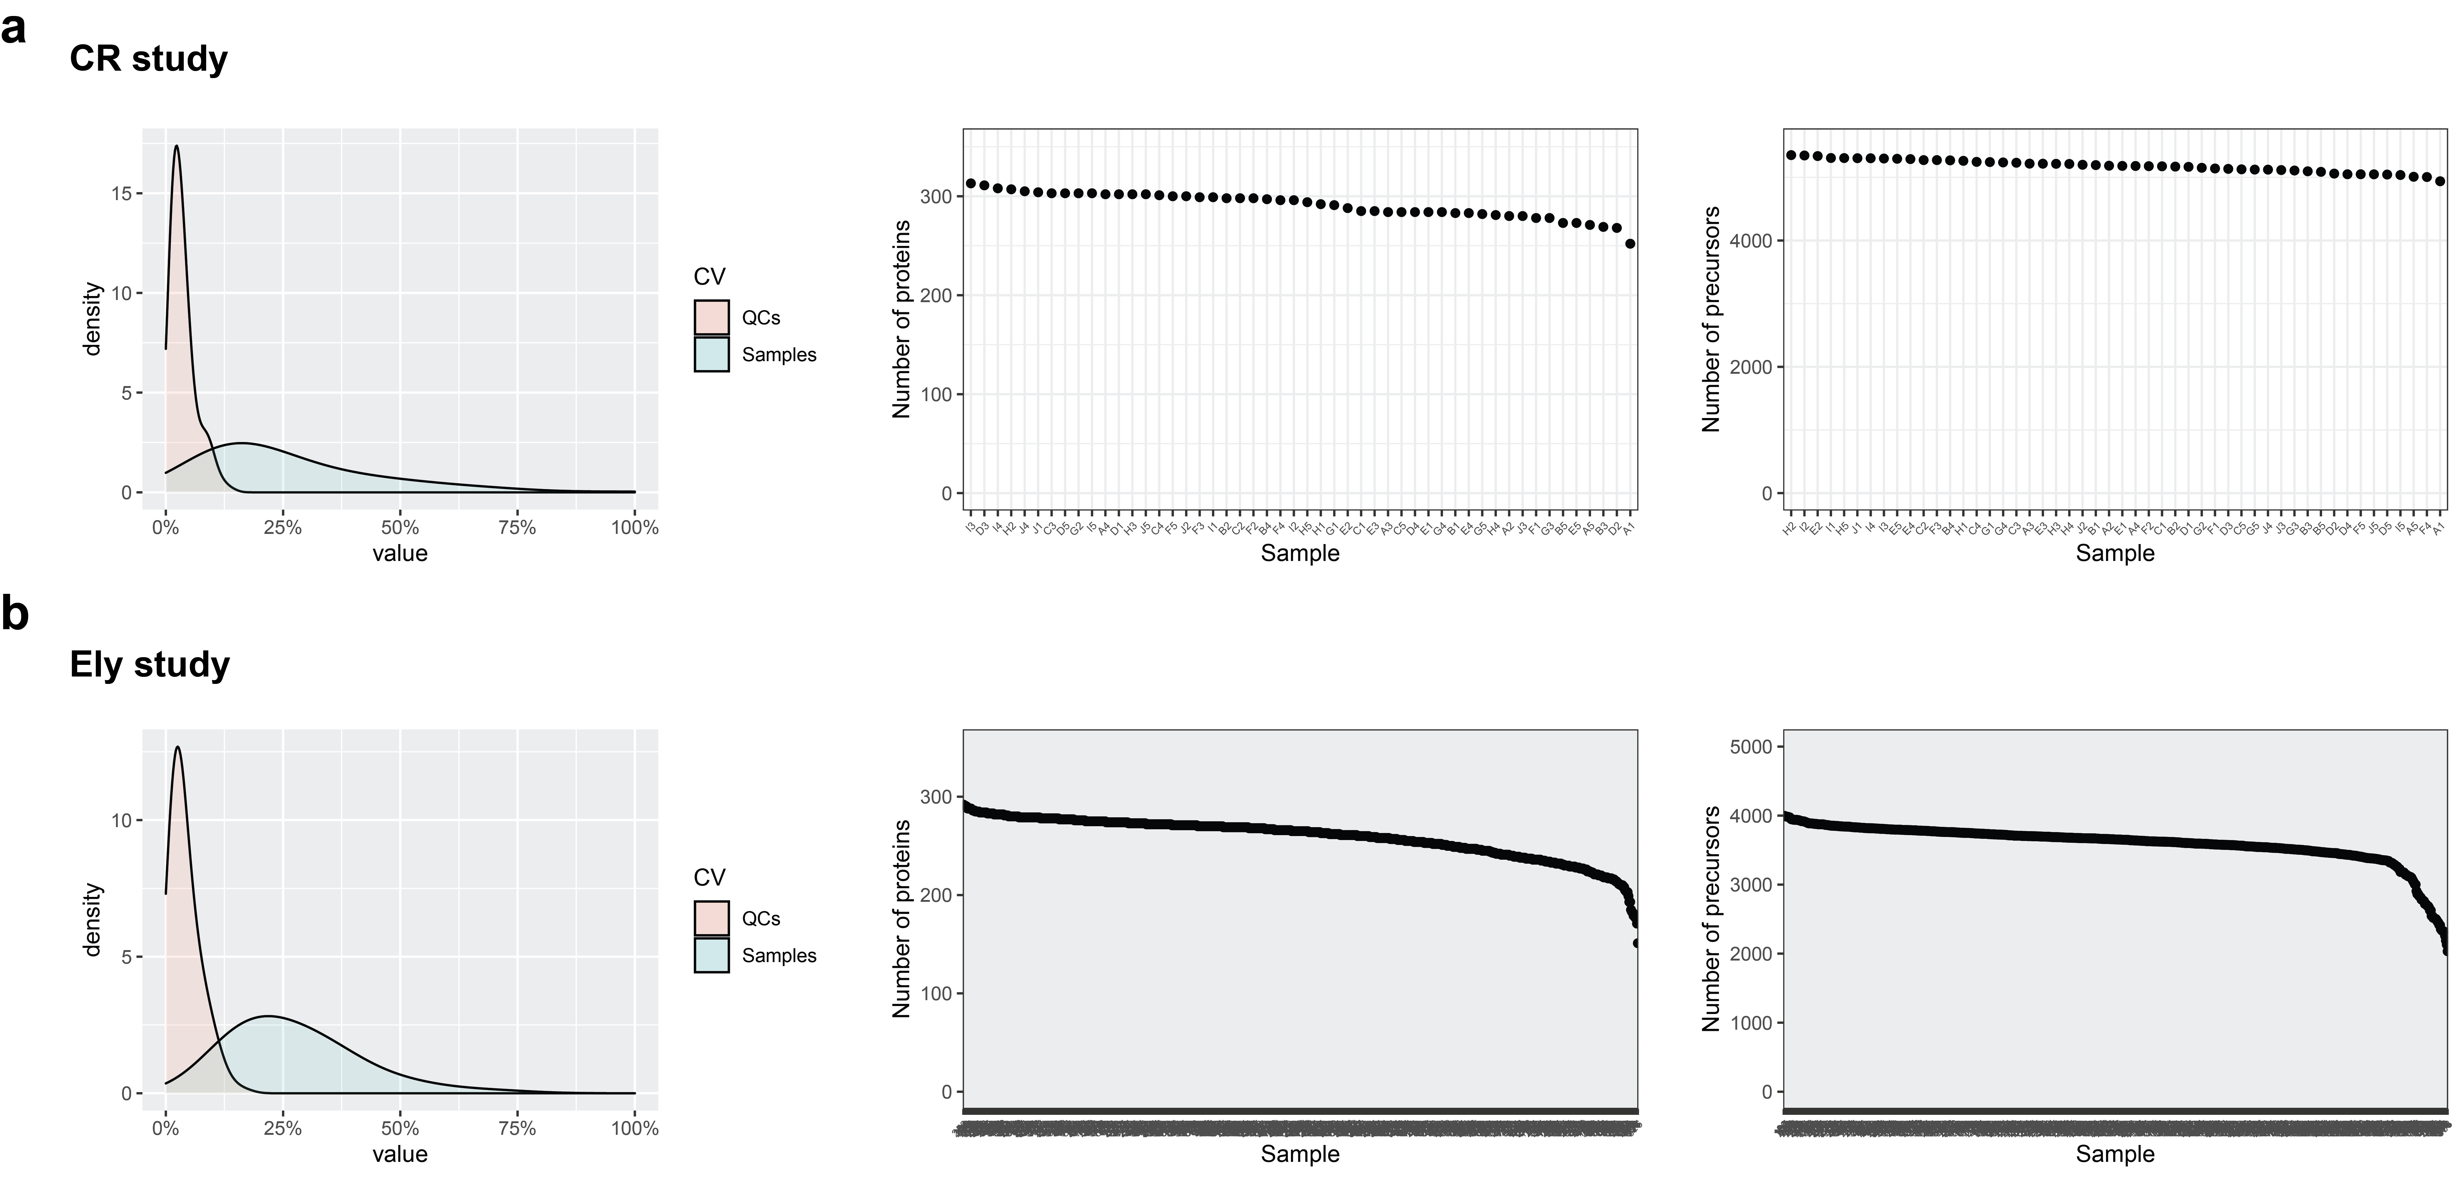

Extended Data Fig. 2
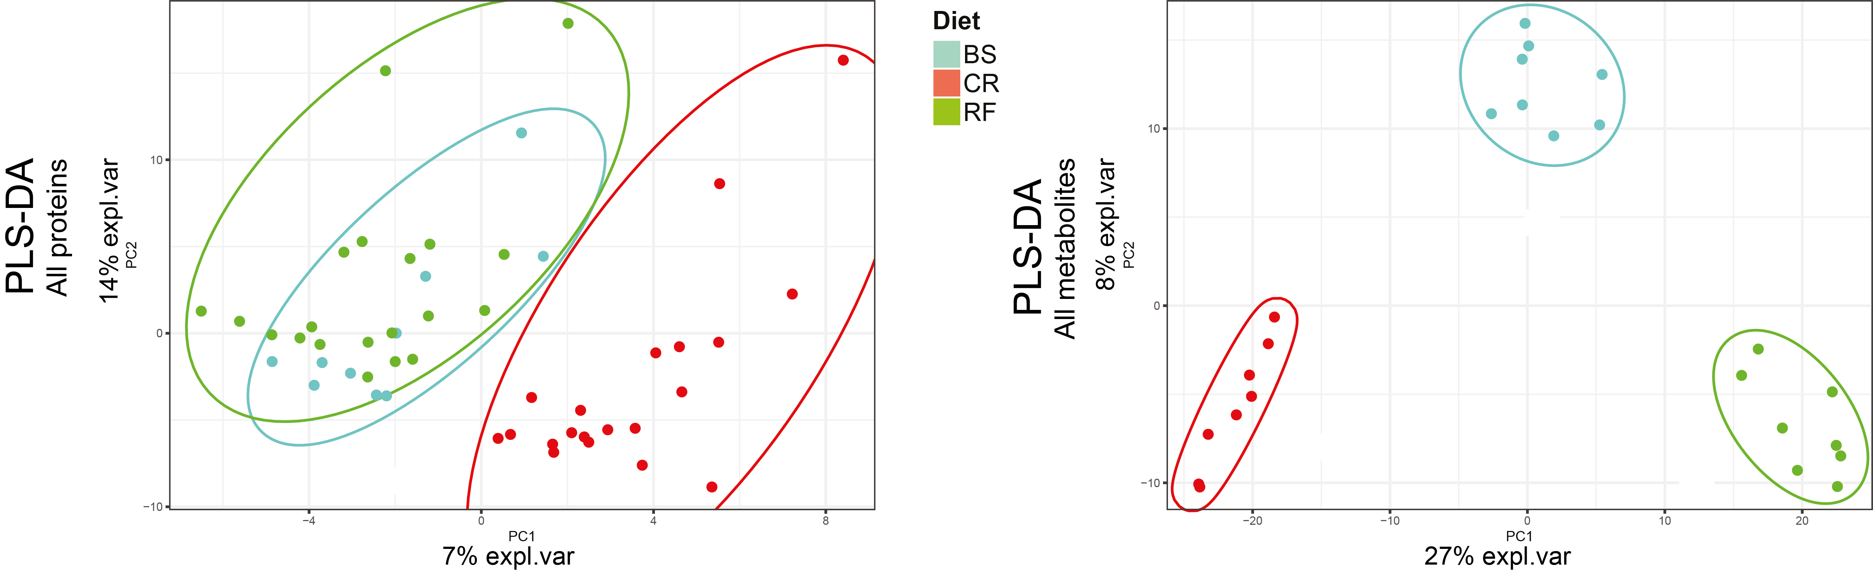

Extended Data Fig. 3
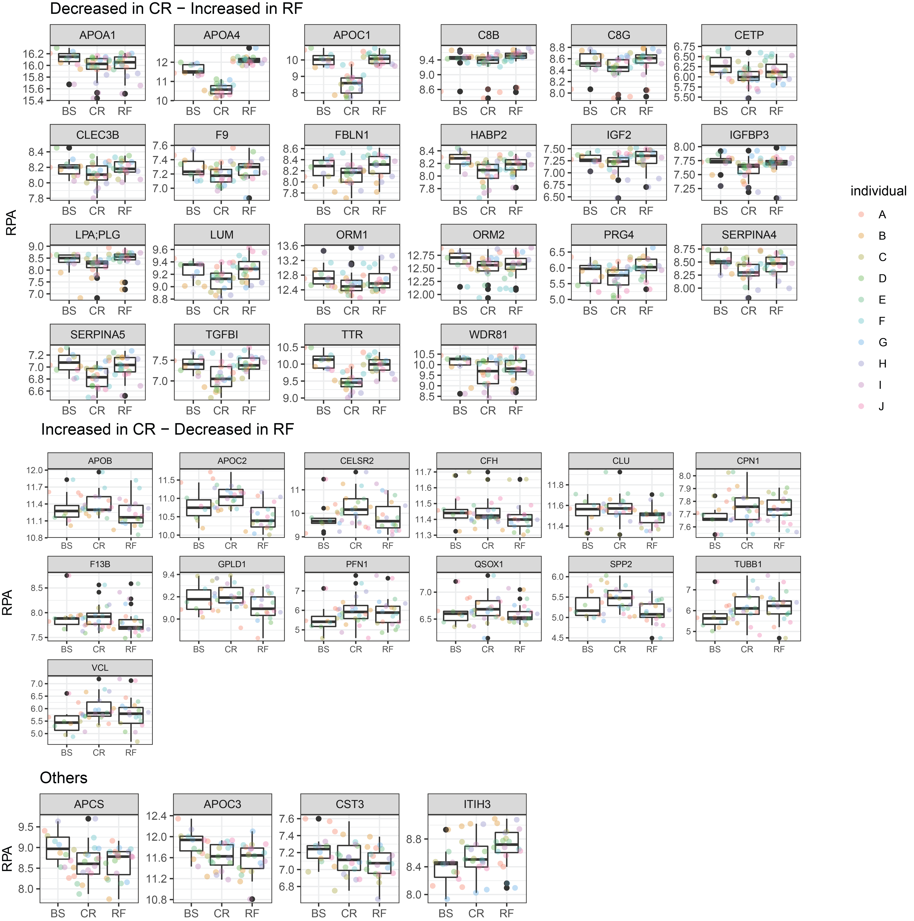

Extended Data Fig. 4
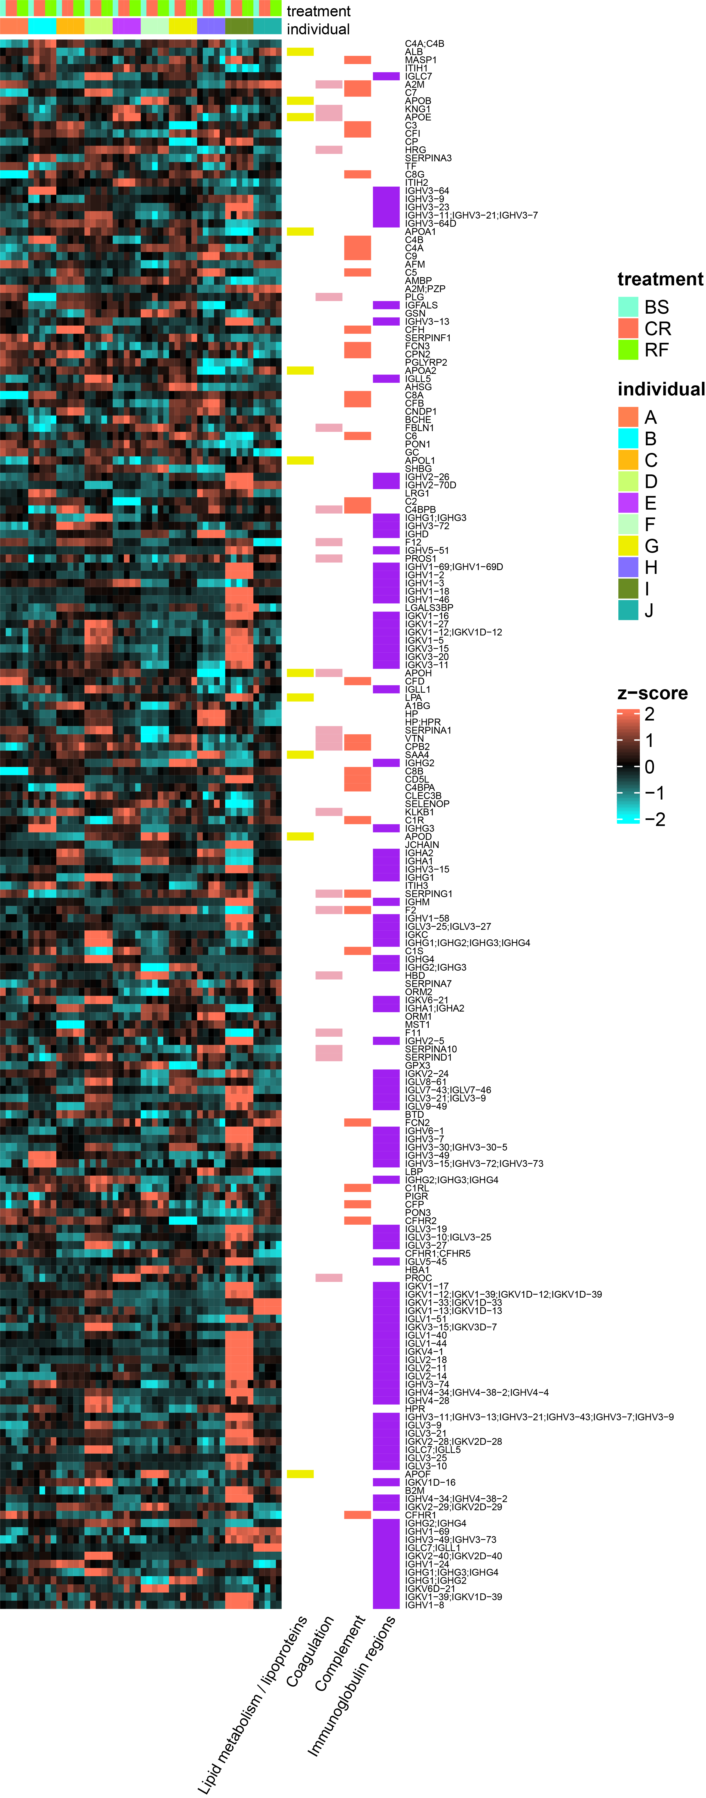

Extended Data Fig. 5
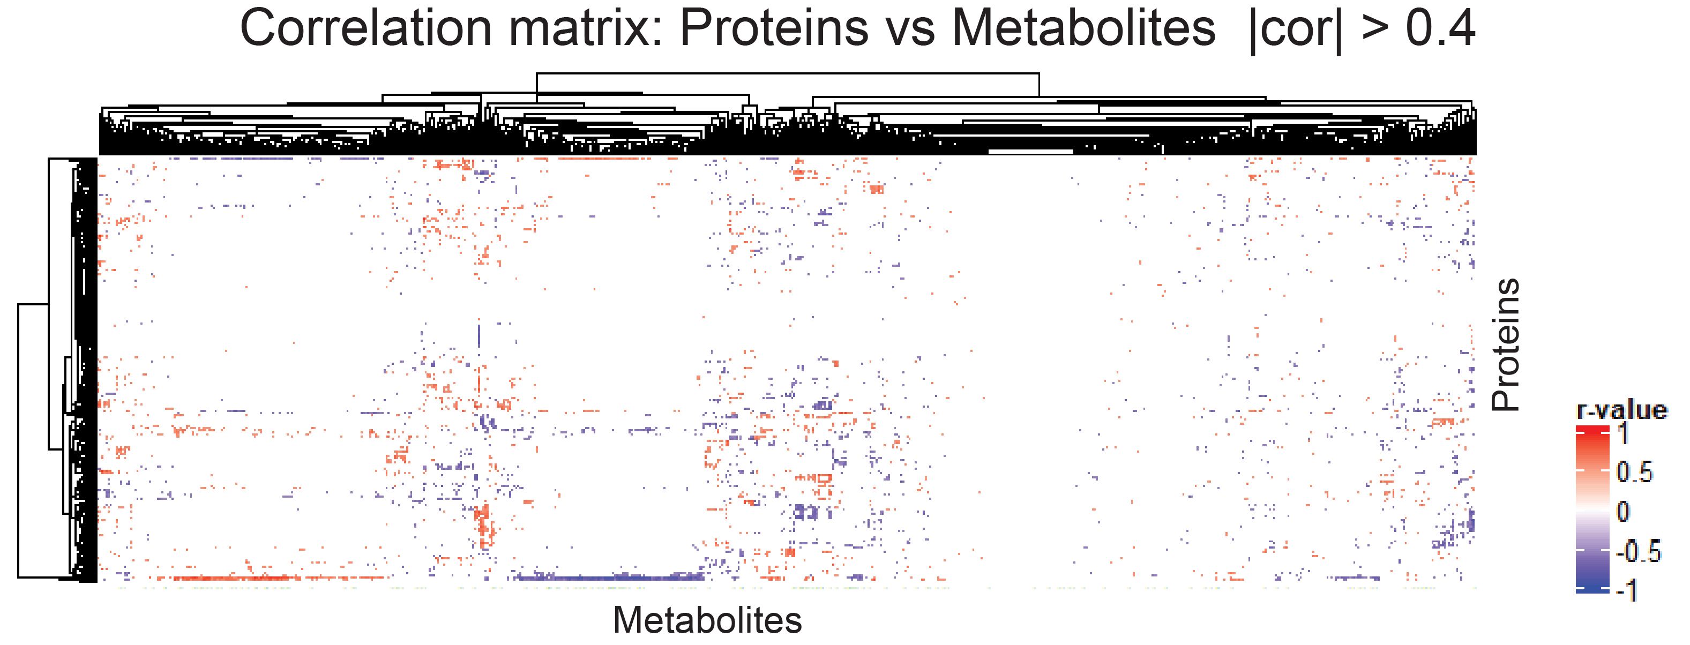

Extended Data Fig. 6
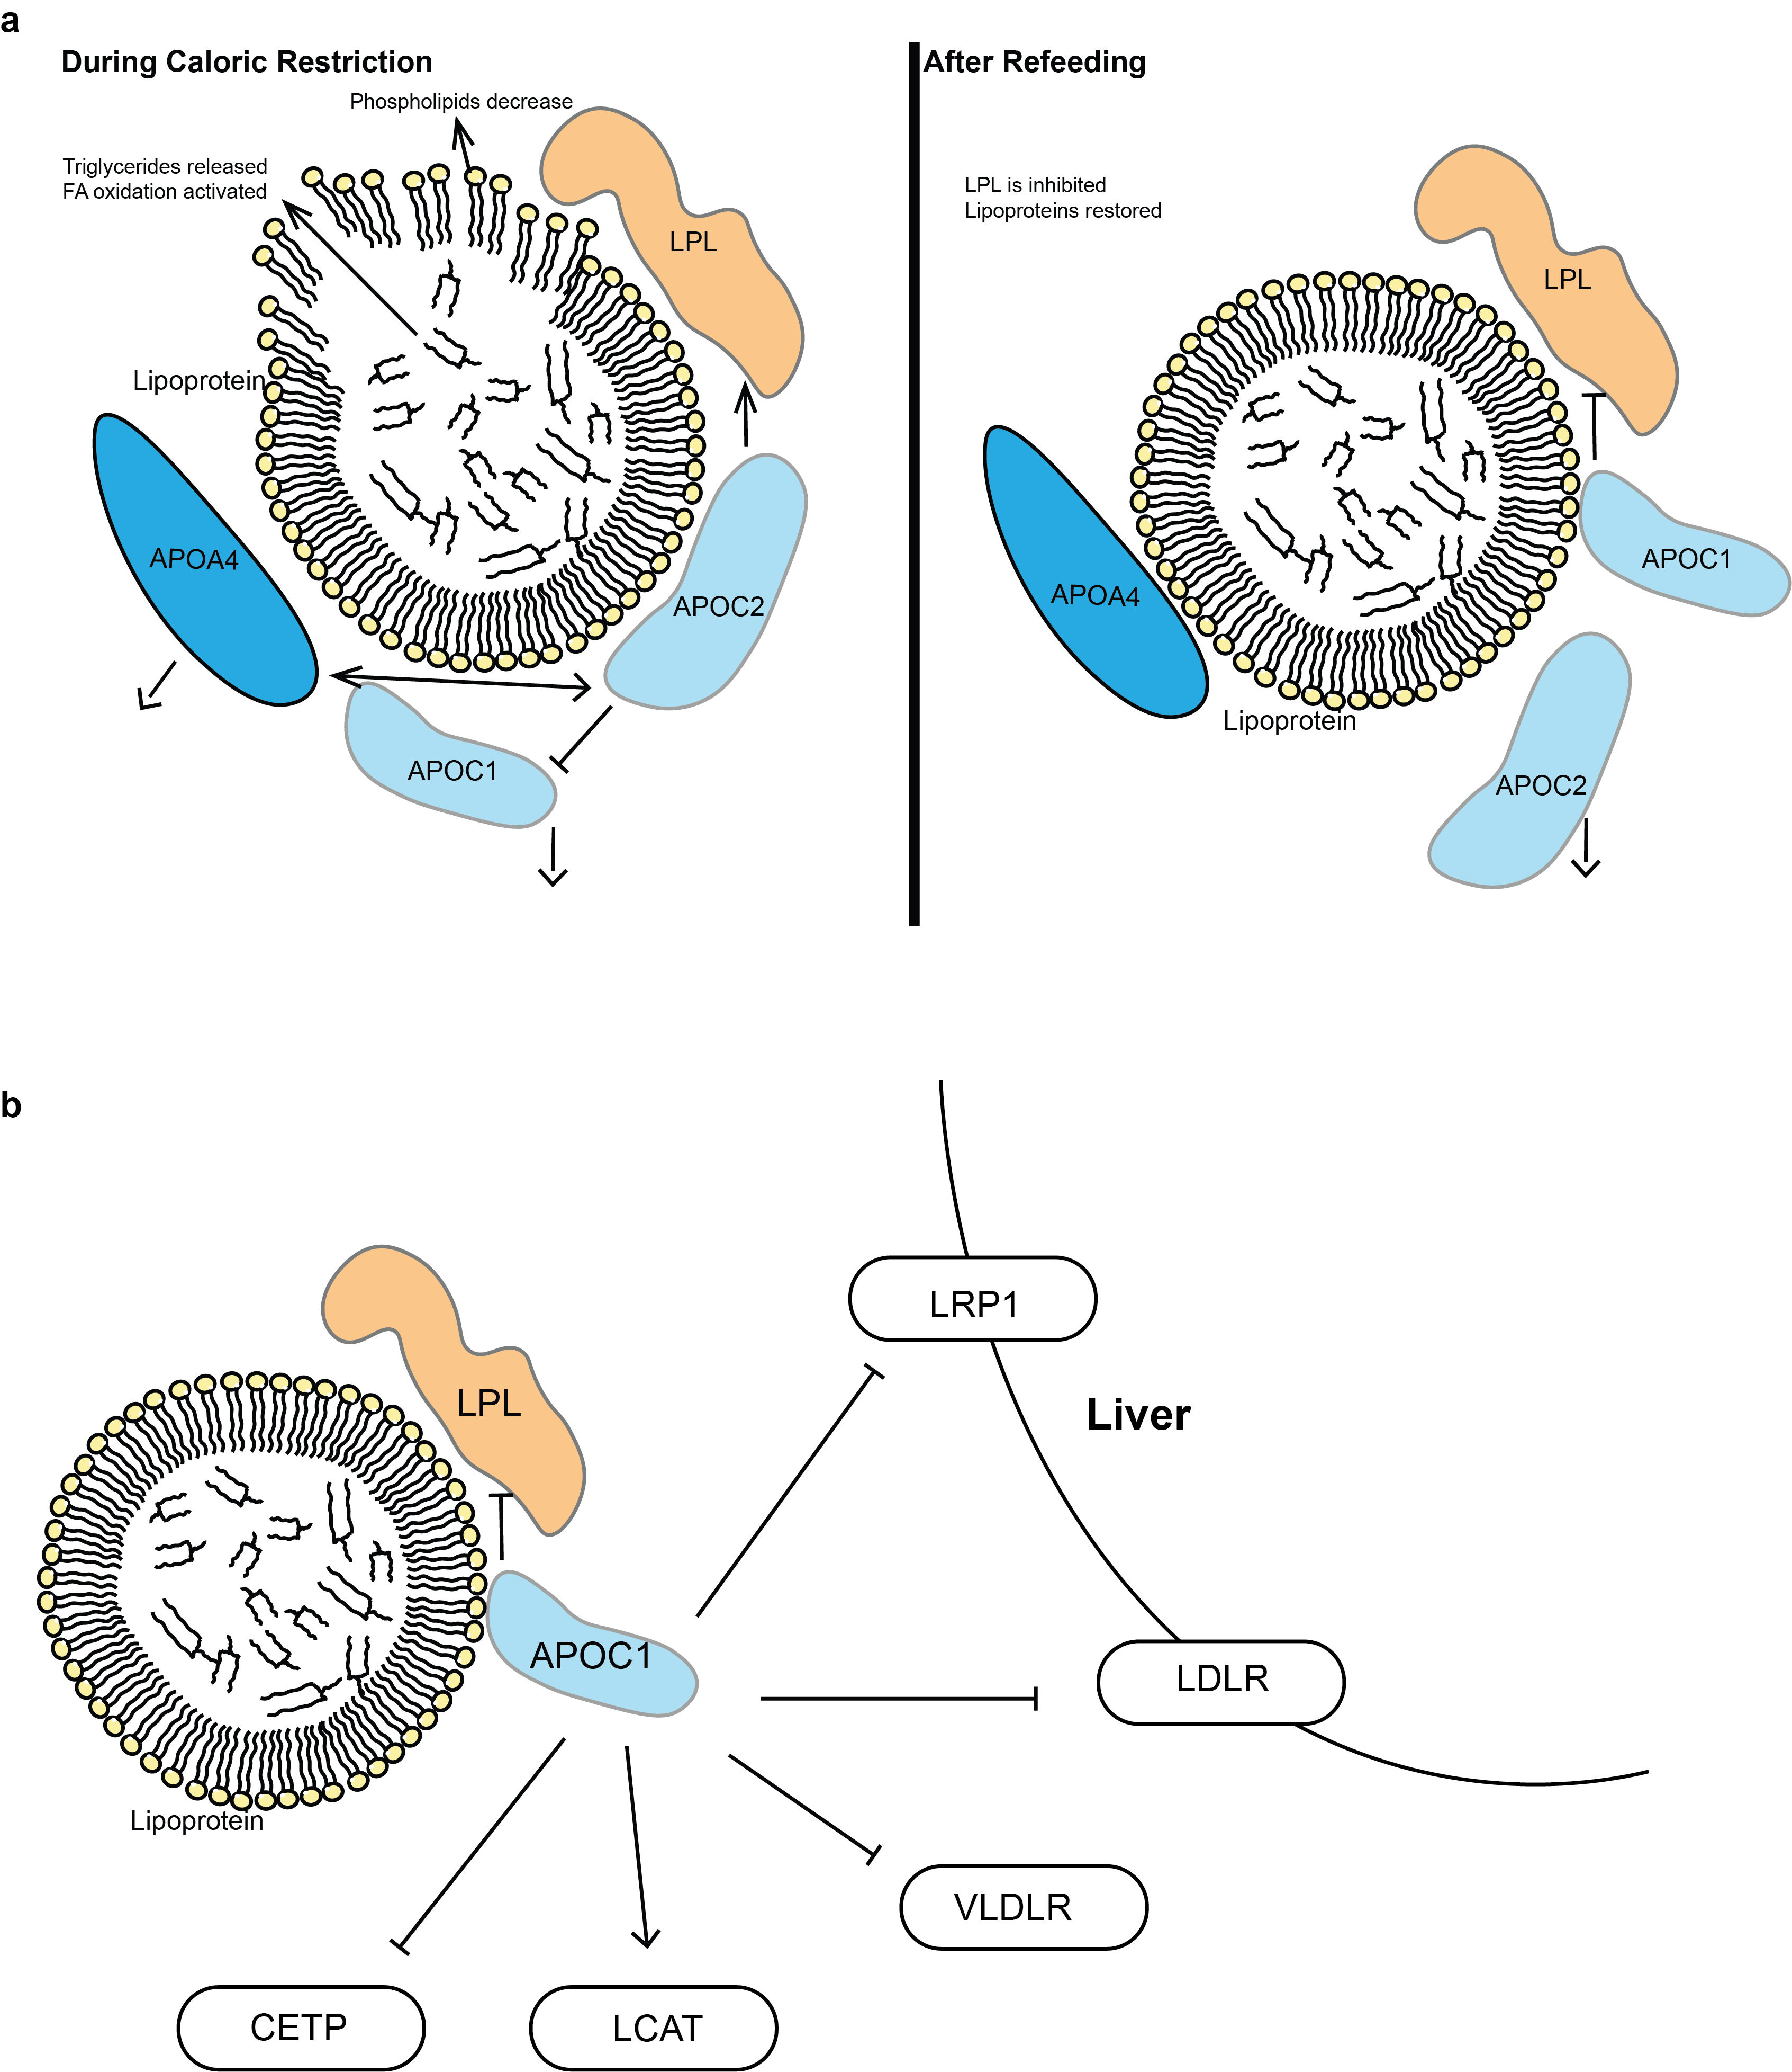

Extended Data Fig. 7
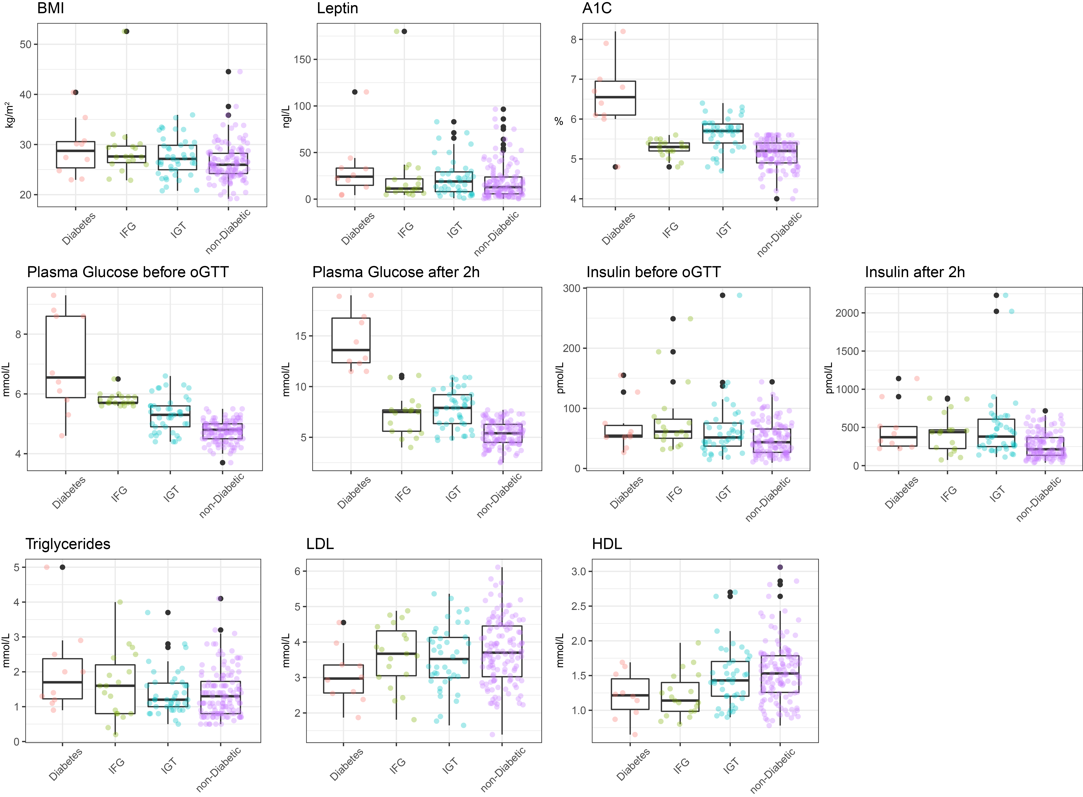

Extended Data Fig. 8

Extended Data Fig. 9
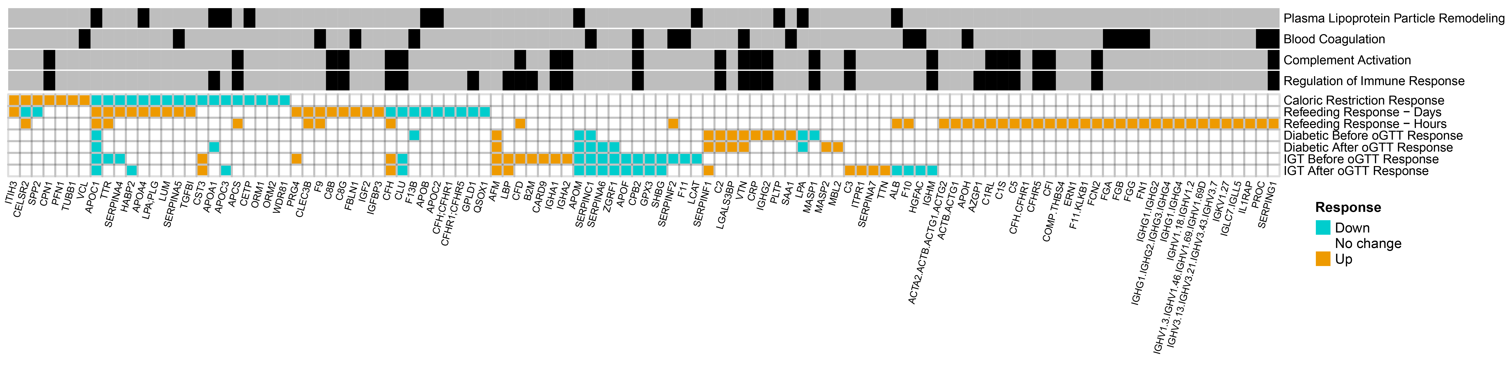

Extended Data Fig. 10
References

1. Frost, S.C., Kohanski, R.A. & Lane, M.D. Effect of phenylarsine oxide on insulin-dependent protein phosphorylation and glucose transport in 3T3-L1 adipocytes. J. Biol. Chem. 262, 9872-9876 (1987).
2. Sun, A., et al. Alanine-scanning mutations of the BMP-binding domain of recombinant secretory bovine spp24 affect cytokine binding. Connect. Tissue Res. 51, 445-451 (2010).
3. Geyer, P.E., et al. Proteomics reveals the effects of sustained weight loss on the human plasma proteome. Mol. Syst. Biol. 12, 901 (2016).
4. Bruderer, R., et al. Analysis of 1508 Plasma Samples by Capillary-Flow Data-Independent Acquisition Profiles Proteomics of Weight Loss and Maintenance. Mol. Cell. Proteomics 18, 1242-1254 (2019).
5. Carpenter, S.L. & Mathew, P. Alpha2-antiplasmin and its deficiency: fibrinolysis out of balance. Haemophilia 14, 1250-1254 (2008).
6. Zhan, X., et al. Apolipoprotein B/apolipoprotein A1 ratio and mortality among incident peritoneal dialysis patients. Lipids Health Dis. 17, 117 (2018).
7. Wolska, A., et al. Apolipoprotein C-II: New findings related to genetics, biochemistry, and role in triglyceride metabolism. Atherosclerosis 267, 49-60 (2017).
8. Harney, D.J., et al. Proteomic Analysis of Human Plasma during Intermittent Fasting. J. Proteome Res. 18, 2228-2240 (2019).
9. Dominiczak, M.H. & Caslake, M.J. Apolipoproteins: metabolic role and clinical biochemistry applications. Ann. Clin. Biochem. 48, 498-515 (2011).
10. Smit, M., van der Kooij-Meijs, E., Frants, R.R., Havekes, L. & Klasen, E.C. Apolipoprotein gene cluster on chromosome 19. Definite localization of the APOC2 gene and the polymorphic Hpa I site associated with type III hyperlipoproteinemia. Hum. Genet. 78, 90-93 (1988).
11. Shulman, R.S., Herbert, P.N., Wehrly, K. & Fredrickson, D.S. Thf complete amino acid sequence of C-I (apoLp-Ser), an apolipoprotein from human very low density lipoproteins. Journal of Biological Chemistry 250, 182-190 (1975).
12. Hoeg, J.M., et al. Lecithin:cholesterol acyltransferase overexpression generates hyperalpha-lipoproteinemia and a nonatherogenic lipoprotein pattern in transgenic rabbits. J. Biol. Chem. 271, 4396-4402 (1996).
13. van Dijk, M.C., et al. Recognition of chylomicron remnants and beta-migrating very-low-density lipoproteins by the remnant receptor of parenchymal liver cells is distinct from the liver alpha 2-macroglobulin-recognition site. Biochem. J 279 ( Pt 3), 863-870 (1991).
14. Havel, R.J., et al. Cofactor activity of protein components of human very low density lipoproteins in the hydrolysis of triglycerides by lipoprotein lipase from different sources. Biochemistry 12, 1828-1833 (1973).
15. Berbée, J.F.P., van der Hoogt, C.C., Sundararaman, D., Havekes, L.M. & Rensen, P.C.N. Severe hypertriglyceridemia in human APOC1 transgenic mice is caused by apoC-I-induced inhibition of LPL. J. Lipid Res. 46, 297-306 (2005).
16. Kei, A.A., Filippatos, T.D., Tsimihodimos, V. & Elisaf, M.S. A review of the role of apolipoprotein C-II in lipoprotein metabolism and cardiovascular disease. Metabolism 61, 906-921 (2012).
17. Hansen, J.-B., et al. The apolipoprotein CI content of very-low-density lipoproteins is associated with fasting triglycerides, postprandial lipemia, and carotid atherosclerosis. J. Lipids 2011(2011).
18. Jong, M.C., et al. In the absence of the low density lipoprotein receptor, human apolipoprotein C1 overexpression in transgenic mice inhibits the hepatic uptake of very low density lipoproteins via a receptor-associated protein-sensitive pathway. J. Clin. Invest. 98, 2259-2267 (1996).
19. Sehayek, E. & Eisenberg, S. Mechanisms of inhibition by apolipoprotein C of apolipoprotein E-dependent cellular metabolism of human triglyceride-rich lipoproteins through the low density lipoprotein receptor pathway. J. Biol. Chem. 266, 18259-18267 (1991).
20. Jong, M.C., Hofker, M.H. & Havekes, L.M. Role of ApoCs in lipoprotein metabolism: functional differences between ApoC1, ApoC2, and ApoC3. Arterioscler. Thromb. Vasc. Biol. 19, 472-484 (1999).
21. Larsson, M., Vorrsjö, E., Talmud, P., Lookene, A. & Olivecrona, G. Apolipoproteins C-I and C-III Inhibit Lipoprotein Lipase Activity by Displacement of the Enzyme from Lipid Droplets. Journal of Biological Chemistry 288, 33997-34008 (2013).
22. Wang, F., et al. Apolipoprotein A-IV: a protein intimately involved in metabolism. J. Lipid Res. 56, 1403-1418 (2015).
23. Goldberg, I.J., Scheraldi, C.A., Yacoub, L.K., Saxena, U. & Bisgaier, C.L. Lipoprotein ApoC-II activation of lipoprotein lipase. Modulation by apolipoprotein A-IV. J. Biol. Chem. 265, 4266-4272 (1990).
24. Weinberg, R.B. Apolipoprotein A-IV polymorphisms and diet-gene interactions. Curr. Opin. Lipidol. 13, 125-134 (2002).
25. Kalogeris, T.J., Fukagawa, K. & Tso, P. Synthesis and lymphatic transport of intestinal apolipoprotein A-IV in response to graded doses of triglyceride. J. Lipid Res. 35, 1141-1151 (1994).
26. Glatzle, J., Darcel, N., Rechs, A.J. & others. Apolipoprotein A-IV stimulates duodenal vagal afferent activity to inhibit gastric motility via a CCK1 pathway. Αm J. Physiol Regul Integr Comp Physiol. 287, 354-9 (2004).
27. Fujimoto, K., Fukagawa, K., Sakata, T. & Tso, P. Suppression of food intake by apolipoprotein A-IV is mediated through the central nervous system in rats. J. Clin. Invest. 91, 1830-1833 (1993).
28. Sharma, A., Monu & Biswas, S. Exploring the Influence of Mutation on Transthyretin Aggregation in Heart Disease. Curr. Comput. Aided Drug Des. 14, 125-130 (2018).
29. Tsegaye, B., Mekasha, A. & Genet, S. Serum Transthyretin Level as a Plausible Marker for Diagnosis of Child Acute Malnutrition. Biochemistry Research International 2017, 1-6 (2017).
30. Dellière, S., Neveux, N., De Bandt, J.-P. & Cynober, L. Transthyretin for the routine assessment of malnutrition: A clinical dilemma highlighted by an international survey of experts in the field. Clin. Nutr. 37, 2226-2229 (2018).
31. Kwanbunjan, K., et al. Association of retinol binding protein 4 and transthyretin with triglyceride levels and insulin resistance in rural thais with high type 2 diabetes risk. BMC Endocr. Disord. 18, 26 (2018).
32. Turner, M.E., et al. Secreted Phosphoprotein 24 is a Biomarker of Mineral Metabolism. Calcif. Tissue Int. 108, 354-363 (2021).
33. Zhao, K.-W., Murray, S.S. & Brochmann Murray, E.J. Secreted phosphoprotein-24 kDa (Spp24) attenuates BMP-2-stimulated Smad 1/5 phosphorylation and alkaline phosphatase induction and was purified in a protective complex with alpha2-Macroglobulins From Serum. Journal of Cellular Biochemistry 114, 378-387 (2013).
34. Pal, D., et al. Fetuin-A acts as an endogenous ligand of TLR4 to promote lipid-induced insulin resistance. Nat. Med. 18, 1279-1285 (2012).
35. Kurano, M., et al. Protection Against Insulin Resistance by Apolipoprotein M/Sphingosine-1-Phosphate. Diabetes 69, 867-881 (2020).
36. Yalcinkaya, M. & von Eckardstein, A. Apolipoprotein M and Sphingosine-1-Phosphate: A Potentially Antidiabetic Tandem Carried by HDL. Diabetes 69, 859-861 (2020).
37. Ye, Z., et al. The association between circulating lipoprotein(a) and type 2 diabetes: is it causal? Diabetes 63, 332-342 (2014).
38. Messner, C.B., et al. Ultra-high-throughput clinical proteomics reveals classifiers of COVID-19 infection. Cell Systems (2020).
39. American Diabetes, A. Addendum. 2. Classification and Diagnosis of Diabetes: Standards of Medical Care in Diabetes-2021. Diabetes Care 2021;44(Suppl. 1):S15-S33. Diabetes Care (2021).

