Supplementary Information

Collective skyrmion motion under the influence of an additional interfacial spin-transfer torque

Callum R. MacKinnon^{1,*}, Katharina Zeissler^{2,3}, Simone Finizio⁴, Jörg Raabe⁴, Christopher H. Marrows^{2,3}, Tim Mercer¹, Philip R. Bissell¹ & Serban Lepadatu^{1,**}
¹ Jeremiah Horrocks Institute for Mathematics, Physics and Astronomy, University of Central Lancashire, Preston PR1 2HE, U.K.
² School of Physics and Astronomy, University of Leeds, Leeds LS2 9JT, UK
³Bragg Center for Materials Research, University of Leeds, Leeds LS2 9JT, UK
⁴Swiss Light Source, Paul Scherrer Institut, 5232 Villigen, Switzerland

Contributions of SOT, ISTT, and STT

The effects of different spin torques acting on a single skyrmion, in a Pt(2.7 nm)/Co(d_{Co})/Ir(0.4 nm) multilayer with d_{Co} ranging from 5 Å to 13 Å, are shown in Fig. S1 for a skyrmion with 100 nm diameter. The different spin torques are computed self-consistently using the spin transport solver for each value of d_{Co}, and skyrmion velocities and SkHA at J_{C} = 2.5×10¹¹ A/m² are shown in Fig. S1 as polar plots, for the individual spin torques and combinations. As expected, the paths under the combined spin torques are exactly those obtained by vector addition of the paths taken under the individual spin torques. The effect of the bulk STT is independent of Co layer thickness, and significantly smaller than those of SOT and ISTT. However, SOT and ISTT are strongly dependent on the Co layer thickness, and rapidly decrease in strength with increasing Co layer thickness, as expected from the interfacial spin torque in Equation (1):

. | (1)

For d_{Co} = 8 Å, as used for the results in the main text, both SOT and ISTT are significantly stronger than bulk STT, and it may be seen from Fig. S1(b) how both the SkHA and skyrmion velocity are affected for the full spin torque model, when compared to the SOT-only model.

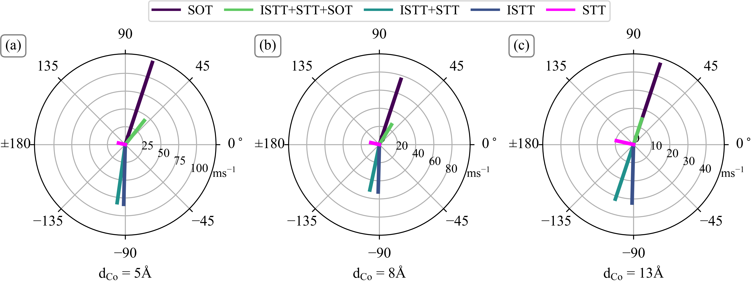
Figure S1. Effect of individual torques on a 100 nm diameter skyrmion, and combined effect, for Co layer of different thickness, (a) 5 Å, (b) 8 Å, and (c) 13 Å. A damping value of α = 0.1 was used here, with a driving current density of J_{C} = 2.5×10¹¹ A/m². The polar plots show the skyrmion velocity, obtained using the Thiele model.

The effect of the different spin torques is also strongly dependent on the skyrmion diameter. SkHA and skyrmion velocity values are shown in Fig. S2 as a function of diameter, obtained using the Thiele model of Equation (2):

,  . | (2)

As expected, the SOT-only model shows a monotonic increase in SkHA with decreasing diameter. On the other hand, the full spin torque model shows a much flatter SkHA-diameter dependence, and for diameters below 100 nm shows a decrease in SkHA with decreasing diameter. Moreover, skyrmion velocities under the full spin torque are much smaller than those of the SOT-only model, and as discussed in the main text more closely aligns with experimental results, particularly when the effect of skyrmion collections on group velocity is taken into account.

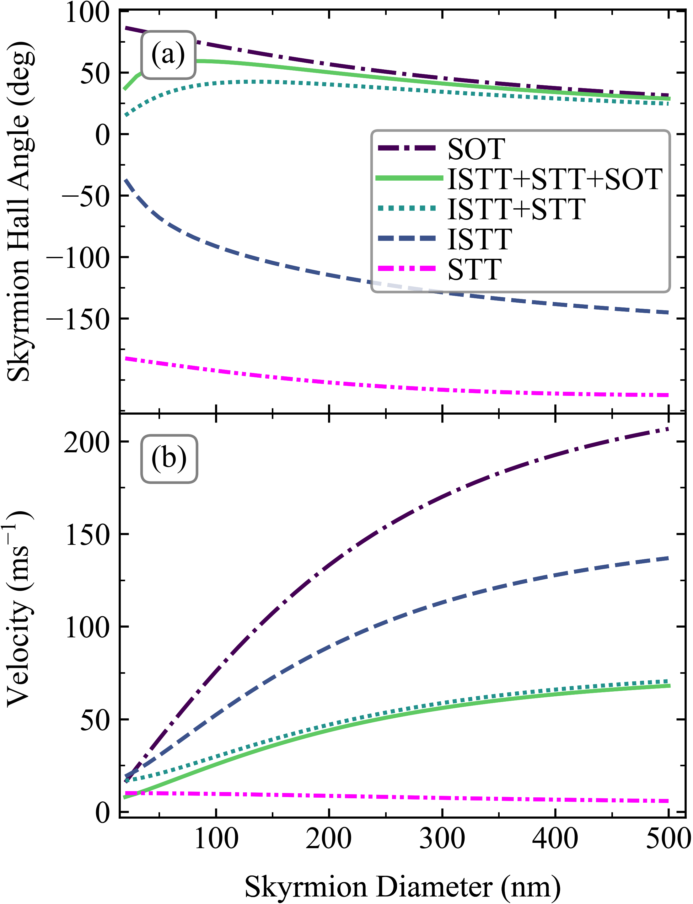
Figure S2. Variation of (a) SkHA, and (b) skyrmion velocity, with skyrmion diameter for the individual spin torques and combinations, obtained using the Thiele model for Co layer thickness of 8 Å. A damping value of α = 0.1 was used here, with a driving current density of J_{C} = 2.5×10¹¹ A/m². SkHA and velocity as a function of diameter are obtained using the Thiele model.

We also note that isolated skyrmion velocities obtained in other experiments align closely with the full spin torque model, whilst the SOT-only model predicts much larger velocities at damping values of α = 0.1 and lower, although disorder also plays a part in reducing velocities. For example Ref. [] shows ~40 ms-1 at JC = 2.5×1011 A/m2 with skyrmion diameters 100-150 nm, Ref. [] shows < 30 ms-1 at JC = 5×1011 A/m2 and room temperature, with skyrmion diameters 100-150 nm, Ref. [] shows ~30 ms-1 at JC = 5×1011 A/m2 with skyrmion diameters 100-150 nm, and Ref. [] with stacks containing Pt(3 nm)/Co(0.9 nm)/Ta(4 nm), and also for Pt(4.5 nm)/CoFeB(0.7 nm)/MgO(1.4 nm), shows ~20 ms⁻¹ at J_{C} = 2.5×10¹¹ A/m² with skyrmion diameters 100-150 nm.
Finally, we show the effect of damping on the SkHA in Fig. S3. As discussed in the main text, increasing damping results in smaller SkHA values as expected, both for the SOT-only as well as the full spin torque models. However, even for large values of α = 0.3, the SOT-only model cannot explain the small SkHA values obtained for small diameter skyrmions, showing instead a rapidly increasing SkHA as the diameter decreases. As discussed in the main text, the full spin torque reproduces experimental results with a realistic damping value (α = 0.1) when comparing modelling results in the elastic depinning regime to experimental results at the same current density, whilst the SOT-only model results in ~50° discrepancy.

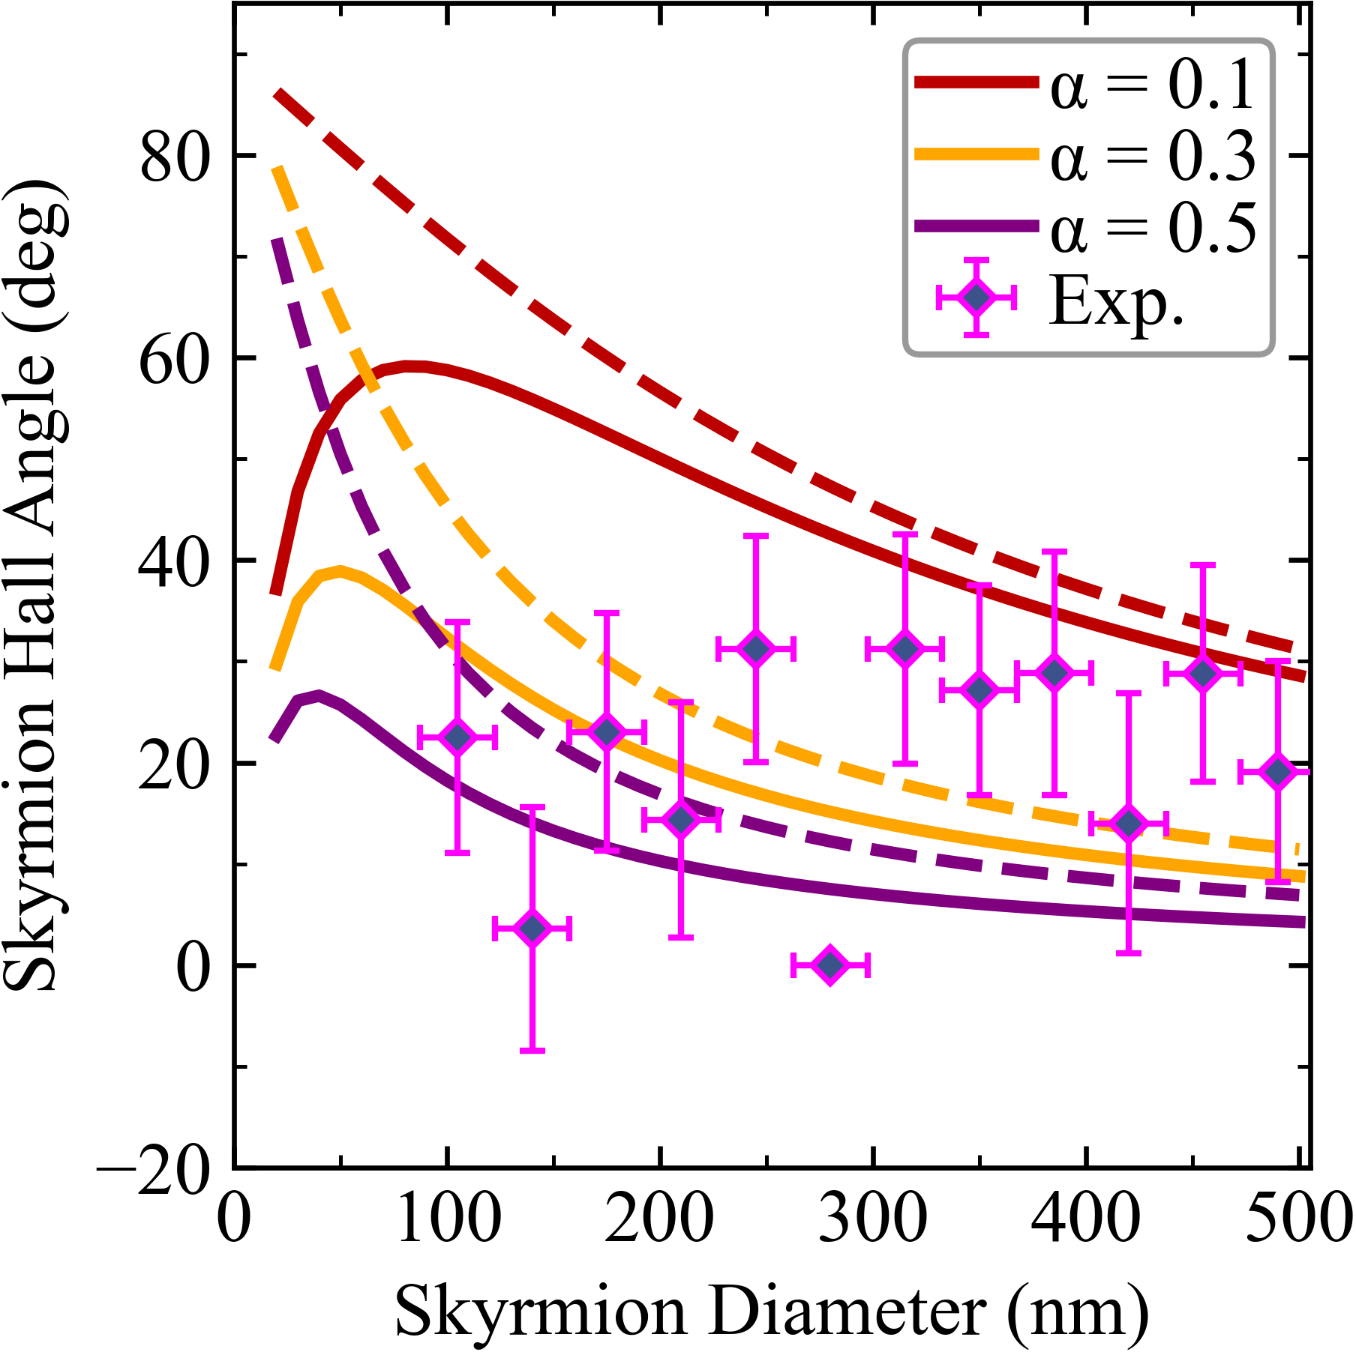
Figure S3. Variation of SkHA as a function of skyrmion diameter for FM layer thickness of 8 Å, where the dashed lines are the SOT-only contribution, whilst the solid lines are the full SOT+ISTT+STT results. The damping value is varied from 0.1 up to 0.5, with Thiele model results compared with the experimental data.

Effect of transport parameters on SkHA and velocity

The material parameters used to model spin transport in the Pt(2.7 nm)/Co(d_{Co})/Ir(0.4 nm) multilayer are shown in Table S1. In order to investigate the effect of various material parameters and layer thicknesses on the SkHA and skyrmion velocities, we concentrate on the most important parameters which have a marked effect on skyrmion motion: Pt and Co layer thicknesses, Pt spin flip length, and spin mixing conductance at the Co/Pt interface; the effect of magnetic damping has already been investigated in Appendix A. The contribution from the Ir layer (and Ir/Co interface) is small compared to that from Pt.

Table S1. Transport parameters used to model spin transport in the Pt/Co/Ir stack.
Transport Parameters (Co) | Value
σ | 5 M S/m []
D_{e} | 0.001 m²/s []
λ_{sf} | 42 nm [5]
λ_{J} | 2 nm []
λ_{φ} | 3.2 nm []
Transport Parameters (Pt)
σ | 7 MS/m []
D_{e} | 0.004 m²/s [6]
λ_{sf} | 1.4 nm [9]
θ_{SHA} | 0.19 [9]
G↑↓ (Pt/Co) | 1.5 + i0.45 PS/m² [9,3,]
Transport Parameters (Ir)
σ | 1.4 MS/m []
D_{e} | 0.0002 m²/s [6]
λ_{sf} | 0.5 nm []
θ_{SHA} | 0.02 [12]
G↑↓ (Co/Ir) | 0.35 + i0.045 PS/m² []

Here, a 100 nm diameter skyrmion is set, and for each combination of material parameters the spin transport solver is used to compute the various spin torques self-consistently using the equations discussed in the main text. The SOT, STT, and ISTT are then fitted to the computed spin torques in order to extract their respective spin torque parameters. Using the spin torque parameters, the Thiele model – Equation (2) – is then used to compute the SkHA and skyrmion velocities. Results are shown in Figs. S4 – S7. It must be emphasized, the results shown below are obtained for ideal and isolated skyrmions, without landscape disorder, and are thus limiting cases. However, this analysis is useful for understanding the effect of the different spin torques and combinations, for experimentally relevant material parameters and associated uncertainty ranges.

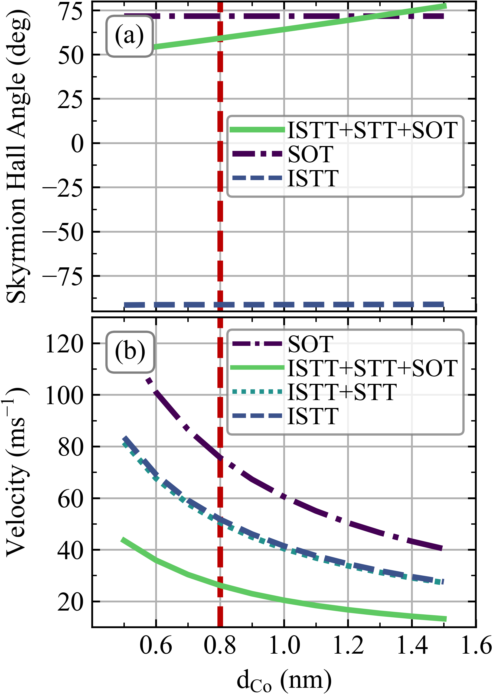
Figure S4. Effect of Co layer thickness, d_{Co}, on (a) SkHA, and (b) velocity (at J_{C} = 2.5×10¹¹ A/m²) for various spin torques and combinations. The dashed vertical line shows the value used for the results in the main text.

Varying the Co layer thickness results in an inverse dependence of the spin torque strengths, as expected from Equation (1), which leads to an inverse dependence of the skyrmion velocity – Fig. S4(b). By comparing the velocities obtained with ISTT+STT and ISTT-only, we can see the effect of the bulk STT on skyrmion velocities is relatively negligible. For SOT-only and ISTT-only, the SkHA value is constant – Fig. S4(a) – however, when the full spin torque is considered, a linear dependence on the Co layer thickness results. This arises since the motion under the combined spin torques is obtained as vector addition of the motion under the separate spin torques; thus, a variation in their relative velocities results in a variation of the SkHA under the combined spin torques.

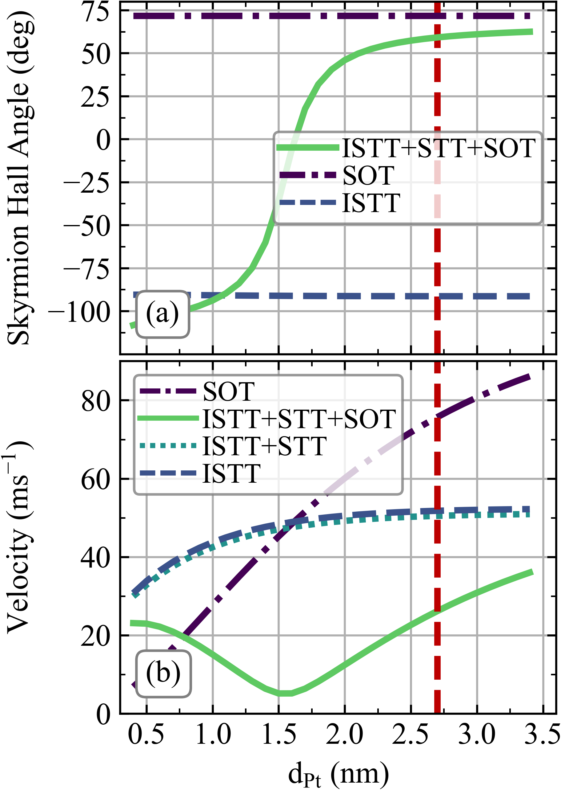
Figure S5. Effect of Pt layer thickness, d_{Pt}, on (a) SkHA, and (b) velocity (at J_{C} = 2.5×10¹¹ A/m²) for various spin torques and combinations. The dashed vertical line shows the value used for the results in the main text.

Varying the Pt layer thickness results in a change in the SOT and ISTT strength, primarily due to a change in the spin accumulation at the Pt/Co interface, which is strongly dependent on the spin-flip length to layer thickness ratio. For the SOT this results in a change in the effective SHA, θ_{SHAeff}, obtained by solving the drift-diffusion model as [10]:

. | (3)

Here and . Thus, for example, with an intrinsic Pt SHA value of θ_{SHA} = 0.19, θ_{SHAeff} = 0.048 at 2.7 nm thickness, but this decreases to θ_{SHAeff} = 0.006 at 0.5 nm thickness. This results in a monotonic dependence of the skyrmion velocity with Pt thickness under SOT, and similarly for ISTT – Fig. S5(b). As the Pt layer thickness is decreased, eventually the velocity contribution from ISTT becomes dominant (noting that an ISTT contribution from the 0.4 nm thick Ir layer is also present). This explains the marked change in SkHA seen in Fig. S5(a). These results show it is possible to control the SkHA by varying the relative strengths of the contributing spin torques. However, zero SkHA desired for applications occurs close to the point when the effects of SOT and ISTT nearly cancel out, and is thus accompanied by very low skyrmion velocities, as seen in Fig. S5.

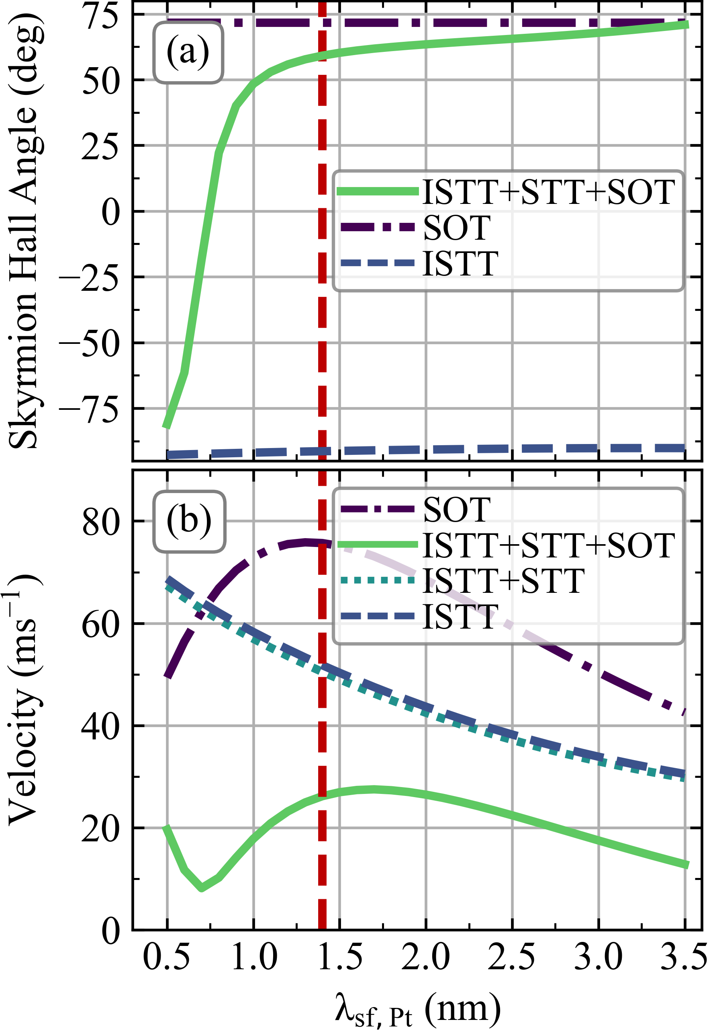
Figure S6. Effect of Pt spin flip length, λ_{sf,Pt}, on (a) SkHA, and (b) velocity (at J_{C} = 2.5×10¹¹ A/m²) for various spin torques and combinations. The dashed vertical line shows the value used for the results in the main text.

Similar remarks also apply to the dependence on Pt spin-flip length, shown in Fig. S6. The ISTT depends inversely on the spin-flip length, since smaller values result in larger spin accumulation gradients at the interface, and thus stronger diffusive vertical spin currents. The SOT strength also depends on the spin-flip length, as given by Equation (3), noting that θ_{SHAeff} depends not just on the d_{Pt} / λ_{sf,Pt} ratio, but also on λ_{sf,Pt} separately.

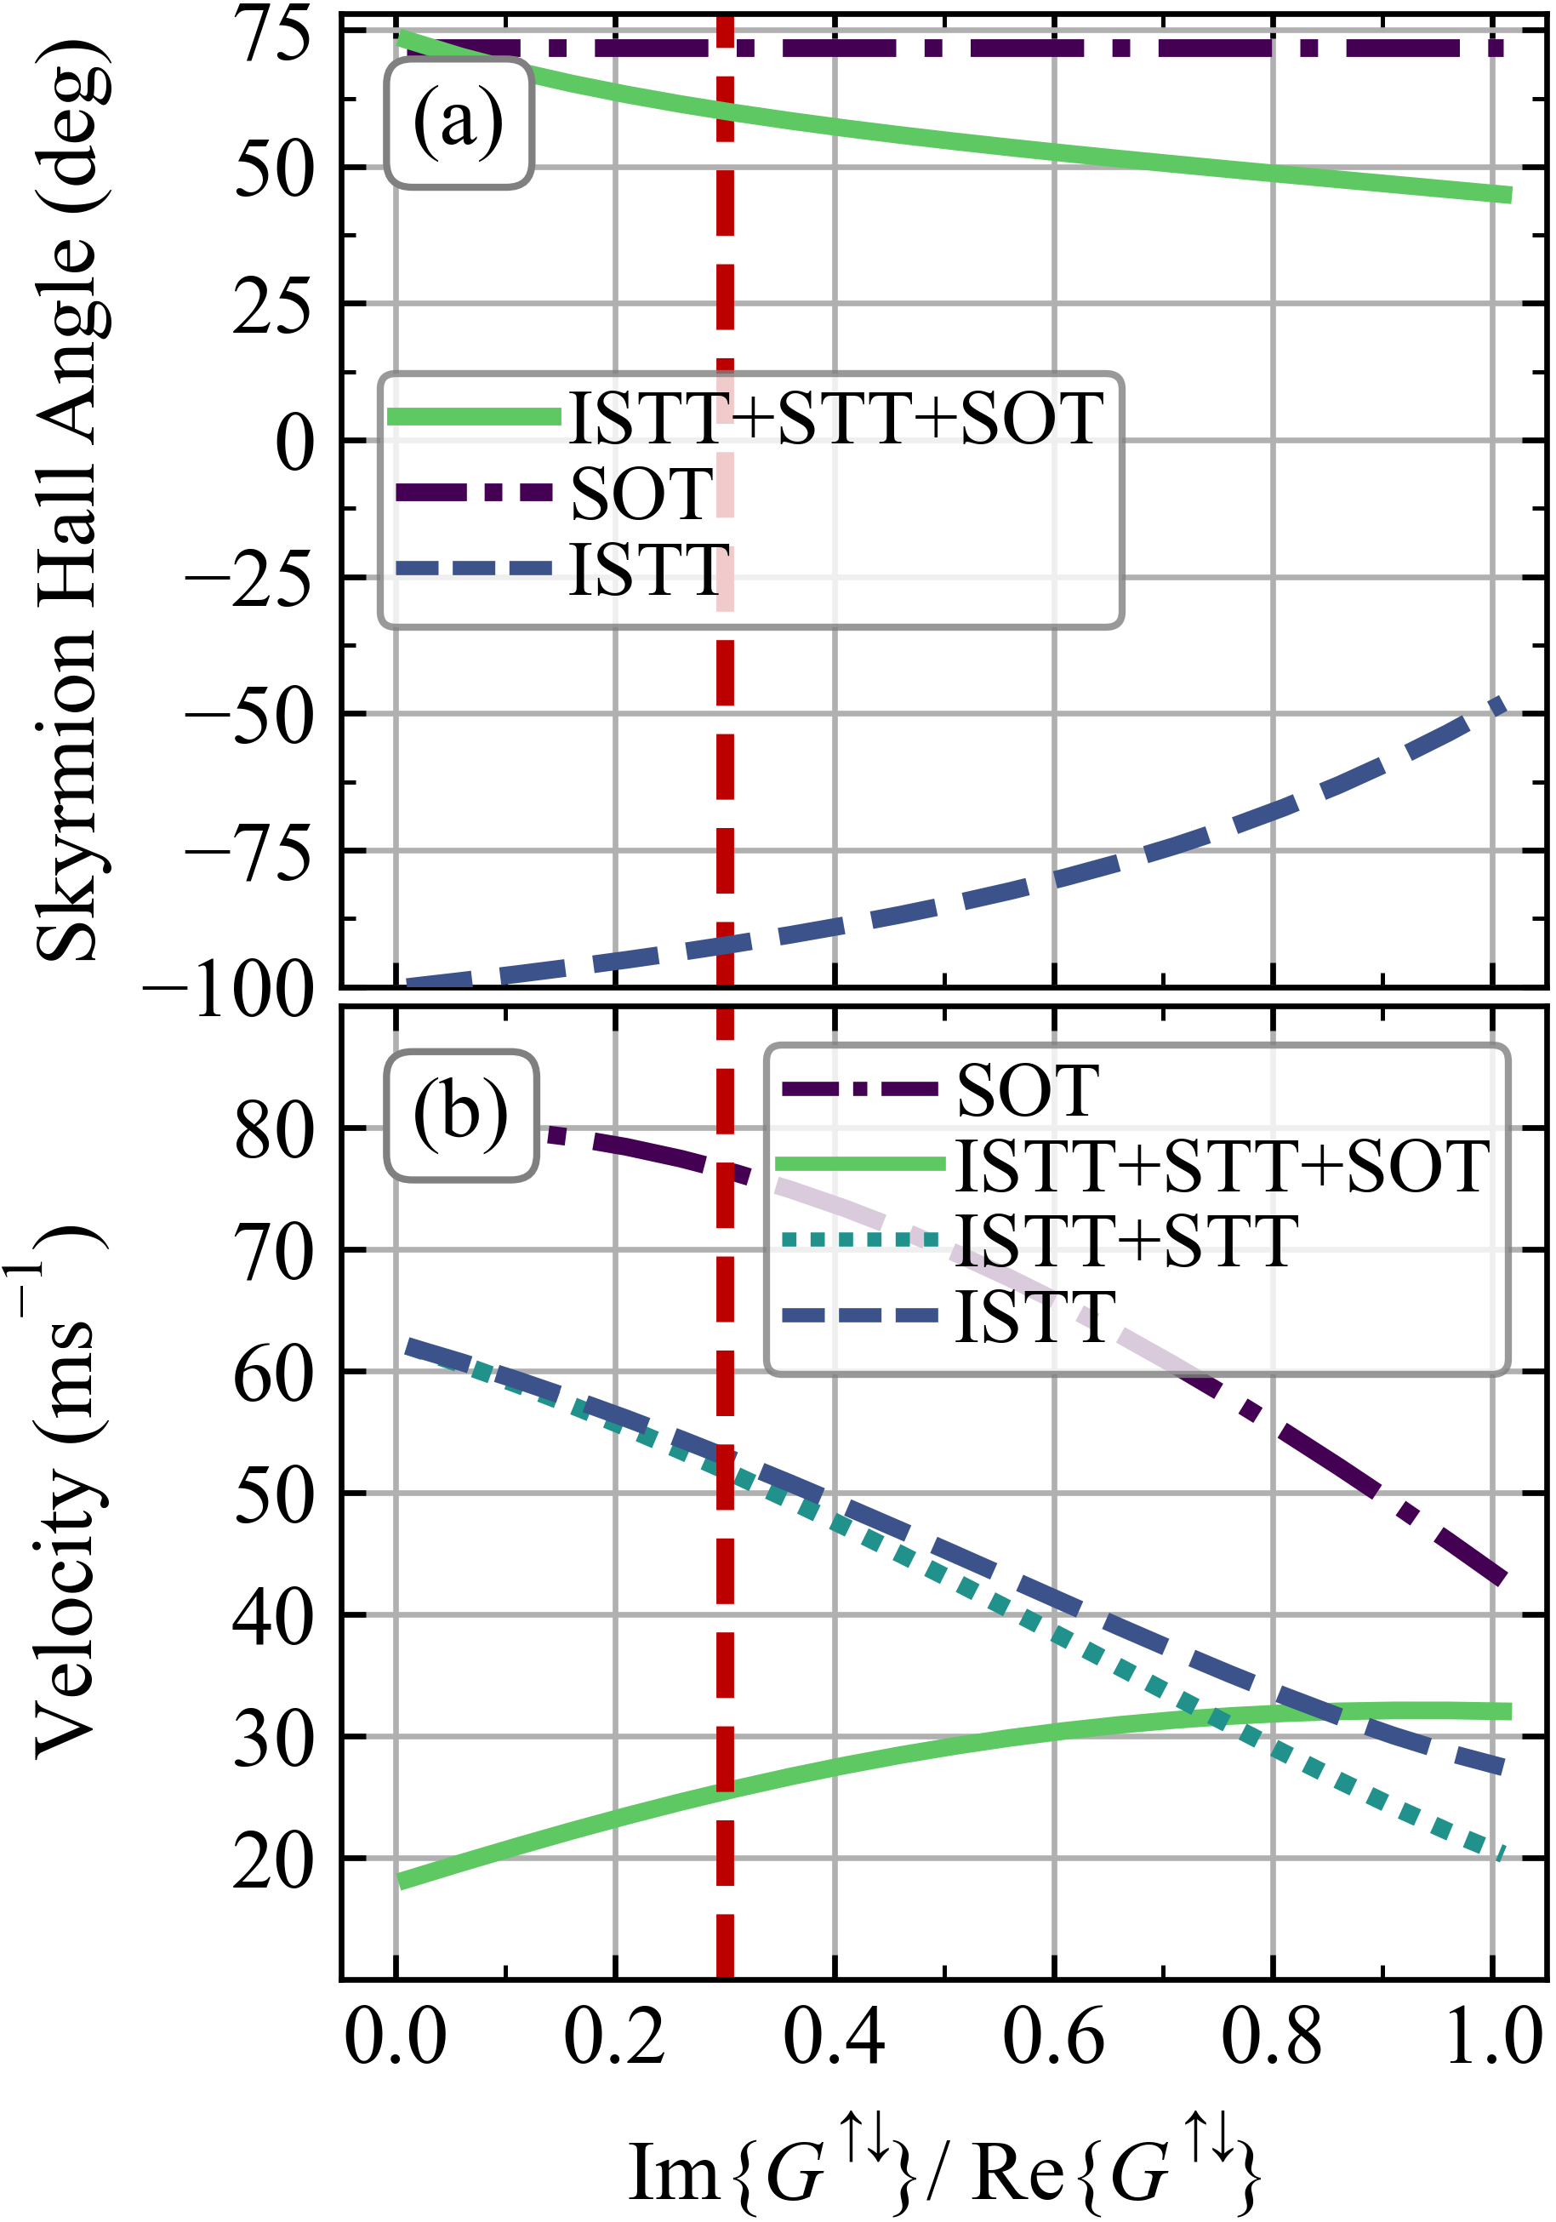
Figure S7. Effect of spin mixing conductance imaginary to real part ratio on (a) SkHA, and (b) velocity (at J_{C} = 2.5×10¹¹ A/m²) for various spin torques and combinations. The dashed vertical line shows the value used for the results in the main text.

The spin mixing conductance, G↑↓, also has an important effect on interfacial spin torques, Equation (1). Experimental data on the real part of G↑↓ are readily available in the literature, e.g. Ref. [9] for Pt/Co interfaces. On the other hand, data on the imaginary part of G↑↓ are scarcer. In this work we obtain Im{G↑↓} by using experimental data on the FL-SOT to DL-SOT ratio, e.g. Ref. [3]. The FL-SOT coefficient, r_{G}, may be obtained by solving the drift-diffusion model as:

. | (4)
From experimental values of r_{G}, this can be solved to obtain Im{G↑↓}. The effect of the imaginary part of the spin-mixing conductance is shown in Fig. S7, by plotting the SkHA and velocity as a function of the ratio r = Im{G↑↓} / Re{G↑↓}. Decreasing r results in stronger SOT and ISTT. At the same time, the interfacial non-adiabaticity parameter, β⊥, also depends on r [], which results in a change of the SkHA under ISTT-only, unlike for SOT-only. For very small values of r the effect of SOT and ISTT are nearly opposite, which results in skyrmion velocities tending towards zero under the combined spin torque.

References

[] Litzius, K. et al. Skyrmion Hall effect revealed by direct time-resolved X-ray microscopy. Nat. Phys. 13, 170-175 (2017).
[] Litzius, K. et al. The role of temperature and drive current in skyrmion dynamics. Nat. Electron. 3, 30-36 (2020).
[] Juge, R. et al. Current-driven skyrmion dynamics and drive-dependent skyrmion Hall effect in an ultrathin film. Phys. Rev. Appl. 12, 044007 (2019).
[] Woo, S. et al. Observation of room-temperature magnetic skyrmions and their curent-driven dynamics in ultrathin metallic ferromagnets. Nat. Mater. 15, 501-506 (2016).
[] Bass, J. & Pratt, W. P. Spin-diffusion lengths in metals and alloys, and spin-flipping at metal/metal interfaces: An experimentalist’s critical review. J. Phys.: Condens. Matter 19, 183201 (2007).
[] Halas, S & Durakiewicz, T. Work functions of elements expressed in terms of the Fermi energy and the density of free electrons. J. Phys.: Condens. Matter 10, 10815 (1998).
[] Zhang, S., Levy, P. M. & Fert, A. Mechanisms of SpinPolarized Current-Driven Magnetization Switching. Phys. Rev. Lett. 88, 236601 (2002).
[] Petitjean, C., Luc, D. & Waintal, X. Unified Drift-Diffusion Theory for Transverse Spin Currents in Spin Valves, Domain Walls, and Other Textured Magnets. Phys. Rev. Lett. 109, 117204 (2012).
[] Zhang, W., Han, W., Jiang, X., Yang, S. H. & Parkin, S. P. P. Role of transparency of platinum–ferromagnet interfaces in determining the intrinsic magnitude of the spin Hall effect. Nat Phys 11, 496 (2015).
[] MacKinnon, C. R., Lepadatu, S., Mercer, T. & Bissell, P. R. Role of an additional interfacial spin-transfer torque for current-driven skyrmion dynamics in chiral magnetic layers. Phys. Rev. B 102, 214408 (2020).
[] Reeves, G. K. & Lawn, M. W. Resistivity measurements of thin film iridium on silicon. Journal of Vacuum Science & Technology A 10, 3203 (1992).
[] Zhang, W. et al. Spin pumping and inverse spin Hall effects—Insights for future spin-orbitronics. J. Appl. Phys. 117, 172610 (2015).
[] Tokaç, M., Bunyaev, S. A., Kakazei, G. N., Schmool, D. S., Atkinson, D. & Hindmarch, A. T. Interfacial Structure Dependent Spin Mixing Conductance in Cobalt Thin Films. Phys. Rev. Lett. 115, 056601 (2015).
[] Lepadatu, S. Effect of inter-layer spin diffusion on skyrmion motion in magnetic multilayers. Sci. Rep. 9, 9592 (2019).

