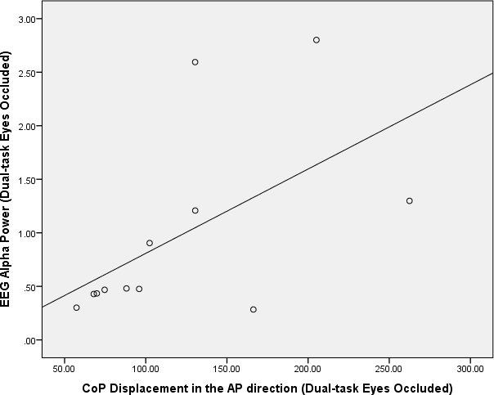
Supplementary Figure 2. Correlation analysis between fronto-central EEG alpha power and CoP displacement in the Anterior-Posterior direction during dual-task eyes occluded

