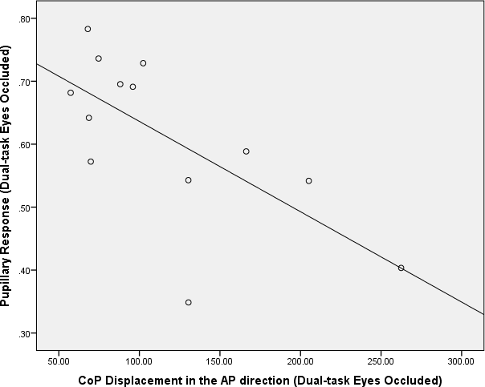
Supplementary Figure 1. Correlation analysis between pupillary response and CoP displacement in the Anterior- Posterior direction during dual-task eyes occluded

