Supplemental Tables
Table S1. Properties of primary and secondary antibodies used in flow cytometry to detect cell surface markers.
Target (clone) | Cat# | Host/clonality | Immunogen | Species reactivity | Conjugation | Supplier
Primary Antibodies
CD44 (CVS18) | MA5-16634 | Mouse mAb | Equine leucocytes | Horse | Unconjugated | ThermoFisher Scientific, USA
CD73 (606112) | FAB5795P | Mouse mAb | CHO-human CD73 | Human, Horse | Phycoerythrin | Novus Biologicals, USA
CD14 (433423) | FAB4597N | Mouse mAb | Recombinant porcine CD14 | Porcine, Horse | AlexaFluor700 | Novus Biologicals, USA
CD45 (MEM-28) | NB-319AF647 | Mouse mAb | Human thymocytes and T lymphocytes | Human, Horse | AlexaFluor647 | Novus Biologicals, USA
CD90 (MRC OX-7) | Ab225 | Mouse mAb | Rat CD90 | Rat, Horse | Unconjugated | Abcam, UK
CD105 (SN6) | MCA1557A488 | Mouse mAb | Human leukaemia cells | Human, Horse | AlexaFluor488 | AbD Serotec, UK
MHC-class I (CVS 22) | Ab23491 | Mouse mAb | Equine leucocytes | Horse | Unconjugated | Abcam, UK
MHC-class II (CVS20) | Ab23206 | Mouse mAb | Equine 3132 cells | Horse, Human | Unconjugated | Abcam, UK
Secondary Antibodies
Goat anti-mouse PE | Ab97024 | Mouse pAb |  | Mouse | Phycoerythrin | Abcam, UK
Goat anti-mouse 647 | Ab150115 | Mouse pAb |  | Mouse | AlexaFluor647 | Abcam, UK
Goat anti-mouse 488 | Ab150113 | Mouse pAb |  | Mouse | AlexaFluor488 | Abcam, UK
mAb = monoclonal antibody, pAb = polyclonal antibody

Table S2. Primer sequences for RT-PCR and qPCR examination of cell surface marker expression.
Marker | Forward (5’ to 3’) | Reverse (5’ to 3’) | Product length (bp) | Annealing temp.
RT-PCR primers
CD105 | TCGTCAACCTCCTGTCAAGC | GGGATACAGGGCTATGGTGC | 389 | 58
CD90 | CCTGAGCACACATACCGCTC | CTTATGCCCTCGCACTTGAC | 194 | 58
CD73 | AAATGGAGGTGGCATTCGGT | TGGTCACCGGAGTCATGTTTT | 402 | 58
CD45 | TCGCAAACACCTCTGAACGA | CACCAGGAGCACTGGCATTA | 117 | 62
CD44 | GCGCTGAACATTGGCTTTGA | GGCTCGGTCTTTGGTAGTGG | 477 | 58
qPCR primers
CD146 | AAAGGAGAGGAAGGTGTG | ATTCAGGATGCTCAGGAC | Designed to have an optimal annealing temperature of 58°C
CD34 | CAAACCAAAATCAAGGGAGAA | AAGGAGCAAGGAGCACACC
CD31 | GGCAAGCCTTCTACCAAGT | TGGCCCCGAGTATCAAGAGA
β-actin | GGACCTGACGGACTACCTC | CACGCACGATTTCCCTCTC
Primers were made up to a 100 µM stock and diluted to a 10 µM working stock using DNase-free water.

Table S3. Summary table of cell surface marker expression for So Flash, Flash Move and Jubilee cell lines at multiple passages by RT-PCR, flow cytometry and qPCR.
 |  | FM p2/p3^ | FM p9/p10^ | FM p16 | SF  p2 | SF  p8 | SF p14/p13^ | SF  p22 | SF  p26 | SF  p30 | J  p2 | J  p7/p8^ | J  p13 | J  p18
Positive markers | CD90  (PCR/Flow) | +/+ | +/+ | +/+ | +/X | +/+ | +/+ | +/+ | +/X | + | +/X | +/+ | +/+ | +/+
Positive markers | CD105  (PCR) | + | + | + | + | + | + | + | + | + | + | + | + | -
Positive markers | CD73  (PCR) | + | + | + | + | + | + | + | + | + | + | + | + | +
Positive markers | CD44  (PCR/Flow) | +/X | +/+ | +/+ | + | +/+ | +/+ | +/+ | +/X | + | +/X | +/+ | +/+ | +/+
Positive markers | CD146  (qPCR) | +++ | ++ | ++ | +++ | ++ | ++ | ++ | ++ | + | +++ | ++ | ++ | +
Positive markers | MHC-I  (Flow) | + | + | + | X | + | + | - | X | X | X | + | + | +
Negative markers | CD45  (PCR/Flow) | -/X | -/+ | -/+ | -/X | -/- | -/+ | -/+ | -/X | X | -/X | -/+ | -/+ | -/+
Negative markers | CD34  (qPCR) | ++ | + | - | ++ | ++ | + | + | - | - | ++ | ++ | ++ | +
Negative markers | CD31  (qPCR) | - | - | - | + | + | + | + | - | - | - | - | - | -
Negative markers | CD14  (Flow) | X | X | - | X | + | - | - | X | X | X | - | X | -
Negative markers | MHC-II  (Flow) | X | - | - | X | - | - | - | X | X | X | - | - | -
Where multiple methods were used, the expression by RT-PCR is indicated first followed by flow cytometry (Flow). For RT-PCR and flow cytometry experiments: + = marker expressed, - = marked not expressed. For qPCR experiments: + = low gene expression, ++ = moderate gene expression and +++ = high gene expression. ^= passage used in flow cytometry experiments, X = not tested.

Table S4. Summary of tri-lineage differentiation capabilities of equine MSC-like cells.
 | SF p7 | SF p13 | SF p18 | FM p7/8/9* | FM p13 | J p7 | J p13/14^ | J p18
Adipogenic | + | + | + | + | + | + | + | +
Osteogenic | -/+ (d21) | + (d21/d24) | + (d21) | + (d21/d24)* | -/+ (d24) | + (d24) | X | X
Chrondrogenic | -/+ | -/+ | + | + | + | + | + | X
For osteogenic differentiation, the experimental day at which positive staining was observed is noted in brackets. *osteogenic differentiation observed at p9 but not p7 FM cells and chondrogenic differentiation of FM investigated at p8. ^chondrogenic differentiation of J was examined at p14.

Table S5. Numbers of EVs in the cell and medium compartment of a blank CELLine bioreactor after 3 days.
 | EV counts |  |  |  | average | sd
cell compartment | 9.60E+07* | 1.03E+07* | 1.13E+07 | 2.01E+07 | 3.44E+07 | 4.13E+07
medium compartment |  | 2.27E+08 | 4.87E+08 | 2.70E+09 | 1.14E+09 | 1.36E+09
Media contained Advanced DMEM/F12 containing 2% FBS in the medium chamber and PBS in the lower chamber. The data is representative of 3 experiments using 3 different bioreactors. *both results were derived from one bioreactor and are 4-days collection and 3-days collection respectively

Supplemental Figures

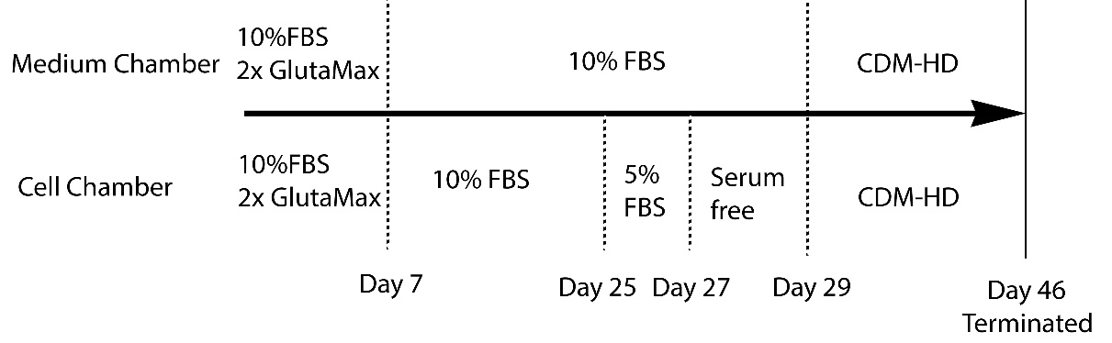
Figure S1. Culturing scheme and media composition in bioreactors.

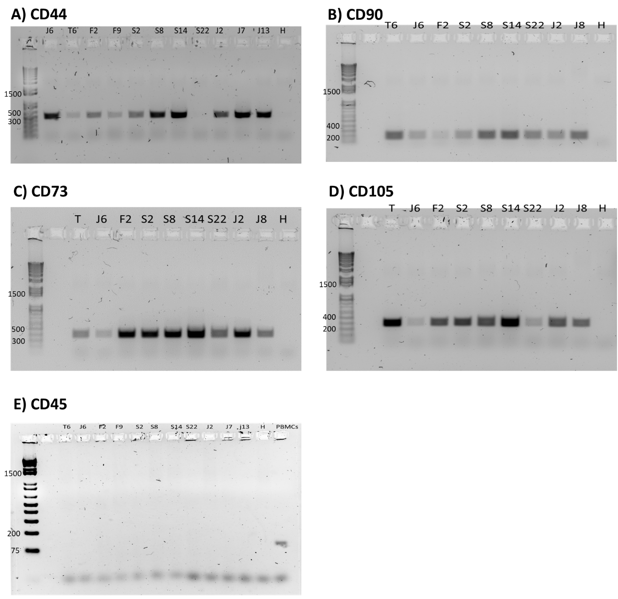
Figure S2. Original RT-PCR gels detecting the presence of CD44, CD90, CD73, CD105 and absence of CD45 in equine embryo-derived MSC-like cells. Samples were run on a 1.5% gel except CD45 which was run on a 2% gel. PBMCs were used as a positive control for CD45. Embryo samples are indicated by an initial (T = Tinks, J = Jubilee, F = Flash move, S = So Flash) followed by the passage number. H = H₂O.

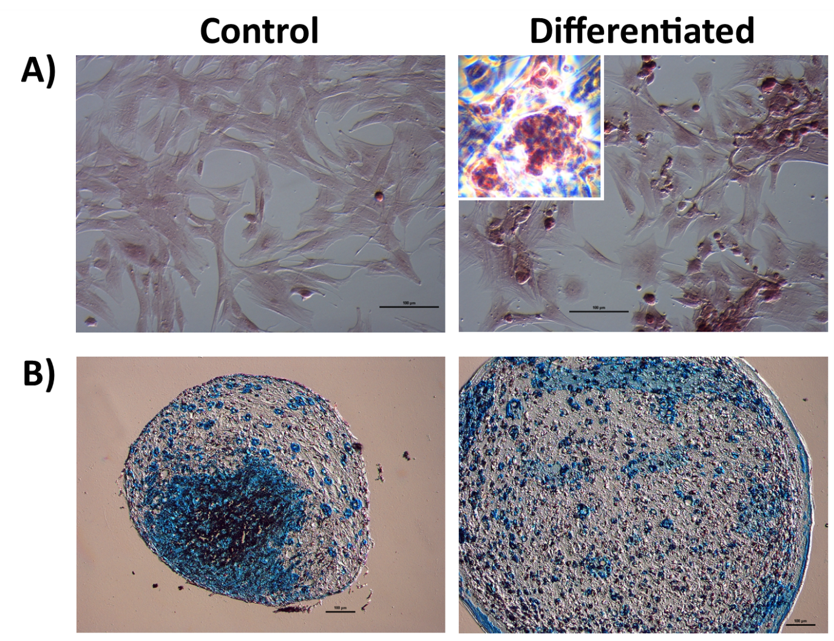
Figure S3. A) FM p13 day 24 osteogenic differentiated cells showing no positive Alizarin Red S staining but a change in cell morphology and aggregation. B) Chondrogenic differentiation of SF p7 showing no obvious difference in staining intensity but a significantly larger size for the differentiated compared to untreated cell pellet sections. Sections were imaged using a 10x non-confocal objective lens. Scale bar, 100 µm.
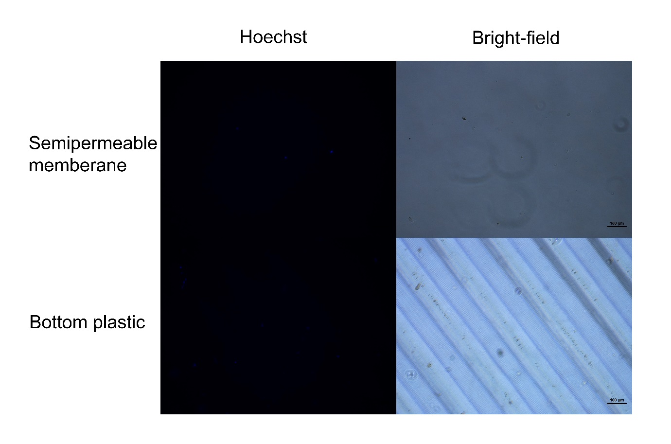
Figure S4. Microscopy images showing very little biomass were observed in the semipermeable dialysis membrane and the bottom gas-permeable membrane of the CELLineTM flask. Scale bar, 100 µm.

Figure S5. Daily EV harvest from CELLineTM flask in basal DMEM/F12 with advanced DMEM/F12 + 2% FBS as nutrient medium.
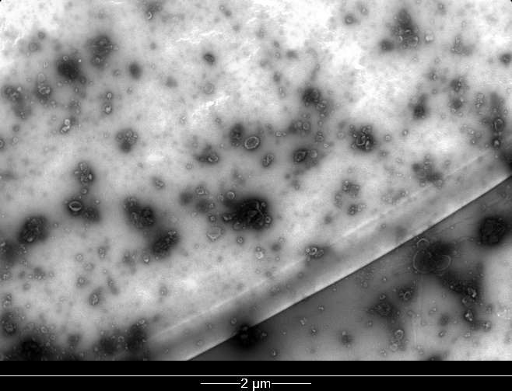
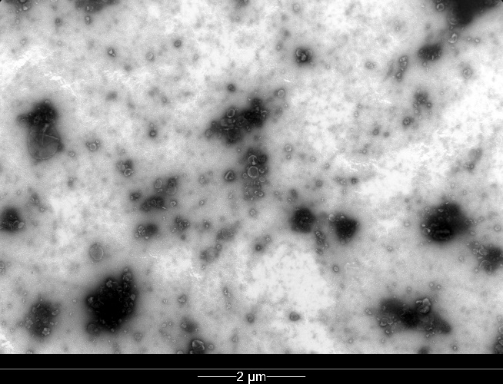
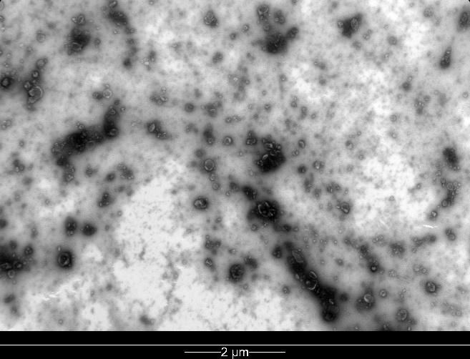
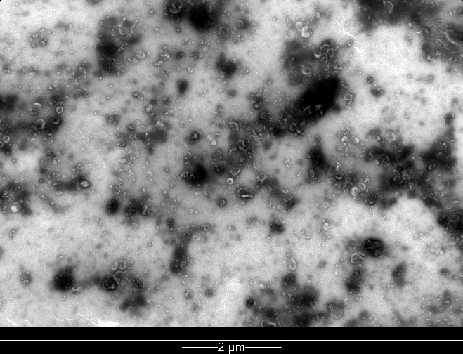

Figure S6. TEM of equine MSC EVs at lower magnification as per MISEV guidelines. Scale bar, 2 µm.

