SUPPLEMENTARY MATERIALS
Table S1: Counties that attained equity in Optimal births between White/Black population
County Name | State
BRISTOL BAY BOROUGH | AK
DENALI | AK
DILLINGHAM | AK
FAIRBANKS NORTH STAR | AK
HAINES | AK
HOONAH-ANGOON CENSUS AREA | AK
LAKE AND PENINSULA | AK
PR.OF WALES-HYDER CNS AREA | AK
GREENLEE | AZ
COLUSA | CA
INYO | CA
KINGS | CA
YOLO | CA
BACA | CO
CHEYENNE | CO
CUSTER | CO
DELTA | CO
HINSDALE | CO
JACKSON | CO
KIOWA | CO
LINCOLN | CO
MINERAL | CO
MORGAN | CO
OURAY | CO
SAN JUAN | CO
SAN MIGUEL | CO
SEDGWICK | CO
TELLER | CO
WELD | CO
LEVY | FL
CARROLL | GA
HABERSHAM | GA
SCHLEY | GA
TALBOT | GA
BOUNDARY | ID
CUSTER | ID
GOODING | ID
JEROME | ID
LEMHI | ID
LEWIS | ID
NEZ PERCE | ID
ONEIDA | ID
OWYHEE | ID
POWER | ID
VALLEY | ID
WASHINGTON | ID
CLAY | IL
JASPER | IL
KANKAKEE | IL
MERCER | IL
SHELBY | IL
BOONE | IN
JAY | IN
NOBLE | IN
SHELBY | IN
SWITZERLAND | IN
TIPPECANOE | IN
WASHINGTON | IN
GRUNDY | IA
IOWA | IA
LUCAS | IA
MILLS | IA
VAN BUREN | IA
WAYNE | IA
ANDERSON | KS
CHASE | KS
CHAUTAUQUA | KS
COMANCHE | KS
DONIPHAN | KS
ELLSWORTH | KS
GEARY | KS
HASKELL | KS
JEWELL | KS
LINN | KS
LOGAN | KS
MEADE | KS
STANTON | KS
STEVENS | KS
WICHITA | KS
WILSON | KS
WYANDOTTE | KS
BUTLER | KY
WASHINGTON | MD
WORCESTER | MD
BARRY | MI
JACKSON | MI
LUCE | MI
MECOSTA | MI
OTSEGO | MI
ANOKA | MN
CLEARWATER | MN
COOK | MN
FILLMORE | MN
LAC QUI PARLE | MN
LYON | MN
NOBLES | MN
POLK | MN
WILKIN | MN
ANDREW | MO
ATCHISON | MO
BUCHANAN | MO
CEDAR | MO
CLAY | MO
CLINTON | MO
DAVIESS | MO
HOLT | MO
KNOX | MO
MONITEAU | MO
MORGAN | MO
OREGON | MO
OSAGE | MO
PUTNAM | MO
ST. CLAIR | MO
SCHUYLER | MO
SCOTLAND | MO
CARTER | MT
CASCADE | MT
CHOUTEAU | MT
DANIELS | MT
GARFIELD | MT
GOLDEN VALLEY | MT
GRANITE | MT
JEFFERSON | MT
JUDITH BASIN | MT
LIBERTY | MT
LINCOLN | MT
MINERAL | MT
MUSSELSHELL | MT
PETROLEUM | MT
POWDER RIVER | MT
ROSEBUD | MT
SANDERS | MT
STILLWATER | MT
TREASURE | MT
VALLEY | MT
WHEATLAND | MT
WIBAUX | MT
YELLOWSTONE | MT
ANTELOPE | NE
BANNER | NE
CEDAR | NE
CUMING | NE
DEUEL | NE
DIXON | NE
DODGE | NE
GRANT | NE
HAYES | NE
HOOKER | NE
JOHNSON | NE
KEYA PAHA | NE
LOUP | NE
PAWNEE | NE
SIOUX | NE
THAYER | NE
VALLEY | NE
WHEELER | NE
ELKO | NV
ESMERALDA | NV
EUREKA | NV
HUMBOLDT | NV
HARDING | NM
LOS ALAMOS | NM
MORA | NM
OTERO | NM
BURKE | NC
CAMDEN | NC
CATAWBA | NC
GATES | NC
GREENE | NC
PAMLICO | NC
PASQUOTANK | NC
VANCE | NC
BILLINGS | ND
BOTTINEAU | ND
BOWMAN | ND
BURKE | ND
BURLEIGH | ND
DUNN | ND
EDDY | ND
EMMONS | ND
FOSTER | ND
GOLDEN VALLEY | ND
GRANT | ND
GRIGGS | ND
HETTINGER | ND
LA MOURE | ND
LOGAN | ND
MCHENRY | ND
MERCER | ND
MORTON | ND
NELSON | ND
OLIVER | ND
PEMBINA | ND
RENVILLE | ND
SHERIDAN | ND
SIOUX | ND
STEELE | ND
WARD | ND
ALFALFA | OK
BEAVER | OK
DEWEY | OK
NOWATA | OK
CROOK | OR
GRANT | OR
JEFFERSON | OR
LINN | OR
MALHEUR | OR
CAMBRIA | PA
FULTON | PA
HUNTINGDON | PA
MONTOUR | PA
JASPER | SC
BON HOMME | SD
BROOKINGS | SD
BUTTE | SD
CLARK | SD
CUSTER | SD
DEUEL | SD
DEWEY | SD
HAAKON | SD
HANSON | SD
HUGHES | SD
HUTCHINSON | SD
KINGSBURY | SD
MOODY | SD
PERKINS | SD
BLEDSOE | TN
FENTRESS | TN
VAN BUREN | TN
ARCHER | TX
CARSON | TX
CLAY | TX
COKE | TX
EDWARDS | TX
GLASSCOCK | TX
HARTLEY | TX
HEMPHILL | TX
KENEDY | TX
KING | TX
LAMPASAS | TX
MENARD | TX
MILLS | TX
MORRIS | TX
MOTLEY | TX
RANDALL | TX
ROBERTS | TX
STERLING | TX
STONEWALL | TX
TERRELL | TX
TERRY | TX
THROCKMORTON | TX
BEAVER | UT
JUAB | UT
KANE | UT
MORGAN | UT
RICH | UT
ESSEX | VT
LAMOILLE | VT
ISLE OF WIGHT | VA
EMPORIA CITY | VA
MANASSAS PARK CITY | VA
RADFORD CITY | VA
COWLITZ | WA
GARFIELD | WA
SAN JUAN | WA
WAHKIAKUM | WA
ADAMS | WI
BROWN | WI
BUFFALO | WI
BURNETT | WI
KEWAUNEE | WI
LA CROSSE | WI
LAFAYETTE | WI
MARQUETTE | WI
OZAUKEE | WI
PEPIN | WI
PIERCE | WI
SAWYER | WI
CROOK | WY
UINTA | WY

Table S2: Counties that attained equity in optimal births between the White and Hispanic populations
County Name | State
DENALI | AK
FAIRBANKS NORTH STAR | AK
LAKE AND PENINSULA | AK
COCONINO | AZ
GREENLEE | AZ
MARICOPA | AZ
YAVAPAI | AZ
ALAMEDA | CA
COLUSA | CA
KINGS | CA
MADERA | CA
PLACER | CA
SAN MATEO | CA
SONOMA | CA
STANISLAUS | CA
ARCHULETA | CO
BOULDER | CO
BROOMFIELD | CO
CUSTER | CO
ELBERT | CO
EL PASO | CO
GARFIELD | CO
HUERFANO | CO
JEFFERSON | CO
MESA | CO
MINERAL | CO
OTERO | CO
SAN JUAN | CO
WELD | CO
BAY | FL
SARASOTA | FL
WALTON | FL
CARROLL | GA
HABERSHAM | GA
MACON | GA
MUSCOGEE | GA
QUITMAN | GA
STEWART | GA
TALBOT | GA
HONOLULU | HI
BINGHAM | ID
BONNEVILLE | ID
GOODING | ID
JEFFERSON | ID
LATAH | ID
CALHOUN | IL
JACKSON | IL
KANKAKEE | IL
WILLIAMSON | IL
DELAWARE | IN
JASPER | IN
PARKE | IN
WASHINGTON | IN
BLACK HAWK | IA
JONES | IA
WASHINGTON | IA
GEARY | KS
HASKELL | KS
JOHNSON | KS
MCPHERSON | KS
RILEY | KS
SEWARD | KS
SHERMAN | KS
OLDHAM | KY
TALBOT | MD
WASHINGTON | MD
BERKSHIRE | MA
GRAND TRAVERSE | MI
KENT | MI
SANILAC | MI
WEXFORD | MI
ANOKA | MN
FILLMORE | MN
MARTIN | MN
RAMSEY | MN
RICE | MN
ROCK | MN
SHERBURNE | MN
TRAVERSE | MN
WILKIN | MN
CLAY | MO
CLINTON | MO
JACKSON | MO
PLATTE | MO
PULASKI | MO
SCOTLAND | MO
CARTER | MT
CHOUTEAU | MT
DANIELS | MT
GALLATIN | MT
GARFIELD | MT
GOLDEN VALLEY | MT
LIBERTY | MT
MUSSELSHELL | MT
PETROLEUM | MT
RICHLAND | MT
SILVER BOW | MT
BANNER | NE
GRANT | NE
HOOKER | NE
KEYA PAHA | NE
LOUP | NE
MADISON | NE
PLATTE | NE
DOUGLAS | NV
PERSHING | NV
GRANT | NM
LOS ALAMOS | NM
RIO ARRIBA | NM
SANTA FE | NM
VALENCIA | NM
CHENANGO | NY
HAMILTON | NY
TOMPKINS | NY
CAMDEN | NC
CRAVEN | NC
DURHAM | NC
FRANKLIN | NC
HARNETT | NC
HOKE | NC
POLK | NC
WARREN | NC
WAYNE | NC
EMMONS | ND
FOSTER | ND
GRANT | ND
GRIGGS | ND
HETTINGER | ND
MORTON | ND
MOUNTRAIL | ND
OLIVER | ND
SHERIDAN | ND
MARION | OH
WAYNE | OH
ATOKA | OK
BLAINE | OK
GARFIELD | OK
BAKER | OR
COOS | OR
MORROW | OR
BLAIR | PA
CHESTER | PA
CUMBERLAND | PA
FRANKLIN | PA
UNION | PA
BEAUFORT | SC
HAAKON | SD
PENNINGTON | SD
CUMBERLAND | TN
FENTRESS | TN
BELL | TX
BLANCO | TX
CARSON | TX
COOKE | TX
CORYELL | TX
DALLAM | TX
GARZA | TX
KING | TX
LUBBOCK | TX
MC LENNAN | TX
MILAM | TX
PALO PINTO | TX
PARKER | TX
RANDALL | TX
SCHLEICHER | TX
STEPHENS | TX
TERRY | TX
YOUNG | TX
BEAVER | UT
BOX ELDER | UT
IRON | UT
SALT LAKE | UT
TOOELE | UT
BENNINGTON | VT
ARLINGTON | VA
CAMPBELL | VA
CHARLES CITY | VA
CHESTERFIELD | VA
FAUQUIER | VA
MONTGOMERY | VA
ORANGE | VA
PRINCE GEORGE | VA
ROCKBRIDGE | VA
STAFFORD | VA
CHARLOTTESVILLE CITY | VA
FREDERICKSBURG CITY | VA
NEWPORT NEWS CITY | VA
SALEM CITY | VA
WILLIAMSBURG CITY | VA
COWLITZ | WA
DOUGLAS | WA
KLICKITAT | WA
SKAGIT | WA
SKAMANIA | WA
GREENBRIER | WV
SUMMERS | WV
KEWAUNEE | WI
LA CROSSE | WI
MARATHON | WI
MARINETTE | WI
WOOD | WI
CROOK | WY
LARAMIE | WY
NIOBRARA | WY

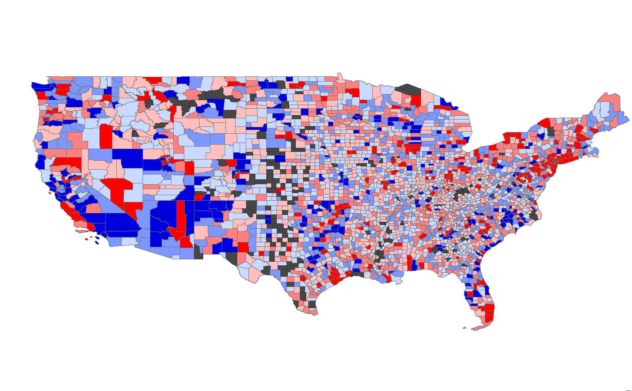
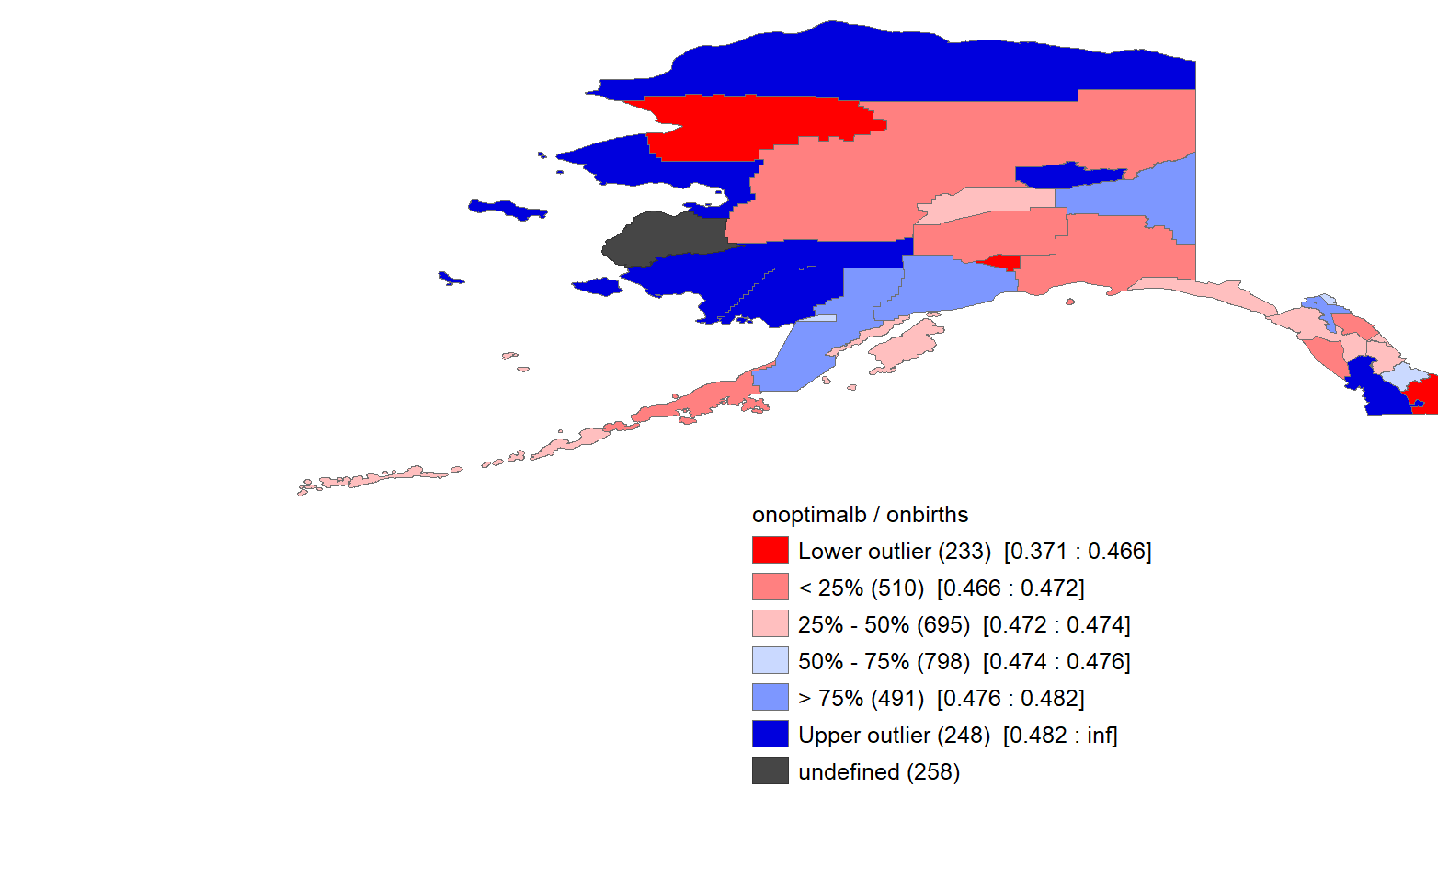
Figure S1: County-level empirical bayes smoothed rates of optimal births for “Other” race, 2018-2019

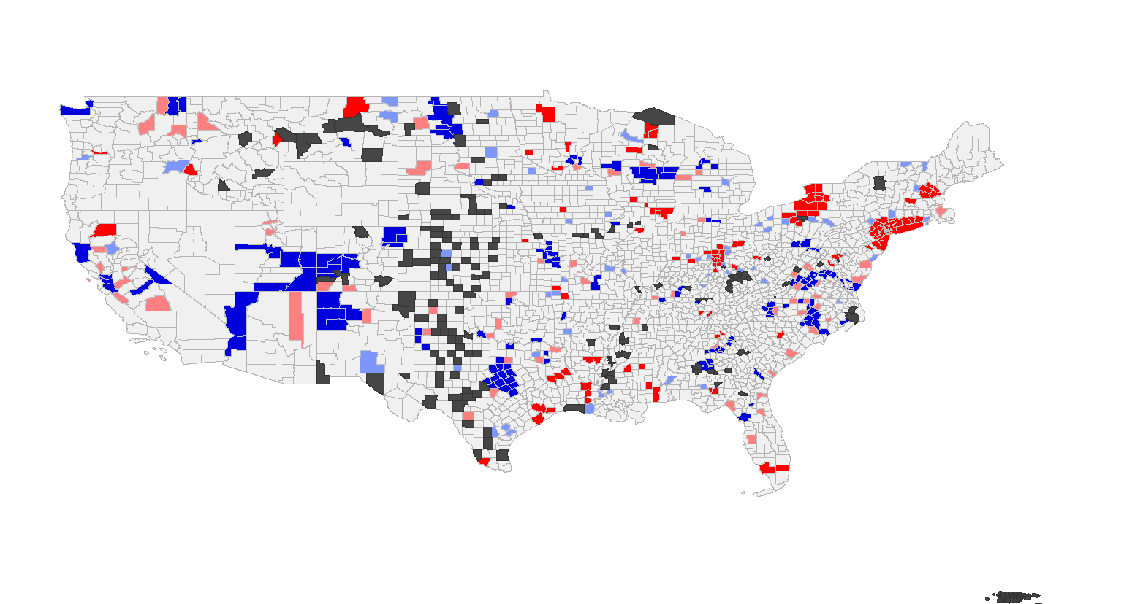
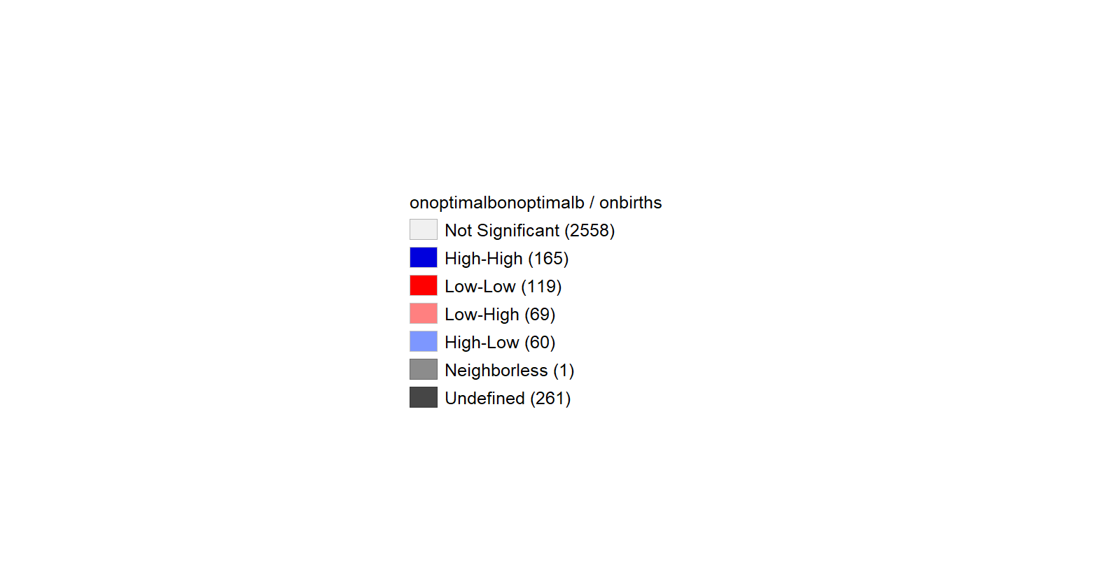
Figure S2: County-level Local-Indicators of Spatial Autocorrelation (LISA) cluster significance
for “Other” race, 2018-2019

