Supplementary figures

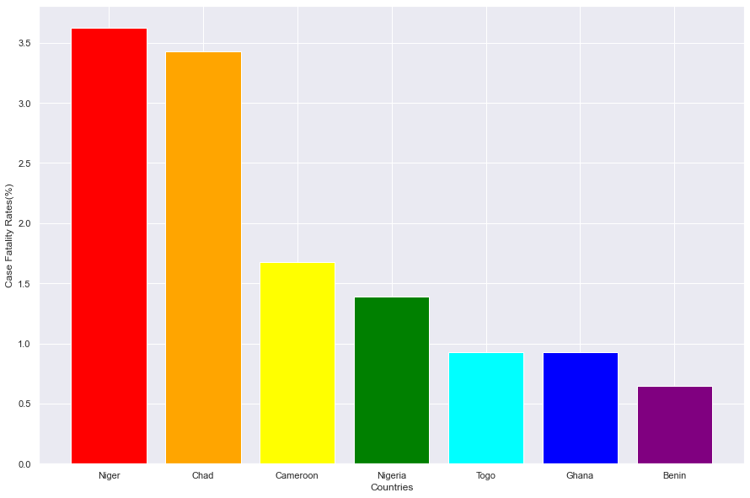
Figure S1. The ranking of the country with regards to the CFR among countries with similar HDI to Nigeria.

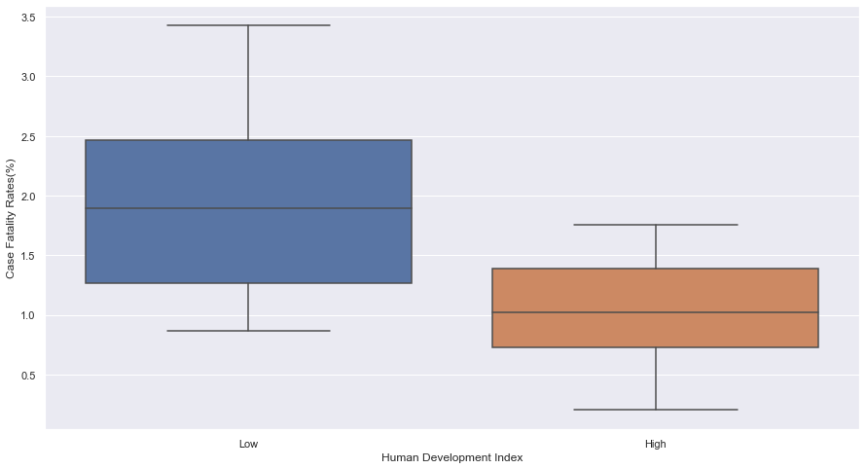
Figure S2. Comparison of CFR among countries with similar HDIs to Nigeria and countries with dissimilar HDIs.

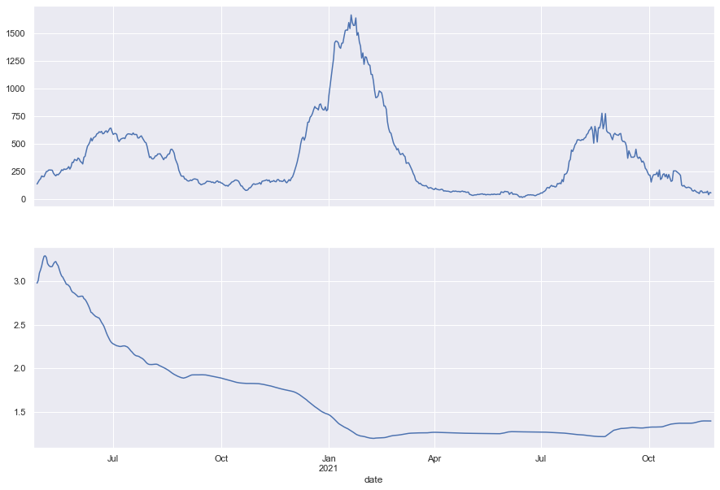
Figure S3. The Trend of the Daily New Cases and Case Fatality Rate in Nigeria

