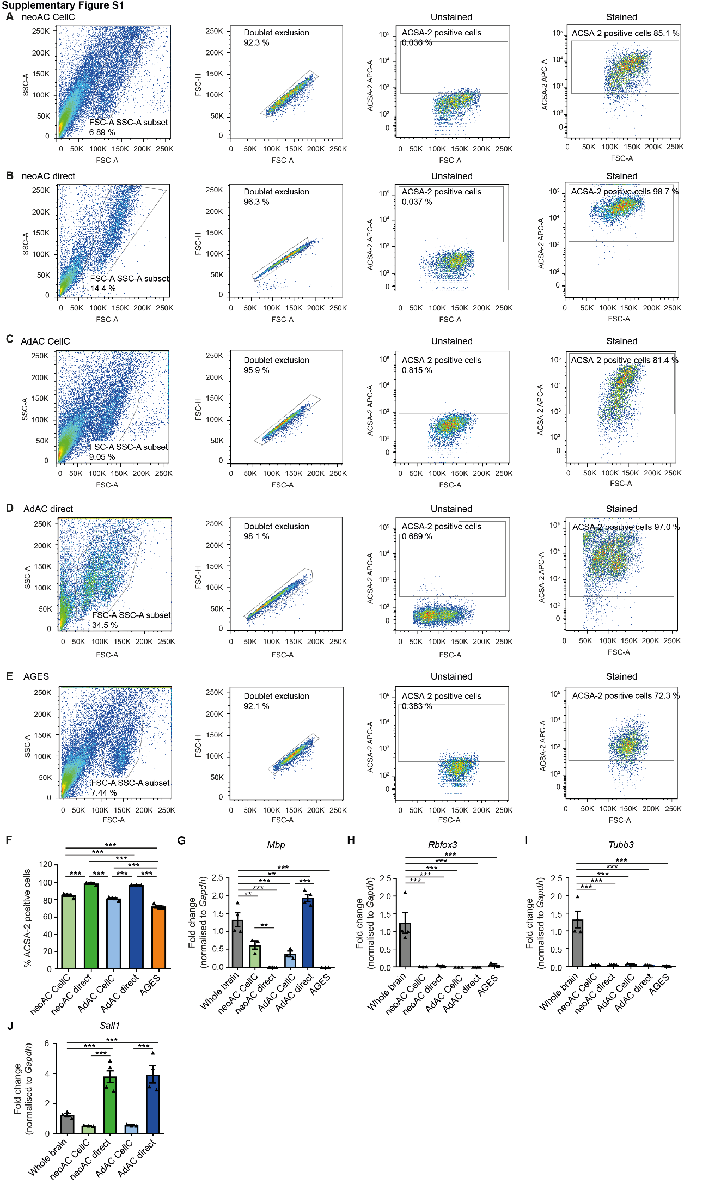
Figure S1: Cell purity and cell type composition changes during cell culturing
(A-E) Fluorescence activated cell sorting (FACS) of ACSA-2-labelled (stained) and unlabelled (unstained) cell suspensions is shown, demonstrating doublet exclusion and gating for APC-labelled ACSA-2 positive cells based on ACSA-2 negative stain in (A) cultured neonatal astrocytes (neoAC CellC), (B) directly isolated neonatal astrocytes (neoAC), (C) cultured adult astrocytes (AdAC CellC), (D) directly isolated adult astrocytes (AdAC) and (E) AGES. Representative FACS blots are shown for each cell type which include the average percentage of ACSA-2 positive cells. (F) Quantities of ACSA-2 expression levels in primary astrocytes and AGES as determined by FACS were summarized. Mean ± SEM; neoAC CellC (n=4), neoAC (n=3), AdAC CellC (n=4), AdAC (n=3), AGES (n=5). ANOVA with Tukey’s post hoc test ***P < 0.001 (G-J) Gene expression of non-astrocytic cell markers was determined by quantitative real-time PCR in cultured neonatal astrocytes (neoAC CellC), directly isolated neonatal astrocytes (neoAC), cultured adult astrocytes (AdAC CellC), directly isolated adult astrocytes (AdAC) and AGES. (G) Mbp was used as an oligodendrocytic marker (whole brain vs AdAC direct **P = 0.008; whole brain vs neoAC CellC **P = 0.004; ***P < 0.001). (H,I) Rbfox3 (NeuN) and Tubb3 represent neuronal marker genes (***P < 0.001). (J) Sall1 is a marker for microglia (***P < 0.001). All expression values were normalized to the internal control Gapdh and whole brain lysates as a reference. Mean ± SEM; Whole brain (n=4), neoAC CellC (n=3), neoAC (n=5), AdAC CellC (n=3), AdAC (n=4), AGES (n=3); ANOVA with Tukey´s post hoc test; significances were only indicated for meaningful comparisons.

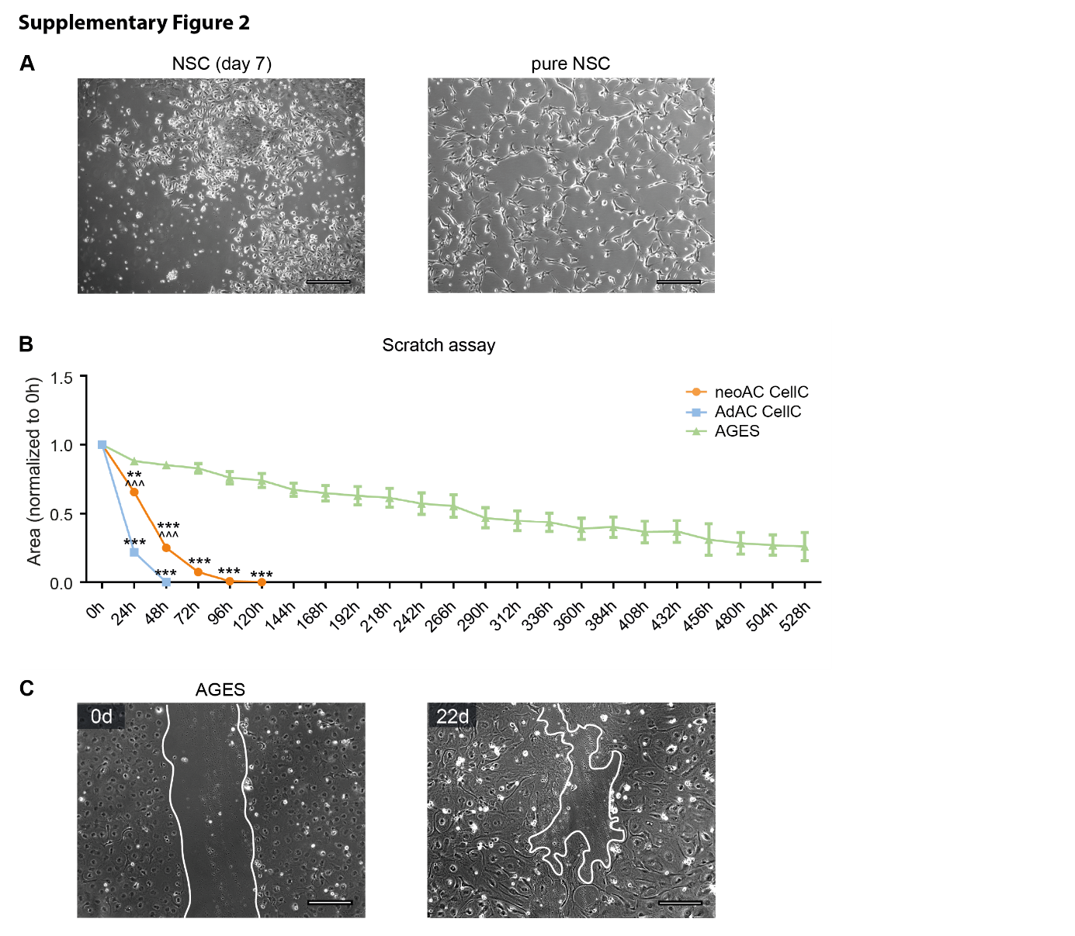
Figure S2: Migratory behavior of primary astrocytes and AGES over 22 days
(A) NSCs were differentiated from mESCs. For receiving pure bipolar NSC cultures, NSCs were cultured for at least eight passages in medium containing the growth factors EGF and FGF. Representative phase contrast images of NSC 7 days after starting the differentiation (mixed mESC and NSC culture) and pure NSC cultures are shown. Scale bar = 200 µm. (B) A scratch assay was used to determine the migratory behaviour of cultured neonatal astrocytes (neoAC CellC), cultured adult astrocytes (AdAC CellC) and AGES. The area of the wound gap normalized to time point 0 h is shown over time. * significance compared to AGES; ^ significance compared to AdAC CellC. Mean ± SEM; neoAC CellC (n=4), AdAC CellC (n=4), AGES (n=4); Two-way ANOVA with Bonferroni post hoc test; **P = 0.004; ***P < 0.001; ^^^P < 0.001. (C) Representative phase contrast images of the wound gap at the starting point (0 d) and after 22 days are shown of AGES. Scale bar = 200 µm.
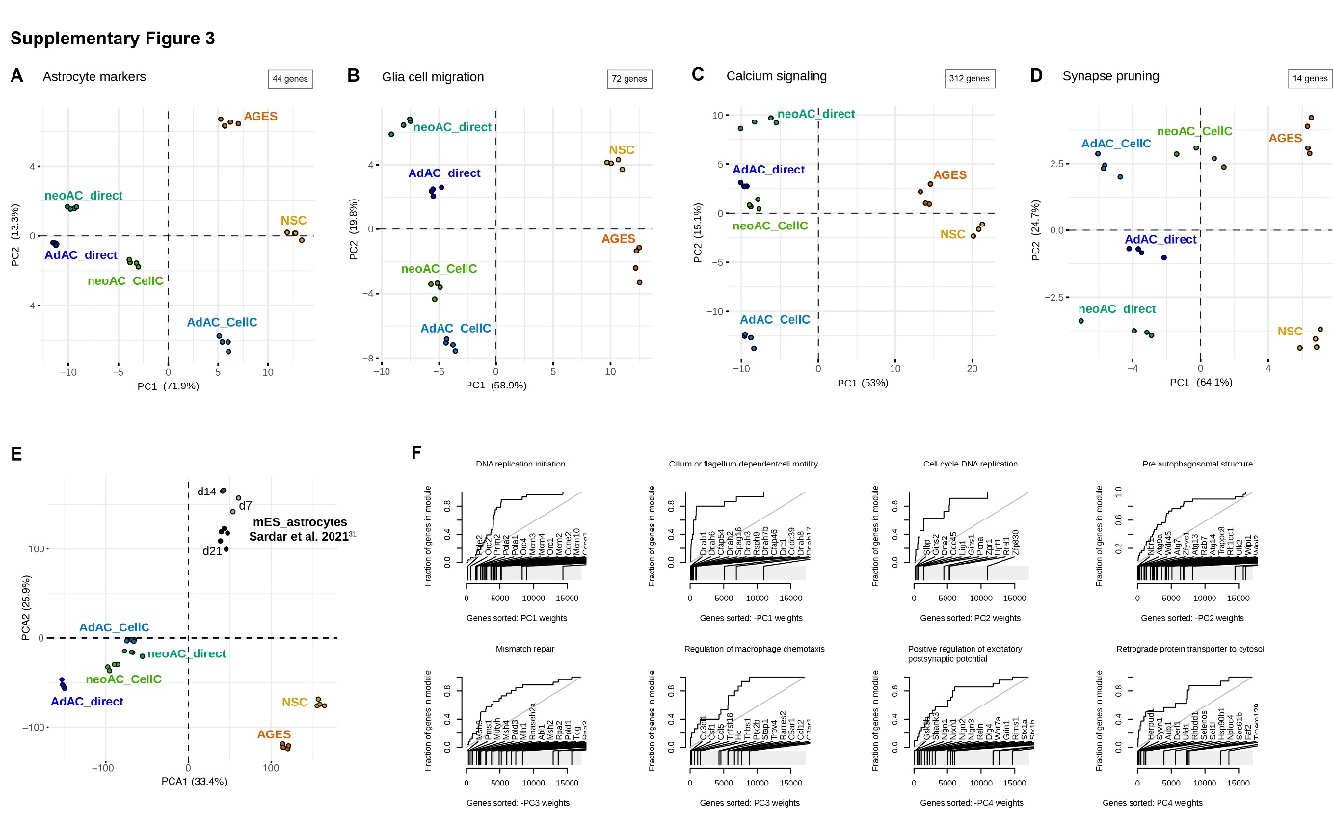
Figure S3: Principal component analysis and evidence plots of RNA-seq data underline functional differences between astrocytic cell types.
RNA-seq was performed from cultured neonatal astrocytes (neoAC CellC; n=4), directly isolated neonatal astrocytes (neoAC direct; n=4), cultured adult astrocytes (AdAC CellC; n=4), directly isolated adult astrocytes (AdAC direct; n=4), AGES (n=4) and NSCs (n=4). (A) Principal component analysis (PCA) of published astrocytic marker genes ⁵ is shown. (B-D) Principal component analysis (PCA) of samples based only on genes from select GO terms relating to our functional assays was performed. The variance explained by the first and second component is shown on the x- and y-axis. (E) PCA of our samples and mouse embryonic stem cell-derived astrocytes (mES_astrocytes) from different time points of culture (day 7, 14, 21) published by Sardar et al. ³¹. (F) Evidence plots of select GO terms from Fig. 6B displaying genes sorted based on the gene PCA loadings on the x-axis and cumulative fraction of genes from a particular gene set (GO term) on the y-axis.
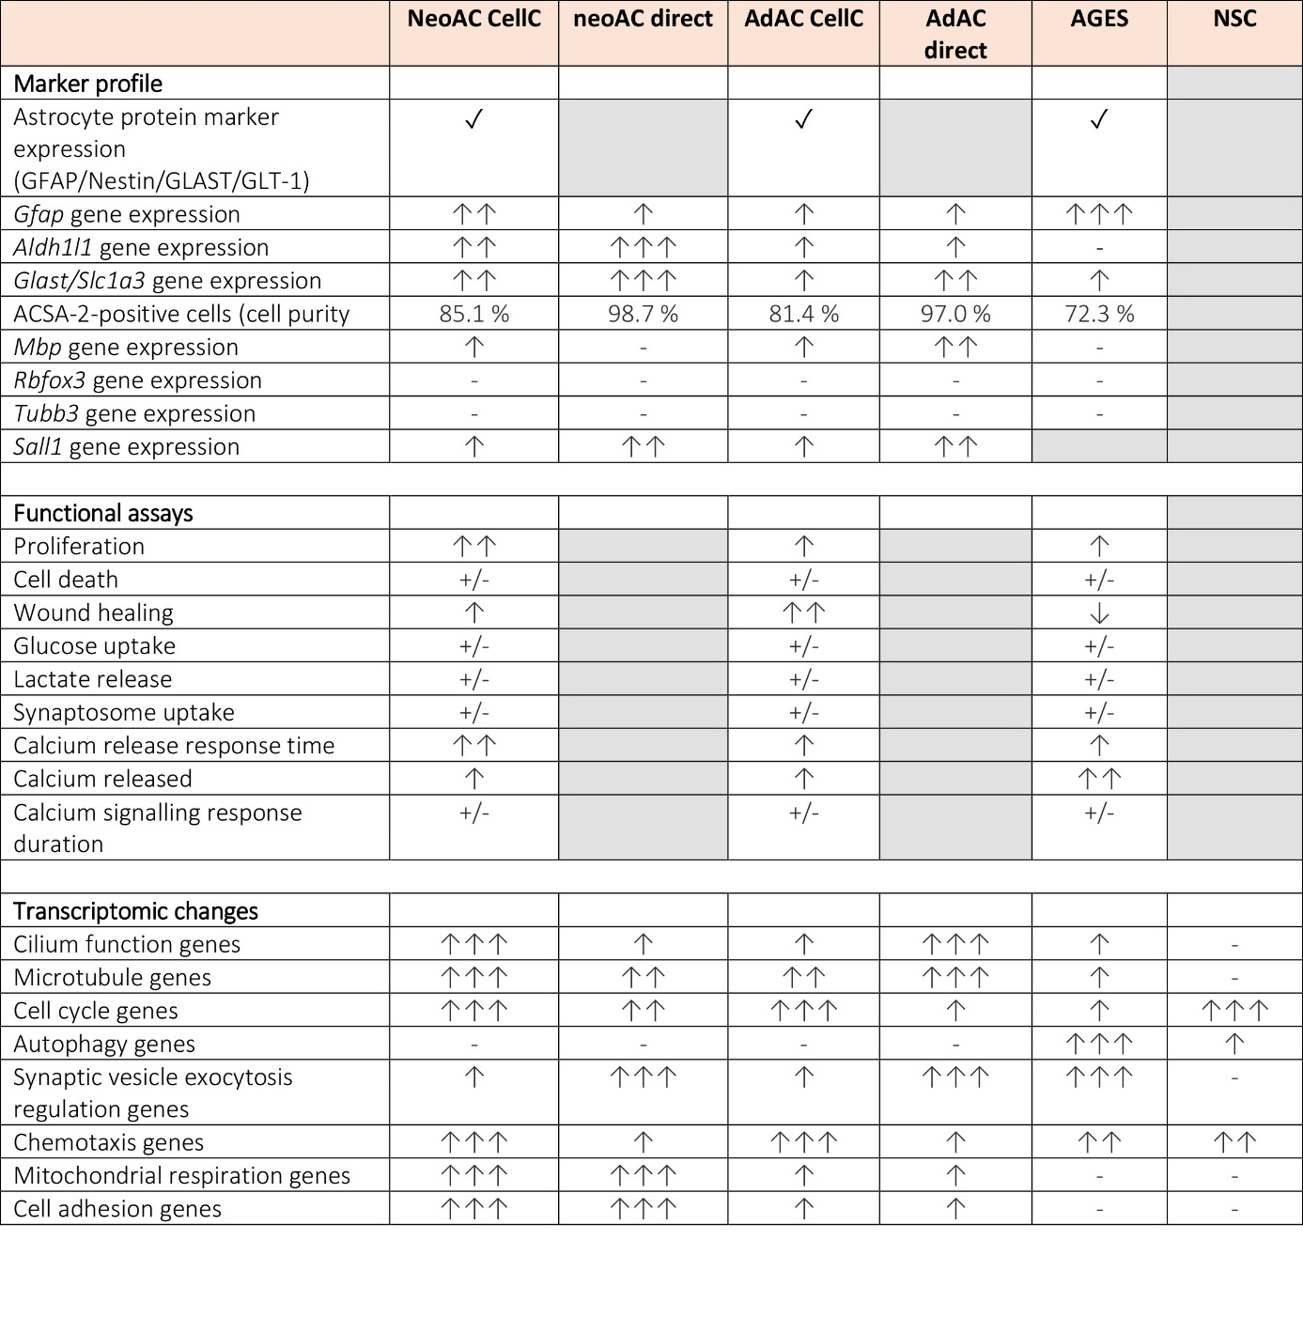
Figure S4: Summary of experimental results comparing cultured and directly isolated primary cells and AGES.
Summary of the comparison of neonatal astrocytes (neoAC CellC), directly isolated neonatal astrocytes (neoAC direct), cultured adult astrocytes (AdAC CellC), directly isolated adult astrocytes (AdAC direct) and AGES. The following symbols were used for visualizing the obtained results: Grey box = The assay was not performed for these cells, ✓= presence for indicated attributes, ↑ = low expression/ functional activity, ↑↑ = intermediate expression/ functional activity, ↑↑↑ = high expression/ functional activity, - = no expression, +/- = no change in all analyzed groups.

