ARTICLE TITLE
LUNG ULTRASOUND TARGETED RECRUITMENT (LUSTR): A NOVEL PROTOCOL TO OPTIMIZE OPEN LUNG VENTILATION IN CRITICALLY ILL NEONATES.

AUTHOR LIST
Roberto Chioma¹, MD, Lorenzo Amabili², MSc, Elena Ciarmoli³, MD, Roberto Copetti⁴, MD, Pier Giorgio Villani⁵, MD, Miria Natile⁶, MD, Giovanni Vento¹, MD, Enrico Storti⁵, MD, Maria Pierro⁷*, MD, PhD.

Affiliations
¹ Dipartimento Universitario Scienze della Vita e Sanità Pubblica, Unità Operativa Complessa di Neonatologia, Fondazione Policlinico Universitario A Gemelli Istituto di Ricovero e Cura a Carattere Scientifico, Università Cattolica del Sacro Cuore, Rome, Italy,
² Bernoulli Institute for Mathematics, Computer Science and Artificial Intelligence, University of Groningen, Groningen, Netherland
³ Department of Pediatrics, ASST Vimercate, Vimercate Hospital, Vimercate, Italy
⁴ Emergency Department, Latisana General Hospital, Udine, Italy
⁵ Department of Critical Care, Maggiore Hospital, Cremona, Cremona, Italy.
⁶ Neonatal Intensive Care Unit, Azienda Sanitaria Romagna, Infermi Hospital Rimini, Rimini, Italy
⁷ Neonatal and Paediatric Intensive Care Unit, M. Bufalini Hospital, AUSL Romagna, Cesena, Italy
- CORRESPONDING AUTHOR
maria.pierro93@gmail.com

SUPPLEMENTAL MATERIAL

Results
Four LUS-guided LRMs starting from a C-pattern performed on 3 neonates were excluded from the study, as they did not develop the S-pattern. The underlying lung condition was: (i) derecruitment during mechanical ventilation in 2 cases, (ii) NARDS in one, and (iii) meconium aspiration syndrome in the other one. The median [IQR] of the starting S/F ratio was 139.6 [114.6 – 148.3]. The LRMs that did not develop the S-pattern presented a mild improvement in the oxygenation (median [IQR] Delta S/F 42.3 [32.7 – 52.1], likely due to a transient inversion of the ventilation/perfusion ratio. A detailed comparison of the LUS-guided recruitment showing the S-pattern with the LUS guided recruitment that did not develop the S-pattern is included in another paper for readability reasons.
The hemodynamic condition of babies was evaluated and optimized before the LRM. In the twelve hours prior to the LRM, inotropic support was administered in two cases in the LUSTR group and three cases in the Ox-group, inhaled nitric oxide was needed in two cases in both groups, while saline bolus was given before one LRM in the Ox-group.
All the cases underwent an echographic evaluation that showed normalization of the hemodynamic conditions (i.e resolution of the indirect signs of pulmonary hypertension, left ventricular dysfunction, or hypovolemia) before starting the LRM.
Five patients enrolled in the study underwent both LUS-guided and oxygenation-guided LRM. Three of them received first a LRM performed in accordance with the LUSTR protocol, while the remaining received first an oxygenation-guided LRM. This depended upon the presence or the absence of a neonatologist trained in LUS and with the expertise in the LUS-guided LRM. The episodes of respiratory deterioration (intended as a progressive increase of oxygen need) were distinct. The procedures were performed with a median [range] gap of 23 [8 – 115] hours.
No patient in either group presented hemodynamic or respiratory deterioration throughout the procedure (figure suppl.1), causing the suspension of the procedure or the need for additional interventions. The Ox-group presented an increase in the diastolic and mean blood pressure from the starting point (figure suppl.1). Since the systolic blood pressure did not change, the pulse pressure slightly decreased in this group reaching the opening CDP/PEEP, returning to the starting value at the closing CDP/PEEP. No changes were detected in the heart rate, while both groups presented a significant improvement in the oxygenation parameters throughout the procedure.
FIGURES

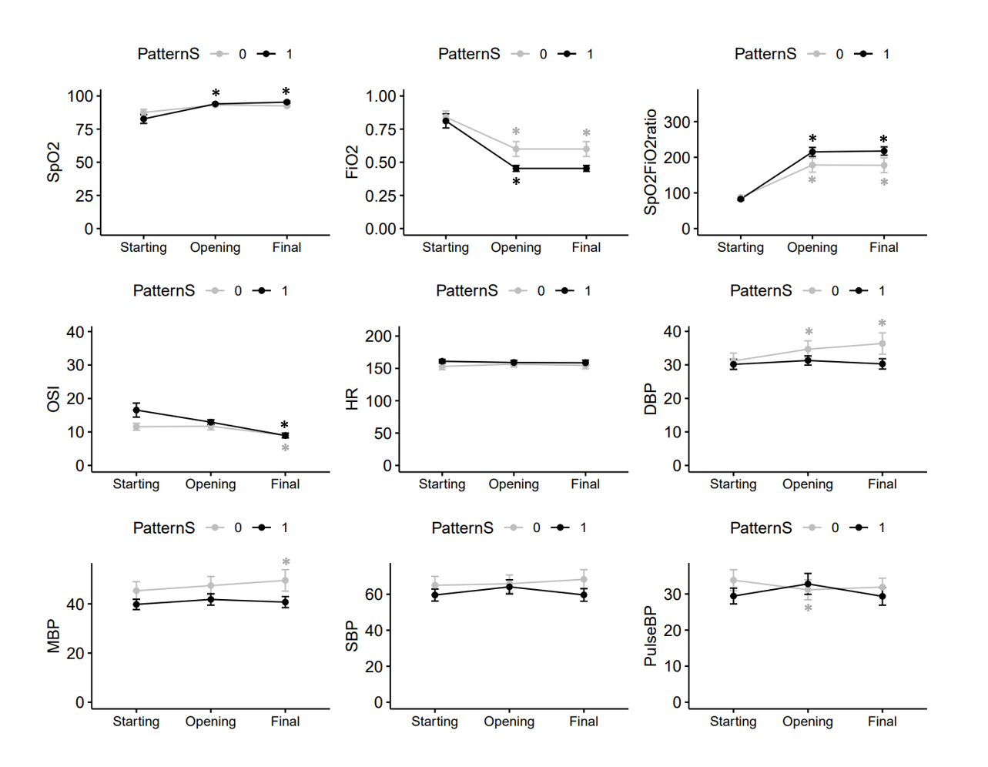
Figure 1. Trends of oxygen parameters and vital signs in the two groups throughout the procedure. The analysis to assess the variation of the different vital signs from the baseline (the starting of the procedure) was performed by comparing them to the subsequent time points within the groups (Opening vs Starting; Final vs Starting). *Indicates significant (P<0.05) variation from the starting parameter in the specific group.

