Fig. S1. Absorption spectra of the crude pigments extracted with 95% (v/v) ethanol from cells of strains (A) DG25A^{T}, (B) DG25B^{T}, and (C) H. tibetensis NRRL B-51271^{T}.
The strain (A) DG25A^{T} showed the absorption peaks of carotenoids at 318.0, 482.5 and 504.0 nm, and the strain (B) DG25B^{T} showed peaks at 304.0, 480.5 and 496.0 nm, similar to those of (C) H. tibetensis NRRL B-51271^{T}at 322.0, 481.5 and 501.5 nm. Alkalisation with 0.1 volume of 0.1 M NaOH did not lead to any shift in peak positions meaning that no strain has flexirubin pigment.
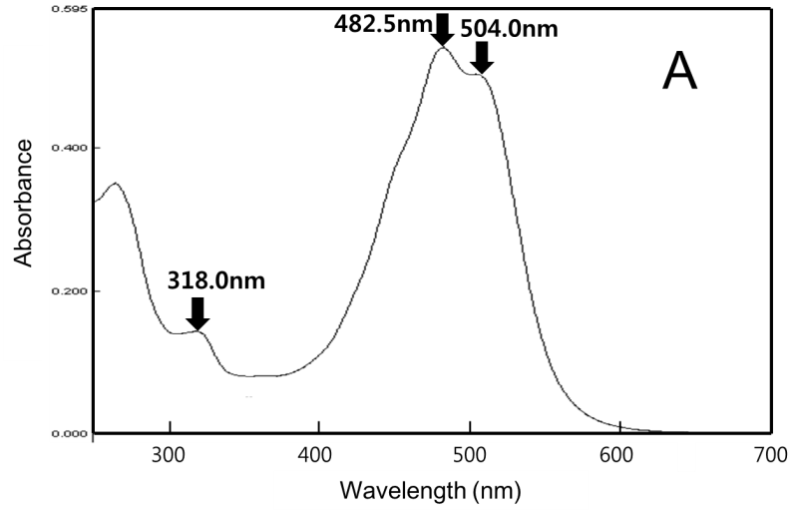
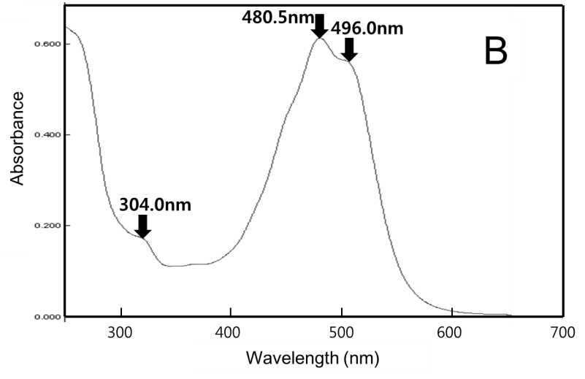
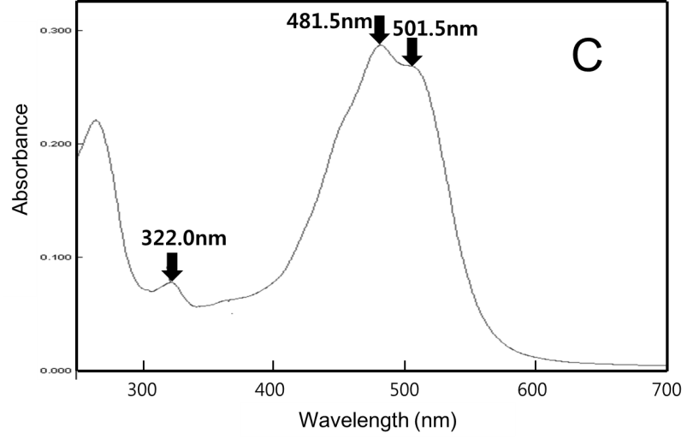
Fig. S2. Polar lipid profile of strain DG25B^{T} separated in two-dimensional TLC and sprayed with molybdophosphoric acid reagent.
Abbreviations: PE, phosphatidylethanolamine; AL_{X}, unknown aminolipids; APL_{X}, unknown aminophospholipids; PIG_{X}, brick-red pigments; Lx, unknown polar lipids (not stainable with any of the specific spray reagents applied, indicating that it does not contain a phosphate group, an amino group, or a sugar moiety).
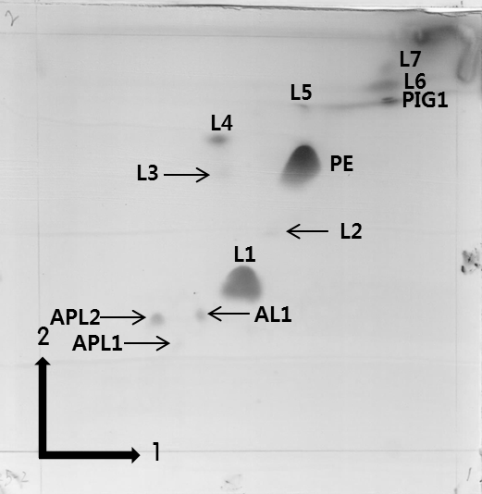

Fig.S3. Representative survival curves for cells of strains DG25A^{T} ( ), DG25B^{T}( ), D. radiodurans R1^{T}(◆) and Escherichia coli K12 (X) following their exposure to (a) gamma radiation and (b) UVC. The y-axis shows survival on a logarithmic scale.

(a)
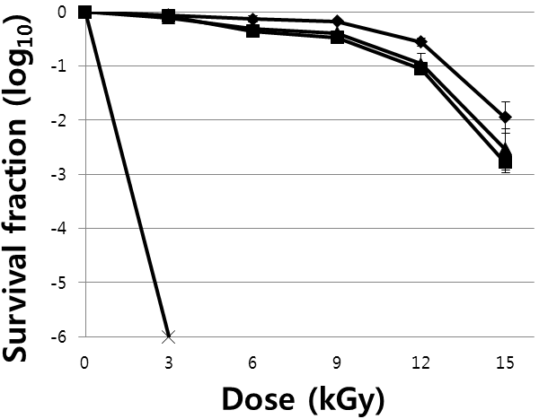
(b)
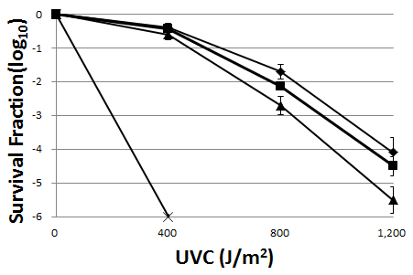

Table S1. Average nucleotide identity (ANI) analysis and digital DNA-DNA hybridisation analysis between strains DG25A^{T}, DG25B^{T} and closely related type strains of Hymenobacter species for which genomes have been published.
 | DG25A^{T} |  | DG25B^{T}
 | OrthoANI value (%) | Orginal ANI value (%) | OrthoANI value (%) | Orginal ANI value (%)
DG25A^{T} | - | - | 89.5 | 89.1
DG25B^{T} | 89.5 | 89.1 | - | -
Hymenobacter_persicinus | 76.4 | 75.3 | 76.2 | 75.3
Hymenobacter_swuensis | 76.0 | 75.2 | 76.0 | 75.1
Hymenobacter_jejuensis | 74.1 | 73.1 | 74.0 | 73.1
Hymenobacter_rigui_KCTC_1253 | 76.4 | 75.5 | 76.3 | 75.5
Hymenobacter_chitinivorans | 76.4 | 75.5 | 76.3 | 75.3

