SUPPLEMENTARY MATERIAL: HEALTHY CONTROLS

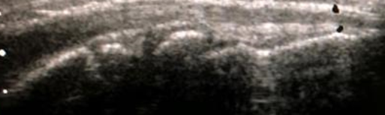
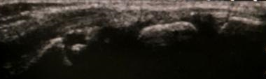

Figure 11.- Wrist (anterior longitudinal scan): the radiocarpal and intercarpal joints:
A
B
12 years
10 years
7 years
C
D
5 years
The ossification of the carpal bones develops at different ages, the first ossification nucleus corresponds to the large bone and the last to the pisiform bone. Image A shows the carpus of a healthy 5-year-old boy without ossification of the lunate bone (yellow arrow). The thickness of the cartilage decreases with age, at 12 years of age complete ossification of the carpal bones is observed (image D).


Figure 12.- 2nd metacarpophalangeal joint (anterior longitudinal scan):
12 years
7 years
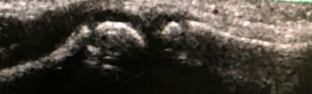
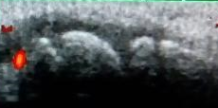

8 years
10 years

The presence of a power Doppler signal in the growth physes and the cartilaginous portion of small bones, which correspond to the vascular channels that nourish the cartilage, is common.

Figure 13.- Humero-ulnar joint (anterior longitudinal scan):
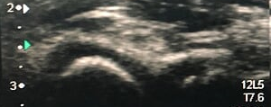
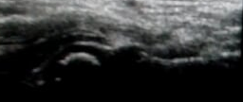

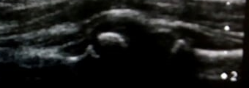
5 years
3 years
B
C
12 years
D
9 years
A
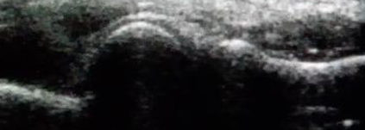
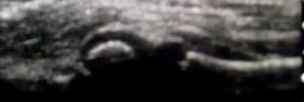
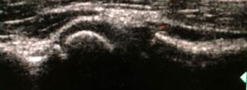
Figure 14.- Humeral-radial joint (longitudinal axis scan):
16 years
7 years
5 years
12 years
D
C
B
A

The elbow joint has 8 ossification nuclei, from the first year ossification of the humerus (capitulum) begins. From the age of 4, the ossification of the radial head begins. Image A shows incomplete ossification of the radial head in a healthy 5-year-old boy (yellow arrow).

Figure 15.- Suprapatellar recess (longitudinal axis scan):
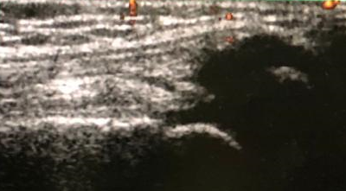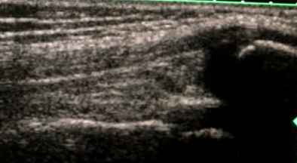
7 years
B
A
5 years
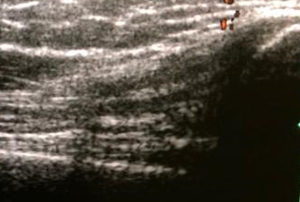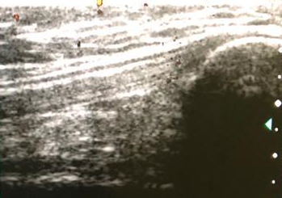
C
D
12 years
10 years
Se Mild suprapatellar recess distention was found in healthy children between 4 and 8 years of age (yellow arrows). One or several ossification centers appear from 2 to 6 years in the patella; until its complete ossification at the age of 14. Image D shows complete ossification of the patella in a 12-year-old boy.

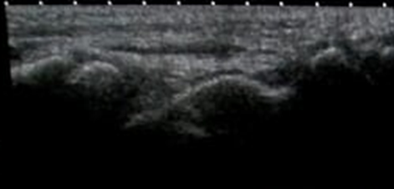
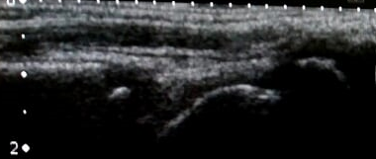
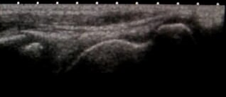
Figure 16.- Tibiotalar joint (longitudinal axis scan)
8 years
5 years
12 years
D
B
A
3 years
C

The thallus is the 1st ossification center to appear from the newborn stage (yellow arrow), followed by the tibia..

