Cistanche tubulosa phenylethanoid glycosides induce apoptosis of hepatocellular carcinoma cells by mitochondria-dependent and MAPK pathways and enhance antitumor effect through combination with cisplatin
Pengfei Yuan, Changshuang Fu, Yi Yang, Aipire Adila, Fangfang Zhou, Xianxian Wei, Weilan Wang, Jie Lv, Yijie Li, Lijie Xia*, Jinyao Li*
Xinjiang Key Laboratory of Biological Resources and Genetic Engineering, College of Life Science and Technology, Xinjiang University, Urumqi 830046, China
* Corresponding authors: J Li (e-mail: ljyxju@xju.edu.cn) and L Xia (xialijie1219@163.com)

The western blots are used in figures as follows.
Figure 1D. HepG2 cells were treated with 200. 400 and 600 μg/mL CTPG for 24 h, then proteins were isolated to detect MAPK signaling pathway proteins by Western blot. From left to right, CTPG treatment concentration was 0,200, 400 and 600 μg/mL.
β-actin
JNK
P-JNK
p38
P-p38
ERK
P-ERK

HepG2 cells were treated with 600 μg/mL CTPG for 0, 0.5, 3, 6 and 12 h, then proteins were isolated to detect MAPK signaling pathway proteins by Western blot. From left to right, CTPG treatment for 0, 0.5, 3, 6 and 12 h.
β-actin
JNK
P-JNK
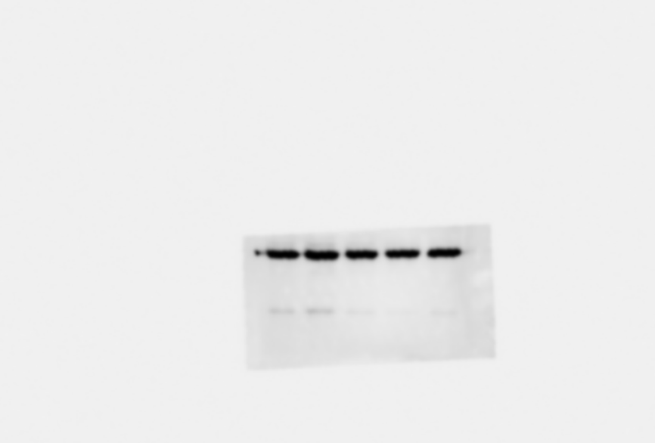
p38
P-p38
ERK

P-ERK

Figure 2B. HepG2 cells were treated with different concentration (0, 200, 400, 600 μg/mL) of CTPG for 24 h, and proteins were isolated to detect the levels of cyclinD1, CDK2, cyclinB1 and CDK1 by Western blot.
From left to right, HepG2 cells were treated with 0, 200, 400, 600 μg/mL.
β-actin
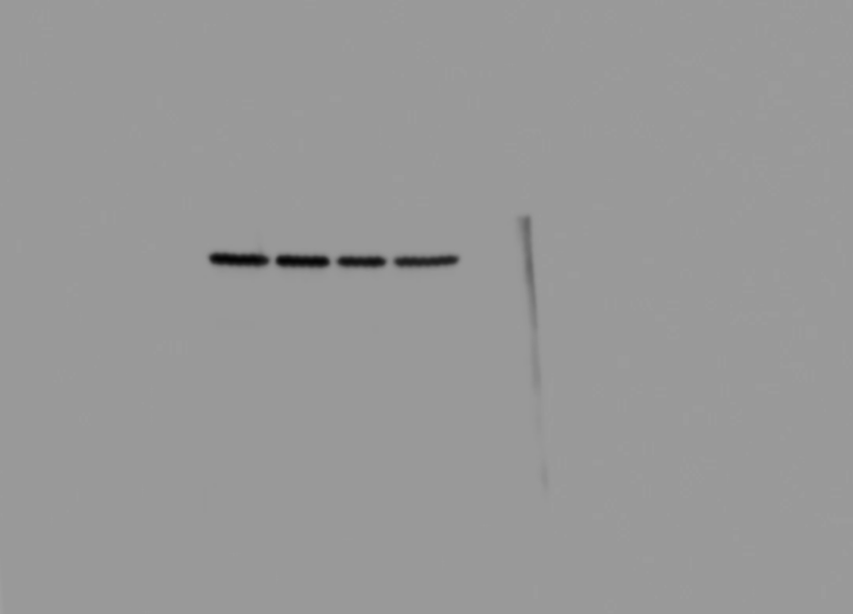
Cyclin D1
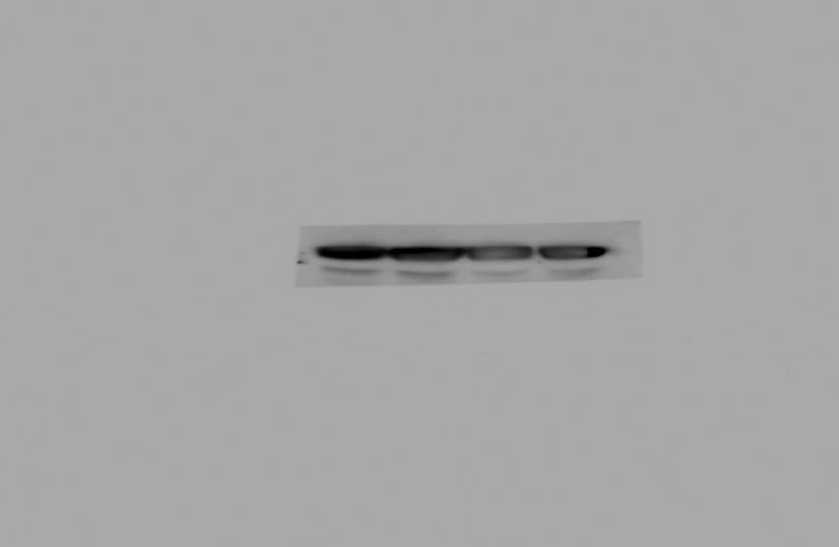
Cyclin B1
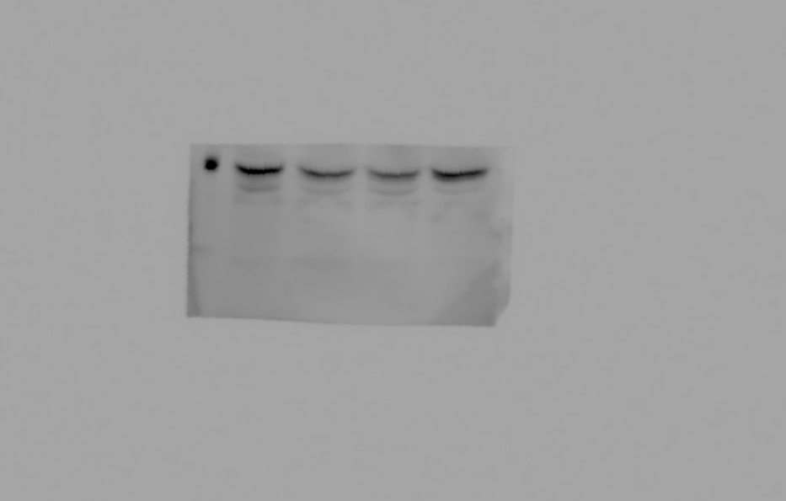
CDK1
CDK2

Figure 3B. BEL-7404 and HepG2 Cells were treated with different concentrations (0, 200, 400, 600 μg/mL) of CTPG for 24 h. Total protein was isolated to analyze the expressions of Bax and Bcl-2 by Western blot.
From left to right, BEL-7404 cells were treated with 0, 200, 400, 600 μg/mL.
β-actin

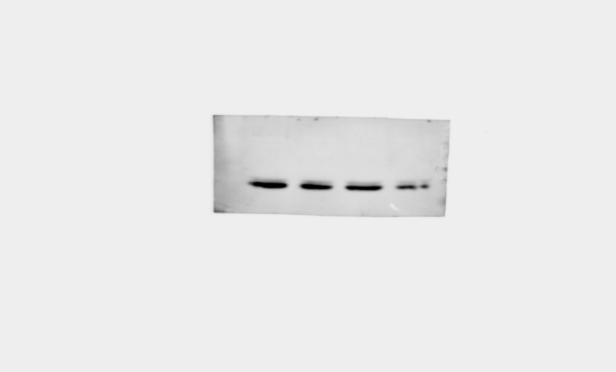
Bax
Bcl-2
Bax

From left to right, HepG2 cells were treated with 0, 200, 400, 600 μg/mL.
β-actin
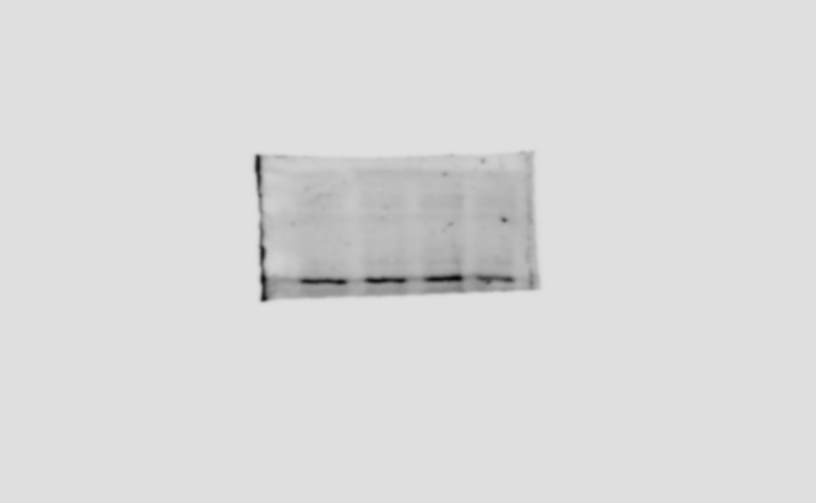
Bcl-2
Bax

Figure 4C. BEL-7404 and HepG2 cells were treated with different concentrations (0, 200, 400, 600 μg/mL) of CTPG. After 24 h, proteins were isolated and the levels of cytochrome c were detected by Western blot.
From left to right, BEL-7404 cells were treated with 0, 200, 400, 600 μg/mL.
β-actin

Cytochrome c

From left to right, HepG2 cells were treated with 0, 200, 400, 600 μg/mL.
β-actin
Cytochrome c

Figure 5A. BEL-7404 and HepG2 cells were treated with different concentrations (0, 200, 400, 600 μg/mL) of CTPG. After 24 h, proteins were isolated and the levels of cleaved-caspases and -PARP were detected by Western blot.
From left to right, BEL-7404 cells were treated with 0, 200, 400, 600 μg/mL.
β-actin
Caspase-3
Cleaved-caspase-3
Cleaved-caspase-9
Caspase-9
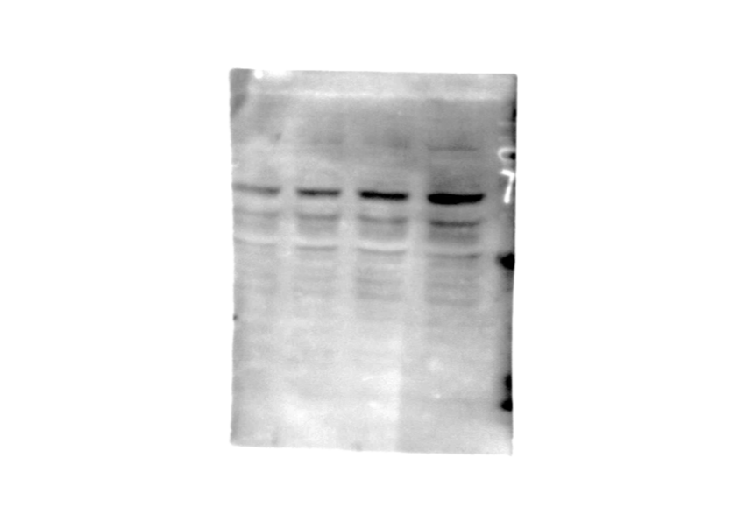
Cleaved-caspase-7
Caspase-7
Cleaved-caspase-8
Caspase-8

PARP
Cleaved-PARP

From left to right, HepG2 cells were treated with 0, 200, 400, 600 μg/mL.
β-actin
Cleaved-caspase-3
Caspase-3
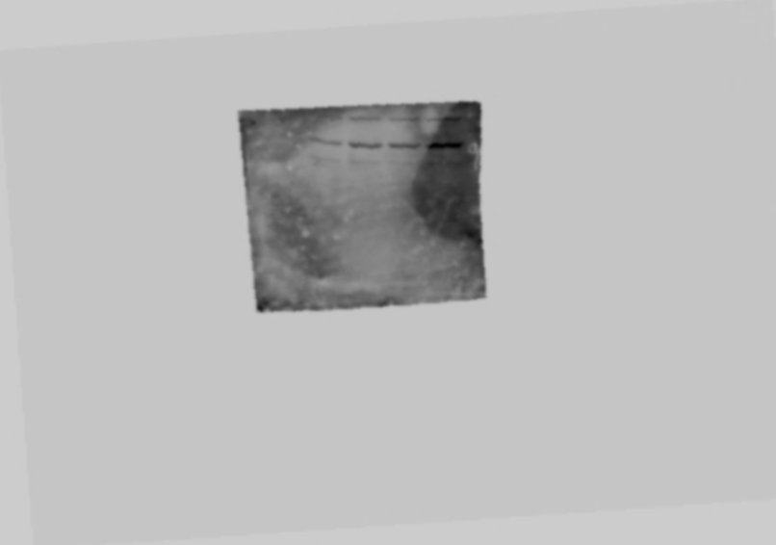
Caspase-9
Cleaved-caspase-9
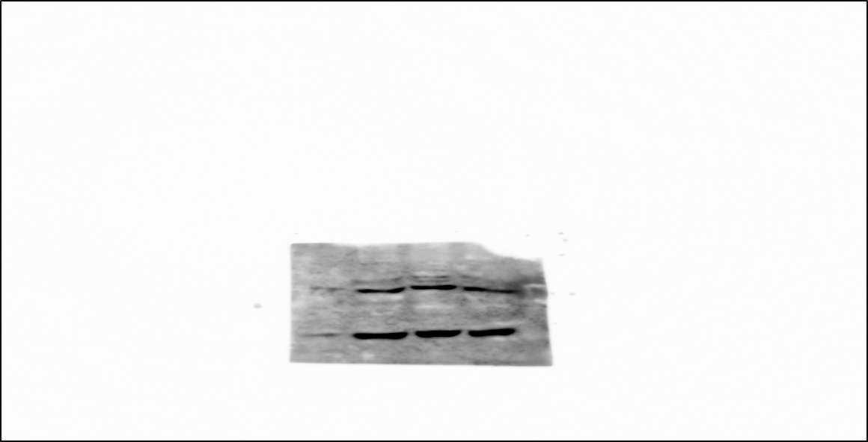
Cleaved-caspase-7
Caspase-7
Caspase-8
Cleaved-caspase-8
Cleaved-PARP
PARP

Figure 6B. HepG2 cells were treated with different concentrations (0, 200, 400, 600 μg/mL) of CTPG for 24 h. Proteins were isolated to detect the levels of MMP-2 and VEGF by Western blot.
From left to right, HepG2 cells were treated with 0, 200, 400, 600 μg/mL.
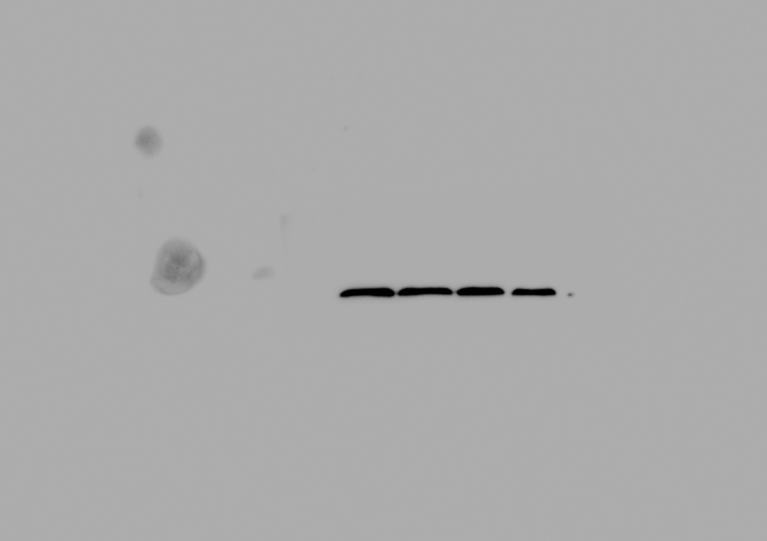
β-actin
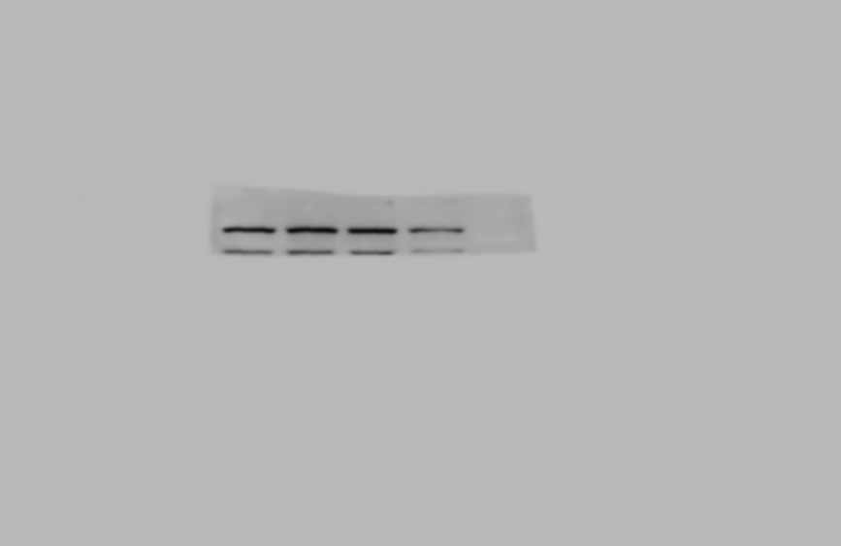
MMP-2

VEGF

