SUPPLEMENTARY MATERIAL
Microbial, chemical and isotopic monitoring integrated approach to assess potential leachate contamination of groundwater in a landfill district in Apulia region (Italy).
L. Beneduce^{1*}, F. Piergiacomo^{1,2}, P.P. Limoni³, L.E. Zuffianò³, M. Polemio³
^{1*-}Department of the Science of Agriculture, Food, Natural resources and Engineering (DAFNE) University of Foggia, Via Napoli 25 -71122 Foggia (Italy) luciano.beneduce@unifg.it
²⁻ Present address: Faculty of Science and Technology, Free University of Bolzano-Bozen, Piazza Università 1, 39100 Bolzano-Bozen, Italy – email Federica.Piergiacomo@natec.unibz.it

³⁻ CNR-IRPI, National Research Council, Research Institute for Hydrogeological Protection, Via Amendola 122/i, Bari, 70126, Italy – email l.zuffiano@ba.irpi.cnr.it; p.limoni@ba.irpi.cnr.it; m.polemio@ba.irpi.cnr.it.
*Author for correspondence

Table S1. Thermal amplification protocols and reaction conditions for End-point PCR of each of the target microbial groups.
 | Bacteroides spp. / Bifidobacterium spp. | Enterococcus spp. | Nitrobacter spp. | Nitrospira spp. | AOB/AOA | NosZ/NirK
 | Layton et al. 2006 | Layton et al. 2010 | Cebron et al. 2015 | Cebron et al. 2015 | Schauss et al. 2009 | Henry et al. 2006/Harter et al. 2014
Thermal protocol | 94°Cx2’ | 95°Cx4’ | 95°Cx3’ | 95°Cx3’ | 95°Cx3’ | 95°Cx5’
Thermal protocol | 94°Cx30’’ | 95°Cx30’’ | 95°Cx1’ | 95°Cx1’ | 95°Cx45’’ | 95°Cx30’’
Thermal protocol | 35X 56°Cx45’’ | 30X 56°Cx1’ | 30X 50°Cx1’ | 30X 50°Cx1’ | 30X 60°Cx45’’ | 30X 60°Cx30’’
Thermal protocol | 72°Cx45’’ | 72°Cx1’ | 72°Cx1’ | 72°Cx1’ | 72°Cx45’’ | 72°Cx30’’
Thermal protocol | 72°Cx2’ | 72°Cx7’ | 72°Cx10’ | 72°Cx10’ | 72°Cx5’ | 72°Cx5’
Master mix Dreamtaq DNA polymerase (Thermo Fisher) V = 25 µL
Buffer 10 x (µL) | 2.5 | 2.5 | 2.5 | 2.5 | 2.5 | 2.5
DNTPs (10mM) | 0.5 | 0.25 | 0.5 | 0.5 | 0.25 | 0.25
Primer F (10µM) | 1 | 1 | 1 | 1 | 1 | 1
Primer R (10 µM) | 1 | 1 | 1 | 1 | 1 | 1
Taq polim. 5U/µL | 0.3 | 0.25 | 0.3 | 0.3 | 0.25 | 0.25
DNA | 2 | 2 | 2 | 2 | 2 | 2
dH₂O | 17.7 | 18 | 17.7 | 17.7 | 18 | 18

Table S2. Primers set for End-point PCR of each of the target microbial groups.
Primer set | Name | Sequence | Amplicon size (bp) | Reference
Bacteroides/Prevotella spp. | Bac32F | AACGCTAGCTACAGGCTT | 676 | Layton et al., 2006; Fiksdal et al., 1985; Bernard &Field,2000
Bacteroides/Prevotella spp. | Bac708R | CAATCGGAGTTCTTCGTG | 676
Bifidobacterium spp. | Bif164F | GGGTGGTAATGCCGGATG | 453 | Layton et al., 2006;  Fiksdal et al., 1985; Bernard & Field,2000
Bifidobacterium spp. | Bif601R | TAAGCGATGGACTTTCACACC | 453
Nitrobacter spp. | NitroBF | TTTTTTGAGATTTGCTAG | 297 | Cebròn et al., 2005; Degrange & Bardin, 1995; Dionisi et al.2002.
Nitrobacter spp. | NitroBR | CTAAAACTCAAAGGAATTGA | 297
Nitrospira spp. | NitrospF | CCTGCTTTCAGTTGCTACCG | 151 | Cebròn et al., 2005; Degrange & Bardin ,2005; Dionisi et al.2002.
Nitrospira spp. | NitrospR | GTTTGCAGCGCTTTGTACCG | 151
Enterococcus Avium | AV1 | GCT GCG ATT GAA AAA TAT CCG | 361 | Layton et al. 2010
Enterococcus Avium | AV2 | AAG CCA ATG ATC GGT GTT TTT | 361 | Layton et al. 2010
Enterococcus Cassellifavus | CA1 | TCC TGA ATT AGG TGA AAA AAC | 269 | Layton et al. 2010
Enterococcus Cassellifavus | CA2 | GCT AGT TTA CCG TCT TTA ACG | 269 | Layton et al. 2010
Enteroccoccus Durans | DU1 | CCT ACT GAT ATT AAG ACA GCG | 286 | Layton et al. 2010
Enteroccoccus Durans | DU2 | TAA TCC TAA GAT AGG TGT TTG | 286 | Layton et al. 2010
Enterococcus Gallinarum | GA1 | TTA CTT GCT GAT TTT GAT TCG | 190 | Layton et al. 2010
Enterococcus Gallinarum | GA2 | TGA ATT CTT CTT TGA AAT CAG | 190 | Layton et al. 2010
Enteroccoccus Hirae | HI 1 | CTT TCT GAT ATG GAT GCT GTC | 186 | Layton et al. 2010
Enteroccoccus Hirae | HI 2 | TAA ATT CTT CCT TAA ATG TTG | 186 | Layton et al. 2010
Enterococcus Saccharolyticus | SA 1 | AAA CAC CAT AAC ACT TAT GTG | 350 | Layton et al. 2010
Enterococcus Saccharolyticus | SA 2 | GTA GAA GTC ACT TCT AAT AAC | 350 | Layton et al. 2010
Enteroccocus Faecalis | FL 1 | ACT TAT GTG ACT AAC TTA ACC | 360 | Layton et al. 2010
Enteroccocus Faecalis | FL 2 | TAA TGG TGA ATC TTG GTT TGG | 360 | Layton et al. 2010
Enterococcus Faecium | FM 1 | GAA AAA ACA ATA GAA GAA TTA T | 214 | Layton et al. 2010
Enterococcus Faecium | FM 2 | TGC TTT TTT GAA TTC TTC TTT A | 214 | Layton et al. 2010
Archaeal AmoA | Amo19F | ATGGTCTGGCTWAGACG | 624 | Leininger et al.2006
Archaeal AmoA | CrenamoA16r48x | GCCATCCABCKRTANGTCCA | 624 | Schauss et al.2009
Bacterial AmoA | Amo1F | GGGGTTTCTACTGGTGGT | 500 | Schauss et al.2009
Bacterial AmoA | AmoA2R | CCCCTCKGSAAAGCCTTCTTC | 500 | Schauss et al.2009
Nirk | nirK876C | ATYGGCGGVCAYGGCGAª | 164 | Harter et al. 2014
Nirk | nirK1040 | GCCTCGATCAGRTTRTGG | 164 | Harter et al. 2014
Nosz | nosZ2F | CGCRACGGCAASAAGGTSMSSGT | 267 | Henry et al. (2006)
Nosz | nosZ2R | CAKRTGCAKSGCRTGGCAGAA | 267 | Henry et al. (2006)
Nirs | nirscd3af | AACGYSAAGGARACSGG | 425 | Throback et al.2004
Nirs | nirsR3cd | GASTTCGGRTGSGTCTTSAYGAA | 425 | Throback et al.2004

Table S3. On site measurements of main physical-chemical features of groundwater samples. EC was estimated at 25 °C.
Location  (well) | Depth  (m) | EC  (mS/cm) | T  (°) | pH  (-) | DO  mg/L | Eh  (mV) | TDS  (mg/L)
2 | 318 | 1.477 | 16.68 | 7.58 | 5.45 | 345 | 1081
3 | 277 | 1.019 | 16.60 | 7.54 | 5.83 | 291 | 595
5 | 289 | 0.888 | 16.56 | 7.51 | 5.59 | 345 | 501
8 | 452 | 0.869 | 16.83 | 7.46 | 4.76 | 346 | 527
11 | 198 | 0.952 | 16.45 | 7.34 | 5.61 | 135 | 812
12 | 250 | 1.047 | 16.49 | 7.40 | 4.47 | n.d. | 561
13 | 349 | 1.640 | 16.97 | 7.32 | 7.54 | 121 | 1249
14 | 250 | 3.170 | 17.90 | 7.14 | 1.39 | 142 | 1651
15 | 250 | 1.155 | 17.03 | 7.30 | 8.03 | 108 | 855

Table S4. Main ions concentration in sampled groundwater and leachate (all data are expressed in mg/L).

Location  (well) | K⁺ | Na⁺ | Ca²⁺ | Mg²⁺ | B⁻ | F⁻ | Br | Cl⁻ | SO₄² | NH₄⁺ | NO₃⁻ | NO₂⁻ | HCO₃⁻
2 | 5.3 | 116.2 | 99.9 | 58 | 0.03 | <0.1 | 0.5 | 179.6 | 48.8 | <0.1 | 36.8 | <0.1 | 520
3 | 2.8 | 48.7 | 121.4 | 28.1 | 0.02 | <0.1 | 0.2 | 92.2 | 13.6 | <0.1 | 56.0 | <0.1 | 410
5 | 2.2 | 27.7 | 90.9 | 46 | 0.03 | <0.1 | <0.1 | 55.3 | 11.1 | <0.1 | 33.7 | <0.1 | 440
8 | 2.4 | 27.3 | 86.3 | 48.3 | 0.02 | <0.1 | 0.4 | 49.2 | 13.2 | <0.1 | 20.9 | <0.1 | 455
11 | 2.1 | 27.3 | 112.8 | 49.2 | 0.02 | <0.1 | <0.1 | 52.8 | 16.9 | <0.1 | 40.9 | <0.1 | 510
12 | 2.7 | 44.8 | 109.7 | 53.8 | 0.02 | <0.1 | <0.1 | 76.8 | 18.0 | <0.1 | 33.7 | <0.1 | 540
13 | 5.2 | 131.8 | 120.3 | 65.8 | 0.05 | <0.1 | 1.1 | 182.6 | 33.8 | <0.1 | 32.9 | <0.1 | 675
14 | 16.1 | 438.9 | 137.3 | 107.2 | 0.14 | <0.1 | 1.6 | 389.7 | 105.0 | <0.1 | 17.2 | <0.1 | 1325
15 | 3.5 | 33.6 | 126.4 | 56.3 | 0.02 | <0.1 | <0.1 | 132.5 | 6.5 | 0.30 | 38.8 | <0.1 | 495
Leachate | 1883.1 | 2134.6 | 65.6 | 53.6 | 1.43 | 2.1 | 2,4 | 2464.4 | 53.3 | 101.9 | 27.5 | <0.1 | 5035

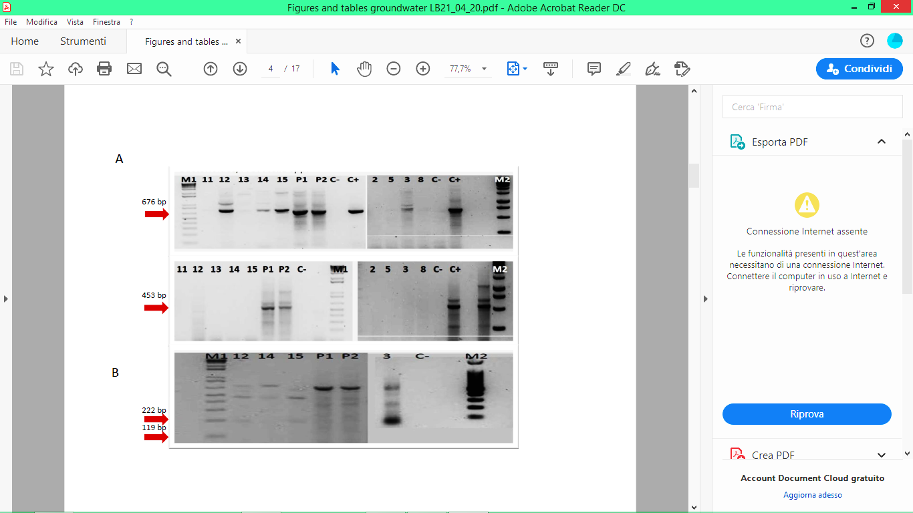
Figure S1. A: Electrophoretic PCR visualization realized with primer for Bacterioides / Prevotella spp. (16SrDNA target gene, expected amplicon size 676 bp, and Bifidobacterium spp., expected amplicon size 453 bp). M1 = molecular weight marker 1kb (Invitrogen); Samples of wells 11, 12, 13, 14, 15; P1, P2 = DNA extracted from leachate coming from the landfill; C- = no template control (white); C + = DNA extracted from purifying sludge; M2 = molecular weight marker 1Kb (Promega); 2-5 = samples of wells 2, 5, 3, 8; C- = no template control (white); C += positive DNA control from sewage sludge. B: Electrophoretic visualization of Enzymatic digestion with HaeIII on PCR products of Bacteroides spp. positive samples. (16SrDNA target gene, expected fragment size for human / bovine, 119/222 bp). [B/W]

Supplementary Materials

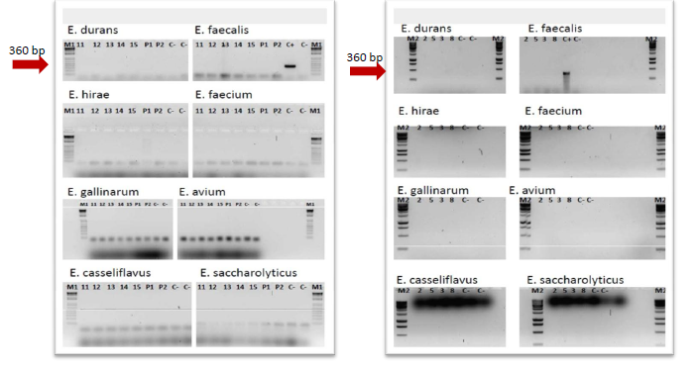
Figure S2. Electrophoretic visualization of PCR carried out on all samples of the 9 wells for the research of 8 different Enterococcus species. [B/W]

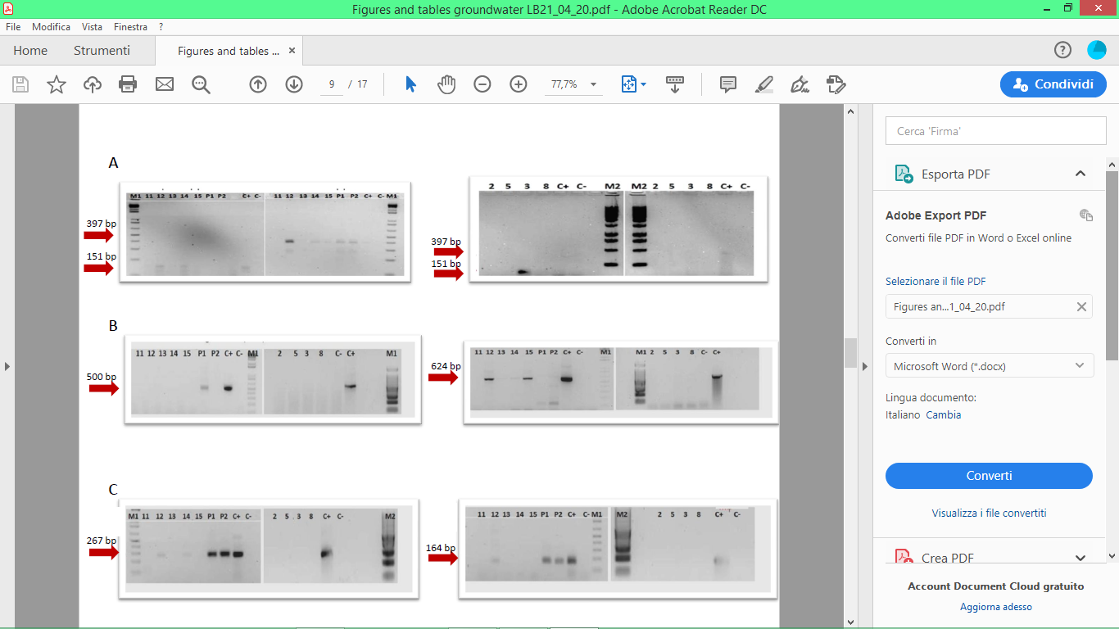
Figure S3. A: Electrophoretic visualization of the PCR carried out on all the samples of the 9 wells for the research of Nitrospira spp. and Nitrobacter spp. (16SrDNA target gene, expected fragment size 397bp for Nitrobacter spp. and 151 bp for Nitrospira spp.). B: Electrophoretic visualization of the PCR conducted on all the samples of the 9 wells for the research of AOB and AOA. (target gene AmoA, expected fragment size 491bp for AOB. and 624 bp for AOA). C: Electrophoretic visualization of the PCR carried out on the samples of the examined wells for the search of denitrifying bacteria. Target NosZ genes, expected fragment dimensions 267bp and NirK, expected fragment dimensions 164 bp. [B/W]

Supplementary references:

Bernhard, A. E., & Field, K. G. (2000). Identification of Nonpoint Sources of Fecal Pollution in Coastal Waters by Using Host-Specific 16S Ribosomal DNA Genetic Markers from Fecal Anaerobes. 66(4), 1587–1594.
Cébron, A., & Garnier, J. (2005). Nitrobacter and Nitrospira genera as representatives of nitrite-oxidizing bacteria: Detection, quantification and growth along the lower Seine River (France). Water Research, 39(20), 4979–4992. https://doi.org/10.1016/j.watres.2005.10.006
Degrange, V., & Bardin, R. (1995). Detection and counting of Nitrobacter populations in soil by PCR. Applied and Environmental Microbiology, 61(6), 2093–2098.
Dionisi, H. M., Layton, A. C., Harms, G., Gregory, I. R., Robinson, K. G., Sayler, G. S., & Gregory, I. R. (2002). Quantification of Nitrosomonas oligotropha -Like Ammonia-Oxidizing Bacteria and Nitrospira spp . from Full-Scale Wastewater Treatment Plants by Competitive PCR Quantification of Nitrosomonas oligotropha-Like Ammonia- Oxidizing Bacteria and Nitrospira spp. Applied and Environmental Microbiology, 68(1), 245–253. https://doi.org/10.1128/AEM.68.1.245
Fiksdal, L., Maki, J. S., LaCroix, S. J., & Staley, J. T. (1985). Survival and detection of Bacteroides spp., prospective indicator bacteria. Applied and Environmental Microbiology, 49(1), 148–150. http://www.ncbi.nlm.nih.gov/pubmed/3919638
Harter, J., Krause, H.-M., Schuettler, S., Ruser, R., Fromme, M., Scholten, T., Kappler, A., & Behrens, S. (2014). Linking N2O emissions from biochar-amended soil to the structure and function of the N-cycling microbial community. The ISME Journal, 8(3), 660–674. https://doi.org/10.1038/ismej.2013.160
Layton, A., McKay, L., Williams, D., Garrett, V., Gentry, R., & Sayler, G. (2006). Development of Bacteroides 16S rRNA gene taqman-based real-time PCR assays for estimation of total, human, and bovine fecal pollution in water. Applied and Environmental Microbiology, 72(6), 4214–4224. https://doi.org/10.1128/AEM.01036-05
Layton, B., Walters, S., Lam, L. and Boehm, A. (2010), Enterococcus species distribution among human and animal hosts using multiplex PCR. J. Appl. Microbiol. 109: 539-547. https://doi.org/10.1111/j.1365-2672.2010.04675.x
Leininger, S., Urich, T., Schloter, M., Schwark, L., Qi, J., Nicol, G. W., et al. (2006). Archaea predominate among ammonia-oxidizing prokaryotes in soils. Nature 442, 806–809. doi: 10.1038/nature04983
S. Henry, D. Bru, B. Stres, S. Hallet, L. Philippot. Quantitative Detection of the nosZ Gene, Encoding Nitrous Oxide Reductase, and Comparison of the Abundances of 16S rRNA, narG, nirK, and nosZ Genes in Soils. Appl. Environ. Microbiol. Aug 2006, 72 (8) 5181-5189; DOI: 10.1128/AEM.00231-06
Schauss, K., Focks, A., Leininger, S., Kotzerke, A., Heuer, H., Thiele‐Bruhn, S., Sharma, S., Wilke, B.‐M., Matthies, M., Smalla, K., Munch, J.C., Amelung, W., Kaupenjohann, M., Schloter, M. and Schleper, C. (2009), Dynamics and functional relevance of ammonia‐oxidizing archaea in two agricultural soils. Environm. Microbiol., 11: 446-456. https://doi.org/10.1111/j.1462-2920.2008.01783.x
Throbäck, I. N., Enwall, K., Jarvis, Å., & Hallin, S. (2004). Reassessing PCR primers targeting nirS, nirK and nosZ genes for community surveys of denitrifying bacteria with DGGE. In FEMS Microbiology Ecology. https://doi.org/10.1016/j.femsec.2004.04.011

