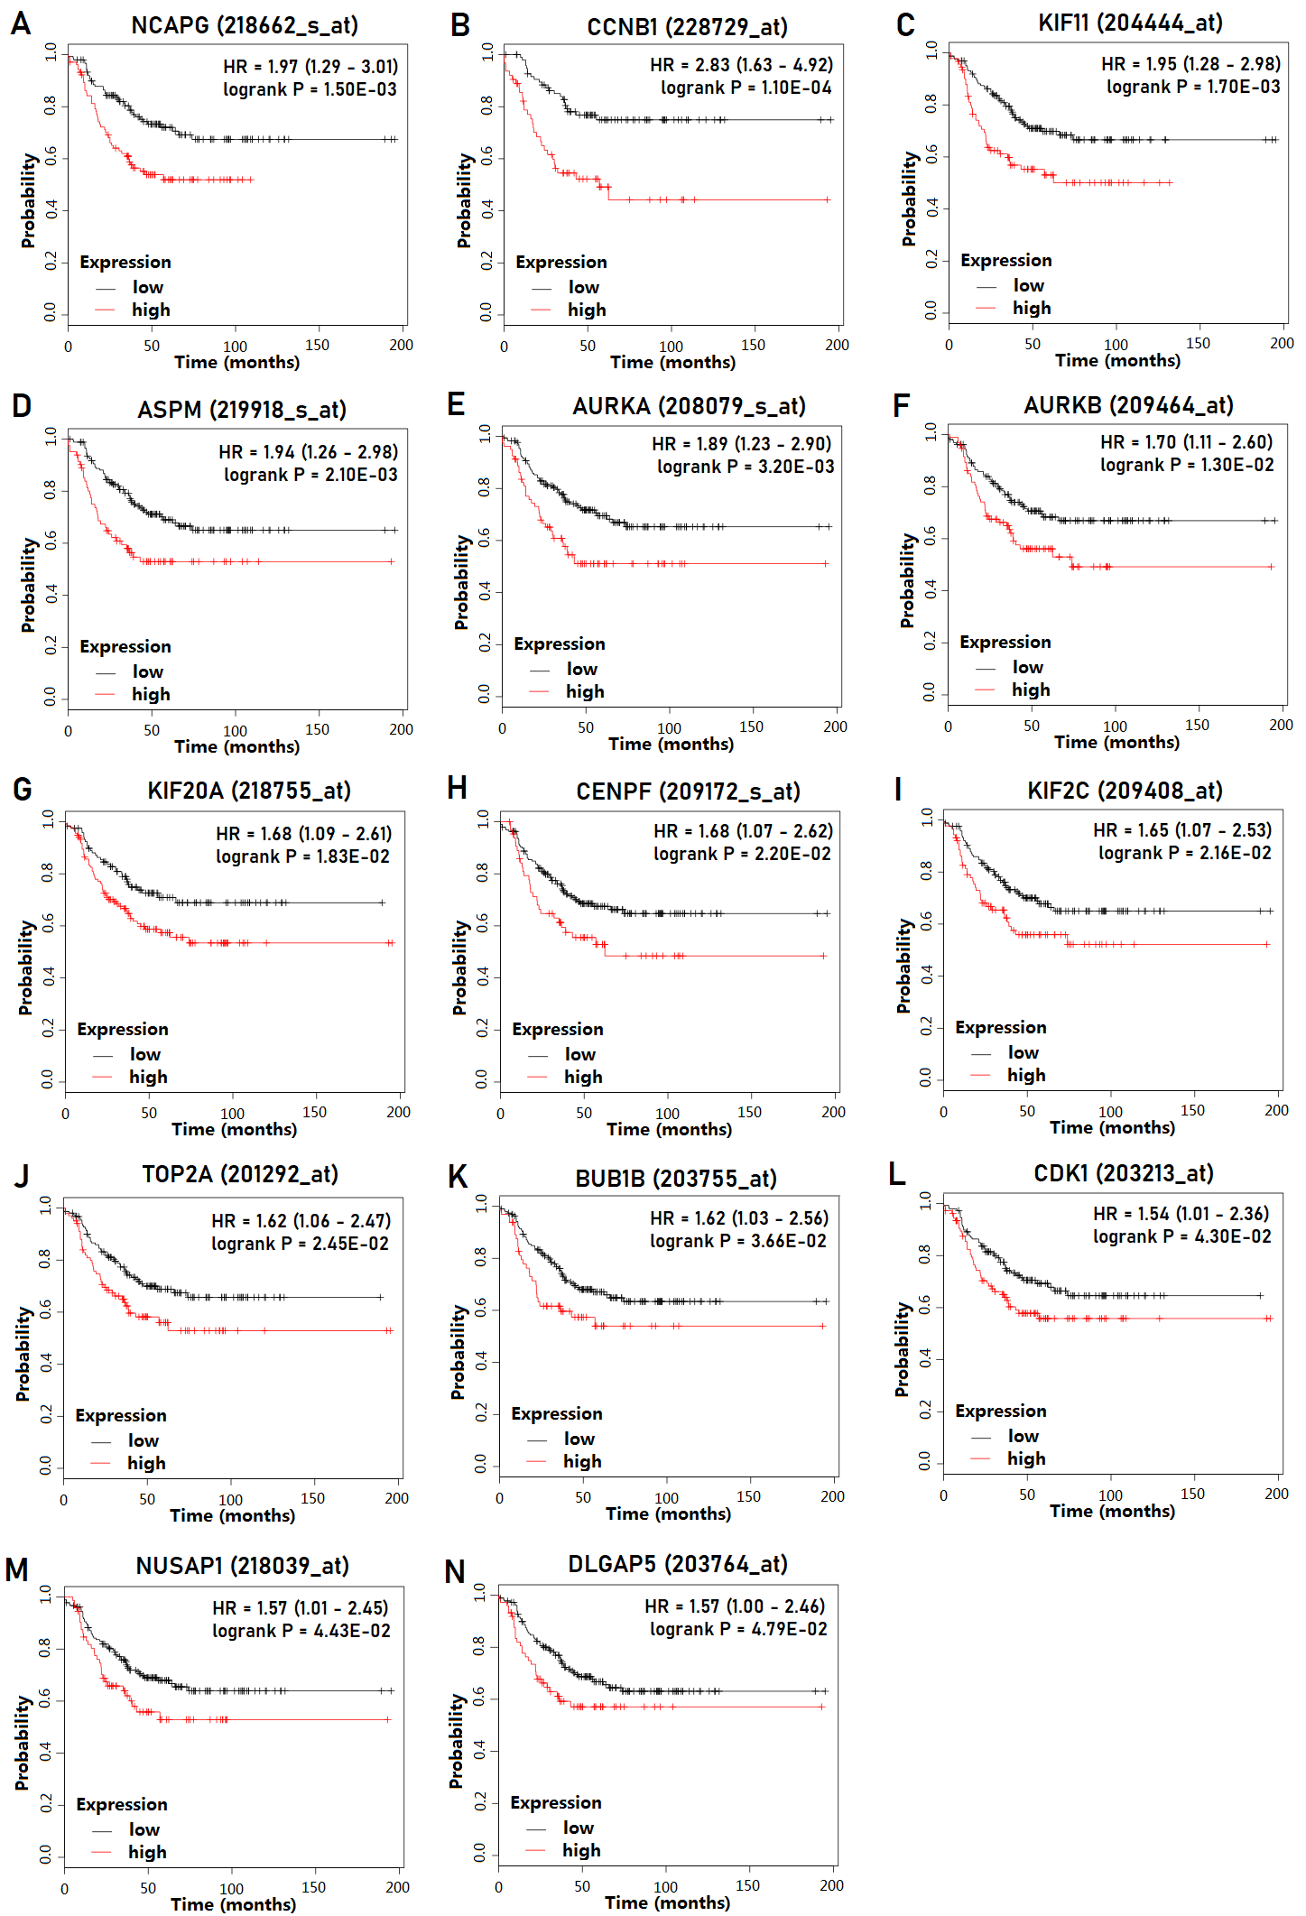
Fig. S1 Kaplan–Meier curves for 14 genes in MCODE 1 that were related to RFS. a NCAPG. b CCNB1. c KIF11. d ASPM. e AURKA. f AURKB. g KIF20A. h CENPF. i KIF2C. j TOP2A. k BUB1B. l CDK1. m NUSAP1. n DLGAP5
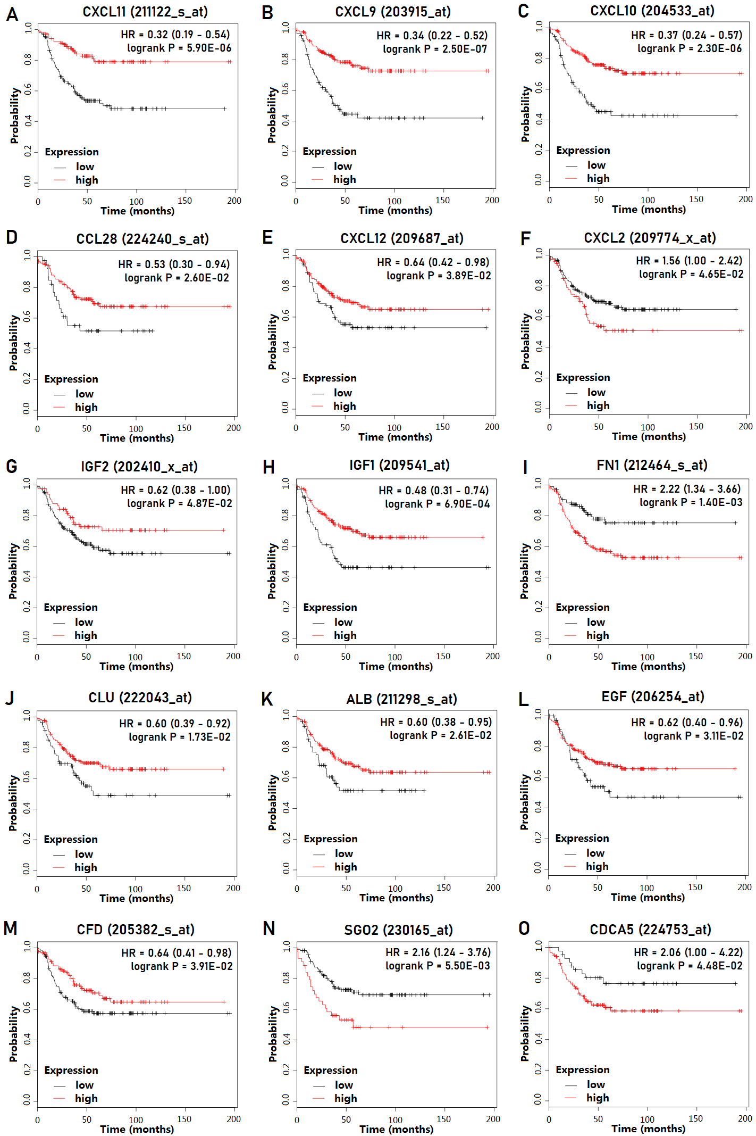
Fig. S2 Kaplan–Meier curves for 15 genes in MCODE 2 - 4 that were related to RFS. a CXCL11. b CXCL9. c CXCL10. d CCL28. e CXCL12. f CXCL2. g IGF2. h IGF1. i FN1. j CLU. k ALB. l EGF. m CFD. n SGO2. o CDCA5

