Supplementary materials

Caloric restriction attenuates C57BL/6J mouse lung injury and systemic toxicity induced by real ambient particulate matter exposure

Daochuan Li^{1,#}, Shen Chen^{1,#}, Qiong Li^{1,#}, Liping Chen¹, Haiyan Zhang¹, Huiyao Li¹, Dianke Yu², Rong Zhang³, Yujie Niu³, Shaoyou Lu¹, Lizhu Ye¹, Xiaowen Zeng¹, Guanghui Dong¹, Rui Chen⁴, Michael Aschner⁵, Yuxin Zheng², Wen Chen^{1,*}

¹Department of Toxicology, School of Public Health, Sun Yat-sen University, Guangzhou 510080, China
²Department of Toxicology, School of Public Health, Qingdao University, Qingdao 266021, China
³Department of Toxicology, School of Public Health, Hebei Medical University, Shijiazhuang 050017, China
⁴Department of Toxicology and Sanitary Chemistry, School of Public Health, Capital Medical University, Beijing 100069, China
⁵ Department of Molecular Pharmacology, Albert Einstein College of Medicine, Forchheimer 209, 1300 Morris Park Avenue, Bronx, NY,10461, USA.

#These authors contributed equally to this work.
*Correspondence to Wen Chen, Department of Toxicology, School of Public Health, Sun Yat-sen University, 74 Zhongshan Road 2, Guangzhou 510080, China. Tel: +86 20 87330599; Email: chenwen@mail.sysu.edu.cn.

Supplementary Materials
Supplementary Methods
1. Estimation of the cumulative lung burden of PM2.5 exposure
The cumulative lung burden of PM2.5 exposure was calculated using the following equation (S1):
Estimated cumulative lung burden=MV×T×CON×DF (S1)
where MV is the minute ventilation in the exposed mice (mL/min); T is the total exposure time (min); CON is the mean concentration of PM2.5 (mg/m³); DF is the pulmonary deposition fraction of PM2.5 (m³), which is estimated by the Multiple-Path Particle Dosimetry Model software (MPPD 3.04, https://www.ara.com/products/multiple-path-particle-dosimetry-model-mppd-v-304) [1, 2].

2. MDA measurement
The levels of malondialdehyde (MDA) in lung tissue, BALF supernatant and plasma were measured by thiobarbituric acid (TBA) reactivity using the commercial colorimetric MDA Assay Kit (Beyotime Biotech Inc., Nantong, China) according to the manufacturer’s instructions. The absorbances were measured at 532 nm. The amounts of MDA in samples were calculated according to the standard curve. The concentration of MDA was normalized to protein concentration and expressed as μmol/mg protein. 16HBE cells treated with or without 100 μM H₂O₂ for 6 h were regarded as a positive or a negative control.

3. GSH detection
The levels of reduced glutathione (GSH) in lung tissue, BALF supernatant and plasma were measured with GSH and GSSG Assay Kit (Beyotime Biotech Inc., Nantong, China) according to the manufacturer’s instructions. The total glutathione level was measured by the 5,5′-dithiobis (2-nitrobenzoic acid)-GSSG recycling assay. The absorbance was measured at 412 nm. The concentrations of total glutathione in samples were calculated according to the standard curve. After samples and standards were treated with 2-vinylpyridine to block GSH, the GSSG level was quantified similarly to the total glutathione. The concentration of reduced GSH were calculated by subtracting the amount of GSSG from the total glutathione. The results were normalized to protein concentration and expressed as nmol/mg protein. 16HBE cells treated with or without 100 μM H₂O₂ for 6 h were regarded as a positive or a negative control.

4. Alkaline comet assay
The mouse peripheral blood cells were collected at the end of experiment and subjected to the alkaline comet assay immediately, according to the protocol reported previously [3]. In brief, a 5μL peripheral blood sample were mixed with 20μL of 0.8% low melting point agarose at 37℃ and spread onto a CometAssay® HT 20-well slide (Trevigen). Alkaline lysis, electrophoresis, neutralization and fixation were conducted sequentially, and analyzed for PI staining. The slides were viewed under a fluorescence microscope (Nikon Eclipse Ti-E) and 150 cells were randomly selected per slide were scored by Comet Assay Software Project-1.2.2 (University of Wroclaw, Poland). Olive tail moment (OTM) was selected for indicating the degree of DNA damage. 16HBE cells exposed to ionizing radiation for 30 min or not were regarded as negative or positive control.

5. Hematology measurement
Cell counting of white blood cell (WBC) and its subsets (neutrophil, monocyte, lymphocyte) were analyzed by HEMAVET 950FS (Drew, USA) according to the manufacturer’s instructions.

6. Blood biochemistry analysis
The plasma levels of glutamic-pyruvic transaminase (ALT), glutamic oxalacetic transaminase (AST), total bilirubin (TBIL), total protein (TP), Albumin (ALB), globulin (GLO), creatinine (CRE), glucose (GLU), triglyceride (TG), cholesterol (CHOL), serum high-density lipoproteins cholesterol (HDL-C), and low-density lipoproteins cholesterol (LDL-C) were determined by a biochemistry kit (MNCHIP, Tianjin, China) using an automatic biochemical analyzer Pointcare M3 (MNCHIP, Tianjin, China).

7. Measurement of ATP contents
ATP contents in liver tissues were measured with an ATP Assay Kit (Promega Corporation, Madison, WI, USA) and analyzed with a Micro-plate Spectrophotometer (Promega, Madison, WI, USA). Results were expressed as nmol/mg protein.

8. Analysis of urinary 8-OHdG
To detect urinary 8-OHdG, 100 μg DNA was dissolved in 80 μL deionized water. 5 μL of [13C10, 15N5]-8-OHdG at a concentration of 740 μg/L was added into the DNA solution and served as an internal standard. The DNA samples were converted into a single-stranded DNA by incubation at 95℃ for 10 min and were digested to single nucleotide fragments by treatment of 5 unit of nuclease P1 for 1 h at 37℃. The mixture was subsequently dephosphorylated by incubation with 10 units of alkaline phosphatase for 1 h at 37℃. The supernatant was subjected to LC-MS/MS analysis after centrifugation at 15,000g for 15 min. The concentration of cellular 8-OHdG was calculated by extrapolating the peak area of the sample from a set of standards (0, 0.25, 0.5, 0.75, 1.5, 2, 4 μg/L). Urinary 8-OHdG concentrations were adjusted for urinary creatinine levels.

9. Flow cytometry analysis
1×10⁶ cells isolated from BALF were blocked with anti-mouse FcR antibody (CD16/CD32; Biolegend, USA) for 15 min at 4°C in FACS buffer (PBS with 2% FBS and 1 mM EDTA), subsequently cells were stained for 15 min at 4°C with Zombie NIR Fixable Viability Kit (Biolegend, USA) to discriminate dead cells, and then surface stained with antibodies for F4/80 (FITC; Biolegend, USA), CD11b (PerPC/Cy5.5; Biolegend, USA), CD11c (PE; Biolegend, USA), CD206 (APC; Biolegend, USA) or isotype control for 30 min at 4°C. Cells were washed three times with FACS buffer, fixed with the Fixation/Permeabilization buffer (eBioscience, USA) for 40 min at 4°C and washed three times in Permeabilization buffer. Cells were then resuspended in FACS buffer and analyzed by flow cytometry using CytoFlex (Beckman Coulter, USA).

Supplementary figures
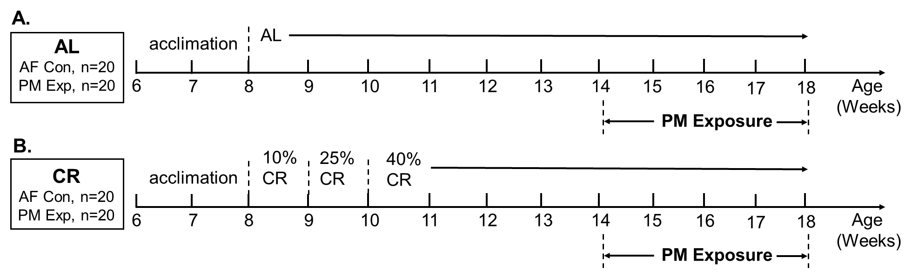
Figure S1. The experiment design of caloric restriction and PM exposure.
The diagram shows the design of the experiments of caloric restriction and PM exposure. Six-week-old C57BL/6 mice were acclimated for two weeks. The mice were then divided into two weight-matched groups and fed with different diets, including ad libitum diet (AL, n=40) (A) and caloric restriction diet (CR, n=40) (B) for a period of 4 weeks, respectively. To achieve the state of CR progressively, mice were fed with CR diet at 10% caloric restriction during the first week, 25% restriction during the second week, and up to 40% restriction for the subsequent experimental period. After adaption to 40% CR for four weeks, mice were exposed to ambient particulate matter (PM) for four weeks.

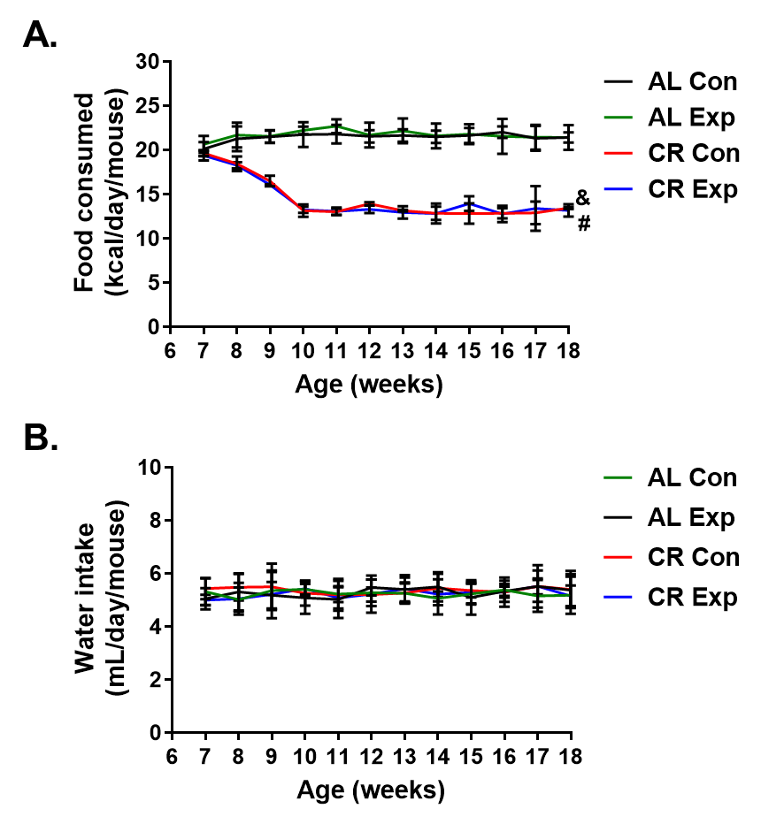
Figure S2. Food intake of C57BL/6 J male mice fed with AL or CR diet.
The data are expressed as the mean ± SD, & P < 0.05 CR-AF vs. AL-AF, # P < 0.05 CR- PM vs. AL- PM. n=20 per group.

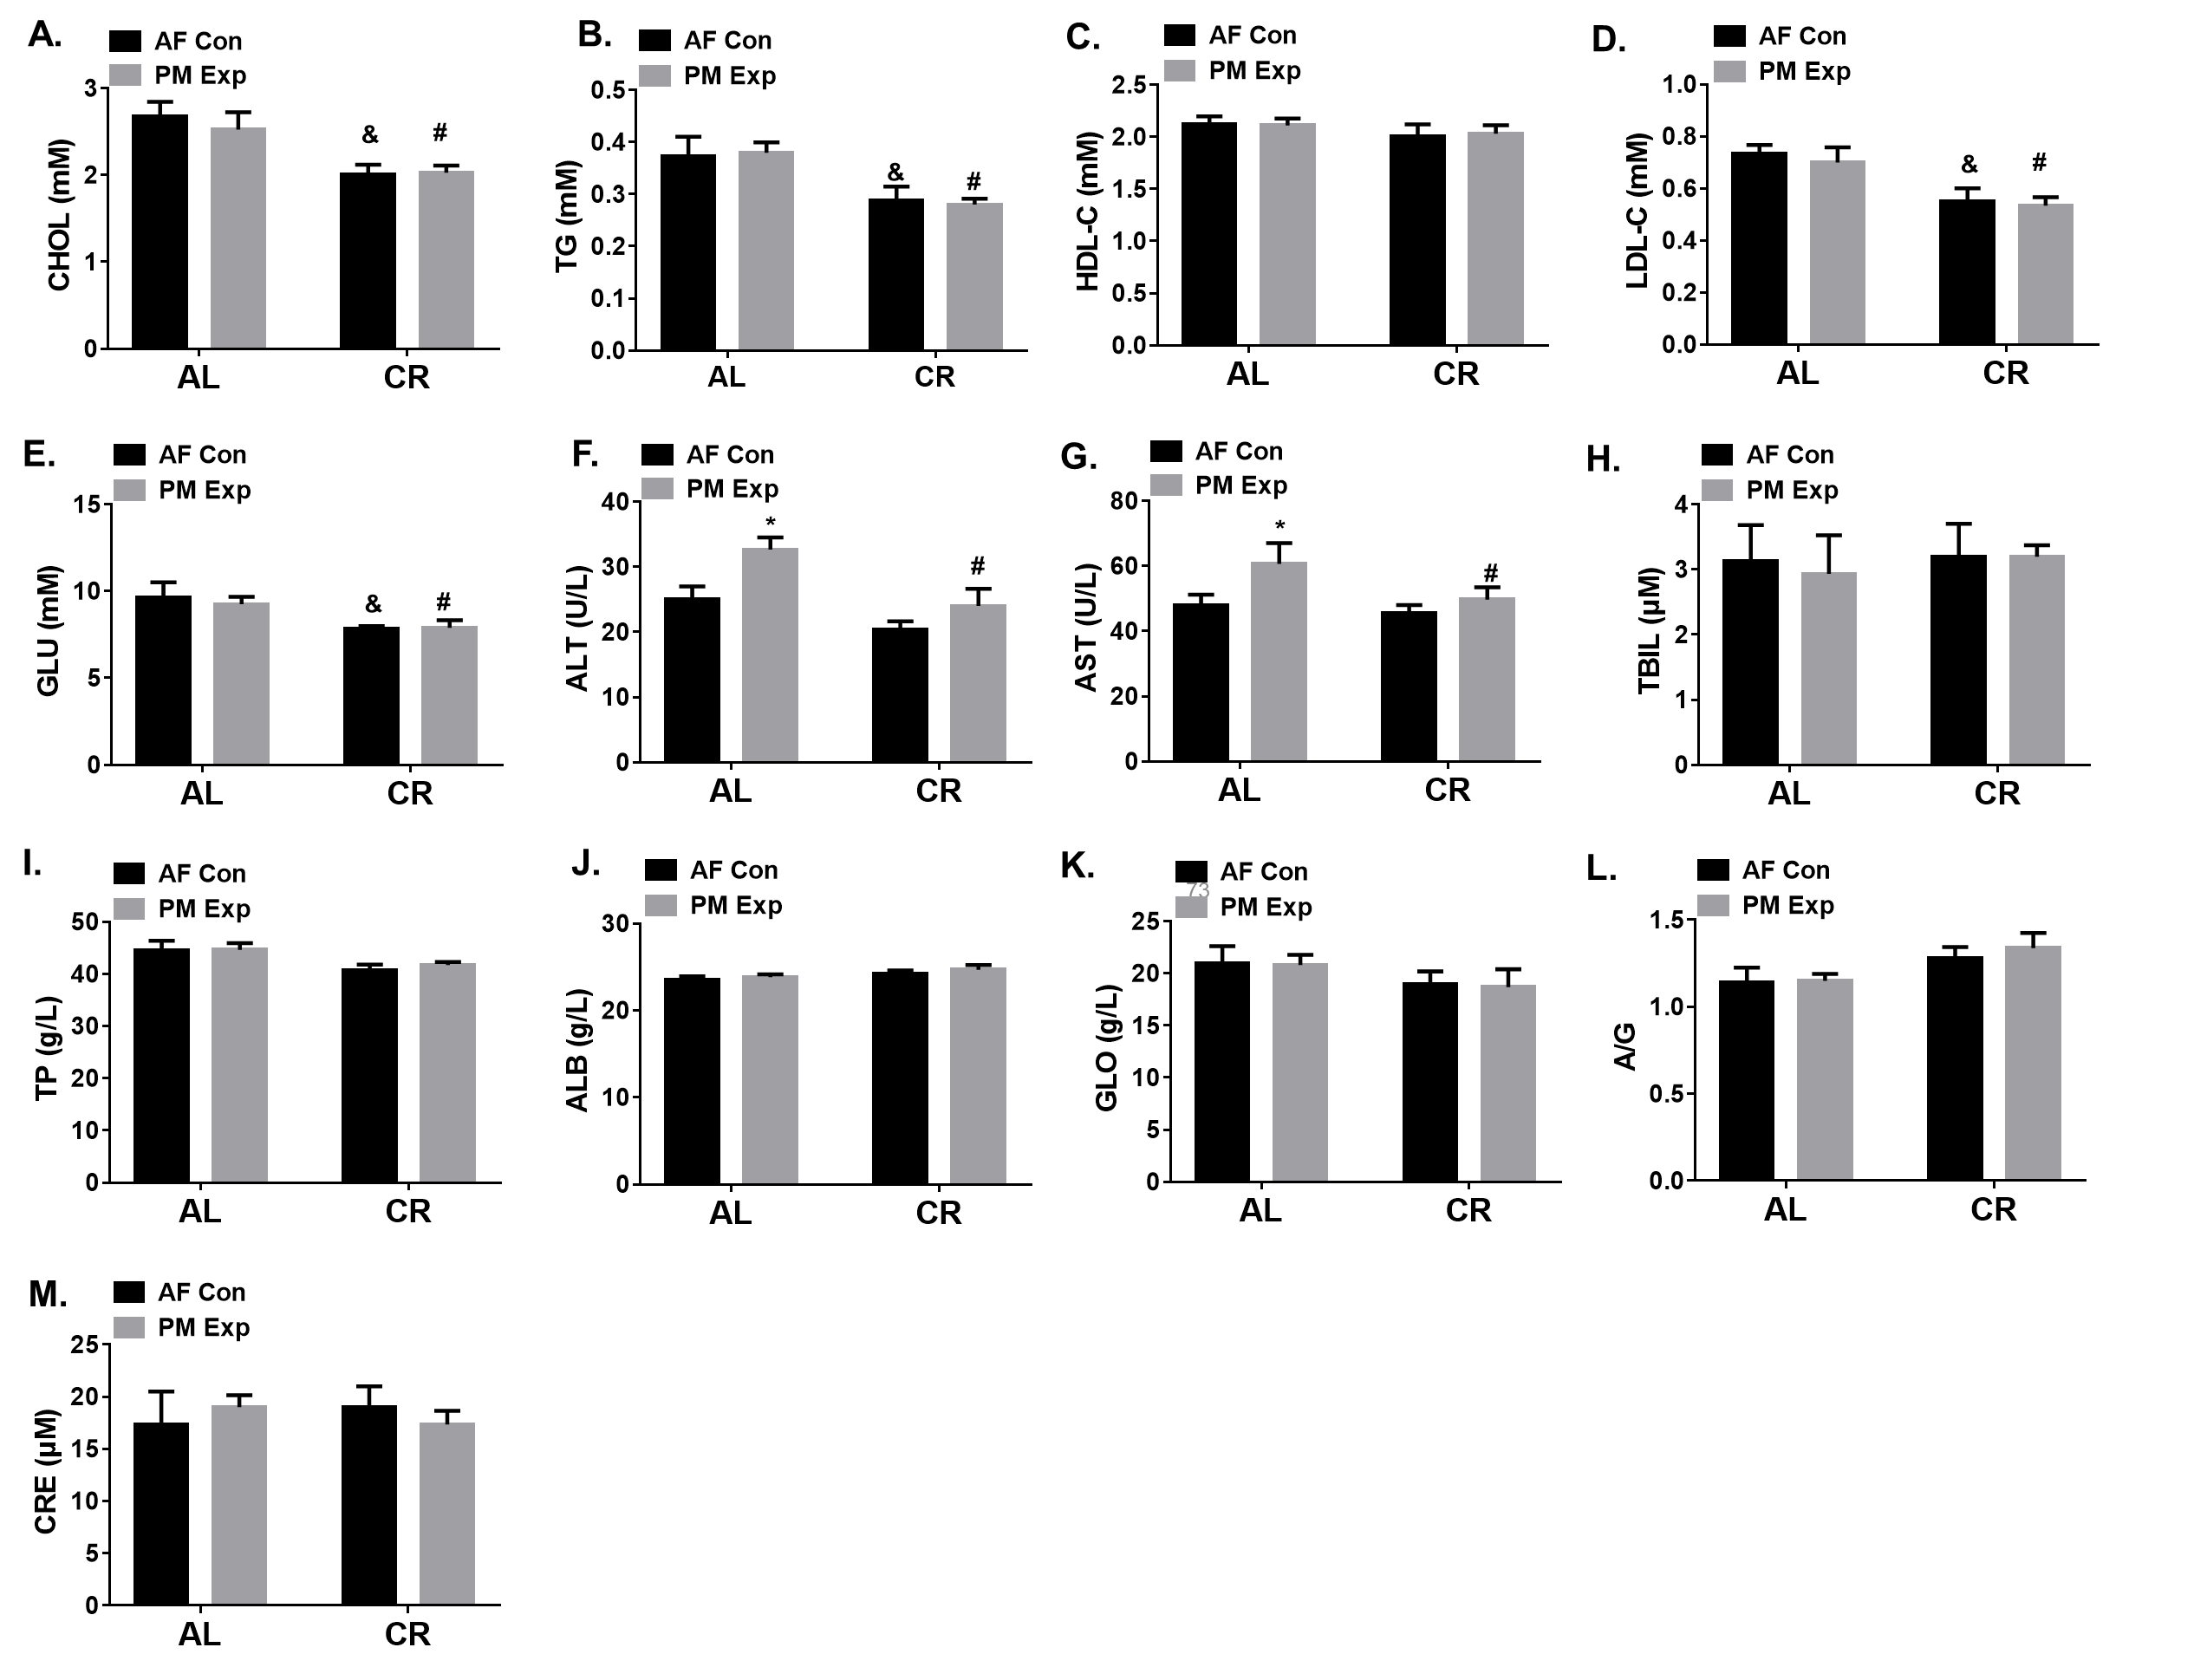
Figure S3. Plasma biochemistry analysis.
Plasma biochemistry analyses of (A) cholesterol (CHOL), (B) triglyceride (TG), (C) high-density lipoproteins cholesterol (HDL-C), (D) low-density lipoproteins cholesterol (LDL-C), (E) glucose (GLU), (F)glutamic-pyruvic transaminase (ALT), (G) glutamic-oxalacetic transaminase (AST), (H) total bilirubin (TBIL), (I) total protein (TP), (J) albumin (ALB), (K) globulin (GLO), (L) The ratio of ALB to GLO (A/G), and (M) creatinine (CRE). n=5 per group. The data are expressed as the mean ± SD, * P < 0.05 AF vs. PM, & P < 0.05 CR-AF vs. AL-AF, # P < 0.05 CR- PM vs. AL- PM.

Figure S4. The schematic diagram of a real-ambient PM exposure system.
The ambient air was introduced into the AF control or PM exposure chambers through an air supply system with or without going through the HEPA filters as described previously [2]. The system was equipped with an auto-temperature control system to keep a constant temperature of the input air. The meteorological condition inside the chambers was closely monitored to keep a relatively constant temperature, humidity, ventilation frequency, air-flow rate, and noise.

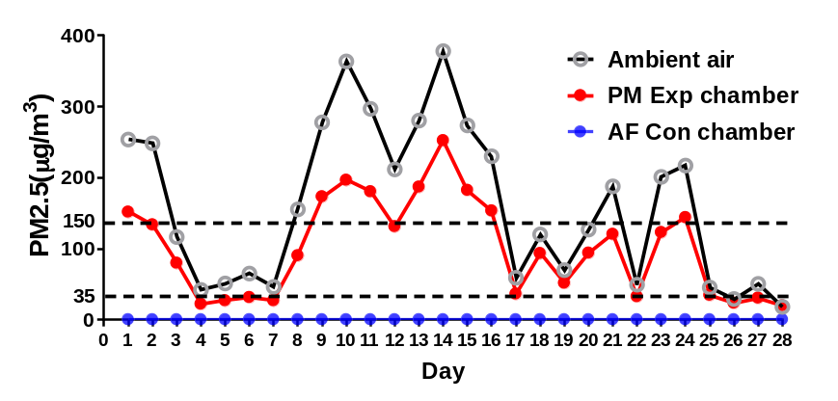
Figure S5. The concentration of PM2.5 in ambient air, PM exposure chamber, AF control chamber during exposure period.
The concentration of PM_{2.5} was monitored in ambient air, PM exposure chamber, AF control chamber over the duration of the experiment. The dashed and dotted lines indicate the mean daily limit and a level of severe air pollution according to the Air Quality Guideline of China.

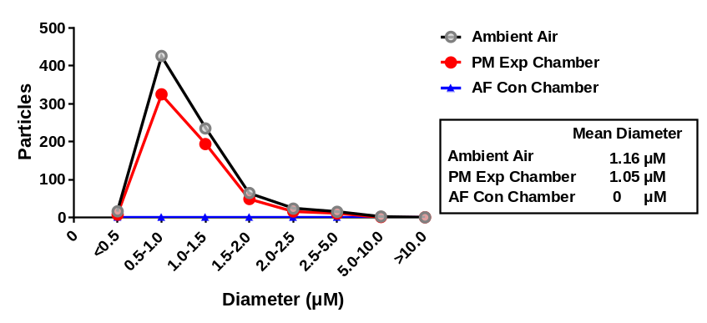
Figure S6. The size distributions of particular matter (PM) in ambient air and PM exposure and AF control chambers.

Figure S7. CR inhibits M1 macrophage polarization and increases M2 macrophage polarization in response to PM exposure.
(A) Flow cytometry analysis was conducted to examine the M1 and M2 macrophage polarization in BALF. The F4/80⁺/CD11b⁺/CD11c⁺/CD206⁻ macrophage was defined as M1 macrophage, and the F4/80⁺/CD11b⁺/CD11c⁻/CD206⁺ macrophage was defined as M2 macrophage. (B-C) The proportions of M1 and M2 macrophages in BALF. (D) The mRNA expression of M1 macrophage associated markers, iNOS2 and Cxcl10. (E) The mRNA expression of M2 macrophage associated markers, Fizz2 and Arg1. n=5 per group. The data are expressed as the mean ± SD, * P < 0.05 AF vs. PM, & P < 0.05 CR-AF vs. AL-AF, # P < 0.05 CR- PM vs. AL- PM.

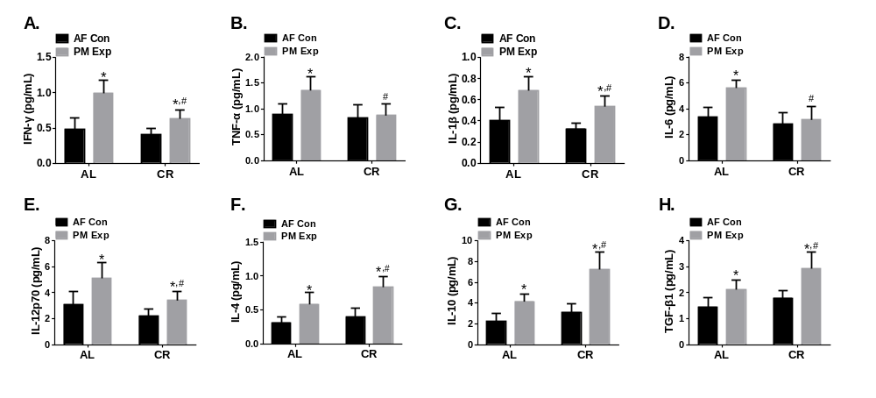
Figure S8. Analysis of the cytokine contents in BALF.
The data are expressed as the mean ± SD, * P < 0.05 AF vs. PM, & P < 0.05 CR-AF vs. AL-AF, # P < 0.05 CR- PM vs. AL- PM. n=5 per group.

Figure S9. The effects of CR on differential expressed genes (DEGs) in lung tissues of mice with or without PM exposure.
(A-B) Transcriptomic profiles of lung tissues of AL-fed and CR-fed mice in AF control and PM exposure groups. The heatmap illustrates the expression of 2299 DEGs and 1928 DEGs in “CR-AF vs. AL-AF” and “CR-PM vs. AL-PM” comparisons, respectively. Average-linkage hierarchical clustering was performed using Pearson correlation. (C-D) Volcano plot of DEGs. The red and blue dots represented the up- and down-regulated genes, respectively. The black dots indicated the genes without significantly differential expression. n=3 per group.

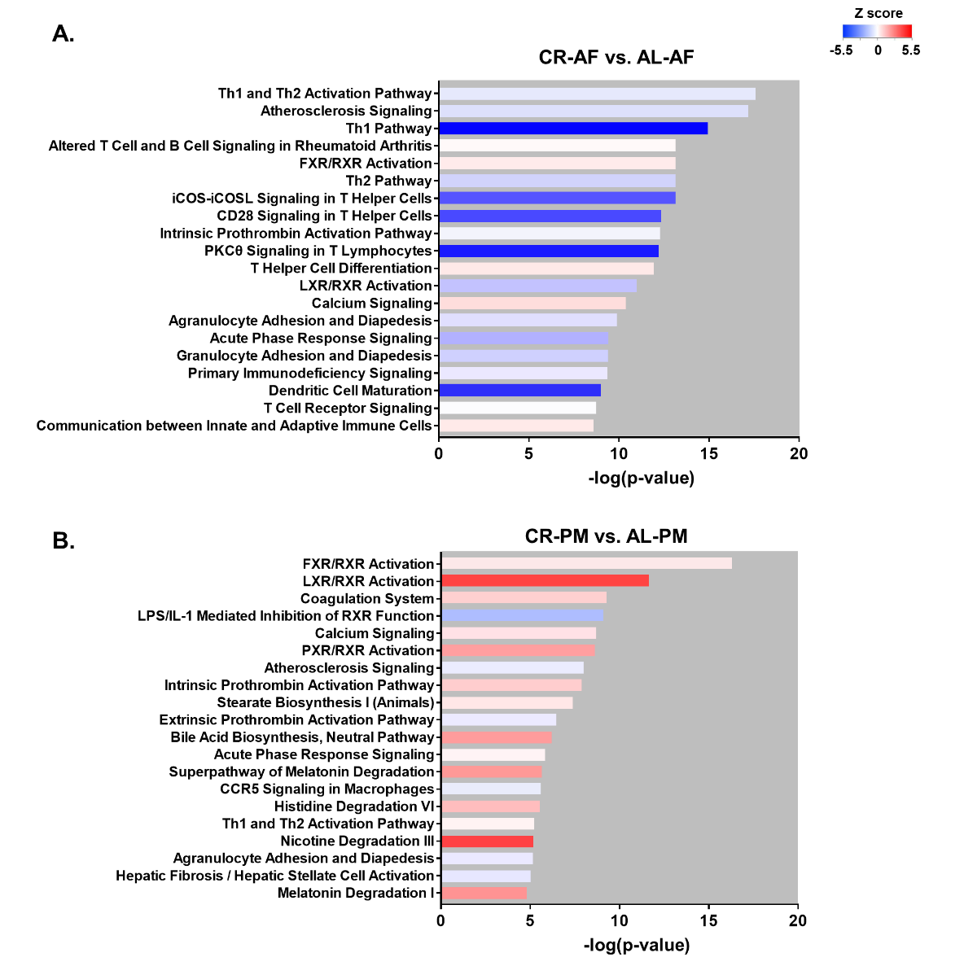
Figure S10. Top 20 pathways in mouse lung.
Comparison of the 20 most significant canonical pathways identified by IPA analysis between CR-AF and AL-AF mice (A) and between CR-PM and AL-PM mice (B).

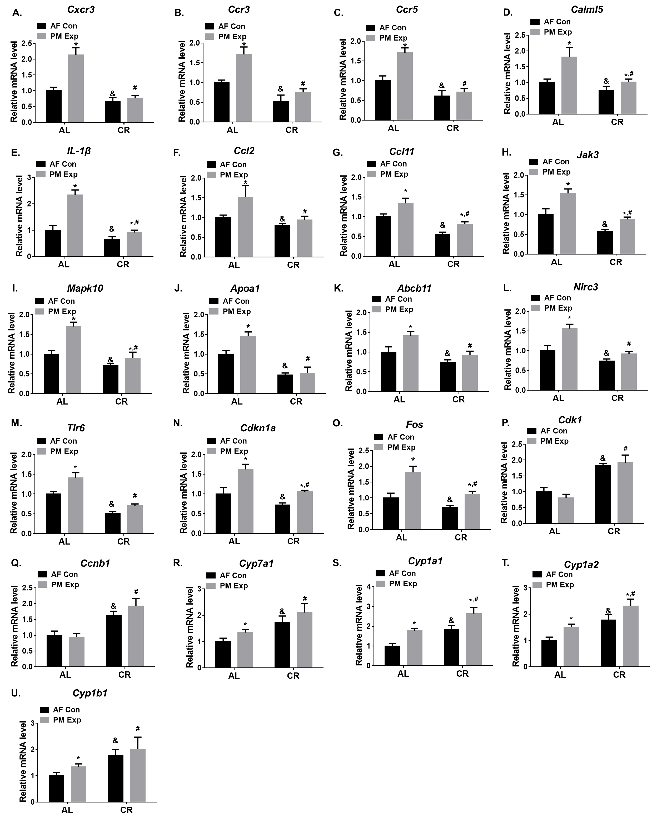
Figure S11. Validation of the gene expression in mouse lung tissues.
qPCR was performed for validation of the major genes involved in the regulation of key pathways. The data are expressed as the mean ± SD, * P < 0.05 AF vs. PM, & P < 0.05 CR-AF vs. AL-AF, # P < 0.05 CR- PM vs. AL- PM. n=3 per group.
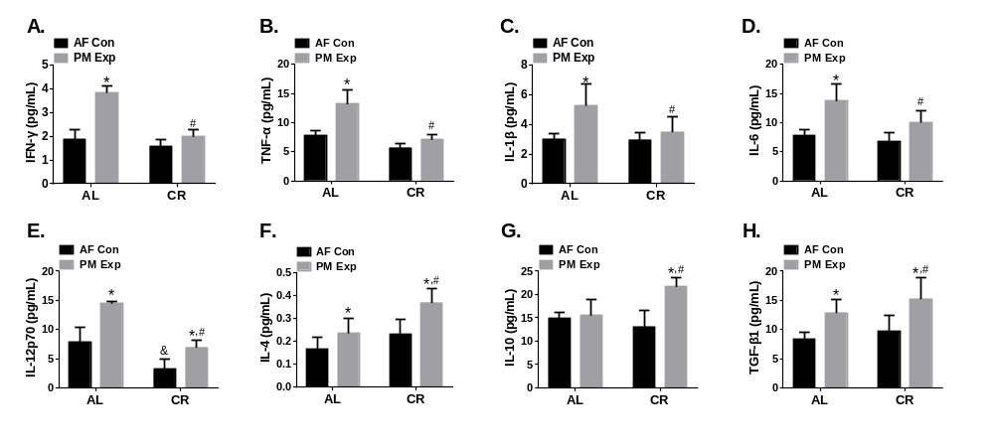
Figure S12. The levels of cytokines in plasma.
The data are expressed as the mean ± SD, * P < 0.05 AF vs. PM, & P < 0.05 CR-AF vs. AL-AF, # P < 0.05 CR- PM vs. AL- PM. n=5 per group.

Figure S13. The effects of CR on DEGs in liver tissues of mice with or without PM exposure group.
(A-B) Transcriptomic profiles of liver tissues of AL-fed and CR-fed mice in AF control and PM exposure group. The heatmap illustrates expression of 2821 DEGs and 2995 DEGs in “CR-AF vs. AL-AF” and “CR-PM vs. AL-PM” comparisons, respectively. Average-linkage hierarchical clustering was performed using Pearson correlation. (C-D) Volcano plot of DEGs. The red and blue dots expressed the up- and down-regulated genes, respectively. The black dots indicated the genes without significantly differential expression. n=3 per group.

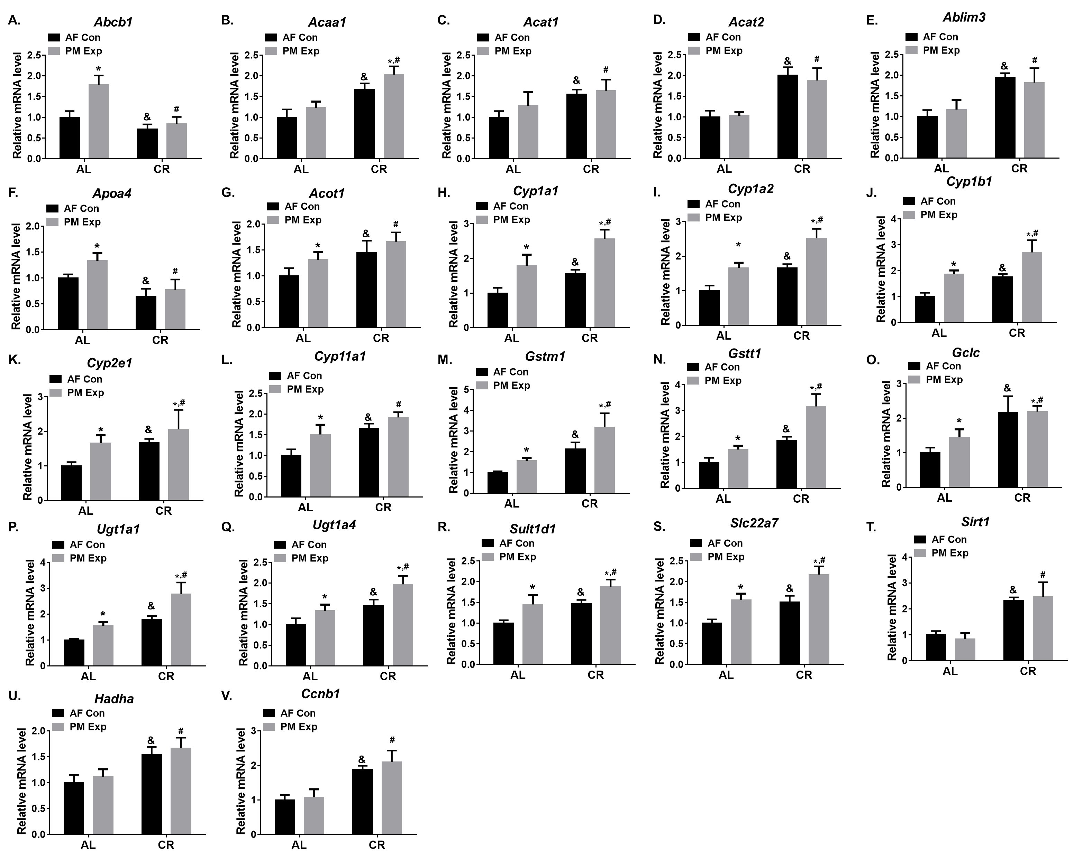
Figure S14. Validation of the gene expression in mouse liver tissues by qPCR.
qPCR was performed for validation of the major genes involved in the regulation of key pathways. The data are expressed as the mean ± SD, * P < 0.05 AF vs. PM, & P < 0.05 CR-AF vs. AL-AF, # P < 0.05 CR- PM vs. AL- PM. n=3 per group.

Supplementary tables
Table S1. Characteristics of AL diet and CR diet [4].
Ingredient | AL |  | CR
Ingredient |  |  | -10% |  | -25% |  | -40%
Ingredient | gram | kcal | gram | kcal | gram | kcal | gram | kcal
Casein, 30 Mesh | 200.00 | 800.00 | 180.00 | 720.00 | 150.00 | 600.00 | 120.00 | 480.00
L-Cystine | 3.00 | 12.00 | 2.70 | 10.80 | 2.25 | 9.00 | 1.80 | 7.20
Corn Starch | 72.80 | 291.00 | 65.52 | 261.90 | 54.60 | 218.25 | 43.68 | 174.60
Maltodextrin 10 | 100.00 | 400.00 | 90.00 | 360.00 | 75.00 | 300.00 | 60.00 | 240.00
Sucrose | 172.80 | 691.00 | 155.52 | 621.90 | 129.60 | 518.25 | 103.68 | 414.60
Soybean Oil | 25.00 | 225.00 | 22.50 | 202.50 | 18.75 | 168.75 | 15.00 | 135.00
Lard | 177.50 | 1598.00 | 159.75 | 1438.20 | 133.13 | 1198.50 | 106.50 | 958.80
Vitamin Mix V10001 | 10.00 | 40.00 | 10.00 | 40.00 | 10.00 | 40.00 | 10.00 | 40.00
Mineral Mix S10026 | 10.00 | 0.00 | 10.00 | 0.00 | 10.00 | 0.00 | 10.00 | 0.00
DiCalcium Phosphate | 13.00 | 0.00 | 13.00 | 0.00 | 13.00 | 0.00 | 13.00 | 0.00
Calcium Carbonate | 5.50 | 0.00 | 5.50 | 0.00 | 5.50 | 0.00 | 5.50 | 0.00
Potassium Citrate, 1H2O | 16.50 | 0.00 | 16.50 | 0.00 | 16.50 | 0.00 | 16.50 | 0.00
Choline Bitartrate | 2.00 | 0.00 | 2.00 | 0.00 | 2.00 | 0.00 | 2.00 | 0.00
Cellulose，BW200 | 50.00 | 0.00 | 125.11 | 0.00 | 242.77 | 0.00 | 358.44 | 0.00
FD&C Red Dye #40 | 0.05 | 0.00 | 0.05 | 0.00 | 0.05 | 0.00 | 0.05 | 0.00
Total | 858.15 | 4057.00 | 858.15 | 3651.30 | 858.15 | 3042.75 | 858.15 | 2434.20

Table S2. The meteorological conditions in the AF control and PM exposure chambers
 | Temperature  (℃) | Humidity  （%） | Ventilation frequency  （/h) | Air-flow rate  （m/s) | Noise  （dB）
AF Control | 20.2±2.4 | 45.1±1.1% | 18-20 | 0.17 | 35-40
PM Exposure | 21.5±3.1 | 46.3±2.1% | 18-20 | 0.17 | 35-40

Table S3. Primers for qPCR.
Gene name | Forward (5’-3’) | Reverse (5’-3’)
iNOS2 | TCTCCCTTTCCTCCCTTCTT | CTTCAGTCAGGAGGTTGAGTTT
Cxcl10 | TCAGGCTCGTCAGTTCTAAGT | CCTTGGGAAGATGGTGGTTAAG
Fizz2 | TTCATCCTCGTCTCCCTTCT | TGAGAGCTTCCTTGATCCTTTG
Arg1 | ACAGCAAAGCAGACAGAACTA | GAAAGGAACTGCTGGGATACA
Cxcr3 | GTGCTTGTCCTCCTTGTAGTT | GTTGTCCTTGTTGCTGAGATTG
Ccr3 | CCAGCTGTCAGCAGAGTAAA | CTCACCAACAAAGGCGTAGA
Ccr5 | GCTCCAAGAGATGAGGAAAGAG | GAACACAGAGAGCAGTCGTTAT
GATA4 | CAAAGGTGATAGACGGGAGAAG | GGTGATGAGGACAAGGAAGAAT
IL-1β | ATGGGCAACCACTTACCTATTT | GTTCTAGAGAGTGCTGCCTAATG
Ccl2 | CTCGGACTGTGATGCCTTAAT | TGGATCCACACCTTGCATTTA
Ccl11 | ACCCACTCTGCTCCCTATAA | CGTGAGCAGCAGGAATAGAA
Jak3 | TGGCATCCTGCCTGTTTATC | TTGAGTGTCCACGTCCTCTA
Mapk10 | CTGGCTTCTCTCAGTCAGTTATC | CTATGCTCCATGACCAAGTCTC
Apoa1 | CTCTGGGTTCAACCGTTAGTC | TCTCCTGTCTCACCCAATCT
Abcb11 | GCTCATCGCTTGTCTACTATCC | CCTTCTGGTCCATCAGTTTCTT
Nlrc3 | GATGGCTTGGATGAGTGTAAGA | TTGCCTCGGATGATGTTAGTG
Tlr6 | CAGAGTGAGTGGTGCCATTAT | GGTTCCAGCAAGATGAGGATTA
Cdkn1a | GTTCCTTGCCACTTCTTACCT | TCATCCTAGCTGGCCTTAGA
Fos | GAATCCGAAGGGAACGGAATAA | TCTCCGCTTGGAGTGTATCT
Cdk1 | TTGAAGAGGCAACCGAGTAAG | GGCGTTAGGTCATCCATCAA
Ccnb1 | GGTGTAACGGCCATGTTTATTG | CTGTCTGATCTGGTGCTTAGTG
Cyp7a1 | CCACATCCTCCTGGCATTTA | CAAGAGCTGTAGACACTGAGAC
Cyp1a1 | GTGAGCAAGGAGGCTAACTATC | GGCTACTGACACGACCAAATA
Cyp1a2 | GTCTTCCTCTTCTTAGCCATCC | GCTTCATGGTCAACCCATAGT
Cyp1b1 | TGGCCCTTTCCTCCTATCT | ACTGACACAACCTGCGTATC
Abcb1 | AGGAGTCATCCTCTCCTTAGTC | GCCAGACAACAGCTTCATTTC
Acaa1 | CAGGTTGTCACGCTACTCAA | TCAGTTCCCAGGGTATTCAAAG
Acat1 | CTAAAGCCCTGGGTTCTTTCT | CTCGGTTCGTTTCTCTCTATGG
Acat2 | AGCAGCATCCACGTACTTATTT | GTCAGTTCCAGTTCCAGTCATC
Ablim3 | GCCTGTACTCTTCAGCCTTATT | GTTGCTTGCTGGAGCTTATTG
Apoa4 | ACTGAGAGGGTGAAGGAAGA | CCGAACGTCTGGGTTACTTT
Acot1 | CGTCATGGCTCTGGCTTATTA | CAGGTAGTTCACGGCTTCTT
Cyp2e1 | GAAGTCTCTGGTTGACCCTAAG | AGGTCTCATGAACGAGGAATG
Cyp11a1 | GGCATTTGAGGGTGGTATCT | GGAAAGAGGGAAAGAGGATGAA
Gstm1 | CTCACGCTTCCTAGAATTACCC | CAGGCTGGCACTCAAGTATT
Gstt1 | GAGTGTGGCTATCTTGCTCTAC | TGCCAGGTACTCGTCTACA
Gclc | CATCGACCTGACCATCGATAAG | AGGGTGAGTGGGTCTCTAATAA
Sirt1 | GGAACCTTTGCCTCATCTACA | CACCTAGCCTATGACACAACTC
Slc22a7 | TGTGTTCCGGGCATCATTAG | GCACAGATGGACAGGTACTTT
Ugt1a1 | TGGACGGACTGCCTTTAATC | CAGCTAGGAGCATACTGGAATC
B3gat3 | CCGGACAGAGAAACCTAAGATG | CCCACAAGGTATGTGCCTAAA
Hadha | AGACATCGGAGCTGTCTTTG | CACTACCTTCTGAGCACCATAC
Sult1d1 | CAGTTCACTGTAGCCCAGTATG | CCAACTCTCCCTAGATCTCTGA

Table S4. Analysis of 16 US EPA priority PAHs# in the organic fraction of PM_{2.5}.
Components | TEF | μg/g PM | ng/m³
Naphthalene | 0.001 | BDL. | BDL.
Acenaphthylene | 0.001 | 5.50 | 0.83
Acenaphthene | 0.001 | BDL. | BDL.
Fluorene | 0.001 | 4.78 | 0.72
Phenanthrene | 0.001 | 60.78 | 9.20
Anthracene | 0.01 | 6.82 | 1.03
Fluoranthene | 0.001 | 153.81 | 23.29
Pyrene | 0.001 | 123.63 | 18.72
Benzo[a]anthracene | 0.1 | 66.87 | 10.13
Chrysene | 0.01 | 101.69 | 15.40
Benzo[b]fluoranthene | 0.1 | 183.37 | 27.77
Benzo[ik]fluoranthene | 0.1 | 50.86 | 7.70
Benzo[a]pyrene* | 1 | 67.43 | 10.21
Indeno[1,2,3-cd]pyrene | 0.1 | 87.19 | 13.20
Dibenzo[a,h]anthracene | 1 | 23.54 | 3.57
Benzo[g,h,i]perylene | 0.01 | 81.16 | 12.29
𝛴₁₆PAHs |  | 1017.43 | 154.07
TEQs _{PAH} |  | 132.045 | 20.00
NOTE:
#16 US EPA priority PAHs: 16 PAHs from the USEPA priority list
BDL: below detection level.
*The concentrations of benzo[a]pyrene in the Ambient Air Quality and Cleaner Air for Europe and
Air Quality Standards (GB 3095-2012) and Ministry of Ecology and Environment, China were
formulated as 1 ng/m³ and 2.5 ng/m³, respectively.
TEF: Toxic equivalent factor.

Table S5. The analysis of 18 nitro-PAHs in the organic fraction of PM2.5.
Components | TEFª | μg/g PM | ng/m³
1-nitronaphthalene | — | 0.009 | 0.001
2-nitronaphthalene | — | 0.071 | 0.006
2-nitrobiphenyl | — | 0.001 | 0.000
3-nitrobiphenyl | — | 0.327 | 0.026
4-nitrobiphenyl | — | 0.168 | 0.014
1,3-dinitronaphthalene | — | 0.006 | BDL.
3-nitrodibenzofuran | — | 0.095 | 0.008
2-nitrofluorene | 0.01 | 0.960 | 0.077
9-nitroanthracene | 0.0032 | 7.518 | 0.607
1,8-dinitronaphthalene | — | BDL. | BDL.
9-nitrophenanthrene | — | 0.290 | 0.023
3-nitrophenanthrene | — | 1.281 | 0.103
2-nitroanthracene | — | 0.176 | 0.014
2-nitrofluoranthene | — | 8.169 | 0.660
1-nitropyrene | 0.1 | 0.461 | 0.037
2-nitropyrene | — | 3.272 | 0.264
7-nitrobenzo[a]anthracene | — | 1.320 | 0.107
6-nitrochrysene | 10 | 0.455 | 0.037
𝛴₁₈nitro-PAHs |  | 24.580 | 1.985
TEQs _{nitro-PAH} |  | 4.633 | 0.374
NOTE: ªTEF: Toxic equivalent factor.

Table S6. Analysis of alkyl PAHs in the organic fraction of PM2.5.
Components | μg/g PM | ng/m³
Alkyl PAHs (μg/g PM)
PAH_166, methyl PAH166, DM PAH166
fluorene | 5.3 | 0.51
methyl fluorene-1 | 10.6 | 1.03
methyl fluorene-2 | 2.6 | 0.25
dimethyl fluorene-1 | 7.4 | 0.72
dimethyl fluorene-2 | 9.4 | 0.91
dimethyl fluorene-3 | 3.4 | 0.33
dimethyl fluorene-4 | 1.5 | 0.14
dimethyl fluorene-5 | BDL. | BDL.
dimethyl fluorene-6 | BDL. | BDL.
dimethyl fluorene-7 | BDL. | BDL.
PAH_178, methyl PAH178, DM PAH178
phenanthrene178 | 85.2 | 8.31
anthracene178 | 50.3 | 4.90
methyl PAH178_1 | 27.2 | 2.65
methyl PAH178_2 | 55.6 | 5.42
methyl PAH178_3 | 34.9 | 3.40
methyl PAH178_4 | 51.9 | 5.05
dimethyl-PAH178_1 | 14.6 | 1.42
dimethyl-PAH178_2 | 19.2 | 1.87
dimethyl-PAH178_3 | 30.8 | 3.00
dimethyl-PAH178_4 | 67.5 | 6.58
dimethyl-PAH178_5 | 13.7 | 1.33
dimethyl-PAH178_6 | 7.1 | 0.69
dimethyl-PAH178_7 | 9.1 | 0.89
PAH_202, methyl PAH202, DM PAH202
fluoranthene202 | 261.3 | 25.47
PAH202_3 | 23.2 | 2.26
pyrene202 | 226.9 | 22.11
methyl PAH202_1 | 46.8 | 4.56
methyl PAH202_2 | 101.2 | 9.86
methyl PAH202_3 | 66.6 | 6.49
methyl PAH202_4 | 39.5 | 3.85
methyl PAH202_5 | 25.2 | 2.45
PAH_226, methyl PAH226
cyclopenta[cd]pyrene226 | 33.8 | 3.30
methyl PAH226 | 8.5 | 0.83
PAH_228, methyl PAH228
chrysene228 | 157.4 | 15.34
triphenylene228 | 135.8 | 13.24
methyl PAH228_1 | 26.9 | 2.62
methyl PAH228_2 | 3.4 | 0.33
methyl PAH228_3 | 50.5 | 4.92
methyl PAH228_4 | 22.1 | 2.15
methyl PAH228_5 | 9.7 | 0.94
methyl PAH228_6 | 16.4 | 1.60
PAH_252, methyl PAH_252
benzo[b+k]fluoranthene252 | 310.9 | 30.30
benzo[a]fluoranthene252 | 29.9 | 2.91
benzo[e]pyrene252 | 155.3 | 15.13
benzo[a]pyrene252 | 179.9 | 17.53
perylene252 | 24.0 | 2.34
methyl PAH252_1 | 18.3 | 1.78
methyl PAH252_2 | 24.0 | 2.34
methyl PAH252_3 | 12.0 | 1.17
methyl PAH252_4 | 25.1 | 2.45
methyl PAH252_5 | 25.8 | 2.52
methyl PAH252_6 | 22.6 | 2.20
methyl PAH252_7 | 10.5 | 1.02
PAH_276, all unsubstituted
PAH276_1 | BDL. | BDL.
PAH276_2 | 32.4 | 3.16
indeno[1,2,3-cd]pyrene276 | 109.6 | 10.68
benzo[ghi]perylene276 | 86.9 | 8.47
PAH_278, all unsubstituted
PAH278_1 | 1.8 | 0.18
PAH278_2 | 1.8 | 0.18
PAH278_3 | 2.0 | 0.20
PAH278_4 | 2.3 | 0.23
PAH278_5 | 2.2 | 0.22
PAH278_6 | 5.1 | 0.50
PAH278_7 | 4.0 | 0.39
PAH278_8 | 2.8 | 0.27
PAH278_9 | 1.0 | 0.10
PAH278_10 | 2.8 | 0.27
PAH278_11 | 2.4 | 0.23
dibenzo[a,h]anthracene | 12.6 | 1.22
benzo[b]chrysene | BDL. | BDL.
dibenzo[a,c]anthracene | BDL. | BDL.
picene | BDL. | BDL.
PAH_300
Coronene | BDL. | BDL.
𝛴 alkyl-PAHs | 2870.50 | 279.71
NOTE: BDL: below detection level.

Table S7. Analysis of 17 PCDD/F and 18 PCB in the organic fraction of PM2.5.
Components | TEF | ng/g PM | pg/m³
PCDD/F | I-TEFª
2,3,7,8-TCDF | 0.1 | 1.884 |  | 0.285
1,2,3,7,8-PeCDF | 0.05 | 2.493 |  | 0.377
2,3,4,7,8-PeCDF | 0.5 | 2.884 |  | 0.436
1,2,3,4,7,8-HxCDF | 0.1 | 4.536 |  | 0.685
1,2,3,6,7,8-HxCDF | 0.1 | 3.436 |  | 0.519
2,3,4,6,7,8-HxCDF | 0.1 | 5.182 |  | 0.783
1,2,3,7,8,9-HxCDF | 0.1 | 0.565 |  | 0.085
1,2,3,4,6,7,8-HpCDF | 0.01 | 9.895 |  | 1.495
1,2,3,4,7,8,9-HpCDF | 0.01 | 1.915 |  | 0.289
OCDF | 0.001 | 13.016 |  | 1.967
2,3,7,8-TCDD | 1 | 0.102 |  | 0.015
1,2,3,7,8-PeCDD | 0.5 | 0.472 |  | 0.071
1,2,3,4,7,8-HxCDD | 0.1 | 0.254 |  | 0.038
1,2,3,6,7,8-HxCDD | 0.1 | 0.612 |  | 0.093
1,2,3,7,8,9-HxCDD | 0.1 | 1.409 |  | 0.213
1,2,3,4,6,7,8-HpCDD | 0.01 | 3.774 |  | 0.570
OCDD | 0.001 | 4.888 |  | 0.739
𝛴 PCDF |  | 45.806 |  | 6.922
TEQs _{PCDF} |  | 3.258 |  | 0.492
𝛴 PCDD |  | 11.513 |  | 1.740
TEQs _{PCDD} |  | 0.609 |  | 0.092
𝛴 PCDF+PCDD |  | 57.318 |  | 8.662
TEQs _{PCDF+PCDD} |  | 3.867 |  | 0.584
PCB | TEF_{WHO-05}^{b}
PCB 77 | 0.0001 | 2.323 |  | 0.351
PCB 81 | 0.0003 | 0.775 |  | 0.117
PCB 105 | 0.00003 | 1.808 |  | 0.273
PCB 114 | 0.00003 | 1.093 |  | 0.165
PCB 118 | 0.00003 | 3.427 |  | 0.518
PCB 123 | 0.00003 | 0.335 |  | 0.051
PCB 126 | 0.1 | 1.421 |  | 0.215
PCB 156 | 0.00003 | 1.511 |  | 0.228
PCB 157 | 0.00003 | 0.651 |  | 0.098
PCB 167 | 0.00003 | 0.649 |  | 0.098
PCB 169 | 0.03 | 0.715 |  | 0.108
PCB 189 | 0.00003 | 0.933 |  | 0.141
PCB 28 | — | 5.772 |  | 0.872
PCB 52 | — | 4.630 |  | 0.700
PCB 101 | — | 5.432 |  | 2863.584
PCB 138 | — | 2.995 |  | 0.453
PCB 153 | — | 2.806 |  | 0.424
PCB 180 | — | 3.100 |  | 0.468
𝛴 PCB |  | 40.375 |  | 6.101
TEQs _{PCB} |  | 0.164 |  | 0.025
Note: ªInternational Toxicity Equivalency Factor (I-TEF) for PCDD/F; ^{b}The 2005 World Health
Organization reevaluation of human and mammalian toxic equivalency factors (TEFWHO-05) for PCB.

Table S8. Analysis of elements and ion species in water-soluble components of PM2.5.
Components | μg/g PM | ng/m³
Elements
Li | 8.615 | 1.302
Be | 0.036 | 0.005
Na | 4145.329 | 626.379
Mg | 1100.435 | 166.281
Al | 147.722 | 22.321
K | 6449.476 | 974.547
Ca | 10633.979 | 1606.846
Ti | 6.200 | 0.937
V | 3.272 | 0.494
Cr | 5.203 | 0.786
Mn | 176.533 | 26.675
Fe | 233.905 | 35.344
Co | 1.153 | 0.174
Ni | 2.889 | 0.436
Cu | 37.322 | 5.640
Zn | 448.365 | 67.750
Ga | 4.765 | 0.720
As | 23.878 | 3.608
Se | 18.636 | 2.816
Rb | 12.030 | 1.818
Sr | 56.980 | 8.610
Y | 0.379 | 0.057
Zr | 1.564 | 0.236
Nb | 0.039 | 0.006
Mo | 7.343 | 1.110
Pd | 0.066 | 0.010
Ag | BDL. | BDL.
Cd | 2.980 | 0.450
Sn | 5.118 | 0.773
Sb | 17.454 | 2.637
Te | 0.185 | 0.028
Ba | 58.405 | 8.825
Ta | BDL. | N.D.
W | 1.354 | 0.205
Tl | 2.170 | 0.328
Pb | 30.050 | 4.541
𝛴 Metal | 23643.83 | 3572.70
Anions
F⁻ | 1157.040 | 174.834
Cl⁻ | 28279.831 | 4273.221
SO₄²⁻ | 72799.701 | 11000.391
NO₃⁻ | 104288.474 | 15758.498
PO₄⁻ | BDL. | BDL.
NO²⁻ | BDL. | BDL.
Br⁻ | BDL. | BDL.
𝛴 Anions | 206525.046 | 31206.944

Table S9. Ambient air quality standards for different components in U.S. EPA, EU and China.
 | U.S. EPAª | EU^{b} | China^{c}
 | ng/m³ | ng/m³ | ng/m³
Benzo[a]pyrene | — | 1 | 2.5
TEQs (PCDF+PCDD) | — | 0.1 | 0.1
Cr | — | — | 000.025 (VI)
Ni | — | 20 | —
As | — | 6 | 6
Pb | 0.15 | 0.5 | 1000
Cd | — | 5 | 5
F⁻ | — | — | 7000
Note: ª Data were collected from National Ambient Air Quality Standards (NAAQS) established by U.S. EPA.
^{b} Data were collected from The Ambient Air Quality and Cleaner Air for Europe.
^{c} Data were collected from Air Quality Standards (GB 3095-2012) established by Ministry of Ecology and Environment of the People’s Republic of China.

Table S10. The major DEGs in key canonical pathways involved in inflammatory response, oxidative stress, DNA damage, and xenobiotic metabolism in mouse lung.
Ingenuity canonical pathways | Genes
CR-AF vs AL-AF
Inflammatory response
Th1 pathway | CXCR3, CD247, CD274, CD28, CD3D, CD3E, CD3G, CD4, CD40LG, CD86, CD8A, CXCR3, H2-Eb2, HLA-A, HLA-DMB, HLA-DOA, HLA-DOB ,HLA-DQB1, HLA-DRB5, ICOS, ICOSLG/LOC102723996, CCR5, IFNG, IL10, IL10RA, IL12B, IL12RB1, IL18R1, IL27, IL27RA, JAK3, KLRC1, KLRD1, LTA, NFIL3, PIK3CD, PIK3CG, PIK3R5, PRKCQ, RUNX3, STAT4, TBX21, TNFSF11, VAV1
Th2 pathway | CCR3, CCR1, CCR5, CCR8, CD247, CD28, CD3D, CD3E, CD3G, CD4, CD86, CXCR4, CXCR6, GFI1,H2-Eb2, HLA-A, HLA-DMB, HLA-DOA, HLA-DOB, HLA-DQB1, HLA-DRB5, ICOS, ICOSLG/LOC102723996, IFNG, IKZF1, IL10, IL12B, IL12RB1, IL2RB, IL2RG, IL4R, JAK3, PIK3CD, PIK3CG, PIK3R5, PRKCQ, RUNX3, SPI1, STAT4, TBX21, TNFRSF4, TNFSF4, VAV1
Acute phase response signaling | IL-1β, A2M, ALB, AMBP, APCS, APOA1, APOA2, APOH, C1R, C5, C9, CRABP2, CRP, F2, F8, FGA, FGB, FGG, FOS, HPX,IKBKE, IL36A, IL36B, IL36RN, ITIH3, KLKB1, MAP3K1, NFKBID, NFKBIE, NGFR, OSM, PIK3CD, PIK3CG, PLG, RBP2, SAA1, SAA2-SAA4, Saa3, SERPINA1, SERPINA3, SERPIND1, SERPINF2, TNFRSF1B, TTR
CCR5 signaling in macrophages | CCR5, CACNA1B, CACNA1D, CACNA1E, CACNA1F, CACNA1I, CACNA1S, CACNA2D2, CACNG1, CACNG6, CACNG8, CALML5, CCL4, CCL5, CD247, CD3D, CD3E, CD3G, CD4, FASLG, FOS, GNG13, MAPK10, PLCG2, PRKCB, PRKCQ, PTK2B
Role of NFAT in Regulation of immune response | GATA4, BLNK, BTK, CALML5, CD247, CD28, CD3D, CD3E, CD3G, CD4, CD79A, CD79B, CD86, FCGR1A, FOS, GATA4, GNG13, H2-Eb2, HLA-A, HLA-DMB, HLA-DOA, HLA-DOB, HLA-DQB1, HLA-DRB5, IKBKE, ITK, LAT, LCK, LCP2, NFKBID, NFKBIE, PIK3CD, PIK3CG, PIK3R5,P LCB1, PLCG2, PRKCQ, SYK, ZAP70
TREM1 signaling | NLRC3, CCL2, CD83, CD86, IL10, IL1B, LAT2, Naip1, NLRC4, NLRP10, NLRP12, NLRP3, NLRP6, PLCG2, TLR1, Tlr13, TLR6, TLR9
Chemokine signaling | CCL11, CALML5, CAMK2A, CAMK2B, CCL2, CCL24, CCL4, CCL5, CCR3, CCR5, CXCR4, FOS, NOX1, PIK3CG, PLCB1, PLCG2, PRKCB, PTK2B
STAT3 pathway | CDKN1A, CSF2RB, CXCR2, IL10RA, IL11RA, IL12RB1, IL17RA, IL18R1, IL18RAP, IL1B, IL21R, IL22RA2, IL27RA, IL2RB, IL2RG, IL31RA, IL4R, IL5RA, IL9R, MAPK10, NGFR, NTRK1, PTPN6
NF-κB signaling | TLR6, CARD11, CD40LG, IL1B, IL36A, IL36B, IL36RN, LCK, LTA, MALT1, MAP3K1, NFKBID, NFKBIE, NGFR, NTRK1, PIK3CD, PIK3CG, PIK3R5, PLCG2, PRKCB, PRKCQ, RELB, TLR1, TLR9, TNFRSF17, TNFRSF1B, TNFSF11, ZAP70
HMGB1 signaling | CCL2, CD40LG, CLCF1, FASLG, FOS, IFNG, IL12B, IL1B, IL36A, IL36B, LTA, LTB, MAPK10, NGFR, OSM, PIK3CD, PIK3CG, PIK3R5, RAC2, RHOF, RHOH, TNFRSF1B, TNFSF11, TNFSF14, TNFSF4, Tnfsf9
IL-17A signaling in airway cells | JAK3, CCL11, CCL20, CXCL6, IKBKE, IL17RA, MAPK10, MUC5AC, NFKBID, NFKBIE, PIK3CD, PIK3CG, PIK3R5
Oxidative stress
Antioxidant action of vitamin C | MAPK10, CSF2RB, GSTO1, IKBKE, LCAT, NFKBID, NFKBIE, PLA2G2D, PLA2G2F, PLA2G3, PLA2G4C, PLA2G4D, PLA2G4E, PLA2G5, PLA2G7, PLAAT1, PLB1, PLCB1, PLCG2, PLCL2, PLD4, PNPLA3, SLC2A3, SLC2A4, SLC2A5
Production of nitric oxide and reactive oxygen Species in macrophages | APOA1, ALB, APOA2, APOA4, APOB, APOC2, APOC4, APOF, FOS, IFNG, IKBKE, IRF8, JAK3, MAP3K1, MAPK10, NCF4, NFKBID, NFKBIE, NGFR, NOS2, PIK3CD, PIK3CG, PIK3R5, PLCG2, PPP1R3A, PPP1R3D, PRKCB, PRKCQ, PTPN6, RAC2, RHOF, RHOH, S100A8, SERPINA1, SPI1, TNFRSF1B
DNA damage
Cell cycle: G2/M DNA damage checkpoint regulation | CDK1, CCNB1, CCNB2, CDC25B, CDC25C, CDKN1A, CKS2, PKMYT1, PLK1, TOP2A, WEE1
GADD45 signaling | CCNB1, CCNE1, CDK1, CDKN1A
Xenobiotic metabolism
LXR/RXR activation | CYP7A1, ACACA, ALB, AMBP ,APOA1, APOA2, APOA4, APOA5, APOB, APOC2, APOC4, APOF, APOH, C9, CCL2, FASN, FGA, GC, HPX, IL18RAP, IL1B, IL36A, IL36B, IL36RN, KNG1, LCAT, MLXIPL, MMP9, NGFR, NOS2, S100A8, SAA1, SCD, SERPINA1, SERPINF2, TNFRSF1B, TTR
LPS/IL-1 mediated inhibition of RXR function | ABCB11, ABCC2, ACSBG1, ACSL6, ALDH1L1, ALDH8A1, APOC2, APOC4, CHST10, CHST3,CYP2A12/CYP2A22, CYP2A6, CYP2C8, CYP2C9, CYP3A5, CYP3A7, CYP4A11, CYP4A14, CYP7A1, FABP1, FABP4, FABP5, FMO4, GSTA5, GSTO1, HMGCS2, HS3ST3A1, IL18RAP, IL1B, IL36A, IL36B, IL36RN, IL4I1, MAP3K1, NGFR, NR1I3, PPARGC1A, SLC10A1, SLC27A5, SLCO1A2, SLCO1B3, SULT1E1, TNFRSF1B
PXR/RXR activation | CYP1A1, ABCB11, ABCC2, CES3, CYP1A2, CYP1B1, CYP2A6, CYP2C8, CYP2C9, CYP3A5, CYP3A7, CYP7A1, G6PC, HMGCS2, HNF4A, IGFBP1, NR1I3, PPARGC1A, SCD, SLCO1B3, UGT1A1
Nicotine degradation III | CYP1A2, ABCB11, ABCC2, CES3, CYP1A1, CYP1B1, CYP2A6, CYP2C8, CYP2C9, CYP3A5, CYP3A7, CYP7A1, G6PC, HMGCS2, HNF4A, IGFBP1, NR1I3, PPARGC1A, SCD, SLCO1B3, UGT1A1
Nicotine degradation II | CYP1B1, ADH7, Aox4, CYP1A1, CYP1A2, CYP2A6, CYP2C40, CYP2C8, CYP2C9, CYP3A5, CYP3A7, FMO4, UGT1A1, UGT2B17, UGT2B28, UGT2B7, UGT3A1
CR-PM vs AL-PM
Inflammatory response
Acute phase response signaling | IL-1β, AGT, AHSG, ALB, AMBP, APOA1, APOA2, APOH, C4A/C4B, C9, CRABP2, CRP, F2, FGA, FGB, FGG, FOS, HPX, ITIH3, MBL2, NGFR, PLG, RASD1, RASD2, RBP2, RBP7, SAA1, SAA2-SAA4, SAA3, SERPINA1, SERPINA3, SERPINF2, TTR
CCR5 signaling in macrophages | CCR5, CACNA1B, CACNA1G, CACNA1H, CACNA1I, CACNG1, CACNG2, CALML5, CCL5, CD247, CD3D, CD3E, CD3G, FAS, FASLG, FOS, GNG3, GNG4, MAPK10, OPN1SW, PRKCQ
Th2 pathway | CCR3, ACVR1C, CCR5, CD247, CD28, CD3D, CD3E, CD3G, DLL1, GFI1, HLA-DOB, HLA-DRA, IKZF1, IL13, IL2RA, IL2RB, IL4R, PRKCQ, PTGDR2, STAT4, TBX21, TNFRSF4, TSLP
Th1 pathway | CXCR3, CCR5, CD247, CD28, CD3D, CD3E, CD3G, CD40LG, CD8A, DLL1, HLA-DOB, HLA-DRA, IL27, KLRC1, KLRD1, NFIL3, PRKCQ, STAT4, TBX21
STAT3 pathway | CDKN1A, IL11RA, IL13RA2, IL18RAP, IL1R2, IL20RA, IL20RB, IL22RA2, IL2RA, IL2RB, IL4R, IL5RA, MAPK10, NGFR, NTRK1, NTRK2, NTRK3, RASD1, RASD2
Chemokine signaling | CCL11, CALML5, CAMK2A, CCL2, CCL24, CCL5, CCR3, CCR5, FOS, OPN1SW, RASD1, RASD2
Role of NFAT in regulation of the immune response | GATA4, CALML5, CD247, CD28, CD3D, CD3E, CD3G, CD79A, CD79B, FCGR3A, FCGR3B, FOS, GNAT1, GNG3, GNG4, HLA-DOB, HLA-DRA, LAT, LCK, MEF2B, PRKCQ, RASD1, RASD2
IL-12 signaling and production in macrophase | FOS, ALB, ALOX15, APOA1, APOA2, APOA4, APOB, APOC4, APOF, CD40LG, MAPK10, PRKCQ, SERPINA1, STAT4
HMGB1 signaling | CCL2, CD40LG, CNTF, FASLG, FOS, IL11, IL13, IL17B, IL1B, LEP, MAPK10, NGFR, RAC2, RASD1, RASD2, RHOU
TREM1 signaling | NLRC3, CCL2, IL1B, MPO, NLRP12, NLRP6, TLR6
NF-κB signaling | TLR6, CD40LG, IL1B, IL1R2, LCK, NGFR, NTRK1, NTRK2, NTRK3, PRKCQ, RASD1, RASD2, TNFRSF17
Oxidative stress
Production of nitric oxide and reactive oxygen Species in macrophages | APOA1, ALB, APOA2, APOA4, APOB, APOC4, APOF, FOS, MAPK10, MPO, NGFR, PPARA, PPP1R3A, PPP1R3C, PRKCQ, RAC2, RHOU, SERPINA1
Antioxidant action of vitamin C | MAPK10, LCAT, PLA2G2F, PLB1, PLD5, PLD6, PNPLA3, SLC2A2, SLC2A5, TXNDC2
DNA damage
Cell cycle: G2/M DNA damage checkpoint regulation | CDK1, AURKA, CCNB1, CCNB2, CDC25C, CDKN1A, PLK1, SFN, TOP2A, WEE1
GADD45 signaling | CCNB1, CDK1, CDKN1A, GADD45G
Xenobiotic metabolism
LXR/RXR activation | CYP7A1, ABCG8, AGT, AHSG, ALB, AMBP, APOA1, APOA2, APOA4, APOA5, APOB, APOC4, APOF, APOH, C4A, C4B, C9, CCL2, FASN, FGA, GC, HPX, IL18RAP, IL1B, IL1R2, IL1RAPL2, KNG1, LCAT, LPL, NGFR, RXRG, SAA1, SCD, SERPINA1, SERPINF2, TTR
LPS/IL-1 mediated inhibition of RXR function | ABCB11, ABCC2, ABCG8, ACSBG1, ACSL1, ALDH1L1, ALDH3A1, ALDH8A1, APOC4, CHST3, CPT1B, CYP2A12, CYP2A6, CYP2C8, CYP3A5, CYP4A11, CYP4A14, CYP7A1, FABP2, FABP3, FABP4, FABP5, FABP7, GAL3ST2, HMGCS1, HMGCS2, HS3ST4, IL18RAP, IL1B, IL1R2, IL1RAPL2, IL4I1, NGFR, NR0B2, NR1I3, PPARA, PPARGC1A, SLC10A1, SLC27A1, SLC27A2, SLC27A5, SLCO1A2, SLCO1B3, SULT1B1, SULT2A1
PXR/RXR activation | CYP1A1, ABCB11, ABCC2, CES3, CYP1A2, CYP2A6, CYP2C8, CYP3A5, CYP7A1, G6PC, HMGCS2, HNF4A, IGFBP1, NR0B2, NR1I3, PPARA, PPARGC1A, PRKAR2B, SCD, SLCO1B3, SULT2A1, UGT1A1
Nicotine degradation III | CYP1A2, AOX2, CYP1A1, CYP1B1, CYP2A6, CYP2C40, CYP2C8, CYP2E1, CYP3A5, UGT1A1, UGT2A3, UGT2B17, UGT2B28, UGT2B7, UGT3A1
Nicotine degradation II | CYP1B1, AOX2, CYP1A1, CYP1A2, CYP2A6, CYP2C40 , CYP2C8, CYP2E1, CYP3A5, UGT1A1, UGT2A3, UGT2B17, UGT2B28, UGT2B7, UGT3A1
Note: Genes labeled in red were selected for validation of mRNA expression by qPCR (Fig.S12).

Table S11. The major DEGs in the 20 most significant canonical pathways in mouse liver.
Ingenuity canonical pathways | Genes
CR-AF vs AL-AF
LPS/IL-1 Mediated Inhibition of RXR Function | ABCB1, ABCB11, ABCC2, ABCG5, ABCG8, ACOX1, ACOX2, ACSBG1, ACSL1, ACSL3, ALDH1A2, ALDH1L1, ALDH1L2, ALDH3A2, CES2, CHST1, CHST10, CHST11, CHST3, CHST4, CPT1A, CPT1B, CPT2, CYP2A6, CYP2C8, CYP4A11, CYP4A14, CYP7A1, FABP2, FABP5, FMO1, FMO2, FMO3, FMO4, FMO5, GSTA3, GSTA5, GSTM1, GSTM2, GSTM3, GSTM4, GSTM5, Gstm6, GSTT2, HMGCS2, HS3ST4, HS6ST1, IL18, IL18RAP, IL1A, IL1R1, IL1RL2, IL1RN, IL36G, JUN, MAOA, MAOB, MGST1, MGST3, NR0B2, PAPSS2, SLC27A1, SLC27A2, SREBF1, SULT1C2, Sult1D1, SULT1E1, TNFRSF1B
Superpathway of Cholesterol Biosynthesis | ACAT1, ACAT2, CYP51A1, DHCR7, FDFT1, FDPS, HADHA, HADHB, HMGCR, HMGCS2, IDI1, LBR, LSS, MVD, NSDHL, PMVK, SC5D, SQLE
Xenobiotic Metabolism Signaling | CYP1A1, ABCB1, ABCC2, ALDH1A2, ALDH1L1, ALDH1L2, ALDH3A2, ARNT, ATM, CAMK4, CES1, CES1G, CES2, CES3, CES4A, CHST1, CHST10, CHST11, CHST3, CHST4, CREBBP, CYP1A2, CYP1B1, CYP2C8, EIF2AK3, FMO1, FMO2, FMO3, FMO4, FMO5, FTL, GCLC, GSTA3, GSTA5, GSTM1, GSTM2, GSTM3, GSTM4, GSTM5, GSTM6, GSTT2, HDAC4, HS3ST4, HS6ST1, HSP90AA1, IL1A, MAOA, MAOB, MAP2K6, MAP3K13, MAPK12, MGST1, MGST3, NFE2L2, NQO1, NQO2, PIK3CG, PIK3R3, RASD1, RRAS, SULT1C2, SULT1D1, SULT1E1, UGT1A1, UGT1A3, UGT1A4, UGT1A7, UGT2A1, UGT2B17, UGT2B28, UGT2B7
Nicotine Degradation II | CYP1A2, AOX1, B3GAT3, CYP1A1, CYP1B1, CYP2A6, CYP2C18, CYP2C40, CYP2C8, CYP2S1, CYP51A1, FMO1, FMO2, FMO3, FMO4, FMO5, INMT, UGT1A1, UGT1A3, UGT1A4, UGT1A7, UGT2A1, UGT2B17, UGT2B28, UGT2B7, UGT3A1
Aryl Hydrocarbon Receptor Signaling | CYP1B1, ALDH1A2, ALDH1L1, ALDH1L2, ALDH3A2, ARNT, ATM, CCNA2, CCND1, CCND3, CCNE1, CCNE2, CDKN1A, CHEK1, CYP1A1, CYP1A2, DCT, E2F1, FAS, FOS, GSTA3, GSTA5, GSTM1, GSTM2, GSTM3, GSTM4, GSTM5, GSTM6, GSTT2, HSP90AA1, HSPB1, IL1A, JUN, MGST1, MGST3, NFE2L2, NQO1, NQO2, NR0B2, POLA1, TGFB3
PXR/RXR Activation | GSTM1, ABCB1, ABCB11, ABCC2, ALDH3A2, CES2, CES3, CPT1A, CYP1A2, CYP2A6, CYP2C8, CYP7A1, FOXO1, GSTM2, HMGCS2, IGFBP1, NR0B2, PAPSS2, PCK2, PRKAR2B, SCD, UGT1A1, UGT1A7
FXR/RXR Activation | SLC22A7, A1BG, ABCB11, ABCB4, ABCC2, ABCG5, ABCG8, ALB, APOA4, APOD, C3, C9, CREBBP, CYP7A1, CYP8B1, FASN, FOXA1, FOXO1, IL18, IL1A, IL1RN, IL36G, KNG1, MAPK12, MLXIPL, NR0B2, PCK2, PKLR, SAA1, SDC1, SERPINA1, SLC51B, SREBF1, TF, VLDLR
Fatty Acid β-oxidation I | ACAA1, ACAA1B, ACADM, ACSBG1, ACSL1, ACSL3, ECI1, EHHADH, HADHA, HADHB, HSD17B10, HSD17B4, SCP2, SLC27A1, SLC27A2
LXR/RXR Activation | APOA4, A1BG, ABCG5, ABCG8, ACACA, ALB, APOD, C3, C9, CD36, CYP51A1, CYP7A1, FASN, FDFT1, HMGCR, IL18, IL18RAP, IL1A, IL1R1, IL1RL2, IL1RN, IL36G, KNG1, LDLR, MLXIPL, PTGS2, SAA1, SCD, SERPINA1, SREBF1, TF, TNFRSF1B, UGT1A3
Superpathway of Melatonin Degradation | B3GAT3, CYP1A1, CYP1A2, CYP1B1, CYP2A6, CYP2C18, CYP2C40, CYP2C8, CYP2S1, CYP51A1, MAOA, MAOB, SULT1D1, UGT1A1, UGT1A3, UGT1A4, UGT1A7, UGT2A1, UGT2B17, UGT2B28, UGT2B7, UGT3A1
Mevalonate Pathway I | ACAT1, ACAT2, HADHA, HADHB, HMGCR, HMGCS2, IDI1, MVD, PMVK
Agranulocyte Adhesion and Diapedesis | ACTA1, ACTA2, ACTG2, AOC3, C5AR1, CCL21, CCL4, CCL5, CCL8, CCL9, CD34, CKLF, CLDN1, CLDN18, CLDN2, CXCL10, CXCL11, CXCL9, CXCR1, CXCR4, GNAI1, IL18, IL1A, IL1R1, IL1RN, IL36G, ITGA4, MMP11, MMP15, MMP2, MMP23B, MMP27, MMP3, MMP7, MYH10, MYH11, MYH6, MYL6B, MYL9, PF4, PPBP, SELE, SELL, SELP, SELPLG
Nicotine Degradation III | UGT1A1, AOX1, B3GAT3, CYP1A1, CYP1A2, CYP1B1, CYP2A6, CYP2C18, CYP2C40, CYP2C8, CYP2S1, CYP51A1, UGT1A3, UGT1A4, UGT1A7, UGT2A1, UGT2B17, UGT2B28, UGT2B7, UGT3A1
Superpathway of Geranylgeranyldiphosphate Biosynthesis | HADHA, ACAT1, ACAT2, FDPS, HADHB, HMGCR, HMGCS2, IDI1, MVD, PMVK
Glutathione-mediated Detoxification | GSTT1, GSTA3, GSTA4, GSTA5, GSTM1, GSTM2, GSTM3, GSTM3, GSTM4, GSTM5, GSTT2, GSTT3, MGST1, MGST3
Stearate Biosynthesis I (Animals) | ACOT1, ACOT11, ACOT2, ACOT8, ACSBG1, ACSL1, ACSL3, BDH2, CYP4A11, CYP4A22, DHRS11, ELOVL6, FASN, PORCN, PRXL2B, SLC27A1, SLC27A2
Melatonin Degradation I | UGT1A1, B3GAT3, CYP1A1, CYP1A2, CYP1B1, CYP2A6, CYP2C18, CYP2C40, CYP2C8, CYP2S1, CYP51A1, SULT1D1, UGT1A3, UGT1A4, UGT1A7, UGT2A1, UGT2B17, UGT2B28, UGT2B7, UGT3A1
NRF2-mediated Oxidative Stress Response | GCLC, ABCC2, ACTA1, ACTA2, ACTG2, AOX1, ATF4, ATM, CBR1, CREBBP, DNAJA4, DNAJB9, EIF2AK3, EPHX1, FKBP5, FMO1, FOS, FTH1, FTL, GCLM, GSTA3, GSTA5, GSTM1, GSTM2, GSTM3, GSTM4, GSTM5, GSTM6, GSTT2, HERPUD1, JUN, MAFF, MAP2K6, MGST1, MGST3, NFE2L2, NQO1, NQO2, PIK3CG, PIK3R3, RASD1, RRAS
Acetone Degradation I (to Methylglyoxal) | CYP1A1, CYP1A2, CYP1B1, CYP2A6, CYP2C40, CYP2C8, CYP2C18, CYP2S1, CYP4A11, CYP4A22, CYP51A1, DHRS11, PRXL2B
GADD45 Signaling | CCNB1, ATM, BRCA1, CCND1, CCND3, CCNE1, CCNE2, CDKN1A, GADD45A
CR-PM vs AL-PM
LPS/IL-1 Mediated Inhibition of RXR Function | ABCB1, ABCB11, ABCG5, ABCG8, ACOX1, ACSL1, ACSL3, ALDH1A2, ALDH1B1, ALDH1L2, ALDH3A2, ALDH3B1, CHST3, CPT1A, CPT1B, CPT2, CYP2A6, CYP2B6, CYP2C8, CYP3A5, CYP4A11, CYP4A14 CYP7A1, FABP2, FABP3, FABP4, FABP5, FABP7, FMO2, FMO3, FMO4, FMO5, GSTA3, GSTA5, GSTM1, GSTM2, GSTM3, GSTM4, GSTM5, GSTM6, GSTT2, HMGCS2, HS6ST1, IL18, IL1R1, IL1RN, IL33, IL36G, JUN, LY96, MAOA, MGST3, NGFR, NR0B2, NR1H4, NR1I3, PAPSS2, PLTP, PPARA, PPARGC1A, PPARGC1B, SLC27A1, SLC27A2, SREBF1, SULT1C2, SULT1D1, SULT3A1, SULT3A2, SULT4A1, TNF
Superpathway of Cholesterol Biosynthesis | ACAT1, ACAT2, CYP51A1, DHCR7, FDFT1, FDPS, HADHA, HADHB, HMGCR, HMGCS2, HSD17B7, IDI1, LBR, LSS, MVD, NSDHL, PMVK, SC5D
PXR/RXR Activation | GSTM1, ABCB1, ABCB11, ALDH3A2, CES3, CPT1A, CYP1A2, CYP2A6, CYP2B6, CYP2C8, CYP3A5, CYP7A1, G6PC, GSTM2, HMGCS2, IGFBP1, NR0B2, NR1I3, PAPSS2, PCK2, PPARA, PPARGC1A, PRKAR1B, PRKAR2B, SCD, TNF, UGT1A7
Calcium Signaling | ACTA2, ACTA1, ASPH, ATP2A1, ATP2B2, CACNA1B, CACNA1S, CACNA2D1, CACNB1, CACNG6, CAMK1, CAMK1D, CAMK2A, CAMK4, CASQ1, CASQ2, CHP1, CHRNA2, CHRNA3, CHRNA4, CHRNE, CREB3L3, GRIN3B, HDAC11, HDAC9, HTR3A, ITPR3, MYH1, MYH2, MYH4, MYH7, MYH7B, MYL1, MYL2, MYL3, MYL4, MYL6B, MYL9, NFATC2, PRKAR1B, PRKAR2B, RCAN1, RCAN2, RYR1, TNNC1, TNNC2, TNNI1, TNNI2, TNNI3, TNNT1, TNNT2, TNNT3, TPM1, TPM2, TRDN, TRPC2
FXR/RXR Activation | SLC22A7, A1BG, ABCB11, ABCB4, ABCG5, ABCG8, ALB, APOA1, APOA4, APOD, C4A/C4B, C9, CYP7A1, CYP8B1, FASN, G6PC, IL18, IL1RN, IL33, IL36G, LPL, MAPK12, NR0B2, NR1H4, PCK2, PKLR, PLTP, PPARA, PPARGC1A, SAA1, SDC1, SERPINA1, SLC10A2, SLC51B, SREBF1, TF, TNF, TTR, VLDLR
Fatty Acid β-oxidation I | ACAA1, ACADM, ACSL1, ACSL3, ECI1, ECI2, ECI3, EHHADH, HADHA, HADHB, HSD17B10, HSD17B4, SCP2, SDS, SLC27A1, SLC27A2
GADD45 Signaling | CCNB1, ATM, BRCA1, CCND1, CCNE1, CCNE2, CDK1, CDKN1A, GADD45A, GADD45B, GADD45G, MAP3K4
Aryl Hydrocarbon Receptor Signaling | CYP1B1, ALDH1A2, ALDH1B1, ALDH1L2, ALDH3A2, ALDH3B1, ATM, CCNA2, CCND1, CCNE1, CCNE2, CDKN1A, CDKN2A, CYP1A1, CYP1A2, DHFR, E2F1, FAS, FOS, GSTA3, GSTA5, GSTM1, GSTM2, GSTM3, GSTM4, GSTM5, GSTM6, GSTT2, HSPB2, HSPB7, JUN, MGST3, MYC, NQO1, NQO2, NR0B2, POLA1, TGFB2, TNF
Nicotine Degradation II | CYP1A2, B3G AT3, CYP1A1, CYP1B1, CYP2A6, CYP2B6, CYP2C18, CYP2C40, CYP2C8, CYP2E1, CYP3A5, CYP51A1, FMO2, FMO3, FMO4, FMO5, INMT, UGT1A4, UGT1A7, UGT2B17, UGT2B28, UGT2B7, UGT3A1
Xenobiotic Metabolism Signaling | CYP1A1, ABCB1, ALDH1A2, ALDH1B1, ALDH1L2, ALDH3A2, ALDH3B1, ATM, CAMK1, CAMK1D, CAMK2A, CAMK4, CES1G, CES3, CES4A, CHST3, CYP1A2, CYP1B1, CYP2B6, CYP2C8, CYP3A5, EIF2AK3, FMO2, FMO3, FMO4, FMO5, GSTA3, GSTA5, GSTM1, GSTM2, GSTM3,GSTM4, GSTM5, GSTM6, GSTT2, HS6ST1, MAOA, MAP2K6, MAP3K13, MAP3K4, MAP3K6, MAP3K9, MAPK12, MGST3, NQO1, NQO2, NR1I3, PIK3C2G, PPARGC1A, PPP2R2C, PRKCA, RRAS, SULT1C2, SULT1D1, SULT3A1/SULT3A2, SULT4A1, TNF, UGT1A4, UGT1A7, UGT2B17, UGT2B28, UGT2B7
Histidine Degradation VI | CYP11A1, AMDHD1, CYP26A1, CYP26B1, CYP2E1, CYP46A1, CYP4A11, CYP4A22, CYP7B1, HAL
AMPK Signaling | SIRT1, ACACA, ACACB, ADIPOQ, ADRA1B, ADRA1D, ADRB1, ADRB2, AK1, AK4, AK6, AK7, ATM, CCNA2, CCND1, CDKN1A, CHRM1, CHRNA2, CHRNA3, CHRNA4, CHRNE, CKM, CPT1A, CPT1B, CPT2, CREB3L3, DPF1, EEF2K, FASN, GYS1, HMGCR, LEP, MAPK12, MLYCD, PCK2, PFKFB2, PFKFB3, PFKFB4, PFKM, PFKP, PIK3C2G, PPARGC1A, PPAT, PPM1D, PPM1K, PPP2R2C, PRKAR1B, PRKAR2B, RAB27A, SLC2A4, SMARCD3
Ketogenesis | ACAT1, ACAT2, BDH2, HADHA, HADHB, HMGCL, HMGCLL1, HMGCS2
Axonal Guidance Signaling | ABLIM3, ACE, ADAM12, ADAM1A, ADAM22, ADAM28, ADAM32, ADAMTS14, ADAMTS15, ADAMTS17, ADAMTS4, ADAMTS7, ADAMTS9, ATM, BDNF, BMP1, BMP10, BMP3, BMP7, CHP1, EFNA3, EFNA5, EPHA1, EPHA2, EPHA3, EPHB6, FES, FZD3, GNA13, GNAI1, GNAO1, GNAT2, ITGA4, KCNJ12, LINGO1, MMP27, MMP28, MMP7, MMP8, MYL1, MYL2, MYL3, MYL4, MYL6B, MYL9, MYLPF, NFATC2, NGEF, NGFR, NRP1, NTF3, NTN3, NTRK2, PAK1, PAK4, PDGFA, PDGFB, PDIA3, PIK3C2G, PLCB4, PLCD4, PLCL1, PLXNA3, PRKAR1B,PRKAR2B,PRKCA,PROK1,ROBO3,RRAS,SEMA3B,SEMA4A,SHANK2, SLIT2, SLIT3, SMO, SOS2, SRGAP2, SRGAP3, TUBA1A, TUBA1B, TUBA1C, TUBA4A, TUBA8, TUBB, TUBB1, TUBB2A, TUBB2B, TUBB3, TUBB4A, TUBB4B, TUBB6, UNC5D, VEGFB, WNT5A, WNT9A
LXR/RXR Activation | APOA4, A1BG, ABCG5, ABCG8, ACACA, ALB, APOA1, APOA5, APOD, C4A/C4B, C9, CYP51A1, CYP7A1, FASN, FDFT1, HMGCR, IL18, IL1R1, IL1RN, IL33, IL36G, LDLR, LPL, LY96, NGFR, NR1H4, PLTP, SAA1, SCD, SERPINA1, SREBF1, TF, TNF, TTR, UGT1A3
Estrogen Biosynthesis | CYP2E1, AKR1B7, CYP1A1, CYP1A2, CYP1B1, CYP2A6, CYP2B6, CYP2C18, CYP2C40, CYP2C8, CYP3A5, CYP51A1, HSD17B10, HSD17B11, HSD17B2, HSD17B4, HSD17B7
Mevalonate Pathway I | SULT1D1, ACAT1, ACAT2, HADHA, HADHB, HMGCR, HMGCS2, IDI1, MVD, PMVK
Superpathway of Melatonin Degradation | UGT1A4, B3GAT3, CYP1A1, CYP1A2, CYP1B1, CYP2A6, CYP2B6, CYP2C18, CYP2C40, CYP2C8, CYP2E1, CYP3A5, CYP51A1, MAOA, MPO, SULT1D1, UGT1A4, UGT1A7, UGT2B17, UGT2B28, UGT2B7, UGT3A1
Nicotine Degradation III | UGT1A1, B3GAT3, CYP1A1, CYP1A2, CYP1B1, CYP2A6, CYP2B6, CYP2C18, CYP2C40, CYP2C8, CYP2E1, CYP3A5, CYP51A1, UGT1A4, UGT1A7, UGT2B17, UGT2B28, UGT2B7, UGT3A1
Glutathione-mediated Detoxification | GSTT1, GSTA3, GSTA4, GSTA5, GSTM1, GSTM2, GSTM3, GSTM4, GSTM5, GSTT2, GSTT3, MGST3
Note: Genes labeled in red were selected for validation of mRNA expression by qPCR (Fig. S15).

Reference
1. Myers, J.L. and R.L. Grant, Development of a chronic inhalation reference value for hexamethylenediamine using an exposure model based on the dihydrochloride salt. Inhalation Toxicology, 2015. 27(9): p. 440-449.
2. Li, D., et al., Multiple organ injury in male C57BL/6J mice exposed to ambient particulate matter in a real-ambient PM exposure system in Shijiazhuang, China. Environ Pollut, 2019. 248: p. 874-887.
3. Olive, P.L. and J.P. Banath, The comet assay: a method to measure DNA damage in individual cells. Nat Protoc, 2006. 1(1): p. 23-9.
4. Pugh, T.D., R.G. Klopp, and R. Weindruch, Controlling caloric consumption: protocols for rodents and rhesus monkeys. Neurobiology of Aging, 1999. 20(2): p. 157-165.

