TABLE OF CONTENTS
- VALIDATION OF YOGA MODULE
- ADDITIONAL RESULTS
TABLE S2. ADDITIONAL CHARACTERISTICS OF THE POPULATION AT BASELINE
TABLE S3. POST-HOC SENSITIVITY ANALYSES FOR THE PRIMARY ENDPOINT
TABLE S4. SUBGROUP ANALYSES OF THE PRIMARY OUTCOME
FIGURE S2.: SURVIVAL THROUGH 28 DAYS FOLLOWING RANDOMIZATION
TABLE S5: CLINICAL STATUS OUTCOMES (INTENTION-TO-TREAT POPULATION)
TABLE S6. BIOMARKER LEVELS AT DAY 5 POST RANDOMIZATION
FIGURE S3: CHANGE IN CLINICAL STATUS OVER TIME
TABLE S7. ADVERSE EVENTS
TABLE S8. CONCOMITANAT MEDICATIONS DURING HOSPITAL STAY
- MEDIATION MODEL

APPENDIX . VALIDATION OF INTEGRATIVE YOGA MODULE FOR COVID-19

The first objective of the trial was to develop an effective intervention module, hence, a module was drafted which was derived from the research evidence available on the antiviral, anti-inflammatory, distressing and respiratory aspects of yoga. The chosen practices have been reported develop the awareness of expansion and contraction of the airways, make breathing uniform, continuous and rhythmic, and aid in uniform and thorough oxygenation of the lungs, opening of blocked air passages, with a balancing effect on bronchial reactivity, and improve respiratory function. Hence, there was a focus on the integration of practices to confer a holistic treatment aiming for: relaxation, breath regulation and strengthening of respiratory muscles through breathing practices, and coping with emotional distress. We drafted the intervention, with texts and pictorials. These exercises were drafted to be followed by quick relaxation and subsequent 10 minutes of pranayama (breathing exercises), that in turn would comprise right nostril breathing/and alternate nostril breathing and Bhramari Pranayama (humming). Pranayama is a term that is associated with Astanga Yoga and deals with formal and traditional practice of control of breath and is intended for regulation of prana-the life-force (). Pranayama is controlling the breathing process in a therapeutic way, leading to improvement of the pulmonary reserve function, and efficient neurological control at a basic and obvious level (). The Bhramari Pranayama is presented for possible lifestyle interventions to reduce the risk of infection, increase lung function, enhance autonomic function, and improve sleep quality in healthy individuals. The practice sessions were further aimed to end with guided relaxation with a resolve. Towards the validation of the drafted module, we included 25 Yoga experts (25 responders). These highly qualified and experienced Yoga practitioners and/or Yoga researchers were purposively selected and were administered with a questionnaire with all the identified practices, electronically through email. The content validity was marked for each practice on a three-point scale (zero = not necessary, one = useful but not essential, two = essential), taking into account the safety aspect. CVR was calculated for each practice but only those with CVR ≥ 0.29 were included in the intervention.

CVR=(ne-N/2)/(N/2)

Where, ne = number of experts indicating “essential”
N = total number of experts.

Lawshe's content validity ratio (CVR) formula (33) was used to validate the content of the intervention. The final intervention consisted of daily 10-15 minutes of integrated yoga practices and additional 10 minutes of pranayama practice in the evening. Towards the validation of the drafted module, we included 25 Yoga experts (25 responders). These highly qualified and experienced Yoga practitioners and/or Yoga researchers were purposively selected and were administered with a questionnaire with all the identified practices, electronically through email. The content validity was marked for each practice on a three point scale (zero = not necessary, one = useful but not essential, two = essential), taking into account the safety aspect. CVR was calculated for each practice but only those with CVR ≥ 0.29 were included in the intervention.

CVR=(ne-N/2)/(N/2)
Where, ne = number of experts indicating “essential”
N = total number of experts.
Table S1: Validation of yoga module for COVID-19 management
Morning Practices | Ne | N | N/2 | Ne-N/2 | CVR
Preparatory practices
Spinal twisting (1 minute) | 11 | 20 | 10 | 1 | 0.1 | Not included
Forward and backward spinal flexion (1 min) | 12 | 20 | 10 | 2 | 0.2 | Not included
Hands in and out breathing (1 min) | 19 | 20 | 10 | 9 | 0.9 | Included
Hands stretch breathing (1 min each variation) | 19 | 20 | 10 | 9 | 0.9 | Included
Shoulder rotation | 19 | 20 | 10 |  | 0.9 | Included
Matsyasana/Sulabha Matsyasana (Fish pose) | 13 | 20 | 10 | 3 | 0.3 | Not included
Mukha dhouti (1 min) | 13 | 20 | 10 | 3 | 0.3 | Not included
Kapalabhati Kriya (30 strokes - 1 min) | 13 | 20 | 10 | 3 | 0.3 | Not included
Breathing practices/Pranayama
Abdominal breathing (1 min) | 17 | 20 | 10 | 7 | 0.7 | Included
Alternate nostril breathing (Nadishuddhi Pranayama (2 min) | 20 | 20 | 10 | 10 | 1 | Included
Bhramari Pranayama (2 min) | 20 | 20 | 10 | 10 | 1 | Included
Meditation (2 min)/ guided resolve | 18 | 20 | 10 | 8 | 0.8 | Included
Evening practices
Pranayama (above 3 practices): 10 min evening with guided resolve | 20 | 20 | 10 | 10 | 1

Overall CVR was found to be 0.70; practices with CVRs below 0.5 were not included in the main intervention (highlighted in yellow). Based on the above analysis, the final intervention module consisted of daily 12 minutes of integrated yoga practices, with 2 preparatory practices coordinated breathing with hands in and out and hand stretching) followed by diaphragmatic breathing, nadish
ADDITIONAL RESULTS:
Table S2. Additional characteristics of the intention-to-treat population at baseline
 | Overall (n=225) | Adjunct Tele yoga (n=113) | Standard of care (n=112)
Vital parameters
Systolic blood pressure, mm Hg | 119.67±13.66 | 118.34±15.29 | 121.01±11.71
Diastolic blood pressure, mm Hg | 78.70±7.797 | 78.38±7.53 | 79.02±8.077
Heart rate, beats/min | 98.23±62.31 | 101.51±86.49 | 94.92±16.25
Peripheral saturation O2, % | 95.20±3.67 | 95.28±3.49 | 95.12±3.85
Laboratory tests
Creatinine, mg/dl | 0.78±0.71 | 0.77±0.93 | 0.79±0.36
HbA1c, % | 6.30 () | 6.30 (2.45) | 6.30 (2.80)

Additionally adjusted for clinical status at day 1 and  symptom duration (continuous variable) | 2.08 (1.26-3.44)
Table S3. Post-Hoc Sensitivity Analyses for the Primary Endpoint

Duration of symptoms from the onset to day 1 was included as a continuous covariate for the proportional odds model

Table S4. Subgroup Analyses of the Primary Outcome
Subgroup | Number of patients |  | aOR (95% CI) for COVID Scale  score at 14 days | P-value for interaction
 | Adjunct Yoga  (n=113) | Standard of care  (n=112)
COVID outcome scale category at randomization
3 | 54 (47.79) | 43 (38.39) |  | 0.955
4 | 57 (50.44) | 63 (56.25) | 2.04 (0.99-4.20)
5 | 2 (1.77) | 6 (5.36)
Duration of symptoms before randomization
Highest tertile (5-9 days) | 39 (34.51) | 42 (37.50) | 2.60 (1.03-6.6)* | 0.569
Middle tertile (3-4 days) | 33 (29.20) | 26 (23.21) | 2.63 (0.86-8.10)
Lowest tertile (0-2 days) | 41 (36.28) | 44 (39.28) | 1.19 (0.52-2.74)
Age, years
≤43.5 | 66(58.41) | 57 (50.89) | 1.90 (0.94-3.83) | 0.497
≥43.5 | 47 (41.59) | 55 (49.11) | 2.49 (1.15-5.39)*
Gender
Male | 51 (45.13) | 51 (45.53) | 1.56 (0.77-3.19) | 0.175
Female | 62 (54.87) | 61 (54.46) | 3.24 (1.47-7.13)*
Major comorbidities
Diabetes
Yes | 42 (37.17) | 43 (38.39) | 2.32 (0.98-5.53)* | 0.769
No | 71 (62.83) | 69 (61.61) | 1.78 (0.93-3.40)
Hypertension
Yes | 21 (18.58) | 26 (23.21) | 1.35 (0.43-4.20) | 0.252
No | 92 (81.42) | 86 (76.78) | 2.35 (1.30-4.22)
Coronary artery disease
CRP, mg/L
>26 | 55 (49.11) | 54 (48.65) | 1.81 (0.86-3.78) | 0.730
≤26 | 57 (50.89) | 57 (51.35) | 2.61(1.28-5.32)
LDH, U/L
≤302 | 62 (54.86) | 51 | 1.54 (0.73-3.26) | 0.810
>302 | 51 () | 61 | 3.21(1.49-6.95)
The adjusted odds ratios and 95% confidence intervals (CI). Adjusted only for age and gender. Adjustments for duration of symptoms before randomization and clinical scores at admission could not be considered as assumptions of proportional odds were violated. The cut off values (26 mg/L) for CRP is derived from the reports on prediction of progression to severe disease of COVID. ¹
None of the interaction terms were found to be significant.

Table S5: Clinical Status Outcomes (Intention-to-Treat Population).

 | Total Subjects | Tele-yoga | Standard of care | Effect Estimate (95% CI) Proportional Odds Ratio
Secondary outcome: seven-level ordinal outcome at 7 days† (%) |  |  |  | 3.61 (2.13-6.10)
Distribution — no. (%)
7: Not hospitalized with no limitations on activities | 49 (21.78) | 35 (30.97) | 14 (12.50)
6: Not hospitalized but with limitations on activities | 112 (49.78) | 60 (53.10) | 52 (46.43)
5: Hospitalized, not receiving supplemental oxygen | 48 (21.33) | 17 (15.04) | 31 (27.68)
4: Hospitalized, receiving supplemental oxygen | 9 (4.00) | 0 (0) | 9 (8.03)
3: Hospitalized, receiving noninvasive ventilation or high-fow nasal cannula | 2 (0.89) | 0 (0) | 2 (1.78)
2: Hospitalized, receiving mechanical ventilation | - | - | -
1: Death | 5 (2.22) | 1 (0.88) | 4 (3.57)
Secondary outcome: seven-level ordinal outcome at 28 days† (%) | Total Subjects | Tele-yoga | Standard of care | 1.70 (0.97-2.99), 0.07
Distribution — no. (%)
7: Not hospitalized with no limitations on activities | 156 (69.33) | 84 (74.34) | 72 (64.29)
6: Not hospitalized but with limitations on activities | 48 (21.33) | 23 (20.35) | 25 (22.32)
5: Hospitalized, not receiving supplemental oxygen | 12 (5.33) | 3 (2.65) | 9 (8.03)
3: Hospitalized, receiving noninvasive ventilation or high-fow nasal cannula | 1 (0.44) | 0 (0) | 1 (0.89)
1: Death | 8(3.57) | 3(2.65) | 5 (4.46)
#Only hospitalized patients who were not receiving supplemental oxygen or who were receiving up to 4 liters per minute of supplemental oxygen were eligible for the trial. Patients who had scores on other levels of the seven-level ordinal scale were not eligible. The difference in clinical status distribution on day 7 between the adjunct tele-yoga group and standard care groups was statistically significant

Table S6. Biomarker levels at day 5 post randomization
 | Median (Interquartile Range, IQR) |  | P and F value
 | Adjunct Tele-Yoga (n=113) | Standard of care  (n=112)
Biomarkers of COVID 19
C-reactive protein, mg/l | 8.11 (2.27-17.34) | 13.83 (5.23-27.91) | 0.001*12.35
Lactate dehydrogenase U/L | 271(211.50-357.57) | 316.67 (253-412.60) | 0.03*, 4.90
Ferritin, ng/ml | 233 (84.57-361) | 229.78 (138.85- 436) | 0.903, 0.015
D-Dimer, ng/ml | 170 (90-335) | 231 (110-415.30) | 0.125, 2.37
Il-6, ng/ml | 9.07 (2.72-32.37)  N’.26 (24.82-193.11) | 18.48 (11.36-30.18) | 0.994, 0.004
Other markers
Ct Value | 33.44 (30.78-34.595) | 33.44 (32.16-34.71) | 0.77, 0.09
Perceived stress scale score | 18 (14.42-22) | 18.58 (15-22) | 0.690, 0.160
Duration of hospital stay -days | 10 (6.5-13) | 8 (6-12) | 0.300, 1.08
Kidney function
Creatinine, mg/dl | 0.62 (0.50-0.74) | 0.62 (0.46-0.82) | 0.150, 0.209
EGFR | 131.32 (109.68-135.38) | 120.13 (101.05-157.69) | 0.499, 0.460
Hemoglobin, mg/dl | 13.75 (12.40-14.80) | 13.50 (12.30-14.60) | 0.911, 0.01
Total Leukocyte count, 10⁹/L | 9.2 (6.4-12.27) | 8.9 (6.8-12.20) | 0.414, 0.671
Differential blood count
Monocytes, % | 6.60 (4.65-9.20) | 7.95 (5.27- 10.60) | 0.154, 2.09
Lymphocytes, % | 19.20 (10.05-30.35) | 19.40 (11.65-31.45) | 0.912, 0.01
Neutrophils, % | 72.80 (58.22-83.08) | 70.15 (56.17-81.02) | 0.861, 0.03
eGFR, estimated glomerular filtration rate

Figure S2. Survival Through 28 Days Following Randomization

The survival curves are survival function (Kaplan-Meier) curves with a P value calculated by the log-rank test. Patients were followed up for death until 28 days following randomization using in-hospital records and telephone follow-up. There was no difference between the tele-yoga group and the standard of care group in survival (adjusted hazard ratio, 1.05 [95% CI, 0.60-1.85])

Figure S3: Change in clinical status over time
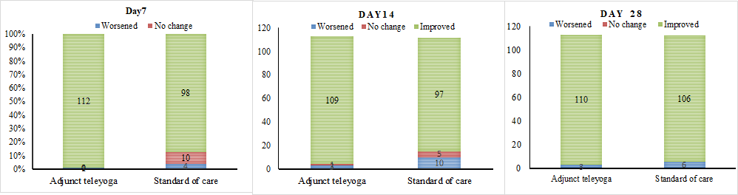
Change in outcomes at Day 7; P <0.001: Change Day 14; P value=0.245: Change Day 28; P value=0.338
The figure depicts the change in clinical status from baseline on days 7, 14, and 28 for the adjunct yoga treatment and the standard of care groups according to the 7-point ordinal scale. Patients who worsened had a loss of at least 1 point and patients who improved had an increase of at least one point. The ordinal scale categories are as follows: 1, death; 2, receiving invasive mechanical ventilation; 3, receiving high-flow oxygen; 4, receiving low-flow oxygen; 5 or 6, breathing ambient air; and 7, discharge
Table S7. Adverse events
 | Adjunct teleyoga  (n=113) | Standard of care  (n=112)
Events
Death, n (%) | 3 (2.65) | 5 (4.46)
Extension of hospitalization — no (%) | 12 (10.62) | 21 (18.75)
Sinus tachycardia (resolved), no. (%) | 1 (0.88) | 0 (0)
Pulmonary embolism — no. (%) | 1 (0.88) | 0 (0.89)
Pneumothorax — no. (%) | 1 (0.88) | 1 (0.89)
Elevated ALT or AST level — no. (%)§ | 3 (2.65) | 3 (2.67)
Acute renal injury, n (%) | 0 (0) | 1 (0)

Table S8. Concomitant Medications During Hospital Stay
Medication class | Adjunct teleyoga  (n-113) | Standard of Care (n=112)
Antivirals
Remdesivir, no. (%) | 44 (39.28) | 55 (48.67)
Other | 76 (67.26) | 64 (57.14)
Immunomodulators
Dexamethasone, no. (%) | 50 (44.25) | 41 (36.61)
Methylprednisolone, no. (%) | 20 (18.69) | 12 (12.00)
Colchicine, no. (%)
Vitamin D | 17 (15.04) | 15 (13.39)
Antibiotics
Azithromycin, | 0 (0) | 2 (1.78s)
Ceftriaxone, no. (%) | 63 (55.75) | 42 (37.50)
Doxycycline, no. (%) | 80 (71.43) | 69 (62.16)
Anticoagulants
Enoxaparin, no. (%) | 46 (40.71) | 42 (37.50)
Others
There was an equal distribution of concomitant medications between both the groups

MEDIATION MODEL

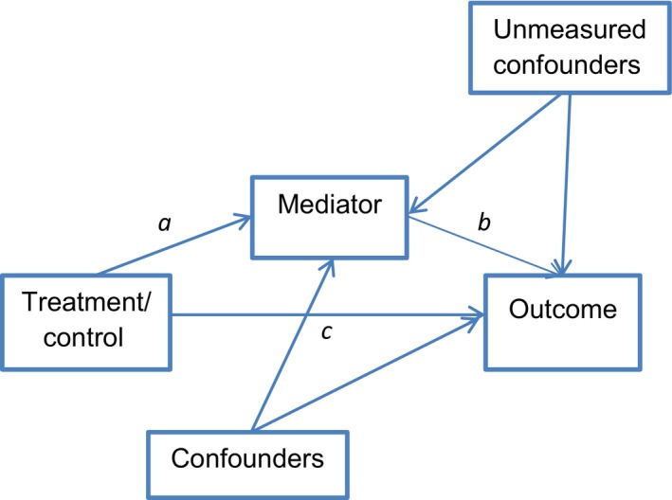

Additional references:
Valeri L, Vanderweele TJ. Mediation analysis allowing for exposure-mediator interactions and causal interpretation: theoretical assumptions and implementation with SAS and SPSS macros [published correction appears in Psychol Methods. 2013 Dec;18(4):474]. Psychol Methods. 2013;18(2):137-150. doi:10.1037/a0031034
Schmidt WP. Randomised and non-randomised studies to estimate the effect of community-level public health interventions: definitions and methodological considerations. Emerg Themes Epidemiol. 2017;14:9. Published 2017 Sep 7. doi:10.1186/s12982-017-0063-5
Wang G, Wu C, Zhang Q, et al. C-Reactive Protein Level May Predict the Risk of COVID-19 Aggravation. Open Forum Infect Dis. 2020;7(5):ofaa153. Published 2020 Apr 29. doi:10.1093/ofid/ofaa153

