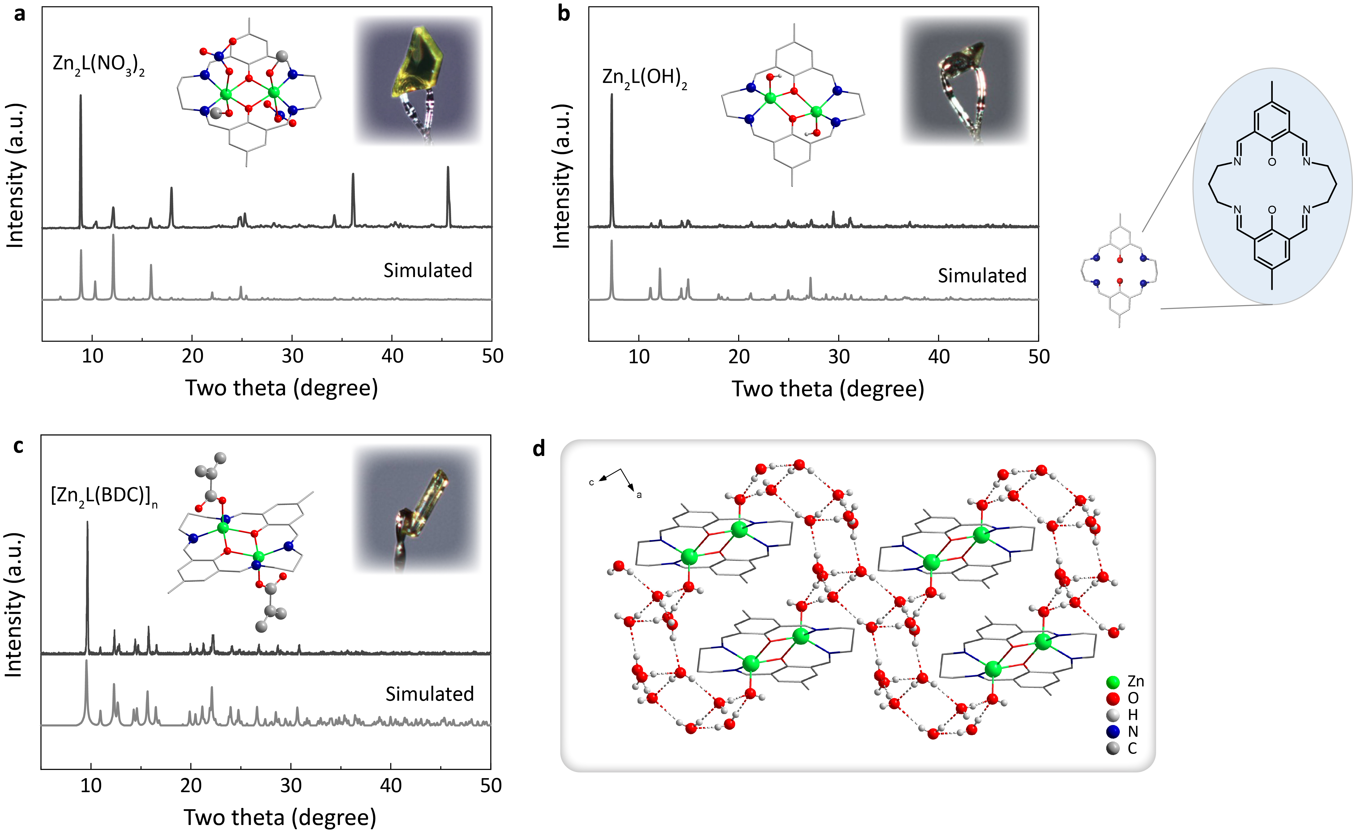
Extended Data Fig. 1 | Structures of binuclear zinc complexes. a‒c, Experimental (gray) and simulated (light gray) SCXRD patterns of Zn₂L(NO₃)₂ (a), Zn₂L(OH)₂ (b), and [Zn₂L(BDC)]_{n} (c). The insets show the optical images of the single crystals and the corresponding simplified crystal structures (green: Zn; blue: N; red: O; gray: C). d, Hydrogen bonding network in Zn₂L(OH)₂ as resolved by SCXRD. Free solvent molecules and hydrogen atoms are omitted for clarity, except for the hydrogen atoms in the coordinated groups and hydrogen bonds.

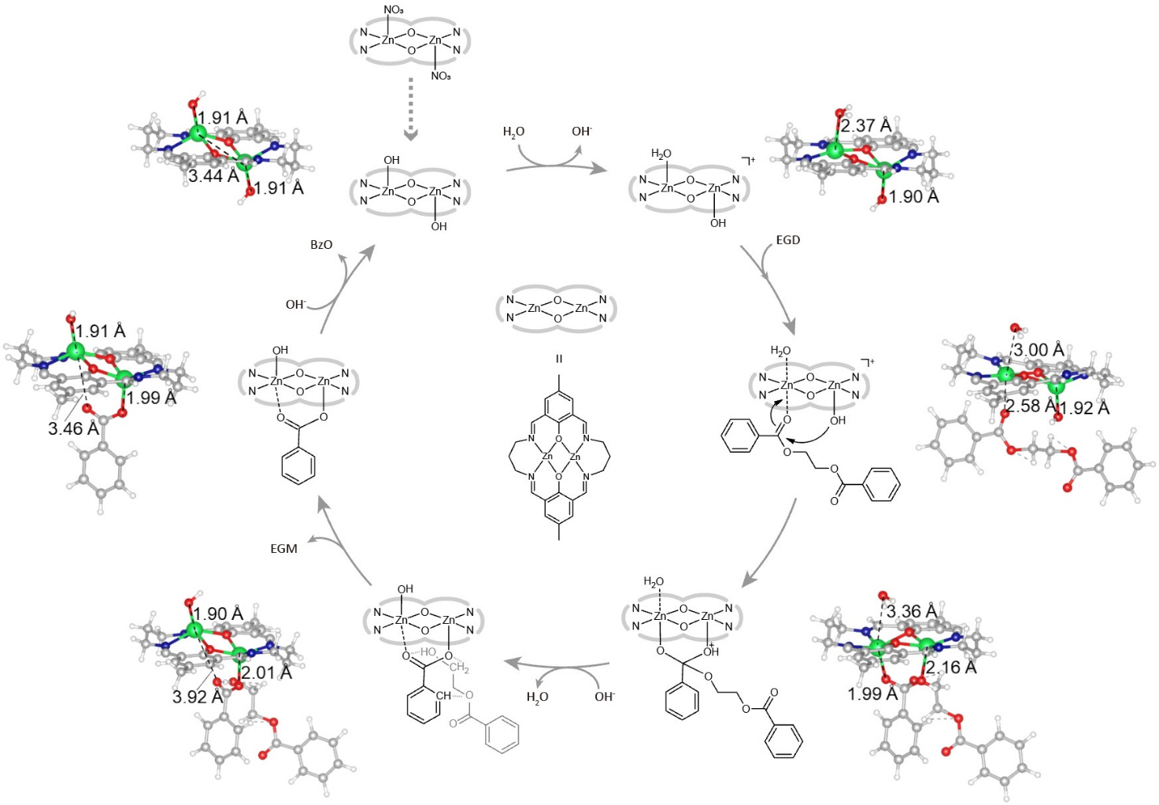
Extended Data Fig. 2 | The PET hydrolysis mechanism proposed based on experimental and DFT results. The mechanism highlights the importance of co-operative substrate-binding on the adjacent zinc sites and the subsequent formation of six-membered (Zn-O-C-O-Zn-μ₂-O) intermediate. Ball-and-stick models are given near the corresponding skeleton formulas (green: Zn; blue: N; red: O; gray: C; white: H). Ethylene glycol dibenzoate (EGD) is employed as the ester substrate for simplicity. EGM and BzO represent ethylene glycol monobenzoate and benzoate, respectively.

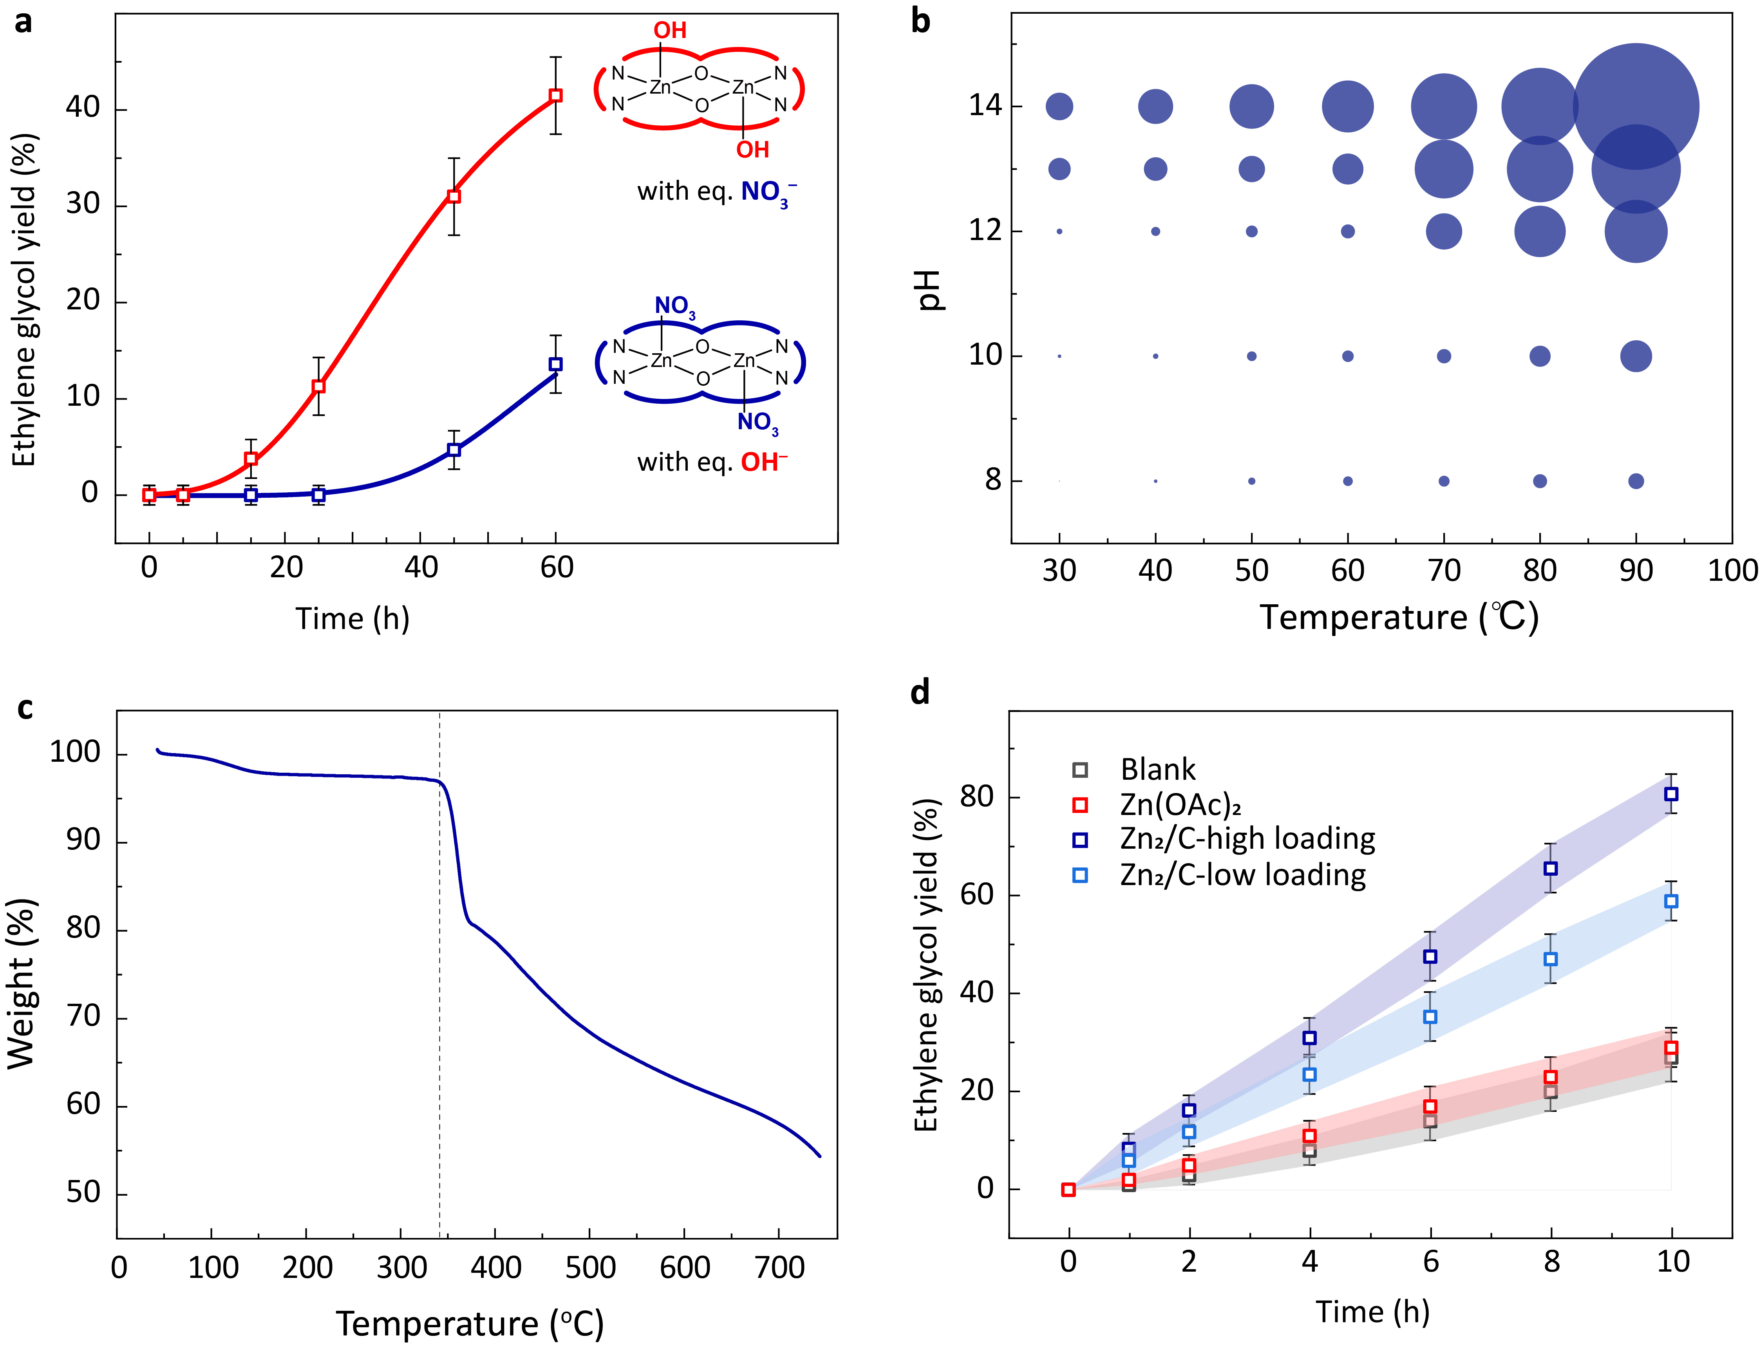
Extended Data Fig. 3 | Performance evaluation of binuclear zinc catalysts. a, The hydrolysis kinetics of crystalline PET granules (38%) over Zn₂L(OH)₂ with equivalent moles of free NO₃‒ and Zn₂L(NO₃)₂ with equivalent moles of free OH‒. Reaction conditions: 1.0 mM Zn₂L(NO₃)₂ or Zn₂L(OH)₂, 2.0 mM NaOH or NaNO₃, 10 mg crystalline PET granules, 60 °C. Note that the induction period was curtailed when the axial ligands were hydroxyl groups, in spite of the same feeding amount in the two cases. b, The performance of Zn₂/C under different pH values and temperatures, where the areas of the circles represent the magnitude of the specific activity. The specific activity of the Zn₂/C at pH 8 and 40 ºC is 36 mg_{PET} d⁻¹ g_{catal}⁻¹. The specific activities were calculated at 80% conversion of PET in 10 mL of NaOH aqueous solution containing 10 mg of PET and 4 mg of Zn₂L(NO₃)₂ supported on carbon. c, Thermogravimetric analysis (TGA) of Zn₂L(NO₃)₂, showing that the binuclear catalyst was stable below 340 ºC. d, The hydrolysis kinetics of crystalline PET granules (38%) over Zn₂/C, Zn(OAc)₂, and blank control at pH 13 and 90 ºC. Reaction conditions: 50 mL of NaOH aqueous solution (pH 13) containing 50 g of crystalline PET (38%) and 5 mg or 50 mg of Zn₂L(NO₃)₂ supported on carbon or 35 mg of Zn(OAc)₂ (Methods). All the error bars represent the standard deviations for three measurements.

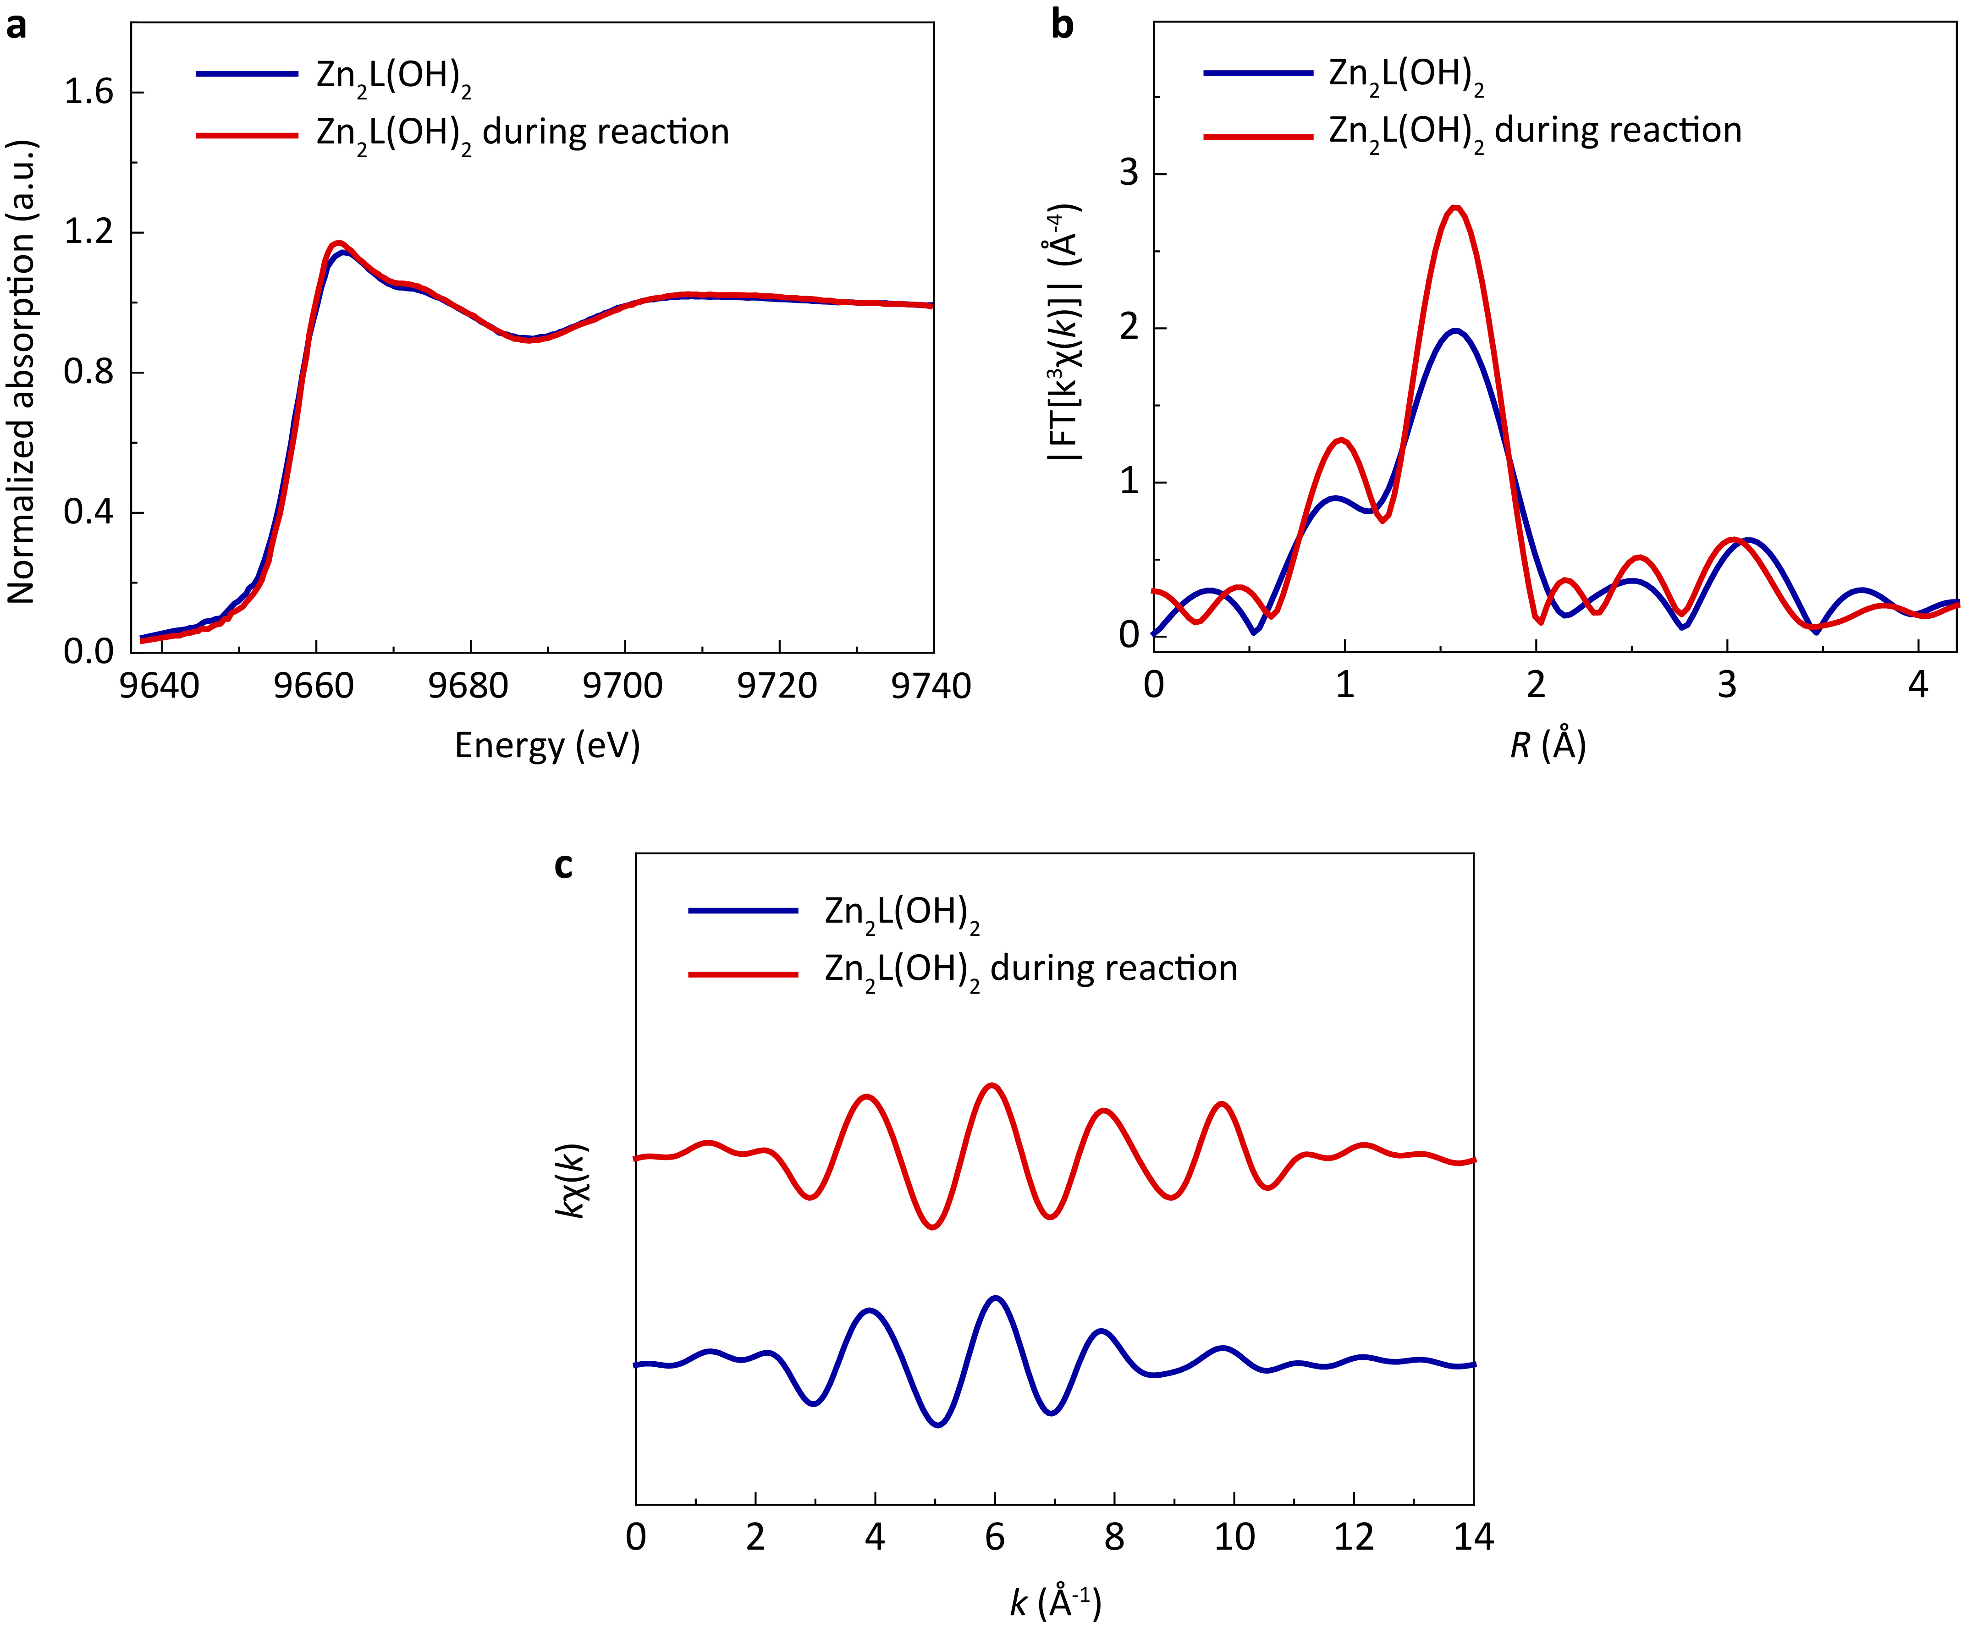
Extended Data Fig. 4 | X-ray adsorption spectroscopy of Zn₂L(OH)₂ during reaction. a‒c, XANES spectra (a), Fourier transforms of EXAFS spectra (b), and EXAFS in k-space spectra (c) of the binuclear Zn catalyst before and during the reaction. EXAFS spectra in R-space indicate an increased coordination number of zinc during the reaction.

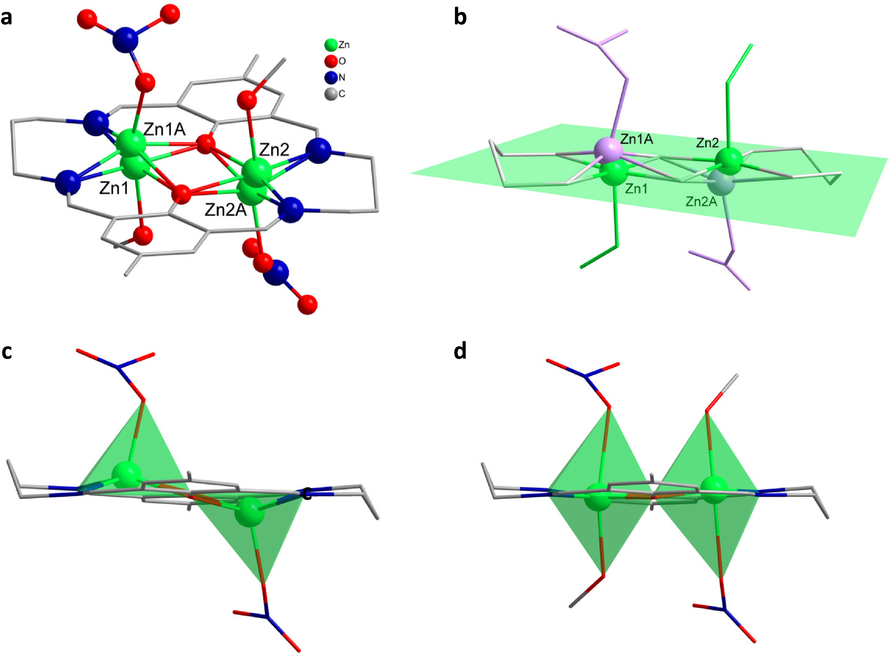
Extended Data Fig. 5 | The variation of coordination geometries in response to the change of coordination number of the metal sites. a, Ball-and-stick model of Zn₂L(NO₃)₂ as resolved by SCXRD, where hydrogen atoms are omitted for clarity. b, The relative position of disordered Zn atoms and N₄O₂ plane. Lavender: pentacoordinated; green: hexacoordinated. Atom–plane distances: Zn1, 0.123 Å; Zn1A, 0.391 Å; Zn2, 0.090 Å; Zn2A, 0.508 Å. c‒d, Pentacoordinated (c) and hexacoordinated (d) configuration of Zn atoms in Zn₂L(NO₃)₂. In the case of pentacoordinate, the axial positions of Zn atoms are occupied by nitrate ions and form distorted square pyramidal geometry. The two Zn atoms distinctly lie out of N₄O₂ plane, with atom–plane distances of 0.391 Å and 0.508 Å, and elongated Zn···Zn distance of 3.249(5) Å, respectively. In the case of hexacoordinate, the two Zn atoms take distorted octahedral configuration, with additional methanol molecules coordinated to the Zn atoms. The Zn–plane distances are negligible 0.123 Å and 0.090 Å, while Zn···Zn distance is shortened to 3.153(3) Å. This statistical distribution in the crystal structure of Zn₂L(NO₃)₂ indicates that the pentacoordinated Zn atoms could form a bond to another molecule and turn into hexacoordinate structure.

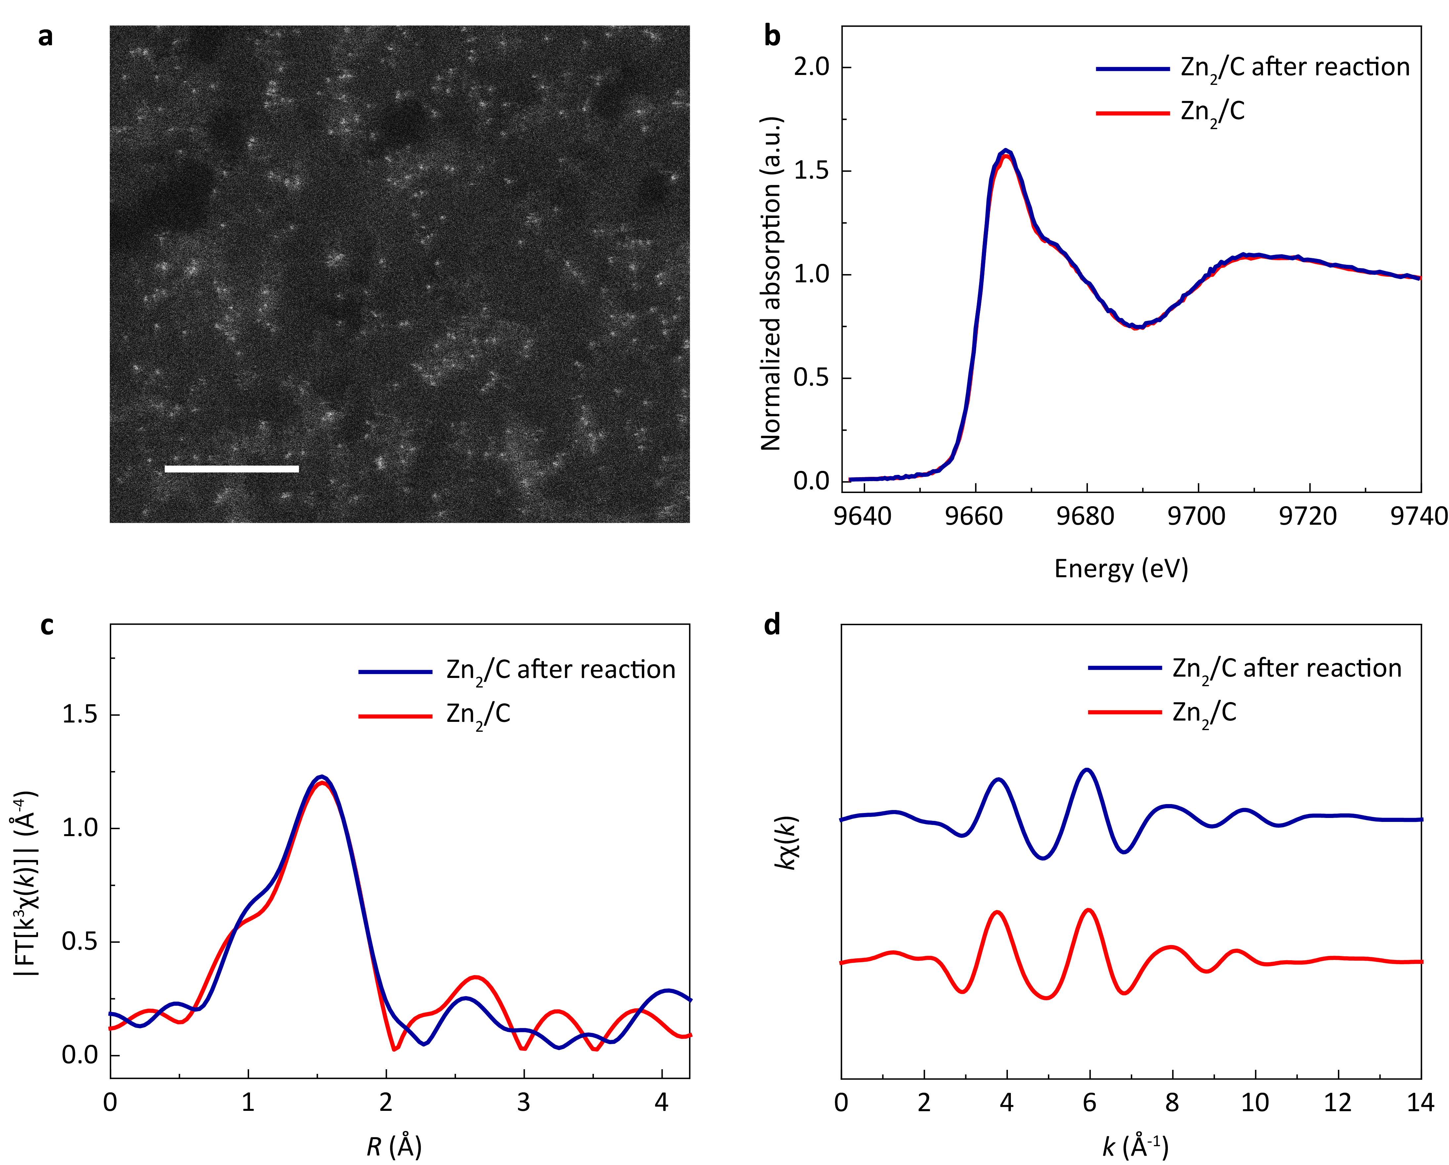
Extended Data Fig. 6 | Post-reaction characterization of Zn₂/C. a‒d, HADDF-STEM image (a), XANES spectra (b), Fourier transforms of EXAFS spectra (c), and EXAFS spectra in k space (d) of the Zn K-edge of spent Zn₂/C. The XAFS spectra of the fresh Zn₂/C were also presented in b‒d for references. These results indicate the structure of the spent Zn₂/C remained the same to its original form.

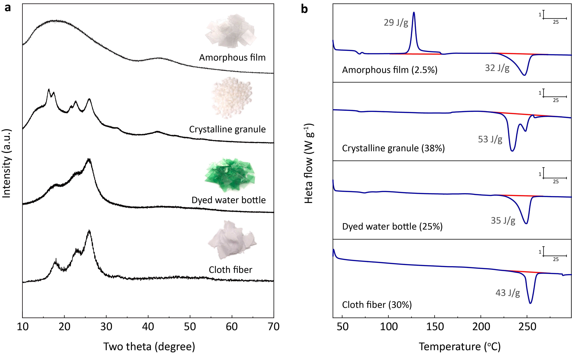
Extended Data Fig. 7 | Crystallinity of different PET materials. a‒b, XRD patterns (a) and differential scanning calorimetry (DSC) analysis (b) of amorphous film (Goodfellow Ltd, ES301445), crystalline granule (Macklin, P875573), dyed water bottle (Coca-cola, USA), and cloth fiber (online purchase). Insets in a show the images of different PET materials. The corresponding crystallinity was listed in parentheses in b.

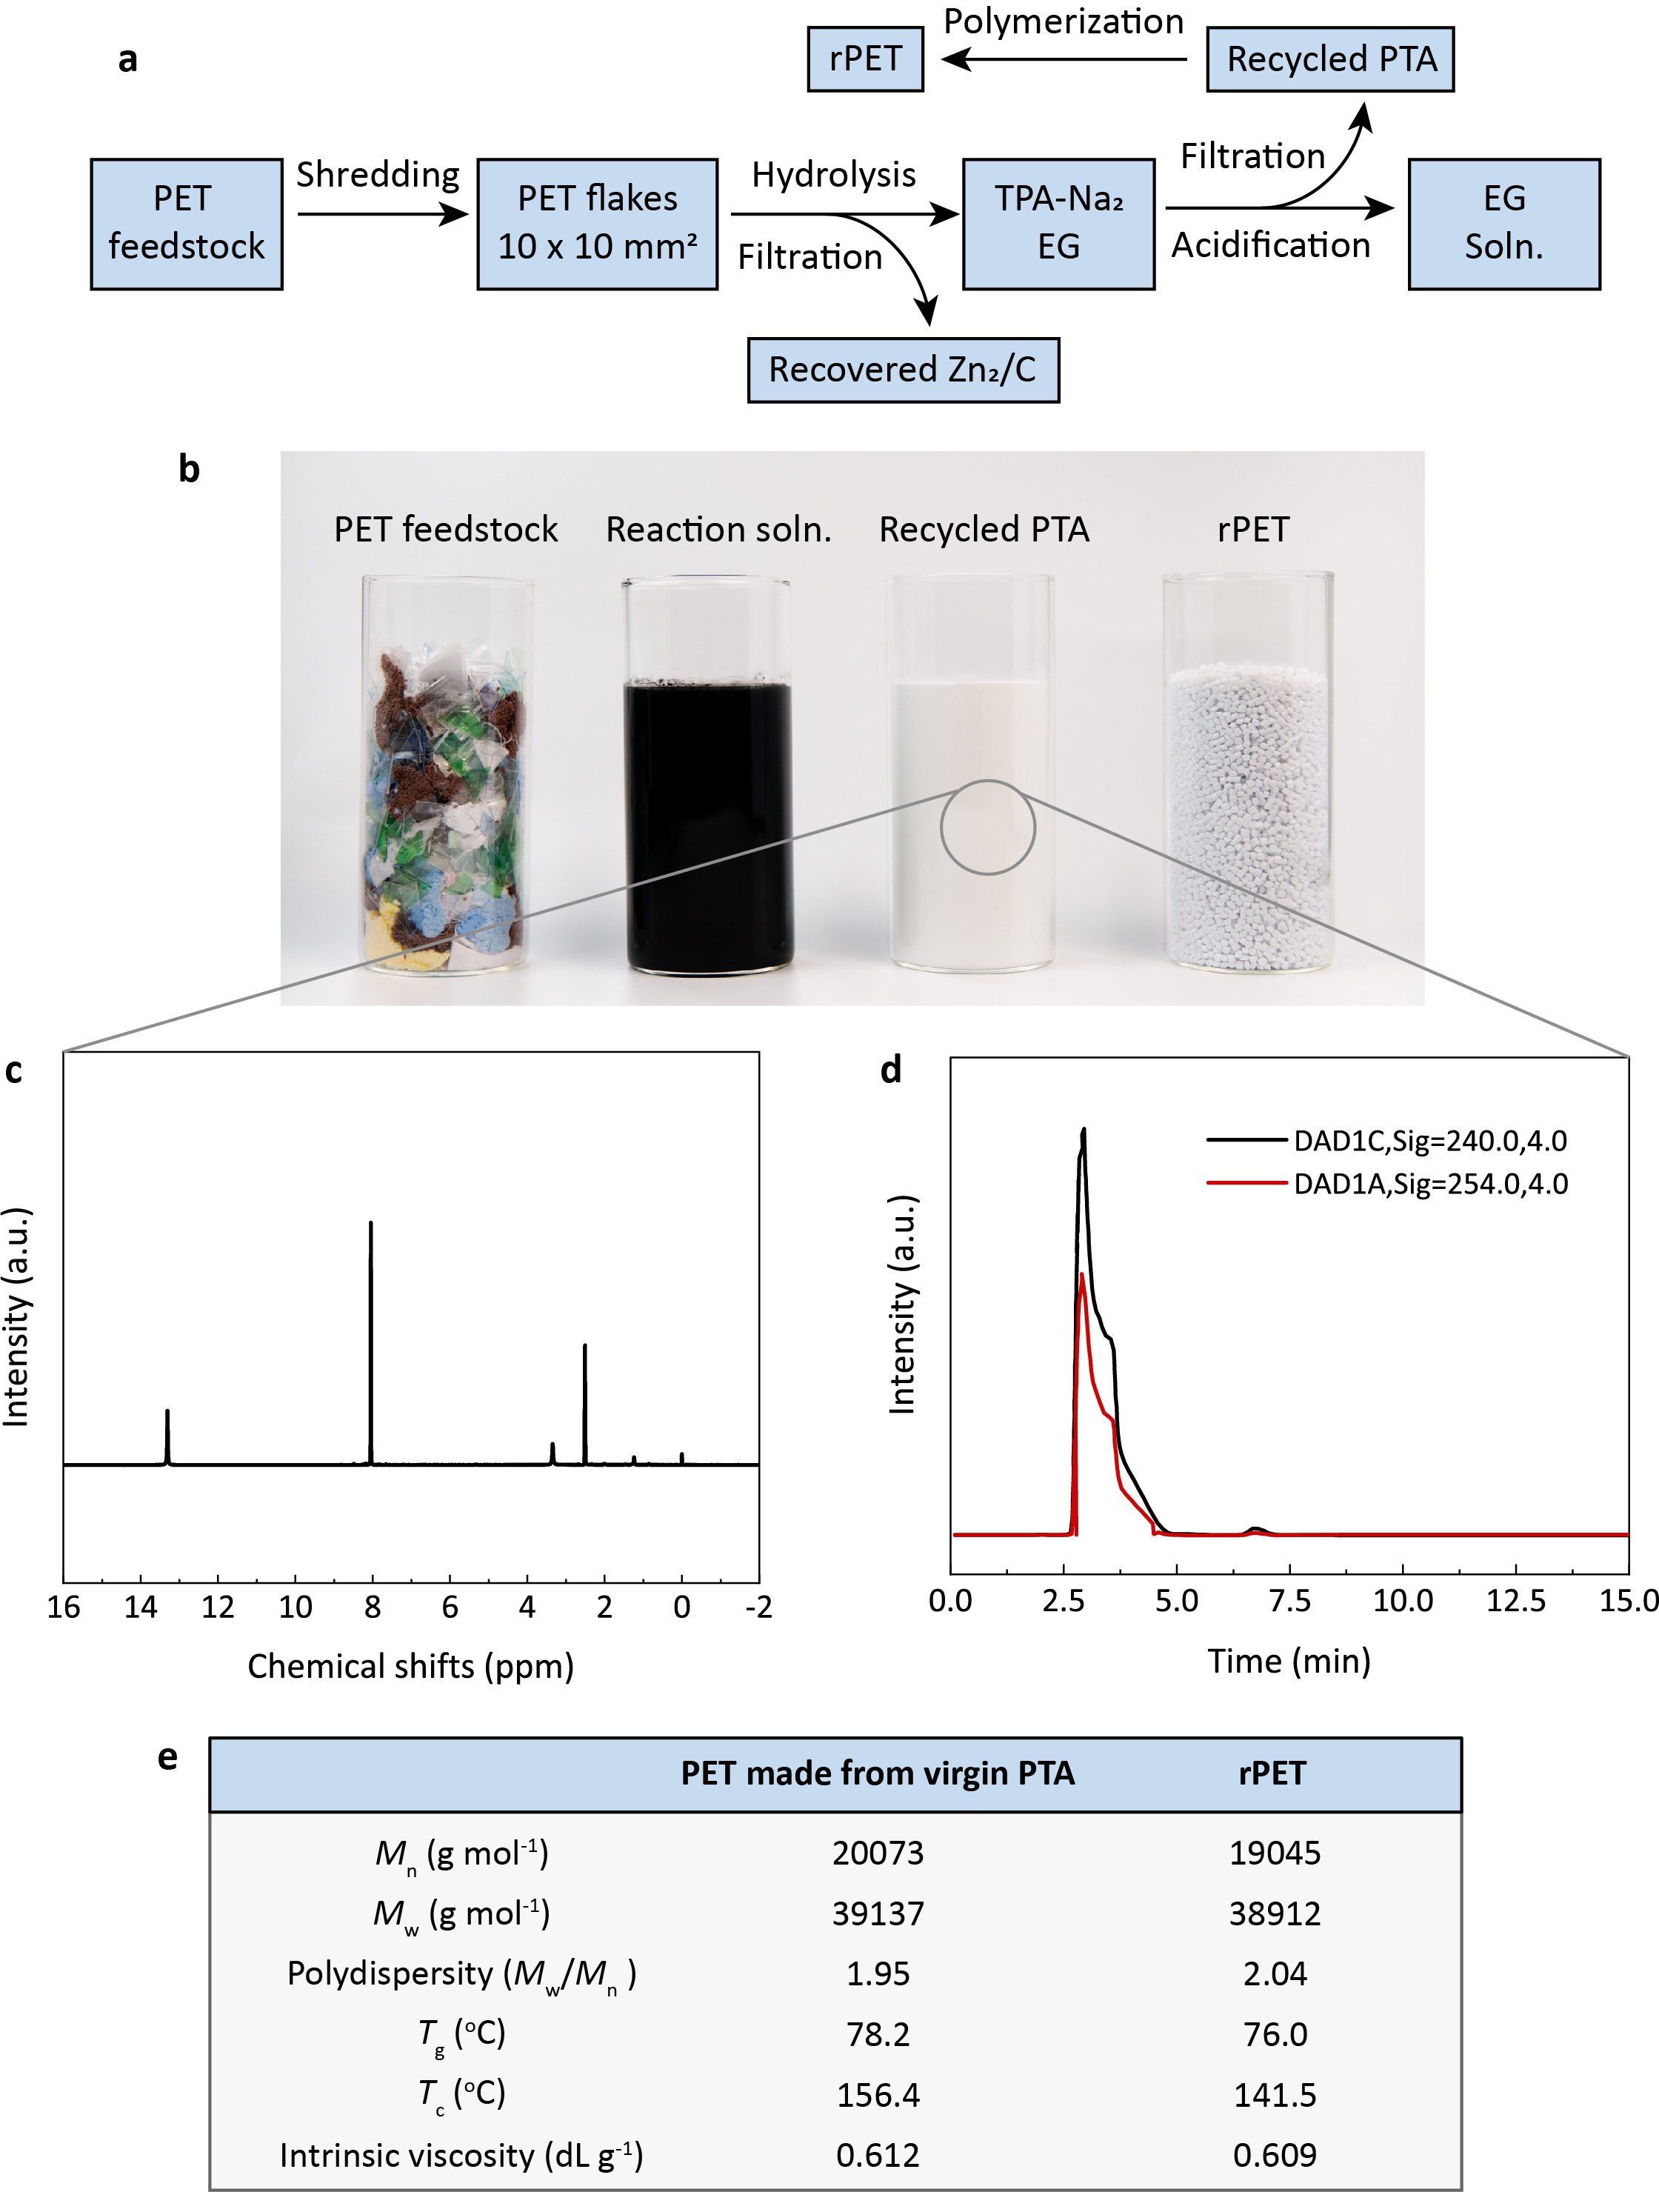
Extended Data Fig. 8 | PET recycling using Zn₂/C. a‒b, Flow diagram (a) and representative photos (b) of the PET recycling process, where TPA-Na₂ and EG represent disodium terephthalate and ethylene glycol, respectively. c‒d, The purity of the recycled pure terephthalic acid (PTA) was checked by ¹H NMR (c) and high-performance liquid chromatography (d). Both confirmed that the purity of terephthalic acid (TPA) was above 99% according to the national standard GB/T 30921.1. e, Comparison of rPET made from the recycled PTA with the PET made from virgin PTA.

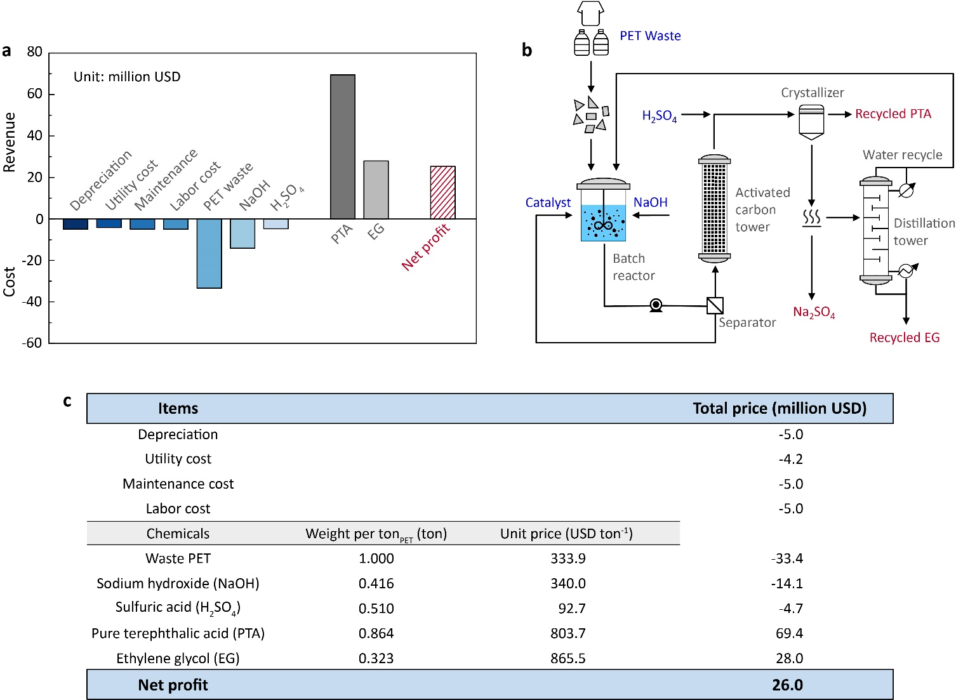
Extended Data Fig. 9 | Techno-economic analysis based on a capability of 100 thousand tons of PET waste per year. a, Histogram analysis of the cost and revenue for Zn₂/C-catalyzed PET recycling, showing an annual profit of 26.0 million USD on 0.1 megatons of PET waste. b, Simplified flow diagram of the PET recycling process. The raw material inputs are shown in blue, and the products are shown in red. c, Simplified economic summary. More detailed analysis is provided in the Supplementary Information.

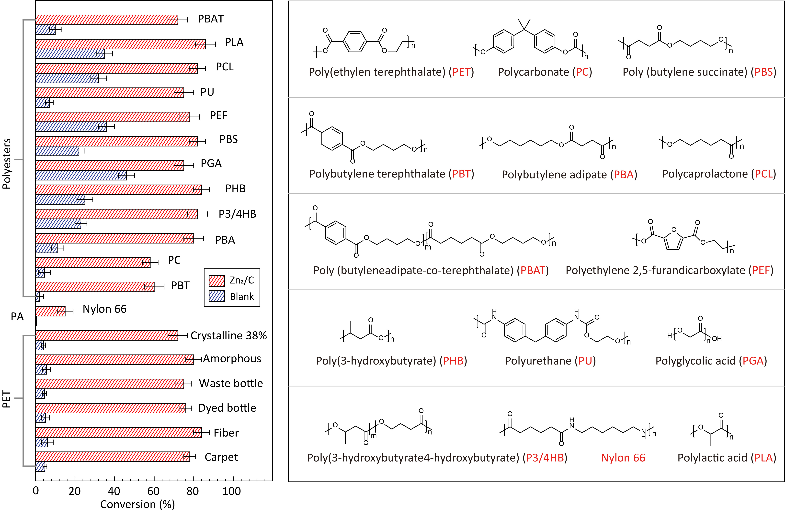
Extended Data Fig. 10 | The depolymerization of different PET sources and various polyesters and polyamide with and without Zn₂/C at pH 13 and 60 ºC. Reaction conditions: 10 mL of NaOH aqueous solution (pH 13), 0.32 g of polyesters or polyamide and 2 mg of Zn₂L(NO₃)₂ supported on carbon. Reaction time: Carpet (60 h), fiber (50 h), dyed bottle (50 h), waste bottle (50 h), amorphous (38 h), crystalline granule (50 h), Nylon 66 (6 day), PBT (12 day), PC (14 day), PBA (38 h), P3/4HB (18 h), PHB (27 h), PGA (10 h), PBS (12 h), PEF (7 h), PU (2 h), PCL (16 h), PLA (18 h), and PBAT (16 h).

