Supplemental Material
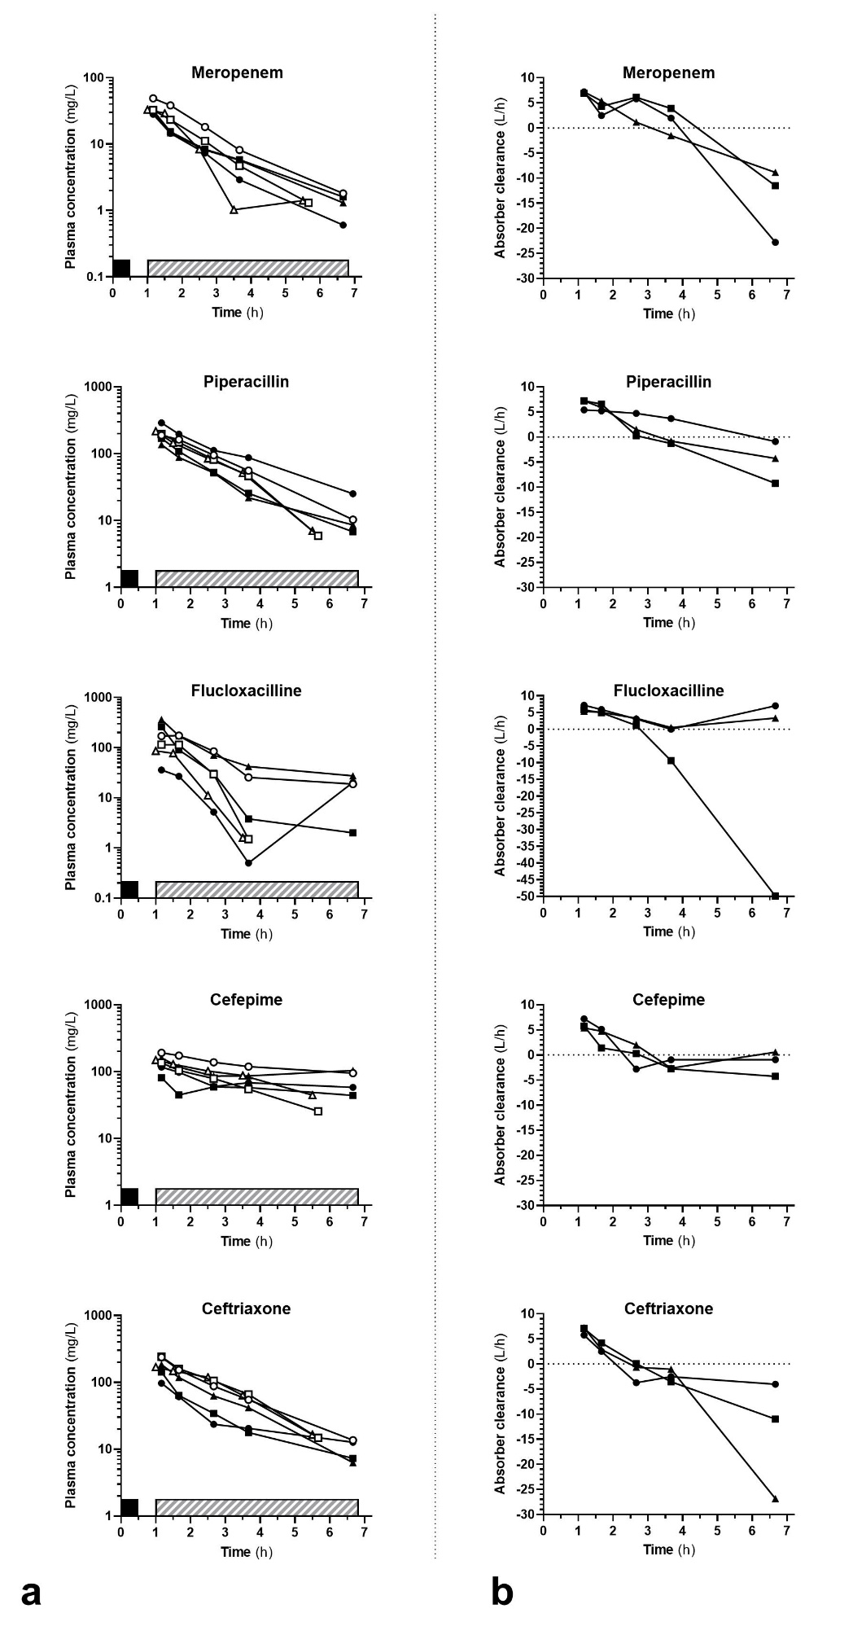
Figure S1: Plasma concentrations (panel A) and calculated clearances (panel B) for beta-lactams. Full symbols correspond to cases (CytoSorb Hemoadsorption) and open symbols to controls
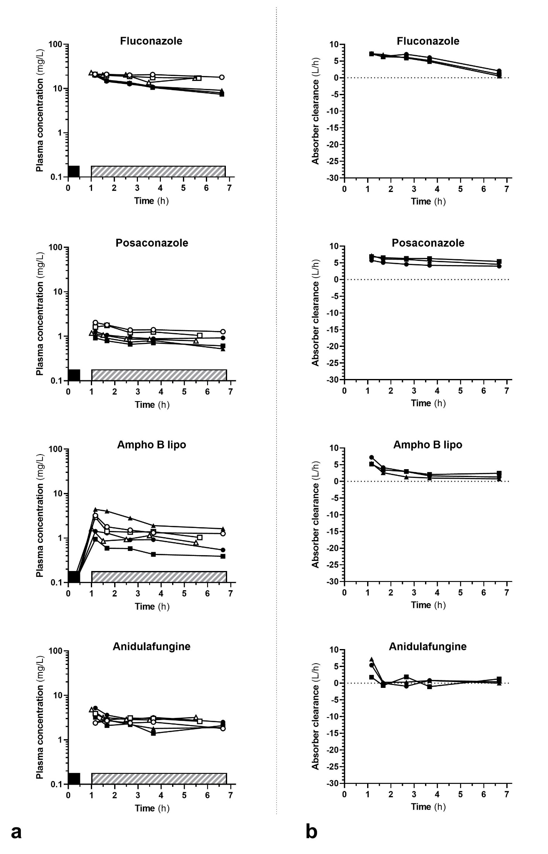
Figure S2: Plasma concentrations (panel A) and calculated clearances (panel B) for antifungals. Full symbols correspond to cases (CytoSorb Hemoadsorption) and open symbols to controls
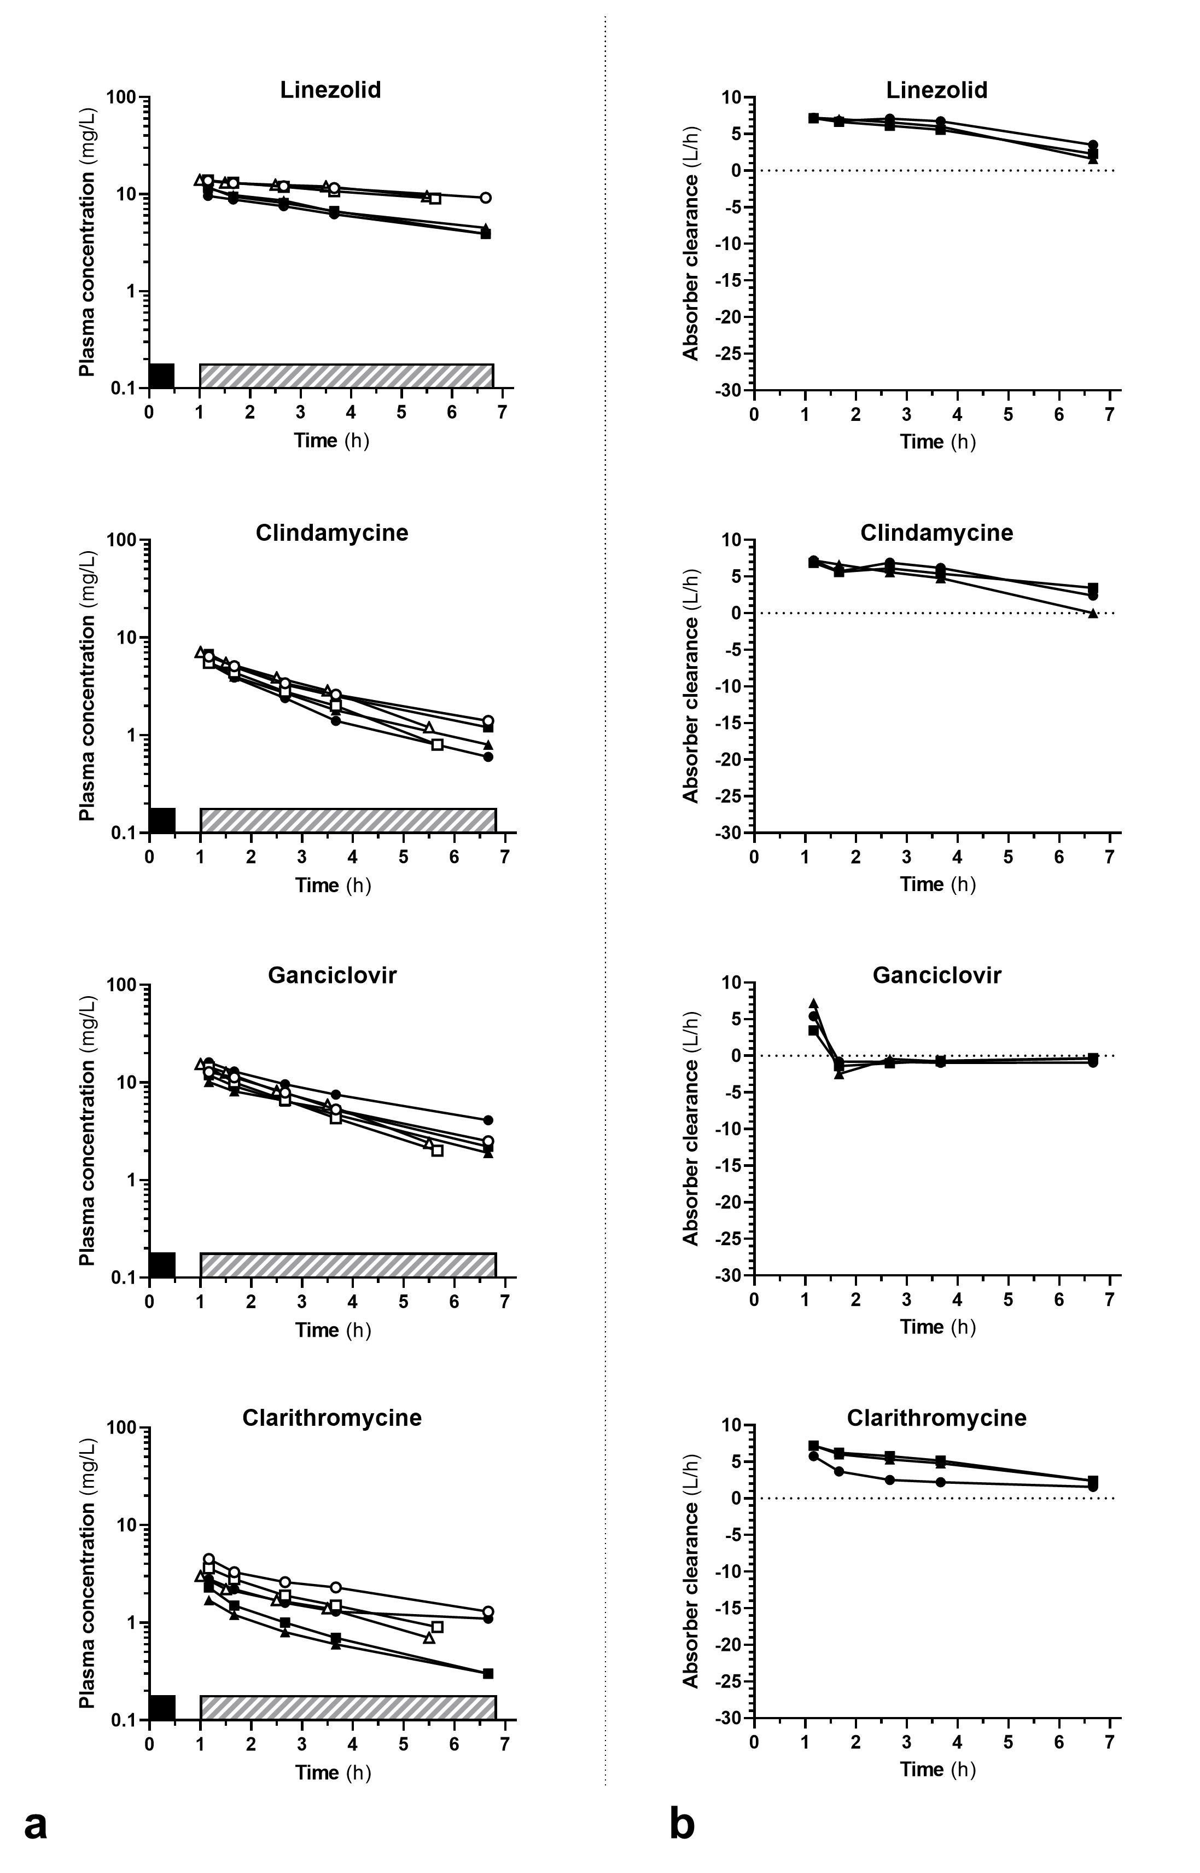
Figure S3: Plasma concentrations (panel A) and calculated clearances (panel B) for other drugs. Full symbols correspond to cases (CytoSorb Hemoadsorption) and open symbols to controls
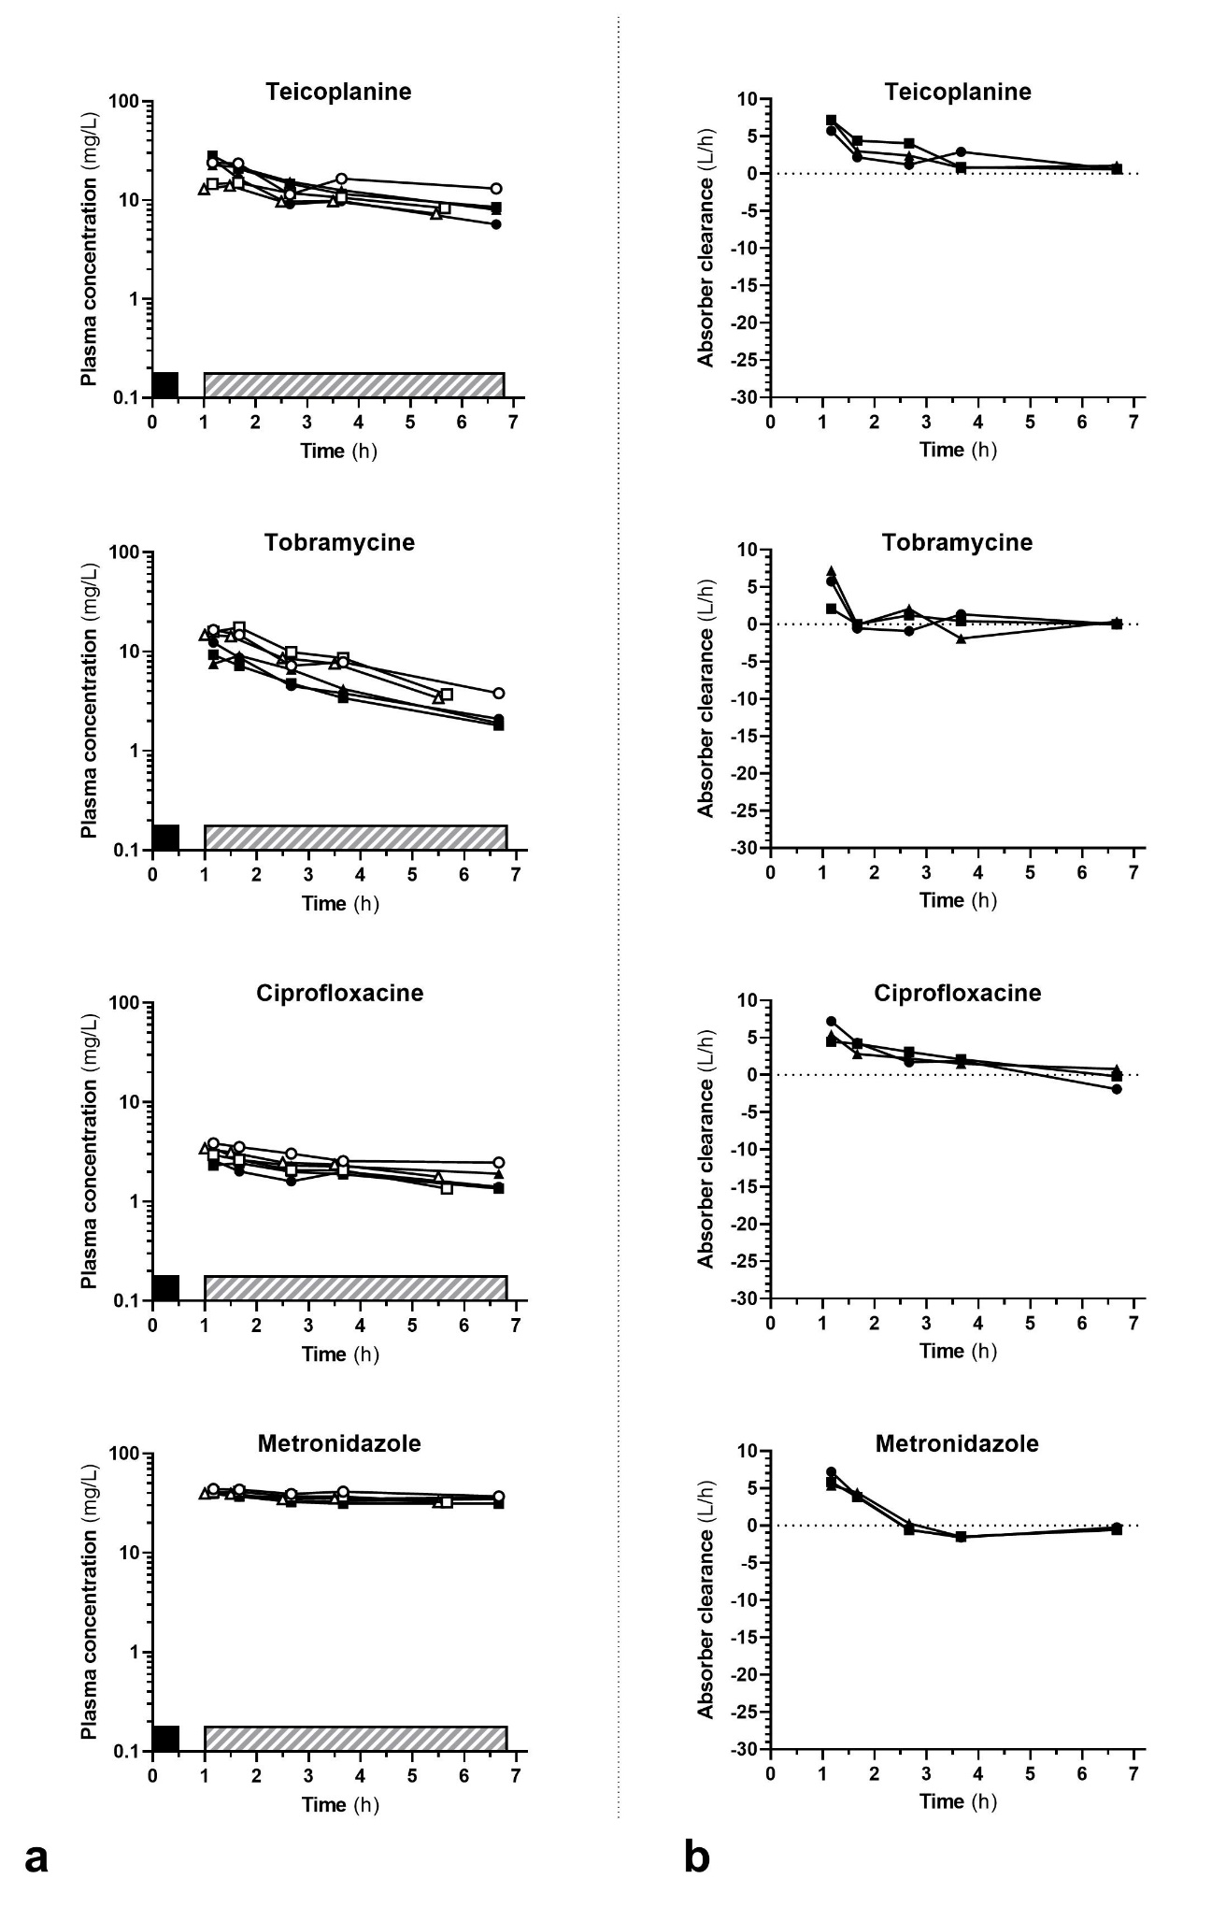
Figure S4: Plasma concentrations (panel A) and calculated clearances (panel B) for other drugs. Full symbols correspond to cases (CytoSorb Hemoadsorption) and open symbols to controls

