Appendix

Green Finance in Alipay
 | 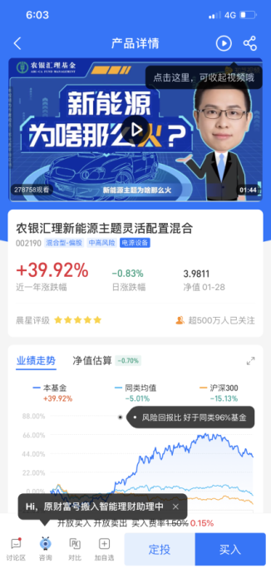 | 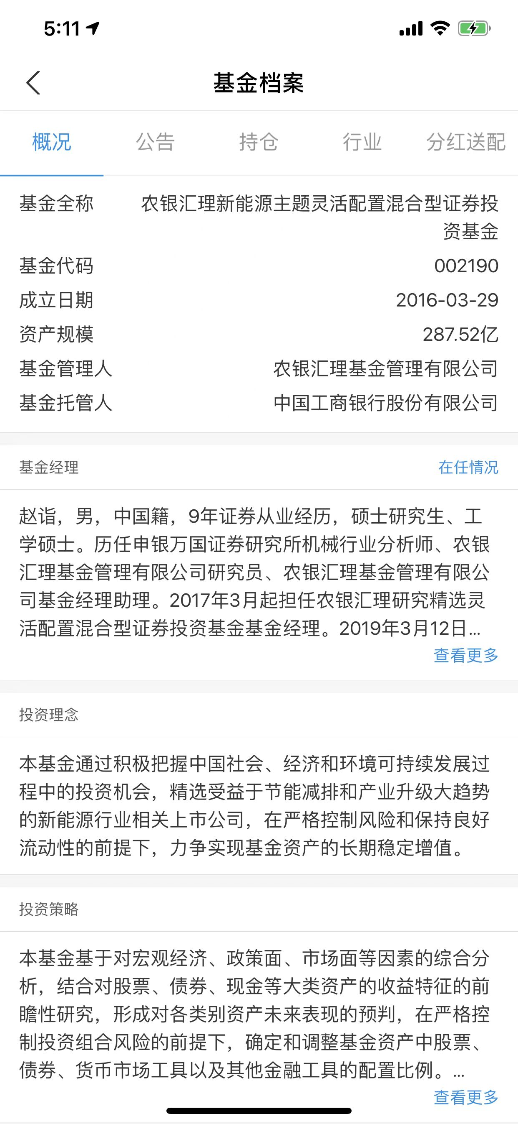
Green finance refers to the economic activities that support environmental improvement, coping with climate change, resource conservation, and efficient utilization. Some of the finance projects are environmental protection, energy conservation, clean energy, green transportation, and green buildings.
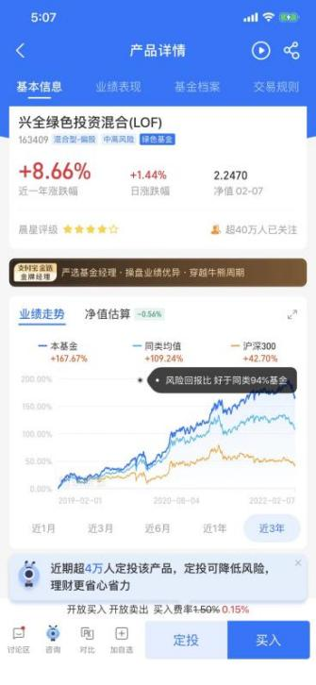 | 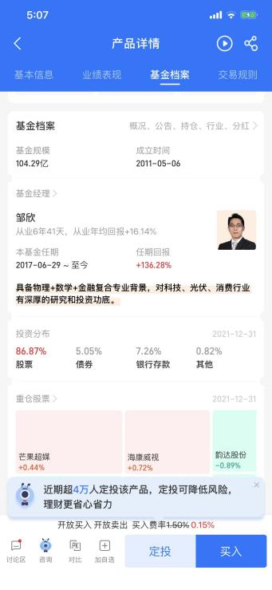 | 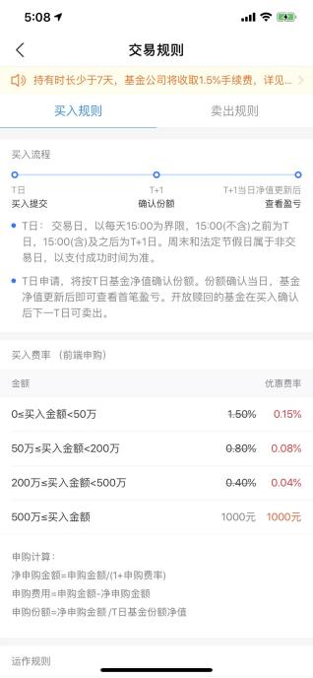
Here is a detailed example of a green finance fund open to individuals.

Sesame Credits
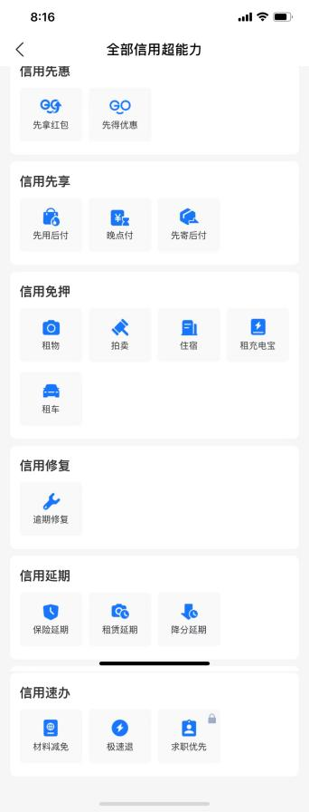 |  | 
Benefits | Behavioral records | Environmental-friendly behavior records

How to increase environmental-friendly behavior scores
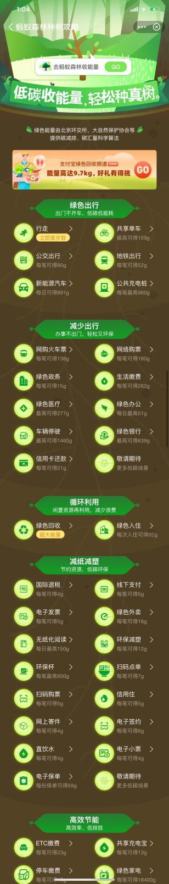
The four main categories are green travel, recycling, paper-reduction and plastic reduction, and energy efficiency.

