Supplementary file

Expression and gene regulation network of GRK6 in clear cell renal cell carcinoma based on comprehensive bioinformatics analysis
Zexun Deng¹, Xiaomei Li¹, Xinxin Peng¹, Weijie Zhao¹,Tiancheng Xia¹,Taoze Ji¹,Junjie Yang¹, Yinxia Wu²,Junjie Yu^{3，4}*, Liqun Zhou⁴*
¹ Dalian Medical University, 9 Western District, Lvshun South Road, Dalian, CN 116044, P. R. China
² Department of Oncology, Clinical Medical College，Yangzhou University, Subei People's Hospital of Jiangsu Province, Yangzhou, Jiangsu 225001，P. R. China
³ Department of Urology, Clinical Medical College，Yangzhou University, Subei People's Hospital of Jiangsu Province, Yangzhou, Jiangsu 225001，P. R. China
⁴ Department of Urology, Peking University First Hospital, Institute of Urology, Peking University, National Urological Cancer Center, Beijing 100034, P. R. China
*Equal contribution
*Corresponding author: Liqun Zhou(Tel:+86 13601239241 ,Email: zhoulqmail@china.com), Department of Urology, Peking University First Hospital, Institute of Urology, Peking University, National Urological Cancer Center, Beijing 100034, China；Junjie Yu(Tel:+86 15380315902, Fax +86 05 148 737 3012,Email: urologistyjj@163.com)，Peking University First Hospital, Institute of Urology, Peking University, National Urological Cancer Center, Beijing 100034, China

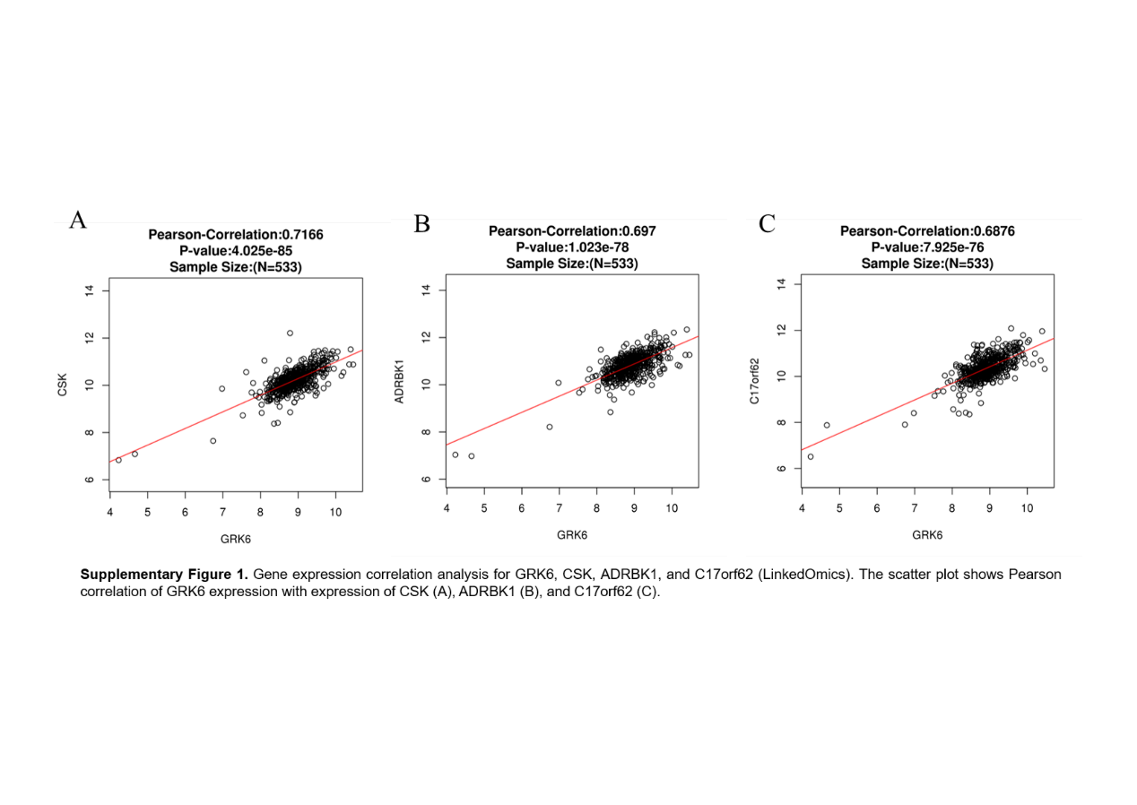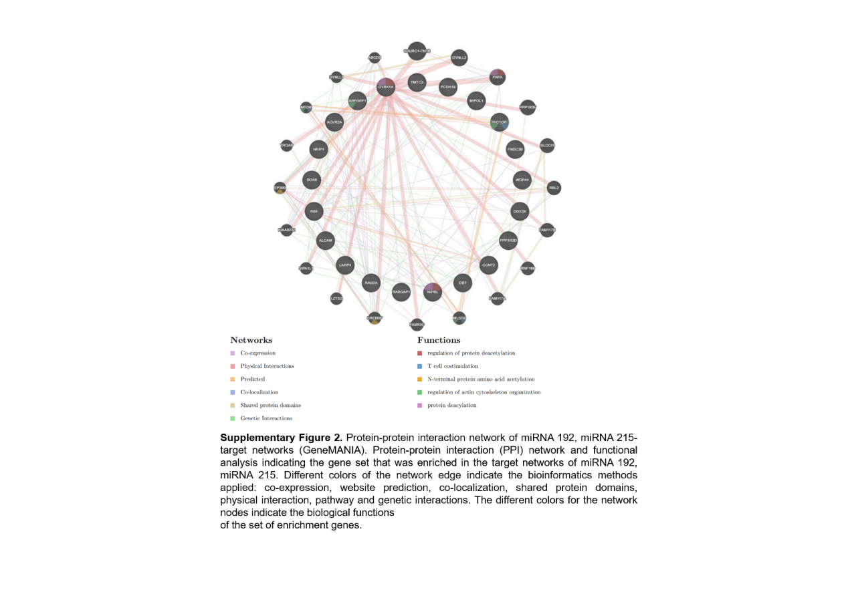

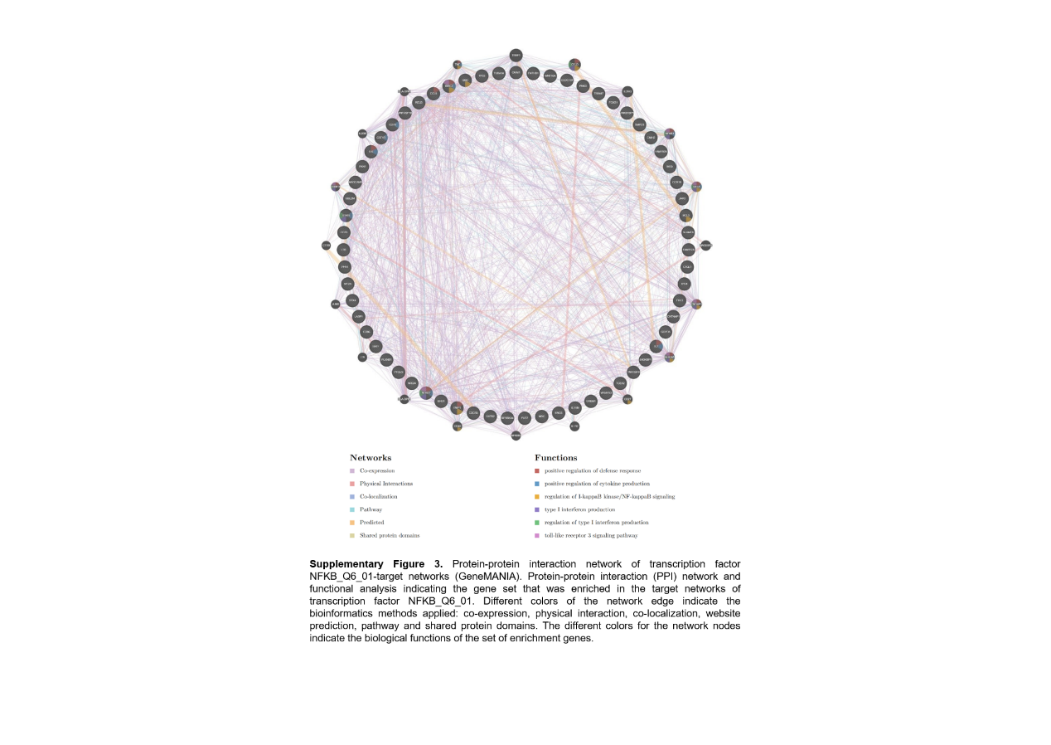

Supplementary Table 1. Significantly enriched GO annotations (cellular component) of GRK6 in clear cell renal cell carcinoma (LinkedOmics).

Description | Leading Edge Num | FDR | Normalized Enrichment  Score | Leading Edge Gene
Sm-like protein family complex | 27 | 0 | 1.5747 | CCDC97;CD2BP2;EFTUD2;GEMIN6;GEMIN7;LSM10;LSM2;LSM4;LSM7;PPIH;PRPF31;PRPF40B;PRPF6;SART1;SF3A2;SF3B2;SF3B5;SNRNP70;SNRPA;SNRPA1;SNRPB;SNRPC;SNRPD2;SNRPD3;SNRPF;SNRPG;TXNL4A
ribosome | 97 | 0 | 1.5290 | AURKAIP1;CHCHD1;EEF2;EIF4G1;FXR2;GADD45GIP1;MPV17L2;MRPL10;MRPL11;MRPL12;MRPL14;MRPL17;MRPL2;MRPL20;MRPL21;MRPL22;MRPL23;MRPL24;MRPL27;MRPL28;MRPL36;MRPL38;MRPL4;MRPL40;MRPL41;MRPL43;MRPL51;MRPL52;MRPL53;MRPL54;MRPL55;MRPL9;MRPS11;MRPS12;MRPS15;MRPS18A;MRPS2;MRPS21;MRPS24;MRPS26;MRPS34;MRPS7;MTG1;NAA10;NDUFA7;RPL10;RPL11;RPL12;RPL13;RPL13A;RPL14;RPL18;RPL18A;RPL19;RPL23;RPL23A;RPL24;RPL26L1;RPL27;RPL27A;RPL28;RPL29;RPL3;RPL30;RPL31;RPL32;RPL35;RPL36;RPL37;RPL37A;RPL38;RPL4;RPL6;RPL7A;RPL8;RPLP0;RPLP1;RPLP2;RPS10;RPS11;RPS14;RPS15;RPS16;RPS17;RPS18;RPS19;RPS2;RPS20;RPS21;RPS3;RPS5;RPS7;RPS8;RPS9;RPSA;RRBP1;UBA52
blood microparticle | 58 | 0.0021786 | 1.4958 | A1BG;ACSM1;ACTA1;ACTB;ACTG1;ACTG2;AHSG;ANGPTL4;APOA1;APOE;APOL1;C1QB;C1QC;C1R;C1S;C3;C8G;CD5L;CFB;CFH;CFHR1;CIB2;CLIC1;CLU;CP;CPN2;DNPEP;ENG;F2;FGA;FGB;FGG;GRIPAP1;HBA1;HBE1;HP;HPR;HPX;HSPA1A;HSPA6;ITGA2B;ITIH1;ITIH4;LGALS3BP;OAZ3;ORM1;PFN1;PON1;PSMC5;SERPINA3;SERPINC1;SERPINF2;SERPING1;SLC2A1;TF;TGFB1;TMPRSS13;VTN
phagocytic cup | 12 | 0.020942 | 1.4840 | ABCA7;AIF1;BIN2;CORO1A;DNM2;LCP1;MCOLN1;MYO1G;PIP5K1C;SH3BP1;TNF;TRIP10
cytosolic part | 94 | 0 | 1.4743 | AIM2;BAIAP2;BCAS4;BLOC1S1;BLOC1S3;CASP1;CASP4;CASP5;CASP9;CCT3;CCT7;CTU1;CYB5R3;DBN1;DTNBP1;EIF4G1;ENO2;ENO3;FADD;FXR2;GET4;GSDMD;HPS1;HPS6;IKBKG;NAA10;NCS1;NLRP1;PFKL;PI4K2A;PIN1;PLCB3;PRKCB;PRKCG;PSMC4;PSMC5;PSMD2;PYCARD;RPL10;RPL11;RPL12;RPL13;RPL13A;RPL14;RPL18;RPL18A;RPL19;RPL23;RPL23A;RPL24;RPL26L1;RPL27;RPL27A;RPL28;RPL29;RPL3;RPL30;RPL31;RPL32;RPL35;RPL36;RPL37;RPL37A;RPL38;RPL4;RPL6;RPL7A;RPL8;RPLP0;RPLP1;RPLP2;RPS10;RPS11;RPS14;RPS15;RPS16;RPS17;RPS18;RPS19;RPS2;RPS20;RPS21;RPS3;RPS5;RPS7;RPS8;RPS9;RPSA;SGTA;SNAP47;TICAM1;TSC2;UBA52;UBQLN4

Abbreviations: LeadingEdgeNum, the number of leading edge genes; FDR, false discovery rate from Benjamini and Hochberg from gene set enrichment analysis (GSEA).

Supplementary Table 2. Significantly enriched GO annotations (biological processes) of GRK6 in clear cell renal cell carcinoma (LinkedOmics).

Description | Leading Edge Num | FDR | Normalized Enrichment  Score | Leading Edge Gene
interferon-gamma production | 36 | 0 | 1.7378 | BCL3;CCR7;CD14;CD2;CD244;CD276;CD3E;CD96;EBI3;EOMES;FADD;FOXP3;HLA-DPB1;HRAS;IL12RB1;IL23A;IL27;IL27RA;ISG15;LGALS9;LILRB1;LTA;PYCARD;RARA;RIPK3;SASH3;SLAMF6;SLC11A1;SPN;TLR9;TNF;TNFRSF13C;XCL1;ZC3H12A;ZFPM1;ZP3
cytokine metabolic process | 32 | 0 | 1.6916 | BCL3;CARD11;CARD9;CD276;CD3E;CD4;CEBPB;EBI3;FOXP3;GHRL;HSPB1;IL27;INPP5D;IRF1;IRF3;IRF4;IRF7;LAG3;LILRB1;LTB;MAP2K3;MAPKAPK2;MAST2;RELA;SIGIRR;SPN;TICAM1;TLR9;TNF;TNFRSF13C;TNFRSF8;ZFPM1
adaptive immune response | 136 | 0 | 1.7147 | ADA;ADCY7;AGER;BATF;BCL3;BTLA;C1QA;C1QB;C1QC;C1R;C1S;C2;CCL19;CD244;CD247;CD27;CD3D;CD3E;CD4;CD40;CD40LG;CD48;CD6;CD7;CD74;CD79A;CD79B;CD8A;CD8B;CLEC10A;CRTAM;CSK;CTLA4;CXCL13;DBNL;DUSP10;EBI3;EOMES;ERCC1;FADD;FCER1G;FCER2;FCGR1B;FCRL4;FOXP3;GNL1;GZMM;HPX;HRAS;ICAM1;IFNG;IL12RB1;IL18BP;IL23A;IL27;IL27RA;IL4R;INPP5D;IRF1;IRF4;IRF7;ITK;JAK3;KDELR1;KLHL6;LAIR1;LAT;LAT2;LAX1;LILRB1;LILRB4;LIME1;LOXL3;LTA;LY9;MAD2L2;MCOLN1;MCOLN2;MICB;MYO1G;NFKB2;NFKBID;NFKBIZ;ORAI1;OTUB1;PIK3CD;PKN1;POU2F2;PRF1PRKCB;PRKD2;PRR7;PTK2B;PTPN6;PYCARD;RELB;RFTN1;RIPK3;SASH3;SEMA4A;SERPING1;SH2D1A;SIGLEC10;SIT1;SLA2;SLAMF1;SLAMF6;SLAMF7;SLC11A1;SPN;TAP1;TBX21;TFE3;TFEB;TGFB1;TNF;TNFRSF13B;TNFRSF13C;TNFRSF17;TNFRSF1B;TRAF2;TRAT1;TREX1;TRPM4;TSTA3;UNC13D;UNC93B1;WAS;XCL1;ZAP70;ZBTB7B;ZC3H12A;ZNF683;ZP3;HLA-DQB1;HLA-F
response to protozoan | 9 | 0 | 1.6789 | BATF;BATF2;BCL3;CCDC88B;HRAS;IL4R;IRF4;SLC11A1;TSPAN32
respiratory burst | 11 | 0 | 1.6900 | CD52;CYBA;DUSP10;HCK;NCF1;NCF4;PIK3CD;RAC2;RPS19;SLAMF8;SLC11A1
Abbreviations: LeadingEdgeNum, the number of leading edge genes; FDR, false discovery rate from Benjamini and Hochberg from gene set enrichment analysis (GSEA).

Supplementary Table 3. Significantly enriched GO annotations (molecular functions) of GRK6 in clear cell renal cell carcinoma (LinkedOmics).

Description | Leading Edge Num | FDR | Normalized Enrichment  Score | Leading Edge Gene
structural constituent of ribosome | 80 | 0 | 1.7107 | MRPL10;MRPL11;MRPL12;MRPL14;MRPL17;MRPL2;MRPL20;MRPL21;MRPL23;MRPL24;MRPL27;MRPL28;MRPL36;MRPL4;MRPL41;MRPL43;MRPL51;MRPL52;MRPL55;MRPL9;MRPS11;MRPS12;MRPS15;MRPS18A;MRPS2;MRPS21;MRPS24;MRPS34;MRPS7;NDUFA7;RPL10;RPL11;RPL12;RPL13;RPL13A;RPL14;RPL18;RPL18A;RPL19;RPL23;RPL23A;RPL24;RPL26L1;RPL27;RPL27A;RPL28;RPL29;RPL3;RPL30;RPL31;RPL32;RPL35;RPL36;RPL37;RPL37A;RPL38;RPL4;RPL6;RPL7A;RPL8;RPLP0;RPLP1;RPLP2;RPS10;RPS11;RPS14;RPS15;RPS16;RPS17;RPS19;RPS2;RPS20;RPS21;RPS3;RPS5;RPS7;RPS8;RPS9;RPSA;UBA52
snRNA binding | 16 | 0.0025126 | 1.6634 | CDK9;EIF5A;HEXIM2;ISG20;LSM10;LSM2;LSM4;LSM7;MEPCE;PRPF31;SNRNP70;SNRPA;SNRPA1;SNRPC;SNRPD3;TOE1
MHC protein binding | 15 | 0 | 1.6430 | BCAP31;CD244;CD4;CD74;CD8A;CD8B;FCRL6;LAG3;LILRB1;PILRA;PILRB;TAP1;TAPBP;TUBB;VCP
snoRNA binding | 9 | 0.015267 | 1.5075 | BYSL;IMP4;ISG20;NHP2;NOP10;NOP56;NUDT1;RRP9;TBL3
threonine-type peptidase activity | 10 | 0.013193 | 1.5012 | PSMA5;PSMA7;PSMB10;PSMB2;PSMB3;PSMB4;PSMB6;PSMB7;PSMB8;PSMB9
Abbreviations: LeadingEdgeNum, the number of leading edge genes; FDR, false discovery rate from Benjamini and Hochberg from gene set enrichment analysis (GSEA).

Supplementary Table 4. Significantly enriched KEGG pathway annotations of GRK6 in clear cell renal cell carcinoma (LinkedOmics).
Description | Leading Edge Num | P Value | Normalized Enrichment  Score | Leading Edge Gene
Proteasome | 20 | 0 | 1.7539 | ADRM1;IFNG;PSMA5;PSMB10;PSMB2;PSMB3;PSMB4;PSMB6;PSMB7;PSMB8;PSMB9;PSMC3;PSMC4;PSMC5;PSMD13;PSMD3;PSMD4;PSMD8;PSME1;PSME2
Ribosome | 73 | 0 | 1.7347 | FAU;MRPL10;MRPL11;MRPL12;MRPL14;MRPL17;MRPL2;MRPL20;MRPL21;MRPL23;MRPL24;MRPL27;MRPL28;MRPL36;MRPL4;MRPL9;MRPS11;MRPS12;MRPS15;MRPS18A;MRPS2;MRPS21;MRPS7;RPL10;RPL11;RPL12;RPL13;RPL13A;RPL14;RPL18;RPL18A;RPL19;RPL23;RPL23A;RPL24;RPL26L1;RPL27;RPL27A;RPL28;RPL29;RPL3;RPL30;RPL31;RPL32;RPL35;RPL36;RPL37;RPL37A;RPL38;RPL4;RPL6;RPL7A;RPL8;RPLP0;RPLP1;RPLP2;RPS10;RPS11;RPS14;RPS15;RPS16;RPS17;RPS19;RPS2;RPS20;RPS21;RPS3;RPS5;RPS7;RPS8;RPS9;RPSA;UBA52
Base excision repair | 16 | 0 | 1.7332 | APEX2;FEN1;LIG1;MPG;MUTYH;NTHL1;OGG1;PARP3;POLD1;POLD2;POLD4;POLE;POLE4;POLL;SMUG1;XRCC1
Primary immunodeficiency | 19 | 0 | 1.7302 | ADA;CD19;CD3D;CD3E;CD4;CD79A;CD8A;CD8B;CIITA;ICOS;IKBKG;IL2RG;JAK3;LCK;ORAI1;RFXANK;TAP1;TNFRSF13B;ZAP70
Cytosolic DNA-sensing pathway | 23 | 0 | 1.7300 | AIM2;CCL4;CCL4L2;CCL5;IKBKE;IKBKG;IRF3;IRF7;NFKBIB;POLR1C;POLR2E;POLR2F;POLR2H;POLR2L;POLR3D;POLR3E;POLR3H;POLR3K;PYCARD;RELA;RIPK3;TREX1;ZBP1
Abbreviations: LeadingEdgeNum, the number of leading edge genes; FDR, false discovery rate from Benjamini and Hochberg from gene set enrichment analysis (GSEA).

Supplementary Table 5. Significantly enriched kinase-target networks of GRK6 in renal clear cell carcinoma (LinkedOmics).
Geneset | LeadingEdgeGene
Kinase_IKBKB | BBC3;DOK1;IKBKG;IRF3;IRF5;NFKBIB;NFKBIE;RELA;RELB;TNFRSF1A
Kinase_PAK1 | ARHGDIA;ARHGEF2；ARPC1B；BAD；CTBP1；CTTN；DYNLL1；FLNA；GIT1;GNAZ;ILK;KIF2C;LIMK1;MAP2K2;MAP2K3;MORC2;MYL9;NF2；PA2G4;PLK1;RUNX3;TBCB
Kinase_LCK | ADAM15;CD247;CD33;CD5;DGKA;FOXP3;IL2RB;TGB2;ITK;LCK;LCP2;PRDX1;PTPN6；SH2D2A；SIGLEC10；SLAMF1；STAT2;STAT5A;TYROBP；VAV1;WAS;ZAP70
Kinase_CHUK | BBC3;IRF7;NCOR2;NFKB2;NFKBIB;NFKBIE;RELA;RELB;TRAF4
Kinase_SGK1 | CDKN1B;CREB1;FOXO3;MAP2K4;MAPK1;NDRG2;NEDD4L;PIKFYVE;RICTOR;SLC2A4;WNK1
Abbreviations: LeadingEdgeNum, the number of leading edge genes; FDR, false discovery rate from Benjamini and Hochberg from gene set enrichment analysis (GSEA).

Supplementary Table 6. Significantly enriched miRNA-target networks of GRK6 in renal clear cell carcinoma (LinkedOmics).
Geneset |  | LeadingEdgeGene
ACATATC,MIR-190 |  | ACTR3;ANO4;ARF4;ASAP1;CDKN1B;CLOCK;DMD;EPC2;FOXP2;GPHN;HECA;HERC4;MYO5A;NLGN1;OTUD4;PAPOLG;PAX6;PCDH9;PHF20L1;PHLPP1;RBAK;RLIM;RPS6KA3;SAMD4A;SMC6;STK24;SYNJ1;TBC1D14;TCF4;TNRC6B;TRPS1;TSHZ1;WDFY3;WDR44;YTHDF3;ZIC3
TAGGTCA,MIR-192,MIR-215 |  | ACVR2A;ALCAM;ARFGEF1;CCNT2;DBT;DDX3X;DDX6;DYRK1A;FNDC3B;LARP4;MIPOL1;NIPBL;NRIP1;PCDH19;PPP1R3D;RAB2A;RABGAP1;RB1;RICTOR;TMTC3;WDR44
CTGTTAC,MIR-194 |  | AP1G1;ARHGAP21;ARHGAP5;ARID2;BTBD7;C18orf25;CDK19;CEP350;CHD6;CHD9;CTDSPL2;DMD;EHBP1;EPC2;ERGIC2;EXOC5;FMR1;GABRB3;GLIS3;GMFB;HOOK3;KLF12;MBNL2;MIB1;MRPL35;NFAT5;OSBPL11;PTPN12;QKI;RAB11FIP2;RSBN1;RSBN1L;SNX1;SOCS2;TRIM23;TRIP12;TSPAN7;TTC7B;UBR3;VAPA;ZNF25
AAAGGGA,MIR-204,MIR-211 |  | AKAP1;ANGPT1;AP3M1;ARCN1;ARHGAP29;ARL8B;ATF2;ATP2B1;BCL2;BCL9;BRPF3;C16orf72;CAPRIN1;CCNT2;CCPG1;CDC42;CLIP1;CPD;DNAJC13;DYRK1A;EEF1E1;ELF2;ESRRG;FAM117B;FAM120C;FNIP1;FRAS1;FREM1;FRY;GABRB3;GAPVD1;GLIS3;GRM1HOOK3;HS2ST1;IGF2R;ITPR1;KCTD1;KHDRBS1;KHDRBS3;KITLG;KLF12;KLHL13;LATS1;MAML3;MAP1LC3B;MBNL1;MED13L;METAP1;MLLT3;MMGT1;MON2;MRPL35;MYO10NAA15;NBEA;NCOA7;NR3C1;PPARGC1A;PPP3R1;RAB10;RAB14;RAB1A;RAP2C;RHOT1;RICTOR;RPS6KA3;RPS6KA5;RPS6KC1;SERINC3;SF3B1;SIN3A;SIRT1;SLC37A3;SOCS6;SPOP;SPRED1;ST7;STXBP5;TCF12;TGFBR2;TMEM30A;TMOD3;TNRC6B;TRIP12;UHRF2;XRN1;YTHDF3;ZCCHC14;ZDHHC17;ZFP91
TATTATA,MIR-374 |  | ABCA8;ADAM10;AFF1;AFF4;AMD1;ARHGAP28;ARHGAP5;ARHGAP6;ARID2;ARL15;ATMIN;BACE1;C16orf72;CAND1;CAPRIN1;CAPZA2;CPEB4;CRIM1;DACH1;DCAF6;DENND4A;DMD;DR1;EIF3A;EIF4G2;EP300;ESRRG;FAM135A;FGFR2;FMR1;FNDC3B;FNIP1;FOXO1;GADD45A;GOPC;HDHD2;HECTD1;HIVEP2;HLF;HOMER1;ICK;KIAA2026;LCA5;LEMD3;LIN9;MAP2;MAP2K4;MAP4K3;MAPK6;MBLAC2;MBNL2;MED13;MEX3C;MGAT4A;MTMR12;NCOA1;NIPBL;NR2F2;NR3C1;NUMB;OCRL;OSBP;PAQR3;PARD6B;PDE4D;PDE7B;PDPK1;PIKFYVE;PMPCB;PNRC1;PPARGC1A;PURA;QKI;RAB10;RALA;RC3H1;RGS7BP;RNF38;RSF1;SETD2;SMARCAD1;SOCS4;SP1;SP3;SP4;SPRY2;SRPK2;STYX;TCF12;TMEM161B;TMEM47;UBE2E3;UBE2H;VEZF1;WDR11;WDR20;YTHDF3;ZCCHC14;ZDHHC9;ZNF131;ZNF711
Abbreviations: LeadingEdgeNum, the number of leading edge genes; FDR, false discovery rate from Benjamini and Hochberg from gene set enrichment analysis (GSEA).

Supplementary Table 7. Significantly enriched transcription factor-target networks of GRK6 in renal clear cell carcinoma (LinkedOmics).
Geneset | LeadingEdgeGene
V$SP1_Q6_01 | ADAM15;ADCK1;ASCL2;ASPHD1;BCL7C;BCL9L;C11orf68;C1orf122;C2CD2L;CALM3;CCDC85B;CD3EAP;CDC37;CLPTM1;CSNK1D;DGKA;DNAJC4;DRAP1;EFNA3;ELAC2;ELL;EML3;EPS8L2;EVI5L;FAM160A2;FKBP8;FLII;GAS7;GGN;GOLGA3;GRB2;INPPL1;KAT2A;LASP1;LZTS2;MAP2K7;MAP3K11;MAP3K6;MAP4K2;MAPK7;MAZ;MYO1C;PAK4;PARD6A;PCYT2;PEX14;PHF23;PITPNM1;PLEKHM1;POLR2I;POLR3E;PPM1J;PRMT1;PTCH2;PTOV1;PUSL1;RAB35;RABEP2;RELA;RELB;RHOG;ROM1;SCYL1;SDHAF2;SEC24C;SERINC2;SIPA1;SLC30A3;SMARCD1;TAGLN;TAGLN2;TBCB;TGFB1;TMEM150A;TMUB2;TRIM28;UBE2O;ULK1;VASP;WDR81;ZNF48;ZNF524;ZNF768
V$ETS_Q4 | ACAP1;AGAP2;AGPAT1;AP1G2;ARAP1;ARHGAP15;ARHGAP30;ARHGAP4;ARPC1B;ARRB2;BIN3;C1orf122;CCDC85B;CD247;CD2BP2;CD79A;CORO1A;DGKA;DGKZ;DPP3;EIF3K;ERCC1;FCHO1;FOXRED1;FURIN;FXYD5;GDPD5;GFI1;GMFG;HCLS1;HCST;HM13;HMGA1;ITGB7;ITPRIPL1;KCNAB2;LCP1;LCP2;LIF;LIMD2;LIME1;LPCAT4;LPXN;LRFN4;LSR;LTBR;MADD;MAP4K1;MAP4K2;MAP7D1;MED26;NCR3;NFKBID;NME2;PDAP1;PDLIM2;PKN1;PLCB2;PML;POLD4;PPP1R9B;RAB43;RGS14;RIN1;RIN3;RPS3;SEC24C;SEC61A1;1-Sep;SIGIRR;SND1;SPIB;SPNS3;TBC1D10C;TEAD3;TMEM185A;TREML2;TRIM41;UBE2L3;UXT;VAV1;YIPF2;ZNF296
V$TEL2_Q6 | AGAP2;ALDH16A1;ANKS3;ARAP1;ARFIP2;ARHGAP1;ARHGAP15;ARHGAP4;ARRB2;BIN3;C16orf71;C1QTNF6;C2CD2L;CCDC85B;CD247;CD2BP2;CD3E;CD40LG;CD79A;CNTROB;CTSW;DGKA;DPCD;DPP3;FCHO1;FIBP;FURIN;FXYD5;GFI1;HCLS1;HIRIP3;HM13;HMGA1;IL23A;INO80B;INO80E;LCP1;LIME1;LPCAT4;LSR;LTBR;LYPLA2;MAP3K11;MAP4K2;MCRS1;MED26;MRPL52;OGG1;PIH1D1;POLL;PPP4C;PRKACA;PSMD13;PTPN6;RAB43;RGS14;RIN1;RIN3;RNPS1;SCAMP2;SEC24C;SF3B4;SIPA1;SIRT3;SMAP2;SNRPB;SPIB;STAT4;SYVN1;TEAD3;TFE3;TGIF2;TIMM10;TMEM185A;TRAPPC1;TRIM41;U2AF2;VAMP8;VPS25;ZNF408;ZNF646;ZNF668;ZNF768
GGGNNTTTCC_V$NFKB_Q6_01 | BATF;BCL3;BIRC3;C1QL1;CCDC107;CCL5;CCR10;CD70;CD74;CD86;CNIH2;CNTNAP1;CSF1R;CXCR5;EHD1;ENO3;ENTHD1;FAM117A;FAM192A;FHL3;FOXS1;FUT7;GDPD5;GREM1;IER5;IL1RN;IL2;IL6;IPO4;JAK3;LASP1;LTB;MADCAM1;MSC;MT2A;NFKB2;NRGN;ORAI1;PFN1;PKN1;PLXNB1;PNKD;PTGES;RELB;RPS6KA4;S1PR2;SH3KBP1;SLAMF8;SMPD3;STAT6;STX4;TCEA2;TNFRSF1B;TNFRSF9;TNIP1;TNKS1BP1;TP53;TRIM47;TUBA1A;UBD;UBE2M;WNT10A;WRAP53
V$NERF_Q2 | AGPAT1;ARAP1;ARHGAP30;ARHGDIB;ARRB2;C1QTNF6;C1orf122;CCDC85B;CCR10;CD40LG;CD79A;CD79B;CDCA3;CDK5;CLIC1;CLVS1;CNPY2;COLQ;CORO1A;CPXM1;CREB3;DEF6;DOK1;DPP3;EIF3K;EML3;FAM110A;FAM160A2;FBLIM1;FBRS;FCER1G;FCGR2B;FCGR2C;FGR;FOSL1;FOXRED1;FURIN;FXYD5;GBF1;GPR132;GPR162;GPR2;GSDMA;HCLS1;HIC1;HMGA1;ITPR3;JUNB;KCND1;LAT;LIMD2;LOXL3;LST1;LYL1;LYPLA2;MAP4K1;MAPK3;MDFI;NCLN;NCS1;PEX16;PLCB2;POLD4;PPP1R9B;PTPN6;RANBP1;ROM1;RPS3;RPS6KA4;SEMA4C;SH2D2A;SH3TC1;SHC3;SHROOM1;SKAP1;SLC4A2;SNCG;SPEG;SPIB;STAT5A;TGIF2;TLN1;TNFRSF6B;TRAPPC3;TRMT2A;TRO;UBE2L3;UBOX5;UBTF;USP5;XKR8;ZBTB7B;ZFPM1;ZNF276;ZNF768
Abbreviations: LeadingEdgeNum, the number of leading edge genes; FDR, false discovery rate from Benjamini and Hochberg from gene set enrichment analysis (GSEA). V$, the annotation found in Molecular Signatures Database (MSigDB) for transcription factors (TF).

