Supplementary information

This supplementary includes:
- A brief description of the movies (S1, S1b, S2a-c, S3, S4).
- A description of the model variations and their results (S2a-c, S3, S4).
- Supplementary figures to illustrate the study.
- The table of the parameters used to run the reference model (S1)

Movies
In all movies, Black arrows are velocity vectors indicating the flowing direction. Coloured layers indicate the compositional fields to which are superposed different fields. Green field indicates active eclogite transformation, back field indicates the plastic strain accumulation, Red field indicates the strain rate and purple field indicates the viscous strain rate. White line isotherms are for 400°C, 800°C, 1300°C, and 1500°C.

Movie S1 (Reference model). Animation of the evolution of the model of reference.
Movie S1b. Animation showing the evolution of the horizontal stress for the model of reference.
Movie S2a. Animation of the evolution of the model variant with a friction at the interface of 0.015.
Movie S2b. Animation of the evolution of the model variant with a friction at the interface of 0.035.
Movie S2c. Animation of the evolution of the model variant with a friction at the interface of 0.06.
Movie S3. Animation of the evolution of the model without eclogitization of the lower crust.
Movie S4. Animation of the evolution of the model with an increase of thermal conductivity for the crust when T>1000K.

Description of the model variations

Models with variable interplate frictions (S2a-c)
The reference model S1 that has a friction coefficient at the subduction interface of 0.05, we ran 3 variations (supplementary Fig. 2, 3, movie S2a-c) where we varied the friction: 0.015 (S2a), 0.035 (S2b), 0.06 (S2c). The friction used in model S2a is thought to be similar to the Southern Andes, although the slab geometry and structure of the upper plate may vary latitudinally. Shortening in model S2a is ~100 km, with most of the deformation being accommodated by orogenic shortening. No underthrusting occurs, suggesting that deformation did not reach the foreland. With a friction of 0.035 (S2b) the orogenic shortening increases (~170km), but once the deformation has migrated to the foreland, the shield underthrusts (~29 My and ~90km). Finally, with a higher friction (0.06) at the interface in S2c, underthrusting of the shield occurs sooner (~25 My and ~105 km). Initially, most of the shortening is accommodated by the orogen before it quickly migrates to the foreland. These models suggest that lower friction at the interface results in higher oceanic plate velocities (supplementary Fig. 4).

No Eclogitization Model (S3)
We ran one model (supplementary Fig. 2, 5, movie S3) without eclogitalization of the lower crust to illustrate its importance. As with the reference model, the slab steepens after the flat subduction stage, however, only a small block of the continental mantle is delaminated. Deformation does not efficiently localize as the plastic strain becomes distributed within the orogen. At ~27.5 My, after the first buckling of the slab, the slab steepens, the orogen shortens, and deformation migrates to the foreland. Shortly after, the shield starts underthrusting as a result of the weakening of the foreland sediments Underthrusting soon becomes inefficient, but after the second slab buckling (~34 My), it reinitiates. After ~38 My, the trench has retreated ~490 km, the orogenic domain has shortened ~100 km, and the total underthrusting is ~60 km.

High heat flow model (S4)
The Central Andes hosts the largest magmatic body in the world (Perkins et al., 2016), and as such the surface heat flux is particularly high (>110 mW/m/K; Hamza et al., 2005; Schilling et al., 2006). This is partly due to partial melting of the crust (up to 20%) as suggested by the high Vp/Vs and high seismic attenuation detected in the area (Haberland et al., 2003; Schurr et al., 2003; Hamza et al., 2005). An increase of partial melting would result in lower viscosities (McKenzie & Bickle, 1988; Dingwell et al., 1996), and stimulate intra-crustal convection (Arndt et al., 1997; Babeyko et al., 2002). To evaluate the importance of lower viscosities related to partial melt, we ran a model (supplementary Fig. 2, 5, 6) where we increased the thermal conductivity of the upper crust by 1000x and decreased its minimum viscosity to 2.5e18 Pas (vs. ~1e22 Pas in the reference model) when the temperature is greater than 1000 K.
The model illustrates that with lower upper crustal viscosities orogenic shortening increases (~270 km vs. ~200 km in the reference model), with the orogenic domain accommodating the majority of the shortening. Strain in the orogen strongly localizes onto a few faults and, thus, does not migrate to the foreland (supplementary Fig. 5, movie S4). Because of the lack of strain in the foreland, the sediments do not accumulate enough plastic strain to weaken and underthrusting does not occur. Shortening after the first slab buckling cycle is more efficient than in the reference model, reaching ~25 mm/yr. Compared to the reference model, the greater orogenic deformation results in a thicker orogen and higher surface heat fluxes (>120 mW/m; supplementary Fig. 6).

Figures

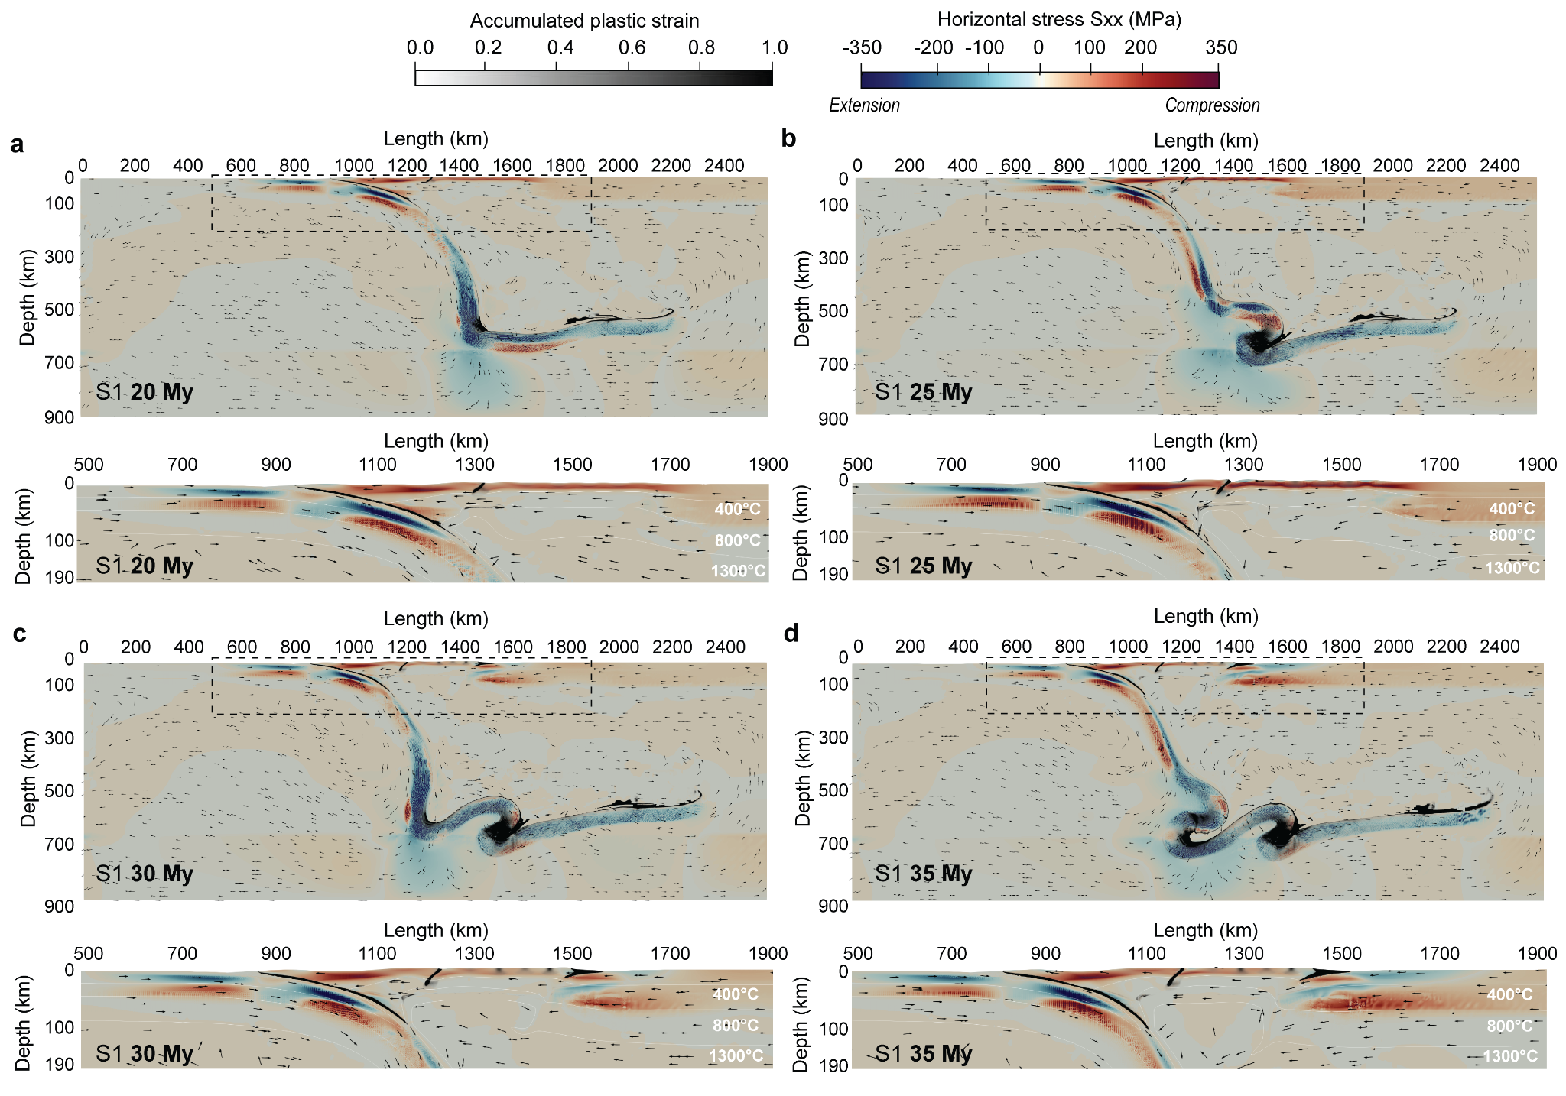
Supplementary Fig. 1. Horizontal stress evolution the model of reference S1. a 20 My. b 25 My. c 30 My. d 35 My.
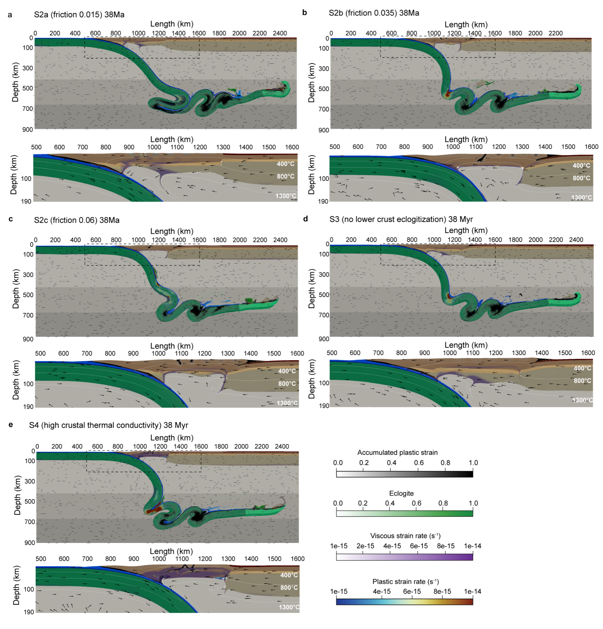
Supplementary Fig. 2. Model variants at ~38 Ma which is supposed to be equivalent to present day. a S2a. b S2b. c S2c. d S3. e S4.

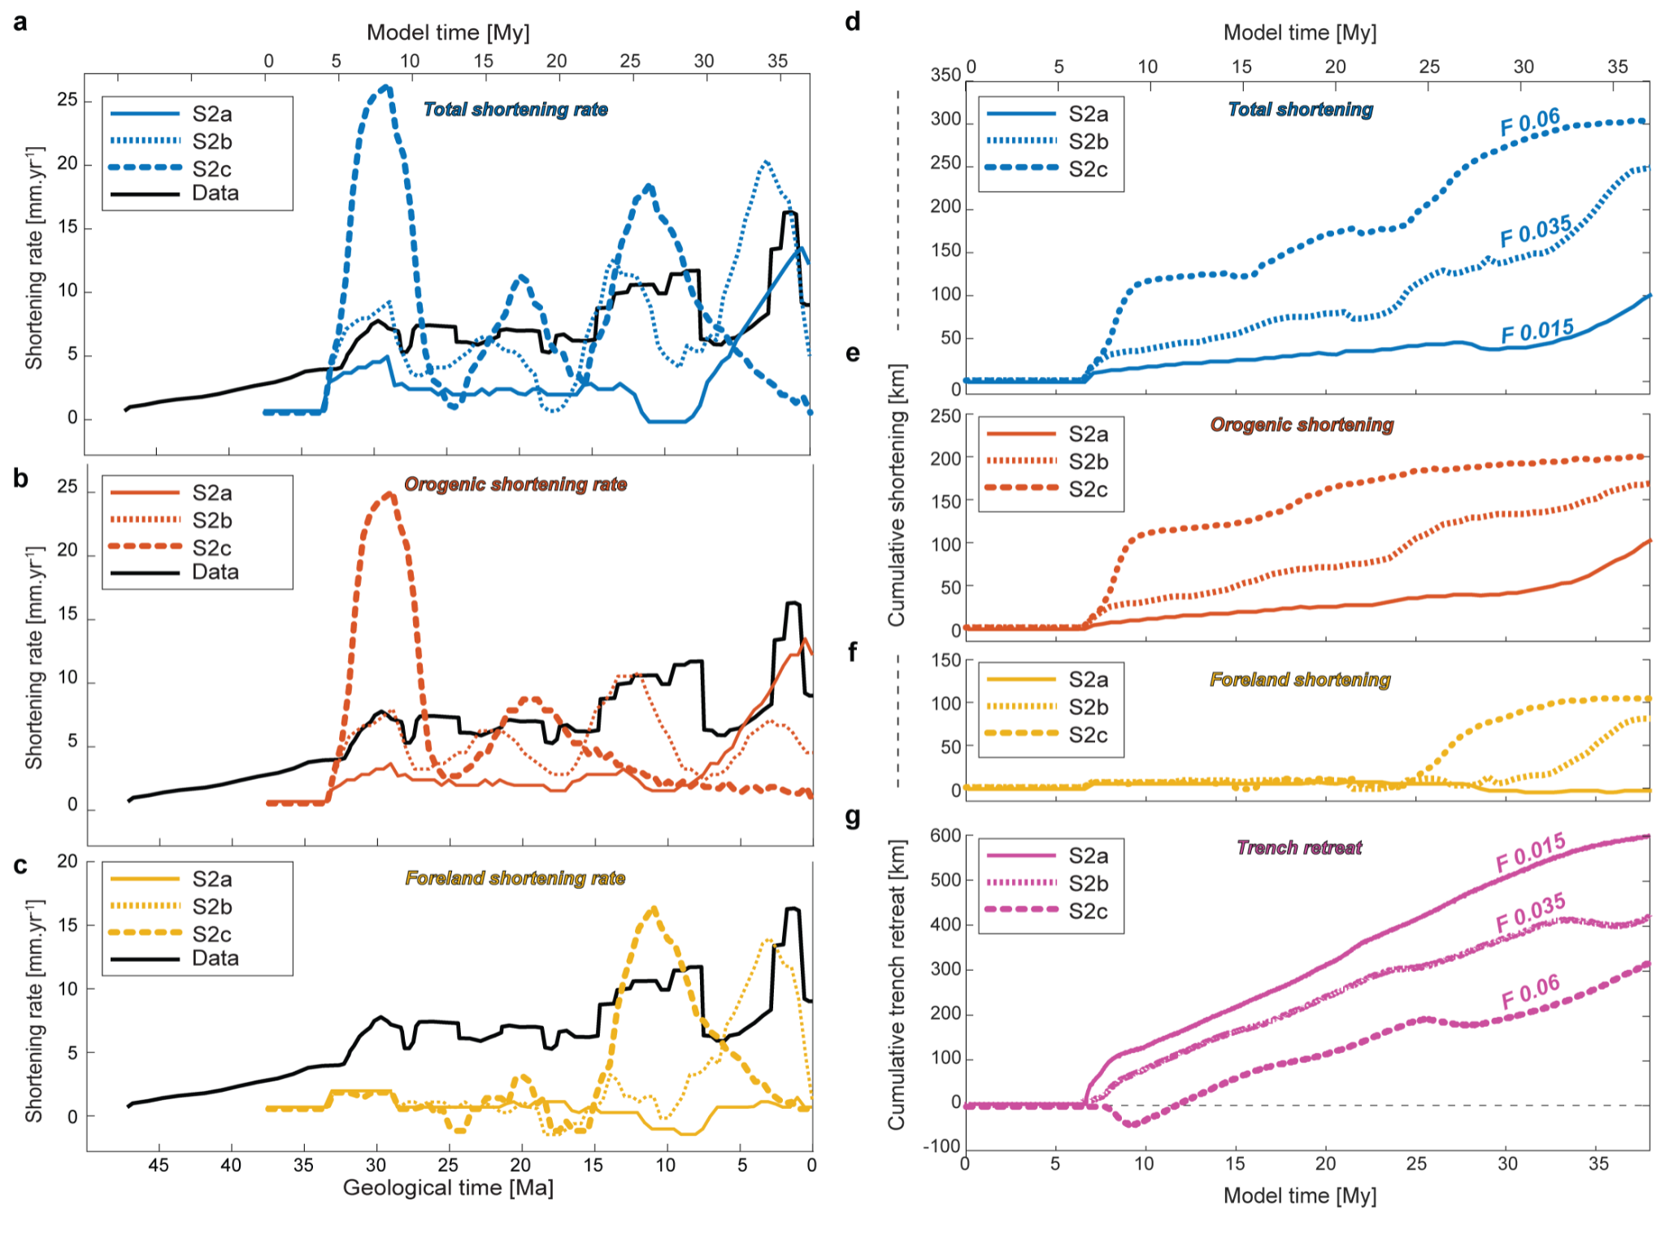
Supplementary Fig. 3. Shortening data for model variants S2a-c. a, b, c Total, orogenic and foreland shortening rate, respectively. d, b, e Total, orogenic and foreland cumulative shortening, respectively. g Cumulative trench retreat.

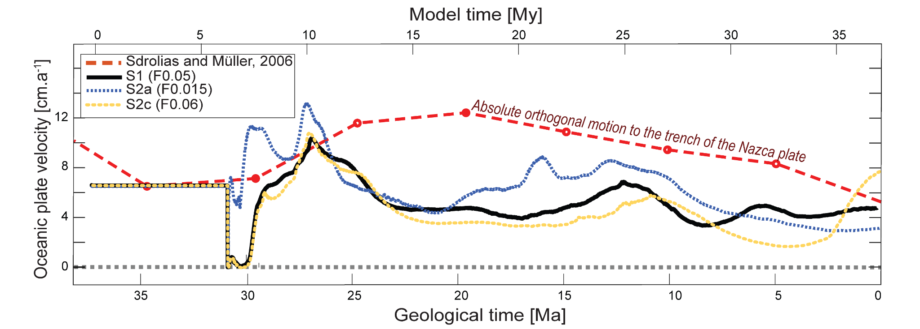
Supplementary Fig. 4. Absolute velocity of the oceanic plate for a S1 Reference model. b S2a, which is the model with the lowest friction at the subduction interface. c S2c, which is the model with the highest friction at the subduction interface.
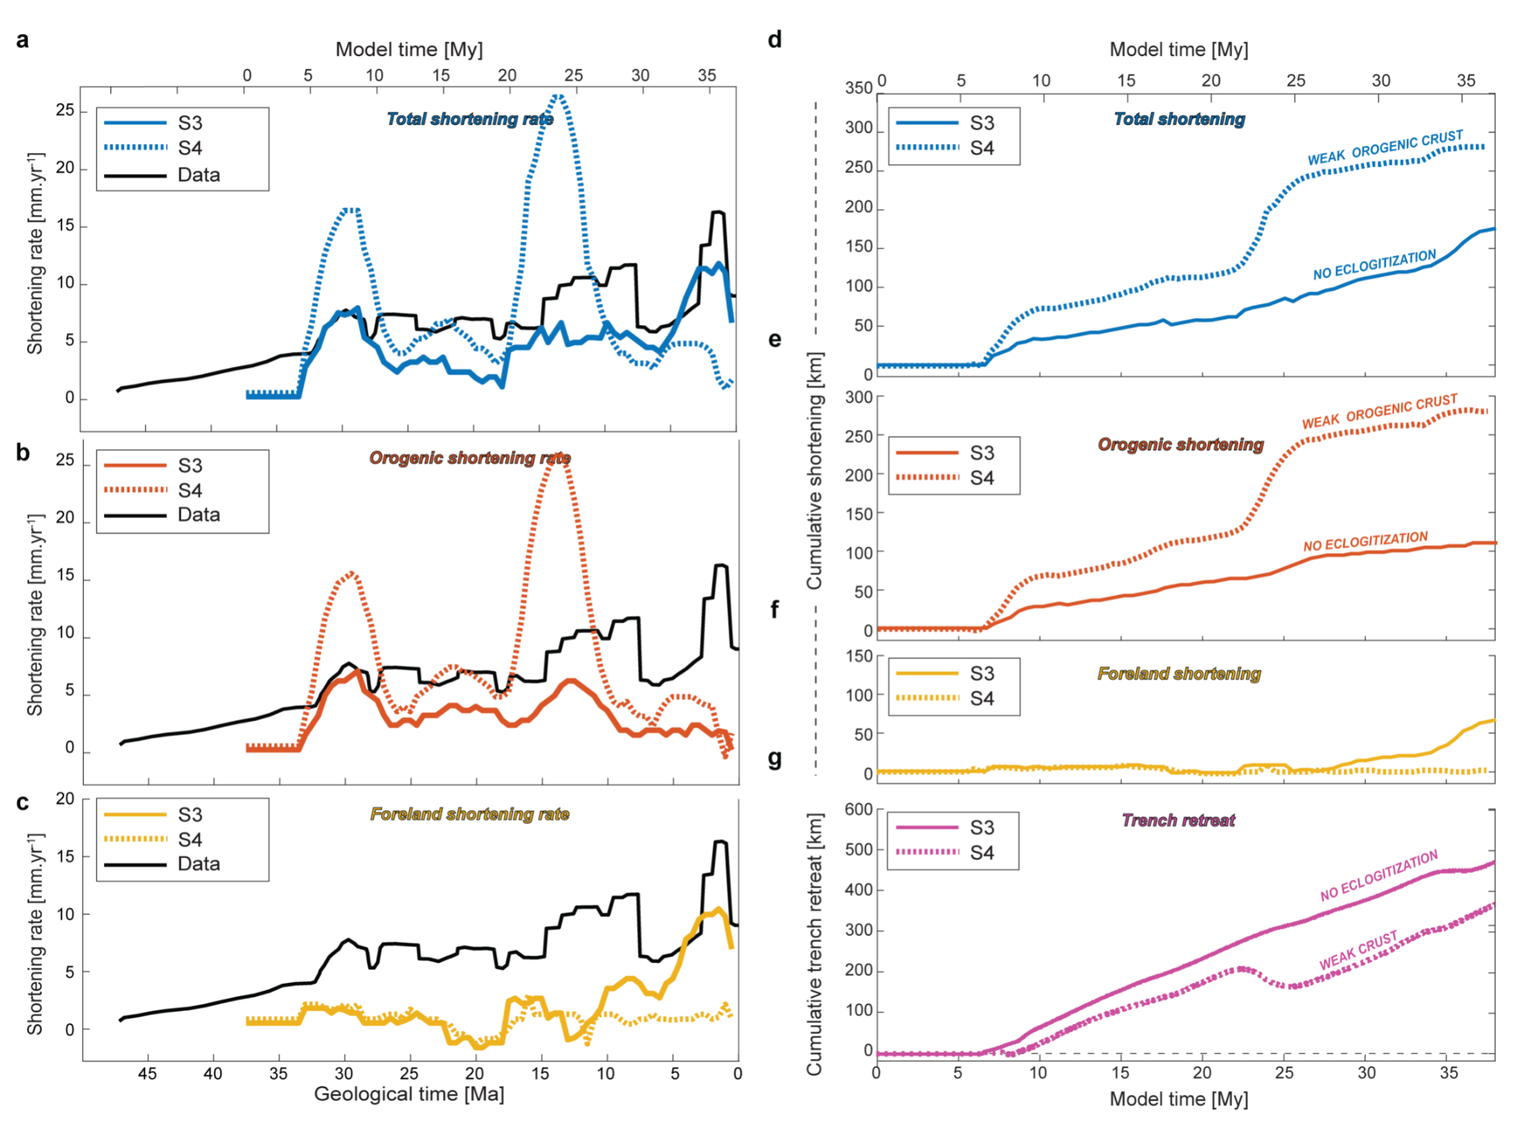
Supplementary Fig. 5. Shortening data for model variants S3 and S4. a, b, c Total, orogenic and foreland shortening rate, respectively. d, b, e Total, orogenic and foreland cumulative shortening, respectively. g Cumulative trench retreat.
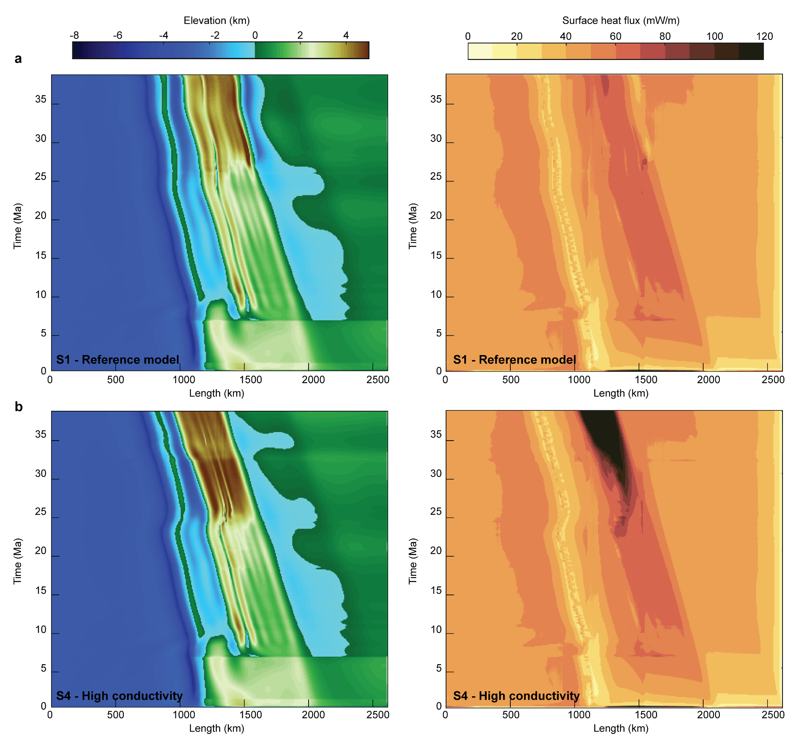
Supplementary Fig. 6. Topography and surface heat flux evolution comparison. a Reference model. b model S4.

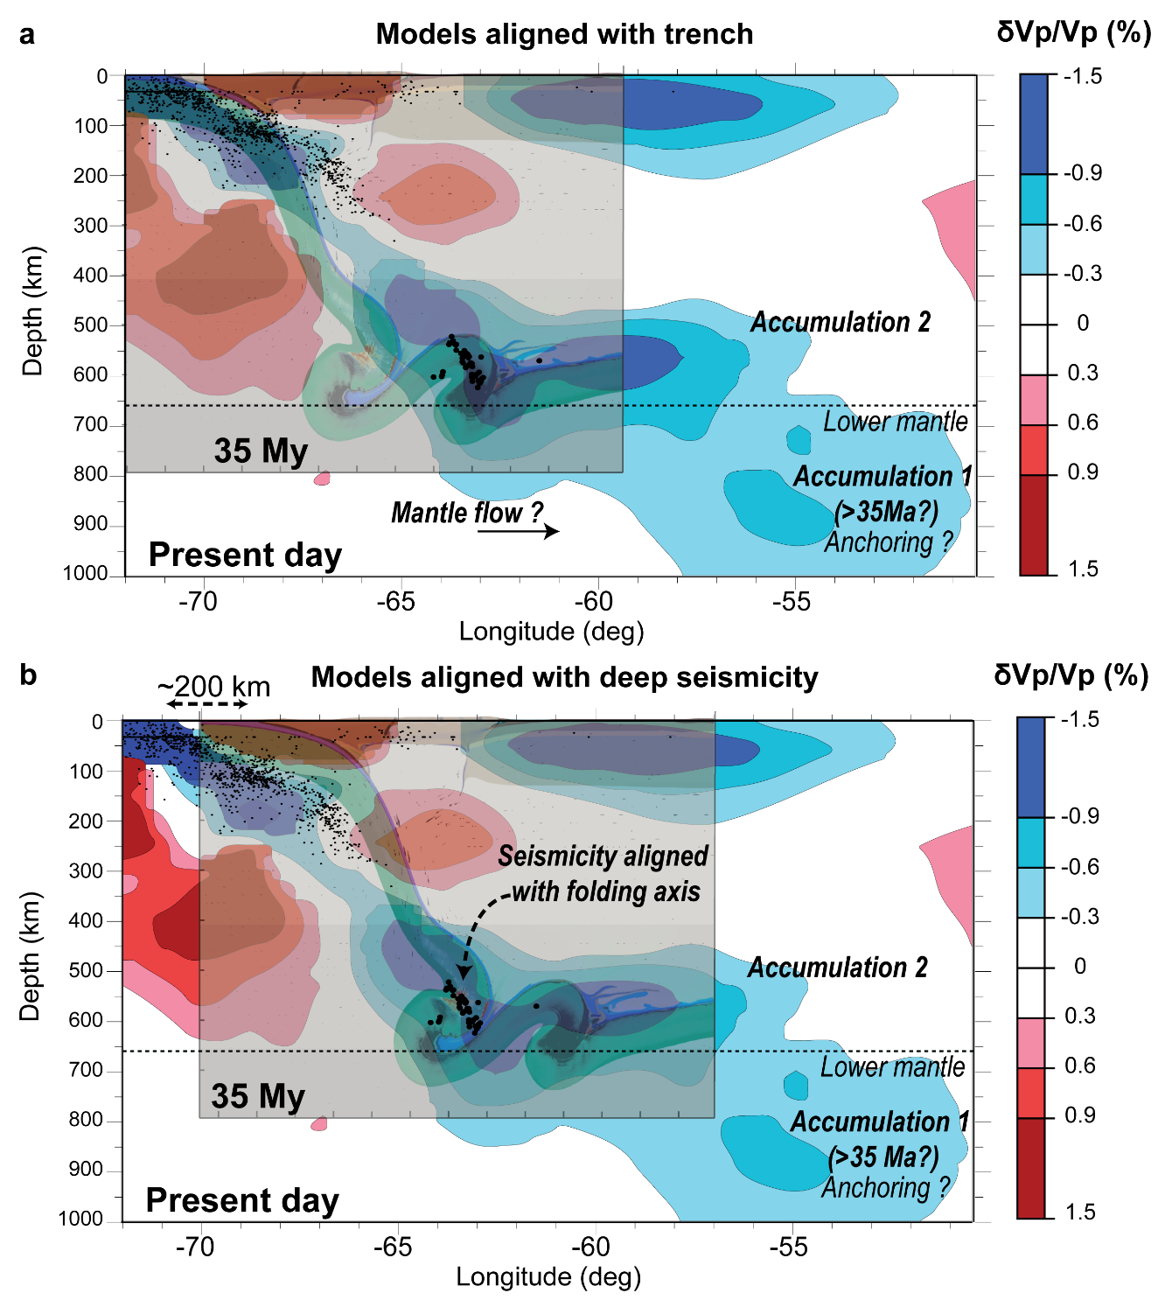
Supplementary Fig. 7 Two propositions for the superposition of the reference model to a tomographic image (Widiyantoro, 1997 and modified from Liu et al., (2003) à 21°S. Seismicity in black dots aligns with the last folding event. In both propositions, the geodynamic model predicts a steeper slab than the seismic tomography. a Proposition 1: The model is aligned with the trench at present day. The slab dip difference could be most likely due to the long term subduction as well as deep eastward mantle flow. b Proposition 2: The buckling fold axis of the model is aligned with the deep seismicity. The dashed line on top shows the difference of the position of the slab between the geodynamic and tomography models (200 km). The difference of slab dip could be due to an underestimation of the trench retreat.

 |  | Asthenosphere (AST)
 |  | Upper Mantle | Transition Zone |  | Lower mantle | Oceanic plate |  |  | Continental plate
 | Units | (< 410 km) | (410-520km) | (520-660km) | (>660km) | Ridge / Weak Gabbro | Gabbro | Lithomantle | Craton | Sediments | UpperCrust | LowerCrust | Lithomantle
Sources for rheology | / | HK2003 |  | SC2006 |  | R1997 | Mk1998 | HK2003 |  | GT1995 |  | Mk1998 | HK2003
Rocks | / | Dry olivine | ƞ =  1e20.83 Pa.s | ƞ =  1e21.03 Pa.s | ƞ =  1e21.87 Pa.s | Wet quartzite | Columbia diabase | Dry olivine |  | Wet quartzite |  | Maryland diabase | Wet olivine
Grainsize | m | 1e-3 | ƞ =  1e20.83 Pa.s | ƞ =  1e21.03 Pa.s | ƞ =  1e21.87 Pa.s | 1e-3 | 1e-3 | 1e-3 |  | 1e-3 |  | 1e-3 | 1e-3
Creep pre-exponential factor Bd / Bn | Pa^{-ndiff/ndisl}. s-1 | 1e-9 / 8.49e-15 | ƞ =  1e20.83 Pa.s | ƞ =  1e21.03 Pa.s | ƞ =  1e21.87 Pa.s | - / 2.25e-17 | - / 1.37e-25 | 2.25e-15 / 2.96e-16 |  | - / 8.57e-28 |  | - / 7.13e-18 | 1e-9 / 2.96e-14
Grain size exponents | mm | 0 | ƞ =  1e20.83 Pa.s | ƞ =  1e21.03 Pa.s | ƞ =  1e21.87 Pa.s | - | - | 3 |  | - |  | - | 0
Activation energies Ed / En | kJ/mol | 335 / 540 | ƞ =  1e20.83 Pa.s | ƞ =  1e21.03 Pa.s | ƞ =  1e21.87 Pa.s | - / 154 | - / 488 | 375 / 535 |  | - / 223 |  | - / 345 | 335 / 515
Activation volume Vd / Vn | m^3/mol | 4.8e-6 / 12e-6 | ƞ =  1e20.83 Pa.s | ƞ =  1e21.03 Pa.s | ƞ =  1e21.87 Pa.s | - / 0 | - / 0 | 10e-6 / 14e-6 |  | - / 0 |  | - / 0 | 4.8e-6 / 14e-6
Stress exponents | n | 3.5 | ƞ =  1e20.83 Pa.s | ƞ =  1e21.03 Pa.s | ƞ =  1e21.87 Pa.s | 2.3 | 4.7 | 3.5 |  | 4 |  | 3 | 3.5
Friction angle | degree | 30 |  |  |  | 2 | 30 | 0 | 30 | 30 -> 3 | 30 -> 6 | 30 -> 6 | 30 ->6
Cohesions | MPa | 40 |  |  |  | 1 | 40 | 500 | 40 | 20 -> 0.2 | 20 | 40 -> 20 | 40 -> 20
Plastic strain weakening interval | none | - |  |  |  | 0 - 0.3 | 0 - 0.3 | - | - | 0 - 0.5 | 0 - 1.5 | 0 - 1.5 | 0 - 1.5
Thermal conductivity | W/K/m | 3.3 |  |  |  | 2.5 | 2.5 | 3.3 | 3.2 | 2.2 | 2.5 | 2.6 | 3.3
Densities at 0 / 60 /270 /  410 / 520 /660 km depth | kg/m^3 | 3300 | 3612 | 3760 | 4171 | 3000 / +450/+50 /  +162 / +148 / +476 |  | AST -20 | 3240 / AST -20 | 2670 | 2800 | 3000 / +450/+50 /  +162 / +148 / +571 | AST -20
Gabbro-eclogite (60 km)  λ 1e6 Pa/K | Pw /T (Pa/K) | - | - | - | - | 1.2e9/1073 | 1.2e9/1073 | - | - | - | - | 0.66e9/973 | -
Coesite-Stishovite (270 km)  λ 3e6 Pa/K | Pw /T (Pa/K) | - | - | - | - | 9e9/1760 | 9e9/1760 | - | - | - | - | 9e9/1760 | -
Olivine-Wadsleyite (410 km)  λ 2e6 Pa/K | Pw /T (Pa/K) | 0.08e9/1810 | - | - | - | 0.16e9/1810 | 0.16e9/1810 | 0.41e9/1810 | 0.41e9/1810 | - | - | 0.16e9/1810 | 0.41e9/1810
Wadsleyite - Ringwoodite (510 km)  λ 3.5e6 Pa/K | Pw /T (Pa/K) | 0.8e9/1870 | 0.8e9/1870 | - | - | 0.16e9/1870 | 0.8e9/1870 | 0.8e9/1870 | 0.8e9/1870 | - | - | 0.16e9/1870 | 0.8e9/1870
Spinel-Perovskite (660km)  λ -0.5e6 Pa/K | Pw /T (Pa/K) | 0.16e9/1940 | 0.16e9/1940 | 0.16e9/1940 | - | 0.16e9/1940 | 0.16e9/1940 | 0.16e9/1940 | 0.16e9/1940 | - | - | 0.16e9/1940 | 0.16e9/1940
Addtionnal blocking temperature | K | - | - | - | - | Ridge : 973 | - | - | - | - | - | - | -
Supplementary Table 1. Bd and Bn, Ed and En, Vd and Vn are for the pre-exponential factor, the energy of activation and the volume of activation for diffusion and dislocation creep, respectively. Pw is the pressure width, T is the temperature, and λ is for Clapeyron slope. SC2006 is for Steiberger and Calderwood, 2006 viscosity profile of reference. HK2003 is for Hirth & Kohlstedt, 2003. Mk1998 is for Mackwell et al., 1998. GT1998 is for Gleason & Tullis, 1995. R1997 is for Ranalli, 1997.

References
Arndt, J., Bartel, T., Scheuber, E., & Schilling, F. (1997). Thermal and rheological properties of granodioritic rocks from the Central Andes, North Chile. Tectonophysics, 271(1), 75–88. https://doi.org/10.1016/S0040-1951(96)00218-1
Dingwell, D. B., Hess, K.-U., & Knoche, R. (1996). Granite and granitic pegmatite melts: Volumes and viscosities. Earth and Environmental Science Transactions of The Royal Society of Edinburgh, 87(1–2), 65–72. https://doi.org/10.1017/S0263593300006489
Gleason, G. C., & Tullis, J. (1995). A flow law for dislocation creep of quartz aggregates determined with the molten salt cell. Tectonophysics, 247(1–4), 1–23. https://doi.org/10.1016/0040-1951(95)00011-B
Haberland, C., Rietbrock, A., Schurr, B., & Brasse, H. (2003). Coincident anomalies of seismic attenuation and electrical resistivity beneath the southern Bolivian Altiplano plateau. Geophysical Research Letters, 30(18), 1–4. https://doi.org/10.1029/2003GL017492
Hamza, V. M., Dias, F. J. S. S., Gomes, A. J. L., & Terceros, Z. G. D. (2005). Numerical and functional representations of regional heat flow in South America. Physics of the Earth and Planetary Interiors, 152(4), 223–256. https://doi.org/10.1016/j.pepi.2005.04.009
Hirth, G., & Kohlstedt, D. (2004). Rheology of the upper mantle and the mantle wedge: A view from the experimentalists. Geophysical Monograph Series, 138, 83–105. https://doi.org/10.1029/138GM06
Liu, S., & Currie, C. A. (2016). Farallon plate dynamics prior to the Laramide orogeny: Numerical models of flat subduction. Tectonophysics, 666, 33-47.
Mackwell, S. J., Zimmerman, M. E., & Kohlstedt, D. L. (1998). High-temperature deformation of dry diabase with application to tectonics on Venus. Journal of Geophysical Research: Solid Earth, 103(1), 975–984. https://doi.org/10.1029/97JB02671
McKenzie, D., & Bickle, M. J. (1988). The Volume and Composition of Melt Generated by Extension of the Lithosphere. Journal of Petrology, 29(3), 625–679. https://doi.org/10.1093/petrology/29.3.625
Perkins, J. P., Ward, K. M., de Silva, S. L., Zandt, G., Beck, S. L., & Finnegan, N. J. (2016). Surface uplift in the Central Andes driven by growth of the Altiplano Puna Magma Body. Nature Communications, 7(1), 13185. https://doi.org/10.1038/ncomms13185
Ranalli, G. (1997). Rheology of the lithosphere in space and time. Geological Society, London, Special Publications, 121(1), 19–37. https://doi.org/10.1144/GSL.SP.1997.121.01.02
Steinberger, B., & Calderwood, A. R. (2006). Models of large-scale viscous flow in the Earth’s mantle with constraints from mineral physics and surface observations. Geophysical Journal International, 167(3), 1461–1481. https://doi.org/10.1111/J.1365-246X.2006.03131.X
Schilling, F. R., Trumbull, R. B., Brasse, H., Haberland, C., Asch, G., Bruhn, D., Mai, K., Haak, V., Giese, P., Muñoz, M., Ramelow, J., Rietbrock, A., Ricaldi, E., & Vietor, T. (2006). Partial Melting in the Central Andean Crust: A Review of Geophysical, Petrophysical, and Petrologic Evidence. In O. Oncken, G. Chong, G. Franz, P. Giese, H.-J. Götze, V. A. Ramos, M. R. Strecker, & P. Wigger (Eds.), The Andes: Active Subduction Orogeny (pp. 459–474). Springer. https://doi.org/10.1007/978-3-540-48684-8_22
Schurr, B., Asch, G., Rietbrock, A., Trumbull, R., & Haberland, C. (2003). Complex patterns of fluid and melt transport in the central Andean subduction zone revealed by attenuation tomography. Earth and Planetary Science Letters, 215(1–2), 105–119. https://doi.org/10.1016/S0012-821X(03)00441-2
Widiyantoro, S. (1997). Studies of seismic tomography on regional and global scale.

