Development of non-soil media capable of degrading organic nitrogen to nitrate, as in natural soil
Jamjan Meeboon^{1†}, Ryoya Nishida^{1,2†}, Takashi Iwai², Kazuki Fujiwara^{1,3}, Masao Takano², Makoto Shinohara¹*
¹ Institute of Vegetable and Floriculture Science, National Agriculture and Food Research Organization (NARO), 360 Ano, Tsu, Mie 514-2392, Japan
² Graduate School of Environmental Studies, Nagoya University, Furo-cho, Chikusa-ku, Nagoya, Aichi 464-8601, Japan
³ Kyushu Okinawa Agricultural Research Center, NARO, 2421 Suya, Koshi, Kumamoto 861-1192, Japan
†Co–first authors
*Correspondence

Table S1 Physical properties of porous carriers.
Materials | Dry weight (g)/100 mL | Specific gravity | Bulk density (g/mL) | Solid phase (%) | Liquid phase (%) | Gas phase (%) | Porosity  (%) | WFPS  (%)
Oyster shell lime (2–4 mm) | 69.38 | 1.82 | 0.6938 | 38.1 | 27.5 | 34.4 | 61.9 | 44.4
Rice husk charcoal | 11.02 | 0.63 | 0.1102 | 19.4 | 63.3 | 17.3 | 80.6 | 78.5
Rockwool (granular) | 21.97 | 1.29 | 0.2197 | 22.8 | 71.6 | 5.6 | 77.2 | 48.0
Coconut husk | 44.97 | 1.46 | 0.4497 | 30.9 | 32.6 | 36.6 | 69.2 | 47.1
Vermiculite | 14.76 | 0.54 | 0.1476 | 28.9 | 50.5 | 20.6 | 71.1 | 71.1
AQ-20 | 2.27 | 0.18 | 0.0227 | 12.3 | 15.2 | 72.5 | 87.7 | 17.4
AQ-15 | 1.85 | 0.19 | 0.0185 | 9.9 | 31.6 | 58.5 | 90.1 | 35.1
AQ-14 | 2.13 | 0.17 | 0.0213 | 12.7 | 32.2 | 55.1 | 87.3 | 36.9
Pumice | 40.87 | 1.01 | 0.4087 | 40.4 | 23.8 | 35.7 | 59.6 | 40.0

Physical properties were measured as follows. First, 100 mL (bulk volume, V) of each material was prepared and weighed (W). The material was transferred to a 500-mL graduated cylinder, which was filled to 100 mL with water. The amount of water added (W_{W}) was measured. The water was decanted, and the total amount discharged (W_{f}) was measured. The dry weight (W_{d}) of 100 mL of each material was measured after drying at 100 °C for 24 h. From the results, we calculated the specific gravity of each material, the bulk density, the solid phase ratio, the liquid phase ratio after decantation, the gas phase ratio after decantation, porosity, and the water-filled pore space (WFPS) as follows:
Solid phase (%) = {100 − W_{W} − (W − W_{d})}/V × 100
Liquid phase (%) = {W + (W − W_{d}) − W_{f}}/V × 100
Gas phase (%) = 100 − (Solid phase) − (Liquid phase)
Specific gravity = W_{d}/100 − W_{W} − (W − W_{d})
Bulk density (g/mL) = W_{d}/100
Porosity (%) = (Liquid phase + Gas phase)
WFPS (%) = (Liquid phase) / (Porosity) × 100

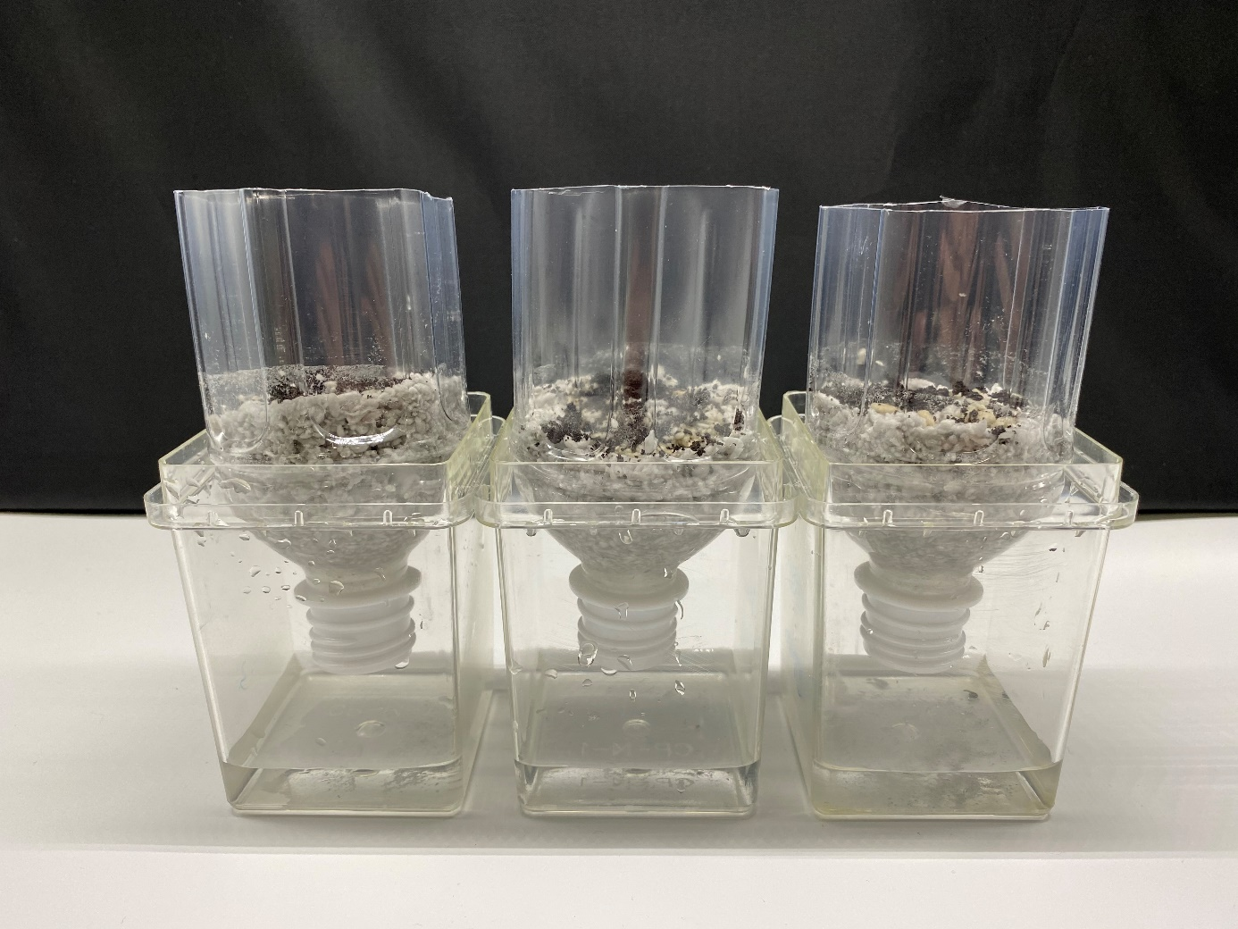
Figure S1. Tubes packed with rockwool.
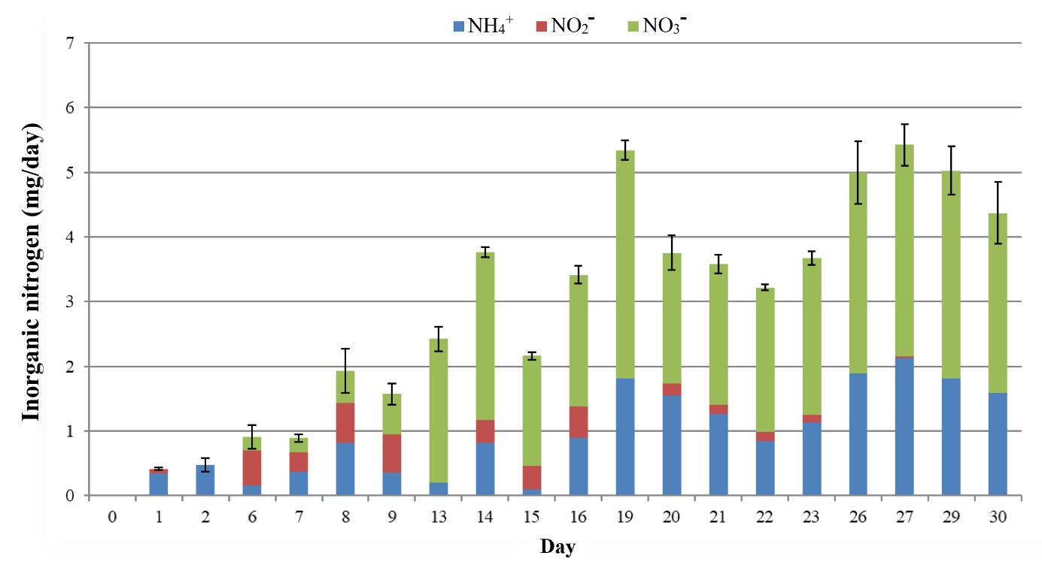
Figure S2. Time course of inorganic N in leachate over 30 days.
Time course of inorganic N in the leachate from the inoculated carrier. Error bars show SD of 3 iterations.
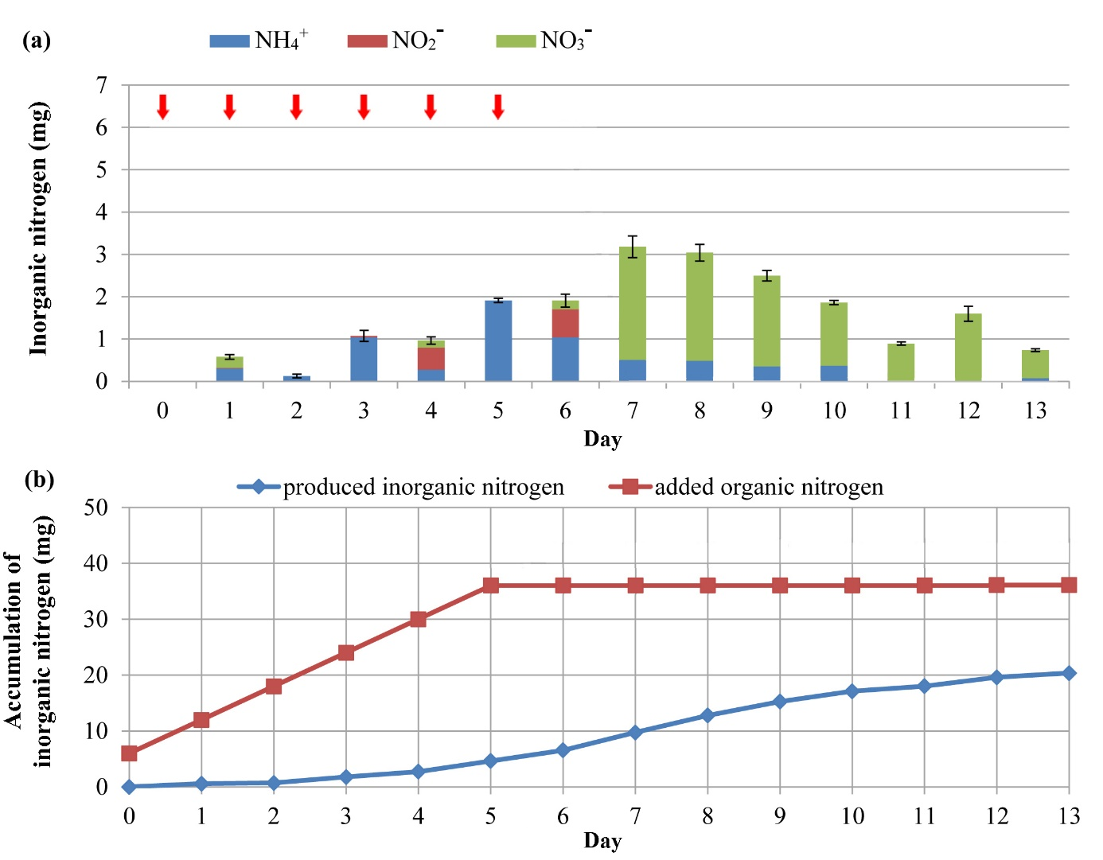
Figure S3. Effect of discontinuation of organic substance addition on the generation of inorganic N.
To 100 mL of rockwool, we added 1 g of bark compost as inoculant and 0.1 g of fish fertilizer as organic substance. After incubation overnight at 25 °C, the rockwool was washed with 100 mL of water. This procedure was repeated for 6 days and ended with washing on day 7. (a) Amount of inorganic N in each leachate solution. (b) Total amount of organic N added, and cumulative amount of inorganic N recovered from the leachate. Error bars show SD of 3 iterations. After the addition of the fish fertilizer (⬇︎) was stopped, inorganic N continued to be produced at a decreasing rate, but the proportion of nitrate increased. This result shows a time lag between degradation of organic substances and the production of inorganic N. Error bars show SD of 3 iterations.
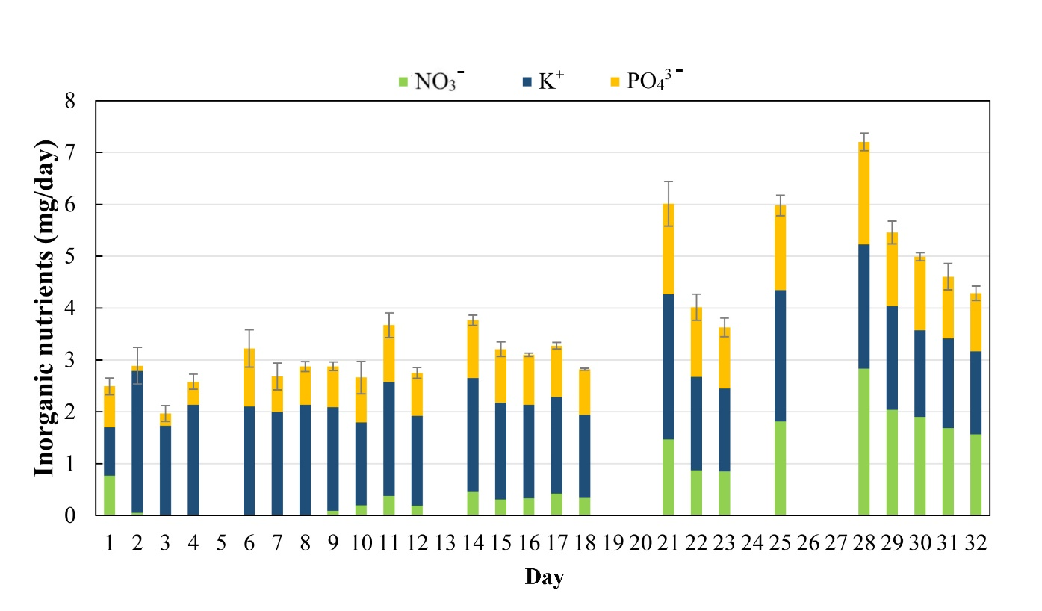
Figure S4. Time course of inorganic N phosphate and potassium ions in leachate over 30 days.
Time course of inorganic phosphate and potassium ions in the leachate from the inoculated carrier. Error bars show SD of 3 iterations.

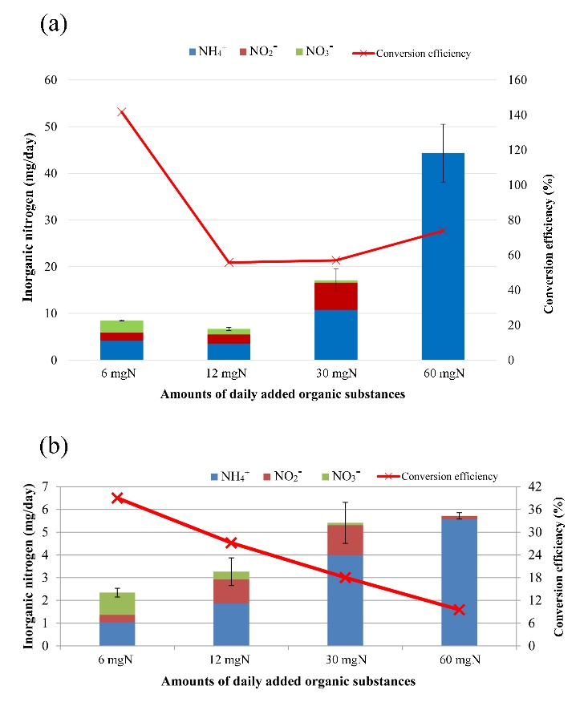
Figure S5. Effect of excessive addition of organic substance and inorganic N composition.
(a) Immediately after addition of bark compost, indicated amounts of fish fertilizer were added, and the composition of inorganic N in the leachate was measured. (b) Composition of inorganic N in the leachate when various amounts of fish fertilizer were added. Error bars show SD of 3 iterations.
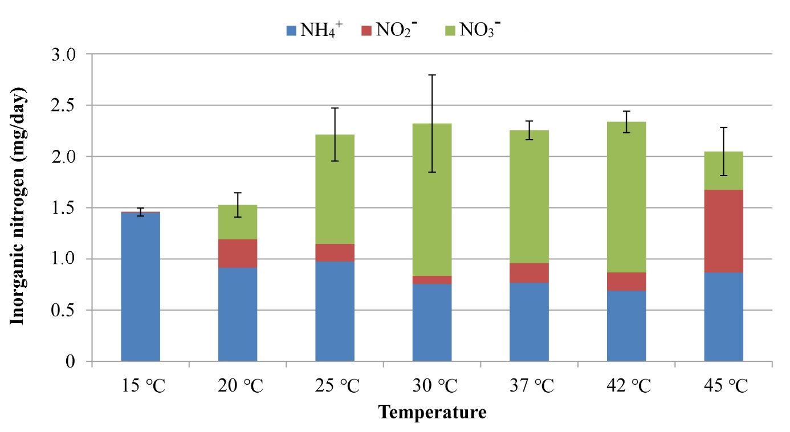
Figure S6. Effect of incubation temperature on N mineralization.
The composition of inorganic N in the leachate was measured following incubation at the indicated temperatures. Error bars show SD of 3 iterations.
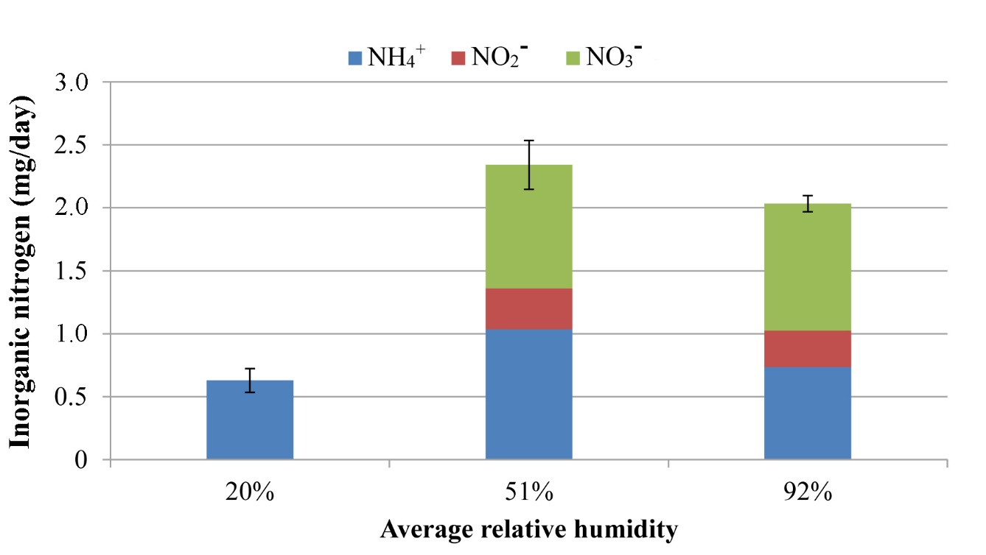
Figure S7. Effect of humidity during incubation on N mineralization.
Inoculated carriers were incubated at the indicated relative humidity and the composition of inorganic N in the leachate was measured. Error bars show SD of 3 iterations.
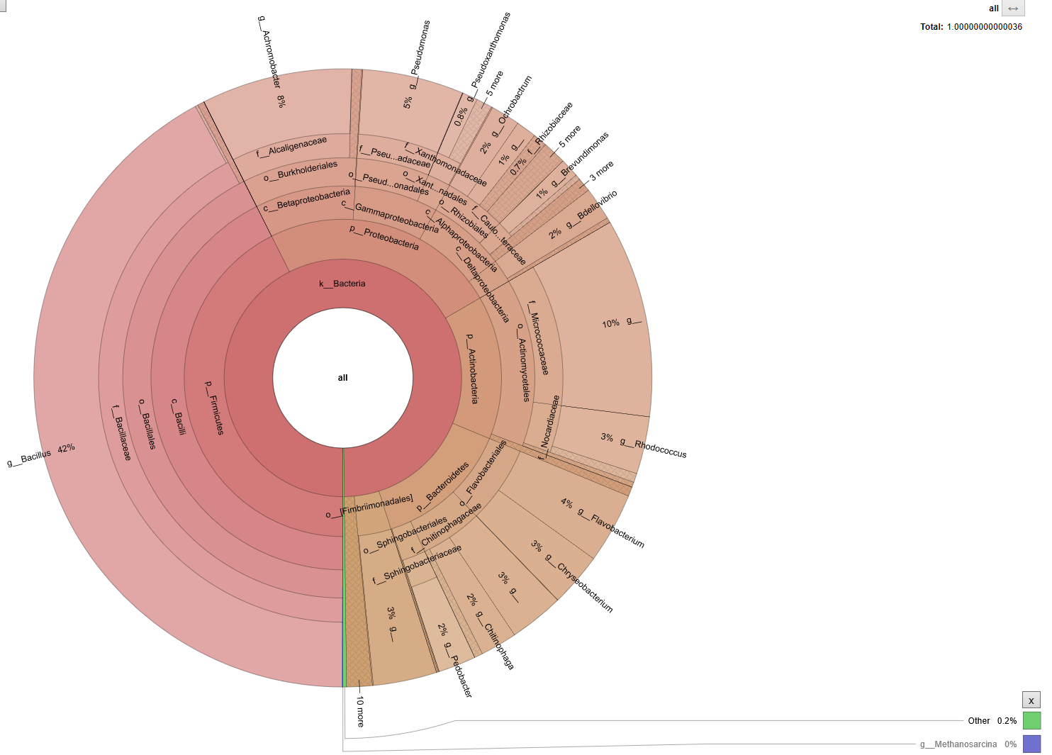
(a)

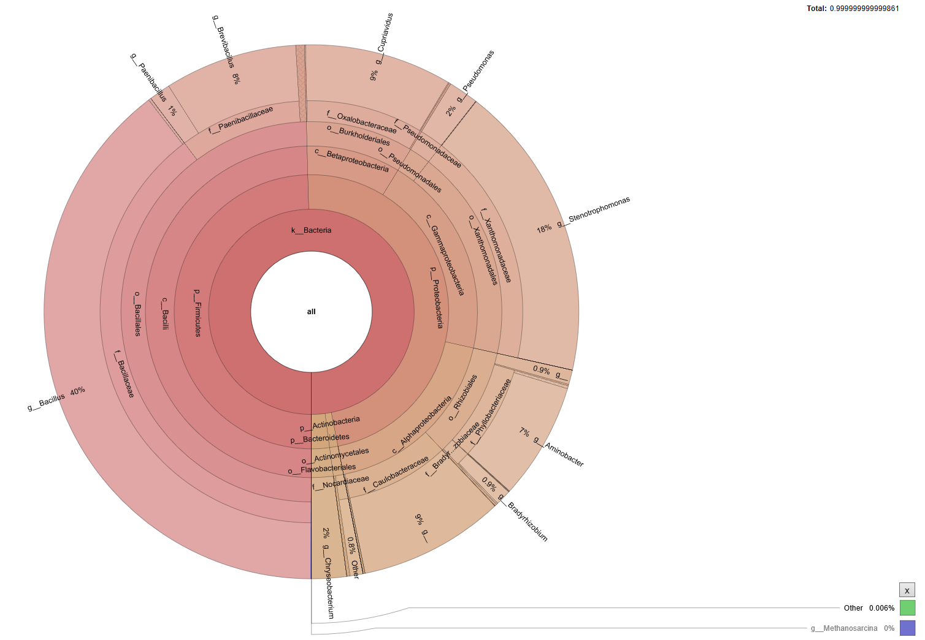
(b)

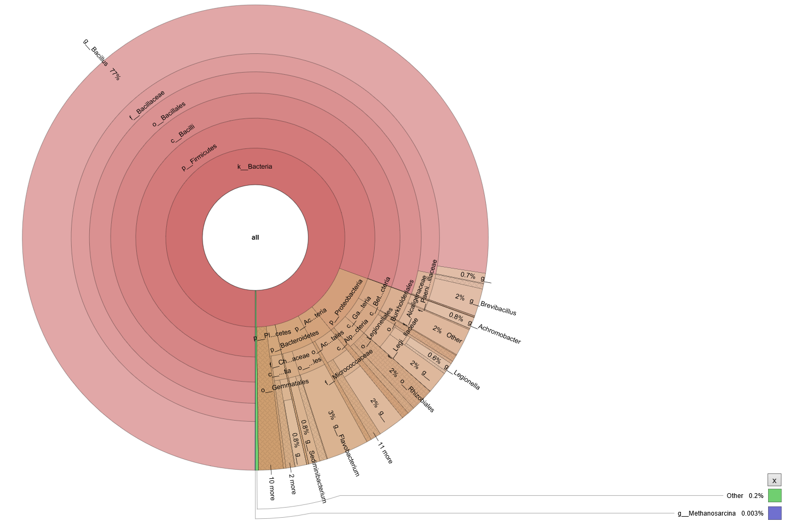
(c)
Figure S8. Microbial phase analysis of inoculated carriers, uninoculated material, and liquid culture.
Krona display of species annotation. Circles from inside to outside indicate taxonomic ranks of descending level. Sector areas indicate relative proportion of operational taxonomic unit annotation results. (a) Inoculated polyurethane AQ-14 (51 157 sequences). (b) Uninoculated AQ-14 (48 955 sequences). (c) Liquid culture solution with 1 g/L of fish fertilizer incubated in flask for 2 weeks at 25 °C, 120 rpm (47 468 sequences). The most abundant genus was Bacillus in all carriers, with a relative abundance of (a) 42.1%, (b) 39.6%, (c) 77.5%. In (a) AQ-14, Actinobacteria (a, 14.6%; b, 1.0%; c, 2.9%), Achromobacter (a, 7.9%; b, 0.0%; c, 0.8%), Pseudomonas (a, 5.3%; b, 1.8%; c, 0.1%), and Rhodococcus (a, 3.0%; c, 0.0%; c, 0.1%) were abundant. In (b) the uninoculated material, Stenotrophomonas (a, 0.3%; b, 17.9%; c, 0.0%), Cupriavidus (a, 0.2%; b, 8.9%; c, 0.0%), Brevibacillus (a, 0.1%; b, 8.0%; c, 1.9%), and Aminobacter (a, 0.1%; b, 7.1%; c, 0.1%) were abundant. In (c) liquid culture, Sediminibacterium (a, 0.0%; b, 0.0%; c, 0.8%), Streptomyces (a, 0.0%; b, 0.0%; c, 0.1%), Candidatus (a, 0.0%; b, 0.0%; c, 0.2%), Parachlamydia (a, 0.0%; b, 0.0%; c, 0.5%), Planctomyces (a, 0.0%; b, 0.0%; c, 0.3%), Hyphomicrobium (a, 0.0%; b, 0.0%; c, 0.1%), Rhodoplanes (a, 0.0%; b, 0.0%; c, 0.1%), Legionella (a, 0.0%; b, 0.0%; c, 0.6%), and Lysobacter (a, 0.0%; b, 0.0%; c, 0.1%) were characteristic.
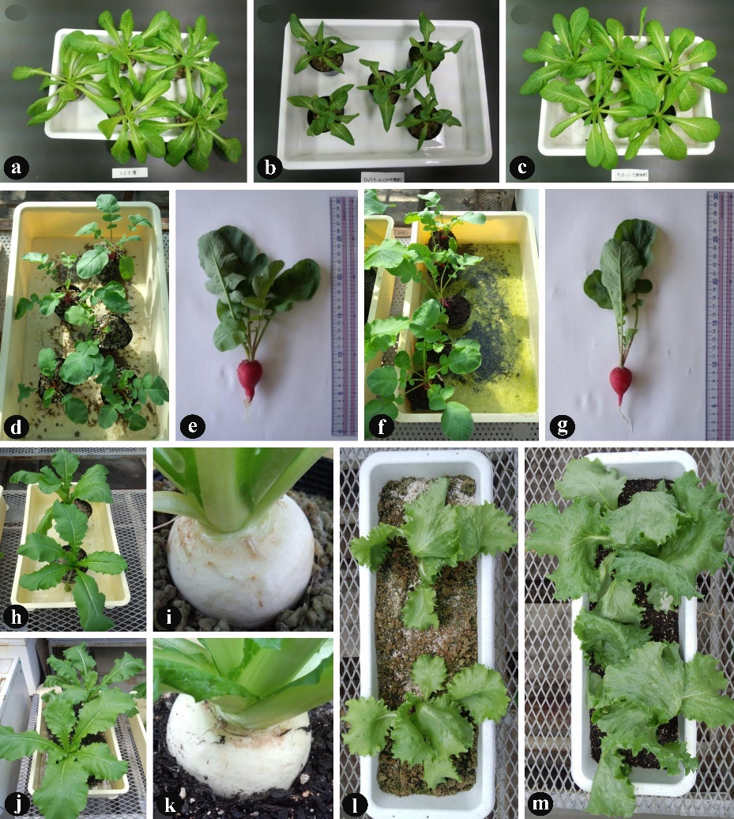
Figure S9. Plant growth in inoculated carriers and nursery soil.
(a–c) Comparison of saradana growth in (a) inoculated carrier, (b) uninoculated material, and (c) soil, 26 days after sowing. (d–g) Radishes grown in (d, e) inoculated carrier and (f, g) soil, 36 days after sowing. (h–k) Turnips grown in (h, i) inoculated carrier and (j, k) soil, 43 days after sowing. (l, m) Lettuces grown in (l) inoculated carrier and (m) soil, 66 days after sowing.

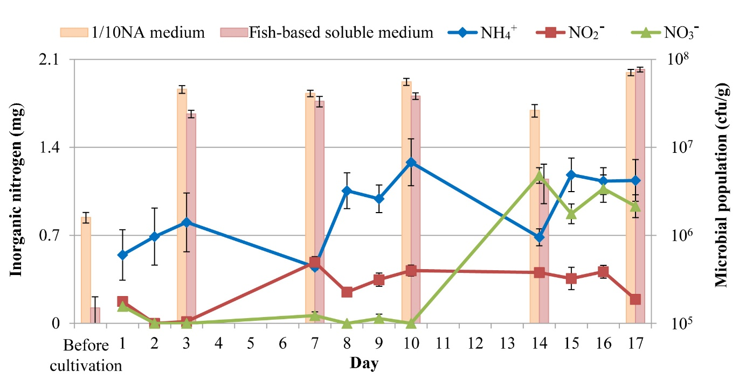
Figure S10. Mineralization of organic N and microbial population density.
Microbial densities in 1/10 NA medium and fish-based soluble fertilizer medium and amounts of inorganic N in inoculated carriers. The population density increased dramatically from ~2 × 10⁶ cfu/g (in 1/10 NA medium) before incubation to ~6 × 10⁷ cfu/g 3 days after incubation. Within 3 days, mainly ammonium was produced. With the later generation of nitrite and nitrate, the population reached ~7 × 10⁷ cfu/g. These results show that microbial population density increased with nitrification. Error bars show SD.

