Table 1 (compounds):
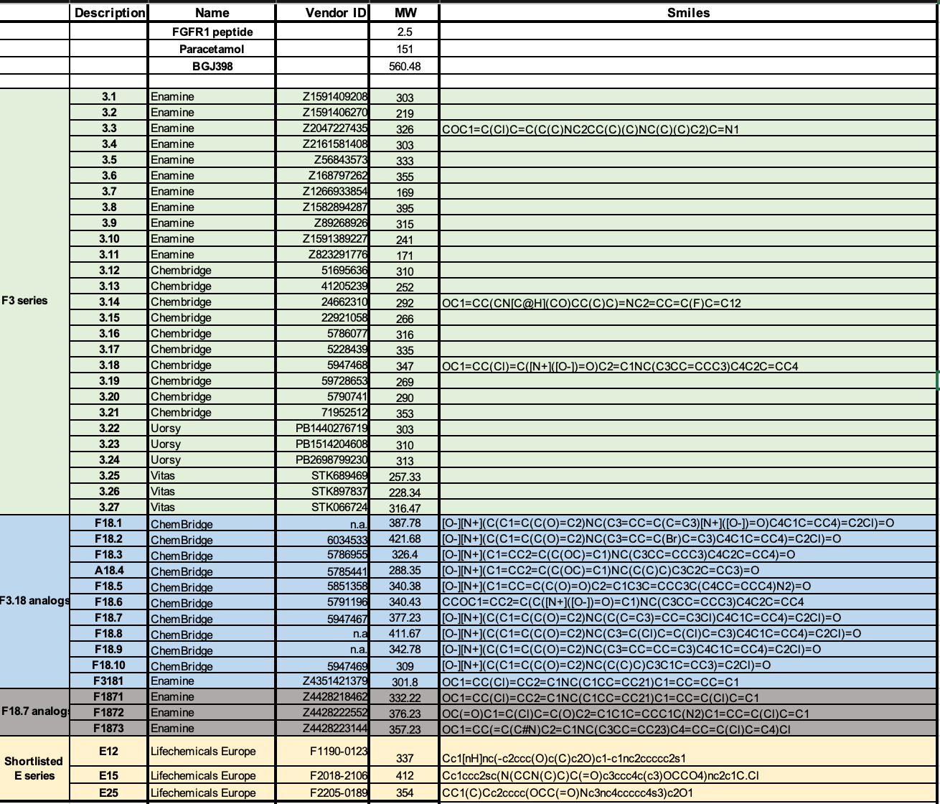

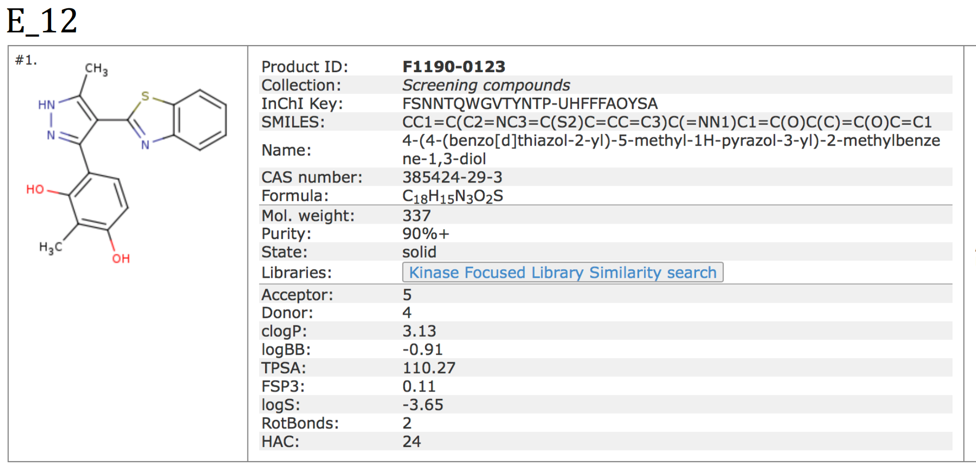
Table 2:
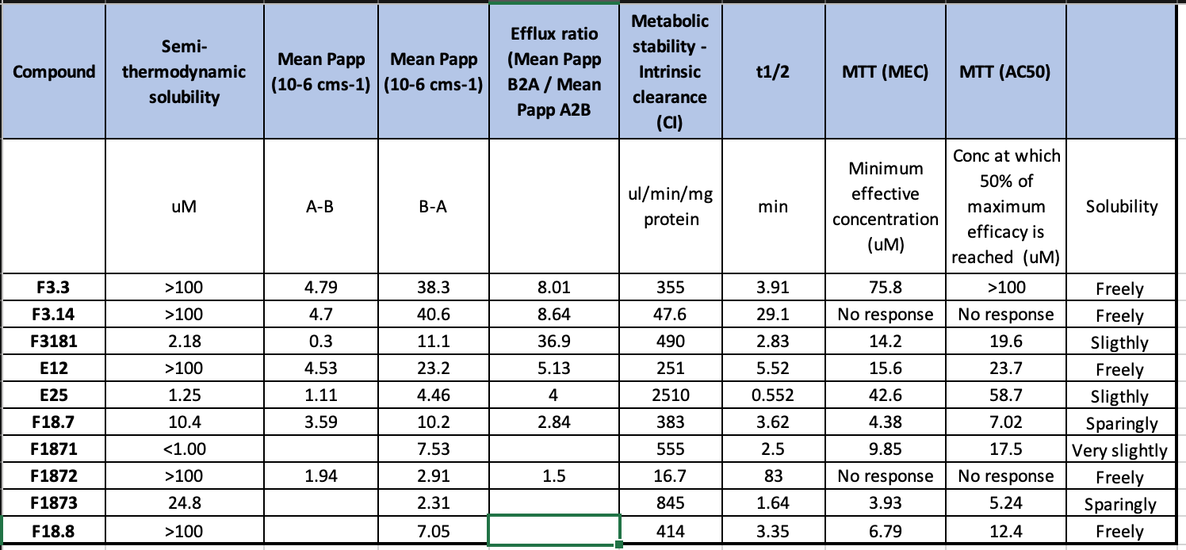

Table 3
Protein_ID | diff_meltP_p2480_comp_1_vs_p2480_DMSO | pVal_adj
Q8N357 | -9.9367719 | 1.0264E-10
Q9H479 | -7.9809774 | 1.4064E-06
Q99643 | -7.5474045 | 6.0726E-05
Q9GZV5 | -6.801595 | 2.1392E-07
O60234 | -5.7920545 | 0.00240558
Q7Z769 | -5.7637845 | 6.9107E-05
Q9H981 | -5.4421212 | 0.00013727
P32321 | -5.3488527 | 0.00034151
Q96N66 | -5.2454481 | 0.00039012
Q86X76 | -5.1257695 | 0.0007017
Q9H1J7 | -4.9895292 | 0.0007017
Q5W0B1 | -4.9390339 | 1.505E-05
Q5VT66 | -4.6981767 | 0.0052621
A0A1B0GTU1 | -4.6460159 | 4.9339E-05
O14681 | -4.5364882 | 0.00474774
Q5HYK7 | -4.4912245 | 0.00055181
P55199 | -4.3615127 | 0.00076051
Q9BW61 | -4.1897645 | 0.00177578
Q96JB3 | -4.0712047 | 5.4638E-05
O95429 | -3.5744093 | 0.00597517
Q9BSE5 | -3.4591792 | 0.00158932
Q9Y6X9 | -3.388782 | 0.00017499
Q9H3P2 | -3.2697128 | 0.00404429
P19447 | -3.0092319 | 0.00526458
Q86UA1 | -2.9062963 | 0.00318829
P33908 | -2.8874372 | 0.00351092
Q14197 | -2.8178792 | 0.00516439
O00459 | 2.65696033 | 0.00126446
P32019 | 2.83932742 | 0.00914644
Q86W42 | 2.84217925 | 0.00993217
Q9UEW8 | 2.95693909 | 0.00301835
P32121 | 2.97646424 | 0.00516439
Q8NEC7 | 3.0017479 | 0.0007017
Q8IWC1 | 3.02190714 | 0.00015074
Q5T013 | 3.06356825 | 0.00052477
P39210 | 3.07364155 | 0.00337267
O95487 | 3.10172872 | 0.00304519
P62875 | 3.20885505 | 0.00189011
Q969E8 | 3.27039721 | 0.0001619
P33121 | 3.37977552 | 0.00080614
Q6P1L5 | 3.41579058 | 0.00126446
P04637 | 3.43173412 | 0.00613724
Q96II8 | 3.45687258 | 7.6286E-06
Q7L311 | 3.48883994 | 0.00052477
Q99714 | 3.6100151 | 0.00096841
P53367 | 3.69526611 | 0.00017502
Q8IZQ5 | 3.8053207 | 0.00516439
Q460N5 | 3.90002868 | 2.6771E-06
Q96BT7 | 4.01388184 | 3.4496E-05
Q9Y6Y0 | 4.03247684 | 0.00231044
Q8NCF5 | 4.30906705 | 0.00571176
P0C1Z6 | 4.33792528 | 0.0052621
Q13356 | 4.77470425 | 1.8028E-05
Q562R1 | 4.81226542 | 1.505E-05
Q93062 | 4.8365371 | 4.2108E-05
Q93015 | 4.86620891 | 1.0536E-07
Q9NWZ8 | 4.89343354 | 9.0047E-09
Q13287 | 5.21415389 | 0.00063878
Q8ND61 | 5.45217205 | 0.00409432
Q5VTB9 | 5.59068346 | 0.00293831
Q96PM5 | 5.62338463 | 2.3353E-10
Q12857 | 5.97574805 | 0.00696824
P08247 | 6.09996174 | 0.00071043
P00750 | 6.22996867 | 4.3624E-14
O15127 | 6.37306305 | 0.00307807
A2RU67 | 6.48386286 | 0.00022239
O14880 | 6.5191079 | 0.00020089
Q8N4H5 | 6.73567463 | 0.00131659
Q969X1 | 6.85110045 | 4.459E-14
Q9UI42 | 7.1167009 | 0.00055181
Q9UGH3 | 7.20421316 | 1.0586E-16
P15104 | 7.22272496 | 3.0008E-11
O95170 | 7.23298798 | 5.9132E-13
Q5XX13 | 7.23298798 | 5.9132E-13
P18583 | 7.33538392 | 6.0328E-05
Q9NNW7 | 7.41277127 | 4.9339E-05
Q6KB66 | 8.84071273 | 7.1794E-13
P29034 | 9.28846331 | 3.3616E-08
Q96LJ7 | 9.30797697 | 2.8082E-09
Q04695 | 13.8343256 | 1.0888E-63

Table 4
Protein_ID | diff_meltP_p2480_drug_1_vs_p2480_vehicle | pVal_adj_p2480_drug_1_vs_p2480_vehicle
P17677 | -10.823969 | 2.0927E-13
Q92844 | -9.1009977 | 1.92E-24
Q96B36 | -6.8591588 | 2.6507E-05
Q9NWA0 | -5.8961708 | 7.7248E-10
O94885 | -5.5265159 | 3.8025E-08
Q9BVC5 | -4.9857865 | 2.0341E-05
Q6UX15 | -4.7917935 | 7.5734E-06
Q9Y2U8 | -4.6965322 | 0.00016672
Q8IWD4 | -4.6352991 | 4.1328E-05
A6NEN9 | -4.5147341 | 1.5792E-05
Q99717 | -4.4495699 | 0.00010944
Q9BZ23 | -4.2626903 | 8.5161E-05
Q9BTL3 | -4.1099092 | 0.00059837
Q9H477 | -4.0620455 | 0.00039282
Q9P0L2 | -4.0480479 | 0.00018427
Q04941 | -4.0121259 | 0.000222
Q9HD20 | -4.0035927 | 0.00026607
Q9P206 | -3.8028329 | 0.00066202
P05089 | -3.7260877 | 0.00092409
O95900 | -3.7127613 | 8.5161E-05
P55201 | -3.4161709 | 0.00082106
Q9BSH4 | 4.31674833 | 0.0003818
Q9NUL7 | 4.67816713 | 0.00074515
Q9BT73 | 5.00468953 | 0.0001195
Q9NSK0 | 5.17713901 | 7.0061E-06
Q8NDV7 | 5.37367665 | 8.5161E-05
P34913 | 5.88575117 | 4E-06
O95197 | 6.197923 | 0.00076364
P55957 | 6.20224278 | 2.8091E-06
Q8WUA4 | 6.40627642 | 0.0001195
Q96H35 | 6.81598842 | 1.7152E-10
Q8IXQ4 | 6.83435693 | 2.6507E-05
Q86X95 | 7.245283 | 4.1328E-05
Q96LZ7 | 7.30573592 | 7.7248E-10
Q7L1V2 | 7.43092446 | 2.4662E-09
Q9H2V7 | 7.50692154 | 8.8241E-06
P50542 | 7.93681193 | 1.6645E-10
Q9H467 | 8.48499928 | 1.7393E-08
A6NDB9 | 9.03568815 | 2.6221E-15

