Distinct CD8 T cell populations with differential exhaustion profiles associate with secondary complications in common variable immunodeficiency
Adam Klocperk, David Friedmann, Alexandra Emilia Schlaak, Susanne Unger, Zuzana Parackova, Sigune Goldacker, Anna Sediva, Bertram Bengsch & Klaus Warnatz
Correspondence:
Adam Klocperk, MD, PhD
Center for Chronic Immunodeficiency (CCI)
Medical Center – University of Freiburg, Faculty of Medicine, University of Freiburg
Breisacher Str. 115
Freiburg im Breisgau
79 106
Germany
ORCID: 0000-0002-1526-4557
Tel: +420 702 013 154
Email: adam.klocperk@fnmotol.cz

Table S1 List of antibodies and dyes used in flow cytometric assays
Antigen | Fluorochrome | Clone | Company
CD3 | BV605 | UCHT1 | BioLegend
CD8 | AF647 | SK1 | BioLegend
2B4 | APC-Cy7 | C1.7 | BioLegend
PD1 | BV421 | EH12.2H7 | BioLegend
CD127 | BV650 | A019D5 | BioLegend
TIGIT | PE-Dazzle 594 | A15153G | BioLegend
Eomesodermin | PE | WD1928 | BioLegend
Tbet | PE-Cy7 | 4B10 | BioLegend
CXCR5 | AF488 | RF8B2 | BD
CCR7 | PE | 150503 | R&D Systems
CD45RA | APC-H7 | HI100 | BD
Perforin | BV711 | dG9 | BioLegend
CD27 | BV605 | L128 | BD
CD28 | PerCP-Cy5.5 | CD28.2 | BioLegend
Ki67 | AF700 | Ki-67 | BioLegend
CD8 | PE | B9.11 | Beckman Coulter
CCR7 | BV650 | G043H7 | BioLegend
HLA-DR | BV711 | L243 | BioLegend
Granzyme B | BV421 | GB11 | BF Biosciences
TCF1 | APC | 7F11A10 | BioLegend
CTLA4 | PE | BNI3 | BioLegend
CD57 | APC | HCD57 | BioLegend
Tim3 | BV711 | F38-2E2 | BioLegend
CD8 | PB | SK1 | BioLegend
IL-10 | PE | JES3-9D7 | BD
Zombie | UV |  | BioLegend

Table S2 List of antibodies used in mass cytometry
Channel | Antigen | Clone | Manufacturer | Catalog number
89Y | CD45 | HI30 | Fluidigm | Cat#304002
104Pd | ß2m-Barcode |  | Henrik Mei
105Pd | ß2m-Barcode |  | Henrik Mei
106Cd | ß2m-Barcode | 2M2 | BioLegend
108Pd | ß2m-Barcode |  | Henrik Mei
110Pd | ß2m-Barcode |  | Henrik Mei
111 Cd | CD4 | RPA-T4 | BioLegend | Cat#300502
112 Cd | CD3 | UCHT1 | BioLegend | Cat#300402
113 Cd | CD39 | A1 | BioLegend | Cat#328202
114 Cd | IL-17A | BL168 | BioLegend | Cat#512302
115 In | CD57 | TB01 | invitrogen | Cat#16-0577-85
116 Cd | CD8 | RPA-T8 | BioLegend | Cat#301002
139 La | MM-DOTA
140 etc | Beads
141 Pr | CD19 | HIB19 | BioLegend | Cat#302202
142 Nd | IFNg | B27 | BioLegend | Cat#506502
143 Nd | GM-CSF | BVD2-21C11 | BioLegend | Cat#502315
144 Nd | CTLA-4 | BNI3 | BD | Cat#555850
145 Nd | TNFa | MAb11 | Thermo Fisher | Cat#14-7349-85
146 Nd | Ki-67 | B56 | BD | Cat#556003
147 Sm | CD45RA | H100 | BioLegend | Cat#304143
148 Nd | CD7 | eBio124-1D1 | invitrogen | Cat#14-0079-82
149 Sm | CD73 | AD2 | BioLegend | Cat#344002
150 Nd | CD127 | HIL-7R-M21 | BioLegend | Cat#351302
151 Eu | Granulysin | DH2 | BioLegend | Cat#348008
152 Sm | IL-2 | MQ1-17H12 | BioLegend | Cat#14-7029-85
153 Eu | Tim-3 | F38-2E2 | BioLegend | Cat#345002
154 Sm | XCL-1 | 109001 | R&D | Cat#MAB6951
155 Gd | CD27 | L128 | BioLegend | Cat#302802
156 Gd | Helios | 22F6 | BioLegend | Cat#137202
157 Gd | Foxo1 | 2F8B08 | BioLegend | Cat#658102
158 Gd | PD-1 | EH12.2H7 | BioLegend | Cat#329902
159 Tb | CCR7 | G043H7 | BioLegend | Cat#353202
160 Gd | Tbet | 4B10 | BioLegend | Cat#644802
161 Dy | CD28 | CD28.2 | BioLegend | Cat#302902
162 Dy | FoxP3 | PCH101 | invitrogen | Cat#14-4776-82
163 Dy | TCF1 | 7F11A10 | BioLegend | Cat#655202
164 Dy | CXCL10 | J034D6 | BioLegend | Cat#519502
165 Ho | EOMES | WD1928 | Thermo Fisher | Cat#14-4877-82
166 Er | Perforin | B-D48 | abcam | Cat#ab47225
167 Er | CD38 | HIT2 | Thermo Fisher | Cat#14-0389-82
168 Er | TOX | Rea473 | Miltenyi | Cat#130-118-335
169 Tm | TIGIT | MBSA43 | Thermo Fisher | Cat#16-9500-82
170 Er | CXCR5 | RF8B2 | BD | Cat#552032
171 Yb | 2B4 | C1.7 | BioLegend | Cat#329502
172 Yb | CD160 | BY55 | BioLegend | Cat#341202
173 Yb | HLA-DR | L243 | BioLegend | Cat#307602
174 Yb | IL-10 | JES3-9D7 | BioLegend | Cat#501402
175 Lu | LAG-3 | 17B4 | enzo | Cat#ALX-804-806-C100
176 Yb | CD120b | 3G7A02 | BioLegend | Cat#358402
191/193 | Iridium
198 Pt | ß2m-Barcode | 2M2 | Biolegend
209 Bi | CD16 | 3G8 | Fluidigm | Cat#3165001B

Fig. S1 Gating strategy for memory subsets, CD127, TIGIT and PD1 markers assessed by flow cytometry
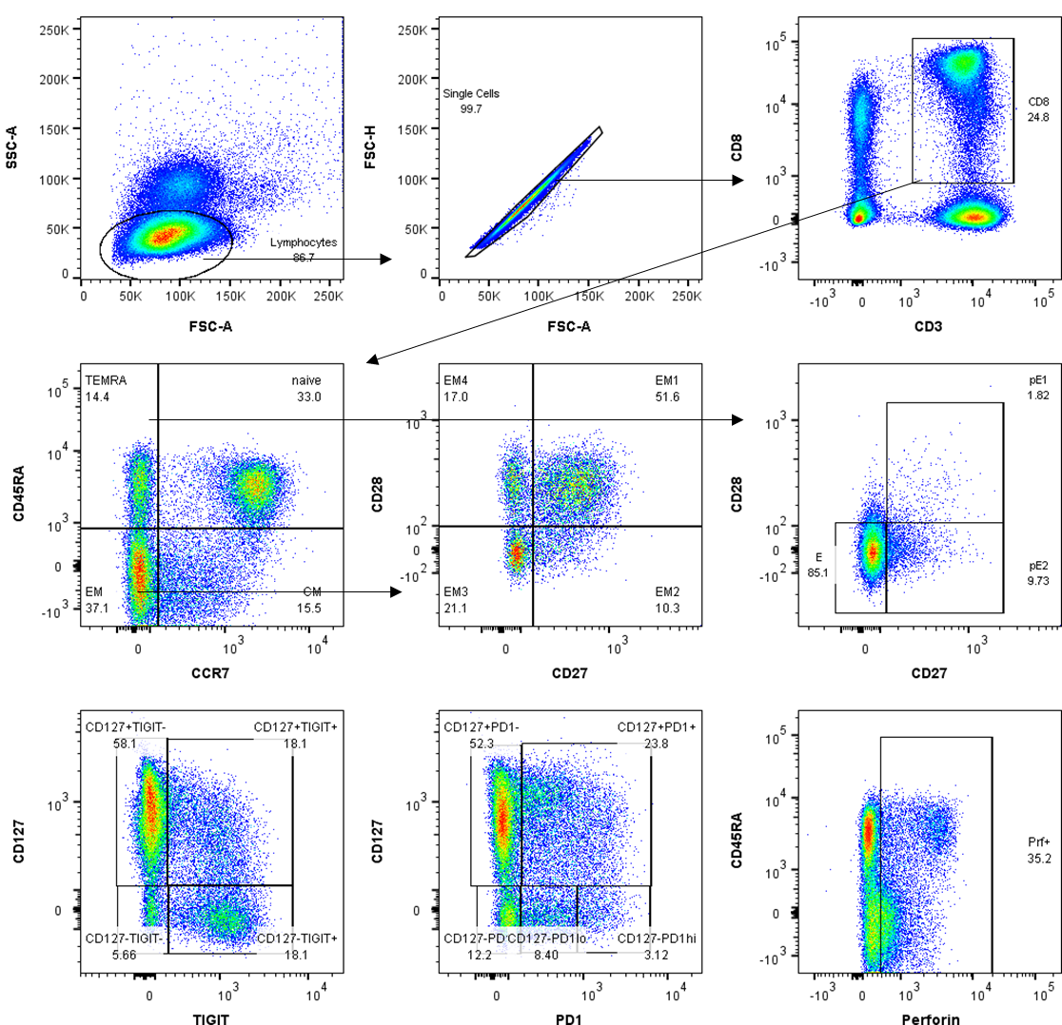

Fig. S2 CD4:8 T cell ratio in HD, CVIDio and CVIDc (n = 57, 17 HD, 11 CVIDio, 29 CVIDc) as assessed by flow cytometry
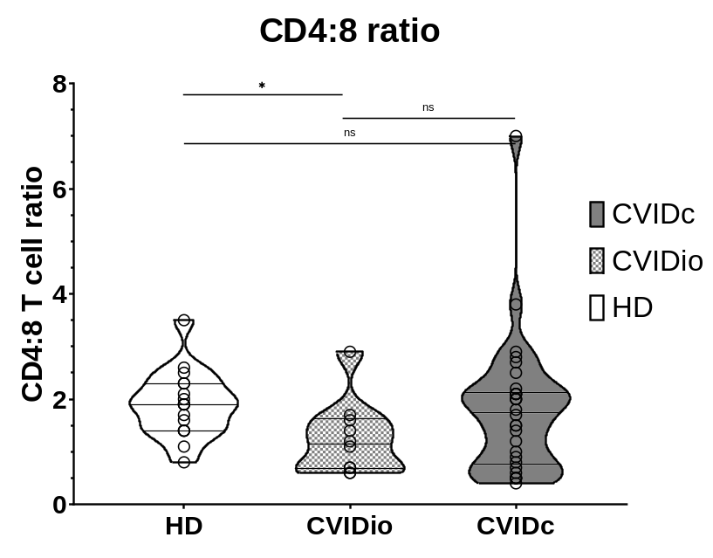

Fig. S3 IL-2 and perforin staining of CD4 T cells (top row), EM2 CD8 T cells (middle row) and EM3 CD8 T cells (bottom row) as assessed by CyTOF (n = 12, 4 HD, 4 CVIDio, 4 CVIDc)
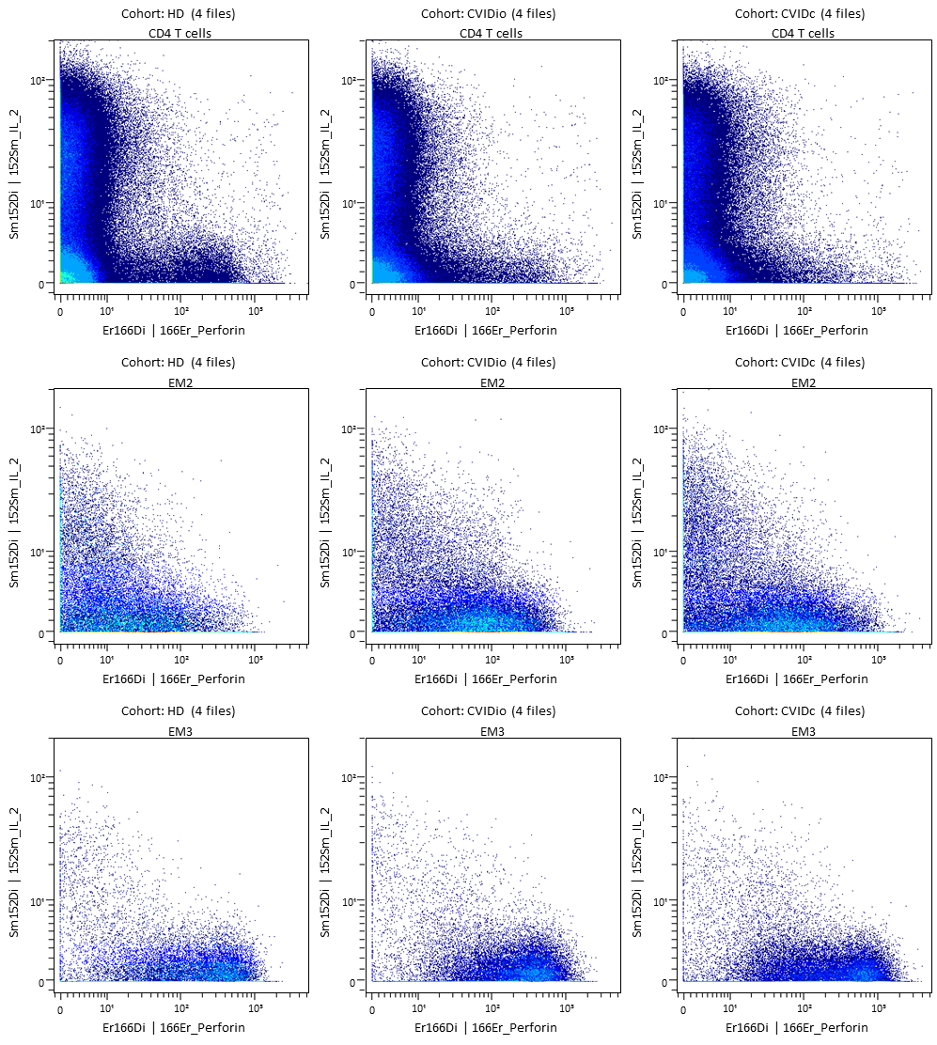

Fig. S4 CyTOF-derived cluster proportion in all samples, as % of CD8 T cells (n = 12, 4 HD, 4 CVIDio, 4 CVIDc)
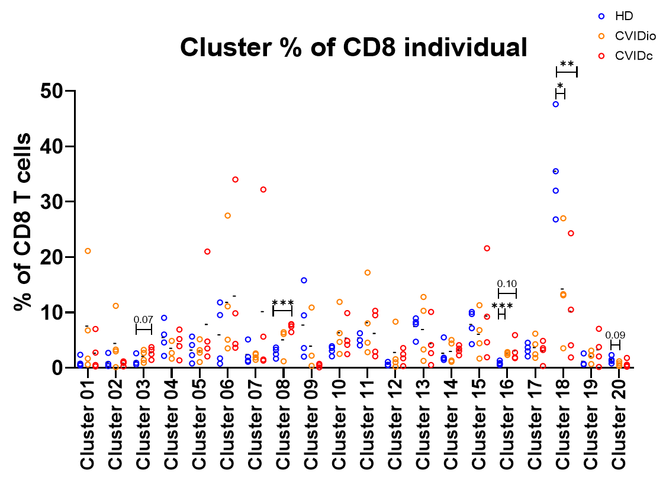

Fig. S5 FES score of all samples within each CyTOF-derived cluster (n = 12, 4 HD, 4 CVIDio, 4 CVIDc)
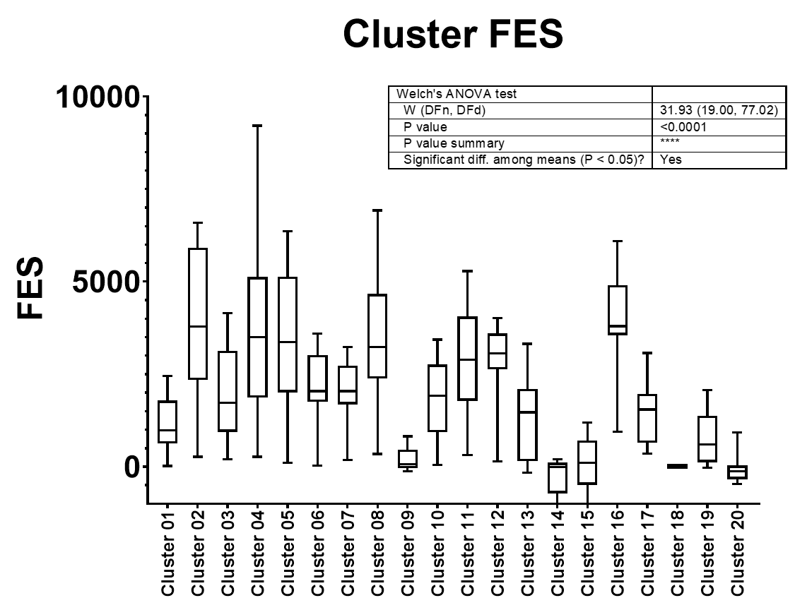
Fig. S6 Expression of PD1, IL-10, CD127 and FoxP3 in CD8 clusters 13, 16, 18 and bulk CD4 T cells as assessed by CyTOF (n = 12, 4 HD, 4 CVIDio, 4 CVIDc)
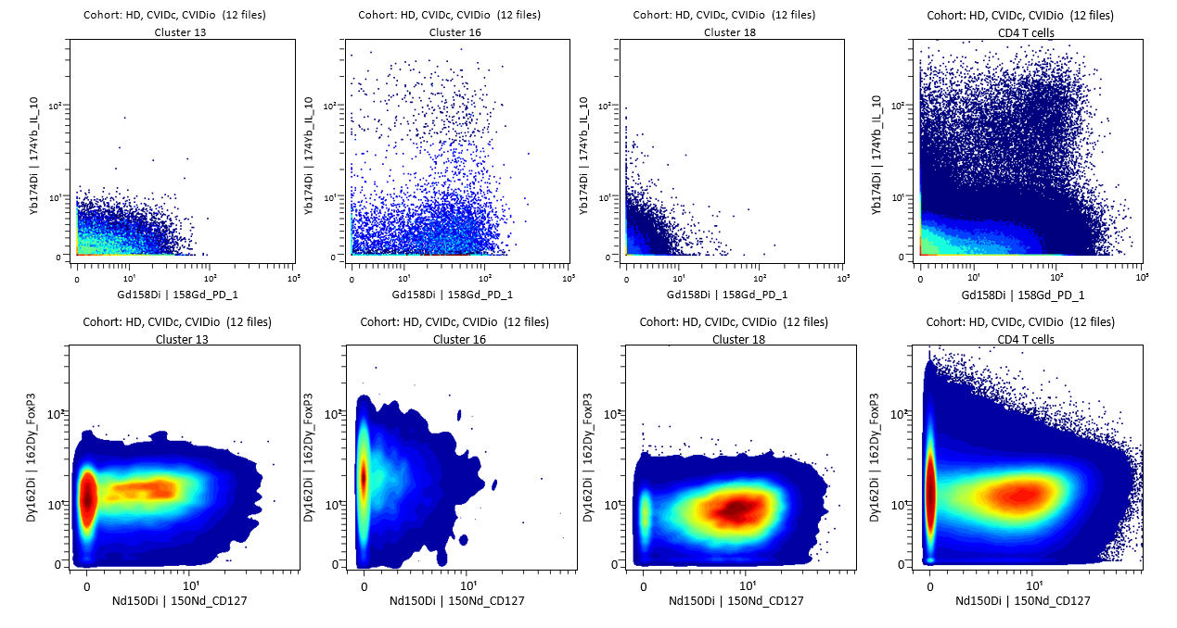

Fig. S7 Expression of markers in all samples stained with flow cytometry (n = 57, 17 HD, 11 CVIDio, 29 CVIDc). Color scale shows Z-score, missing values are white with a cross-through
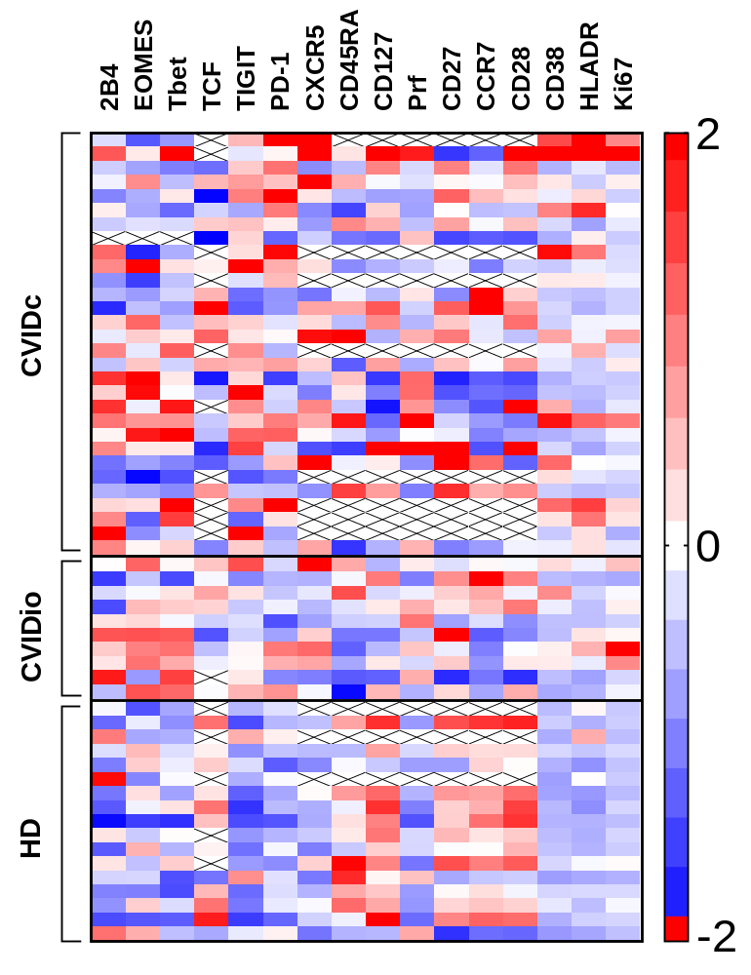
Fig. S8 Expression of PD1, CD127 and TIGIT in naive, EM, EM3, TEMRA and CD27-28- TEMRA CD8 T cells assessed by flow cytometry (n = 57, 17 HD, 11 CVIDio, 29 CVIDc)
