Supplementary File

Outcomes of patients with initial acute respiratory failure on veno-venous extracorporeal membrane oxygenation (ECMO) requiring additional circulatory support by VVA ECMO

Rolf Erlebach¹*, Lennart Wild²*, Benjamin Seeliger³*, Ann-Kathrin Rath⁴, Rea Andermatt¹, Daniel Hofmaenner¹, Jens-Christian Schewe², Christoph Camille Ganter¹, Christian Putensen², Christian Kuehn⁵, Ruslan Natanov⁵, Tobias Welte³, Marius M Hoeper³, Pedro David Wendel-Garcia¹, Sascha David^{1#}, Christian Bode^{2#}, Klaus Stahl^{4#}

Running Title: Veno-venous-arterial ECMO in ARDS
*, # contributed equally

¹ Institute of Intensive Care Medicine, University Hospital Zurich, Zurich, Switzerland
² Department of Anaesthesiology and Intensive Care Medicine, University Hospital Bonn,
Bonn, Germany
³ Department of Respiratory Medicine and German Centre of Lung Research (DZL),
Hannover Medical School, Hannover, Germany
⁴ Department of Gastroenterology, Hepatology and Endocrinology, Hannover Medical School,
Hannover, Germany
⁵ Department of Cardiothoracic, Transplantation and Vascular Surgery (HTTG), Hannover
Medical School, Hannover, Germany

Table S1: Missing data of variables in Table 1: Patient characteristic

Variable | % Missing
Age, years | 0
Sex, female | 0
Body-mass index, kg/m2 | 0
ARDS, primary | 0
Resp-Score diagnosis | 4
Preserve Score | 36
Sepsis | 0
Comorbidities
Adipositas | 0
COPD | 0
Arterial hypertension | 0
Coronary artery disease | 0
Congestive heart failure | 0
Diabetes mellitus | 0
Chronic kidney disease | 0
Immunosuppression | 0
Solid organ transplantation | 0

Percentage of missing data is given for each variable. ARDS: acute respiratory distress syndrome, COPD: chronic obstructive pulmonary disease.

Table S2: Missing data of variables in Table 2: Clinical condition and organ support before VV ECMO implantation and VVA ECMO upgrade
Variables | % Missing  VV ECMO | % Missing  VVA ECMO
Primary VVA ECMO |  | 0
VV ECMO to VVA ECMO cannulation, hours |  | 0
CPR before VVA ECMO |  | 0
Hospital admission to cannulation, days | 0 | 0
ICU admission to cannulation, days | 0 | 0
iMV to cannulation, days | 0 | 0
SOFA score | 13 | 3
Respiratory support | 2 | 0
PEEP, cmH₂O | 17 | 10
Minute ventilation, L/min | 32 | 25
Plateau pressure, cmH₂O | 40 | 26
SaO₂, % | 9 | 11
PaO₂/FiO2, mmHg | 8 | 8
PaCO₂, mmHg | 9 | 11
pH | 13 | 12
Lactate, mmol/L | 13 | 14
Inhalative nitric oxide | 6 | 5
Norepinephrine | 6 | 1
Norepinephrine dose, μg/kg/min | 15 | 5
Epinephrine | 8 | 1
Epinephrine dose, μg/kg/min | 8 | 5
Dobutamine | 8 | 1
Dobutamine dose, μg/kg/min | 8 | 3
Vasoactive-inotropic score | 15 | 7
LVEF | 53 | 49
RVEF | 53 | 47
Renal replacement therapy (n) | 2 | 0

Percentage of missing data is given for each variable. CPR: cardiopulmonary resuscitation, FiO2: fraction of inspired oxygen, HFOT: high-flow oxygen therapy, ICU: intensive care unit, iMV: invasive mechanical ventilation, LVEF: left ventricular ejection fraction, NIV: non-invasive ventilation, PaCO2: partial pressure of carbon dioxide, PaO2: partial pressure of oxygen, PEEP: positive end-expiratory pressure, RVEF: right ventricular ejection fraction, SaO2: arterial oxygen saturation, SOFA: Sequential Organ Failure Assessment

Table S3: Missing data of variables in Table 3: ECMO configuration, setting and complications
Variables | % Missing
ECMO cannulation (N = 73)
Venous drainage site | 0
Venous return site | 0
Arterial return site | 0
Antegrade leg perfusion cannula | 2
VV ECMO settings (N = 53)
Pump speed, rpm | 30
Blood flow, L/min | 13
Sweep gas flow, L/min | 17
FsO2 | 13
VVA ECMO settings (N = 73)
Pump speed, rpm | 21
Total blood flow, L/min | 0
Arterial blood flow, L/min | 15
Sweep gas flow, L/min | 7
Complications of VVA ECMO therapy (N = 73)
Complications during insertion | 0
Complications during insertion requiring surgery | 0
≥4 red blood cell concentrates / 24 hours | 0
Major intracranial hemorrhage | 0
Minor intracranial hemorrhage | 0
Thromboembolic events | 0
Leg ischemia | 0
Other complications | 0

Percentage of missing data is given for each variable. FsO2: Sweep gas inlet oxygen fraction. Major intracranial hemorrhage: requiring neurosurgical intervention or resulting in any neurological deficit. Minor intracranial hemorrhage: occasionally identified on cerebral imaging. Rpm: revolutions per minute.

Table S4: Missing data of Table 4: Outcome and Follow-up
Variables | % Missing
ECMO runtime, days | 1
VVA ECMO runtime, days | 0
ICU length of stay, days | 4
Hospital length of stay, days | 4
ICU mortality | 0
Hospital mortality | 0
Lung Transplantation | 0
Mortality at 1 year | 7
Mortality at 2 years | 8
Organ specific outcome at 2 years (N = 28)
Long-term oxygen therapy | 7
Chronic kidney disease | 7
Congestive heart failure | 25

Percentage of missing data is given for each variable. ICU: intensive care unit, KDIGO: Kidney Disease: Improving Global Outcomes, NYHA: New York Heart Association

Figure S1: Survival function from VVA ECMO cannulation stratified by renal replacement therapy
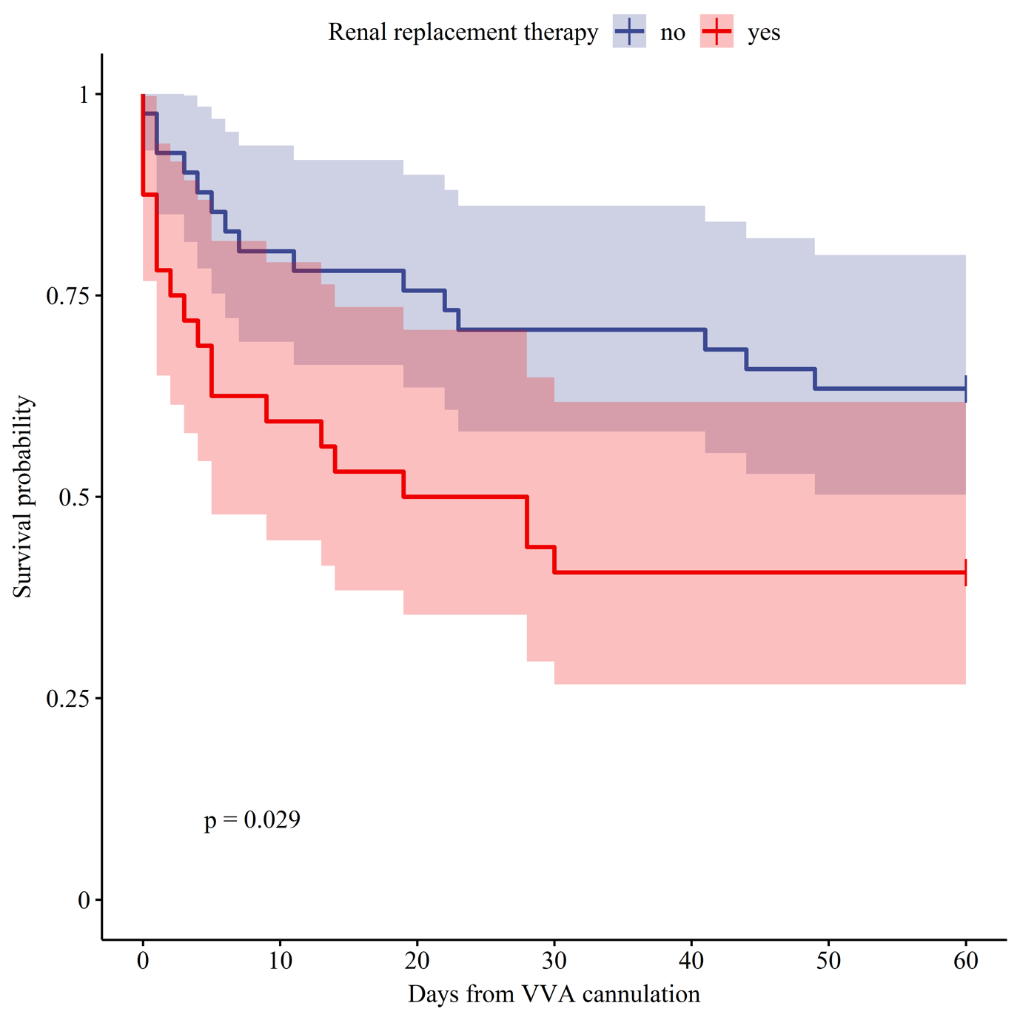
SOFA: Sequential Organ Failure Assessment, VIS: Vasoactive inotropic score

