Supplementary Information (SI) for
A cluster-based phosphor against thermal quenching via dynamic metallic bonding

Miao Li,^{1,3} Xiancheng Pan,^{2,3} Huixian Miao,¹ Jing Wu,¹ Zongsu Yu,¹ Luying Liu,¹ Wenjiang Zhaxi,¹ Xiao Ma,¹ Shenlong Jiang,² Wei Huang,*^{,1} Qun Zhang,*^{,2} & Dayu Wu*^{,1}

¹Jiangsu Key Laboratory of Advanced Catalytic Materials and Technology, Advanced Catalysis & Green Manufacturing Collaborative Innovation Center, School of Petrochemical Engineering, Changzhou University, Changzhou, Jiangsu 213164, P. R. China.
²Hefei National Laboratory for Physical Sciences at the Microscale, Department of Chemical Physics, Synergetic Innovation Center of Quantum Information & Quantum Physics, University of Science and Technology of China, Hefei, Anhui 230026, P. R. China.
³These authors contributed equally to this work.

*Correspondence should be addressed to D.W. (wudy@cczu.edu.cn) or to W.H. (whuang@cczu.edu.cn) or to Q.Z. (qunzh@ustc.edu.cn).

Content
Experimental Section
Supplementary Figure 1. Different thermal quenching modes of PL materials.
Supplementary Figure 2. FT-IR spectra of ligand of bpp and complex bppCu₄I₄P₄.
Supplementary Figure 3. TGA diagram of bppCu₄I₄P₄.
Supplementary Figure 4. Calculated XRD patterns at different temperatures.
Supplementary Figure 5. Powder XRD patterns at different temperatures.
Supplementary Figure 6. The UV-vis absorption spectra.
Supplementary Figure 7. Temperature-dependent Raman spectra of bppCu₄I₄P₄.
Supplementary Figure 8. The CPMAS ³¹P NMR spectra at different temperatures.
Supplementary Figure 9. The measurement of PLQY for bppCu₄I₄P₄.
Supplementary Figure 10. The PL excitation spectra.
Supplementary Figure 11. PL decay curve of bppCu₄I₄P₄ at 298 K.
Supplementary Figure 12. Temperature-dependent fs-TA spectra of bppCu₄I₄P₄.
Supplementary Figure 13. Temperature-dependent PL emission spectra.
Supplementary Figure 14. Electroluminescent (EL) spectra of bppCu₄I₄P₄-based LED.
Supplementary Figure 15. Electroluminescent (EL) spectra of (Sr,Ba)₂SiO₄:Eu²⁺-based LED.
Supplementary Table 1. The crystallographic data at the different temperature.
Supplementary Table 2. The selected bond distances (Å) at different temperature.
Supplementary Table 3. The EL parameters of bppCu₄I₄P₄ LED at different currents.
Supplementary Table 4. The EL parameters of bppCu₄I₄P₄-based wLED at different currents. Supplementary Table 5. The EL parameters of (Sr,Ba)₂SiO₄:Eu²⁺ LED at different currents.
Supplementary Table 6. The EL parameters of YAG:Ce³⁺ wLED at different currents.
Supplementary References

Experimental Section
Materials Preparation
All chemicals and reagents were purchased from Aldrich and used as received without further purification. Copper(I) iodide and 1,3-bis(diphenylphosphino)propane (PPh₂(CH₂)₃PPh₂, bpp) were purchased from Aldrich and used as received. Commercial phosphors, such as YAG:Ce³⁺, BAM:Eu²⁺ and (Sr,Ba)₂SiO₄:Eu²⁺, were obtained from commercial sources. Light-emitting diodes (LEDs) chips used for both the single-component and white electroluminescence were provided by San'an Optoelectronics Co., Ltd.
Synthesis of [Cu₄I₄(PPh₂(CH₂)₃PPh₂)₂] (bppCu₄I₄P₄)
A mixture of CuI (19 mg, 0.1 mmol), bpp (20.6 mg, 0.05 mmol), CH₃CN (4 mL) and H₂O (4 mL) was sealed in a 15-mL Telflon-lined autoclave, which was heated to 150 °C for 4 days. After slowly cooling to room temperature, it was filtered to obtain colorless crystals, which were washed with distilled water and acetonitrile and finally dried in air. Yield: 65%. Infrared (IR) analysis (KBr, cm⁻¹): 438(w), 479(m), 499(m), 510(m), 692(s), 744(s), 843(w), 917(w), 969(w), 999(m), 1025(s), 1038(m), 1067(w), 1092(s), 1114(w), 1155(w), 1185(m), 1201(w),1269(m), 1306(m), 1328(w), 1379(s), 1431(s), 1479(s), 1581(s),1661(w), 1754(w), 1812(w), 1885(w), 1953(w). Anal. Calcd. for C₅₄H₅₂Cu₄I₄P₄: C, 40.88; H, 3.30. Found: C, 40.90; H, 3.28.
Spectroscopic Measurements
The IR spectra of polycrystalline solids were performed on a Nicolet Magna-IR750 spectrophotometer in the 4000−400 cm⁻¹ region (w, weak; b, broad; m, medium; s, strong) by KBr disc. UV−visible studies were performed in PerkinElmer Lambda 950 UV−vis instrument. H NMR measurements were carried out on a Bruker DMX500 spectrometer using tetramethylsilane (TMS) as an internal standard. Elemental analyses (C, H and N) were conducted with a Perkin Elmer 2400 analyzer. Fluorescence spectra were recorded on an Edinburgh FS5 instrument. The slit width was fixed (0.5 nm) for bppCu₄I₄P₄ for both excitation and emission during performing the temperature-dependent spectral experiments. Emission and excitation spectra were corrected against the spectral response of the monochromator and the detector, using typical correction spectra provided by the manufacturer. The absolute emission quantum yield (QY) values were measured at room temperature using an Edinburgh quantum yield measurement system, equipped with a 150-W xenon lamp coupled to a monochromator for wavelength discrimination, an integrating sphere as the sample chamber and a multichannel analyzer for signal detection. PL decays were recorded on an Edinburgh FLS980 steady-state fluorimeter (using the time-correlated single-photon counting (TCSPC) technique) and a pulsed xenon lamp as the excitation source.
Temperature-Dependent Ultrafast Transient Absorption (TA) Measurements
The femtosecond time-resolved transient absorption (fs-TA) measurements were performed on an EOS pump–probe system (Ultrafast Systems LLC) in combination with an amplified femtosecond laser system (Coherent). The pump pulses (~56 μW at the sample) were delivered by an optical parametric amplifier (TOPAS-800-fs), which was excited by a Ti:sapphire regenerative amplifier (Legend Elite-1K-HE; center wavelength 800 nm, pulse duration 35 fs, pulse energy 3 mJ, repetition rate 1 kHz) seeded with a mode-locked Ti:sapphire laser system (Micra 5). The WLC probe pulses (400–800 nm) were generated by focusing a picosecond Nd:YAG laser beam into a photonic crystal fiber. The time delays (from 8 ns up to 100 μs) between the pump and probe pulses were controlled by a digital delay generator. The IRF was determined to be ~100 ps. The temporal and spectral profiles (chirp-corrected) of the pump-induced differential transmission of the WLC probe light were visualized by an optical fiber-coupled multichannel spectrometer (with a CMOS sensor) and further processed by the Surface Xplorer software. The samples sandwiched between two 1-mm quartz plates were placed in an Oxford instrument that provided a temperature-varying environment (77‒350 K).
In situ Confocal Raman (CR) Spectroscopic Characterization
The CR was carried out under ambient conditions on a WITec alpha300 RAS+ confocal Raman microscope (WITec GmbH, Germany) equipped with a diode-pumped continuous-wave (CW) laser source (532 nm, Cobalt Laser). The excitation laser was reflected by the BragGrate notch filters (OptiGrate Corp.) into the objective (100x, NA = 0.90) and then focused on the sample. A diffraction-limited spot size of the laser was measured to be about 300 nm. A piezo-stage was employed to control the sample movement. The Raman signal was filtered by the BragGrate notch filters and dispersed by a 600-mm focal-length spectrometer with the 150, 600 or 1800 grooves/mm grating (UHTS 300). The collected signals were eventually detected using a Back-illuminated EMCCD (DU970N-BV, Andor) thermoelectrically cooled to -60 ºC. The spectral bandwidth of ~5–10 cm⁻¹ was adopted to ensure that the Rayleigh line can be suppressed for acquiring the low-wavenumber Raman spectra.
Solid-state Nuclear Magnetic Resonance (NMR) Spectroscopy
The solid-state static ⁶³Cu NMR spectra were acquired at a magnetic field of 9.4 T on a Bruker AVANCE III 400WB spectrometer. The wideband uniform rate and smooth truncation Carr–Purcell Meiboom–Gill (WURST-QCPMG) pulse sequence was applied, with an inter-pulse delay of 1 s. The WURST pulse length was set at 50 µs, with an excitation bandwidth of 500 kHz. The chemical shifts were externally referenced to CuI at 0 ppm. The ³¹P signals were acquired at the resonance frequency of 161.98 MHz using a 4 mm double-resonance probe. The magic-angle spinning rate was set at 10 kHz. The ³¹P chemical shifts were referenced to a solid sample of NH₄H₂PO₄ at 0.81 ppm. The temperature was controlled by a Bruker temperature controller with a deviation of ±1.0 K. The 20-min period was found sufficient to allow temperature stabilization before data collection.
Electron Paramagnetic Resonance (EPR) Spectroscopy at Varied Temperatures
The EPR spectra were recorded on a JEOL JES-FA200 X-band EPR spectrometer. The g values were determined using a 2,2-diphenyl-1-picrylhydrazyl (DPPH) standard. The temperature control of the experimental environment came from the temperature-rise/temperature-control module of JEOL.
Crystal-Structure Determination
The diffraction intensity data of bppCu₄I₄P₄ at different temperatures (in the sequence of 100→200→250→300→325→350→375→400→100 K) were collected on a Bruker APEX-2 CCD with graphite-monochromated MoK_{α} radiation (λ = 0.71073 Å). Data collection, data reduction and cell refinement were performed by using the Bruker Instrument Service v4.2.2 and SAINTV 8.34A softwares.^{1,2} Structures were resolved by direct methods using the SHELXS program, and the refinement was performed using SHELXL based on F² through full-matrix least-squares routine.³ Absorption corrections were applied upon using multiscan program SADABS.⁴ Hydrogen atoms of organic ligands were generated geometrically by the riding mode, and all the non-hydrogen atoms were refined anisotropically through full-matrix least-squares technique on F² with the SHELXTL program package.^{5,6} Crystallographic data for the structures reported in this paper have been deposited with the Cambridge Crystallographic Data Centre under reference numbers CCDC 2150238‒2150246. These data can be obtained free of charge via www.ccdc.cam.ac.uk/conts/retrieving.html (or from the Cambridge Crystallographic Data Centre, 12 Union Road, Cambridge CB2 1EZ, UK).
PXRD pattern analysis
Powder X-ray diffraction (PXRD) measurements were performed on a Bruker D8 Avance X-ray powder diffractometer with the Cu Kα (1.5418 Å) source. The temperature-dependent data (298–493 K) were collected in a 2θ range of 3–50° with a scan speed of 1°/min. The operating power was 40 kV/40 mA.
TGA analysis
Thermogravimetric (TGA) analyses of samples were performed on the Labsys Evo thermal gravimetric analyzer under the atmosphere of nitrogen. About 5 mg of samples were loaded onto a platinum sample pan and heated from room temperature to 900 °C at a rate of 10 °C/min.
LED devices fabrication
The dppCu₄I₄P₄ powders were mixed with stoichiometric pouring sealant (ZWL8820) and then stirred for 10 min. After deaeration in vacuum oven at room temperature, the mixture was covered on a fully packaged Epileds InGaN LED chips with an emission wavelength of about 360 nm. The forward bias current of the LEDs was in the range of 100−1000 mA. Electroluminescence (EL) spectra of the LEDs were recorded at room temperature with an Everfine HAAS-2000.^{7,8} For the purpose of light collection, the LEDs were placed inside an integrating sphere (diameter 30 cm) coupled to a high-accuracy array spectroradiometer (wavelength accuracy <0.3 nm) and a programmable test power LED 300E.⁹ For a warm white pc-LED, a UV LED chip was integrated with commercial blue phosphor (BAM:Eu²⁺) and bppCu₄I₄P₄ phosphor. The weight ratio of BAM:Eu²⁺ and bppCu₄I₄P₄ was about 1:1.
Supplementary Figure 1 | Different thermal quenching modes of PL materials. a, Positive TQ. b, Zero TQ. c, Negative TQ. The PL temperature dependences are also depicted alongside.

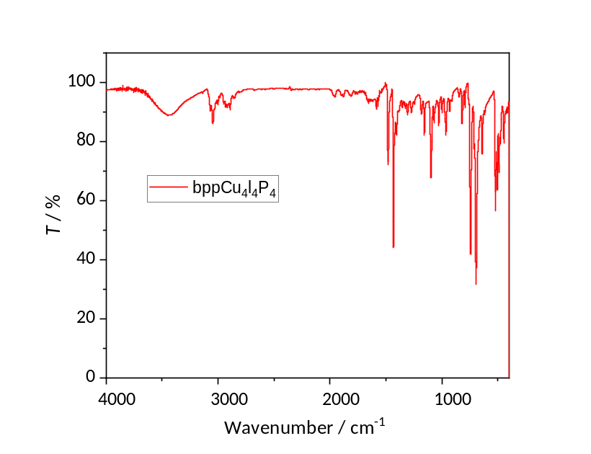
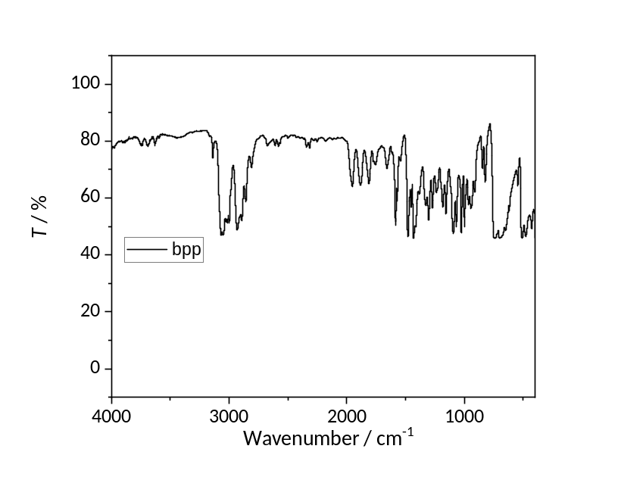
Supplementary Figure 2 | FT-IR spectra of the bppCu₄I₄P₄ complex and the bpp ligand.

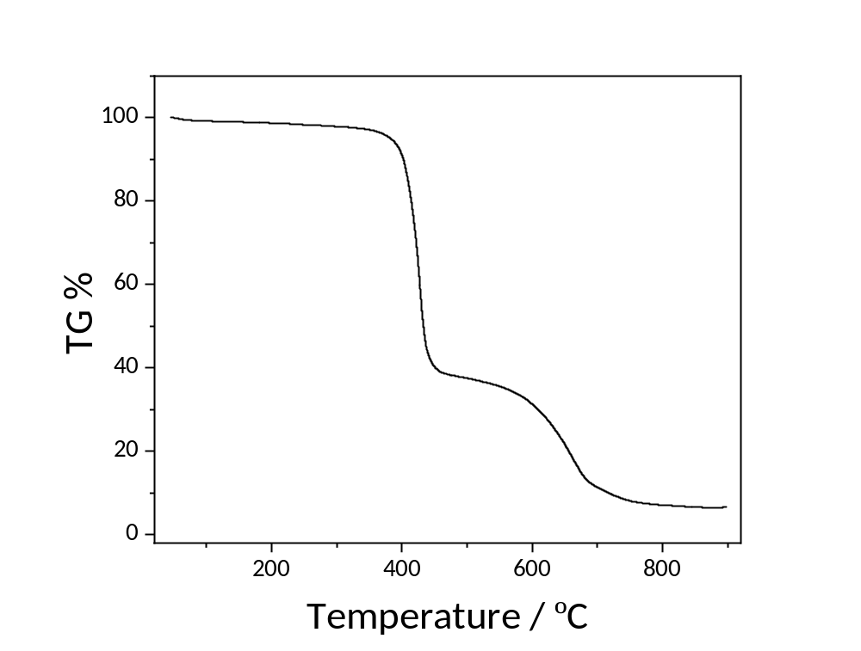
Supplementary Figure 3 | TGA diagram of bppCu₄I₄P₄.

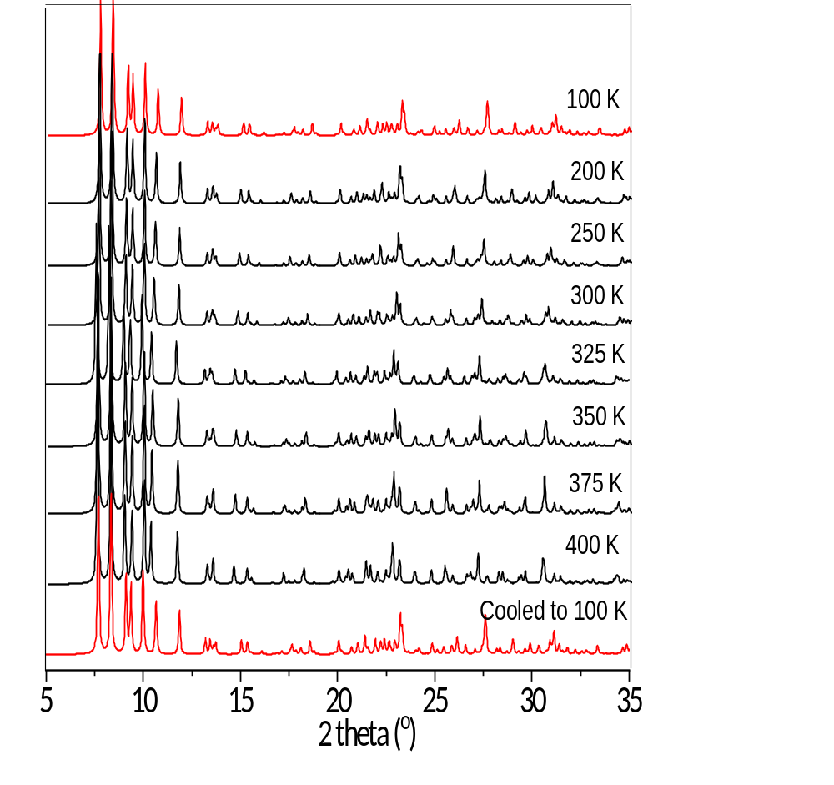
Supplementary Figure 4 | Calculated XRD patterns at different temperatures from the single-crystal XRD data.

Supplementary Figure 5 | Powder XRD patterns at different temperatures.

Supplementary Figure 6 | The UV–Vis absorption spectra of bpp and bppCu₄I₄P₄ at different temperatures (along with that of transparent tape as the blank). The spectra of the Cu complex consist of several strong absorption bands in the NUV (λ < 300 nm), which can be assigned to spectrally overlapping ligand-centered π–π* transitions of the bpp ligand.

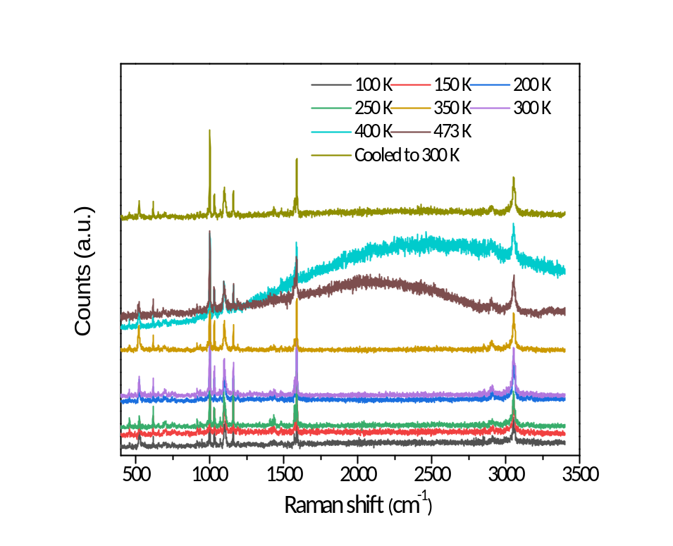
Supplementary Figure 7 | Temperature-dependent Raman spectra of bppCu₄I₄P₄ in low- (top) and high-frequency (bottom) regions.

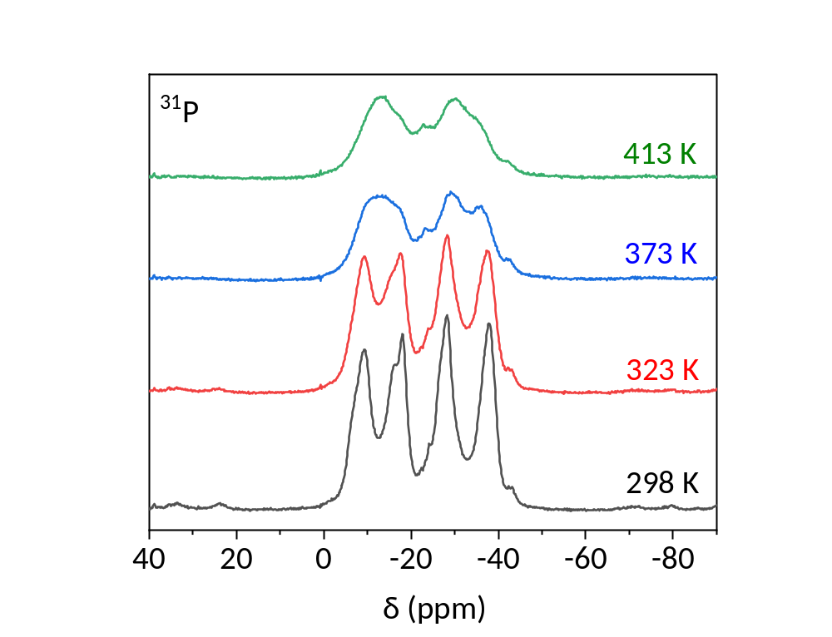
Supplementary Figure 8 | CPMAS ³¹P NMR spectra at different temperatures.

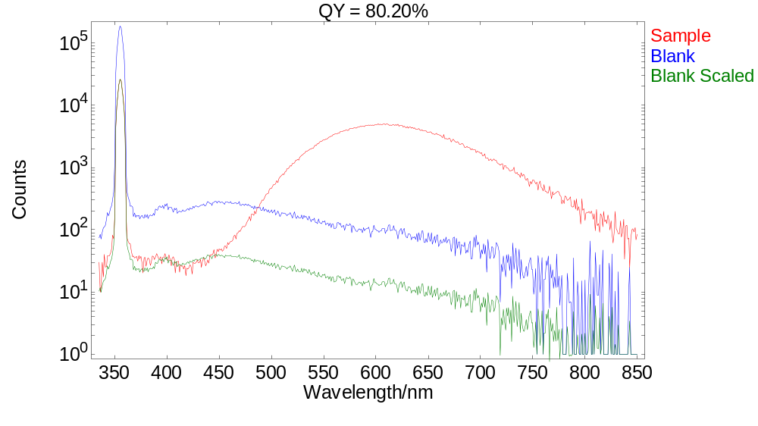
Supplementary Figure 9 | The measurement of PLQY for bppCu₄I₄P₄.

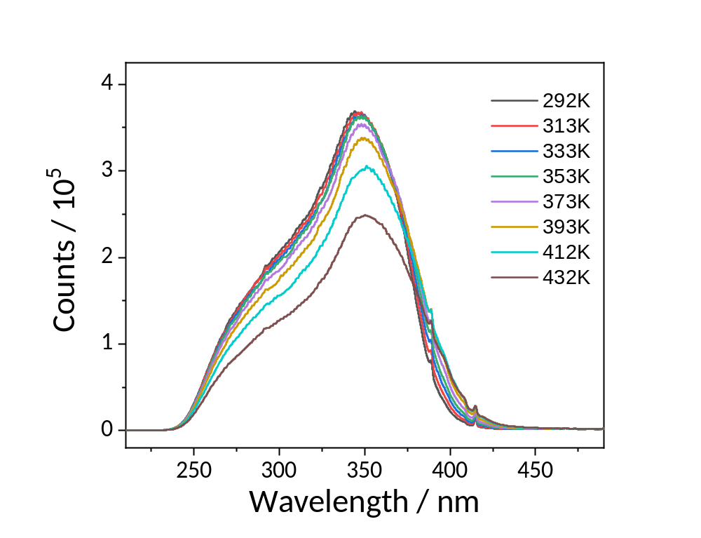
Supplementary Figure 10 | PL excitation spectra (292–432 K) for bppCu₄I₄P_{4.}
Supplementary Figure 11 | PL decay curve of bppCu₄I₄P₄ at 298 K.

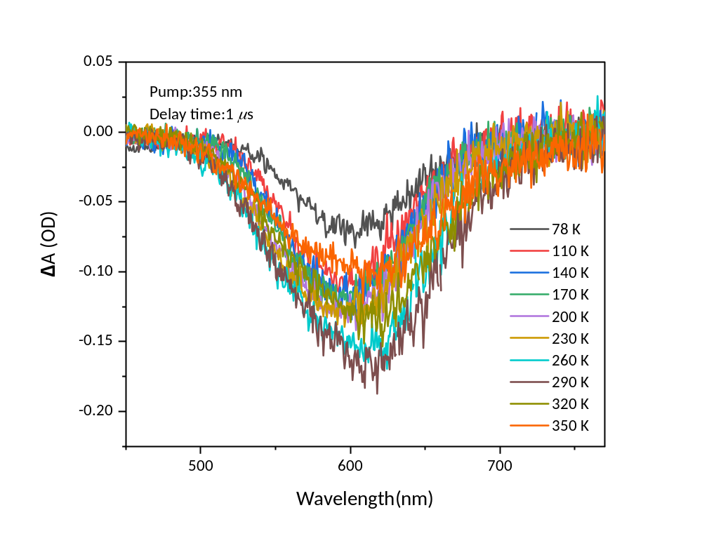
Supplementary Fig. 12 | Temperature-dependent femtosecond time-resolved transient absorption (fs-TA) spectra of bppCu₄I₄P₄.

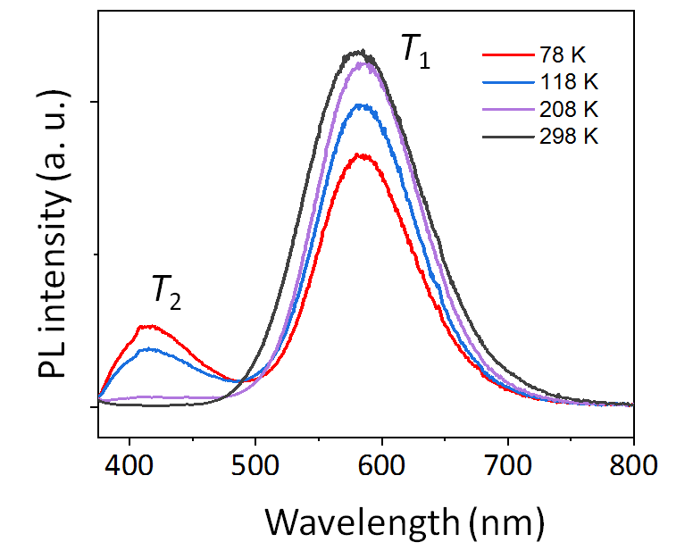
Supplementary Figure 13 | Temperature-dependent PL emission spectra below 298 K.

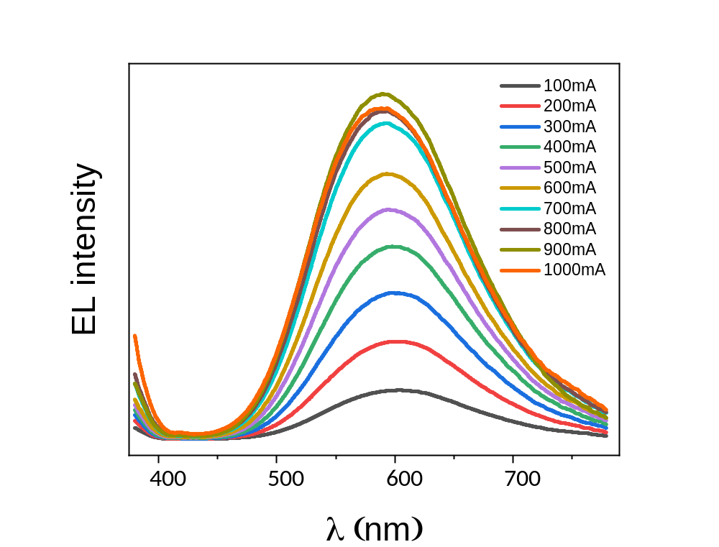
Supplementary Figure 14 | Electroluminescence (EL) spectra of bppCu₄I₄P₄-based LED with a 365-nm LED chip under the high-flux operating currents of 100–1,000 mA.

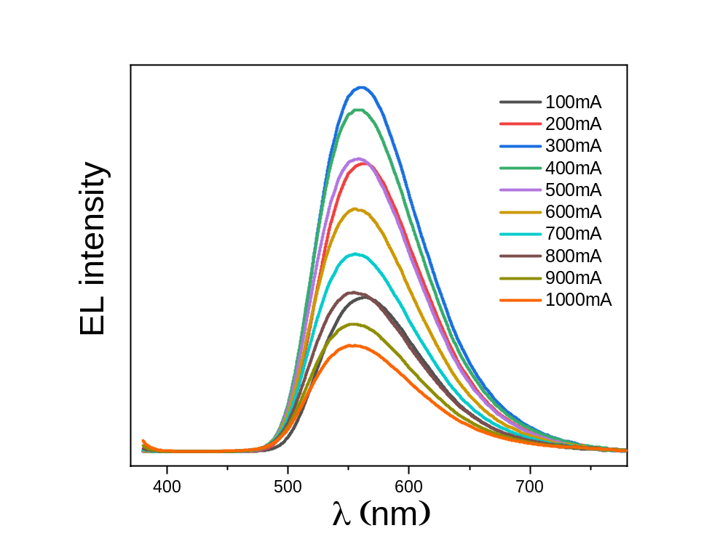Supplementary Figure 15 | Electroluminescence (EL) spectra of (Sr,Ba)₂SiO₄:Eu²⁺-based LED with a 365-nm LED chip under the high-flux operating currents of 100–1,000 mA.
Supplementary Table 1 | The crystallographic data at different temperatures.

Complex | C₁₀₈H₁₀₄Cu₈I₈P₈ | C₅₄H₅₂Cu₄I₄P₄ |  |  |  |  |  |  | C₁₀₈H₁₀₄Cu₈I₈P₈
Temp. (K) | 100 | 200 | 250 | 300 | 325 | 350 | 375 | 400 | Cooled to 100 K
F.W. | 3173.19 | 1586.59 |  |  |  |  |  |  | 3173.19
Crystal system | monoclinic
Space group | P2/c | C2/c |  |  |  |  |  |  | P2/c
a [Å] | 26.8741(3) | 23.7991(6) | 23.9019(6) | 24.0306(6) | 24.0848(6) | 24.1637(6) | 24.2597(6) | 24.3684(6) | 26.8685(3)
b [Å] | 11.9434(10) | 12.0136(2) | 12.0396(2) | 12.0686(2) | 12.0693(2) | 12.0837(2) | 12.0858(2) | 12.0881(2) | 11.94570(10)
c [Å] | 33.8548(4) | 19.4807(4) | 19.5200(4) | 19.5844(4) | 19.5948(4) | 19.6452(4) | 19.6699(4) | 19.7195(4) | 33.8560(4)
α [º] | 90
β [º] | 101.475(10) | 103.986(2) | 104.248(2) | 104.574(2) | 104.723(2) | 104.949(2) | 105.255(2) | 105.626(2) | 101.4770(10)
γ [º] | 90
V [Å³] | 10649.1(2) | 5404.7(2) | 5444.5(2) | 5497.0(2) | 5508.9(2) | 5542.0(2) | 5564.0(2) | 5594.0(2) | 10649.2(2)
Z | 4
F (000) | 6112 | 3056 | 3056 | 3056 | 3056 | 3056 | 3056 | 3056 | 6112
R₁ª/wR₂^{b}[I>2σ(I)] | 0.0504/ 0.0645 | 0.0304/0.0593 | 0.0320/0.0587 | 0.0321/0.0578 | 0.0335/0.0587 | 0.0373/0.0628 | 0.0396/0.0655 | 0.0400/0.0753 | 0.0311/0.0636
R₁/wR₂ (all date) | 0.0293/ 0.0581 | 0.0253/0.0572 | 0.0261/0.0565 | 0.0256/0.0556 | 0.0260/0.0559 | 0.0276/0.0593 | 0.0288/0.0619 | 0.0297/0.0708 | 0.0537/0.0709
GOF on F² | 1.022 | 1.092 | 1.063 | 1.028 | 1.015 | 1.040 | 1.080 | 1.043 | 1.036
ªR₁ =∑||F_{o}| ‒ |F_{c}||/∑|F_{o}|. ^{b}wR₂ = {∑[w(F_{o}² ‒ F_{c}²)²]/∑[w(F_{o}²)²]}^{1/2}
Supplementary Table 2 | The selected bond distances (Å) for bppCu₄I₄P₄ at different temperatures.

Temp. (K) | 100 | Cooled to 100 K |  | 200 | 250 | 300 | 325 | 350 | 375 | 400
Cu1P1 | 2.2658(8) | 2.2649(9) | Cu1P2 | 2.2596(8) | 2.2610(8) | 2.2612(9) | 2.2597(9) | 2.2591(10) | 2.2576(10) | 2.2592(10)
Cu1I1 | 2.6492(4) | 2.6494(4) | Cu1I2 | 2.6736(4) | 2.6734(4) | 2.6762(4) | 2.6743(4) | 2.6774(5) | 2.6771(5) | 2.6793(5)
Cu1I3 | 2.6552(4) | 2.6555(4) | Cu1I2 | 2.6851(4) | 2.6878(5) | 2.6923(4) | 2.6939(5) | 2.6973(5) | 2.7014(5) | 2.7074(6)
Cu1Cu3 | 2.7354(5) | 2.7361(5) | Cu1I1 | 2.7631(4) | 2.7705(4) | 2.7803(4) | 2.7826(5) | 2.7895(5) | 2.7936(5) | 2.7975(6)
Cu1I4 | 2.7792(4) | 2.7783(4) | Cu1Cu2 | 2.8393(5) | 2.8683(5) | 2.9040(5) | 2.9177(5) | 2.9379(6) | 2.9557(6) | 2.9745(7)
Cu1Cu4 | 2.8788(5) | 2.8790(5) | Cu1Cu2 | 2.9187(5) | 2.9437(6) | 2.9709(6) | 2.9816(6) | 2.9951(6) | 3.0070(7) | 3.0175(7)
Cu2P5 | 2.2671(8) | 2.2678(9) | Cu1Cu1 | 2.9703(8) | 3.0069(8) | 3.0507(8)
Cu2I4 | 2.6367(4) | 2.6367(5) | Cu2P1 | 2.2655(8) | 2.2656(8) | 2.2668(8) | 2.2651(8) | 2.2657(9) | 2.2655(9) | 2.2648(9)
Cu2I2 | 2.6601(4) | 2.6593(4) | Cu2I1 | 2.6454(4) | 2.6468(4) | 2.6512(4) | 2.6497(4) | 2.6539(5) | 2.6547(5) | 2.6577(5)
Cu2I3 | 2.7719(4) | 2.7709(4) | Cu2I2 | 2.6553(4) | 2.6569(4) | 2.6615(4) | 2.6611(4) | 2.6647(5) | 2.6661(5) | 2.6688(5)
Cu2Cu4 | 2.8471(5) | 2.8475(5) | Cu2I1 | 2.7773(5) | 2.7787(5) | 2.7783(5) | 2.7761(5) | 2.7743(5) | 2.7714(5) | 2.7674(6)
Cu2Cu3 | 2.8628(5) | 2.8622(5) | P1C13 | 1.821(4) | 1.824(3) | 1.820(3) | 1.816(4) | 1.815(4) | 1.813(4) | 1.815(4)
Cu3P8 | 2.2589(8) | 2.2592(9) | P1C19 | 1.824(3) | 1.825(4) | 1.823(3) | 1.823(3) | 1.816(3) | 1.818(3) | 1.815(5)
Cu3I2 | 2.6792(4) | 2.6786(4) | P1C25 | 1.837(3) | 1.837(3) | 1.844(3) | 1.842(3) | 1.842(4) | 1.844(4) | 1.842(4)
Cu3I1 | 2.6817(4) | 2.6812(4) | P2C1 | 1.825(3) | 1.826(3) | 1.828(3) | 1.827(3) | 1.827(3) | 1.825(4) | 1.824(4)
Cu3I3 | 2.7306(4) | 2.7308(4) | P2C27 | 1.833(3) | 1.836(3) | 1.836(3) | 1.841(3) | 1.841(3) | 1.841(3) | 1.848(4)
Cu3Cu4 | 2.8944(6) | 2.8943(6) | P2C7 | 1.822(3) | 1.825(3) | 1.824(3) | 1.821(3) | 1.821(3) | 1.821(3) | 1.823(4)
Cu4P4 | 2.2643(8) | 2.2632(9)
Cu4I2 | 2.6716(4) | 2.6714(4)
Cu4I1 | 2.6775(4) | 2.6771(4)
Cu4I4 | 2.7694(4) | 2.7701(4)
Cu5P7 | 2.2651(8) | 2.2656(9)
Cu5I5 | 2.6542(4) | 2.6536(4)
Cu5I6 | 2.6543(4) | 2.6542(4)
Cu5Cu6 | 2.7528(5) | 2.7525(5)
Cu5I6 | 2.7723(4) | 2.7715(4)
Cu5Cu6 | 2.8283(5) | 2.8277(5)
Cu6P6 | 2.2599(8) | 2.2613(9)
Cu6I5 | 2.6750(4) | 2.6749(4)
Cu6I5 | 2.6911(4) | 2.6907(4)
Cu6I6 | 2.7398(4) | 2.7398(4)
Cu6Cu5 | 2.7529(5) | 2.7525(5)
Cu6Cu6 | 2.8971(7) | 2.8976(8)
Cu7P3 | 2.2660(8) | 2.2669(9)
Cu7I8 | 2.6337(4) | 2.6332(5)
Cu7I7 | 2.6528(4) | 2.6527(4)
Cu7I8 | 2.7586(4) | 2.7579(4)
Cu7Cu8 | 2.8195(5) | 2.8197(5)
Cu7Cu8 | 2.8845(5) | 2.8847(5)
Cu8P2 | 2.2631(8) | 2.2619(9)
Cu8I7 | 2.6701(4) | 2.6696(4)
Cu8I7 | 2.6755(4) | 2.6751(4)
Cu8I8 | 2.7660(4) | 2.7668(4)
Cu8Cu7 | 2.8194(5) | 2.8197(5)
Cu8Cu8 | 2.8789(7) | 2.8791(8)
I5Cu6 | 2.6749(4) | 2.6747(4)
I6Cu5 | 2.6542(4) | 2.6541(4)
I7Cu8 | 2.6755(4) | 2.6752(4)
I8Cu7 | 2.6337(4) | 2.6332(5)

Supplementary Table 3 | The EL parameters of bppCu₄I₄P₄-based yellow-light LED at different currents.

Current(mA) | 100 | 200 | 300 | 400 | 500 | 600 | 700 | 800 | 900 | 1000
CIE x | 0.5092 | 0.5088 | 0.5065 | 0.5039 | 0.4981 | 0.4948 | 0.4893 | 0.4847 | 0.4829 | 0.479
CIE y | 0.4686 | 0.4702 | 0.4717 | 0.4734 | 0.476 | 0.4789 | 0.4803 | 0.4821 | 0.4839 | 0.484
CCT[K] | 2512 | 2527 | 2560 | 2601 | 2681 | 2737 | 2806 | 2875 | 2907 | 2955
R1 | 69.5 | 66.2 | 64.5 | 61.5 | 61.5 | 60.7 | 63.3 | 64.4 | 67 | 65.3
R2 | 79.3 | 75 | 73.4 | 70.3 | 70.2 | 68.9 | 71.6 | 72.7 | 74.6 | 72.6
R3 | 85.5 | 81.1 | 80.1 | 77.8 | 78 | 76.2 | 78.9 | 79.9 | 80.2 | 79.3
R4 | 59.7 | 57.6 | 58.4 | 59.4 | 60.7 | 57.2 | 59.1 | 59.7 | 57.7 | 56.1
R5 | 60.6 | 60.9 | 62.2 | 64.2 | 65.2 | 62.7 | 63.5 | 63.8 | 62.4 | 60
R6 | 62.2 | 67 | 68.5 | 71.1 | 71.3 | 70.6 | 69.4 | 68.3 | 66.4 | 67.1
R7 | 76.7 | 83.2 | 81.9 | 80.5 | 80 | 82.2 | 81.4 | 79.7 | 78.8 | 87.6
R8 | 55.8 | 53.9 | 51.9 | 49 | 49.5 | 49.2 | 51.8 | 52.9 | 55.7 | 55.4
R9 | -6.7 | -10.1 | -12.3 | -14.9 | -15 | -17.3 | -15.2 | -14.7 | -11.3 | -13.9
R10 | 50.3 | 45.3 | 43 | 38.9 | 38.5 | 37.1 | 40.2 | 41.3 | 44 | 42.8
R11 | 46.9 | 44.4 | 45.1 | 46 | 47.6 | 44.2 | 46.6 | 47.4 | 45.7 | 44.7
R12 | 34 | 32.9 | 33.6 | 34.1 | 34.7 | 32.8 | 34.2 | 34.9 | 35.2 | 32.9
R13 | 70.6 | 65.8 | 63.7 | 59.7 | 59.8 | 58.6 | 62.1 | 63.7 | 66.9 | 64.1
R14 | 92.7 | 89.7 | 89 | 87.5 | 87.7 | 86.7 | 88.6 | 89.4 | 89.9 | 88.8
R15 | 63.8 | 59.3 | 57.3 | 53.9 | 53.8 | 52.3 | 55.2 | 56.5 | 59.1 | 56.4
Ra | 68.7 | 68.1 | 67.6 | 66.7 | 67 | 66 | 67.4 | 67.7 | 67.9 | 67.9

Supplementary Table 4 | The EL parameters of bppCu₄I₄P₄-based white-light LED at different currents.

Current(mA) | 100 | 200 | 300 | 400 | 500 | 600 | 700 | 800 | 900 | 1000
CIE x | 0.3476 | 0.3501 | 0.3517 | 0.3522 | 0.3517 | 0.3516 | 0.3521 | 0.3528 | 0.3528 | 0.3502
CIE y | 0.3147 | 0.3208 | 0.3265 | 0.3308 | 0.3353 | 0.3409 | 0.346 | 0.3493 | 0.3531 | 0.3521
CCT[K] | 4717 | 4635 | 4610 | 4617 | 4665 | 4697 | 4708 | 4698 | 4719 | 4809
R1 | 92.9 | 93.4 | 93.6 | 92.9 | 91.3 | 90.4 | 91 | 89.5 | 88.8 | 89.8
R2 | 89.3 | 90.7 | 93.6 | 95.3 | 96.9 | 97.5 | 97.5 | 97 | 97.4 | 98.3
R3 | 88.8 | 89.3 | 91.4 | 92.6 | 94.4 | 94.7 | 93.7 | 94 | 94.9 | 94.1
R4 | 90.6 | 90.5 | 91 | 91 | 91.5 | 89.7 | 87.2 | 86.6 | 85.4 | 84.5
R5 | 90.1 | 92.8 | 94.1 | 95.3 | 96.6 | 96.1 | 93.6 | 92.7 | 90.5 | 89.7
R6 | 82.7 | 85.6 | 87.1 | 88.7 | 90.3 | 93.2 | 96.4 | 97.9 | 95.2 | 94.6
R7 | 85.1 | 85.4 | 84.5 | 84.3 | 83.8 | 84.7 | 87 | 86.4 | 87.3 | 88.1
R8 | 87.9 | 86.3 | 83.4 | 81.7 | 79.6 | 78.3 | 79.6 | 78 | 76.7 | 77.7
R9 | 88 | 82.9 | 76 | 70.9 | 65.7 | 58.7 | 56.1 | 51.4 | 46.5 | 47.5
R10 | 81.1 | 84.2 | 89.4 | 92.7 | 96.1 | 96.5 | 96.5 | 94.7 | 92.9 | 94.3
R11 | 88.2 | 88.3 | 88.7 | 88.8 | 89.3 | 87.5 | 85.3 | 84.5 | 83.3 | 82.7
R12 | 73.2 | 76.4 | 79 | 81.1 | 83.4 | 84.4 | 84.5 | 85 | 81.8 | 80.8
R13 | 92 | 93.2 | 95.1 | 95 | 93.5 | 92.7 | 93.7 | 92.1 | 91.5 | 92.7
R14 | 95.5 | 95.7 | 96.8 | 97.4 | 98.2 | 98.2 | 97.3 | 97.3 | 97.7 | 97.2
R15 | 94.3 | 96.9 | 98.5 | 96.1 | 92.9 | 90.5 | 90.7 | 88.9 | 86.3 | 87.1
Ra | 88.4 | 89.3 | 89.8 | 90.2 | 90.5 | 90.6 | 90.7 | 90.2 | 89.5 | 89.6

Supplementary Table 5 | The EL parameters of (Sr,Ba)₂SiO₄:Eu²⁺-based LED at different currents.

Current(mA) | 100 | 200 | 300 | 400 | 500 | 600 | 700 | 800 | 900 | 1000
CIE x | 0.4517 | 0.4488 | 0.4446 | 0.4414 | 0.4372 | 0.4347 | 0.4323 | 0.4305 | 0.4286 | 0.4266
CIE y | 0.5352 | 0.5371 | 0.54 | 0.5423 | 0.5452 | 0.5465 | 0.5478 | 0.548 | 0.5483 | 0.5479
CCT[K] | 3609 | 3657 | 3716 | 3773 | 3851 | 3888 | 3923 | 3963 | 3979 | 4006
R1 | 37.3 | 37.4 | 37.4 | 32.8 | 36.9 | 37 | 37.3 | 38 | 38.1 | 38.4
R2 | 43.2 | 43.3 | 44 | 38.4 | 42.8 | 43 | 43.2 | 44.2 | 45.7 | 46.4
R3 | 31.8 | 32.2 | 33.4 | 29.9 | 32.5 | 33.5 | 34.2 | 36.7 | 39.5 | 42.6
R4 | 0.2 | 0.7 | 1.4 | -2 | -1.3 | -1.8 | -3 | -0.9 | 1.3 | 2.8
R5 | 33.6 | 34.8 | 35.4 | 36.6 | 35.2 | 34.5 | 33.2 | 33.8 | 34.4 | 33.8
R6 | 35.1 | 35.3 | 34.6 | 42.3 | 36.4 | 38 | 39.7 | 41.1 | 41.5 | 44.7
R7 | 36.6 | 34.8 | 32.2 | 37 | 32.2 | 34.5 | 37.9 | 40.7 | 41 | 48.7
R8 | 13.4 | 12.9 | 11.7 | 10.3 | 11.8 | 13 | 14.8 | 16.6 | 16.7 | 19.9
R9 | -122.1 | -121.6 | -122.5 | -127.8 | -125 | -125.4 | -125.6 | -123.5 | -123 | -121.5
R10 | -18.2 | -17.8 | -16.6 | -22.5 | -17.3 | -16.1 | -14.7 | -12.5 | -10 | -7.1
R11 | -27.7 | -26.9 | -25.9 | -29 | -28.1 | -27.9 | -28.4 | -25.5 | -22.7 | -19.9
R12 | -3 | -1.6 | -0.2 | 4.4 | 3.2 | 4.9 | 6.3 | 7.7 | 8.8 | 9.8
R13 | 36.6 | 36.7 | 37.2 | 30.1 | 36.2 | 36.2 | 36.3 | 36.9 | 37.7 | 37.5
R14 | 65 | 65.5 | 66.5 | 64.3 | 66.4 | 66.8 | 67.1 | 68.5 | 70.1 | 71.5
R15 | 23.1 | 23 | 22.9 | 16.7 | 21.5 | 21.3 | 21.1 | 21.8 | 22.2 | 22.1
Ra | 28.9 | 28.9 | 28.8 | 28.2 | 28.3 | 29 | 29.7 | 31.3 | 32.3 | 34.7

Supplementary Table 6 | The EL parameters of YAG:Ce³⁺-based wLED at different currents.

Current(mA) | 100 | 200 | 300 | 400 | 500 | 600 | 700 | 800 | 900 | 1000
CIE x | 0.329 | 0.3265 | 0.3249 | 0.3225 | 0.3201 | 0.3264 | 0.3285 | 0.3259 | 0.3262 | 0.3185
CIE y | 0.342 | 0.3365 | 0.332 | 0.3272 | 0.3226 | 0.3347 | 0.338 | 0.3342 | 0.3346 | 0.3222
CCT[K] | 5652 | 5776 | 5861 | 5995 | 6145 | 5781 | 5677 | 5805 | 5794 | 6230
R1 | 67 | 67.7 | 68.4 | 69.5 | 70.4 | 67.9 | 66.9 | 68.6 | 68.1 | 70.3
R2 | 70.1 | 69.6 | 69.8 | 70.4 | 69.9 | 69.1 | 71 | 69.7 | 70.9 | 74
R3 | 71.1 | 69.6 | 68.7 | 68.3 | 67 | 68.6 | 71.3 | 69.4 | 70.9 | 72.3
R4 | 69.5 | 69.4 | 70.3 | 71.3 | 70.6 | 69.1 | 72.2 | 68.7 | 71.6 | 76.6
R5 | 67.7 | 68.4 | 69.2 | 69.9 | 70.8 | 68.9 | 68 | 69 | 70.2 | 71.2
R6 | 59.7 | 59.5 | 58.7 | 57.7 | 59.9 | 61 | 55.1 | 63.5 | 61.8 | 57.1
R7 | 74.9 | 73.9 | 72.1 | 70.1 | 73.5 | 75.6 | 66 | 80 | 75.1 | 67.4
R8 | 57.6 | 58.5 | 58.7 | 59 | 62.2 | 60.1 | 53.8 | 62.6 | 59.3 | 57.4
R9 | -35 | -32.3 | -28.8 | -25 | -21.4 | -29.2 | -31.2 | -26.5 | -26.9 | -17.8
R10 | 28.1 | 26.8 | 26.4 | 26.8 | 26.4 | 26.3 | 27.9 | 28.3 | 29.5 | 33.2
R11 | 68.4 | 69.4 | 70.4 | 71.5 | 71.7 | 69.5 | 70.2 | 69.1 | 70.1 | 73.1
R12 | 35.8 | 37.2 | 37.7 | 38.4 | 39.7 | 39.8 | 38.5 | 41.9 | 42.2 | 43
R13 | 66 | 66.2 | 66.8 | 68 | 68 | 65.7 | 66.7 | 66 | 66.7 | 70.3
R14 | 83.5 | 82.5 | 82 | 81.9 | 80.8 | 81.7 | 83.9 | 81.9 | 83.1 | 84.3
R15 | 62.3 | 63.1 | 64.3 | 66 | 66.9 | 63.2 | 63.4 | 63.9 | 64.2 | 68.5
Ra | 67.2 | 67.1 | 67 | 67 | 68 | 67.5 | 65.5 | 68.9 | 68.5 | 68.3

Supplementary References

- Bruker. SAINT, v8.34A; Bruker AXS Inc: Madison, WI (2013).
- Bruker APEX2, v2014.5−0; Bruker AXS Inc: Madison, WI (2007).
- Sheldrick, G. M. A short history of SHELX. Acta Crystallogr., Sect. A: Found. Crystallogr. 64, 112– 122 (2008).
- Bruker. SADABS, Bruker AXS Inc: Madison, WI (2014).
- SHELXTL V5.1, Software Reference Manual; Bruker, AXS, Inc: Madison, WI (1997).
- Spek, A. L. Single-crystal structure validation with the program PLATON. J. Appl. Crystallogr. 36, 7−13 (2003).
- Ceng, X. et al. Abnormal thermal quenching and application for w-LED: Double perovskite Ca₂InSbO₆:Eu³⁺ red-emitting phosphor. J. Alloys & Comp., 847, 156249 (2020).
- Yang, S. et al. Highly efficient room-temperature phosphorescence and afterglow luminescence from common organic fluorophores in 2D hybrid perovskite. Chem. Sci., 9, 8975−8981 (2018).
- Ji, C. et al. High thermal stability and colour saturation red-emitting Ba₂AGe₂O₇: Eu³⁺ (A=Mg, Zn) phosphors for WLEDs. J. Lumin. 216, 11734 (2019).

