The evolutionary fate of rpl32 and rps16 losses in the Euphorbia schimperi ( Euphorbiaceae) plastome

Aldanah A Alqahtani^{1,2}, Robert K. Jansen^{1,3}

¹Department of Integrative Biology, University of Texas at Austin, TX, 78712, USA
²Department of Biology, Prince Sattam Bin Abdulaziz University, Al-Kharj 11942, Saudi Arabia
³Centre of Excellence in Bionanoscience Research, Department of Biological Sciences, Faculty of Science, King Abdulaziz University, Jeddah 21589, Saudi Arabia
*Corresponding author
Aldanah A. Alqahtani
aldanaha2016@utexas.edu
Ald.alqahtani@psau.edu.sa

Figure S1
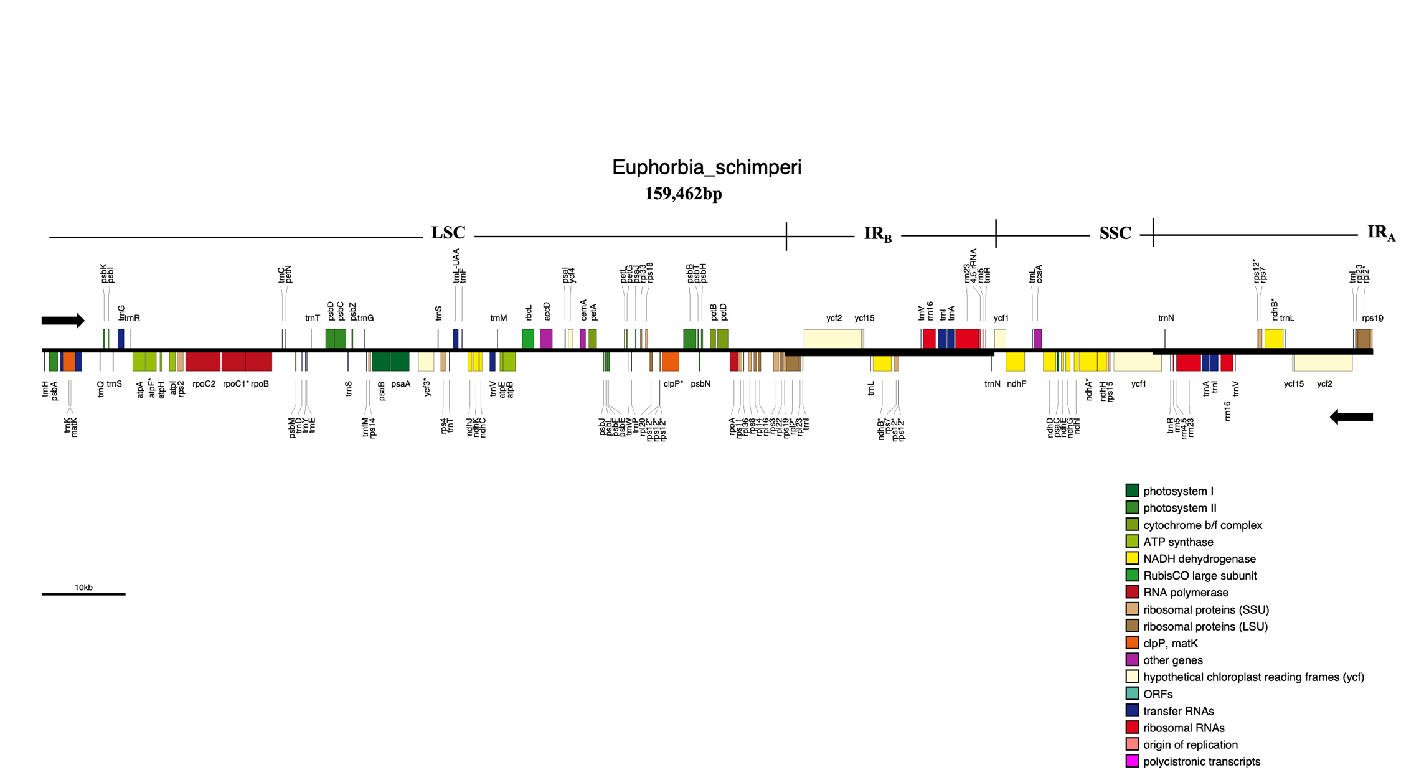
Figure S2
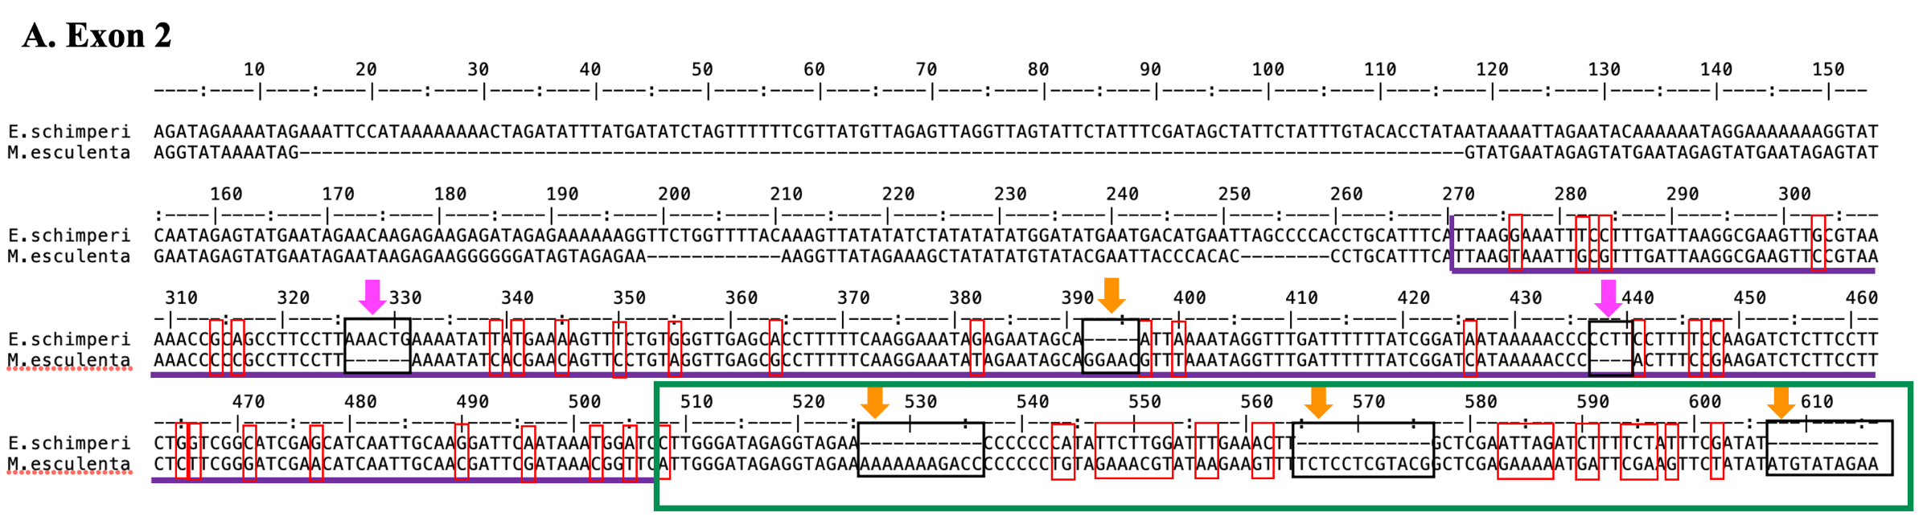

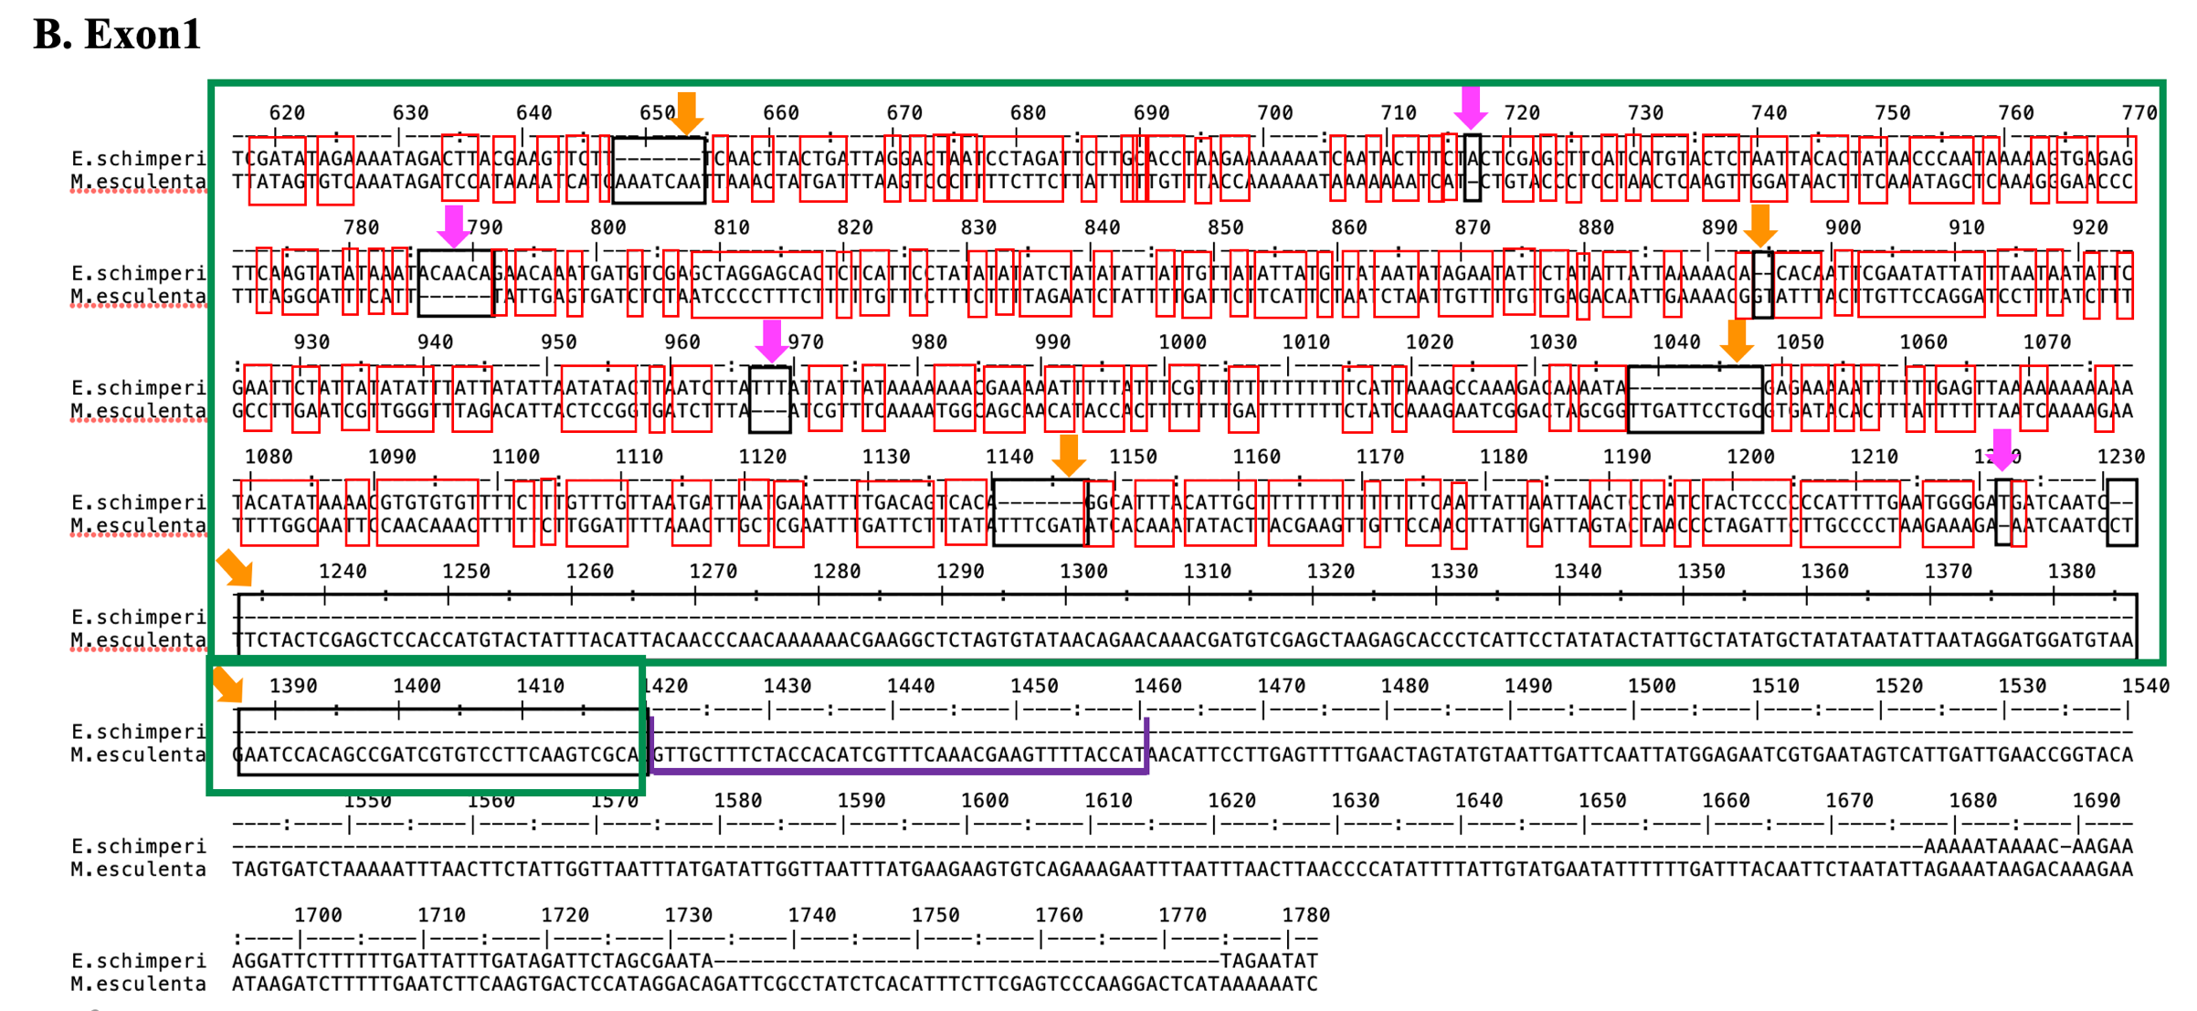

Figure S3
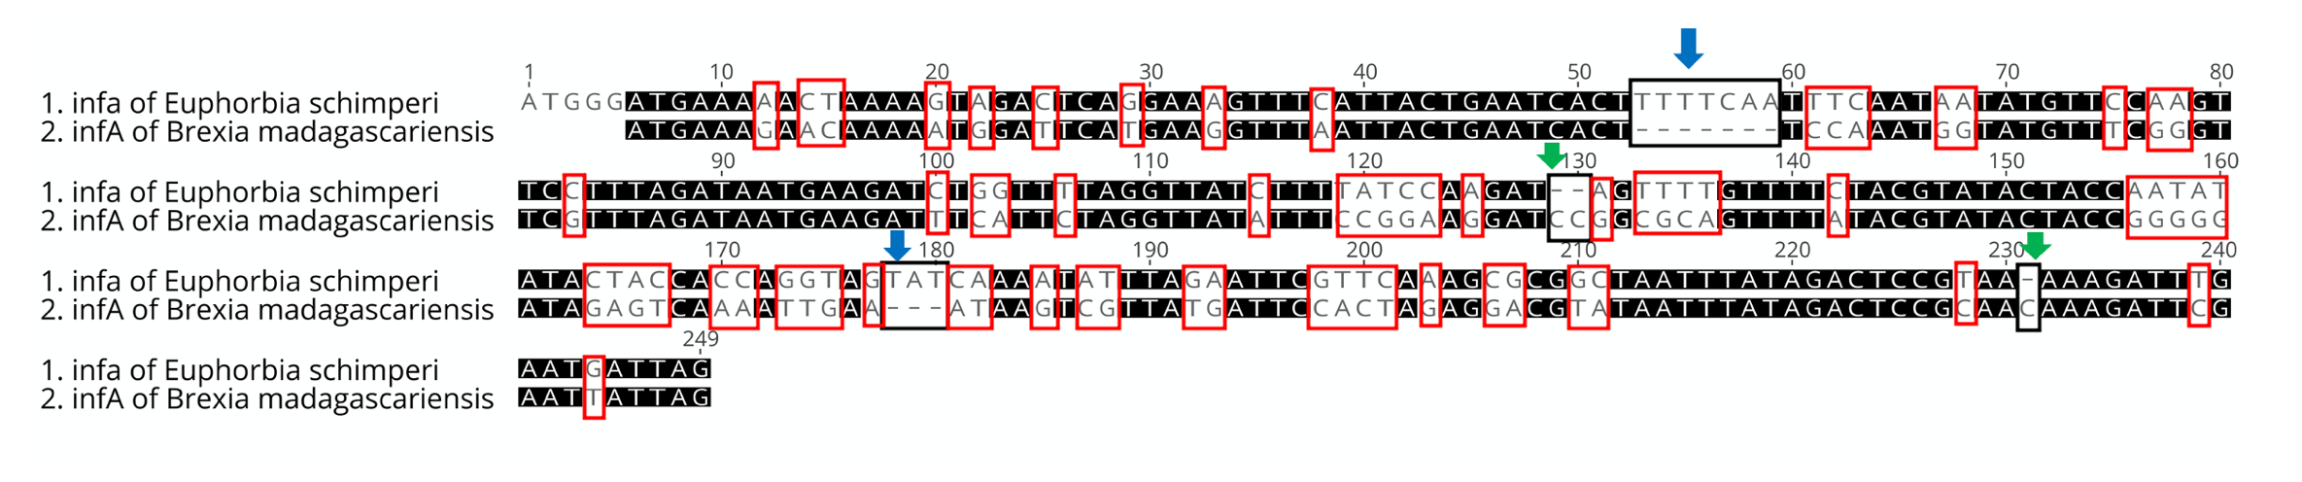

TP
Figure 4: Multiple alignments of nuclear RPL32 of E.schimperi and plastid RPL32 of other Euphorbiaceae (E. marginata, Jatropha curcas, Hevea brasiliensis, Manihot esculenta, Ricinus communis, Vernicia fordii), Arabidopsis thaliana and Nicotiana tabacum. Blue boxes indicate plastid transit peptide (TP) predicted using TargetP. Red box indicates a conserved domain of RPL32.
ribosomal protein L32

