Supporting Information
Random-Forest Model for Drug Target-Interaction Prediction via Kullbeck–Leibler Divergence

Sangjin Ahn^{a,b}, Sieun Leeª and Mi-hyun Kim^{a,*}

ªGachon Institute of Pharmaceutical Science and Department of Pharmacy, College of Pharmacy, Gachon University, 191 Hambakmoeiro, Yeonsu-gu, Incheon, Republic of Korea
^{b}Department of Financial Engineering, College of Business, Ajou University, Suwon, 16499, Republic of Korea

* Author for correspondence
E-mail: kmh0515@gachon.ac.kr

Table of Contents

- Dataset Description(S.Table1)
- The Overlapped Ligands Among Targets (S.Table2)
- The Confusion Matrix for Test Data (S.Table3)
- Computation of Kullbeck-Leibler Divergence Vectors
- Structural Information of Q-Q Density Models by Each Target (S.Table4, S.Fig1)
- The Pair-Plot for Random Forest Model (S.Fig2)

- Dataset Description (S.Table1)
Target  Info.  [Q]CHEMBL  (Name) | No. of  Compounds  (Raw) | No. of  Compounds  (Successful Generation of Conformers) | Conformer  Population  Size  (E3FP) | Sampling
[1]CHEMBL2366517  (HIV-1 Protease) | 660 | 581 | 94421 | 15000
[2]CHEMBL4303  (Heat shock protein 90 kDa beta) | 601 | 524 | 84375 | 15000
[3]CHEMBL4153  (Sigma opioid receptor ) | 8 | 5 | 634 | 634
[4]CHEMBL3119  (Transient receptor potential  cation C subfamily V4) | 394 | 363 | 61060 | 15000
[5]CHEMBL339  (Dopamine D2 receptor ) | 2416 | 2005 | 287494 | 15000
[6]CHEMBL274  (CC-Chemokine Receptor 5 ) | 3813 | 2751 | 429802 | 15000
[7]CHEMBL1781  (DNA topoisomerase I ) | 511 | 440 | 29493 | 15000
[8]CHEMBL5251  (Tyrosine-protein kinase BTK ) | 2834 | 2231 | 379529 | 15000
[9]CHEMBL1978  (Cytochrome P450 (CYP) 1B1) | 2767 | 2047 | 140781 | 15000
[10]CHEMBL4142  (Fibroblast growth factor receptor 1 ) | 1131 | 1055 | 200052 | 15000
[11]CHEMBL2056  (Dopamine D1 receptor ) | 1021 | 901 | 67314 | 15000
[12]CHEMBL2973  (Rho-associated protein kinase 2 ) | 2386 | 1836 | 297138 | 15000
[13]CHEMBL1667684  (Neuraminidase - Influenza A virus ) | 78 | 45 | 8557 | 8557
[14]CHEMBL2842  (Serinethreonine-protein kinasemTOR) | 4596 | 4139 | 602995 | 15000
[15]CHEMBL204  (Hepsin serine protease ) | 3236 | 1777 | 291887 | 15000
[16]CHEMBL5023  (p53-binding protein Mdm-2 ) | 2900 | 2089 | 175930 | 15000
[17]CHEMBL203  (Epidermal growth factor receptor) | 12496 | 8936 | 1254040 | 15000

- The Overlapped Ligands Among Targets (S.Table2)
 | T1 | T2 | T3 | T4 | T5 | T6 | T7 | T8 | T9 | T10 | T11 | T12 | T13 | T14 | T15 | T16 | T17
T1 | Self | 0 | 0 | 0 | 0 | 5 | 0 | 0 | 3 | 0 | 5 | 0 | 0 | 0 | 0 | 0 | 6
T2 | 0 | Self | 0 | 0 | 0 | 0 | 1 | 0 | 1 | 1 | 0 | 1 | 0 | 1 | 0 | 0 | 1
T3 | 0 | 0 | Self | 0 | 2 | 1 | 0 | 0 | 0 | 0 | 1 | 0 | 0 | 0 | 0 | 0 | 1
T4 | 0 | 0 | 0 | Self | 0 | 0 | 0 | 0 | 0 | 0 | 0 | 0 | 0 | 0 | 0 | 0 | 0
T5 | 0 | 0 | 2 | 0 | Self | 24 | 1 | 0 | 0 | 0 | 37 | 0 | 0 | 0 | 0 | 5 | 24
T6 | 11 | 0 | 2 | 0 | 104 | Self | 33 | 1 | 112 | 0 | 874 | 6 | 0 | 20 | 1 | 2 | 898
T7 | 0 | 1 | 0 | 0 | 1 | 7 | Self | 0 | 2 | 0 | 7 | 0 | 0 | 0 | 0 | 0 | 11
T8 | 0 | 0 | 0 | 0 | 0 | 1 | 0 | Self | 0 | 24 | 1 | 25 | 0 | 25 | 0 | 0 | 233
T9 | 2 | 1 | 0 | 0 | 0 | 14 | 2 | 0 | Self | 0 | 14 | 0 | 0 | 0 | 2 | 0 | 24
T10 | 0 | 1 | 0 | 0 | 0 | 0 | 0 | 64 | 0 | Self | 0 | 14 | 0 | 4 | 0 | 0 | 113
T11 | 11 | 0 | 2 | 0 | 113 | 871 | 33 | 1 | 112 | 0 | Self | 6 | 0 | 20 | 1 | 2 | 899
T12 | 0 | 1 | 0 | 0 | 0 | 1 | 0 | 29 | 0 | 18 | 1 | Self | 0 | 5 | 0 | 0 | 141
T13 | 0 | 0 | 0 | 0 | 0 | 0 | 0 | 0 | 0 | 0 | 0 | 0 | Self | 0 | 0 | 0 | 0
T14 | 0 | 1 | 0 | 0 | 0 | 5 | 0 | 29 | 0 | 9 | 5 | 6 | 0 | Self | 0 | 0 | 407
T15 | 0 | 0 | 0 | 0 | 0 | 1 | 0 | 0 | 2 | 0 | 1 | 0 | 0 | 0 | Self | 0 | 4
T16 | 0 | 0 | 0 | 0 | 20 | 2 | 0 | 0 | 0 | 0 | 2 | 0 | 0 | 0 | 0 | Self | 2
T17 | 13 | 1 | 2 | 0 | 104 | 871 | 34 | 233 | 127 | 81 | 875 | 83 | 0 | 283 | 3 | 0 | Self

- The Confusion Matrix for Test Data (S.Table3)
 | T1 | T2 | T3 | T4 | T5 | T6 | T7 | T8 | T9 | T10 | T11 | T12 | T13 | T14 | T15 | T16 | T17
T1 | 2759 | 0 | 0 | 0 | 3 | 27 | 9 | 2 | 19 | 0 | 21 | 2 | 0 | 6 | 91 | 12 | 3
T2 | 1 | 2948 | 0 | 1 | 26 | 4 | 5 | 11 | 17 | 2 | 2 | 33 | 0 | 15 | 10 | 3 | 23
T3 | 0 | 0 | 133 | 0 | 7 | 0 | 0 | 0 | 0 | 0 | 1 | 0 | 0 | 0 | 0 | 0 | 0
T4 | 0 | 2 | 0 | 2913 | 12 | 14 | 1 | 11 | 15 | 0 | 7 | 9 | 0 | 54 | 14 | 3 | 3
T5 | 2 | 5 | 2 | 8 | 2744 | 40 | 4 | 9 | 17 | 0 | 52 | 26 | 0 | 10 | 17 | 19 | 13
T6 | 41 | 3 | 0 | 4 | 53 | 2361 | 9 | 17 | 20 | 0 | 309 | 20 | 0 | 37 | 48 | 43 | 14
T7 | 20 | 3 | 0 | 0 | 3 | 0 | 2895 | 1 | 22 | 0 | 26 | 1 | 0 | 2 | 5 | 2 | 10
T8 | 1 | 5 | 0 | 6 | 7 | 24 | 4 | 2556 | 11 | 28 | 1 | 44 | 0 | 92 | 18 | 8 | 135
T9 | 27 | 4 | 0 | 3 | 24 | 16 | 44 | 2 | 2778 | 0 | 59 | 35 | 0 | 25 | 20 | 2 | 12
T10 | 0 | 1 | 0 | 0 | 4 | 15 | 2 | 79 | 4 | 2688 | 0 | 52 | 0 | 28 | 10 | 6 | 101
T11 | 65 | 13 | 0 | 3 | 141 | 128 | 35 | 6 | 114 | 0 | 2349 | 11 | 0 | 17 | 58 | 19 | 52
T12 | 1 | 8 | 0 | 3 | 17 | 26 | 8 | 37 | 23 | 5 | 4 | 2731 | 0 | 69 | 32 | 9 | 48
T13 | 0 | 0 | 0 | 0 | 0 | 0 | 0 | 0 | 0 | 0 | 0 | 0 | 1759 | 0 | 0 | 0 | 0
T14 | 2 | 7 | 0 | 5 | 7 | 23 | 3 | 58 | 16 | 3 | 6 | 50 | 0 | 2616 | 33 | 10 | 75
T15 | 84 | 10 | 0 | 4 | 47 | 66 | 13 | 20 | 71 | 0 | 58 | 68 | 0 | 108 | 2359 | 45 | 30
T16 | 27 | 4 | 0 | 0 | 2 | 42 | 5 | 37 | 5 | 0 | 9 | 18 | 0 | 24 | 40 | 2790 | 16
T17 | 12 | 14 | 0 | 10 | 26 | 30 | 24 | 239 | 74 | 32 | 182 | 122 | 0 | 143 | 69 | 30 | 2054

- Computation of Kullbeck-Leibler Divergence Vectors

Let p(x) be a density from Q-L vector and q(x) be from Q-Q matrix,
The Kullbeck-Leibler Divergence(cite) for nonparametric density is defined by:

$$D\left(P\left\|Q\right.\right) := \int_{-∞}^{∞}{\ln\left(\frac{p\left(x\right)}{q\left(x\right)}\right)p\left(x\right)dx}$$
for x_i in (0, 1) where x1, …x_100

For each p(x), we obtain 17 divergence calculated by candidate targets, The divergence vector for each ligand is labeled by their own target as shown in the next examples.

Drugs | KLDQ1 | KLDQ2 | KLDQ3 | KLDQ4 | KLDQ5 | KLDQ6 | KLDQ7 | KLDQ8 | KLDQ9 | KLDQ10 | KLDQ11 | KLDQ12 | KLDQ13 | KLDQ14 | KLDQ15 | KLDQ16 | KLDQ17
CHEMBL3126454_0 | 0.59333 | 0.903644 | 3.847702 | 2.2452 | 1.353567 | 0.88767 | 0.124954 | 2.457438 | 0.622791 | 3.606968 | 0.161093 | 2.3451 | 5.951562 | 2.443589 | 0.83235 | 1.076318 | 1.389519
CHEMBL3126453_0 | 0.319358 | 0.617718 | 2.163279 | 1.448611 | 1.319439 | 0.668798 | 0.100405 | 1.80478 | 0.476255 | 3.324672 | 0.194852 | 2.110077 | 7.222029 | 1.983163 | 0.519279 | 0.566461 | 1.050486
CHEMBL3799995_0 | 0.617898 | 0.779734 | 4.100718 | 2.2965 | 1.803264 | 1.214501 | 0.230805 | 3.475001 | 0.780587 | 3.876629 | 0.072032 | 1.278461 | 6.73808 | 2.889051 | 0.628621 | 1.773783 | 1.152712
CHEMBL572988_0 | 0.36622 | 0.369239 | 2.353694 | 1.253695 | 1.11142 | 0.769719 | 0.531816 | 1.881659 | 0.1645 | 2.137363 | 0.348618 | 1.439828 | 7.307991 | 1.854418 | 0.576496 | 1.317806 | 1.165088
CHEMBL556509_0 | 0.223933 | 0.196037 | 1.443353 | 0.320509 | 0.428653 | 0.105264 | 0.232352 | 0.264721 | 0.163272 | 1.069166 | 0.09811 | 0.157102 | 5.023408 | 0.239203 | 0.119151 | 0.353498 | 0.319624

- Structural Information of Q-Q density models by each target (S.Table4, S.Fig1)
S.Table4) The Table of Descriptive statistics by Targets
Target | KDE Model (Mean-Std)
[1]CHEMBL2366517(HIV-1 Protease) | 0.127-0.051
[2]CHEMBL4303(Heat shock protein 90 kDa beta) | 0.126-0.070
[3]CHEMBL4153(Sigma opioid receptor ) | 0.195-0.128
[4]CHEMBL3119(Transient receptor potential cation C subfamily V4) | 0.154-0.076
[5]CHEMBL339(Dopamine D2 receptor ) | 0.124-0.045
[6]CHEMBL274(CC-Chemokine Receptor 5 ) | 0.123-0.041
[7]CHEMBL1781(DNA topoisomerase I ) | 0.113-0.078
[8]CHEMBL5251(Tyrosine-protein kinase BTK ) | 0.139-0.045
[9]CHEMBL1978(Cytochrome P450 (CYP) 1B1) | 0.108-0.049
[10]CHEMBL4142(Fibroblast growth factor receptor 1 ) | 0.185-0.086
[11]CHEMBL2056(Dopamine D1 receptor ) | 0.098-0.040
[12]CHEMBL2973(Rho-associated protein kinase 2 ) | 0.145-0.054
[13]CHEMBL1667684(Neuraminidase - Influenza A virus ) | 0.3-0.077
[14]CHEMBL2842(Serinethreonine-protein kinasemTOR) | 0.140-0.052
[15]CHEMBL204(Hepsin serine protease ) | 0.117-0.039
[16]CHEMBL5023(p53-binding protein Mdm-2 ) | 0.132-0.053
[17]CHEMBL203(Epidermal growth factor receptor ) | 0.126-0.044

S.Fig1) The Overall Density Structure re of 17 Q-Q Matrix
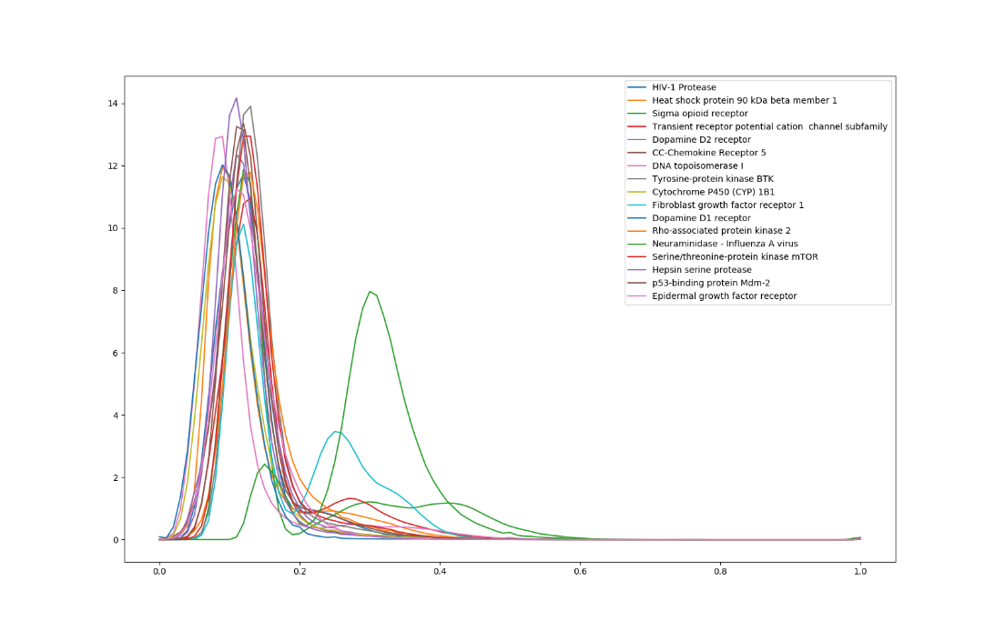

- The Pair-plot for Random Forest Model (S.Fig2)
S.Fig2) The pair-plots, which can be obtained from the Random Forest model, represent the detailed information of classifier.
