Soluble receptor for advanced glycation end products (sRAGE) as a biomarker of COPD

Katherine A. Pratte, Jeffrey L. Curtis, Katerina Kechris, David Couper, Michael H. Cho, Edwin K. Silverman, Dawn L. DeMeo, Frank Sciurba, Yingze Zhang, Victor E. Ortega, Wanda O’Neal, Lucas A. Gillenwater, David A. Lynch, Eric Hoffman, John D. Newell Jr, Alejandro P. Comellas, Peter J. Castaldi, Bruce Miller, Simon D. Pouwels, Nick H.T. ten Hacken, Rainer Bischoff, Frank Klont, Prescott Woodruff, Robert Paine, R. Graham Barr, John Hoidal , Claire M. Doerschuk, Jean-Paul Charbonnier, Ruby Sung, Nick Locantore, John Yonchuk, Sean Jacobson, Ruth Tal-singer, Debbie Merrill, Russell P. Bowler

Online Data Supplement

Methods:

Clinical subtypes
Airflow obstruction. COPD was defined by post-bronchodilator forced expiratory volume in the first second (FEV₁) to forced vital capacity (FVC) ratio of <0.70. Smoker controls were current or former smokers without evidence of airflow limitation (FEV₁/FVC ≥ 0.70) and FEV1 percent predicted (FEV1%) ≥ 80.0. The severity of COPD was defined by FEV₁% and categorized as follows: mild (≥ 80%); moderate (≥ 50% and <80%); severe (≥ 30% and <50%); or very severe (<30%). COPD progression was reported as change in FEV₁ (ml/year). Subjects with FEV₁/FVC ≥ 0.70 and FEV₁% < 80% predicted were defined as having Preserved Ratio Impaired Spirometry (PRISm).
Emphysema. Emphysema was defined using the percent of voxels with Hounsfield Units (HU) < −950 (%LAA) on CT. Measurements below -1000 HU were removed from the analyses. The severity of emphysema was classified as none (LAA ≤ 5%), mild (LAA 5–≤10%), moderate (LAA 10–≤20%), or severe (LAA > 20%). Emphysema was also defined using the HU of the 15th percentile adjusted for total lung capacity (PD15_{adj}) determined using the lung density (g/L) adjusted for the race‐adjusted predicted TLC value versus the actual lung volumes achieved (adj. g/L), as previously described (1). Emphysema density (HU) was converted to density (g/L) by adding 1000 to its HU value. Visual assessment of emphysema was available for cohorts as described for COPDGene (2), ECLIPSE (3), and SCCOR (4), and defined as a consensus below.

Visual Emphysema Assessment Harmonization
Consensus Name | COPDGene | ECLIPSE | SCCOR
None | None | Not affected | None (0 points)
Trace | Trace | Trivial (<5%) | 0-10% (1 point)
Mild | Mild | Mild (5-25%) | 11% to 25% (2 points)
Moderate | Moderate | Moderate (25-50%) | 26% to 50% (3 points)
Confluent | Confluent | Severe (50-75%%) | 51% to 75% (4 points)
Advanced Destructive | Advanced Destructive | Very Severe (>75%) | >75% (5 points)

rs2070600 and rs2071288 Genotyping. In COPDGene, the genotype data for rs2070600 in non-Hispanic whites and rs2071288 in non-Hispanic African Americans were determined using the Illumina HumanOmniExpress Beadchip (5). The other cohorts only had genotype data for rs2070600. SPIROMICS used the Illumina OmniExpress HumanExome BeadChip for SPIROMICS (6) and ECLIPSE the Illumina’s HumanHap550 genotyping BeadChip (version 3) (7). SCCOR genotyped rs2070600 using Taqman primer and probe set from Applied Biosystems. All single nucleotide polymorphisms (SNP) were in Hardy Weinberg Equilibrium (p>0.05).
Statistical analysis
All statistical analyses were conducted on the former and current smokers for all cohorts. For ECLIPSE, the smoker controls were missing data on exacerbations and were excluded from the linear mixed models for both FEV₁ and PD15_{adj}.
sRAGE. Serum and plasma levels of sRAGE were converted to ng/ml if reported on a different quantitative scale. sRAGE values were log₁₀ transformed for all analyses and graphs. For the linear mixed models, the log₁₀ transformed levels were standardized by their standard deviations in their respective studies. Pearson correlations were performed to evaluate the linear relationship between the 4 different sRAGE platforms measured in the COPDGene cohort. Additionally, Bland-Altman analyses were conducted to evaluate agreement between the different assays using log₁₀ transformed sRAGE values. The results are reported on the proportionally to the magnitude of measurements.
sRAGE association with clinical covariates. An analysis of variance (ANOVA) was used to analyze mean differences in sRAGE levels between the different groups for categorical covariates (sex, race, current smoking status, self-reported history of: diabetes, heart attack, coronary artery disease and stroke). Race was defined as self-reporting being non-Hispanic white, non-Hispanic African American, or other race. Linear regression was used to determine the relationship between sRAGE and age.
Modelling FEV₁ and emphysema. Random coefficient models with both a random intercept and slope at a subject level were constructed to evaluate the effect of baseline covariates and sRAGE on FEV₁ or PD15_{adj} at baseline and their rate of change over the time period of each study (8). The random slope was based on time (years) between measurements. Interaction terms between covariates and time were included in models to control for their association with change over time, and for sRAGE to estimate its association with change over time. Models for FEV₁ included log₁₀ sRAGE with baseline covariates: age, age², race, height, height², weight, number of exacerbations as previously described (8), sex, current smoking status, pack-years, and time between measurements with interaction terms of years with current smoking status, sex and sRAGE. For PD15_{adj} models were constructed as previously reported in (8). Because sRAGE levels significantly differed between the races, race and race*sRAGE were included in both models to control for the differences in the populations. Because rs2070600 and rs2071288 had low minor allele counts in our stratified populations we did not include them in these analyses.
Meta-analyses of results. A meta-analysis was conducted for FEV₁ decline and emphysema progression using an inverse variance weighted random-effects-model. Between study variance was estimated using the restricted maximum likelihood.
Influence of rs2070600 and rs2071288 genotype on circulating sRAGE levels and phenotype interactions. An ANOVA was used to evaluate the least squared means differences between genotypes and sRAGE levels. To evaluate the influence rs2070600 and rs2071288 genotypes have on sRAGE’s relationship with percent emphysema, an additive genetic model was tested for the minor allele (A) of rs2070600 and rs2071288. Linear regression was used including both the genotype, percent emphysema and percent emphysema*genotype interaction term. Models for COPDGene, SPIROMICS, and ECLIPSE, included ancestry-based principal components, to control for population substructure. SCCOR did not have any ancestry-principal components, but the results are in a white population.
Sensitivity and specificity of sRAGE to detect emphysema. We used logistic regression to estimate the sensitivity and specificity of sRAGE to detect emphysema. Receiver operator curve (ROC) plots and area under the curves (AUC) were estimated for the different quantitative emphysema cutpoints and for visually assessed emphysema.
SAS (9.4) was used to create the panel graphs and all analyses, with the exception of the Bland-Altman and meta-analysis. The Bland-Altman analysis was conducted in R3.6.3 with the ‘blandr’ version 0.3.1; and meta-analysis was conducted in R 3.5.2, with packages meta (version 3.5.2) and metafor (version 2.0-0), and the beeswarm plots were produced with R packages ggplot2 (version 3.1.1) and ggbeeswarm (version 0.6.0).

Supplement Figure and Tables

Figures:

A | B | C
D | E | F
Figure E1. Bland-Altman plots between the different assays reveals significant mean differences among most of the assays and proportional bias when RBM assay was one of the comparators. Plots are the differences between: A) QBR and RBM, B) QBR and LCMS, C) RBM and LCMS, D) QBR and SOMAscan, E) RBM and SOMAscan, F) LCMS and SOMAscan. The middle dashed horizontal line is the bias line (the mean differences between the assays). The parallel dashed line above and below represents the 95% confidence interval (CI). The blue solid line is the regression line of the proportional differences The green, purple, blue and red shade areas represent the error margins.

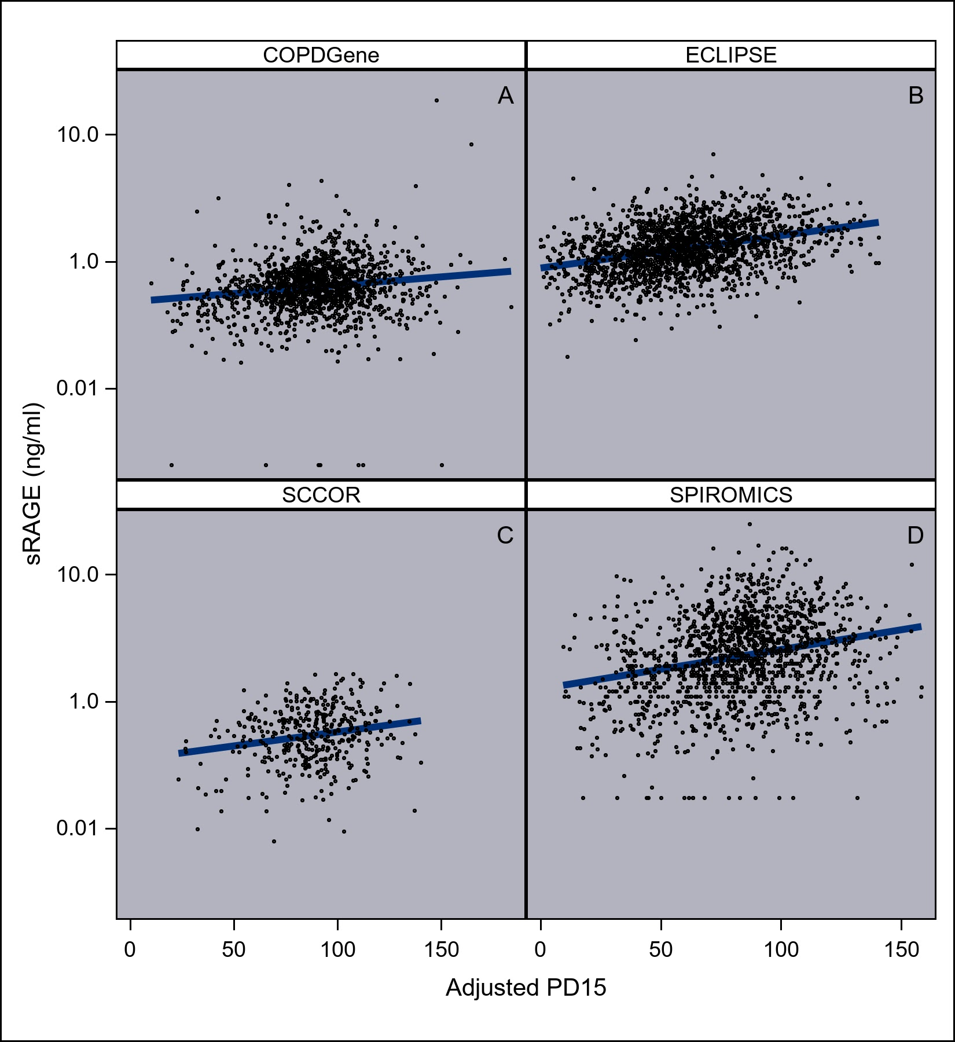
Figure E2: Relationship between baseline adjusted PD15_{adj} and sRAGE in smoking population. Association between sRAGE and emphysema severity as measured by the adjusted 15% percentile (PD15_{adj}). Cohorts (platform) were (A) COPDGene (QBR), (B) ECLIPSE (QBR), (C) SCCOR (R & D DuoSet), (D) SPIROMICS (RBM) Each dot represents one subject. The lines represent regression lines, of which all are > 0 (p-value < 0.001).

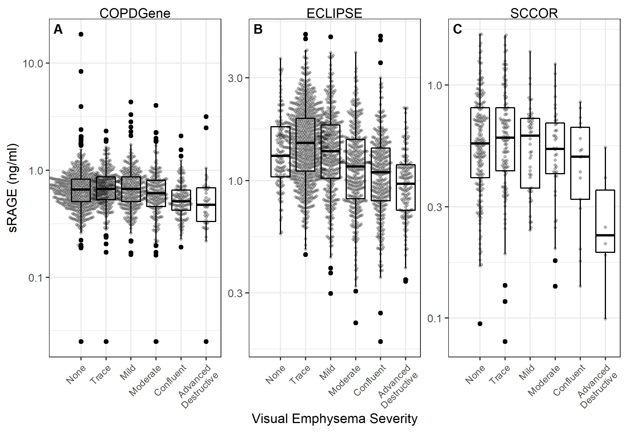
Figure E3: Association between sRAGE and visual emphysema severity. Each dot represents one subject.

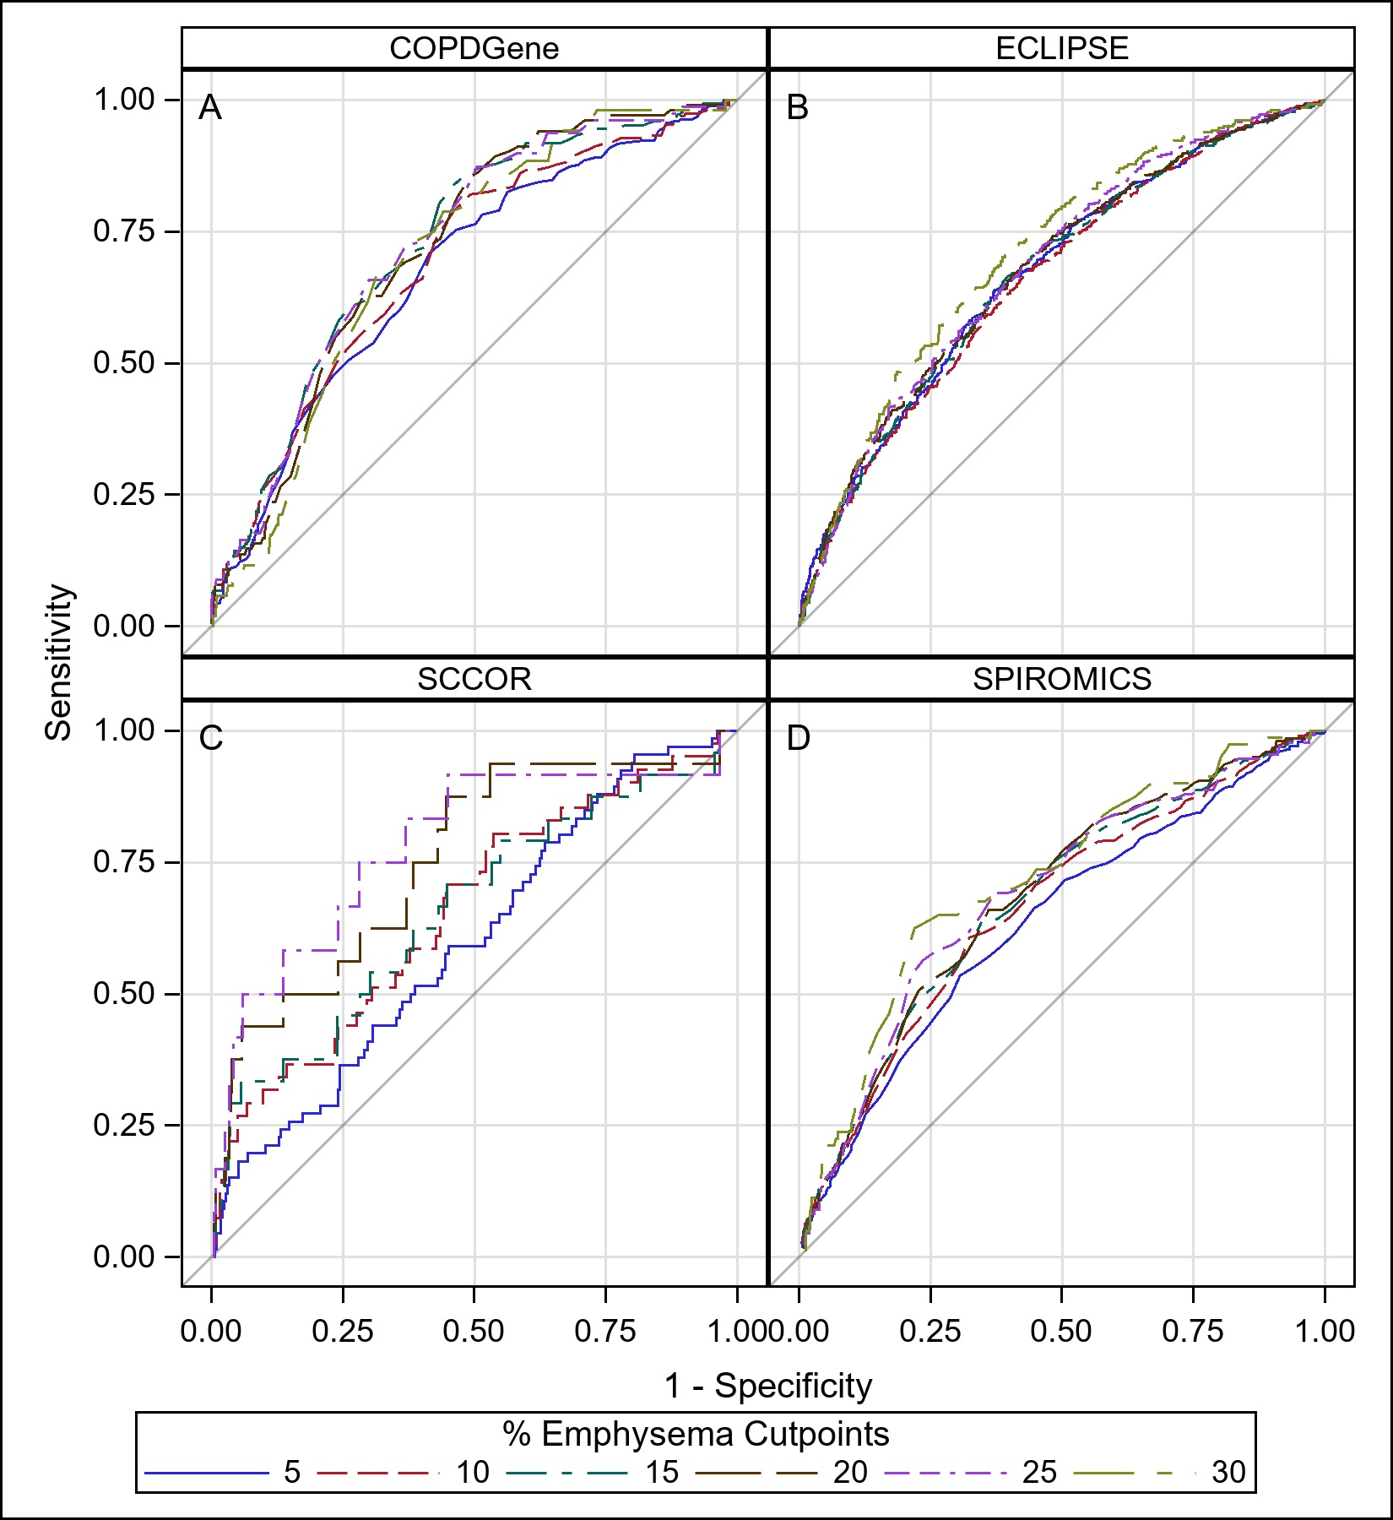

Figure E4. sRAGE ROC curves of the different percent emphysema cut-points. Shown are data using the RBM assay in COPDGene (A) and SPIROMICS (D), QBR assay in ECLIPSE (B), and R & D DuoSet in SCCOR (C). Different curves represent different definitions based on the %LAA < 950 Hounsfield Units.

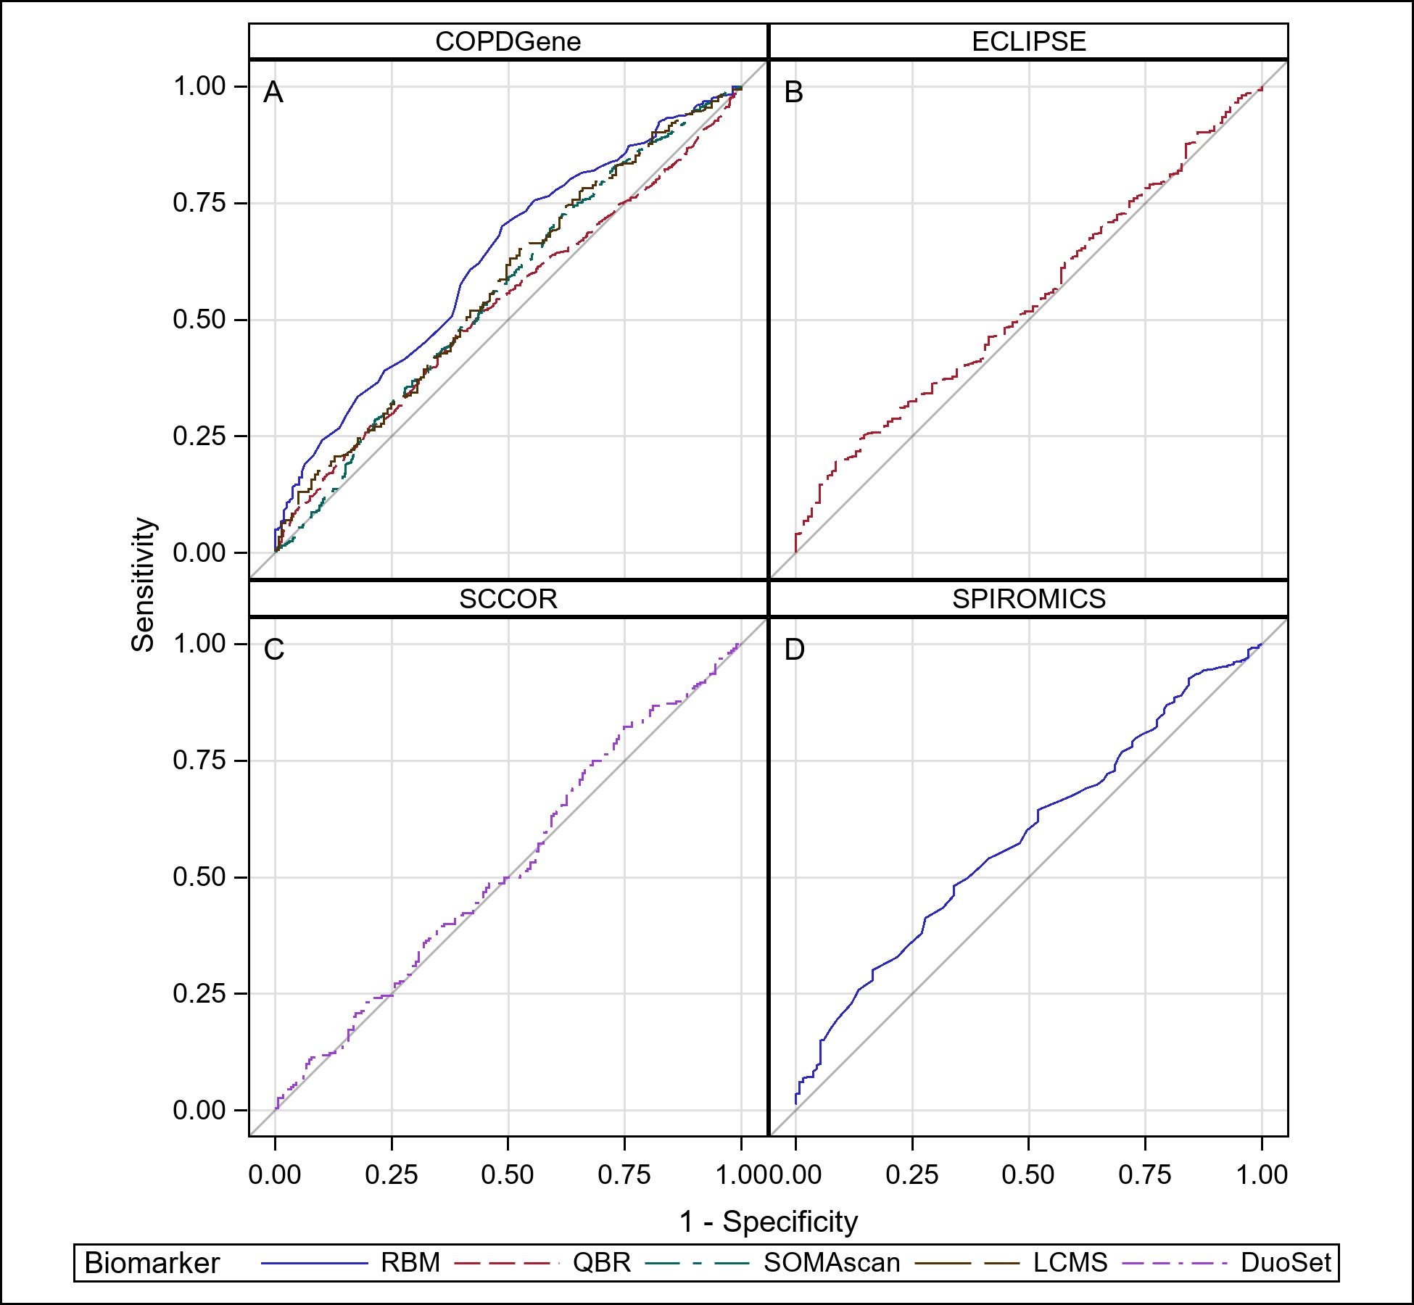

Figure E5. ROC curves for sRAGE and visually assessed emphysema. Shown are data using different assays in COPDGene (A), QBR assay in ECLIPSE (B), and R & D DuoSet in SCCOR (C), and RBM in SPIROMICS (D). Emphysema was assessed by readers (see methods) as yes or no.

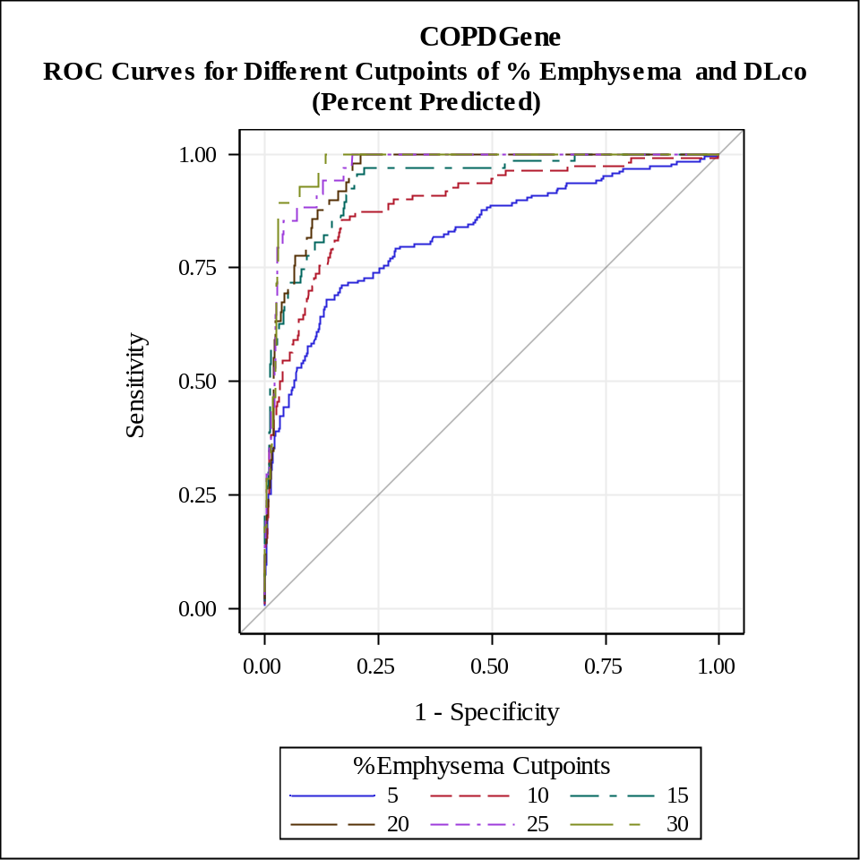
Figure E6. ROC of different cutpoints of % emphysema and DLco percent predicted for all visit 2 observations with sRAGE measurements.

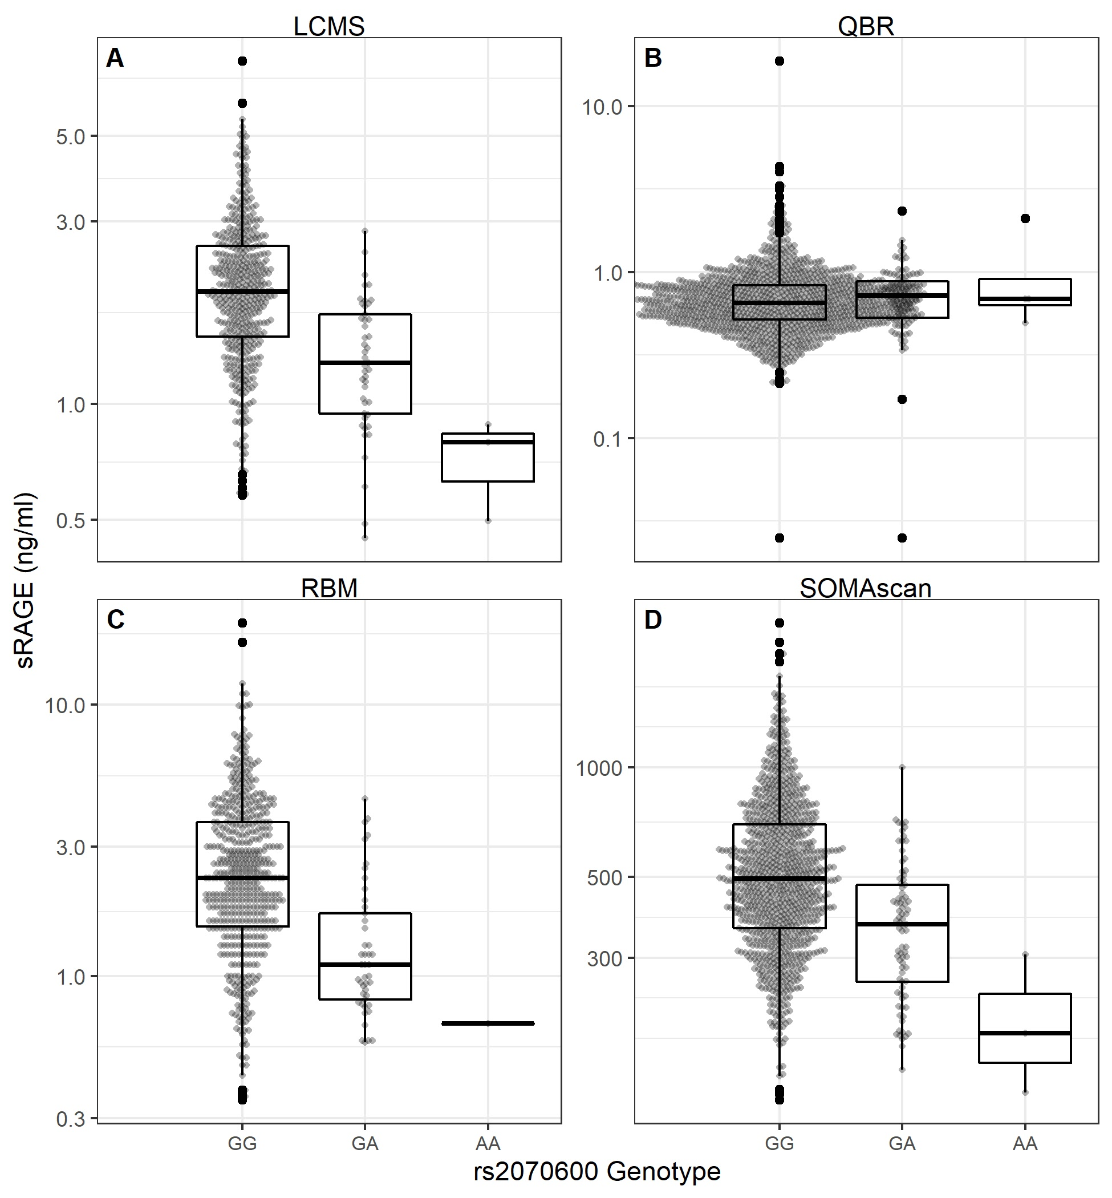
Figure E7A. Relationship between rs2070600 and plasma sRAGE. (A) Using LCMS assay (p-value < 0.001), (B) using QBR (P = N.S.), (C) using RBM assay (p-value < 0.001), (D) using SOMAscan aptamer X4125_52_2 (p-value < 0.001). The x-axis shows genotype (minor allele A). Lines represent divisions between quartiles. Note that only non-Hispanic white subjects are shown because the rs2070600 minor allele frequencies are very low in noon-Hispanic African-American populations.

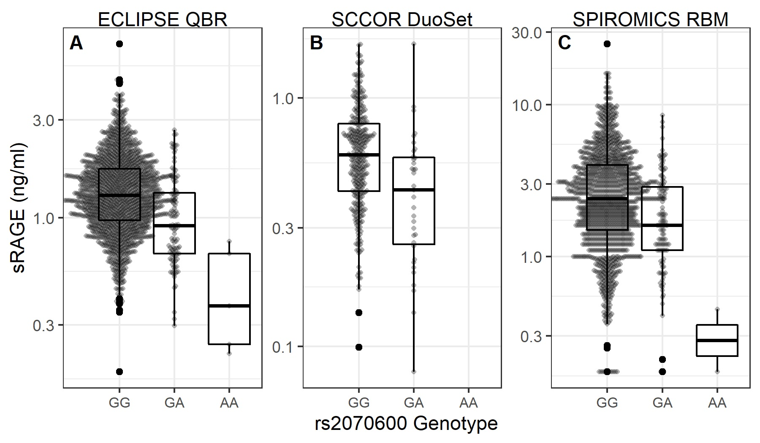
Figure E7B. Relationship between rs2070600 and plasma sRAGE. (A) ECLIPSE using QBR (p-value <0.001), (B) SCCOR using DuoSet (p-value < 0.001), (C) SPIROMICS using RBM (p-value < 0.001). The x-axis shows genotype (minor allele A). Lines represent divisions between quartiles.

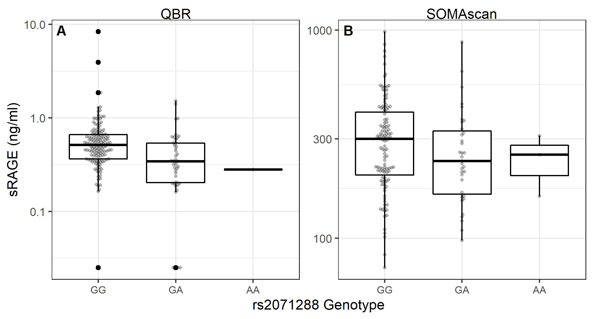
Figure E7C. Relationship between rs2071288 and plasma sRAGE in the COPDGene non-Hispanic African American population. sRAGE was only measured in non-Hispanic African Americans for the QBR and SOMAscan assays were: (A) QBR (p-value = 0.0002), (B) SOMAscan (p-value = 0.1950). The x-axis shows genotype (minor allele A). Lines represent divisions between quartiles.
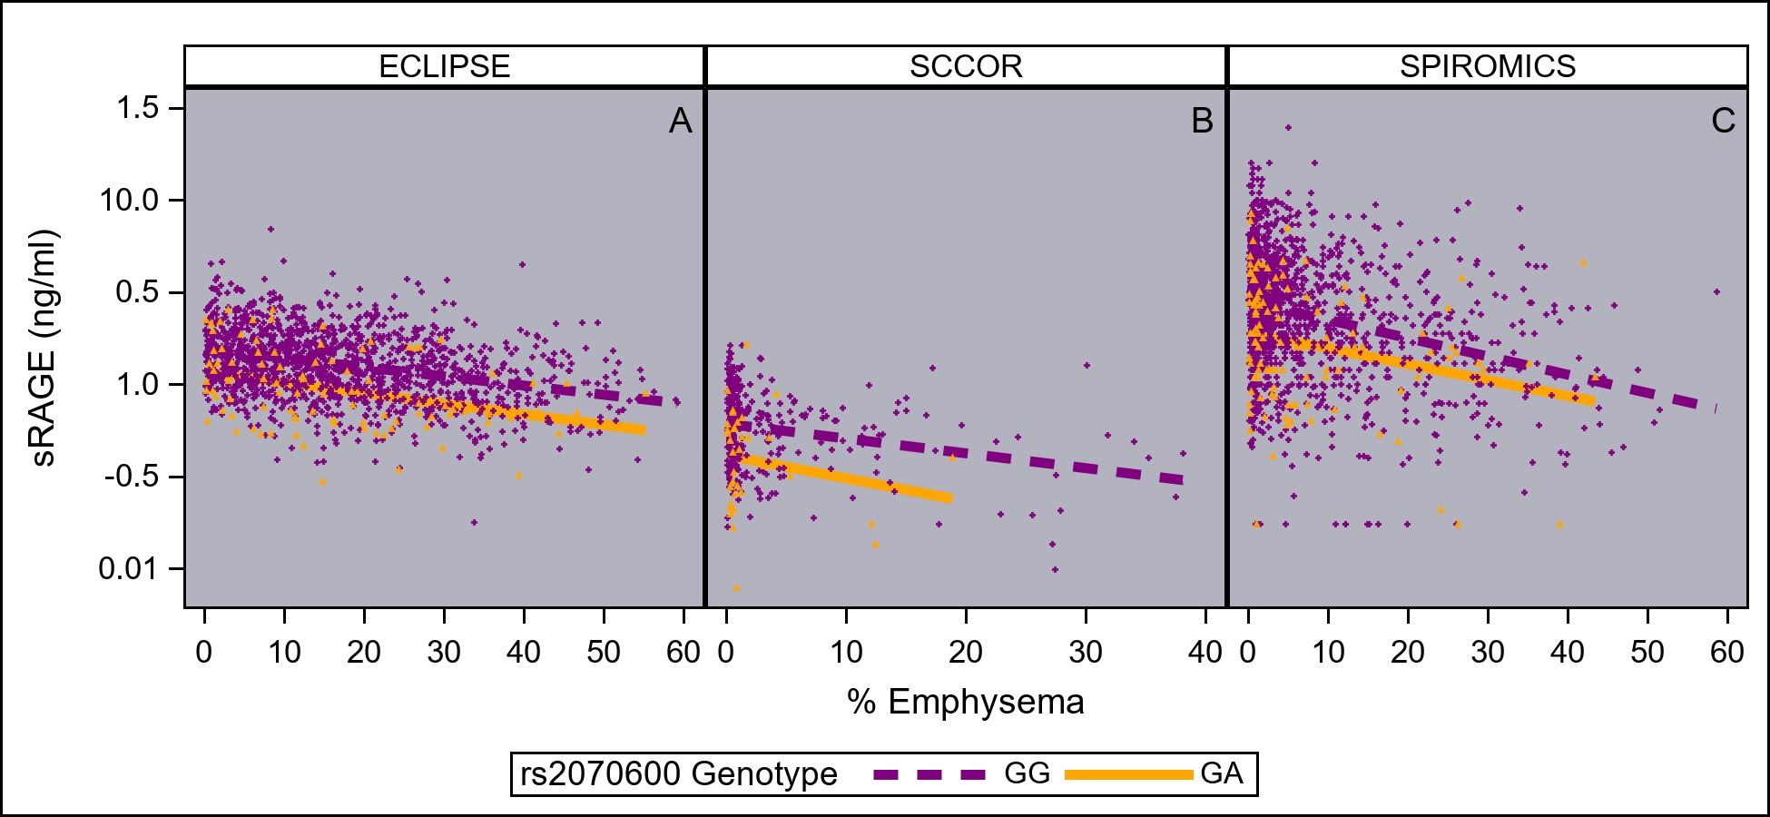
Figure E8A. Relationship between sRAGE and percent emphysema by rs2070600 genotype. ECLIPSE (A), SCCOR (C), and SPIROMICS (C) scatter plots showing the inverse relationship between plasma sRAGE and percent emphysema by rs2070600 genotype showing that the slope is not different (genotype*percent emphysema interaction N.S.).

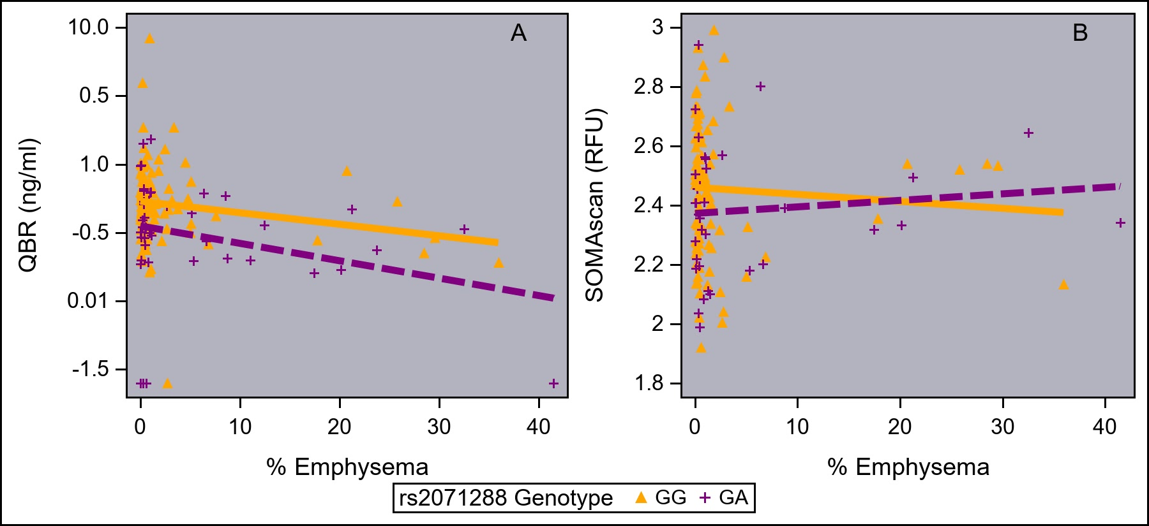
Figure E8B. Relationship between sRAGE and percent emphysema by rs2071288 genotype in COPDGene non-Hispanic African Americans. QBR scatter plot (A) showing an inverse relationship between emphysema and plasma sRAGE by rs2071288 genotype and that the slope are not different (genotype*percent emphysema interaction p-value=0.51.). SOMAscan (B) showed no relationship between percent sRAGE and percent emphysema. While the regression line for the genotype suggest an interaction there is no significant interaction between the genotypes (p=0.50). Influential and extreme outliers were tested for their effect on evaluating the interaction but no difference was found.

SUPPLEMENT TABLES:

Table E1: Baseline characteristics of COPDGene subjects who have an sRAGE measurement determined by LCMS, RBM, and SOMAscan at phase 1.
 | LCMS  n=509 | RBM  N = 594 | SOMAscan  N = 1243
Age (yr) (mean ± SD) | 65 ± 7 | 64 ± 9 | 62 ± 9
Sex (male) (%) | 48% | 52% | 49%
Race (%)
Non-Hispanic White | 100% | 99.8% | 87%
Non-Hispanic African American | 0% | 0.2% | 13%
Other | 0% | 0% | 0%
BMI (kg/m²) ( mean ± SD) | 29 ± 5 | 28 ± 6 | 29 ± 6
Never Smoker (%) | 0% | 0% | 3%
Current Smoker (%) | 25% | 24% | 40%
Pack-years  median (5th and 95th percentile) | 42.0 (14.0 ; 94.0) | 42.0 (12.8 ; 98.0) | 39.4 (11.0 ; 90.8)
COPD Patients (%) | 64% | 58% | 45%
PRISm (%) | 0% | 2% | 10%
FEV1 (% predicted)  ( mean ± SD) | 75 ± 25 | 68 ± 30 | 78 ± 26
FEV1 (L) ( mean ± SD) | 2.15 ± 0.82 | 2.02 ± 1.03 | 2.26 ± 0.91
FVC (L) ( mean ± SD) | 3.42 ± 0.95 | 3.33 ± 1.03 | 3.38 ± 0.97
Emphysema (% LAA < -950 HU) median (5th and 95th percentile) | 3.48 (0.17 ; 28.54) | 4.28 ( 0.14 ; 37.56) | 1.50 (0.07 ; 28.4)
Adjusted PD 15  ( mean ± SD) | 81 ± 23 | 76 ± 25 | 87 ± 25
History of diabetes (%) | 13% | 11% | 11%
History of heart attack (%) | 6% | 6% | 6%
History of coronary artery disease (%) | 7% | 7% | 7%
History of stroke (%) | 1% | 2% | 3%
Follow-up (years)  median (5th and 95th percentile) | 5.4 (4.7 ; 10.2) | 5.2 (0 ;10.1 ) | 5.1 (0 ; 10.1)
Spirometries per subject: 0 |  |  | 0.2%
1 | 0.4% | 36% | 40 %
2 | 68.6% | 46% | 44%
3 | 31% | 18% | 16%
CT scans per subject: 0 | 0.6% | 1% | 2%
1 | 8% | 40% | 42%
2 | 91% | 58% | 56%

Table E2: sRAGE associations with clinical covariates in smoking population
 | COPDGene  n=1408 | ECLIPSE  n=2146 | SCCOR  n=399 | SPIROMICS  n=1486
Age (yr) | 0.002  (p=0.0042) | -0.0003 (p=<0.60) | 0.002  (p=0.24) | 0.0035 (p=0.004)
Sex (female - male) | 0.018  (p=0.13) | 0.034 (p=0.0001) | 0.055  (p=0.0146) | 0.066 (p=0.002)
Race (AA – NHW) | -0.168  (p<0.0001) | -0.144  (p<0.0001) | -0.223  (p<0.0001) | -0.274 (P<0.0001)
Race (other – NHW) | NA | -0.0008  (p=0.96) | 0.078  (p=0.48) | -0.061  (p=0.049)
Race (other – AA) | NA | 0.143  (p=0.0003) | 0.301  (p=0.0147) | 0.274 (p<0.0001)
Current Smoker | -0.003  (p=0.79) | 0.031  (p=0.0003) | 0.055  (p=0.0159) | 0.0015  (p=0.93)
Diabetes | -0.013  (p=0.49) | 0.027  (0.07) | NC | -0.0057  (p=0.83)
Heart Attack | 0.034  (p=0.16) | 0.029  (p=0.059) | 0.021  (p=0.70) | 0.034  (p=0.43)
Coronary Artery disease | 0.022  (p=0.32) | NC | -0.092 (p=0.057) | 0.042  (p=0.18)
Stroke | 0.031  (p=0.42) | 0.029  (p=0.20) | -0.087  (p=0.23) | -0.0027  (p=0.95)
Mean differences in log₁₀(sRAGE) and p-value for bivariate variables and ß-estimates and p-value for continuous variables; difference in race is paired comparisons for non-Hispanic white (NHW), non-Hispanic African American (AA), and other races. NC means not collected.

Table E3. ROC for the different emphysema cut-points
 | Area Under the Curves
 | COPDGene | ECLIPSE | SCCOR | SPIROMICS
% Emphysema cut-points | RBM  n=580 | QBR  n=1849 | DuoSet  n=399 | RBM  n=1477
5% | 0.675 | 0.670 | 0.599 | 0.635
10% | 0.693 | 0.660 | 0.657 | 0.663
15% | 0.727 | 0.669 | 0.657 | 0.675
20% | 0.719 | 0.676 | 0.750 | 0.683
25% | 0.726 | 0.682 | 0.782 | 0.689
30% | 0.705 | 0.708 | * | 0.716
*Too few positive for emphysema. All area under the curves were significantly different from 0.50 (p-value range <0.0001 - <0.05).

Table E4. ROC for the different emphysema cut-points and DLco percent predicted
 |  |  | Area Under the Curves
 |  |  | COPDGene at Visit 2
 |  | % Emphysema cut-points | Subset of QBR visit 1 observations (figure 1)  n=767 | All observation at Visit 2 (figure2)  n=4624
 |  | 5% | 0.82 | 0.78
 |  | 10% | 0.89 | 0.86
 |  | 15% | 0.94 | 0.90
 |  | 20% | 0.95 | 0.93
 |  | 25% | 0.97 | 0.95
 |  | 30% | 0.97 | 0.96
 |  | All area under the curves were significantly different from 0.50 (p<0.0001)

Table E5 ROC area under the curves for visual emphysema (present/absent) and the different sRAGE platforms
Cohort | Biomarker | Area Under the Curve
COPDGene | LCMS | 0.572*
COPDGene | QBR | 0.531
COPDGene | RBM | 0.627
COPDGene | SOMAscan | 0.560
ECLIPSE | QBR | 0.541*
SCCOR | DuoSet | 0.521*
SPIROMICS | RBM | 0.578
*Area under the curves are not significantly different from 0.050, rest (p-value range 0.02 - <0.0001)

References
1. Hoffman EA, Ahmed FS, Baumhauer H, Budoff M, Carr JJ, Kronmal R, Reddy S, Barr RG. Variation in the percent of emphysema-like lung in a healthy, nonsmoking multiethnic sample. The MESA lung study. Ann Am Thorac Soc 2014; 11: 898-907.
2. Lynch DA, Moore CM, Wilson C, Nevrekar D, Jennermann T, Humphries SM, Austin JHM, Grenier PA, Kauczor HU, Han MK, Regan EA, Make BJ, Bowler RP, Beaty TH, Curran-Everett D, Hokanson JE, Curtis JL, Silverman EK, Crapo JD, Genetic Epidemiology of CI. CT-based Visual Classification of Emphysema: Association with Mortality in the COPDGene Study. Radiology 2018; 288: 859-866.
3. Gietema HA, Muller NL, Fauerbach PV, Sharma S, Edwards LD, Camp PG, Coxson HO, Evaluation of CLtIPSEi. Quantifying the extent of emphysema: factors associated with radiologists' estimations and quantitative indices of emphysema severity using the ECLIPSE cohort. Acad Radiol 2011; 18: 661-671.
4. Ajala O, Zhang Y, Gupta A, Bon J, Sciurba F, Chandra D. Decreased serum TRAIL is associated with increased mortality in smokers with comorbid emphysema and coronary artery disease. Respiratory medicine 2018; 145: 21-27.
5. Cho MH, McDonald ML, Zhou X, Mattheisen M, Castaldi PJ, Hersh CP, Demeo DL, Sylvia JS, Ziniti J, Laird NM, Lange C, Litonjua AA, Sparrow D, Casaburi R, Barr RG, Regan EA, Make BJ, Hokanson JE, Lutz S, Dudenkov TM, Farzadegan H, Hetmanski JB, Tal-Singer R, Lomas DA, Bakke P, Gulsvik A, Crapo JD, Silverman EK, Beaty TH, Nett Genetics IE, Investigators CO. Risk loci for chronic obstructive pulmonary disease: a genome-wide association study and meta-analysis. The Lancet Respiratory medicine 2014; 2: 214-225.
6. Sun W, Kechris K, Jacobson S, Drummond MB, Hawkins GA, Yang J, Chen TH, Quibrera PM, Anderson W, Barr RG, Basta PV, Bleecker ER, Beaty T, Casaburi R, Castaldi P, Cho MH, Comellas A, Crapo JD, Criner G, Demeo D, Christenson SA, Couper DJ, Curtis JL, Doerschuk CM, Freeman CM, Gouskova NA, Han MK, Hanania NA, Hansel NN, Hersh CP, Hoffman EA, Kaner RJ, Kanner RE, Kleerup EC, Lutz S, Martinez FJ, Meyers DA, Peters SP, Regan EA, Rennard SI, Scholand MB, Silverman EK, Woodruff PG, O'Neal WK, Bowler RP, Group SR, Investigators CO. Common Genetic Polymorphisms Influence Blood Biomarker Measurements in COPD. PLoS Genet 2016; 12: e1006011.
7. Pillai SG, Kong X, Edwards LD, Cho MH, Anderson WH, Coxson HO, Lomas DA, Silverman EK, Eclipse, Investigators I. Loci identified by genome-wide association studies influence different disease-related phenotypes in chronic obstructive pulmonary disease. Am J Respir Crit Care Med 2010; 182: 1498-1505.
8. Coxson HO, Dirksen A, Edwards LD, Yates JC, Agusti A, Bakke P, Calverley PM, Celli B, Crim C, Duvoix A, Fauerbach PN, Lomas DA, Macnee W, Mayer RJ, Miller BE, Muller NL, Rennard SI, Silverman EK, Tal-Singer R, Wouters EF, Vestbo J, Evaluation of CLtIPSEI. The presence and progression of emphysema in COPD as determined by CT scanning and biomarker expression: a prospective analysis from the ECLIPSE study. The Lancet Respiratory medicine 2013; 1: 129-136.

