Supplementary Information

Strain-ultrasensitive surface wrinkles for visual wearable optical sensor

Tianjiao Ma, Shuai Chen, Jin Li, Jie Yin, Xuesong Jiang*

School of Chemistry& Chemical Engineering, Frontiers Science Center for Transformative Molecules, State Key Laboratory for Metal Matrix Composite Materials, Shanghai Jiao Tong University, Shanghai 200240, P. R. China
*Corresponding author. E-mail: ponygle@sjtu.edu.cn

Supplementary Methods
Materials
Sodium methanolate and potassium iodide purchased from China National Pharmaceutical Group were used directly without further purification. 9-anthracenemethanol and 4-vinylbenzyl chloride purchased from Adamas-Beta Co. Ltd. were used as received. n-Butyl acrylate obtained from China National Pharmaceutical Group was washed by 5 wt% sodium hydroxide solution and then dried by anhydrous magnesium chloride. Multiwalled carbon nanotubes obtained from J&K Scientific Ltd. were used as received.

Characterization
¹H NMR spectra were recorded on a nuclear magnetic resonance (AVANCE III HD 500) instrument with chloroform-d (CDCl₃) as the solvent and tetramethyl silane (TMS) as an internal standard at room temperature. Average molecular weights were determined by means of gel permeation chromatography (GPC, LC-20A, Shimadzu, Japan), using tetrahydrofuran as an eluent at a flow rate of 1.0 mL min⁻¹ with a combination of two columns (Shodex, KF-802 and 804, 300 × 8 mm) and equipped with a RID-10A differential refractive index detector. The sample concentration was 2 mg mL⁻¹ and the injection volume was 50 μL. Observation of the surface morphology and the measurement of the top-layer film thickness were performed by laser scanning confocal microscopy (LSCM, LEXT OLS5000, Olympus, Japan). The UV light source is LED and the intensity is 15 mW cm⁻².

Synthesis of 9-(4-vinylbenzyloxymethyl) anthracene (VBAN)
9-Anthracenemethanol (6.248 g, 30 mmol), 4-vinylbenzyl chloride (4.579 g, 30 mmol), sodium methanolate (8.103 g, 150 mmol) and potassium iodide (4.98 g, 30 mmol) were dissolved into 100 ml of dried tetrahydrofuran (THF) solvent. Then the reaction system was heated to 50 °C for 24 hours under nitrogen protection. After cooling to room temperature, the mixture solution was filtered to remove sodium methanolate. The solution was precipitated in cold methanol for three times to obtain yellow solid (VBAN). The yellow solid was collected by filtration and dried in a vacuum oven at 50°C for 12 hours. ¹H NMR (500 MHz, CDCl₃, δ ppm): 4.73 (s, 2H), 5.29 (d, 1H), 5.52 (s, 2H), 5.81 (d, 1H), 6.77 (q, 1H), 7.39-7.57 (m, 8H), 8.04 (d, 2H), 8.34 (d, 2H), 8.50 (s, 1H).

Synthesis of anthracene-containing polymer (PAN-BA)
The anthracene-containing polymer (PAN-BA) was synthesized by free radical copolymerization. VBAN (5.19 g, 16 mmol) and n-butyl acylate (10.25 g, 80 mmol) were dissolved in 20 mL toluene at a feed molar ration 1:5, and then 154 mg 2,2-azobisisobutyronitrile (AIBN) was added (1 wt% total monomer weight). The polymerization reaction was performed at 70 °C for 24 hours under nitrogen protection. The reaction mixture was precipitated for three times in cold petroleum ether when cooled to room temperature. After the mixture was filtered, the product was dried at 70 °C for 12 hours. At last, we could obtain light yellow solid copolymer (PAN-BA, M_{n} = 23400, M_{w}/M_{n} = 1.75). ¹H NMR (500 MHz, CDCl₃, δ ppm): 8.59-6.47 (benzene or anthracene ring), 5.61-3.35 (-O-CH₂-), 2.55-0.44 (-CH-CH₂-CH₃).

Supplementary Discussion
The typical wavelength (λ) and amplitude (A) in the bilayer system
According to linear buckling theory, the classical equation for bending of a stiff film on a more compliant, elastic substrate is
${\overline{E}}_{f}I\frac{d^{4}z}{dx^{4}}+F\frac{d^{2}z}{dx^{2}}+kz=0$ (1)
Here, Ē and F represent the plane-strain modulus and the uniaxially applied force or load, respectively. The subscript f refers to the skin layer in the bilayer system. I and k refer to the moment of inertia and the Winkler’s modulus of an elastic half-space, respectively, which are described by Supplementary Equations 2 and 3. The z-axis is defined to be normal to the surface and the x-axis parallel to the direction of F. The sinusoidal vertical deflection of the film (z) is described by Supplementary Equation 4.
$I=\frac{wh^{3}}{12}$ (2)
$k= \frac{{\overline{E}}_{s}wπ}{λ}$ (3)
$z\left(x\right)=A\sin{\frac{2πx}{λ}}$ (4)
Here, w and h represent the width of the film and its thickness, respectively. The subscript s refers to the substrate in the bilayer system.
Supplementary Equation 5 is obtained by substituting Supplementary Equations 3 and 4 into Supplementary Equation 1.
$F=4{\overline{E}}_{f}I{\left(\frac{π}{λ}\right)}^{2}+\frac{{\overline{E}}_{s}w}{4}{\left(\frac{π}{λ}\right)}^{-1}$ (5)
Solving Supplementary Equation 5 yields the typical wavelength and critical force, as given by Supplementary Equations 6 and 7, respectively.
$λ=2πh{\left(\frac{{\overline{E}}_{f}}{3{\overline{E}}_{s}}\right)}^{1/3}$ (6)
$F_{c}=\frac{{\overline{E}}_{f}wh}{4}{\left(\frac{3{\overline{E}}_{s}}{{\overline{E}}_{f}}\right)}^{2/3}$ (7)
The critical strain is obtained from Supplementary Equation 7 and given as Supplementary Equation 8.
$ε_{c}=\frac{σ_{c}}{{\overline{E}}_{f}}=\frac{F_{c}}{{hw\overline{E}}_{f}}=\frac{1}{4}{\left(\frac{3{\overline{E}}_{s}}{{\overline{E}}_{f}}\right)}^{2/3}$ (8)
The amplitude can be calculated from geometric deformation, as shown in Supplementary Equation 9.
$ε-ε_{c}=\frac{1}{λ}\int_{0}^{λ}{\sqrt{1+{\left(\frac{dz}{dx}\right)}^{2}}dx}-1≈\frac{π^{2}A^{2}}{λ^{2}}$ (9)
Solving Supplementary Equation 9 yields the typical amplitude, as given by Supplementary Equation 10.
$A=h\sqrt{\frac{ε-ε_{c}}{ε_{c}}}$ (10)
Here, ε can be described as ε_{pre} - ε_{applied}. Thus, Supplementary Equation 11 is obtained.
$A= h\sqrt{\frac{ε_{pre}-ε_{applied}-ε_{c}}{ε_{c}}}$ (11)

The modified amplitude (A) in the bilayer system
Owing to the plastic deformation of PDMS, the modified equation for bending of a stiff film on a more compliant, elastic substrate is
${\overline{E}}_{f}I\frac{d^{4}z}{dx^{4}}+F\frac{d^{2}z}{dx^{2}}+k\left(z-z_{0}\right)=0$ (12)
Here, z₀ is the sinusoidal vertical predeflection of the PDMS and described by Supplementary Equation 13.
$z_{0}=A_{0}\sin{\frac{2πx}{λ}}$ (13)
Here, A₀ represents the amplitude of sinusoidal predeformation of PDMS. λ shows same value with that in Supplementary Equation 6 due to the preparation process.
By substituting Supplementary Equations 3, 4 and 13 into Supplementary Equation 12, Supplementary Equation 14 is obtained.
$F=4{\overline{E}}_{f}I{\left(\frac{π}{λ}\right)}^{2}+\frac{{\overline{E}}_{s}w}{4}{\left(\frac{π}{λ}\right)}^{-1}-\frac{{\overline{E}}_{s}w}{4}{\left(\frac{π}{λ}\right)}^{-1}\frac{A_{0}}{A}$ (14)
By substituting Supplementary Equations 2 and 6 into Supplementary Equation 14, the modified critical force is obtained and given as Supplementary Equation 15.
$F_{c}^{'}=\frac{{\overline{E}}_{f}wh}{4}{\left(\frac{3{\overline{E}}_{s}}{{\overline{E}}_{f}}\right)}^{2/3}\left(1-\frac{2}{3}\frac{A_{0}}{A}\right)=F_{c}\left(1-\frac{2}{3}\frac{A_{0}}{A}\right)$ (15)
The critical strain is obtained from Supplementary Equation 15 and given as Supplementary Equation 16.
$ε_{c}^{'} =\frac{σ_{c}^{'}}{{\overline{E}}_{f}}=\frac{F_{c}^{'}}{{hw\overline{E}}_{f}}=ε_{c}\left(1-\frac{2}{3}\frac{A_{0}}{A}\right)$ (16)
The amplitude can be calculated from geometric deformation, as shown in Supplementary Equation 17.
$ε-ε_{c}^{'}=\frac{1}{λ}\int_{0}^{λ}{\sqrt{1+{\left(\frac{dz}{dx}\right)}^{2}}dx}-1≈\frac{π^{2}A^{2}}{λ^{2}}$ (17)
Solving Supplementary Equation 17 yields the modified amplitude, as given by Supplementary Equation 18.
$A=h\sqrt{\frac{ε-ε_{c}}{ε_{c}}+\frac{2}{3}\frac{A_{0}}{A}}$ (18)
Here, ε can be described as ε_{pre} - ε_{applied}. Thus, Supplementary Equation 19 is obtained.
$A= h\sqrt{\frac{ε_{pre}-ε_{applied}-ε_{c}}{ε_{c}}+\frac{2}{3}\frac{A_{0}}{A}}$ (19)

Critical strain to eliminate wrinkles in the bilayer system and two typical modes of external strain
According to linear buckling theory, the critical elimination strain is given by Supplementary Equation 20.
$ε_{critical applied}=ε_{pre}-ε_{c}^{'}$ (20)
Two typical modes of external strain are shown in Supplementary Fig. 14. The ε_{applied} is calculated by Supplementary Equations 21 and 22 for stretching and bending mode, respectively.
$ε_{applied}=\frac{l-l_{0}}{l_{0}}=\frac{L-L_{0}}{L_{0}}=ε_{external}$ (21)
$ε_{applied}=\frac{l-l_{0}}{l_{0}}=h_{PDMS}\frac{1}{R}=h_{PDMS}ρ$ (22)
Here, l, l₀, h_{PDMS}, L, and L₀ represent the current length of PDMS, the initial length of PDMS, the thickness of PDMS, the current length of foundation, and the initial length of foundation, respectively. ε_{external} refers to the external strain applying on the foundation in the stretching mode. R and ρ represent the curvature radius and curvature in the bending mode, respectively.

Average orientation angle ($\overline{φ}$) of surface wrinkles
We defined a quantity of average orientation angle ($\overline{φ}$) as given in Supplementary Equation 23 to describe the average orientation of wrinkles.
$\overline{φ}=\frac{\sum{φ∙l∙A}}{\sum{l∙A}}$ (23)
Here, in a small element of wrinkle, φ represent the included angle between strain direction and wave crest, which is perpendicular to the wrinkle direction ($θ_{W}$). l, and A represent the length of wave crest, and amplitude, respectively. Thus, $\overline{φ}$ represents the weighted average included angle between wave crest and strain direction for a group of wrinkles.

Viewable angle (δ) of the reflected optical signals
As shown in Supplementary Fig. 17, z-axis is defined to be normal to the surface and x-axis parallel to the direction of wrinkle. The blue, grey, red and green planes were xz-plane, tangent plane of the wrinkle profile, orthogonal plane of surface, and orthogonal plane of grey plane, respectively. The red solid line and dotted line represent the light and the image of reflected light, respectively. α and β refer to the included angle between incident light and z-axis, and included angle between projection of incident light on the surface and x-axis, respectively.
According to geometry, the included angle between incident angle and its projection on xz-plane ($α'$) and the included angle between projection of incident light on the xz-plane and z-axis ($α''$) were described in Supplementary Equations 24 and 25, respectively.
$\sin{α^{'}=\sin{α}\sin{β}}$ (24)
$\tan{α^{''}}{=\tan{α}\cos{β}}$ (25)
γ is the inclination angle of wrinkle profile, which is described in Supplementary Equations 26 and 27.
$\tan{γ}\left(x\right){=A\frac{2π}{λ}\cos{\frac{2πx}{λ}}}$ (26)
$γ_{max}{=\tan^{-1}{A\frac{2π}{λ}}}$ (27)
According to geometry, the include angle between incident light and the image of reflected light ($∠{AOA}^{'}$) can be calculated by Supplementary Equation 28.
$∠{AOA}^{'}=2∠{AOO}^{'}=2\sin^{-1}\left[\cos{α'}\sin\left(γ+α''\right)\right]$ (28)
Thus,
$∠{AOA}^{'}=2\sin^{-1}\left[\frac{\sqrt{1-\sin^{2}{α\sin^{2}{β}}}}{\sqrt{1+\tan^{2}{α\cos^{2}{β}}}}\left(\sin{γ+\cos{γ\tan{α}\cos{β}}}\right)\right]$ (29)
2δ is defined as the maximum included angle of reflected lights, which is equal to the maximum included angle of all possible ${OA}^{'}$s. Thus,
$2δ=\sin^{-1}\left[\frac{\sqrt{1-\sin^{2}{α\sin^{2}{β}}}}{\sqrt{1+\tan^{2}{α\cos^{2}{β}}}}\left(\sin{γ_{max}+\cos{γ_{max}\tan{α}\cos{β}}}\right)\right]+$
$\sin^{-1}\left[\frac{\sqrt{1-\sin^{2}{α\sin^{2}{β}}}}{\sqrt{1+\tan^{2}{α\cos^{2}{β}}}}\left(\sin{γ_{max}-\cos{γ_{max}\tan{α}\cos{β}}}\right)\right]$ (30)
For some special cases, if β = 0,
$2δ{=}γ_{max}$ (31)
If β = 90°,
$2δ{=\sin^{-1}\left(\cos{α\sin{γ_{max}}}\right)}$ (32)
The Viewable angle (δ) can also be obtained experimentally. According to geometry, δ is calculated by utilizing the reflected light diffraction pattern. The result is given in Supplementary Equation 33.
$δ=\tan^{-1}{\frac{r}{d}}$ (33)
Here, r represents the radius of the diffraction pattern, and d refers to the distance between the sample and the screen.

Supplementary figures
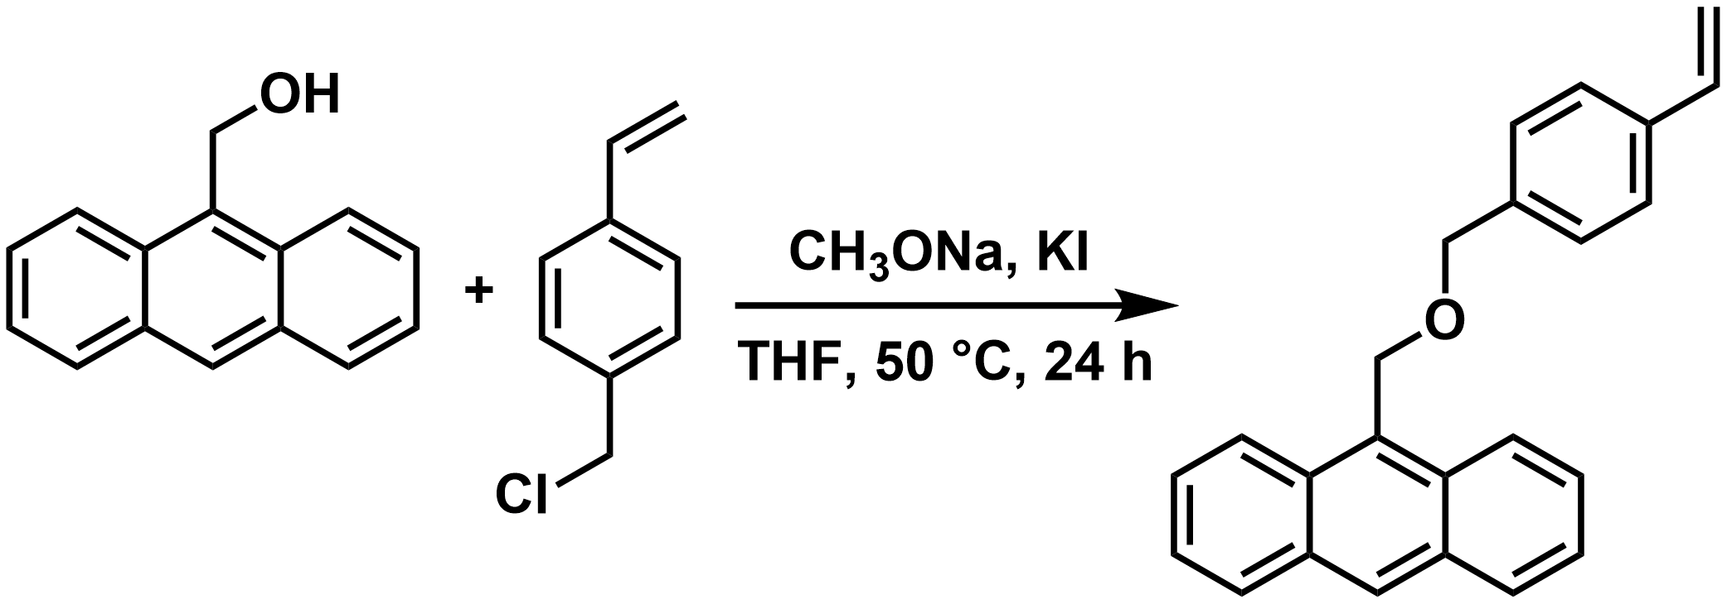
Supplementary Figure 1. The synthesis of 9-(4-vinylbenzyloxymethyl) anthracene (VBAN).

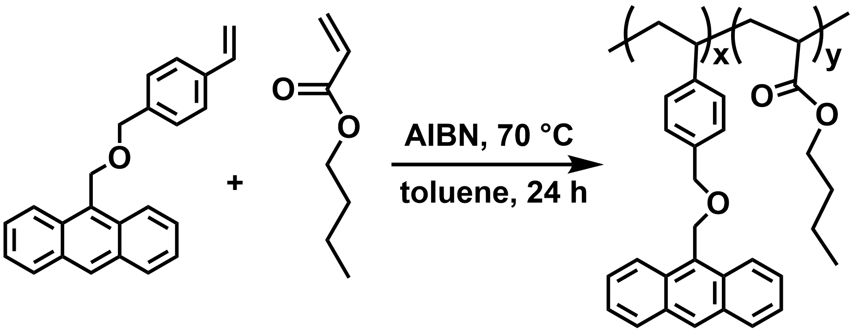
Supplementary Figure 2. The synthesis of anthracene-containing polymer (PAN-BA).

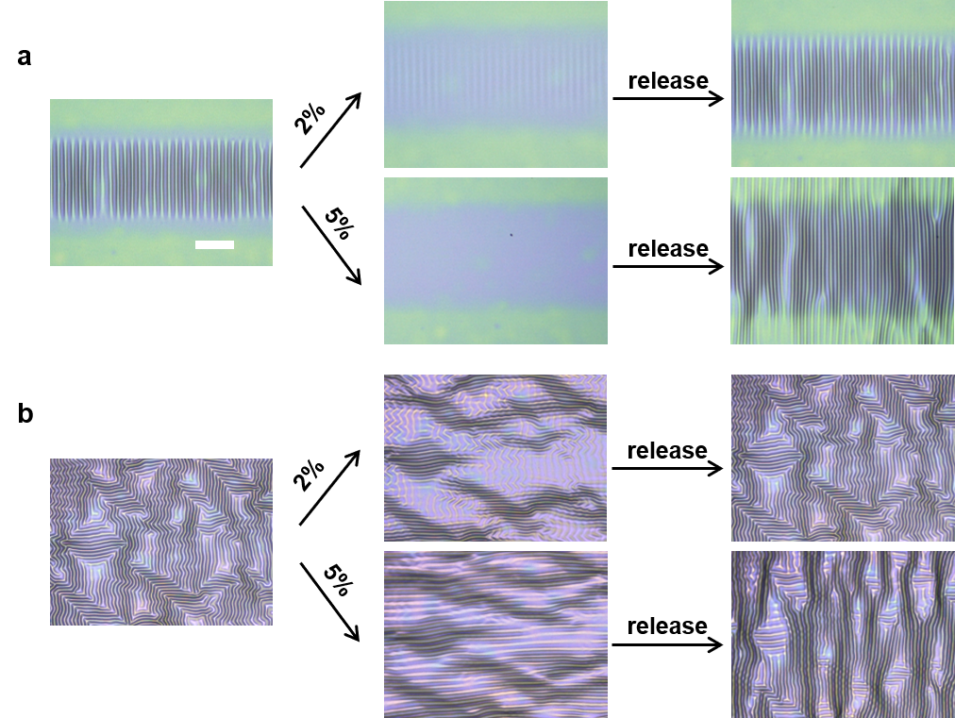
Supplementary Figure 3. The topography evolution and reversible stretching range of (a) ordered wrinkles and (b) random wrinkles under applied strain in parallel direction. Scale bar: 100 μm.

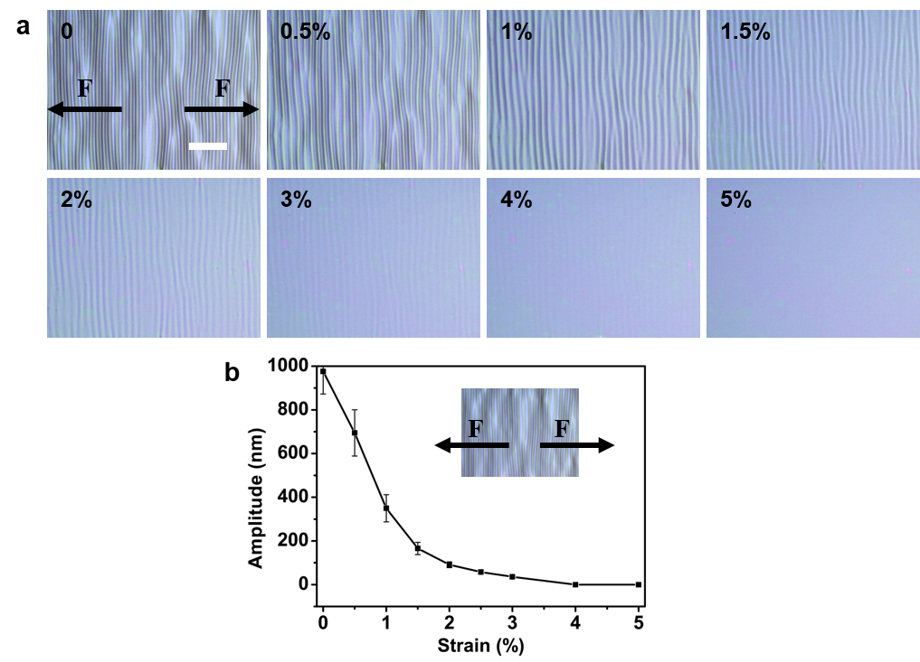
Supplementary Figure 4. a Laser scanning confocal microscope (LSCM) images of prestretching induced wrinkles under applied strain in parallel direction. Scale bar: 100 μm. b Amplitude (A) of prestretching induced ordered wrinkles as a function of applied strain in parallel direction. Error bars represent the standard deviations of three independent data.

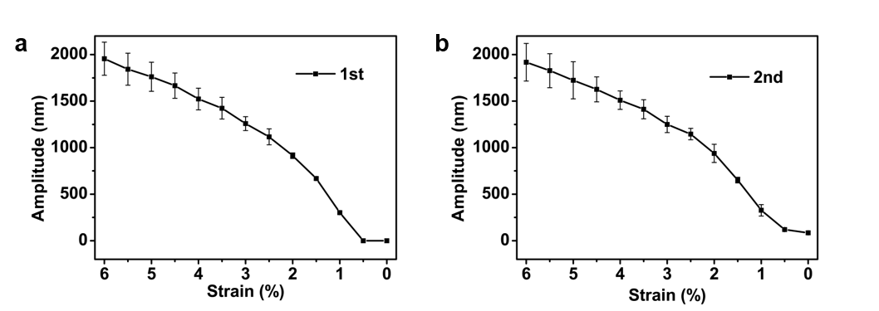
Supplementary Figure 5. Amplitude (A) of prestretching induced wrinkles as a function of prestrain during (a) the first compressive processing and (b) the second compressive processing. Error bars represent the standard deviations of three independent data.

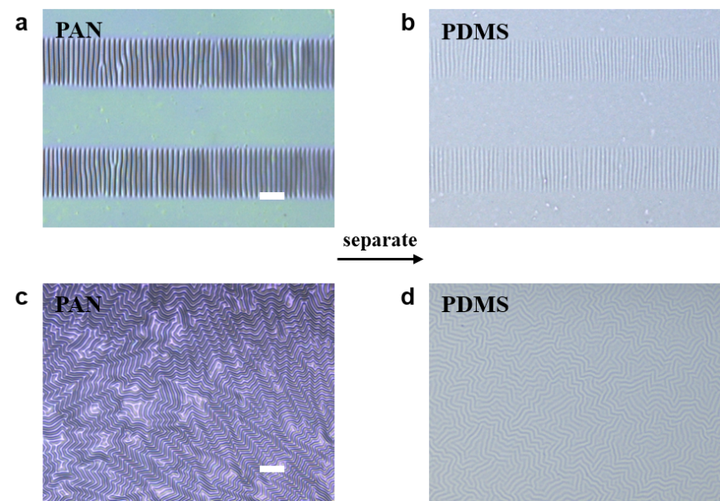
Supplementary Figure 6. Topography of PDMS after separating the top film. a Ordered wrinkles in the bilayer system. b Topography of PDMS beneath ordered wrinkled film. c Random wrinkles in the bilayer system. d Topography of PDMS beneath random wrinkled film. Scale bar: 100 μm.

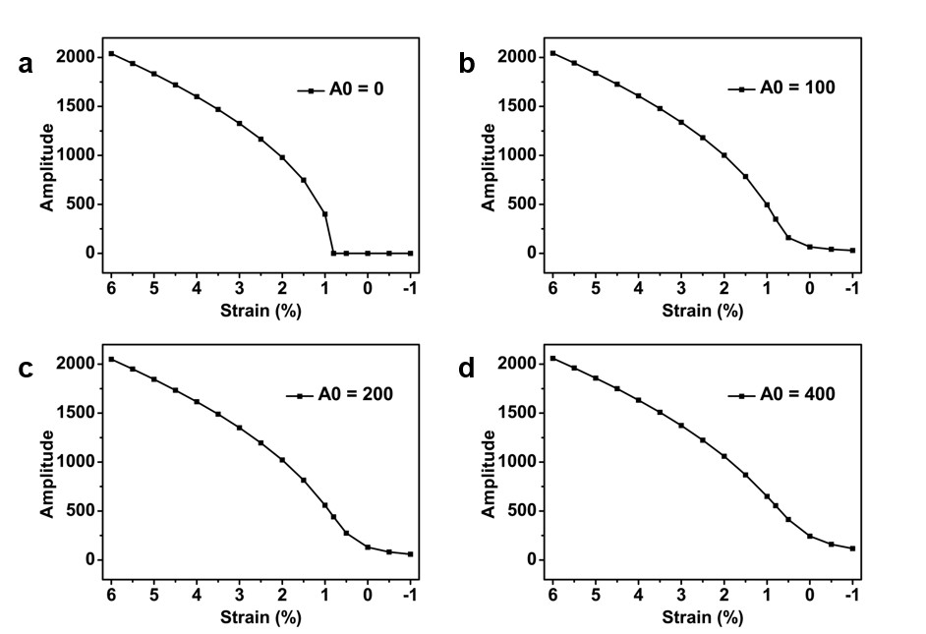
Supplementary Figure 7. Amplitude (A) as a function of strain with different amplitudes (A₀) of sinusoidal predeformation of substrate. (a) A₀= 0. (b) A₀= 100. (c) A₀= 200. (d) A₀= 400.

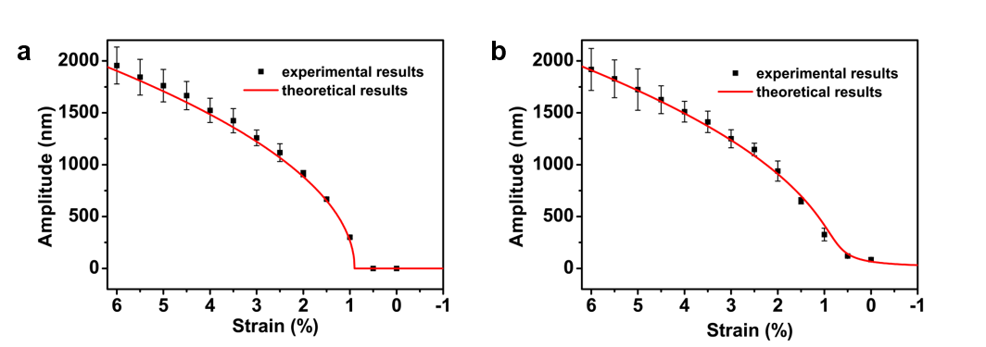
Supplementary Figure 8. Amplitude (A) of prestretching induced wrinkles as a function of strain during (a) the first compressive processing and (b) the second compressive processing. Error bars represent the standard deviations of three independent data.

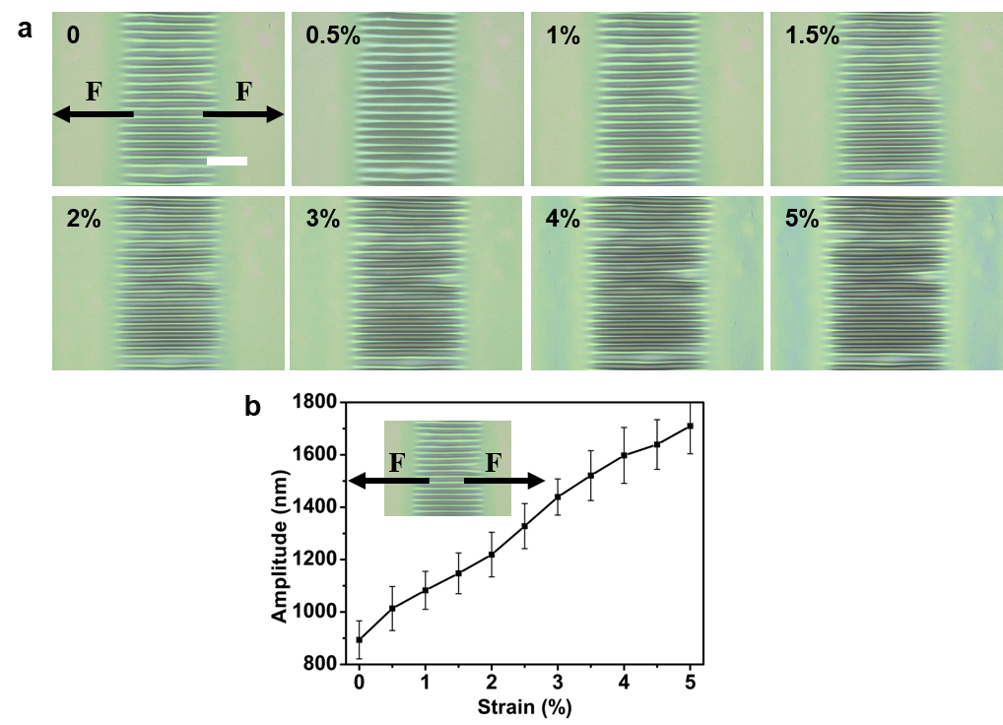
Supplementary Figure 9. a LSCM images of ordered wrinkles under applied strain in perpendicular direction. Scale bar: 100 μm. b Amplitude (A) of ordered wrinkles as a function of applied strain in perpendicular direction. Error bars represent the standard deviations of three independent data.

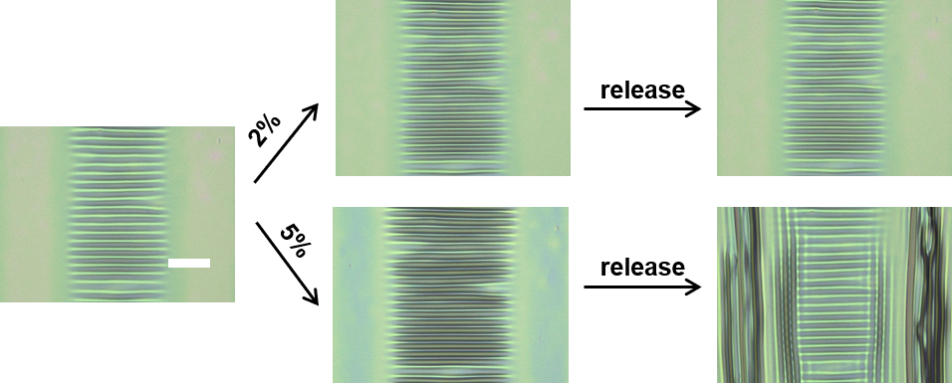
Supplementary Figure 10. The topography evolution and reversible stretching range of ordered wrinkles under applied strain in perpendicular direction. Scale bar: 100 μm.

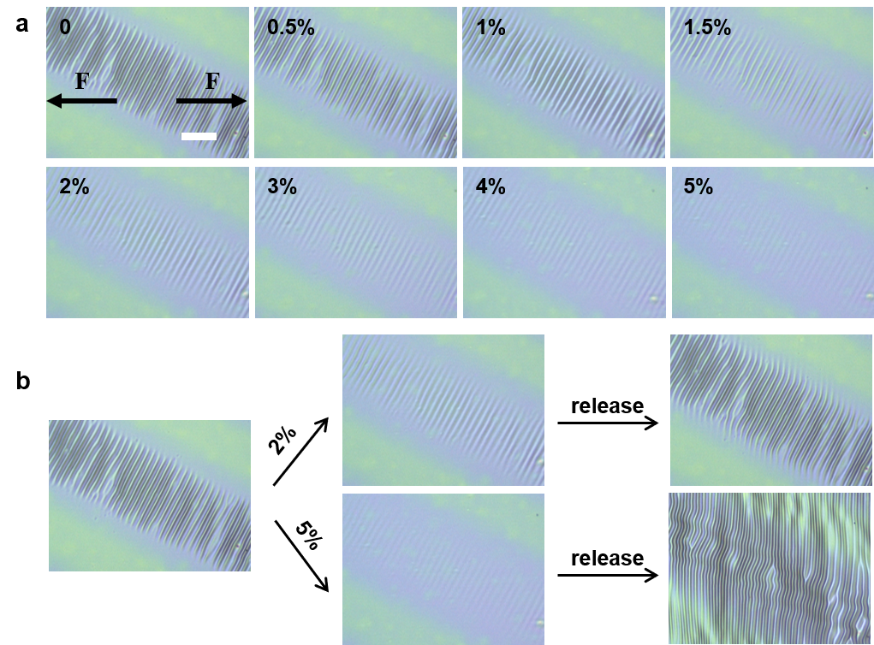
Supplementary Figure 11. a LSCM images of ordered wrinkles under applied strain in 30° direction. b The topography evolution and reversible stretching range of ordered wrinkles under applied strain in 30° direction. Scale bar: 100 μm.

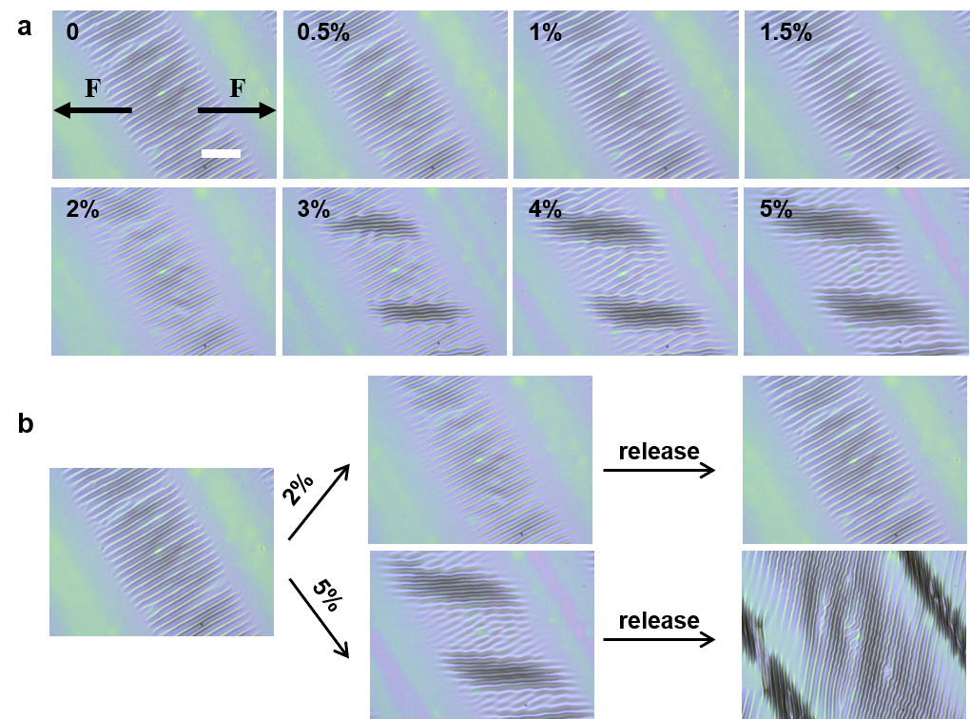
Supplementary Figure 12. a LSCM images of ordered wrinkles under applied strain in 60° direction. b The topography evolution and reversible stretching range of ordered wrinkles under applied strain in 60° direction. Scale bar: 100 μm.

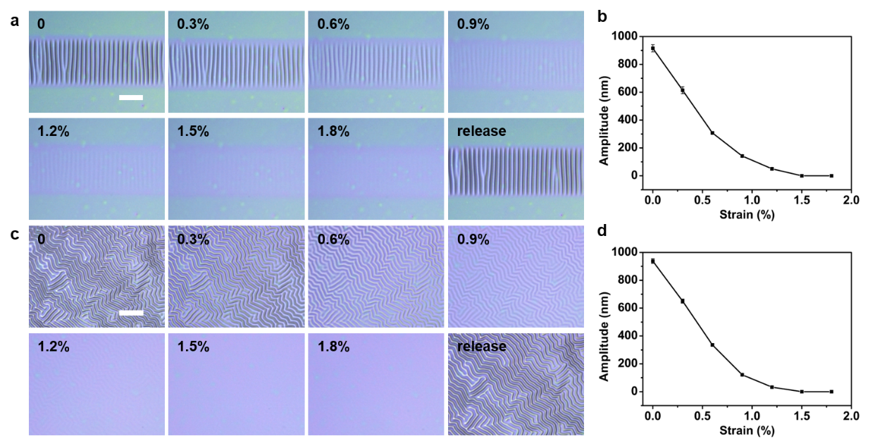
Supplementary Figure 13. a LSCM images of ordered wrinkles under equiaxed strain. b Amplitude (A) of ordered wrinkles as a function of equiaxed strain. c LSCM images of random wrinkles under equiaxed strain. d Amplitude (A) of random wrinkles as a function of equiaxed strain. Scale bar: 100 μm. Error bars represent the standard deviations of three independent data.

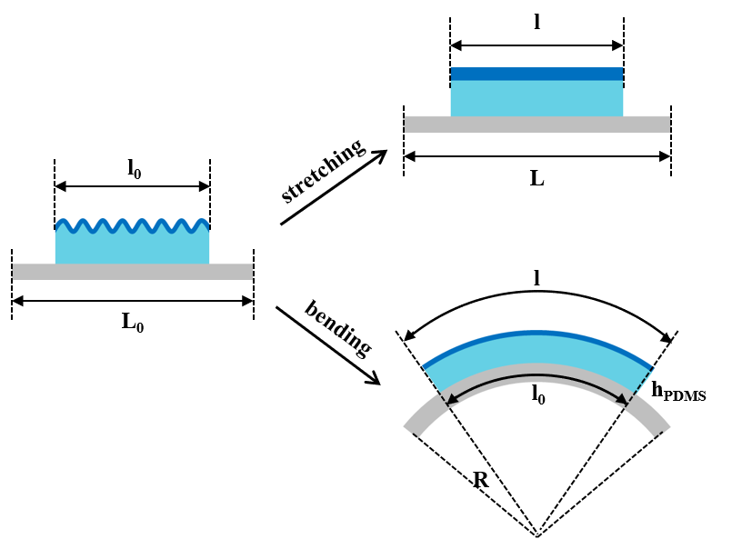
Supplementary Figure 14. Schematic illustration of two typical modes of surface wrinkles ultrasensitive to external strain: Stretching and Bending.

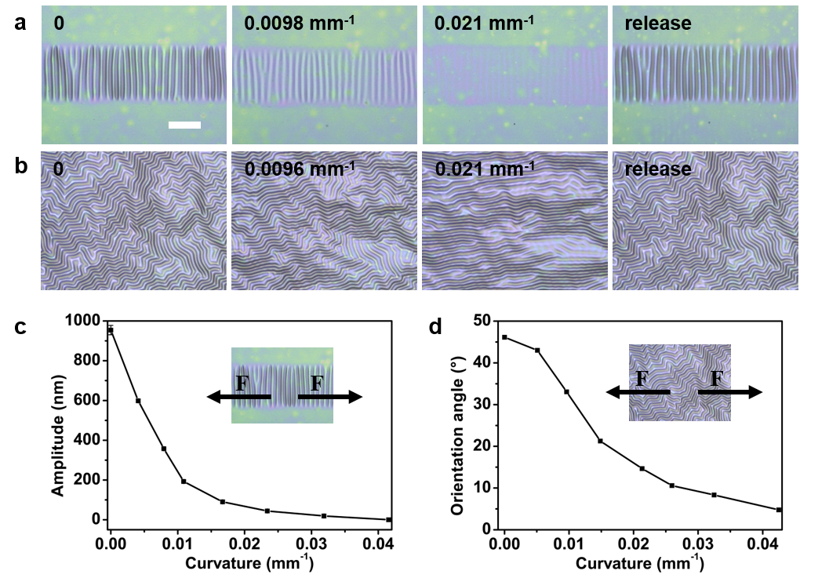
Supplementary Figure 15. Topography evolution of wrinkles during bending. a LSCM images of ordered wrinkles during bending in parallel direction. b LSCM images of random wrinkles during bending. Scale bar: 100 μm. c Amplitude (A) of ordered wrinkles as a function of curvature in parallel direction. Error bars represent the standard deviations of three independent data. d Average orientation angle ($\overline{φ}$) of random wrinkles as a function of curvature.

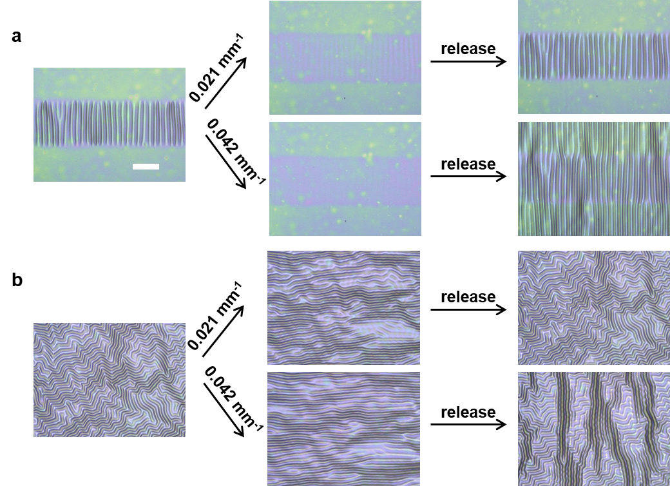
Supplementary Figure 16. The topography evolution and reversible bending range of (a) ordered wrinkles and (b) random wrinkles during bending in parallel direction. Scale bar: 100 μm.

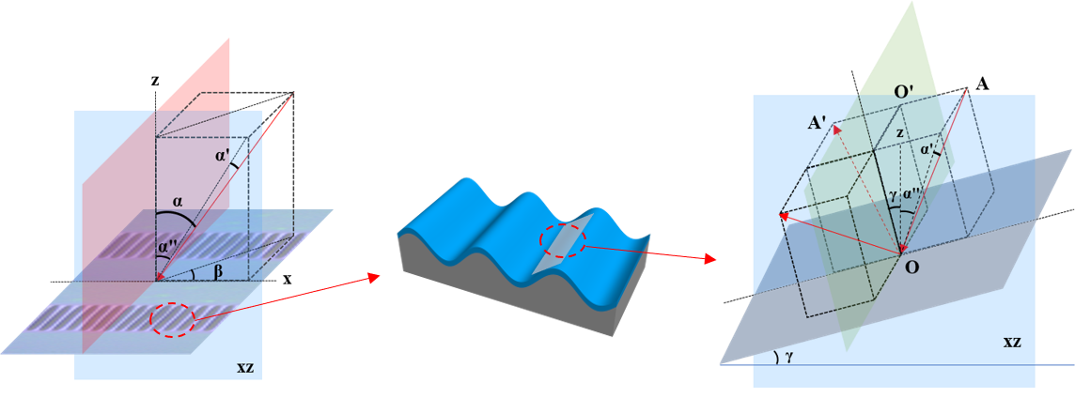
Supplementary Figure 17. Schematic illustration of reflected light by surface wrinkles.

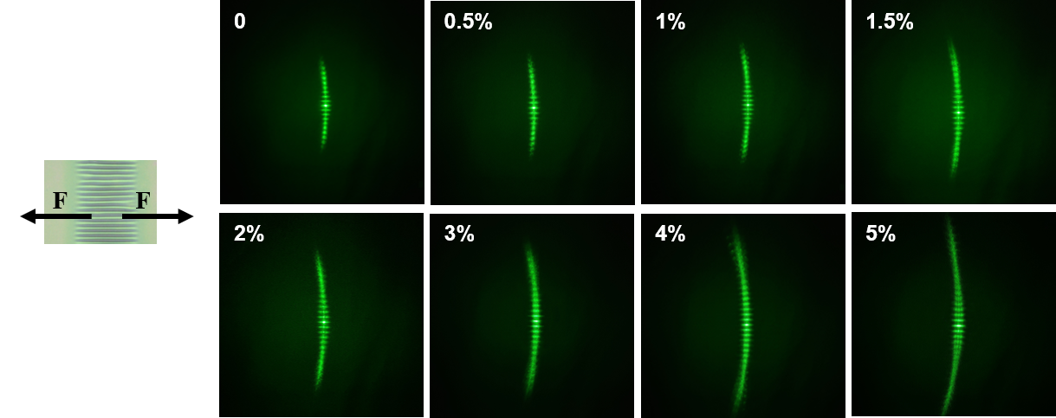
Supplementary Figure 18. Images of reflected diffraction pattern evolution corresponding with ordered wrinkles under strain in perpendicular direction.

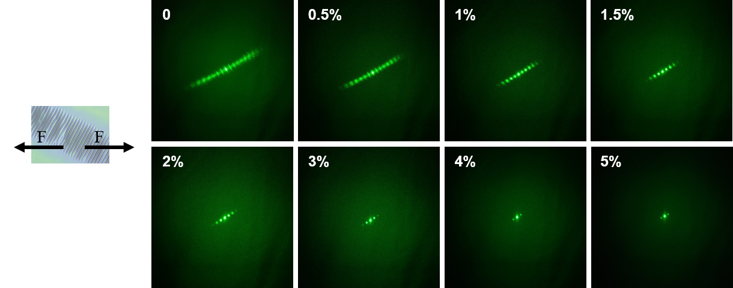
Supplementary Figure 19. Images of reflected diffraction pattern evolution corresponding with ordered wrinkles under strain in 30° direction.

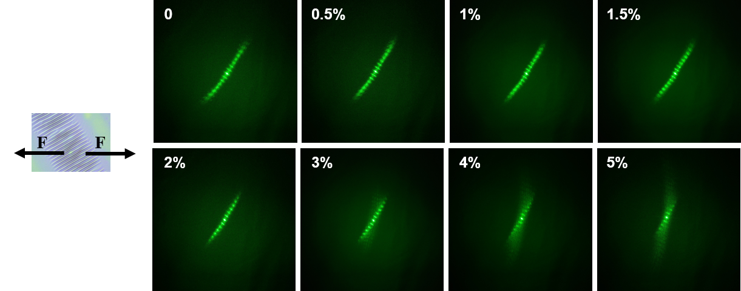
Supplementary Figure 20. Images of reflected diffraction pattern evolution corresponding with ordered wrinkles under strain in 60° direction.

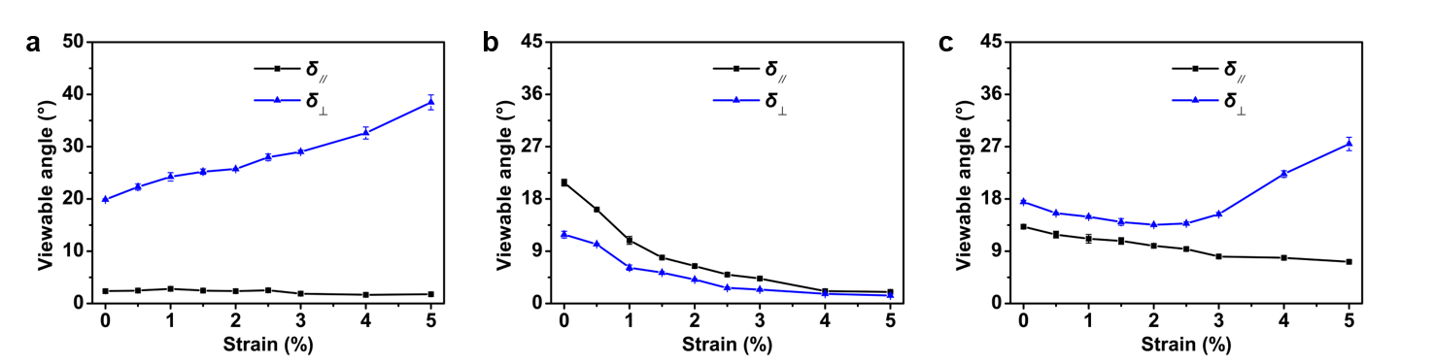
Supplementary Figure 21. Ordered wrinkles corresponding viewable angles as a function of strain in the (a) perpendicular (b) 30° (c) 60° direction. Error bars represent the standard deviations of three independent data.

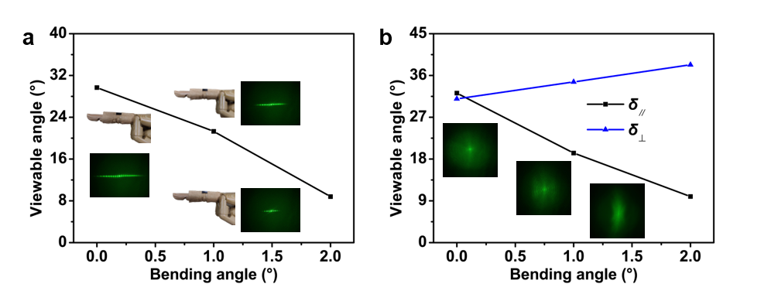
Supplementary Figure 22. Viewable angle and reflected diffraction pattern evolution corresponding with (a) ordered wrinkles and (b) random wrinkles during a prosthetic finger bending.

Supplementary movies
Supplementary movie 1. In-situ observation of color change of an ordered wrinkles-based sensor attached to the joint during slightly bending of the human wrist.
Supplementary movie 2. In-situ observation of reflected diffraction pattern evolution corresponding with ordered wrinkles and random wrinkles attached to the joint during slightly bending of the human wrist.
Supplementary movie 3. In-situ observation of color change of an ordered wrinkles-based sensor attached to the joint during slightly bending of the human finger.

