Supplemental materials

Procedures of the two precursors compound 3, compound 5, and two standards compound 7, compound 9
The general coupling reactions were compound 1 (6-hydroxyquinoline-4-carboxylic acid, 1 eq.) or compound 6 (6-methoxyquinoline-4-carboxylic acid, 1 eq.) react with N, N-diisopropylethylamine (DIPEA, 1.2 eq.), N-hydroxy-benzotriazole (HOBt, 1.2 eq.), and 2-(1Hbenzotriazole-1-yl)21,1,3,3-tetramethyluronium hexafluorophosphate (HBTU, 1.9 eq.) in an ice-water bath for two minutes, and then compound 2 ((S)-4,4-difluoro-1-glycylpyrrolidine-2-carbonitrile, 1.3 eq.) or compound 4 ((S)-1-glycylpyrrolidine-2-carbonitrile, 1.3 eq.) were added in the above solution, respectively. The reaction was carried out at room temperature for 2 h. Then the four products were collected by chromatographic separations which were performed on a silica gel column. The LC/MS and ¹H-NMR data were illustrated in Supplemental Fig. 2-9

Supplemental Figures
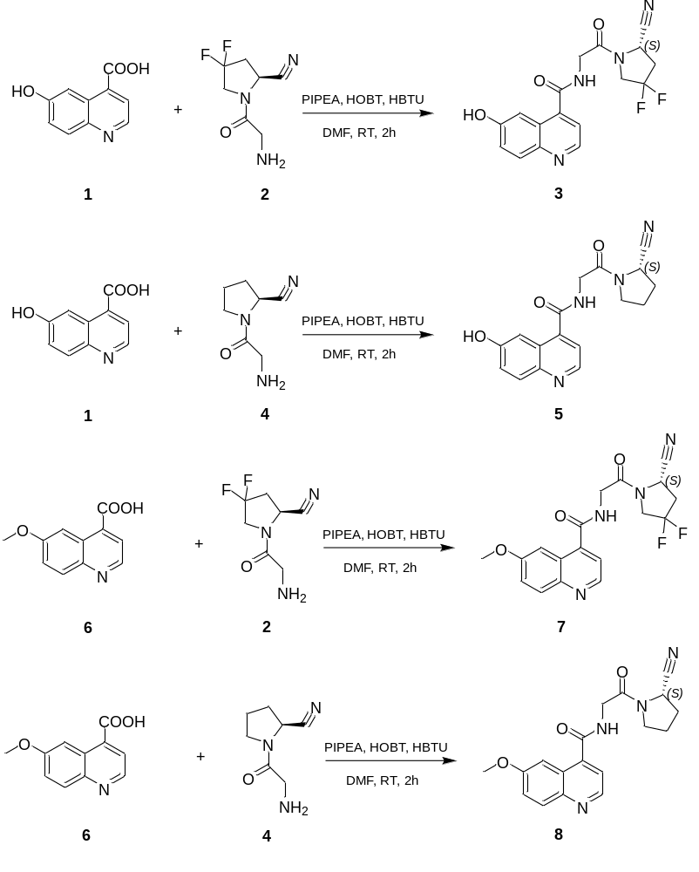
Fig.S1 Procedures of the precursors and standards.

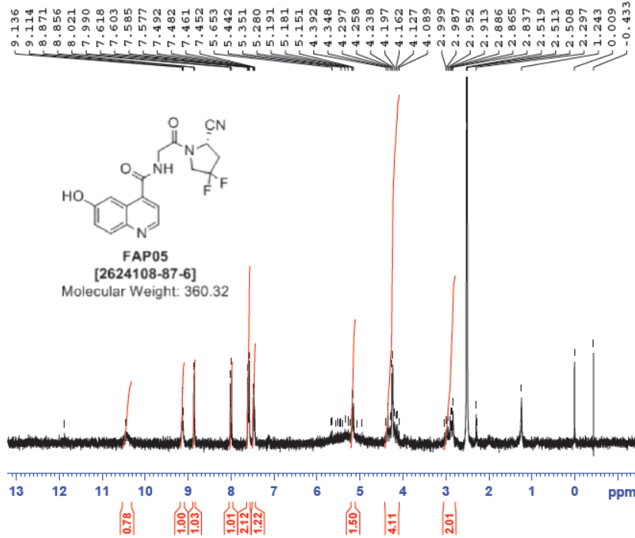
Fig.S2 1H NMR spectroscopic data for compound 3.

Fig.S3 LC/MS spectrometry for compound 3.
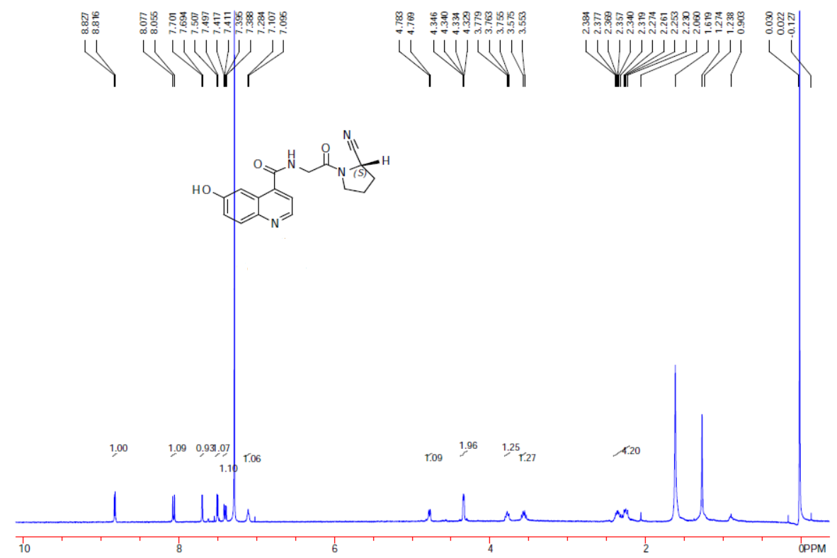
Fig.S4 1H NMR spectroscopic data for compound 5.

Fig.S5 1H NMR spectroscopic data for compound 5.

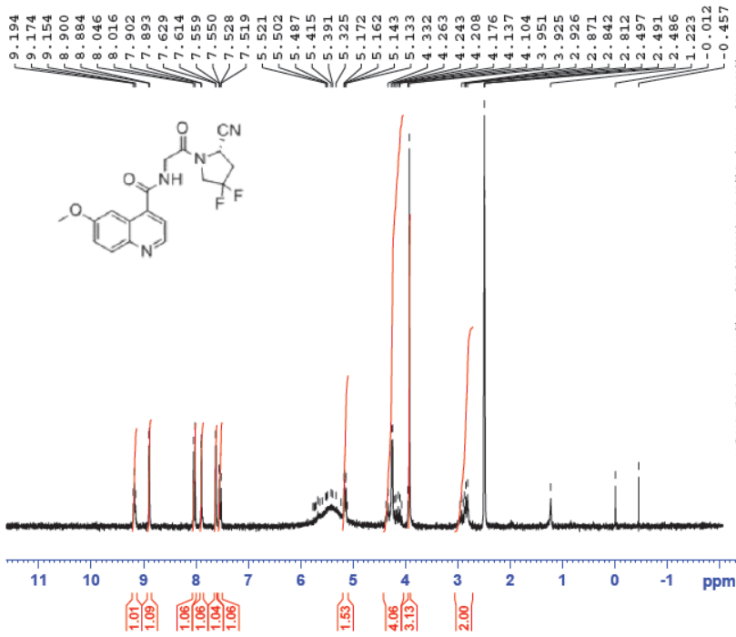
Fig.S6 1H NMR spectroscopic data for compound 7.

Fig.S7 LC/MS spectrometry for compound 7.
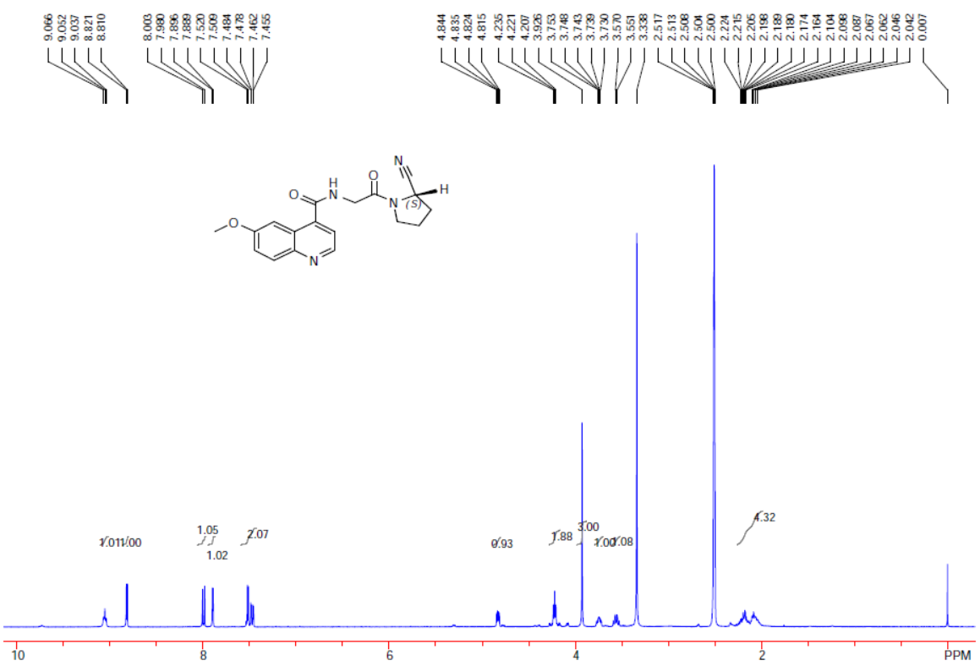
Fig.S8 1H NMR spectroscopic data for compound 8.

Fig.S9 LC/MS spectrometry for compound 8.

Fig.S10 The preparational HPLC data of ¹¹C-FAPI-01. The HPLC separation conditions: the UV wavelength is 254nm, the Flow rate is 4mLmin⁻¹, the mobile phase is V _{acetonitrile}/ V _{water} =32/68. ¹¹C-FAPI-01 was collected from 9:38 to 9:40, also the retention time was from 10-12min.
Fig.S11 The preparational HPLC data of ¹¹C-FAPI-02. The HPLC separation conditions: the UV wavelength is 254nm, the Flow rate is 4mLmin⁻¹, the mobile phase is V _{acetonitrile}/ V _{water} =42/58. ¹¹C-FAPI-02 was collected from 15:32 to 15:34, also the retention time was from 9-11min.
NOTE: In Fig.S10 and Fig.S11, the red curve is the radio monitoring curve and the blue curve is the UV monitoring curve. The first radio-peek is the injected monitoring curve also the time point of sample injection.

Fig.S12 The HPLC analysis of ¹¹C-FAPI-02. a. the radio-retention time was 7.035min; b. the UV-retention time was 6.846min.

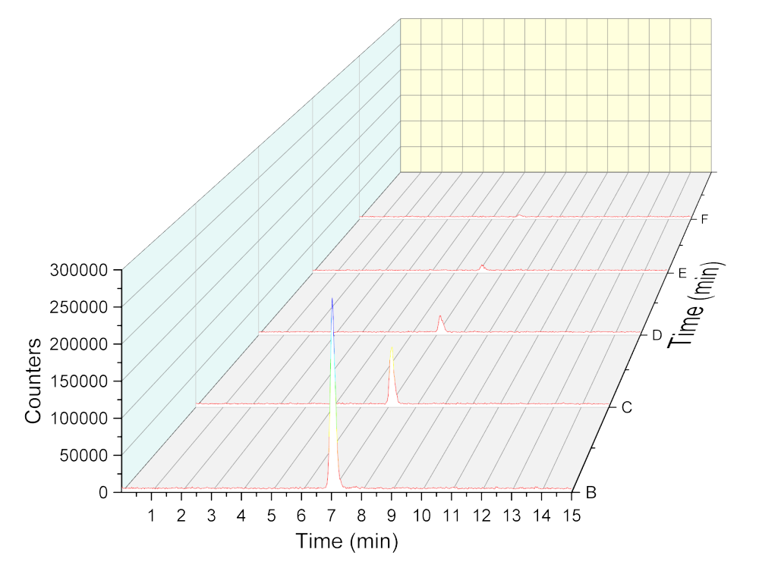Fig.S13 The stability of ¹¹C-FAPI-02 in PBS at 30, 60, 90, 120, and 150min.

Fig.S14 The iTLC of ¹[⁶⁸Ga]Ga-DOTA-FAPI-04 and the retention time is 0.594min and the retention factor value (R_{f}) is 0.713.
Fig.S15 Representative static PET imaging of [⁶⁸Ga]Ga-DOTA-FAPI-04 at 10, 30,60, and 90min.

Fig.S16 The Representative static PET imaging and distribution of [⁶⁸Ga]Ga-DOTA-FAPI-04. a: The organs or tissues uptakes of ¹¹C-FAPI-02 in U87MG tumor-bearing nude mice at 30, 60, 90min; b: the time-active-curve (TAC) of ¹¹C-FAPI-02 at 30, 60, 90min.

