Supplementary Information
Fluoride exposure induced bloom of Erysipelatoclostridium ramosum mediates the exacerbation of obesity in high-fat-diet fed mice
Guijie Chen¹, Yujia Peng¹, Yujie Huang¹, Minhao Xie², Zhuqing Dai³, Huimei Cai⁴, Wei Dong¹, Weiqi Xu¹, Zhiyong Xie¹, Dan Chen¹, Xia Fan¹, Wangting Zhou¹, Xuhui Kan¹, Tingting Yang¹, Chunxu Chen¹, Yi Sun¹, Xiaoxiong Zeng¹* , Zhonghua Liu^{5,6}*
¹ College of Food Science and Technology, Nanjing Agricultural University, Nanjing 210095, Jiangsu, China
² Collaborative Innovation Center for Modern Grain Circulation and Safety, College of Food Science and Engineering, Nanjing University of Finance and Economics, Nanjing 210023, China
³ Institute of Agro-product Processing, Jiangsu Academy of Agricultural Sciences, Nanjing 210014, China
⁴ State Key Laboratory of Tea Plant Biology and Utilization, School of Tea & Food Science and Technology, Anhui Agricultural University, Hefei 230036, Anhui, China
⁵ Key Laboratory of Ministry of Education for Tea Science, Hunan Agricultural University, Changsha 410128, China
⁶ National Research Center of Engineering Technology for Utilization of Botanical Functional Ingredients, Changsha 410128, China

Table S1. The composition of D12492 and D12450J.
Product# | D12492 | D12450J
Protein | 20% kcal | 20% kcal
Carbohydrate | 20% kcal | 70% kcal
Fat | 60% kcal | 10% kcal
Total | 100% | 100%
kcal/g | 5.21 | 3.82

Table S2. Primer sequences used in the RT-qPCR experiment.
Target gene | Primer Sequence (5´-3´)
Tnf-α | FW: CTCATGCACCACCATCAAGG
Tnf-α | RV: ACCTGACCACTCTCCCTTTG
Il-1β | FW: AGCTTCAAATCTCGCAGCAG
Il-1β | RV: TCTCCACAGCCACAATGAGT
Il-6 | FW: CTCTGGCGGAGCTATTGAGA
Il-6 | RV: AAGTCTCCTGCGTGGAGAAA
Tlr4 | FW: GCTCTCAGCCATCCACAAAG
Tlr4 | RV: GAGTCGGGAAGAGGAAGAGG
Myd88 | FW: TTTCCCAGTATCCTGCGGTT
Myd88 | RV:GCGGAAGAACACAGACAGAC
Zo-1 | FW: TGAGTGCGTTTCTCTCCCTT
Zo-1 | RV: CCCTCTGTGTTCCTCATGGT
Occludin | FW: AGCACTTAACCTGCCTGGAT
Occludin | RV: AGCCTGTGGAAGCAAGAGAT
Claudin-1 | FW: AGCTGCCTGTTCCATGTACT
Claudin-1 | RV: CTCCCATTTGTCTGCTGCTC
Muc1 | FW: CACAACTACCAGCTCTGCAC
Muc1 | RV: CTGAGCCTGACGTCACTTTG
Gapdh | FW: GGACTTACAGAGGTCCGCTT
Gapdh | RV: CTATAGGGCCTGGGTCAGTG
E. ramosum | FW: ACAATGGATGGTGCAGAGGG  RV: TCAACTCTCTCGTGGTGTGACG

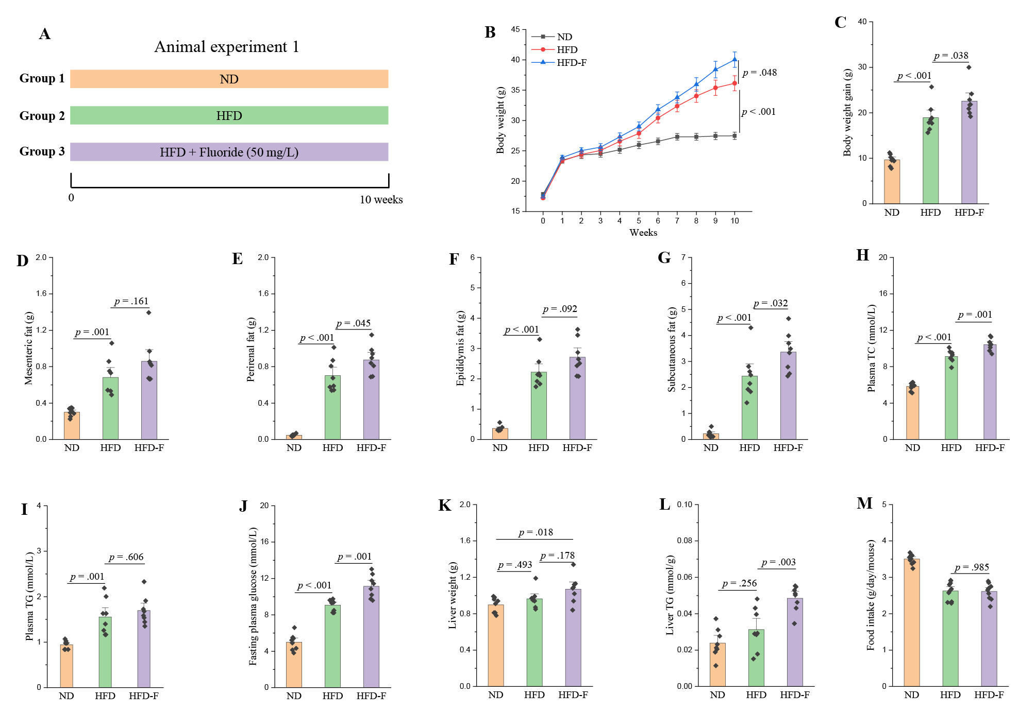
Fig. S1. Fluoride exacerbates the obesity in high-fat diet (HFD) mice. Mice were randomly divided into three groups including normal diet (ND) group, high-fat diet (HFD) group, and HFD plus 50 mg/L of fluoride in drinking water (HFD-F) group (n = 8 per group). (A) Scheme of animal experiment 1 over the 10 weeks of dietary intervention. (B) Dynamic changes in body weight in mice. (C) Body weight gain. (D) Mesentery fat. (E) Perirenal fat. (F) Epididymal fat. (G) Subcutaneous fat. (H-I) Plasma levels of TC and TG. (J) Fasting plasma glucose. (K) Liver weight. (L) Liver TG. (M) Food intake. The results were expressed as means ± SEM. Statistical significance was carried out by one-way analysis of variance (ANOVA) with Tukey test. A value of p < 0.05 was considered to be significant.

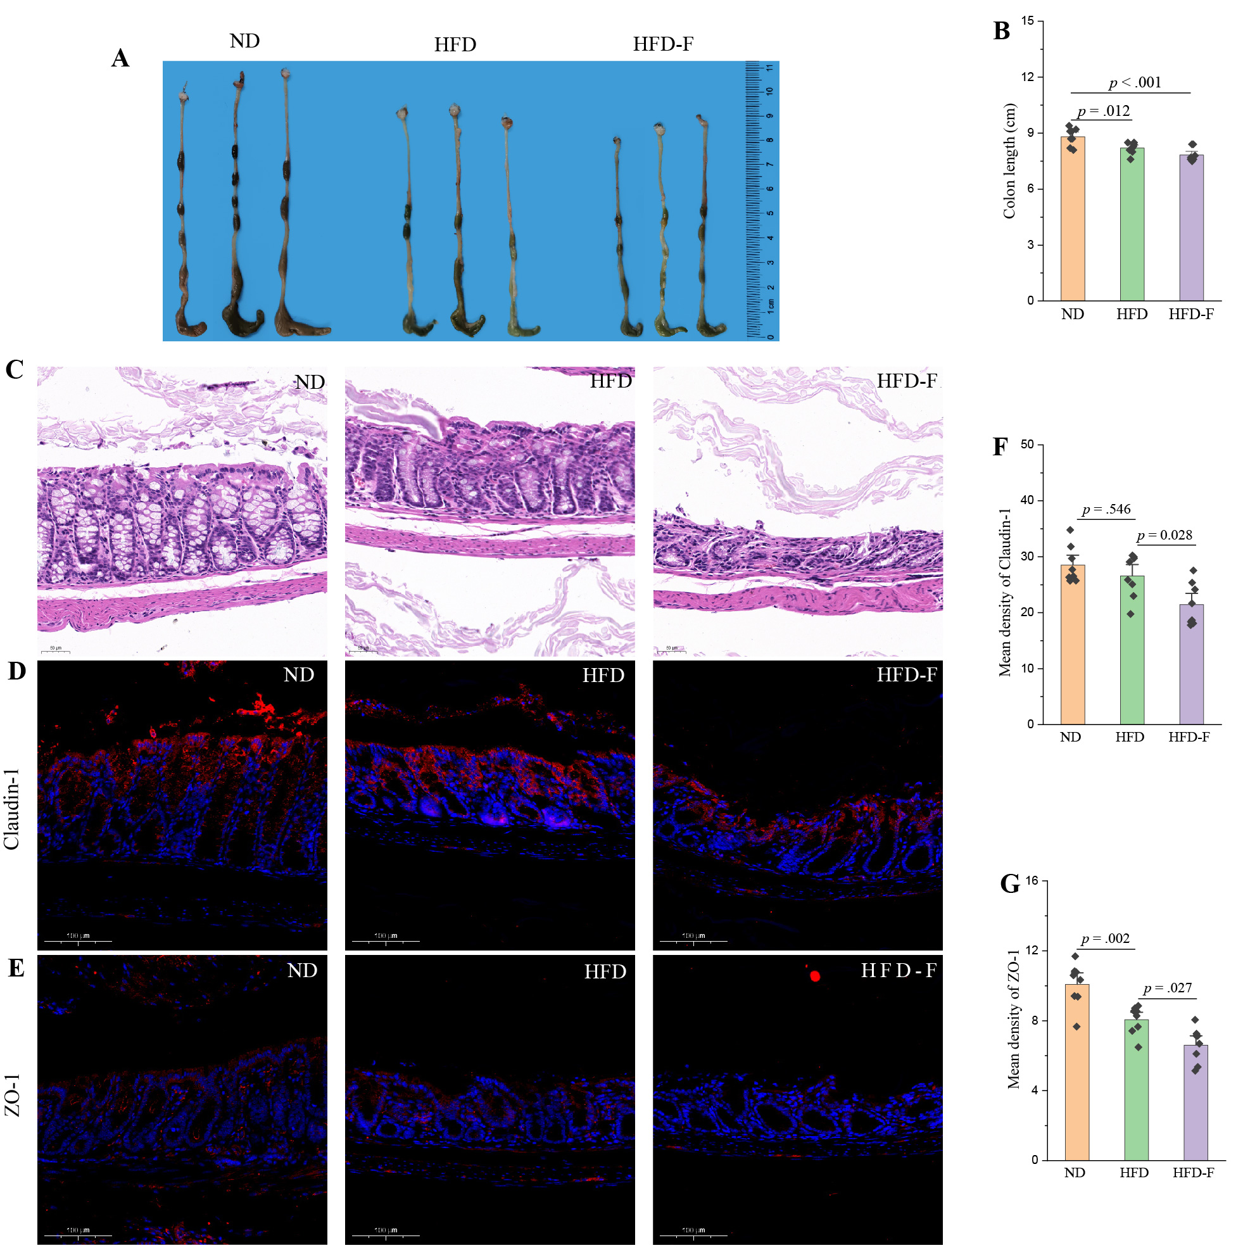
Fig. S2. Fluoride drives the intestinal barrier permeability in HFD mice. (A) Representative morphology of colon. (B) Colon length (n = 8). (C) Representative H&E staining of colon, Scale bar = 100 μm. (D-E) Representative immunofluorescence images of Claudin-1 and ZO-1 in colon, 20 ×, Scale bar = 100 μm. (F-G) Mean density of Claudin-1, MUC1 and ZO-1 in immunofluorescence images was evaluated by ImageJ software (n = 8). The results were expressed as means ± SEM. Statistical significance was carried out by one-way analysis of variance (ANOVA) with Tukey test. A value of p < 0.05 was considered to be significant.

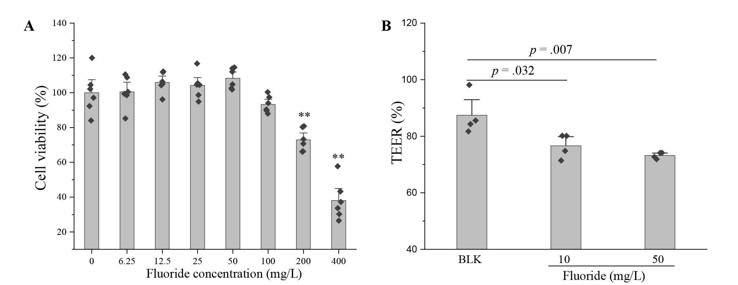
Fig. S3. Fluoride drives Caco-2 cell permeability in vitro. (A) The cytotoxicity of fluoride on the Caco-2 cells evaluated by MTT method (n = 6). (B) The effect of fluoride on the Caco-2 cell permeability evaluated by transepithelial electrical resistance (TEER) assay (n = 4). The results were expressed as means ± SEM. Statistical significance was carried out by one-way analysis of variance (ANOVA) with Tukey test. A value of p < 0.05 was considered to be significant.

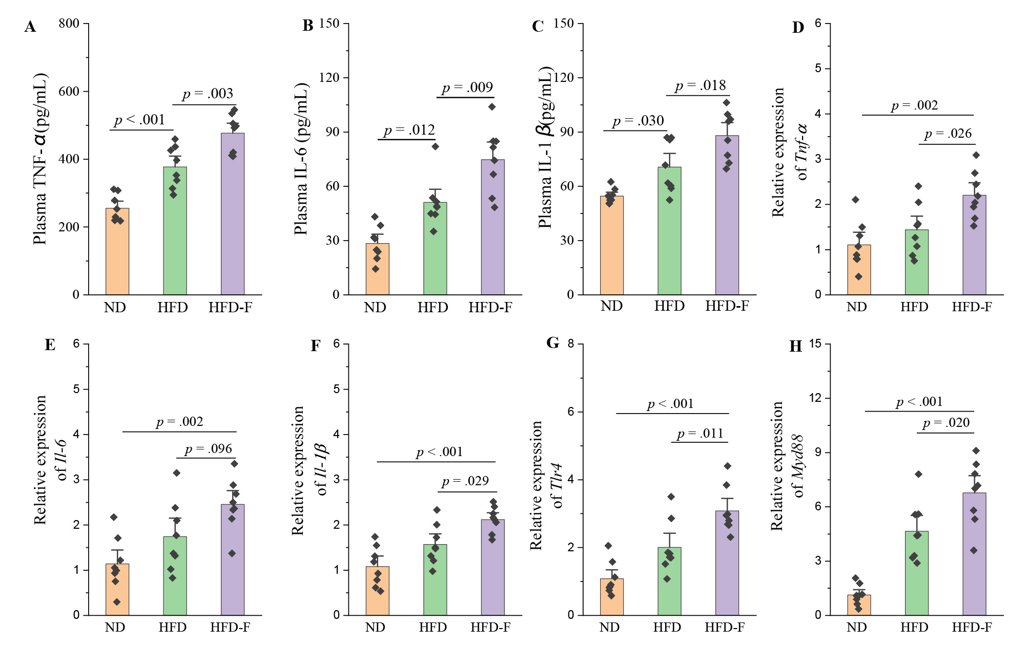
Fig. S4. Fluoride deteriorates the inflammation in HFD mice. (A-C) The plasma levels of TNF-α, IL-6, and IL-1β (n = 8). (D-H) Relative mRNA expression levels of Tnf-α, Il-6, Il-1β, Myd88 and Tlr4 in liver (n = 8). The results were expressed as means ± SEM. Statistical significance was carried out by one-way analysis of variance (ANOVA) with Tukey test. A value of p < 0.05 was considered to be significant.

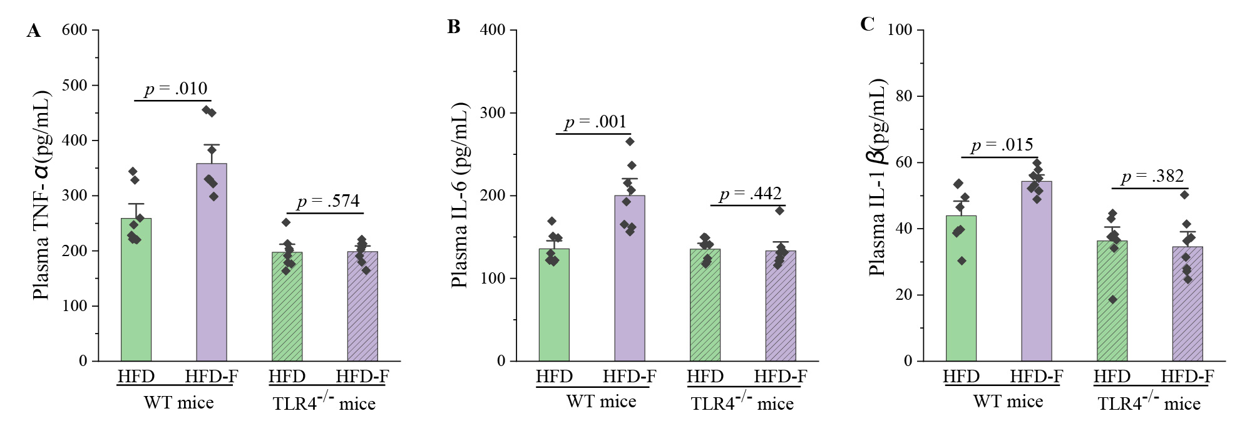
Fig. S5. Fluoride fails to induce the inflammation in Tlr4^{-/-} mice. (A-C) The plasma levels of TNF-α, IL-6, and IL-1β. The results were expressed as means ± SEM. Difference in two groups was calculated using the Mann-Whitney test or Kruskal-Wallis test. A value of p < 0.05 was considered to be significant.

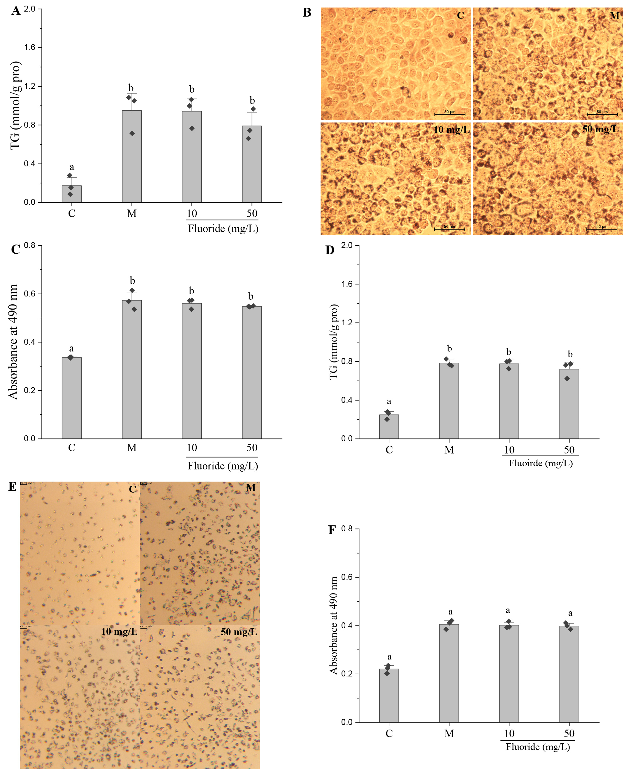
Fig. S6. Fluoride shows limited effect on lipid accumulation using HepG2 cell and primary murine hepatocytes in vitro. The HepG2 cells or primary murine hepatocytes were cultivated with oleic acid/palmitic acid (OA/PA) and fluoride (10 and 50 mg/L), C: control group without OA/PA or fluoride, M: model group with OA/PA, fluoride: fluoride group with OA/PA and fluoride. (A) The effect of fluoride (10 and 50 mg/L) on the level of TG in OA/PA-induced HepG2 cell (n = 3). (B) Representative oil red O staining of HepG2 cell. (C) The absorbance at 490 nm of oil red solution washed from HepG2 cell by isopropanol (n = 3). (D) The effect of fluoride (10 and 50 mg/L) on the level of TG in OA/PA-induced primary murine hepatocytes (n = 3). (B) Representative oil red O staining of primary murine hepatocytes. (C) The absorbance at 490 nm of oil red solution washed from primary murine hepatocytes by isopropanol (n = 3). The results were expressed as means ± SEM. Statistical significance was carried out by one-way analysis of variance (ANOVA) with Tukey test. A value of p < 0.05 was considered to be significant.

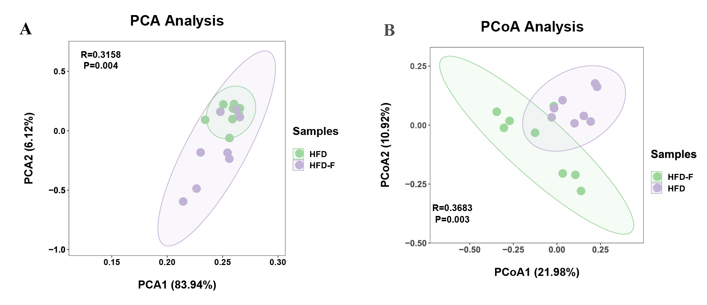
Fig. S7. Fluoride affects the Beta-diversity of gut microbiota in HFD fed mice including PCA and PCoA. Gut microbiota was analyzed by 16S rRNA gene sequencing (n = 8 for each group). (A) PCA based on the relative abundance of Features of the gut microbiota, (B) PCoA of the gut microbiota based on the unweighted unifrac distance matrix.

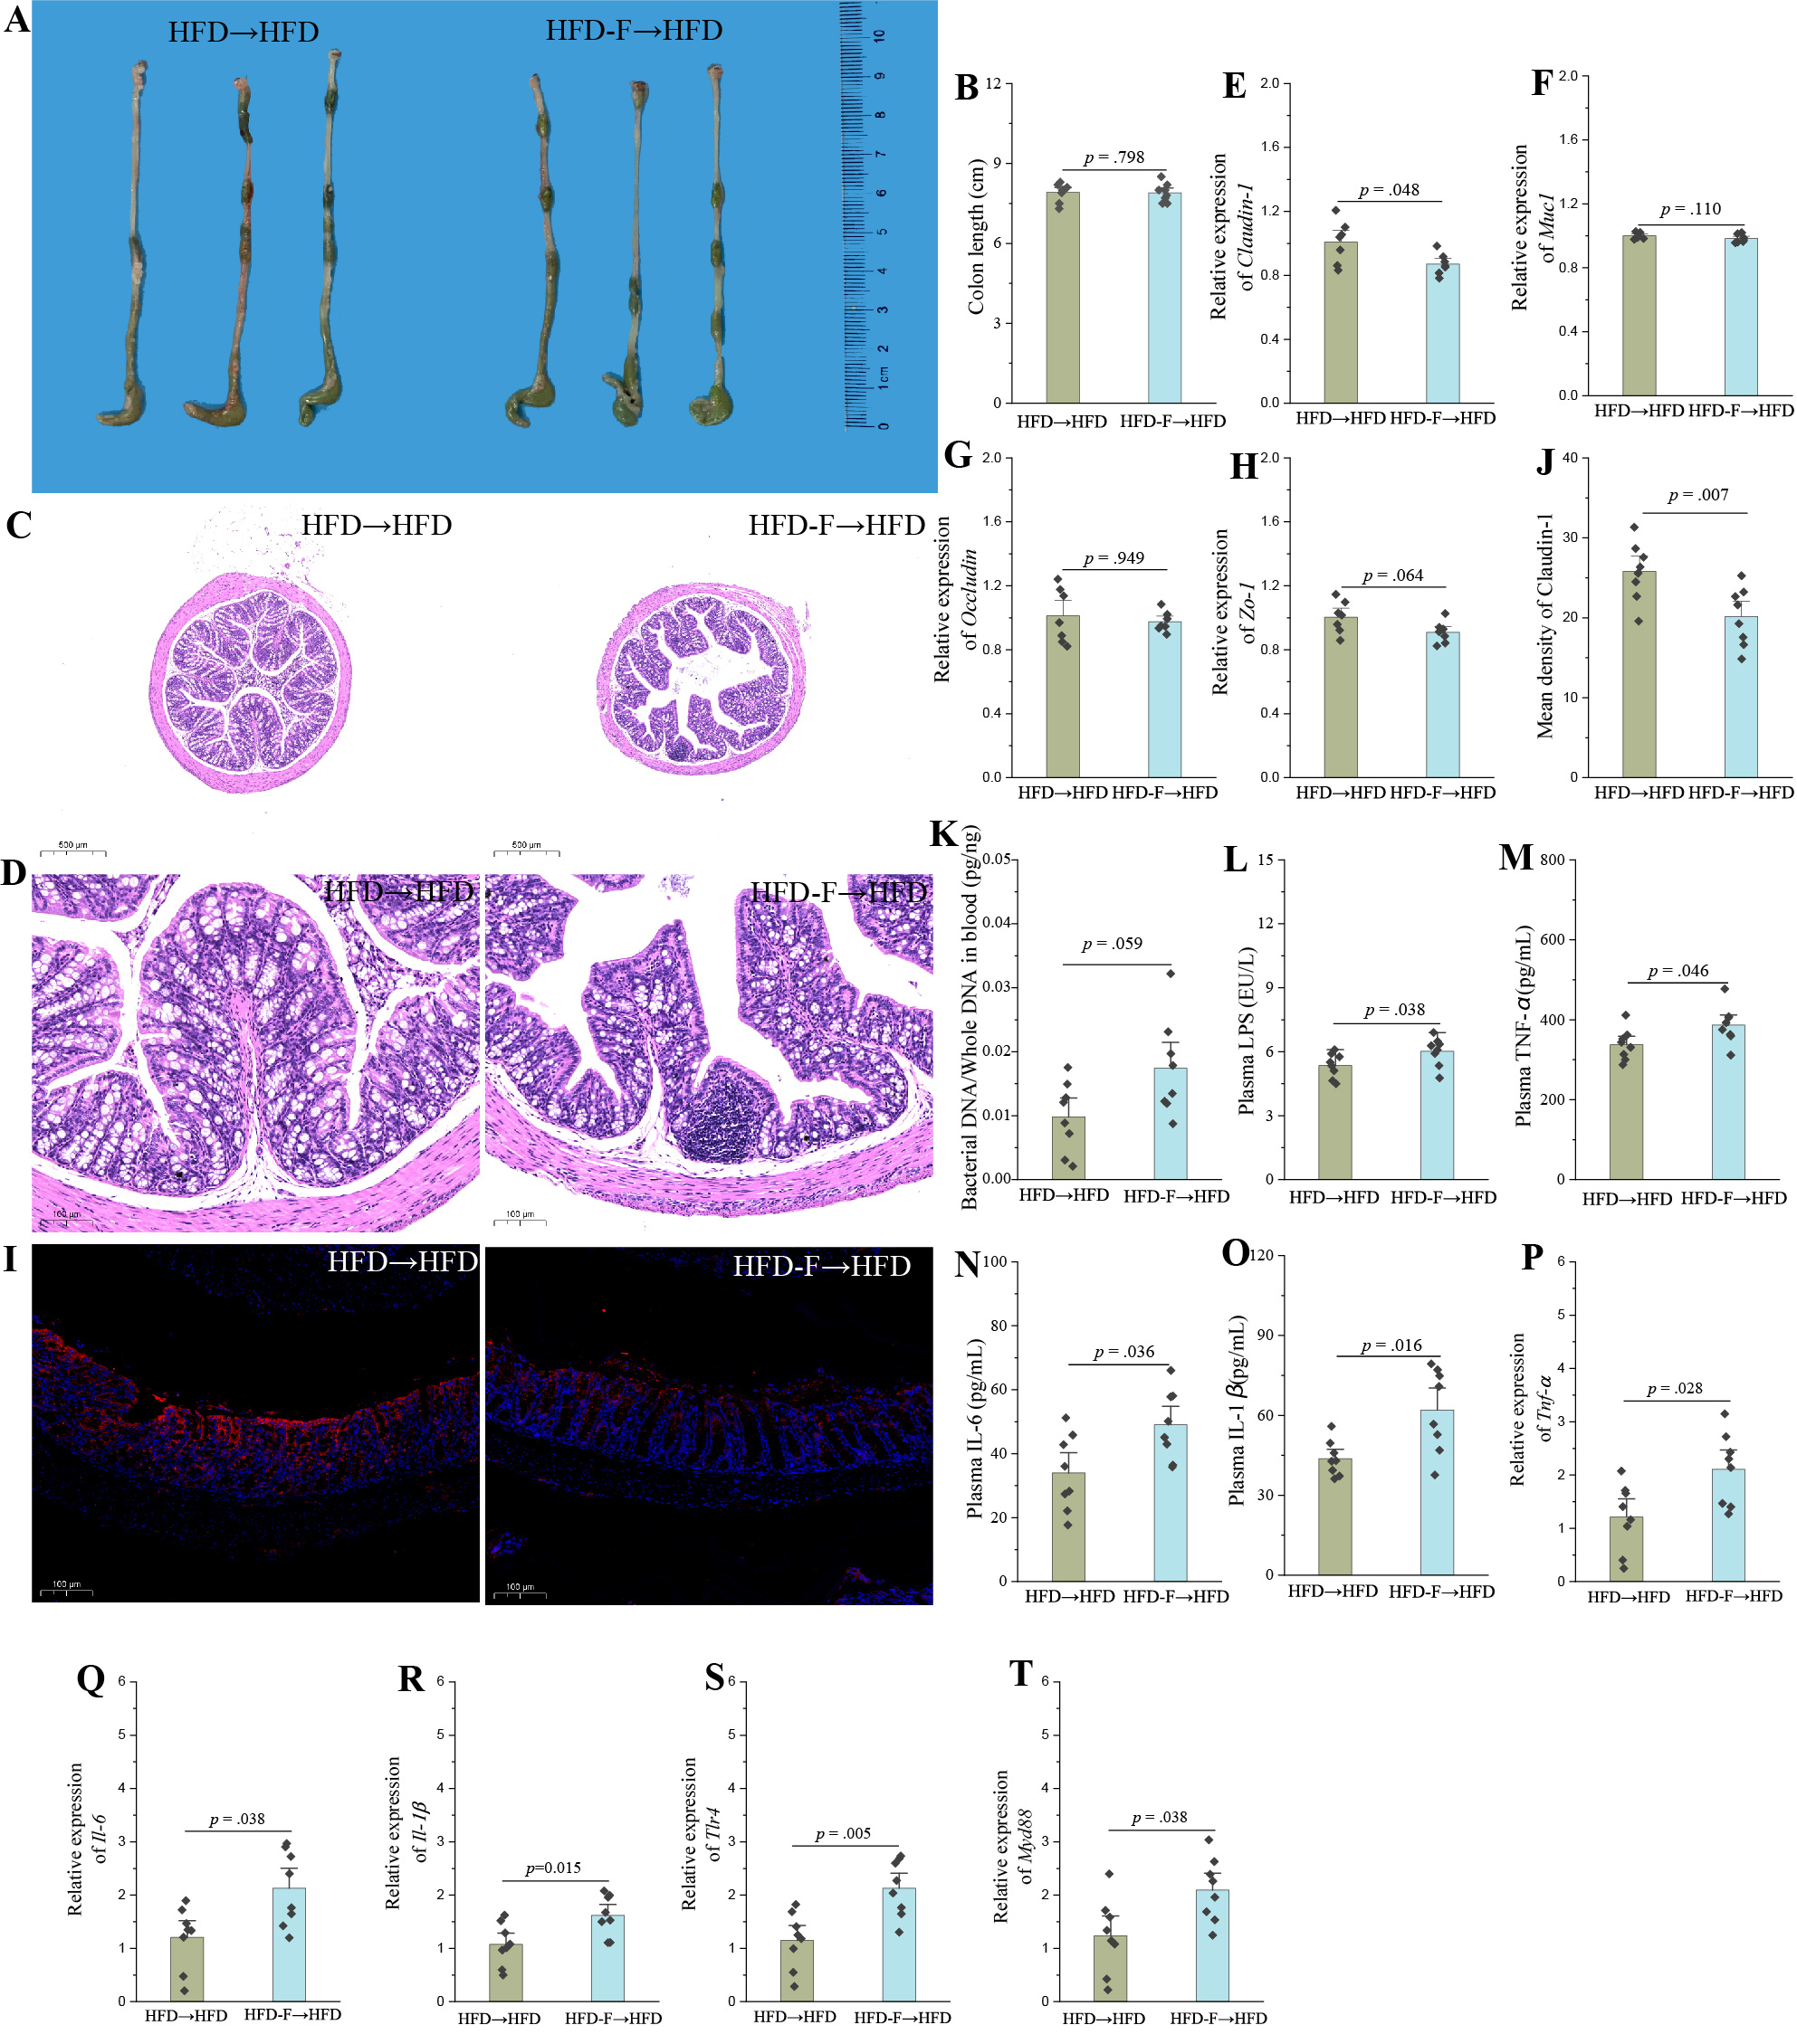
Fig. S8. Fluoride-induced gut microbiota impairs gut barrier function and promotes the inflammation. (A) Representative morphology of colon. (B) Colon length (n = 8). (C-D) Representative H&E staining of colon (10× and 40×, respectively). (E-H) Relative mRNA expression levels of Claudin-1, Muc1, Occludin and Zo-1 in colon (n = 7). (I) Representative immunofluorescence images of Claudin-1 in colon, 20 ×, Scale bar = 100 μm. (J) Mean density of Claudin-1 in immunofluorescence images was evaluated by ImageJ software (n = 8). (K) Bacterial DNA/Whole DNA in blood was measured by RT-qPCR (n = 8). (L) Plasma LPS (n = 8). (M-O) The plasma levels of TNF-α, IL-6, and IL-1β (n = 8). (P-T) Relative mRNA expression levels of Tnf-α, Il-6, Il-1β, Myd88 and Tlr4 in liver (n = 8). The results were expressed as means ± SEM. Difference in two groups was calculated using the Mann-Whitney test or Kruskal-Wallis test. A value of p < 0.05 was considered to be significant.

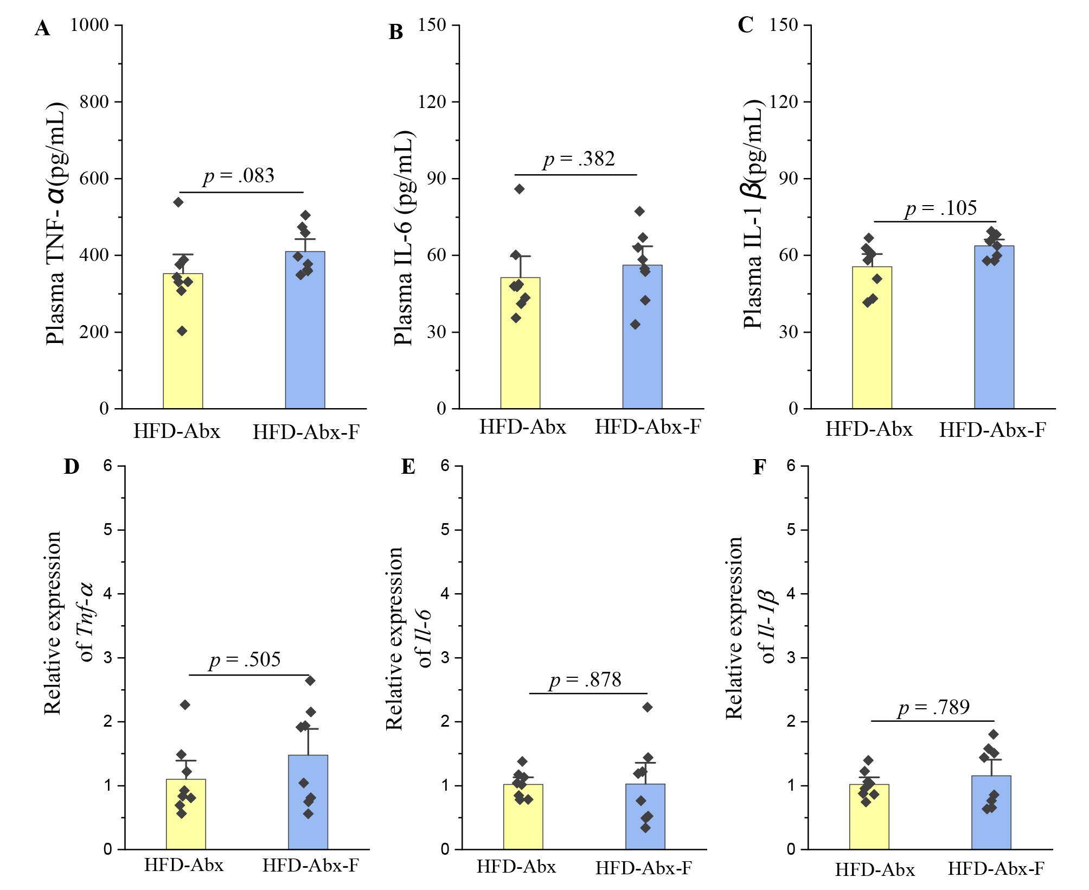
Fig. S9. Fluoride fails to induce the inflammation after depletion of the gut microbiota by Abx. (A-C) The plasma levels of TNF-α, IL-6, and IL-1β (n = 8). (D-F) Relative mRNA expression levels of Tnf-α, Il-6, and Il-1β in liver (n = 8). The results were expressed as means ± SEM. Difference in two groups was calculated using the Mann-Whitney test or Kruskal-Wallis test. A value of p < 0.05 was considered to be significant.

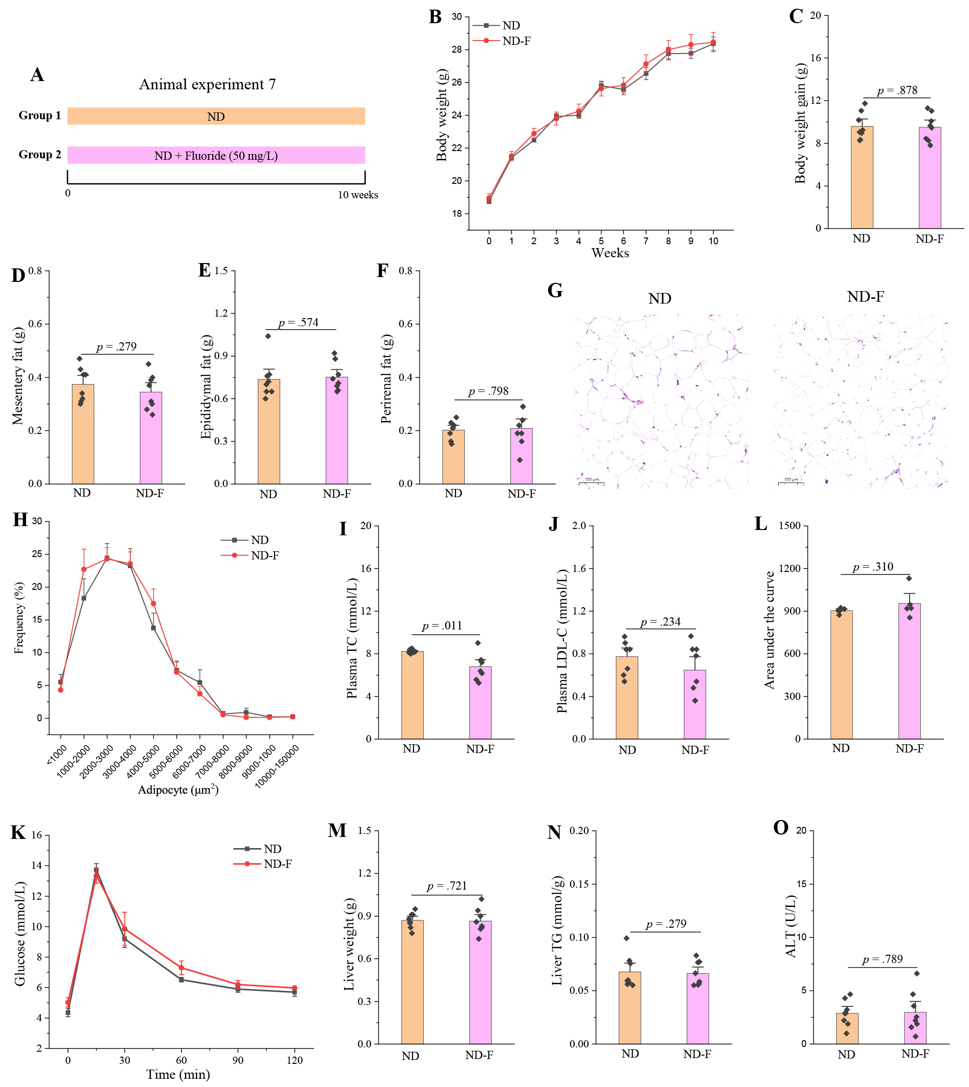
Fig. S10. Fluoride fails to induce the obesity in ND mice. (A) Scheme of animal experiment 7 over the 10 weeks of dietary intervention. Mice were randomly divided into two groups including ND group, and ND plus 50 mg/L of fluoride in drinking water (ND-F) group (n = 8 per group). (B) Dynamic changes in body weight in mice. (C) Body weight gain. (D) Mesentery fat. (E) Epididymal fat. (F) Perirenal fat. (G) Representative H&E staining of Epididymal fat, Scale bar = 100 μm. (H) Adipocytes (μm²) distribution in the Epididymal fat tissue. (I-J) Plasma levels of TC and LDL-C. (K) OGTT was carried out at week 9, mice were fasted overnight and gavaged with a dosage of glucose with 1.5 mg/g body weight (n = 5 per group). (L) Area under the curve (AUC) for OGTT. (M) Liver weight. (N) Liver TG. (O) Plasma ALT. The results were expressed as means ± SEM. Difference in two groups was calculated using the Mann-Whitney test or Kruskal-Wallis test. A value of p < 0.05 was considered to be significant.

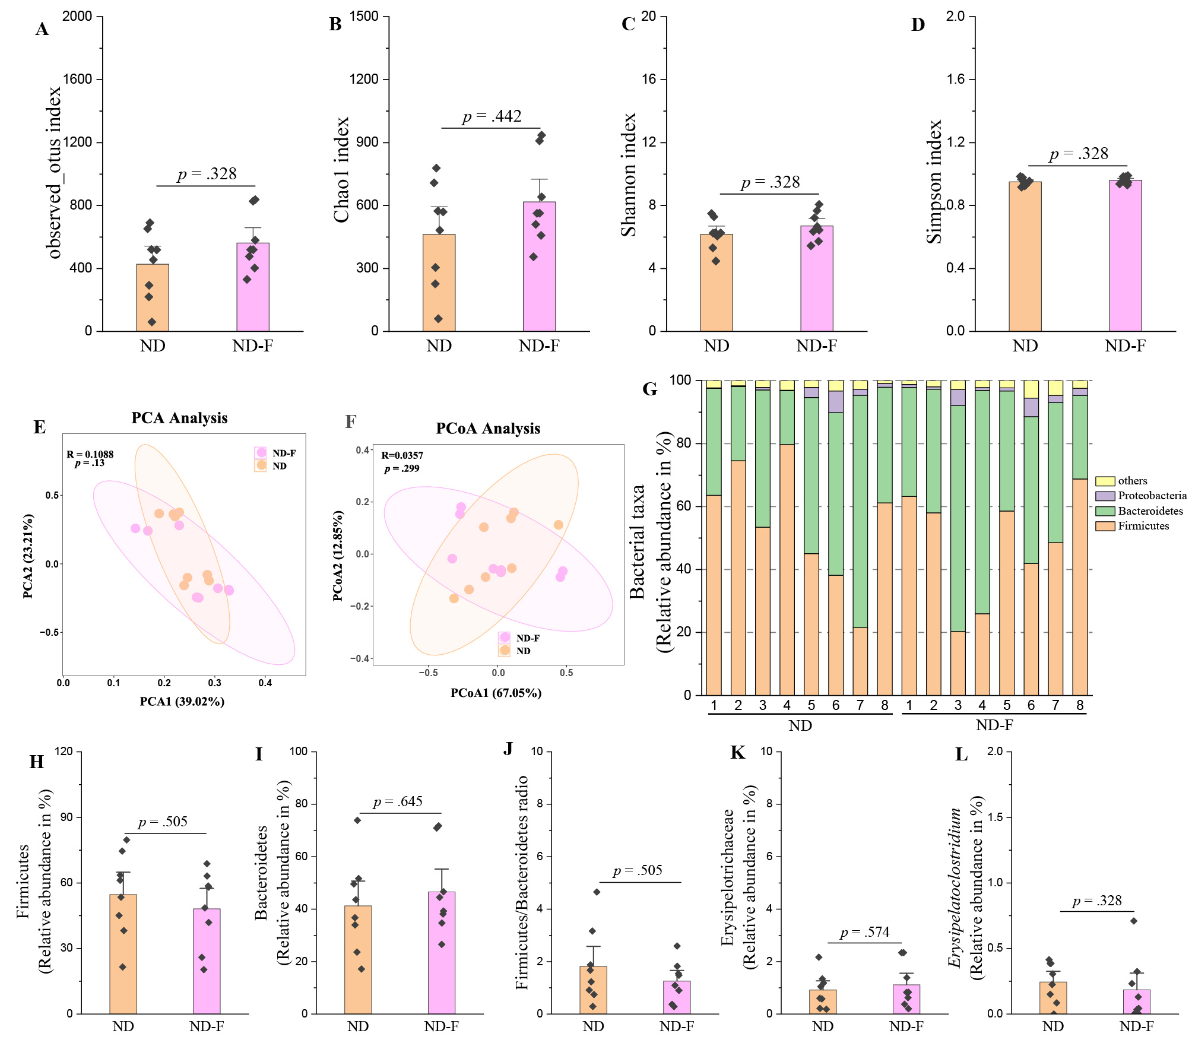
Fig. S11. Fluoride showed limited effect on the gut microbiota of ND mice. Gut microbiota was analyzed by 16S rRNA gene sequencing (n = 8 for each group). (A-D) α-diversity of gut microbiota evaluated by (A) observed_otus, (B) Chao1, (C) Shannon, and (D) Simpson indexes. (E) principal component analysis (PCA) based on the relative abundance of Features of the gut microbiota, (F) Principal coordinates analysis (PCoA) of the gut microbiota based on the weighted unifrac distance matrix, (G) Bacterial taxonomic profiling at the phylum level of gut microbiota, the relative abundances of (H) Firmicutes, (I) Bacteroidetes, and (J) the ratio of Firmicutes to Bacteroidetes. The relative abundances of (K) Erysipelotrichaceae, and (L) Erysipelatoclostridium. The results were expressed as means ± SEM. Difference in two groups was calculated using the Mann-Whitney test or Kruskal-Wallis test. A value of p < 0.05 was considered to be significant.

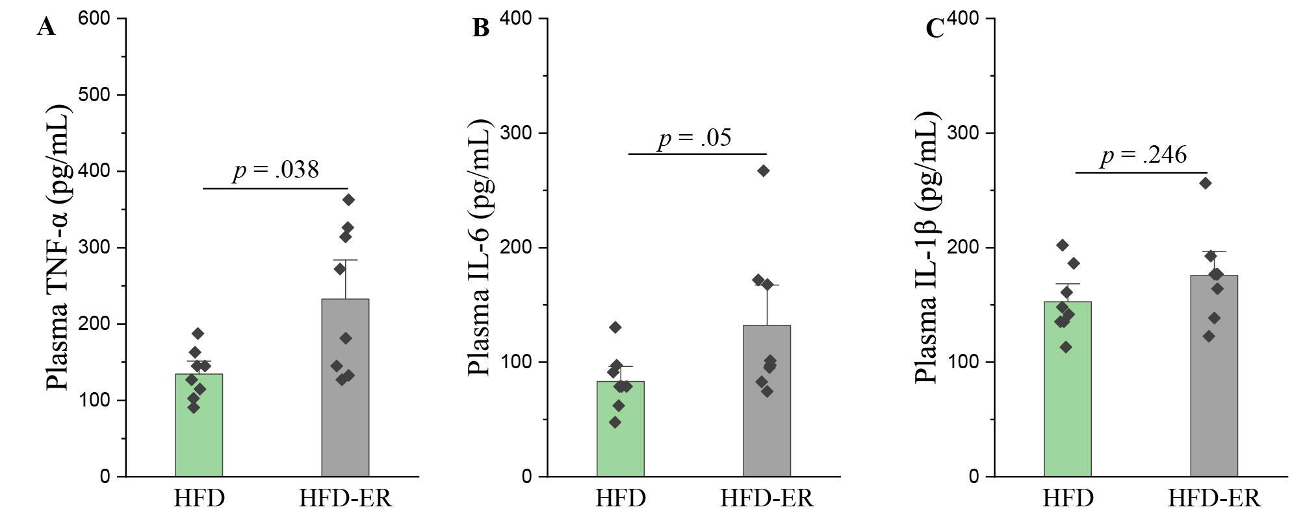
Fig. S12. E. ramosum aggravates the inflammation in HFD mice. (A-C) The plasma levels of TNF-α, IL-6, and IL-1β (n = 8). The results were expressed as means ± SEM. Difference in two groups was calculated using the Mann-Whitney test or Kruskal-Wallis test. A value of p < 0.05 was considered to be significant.

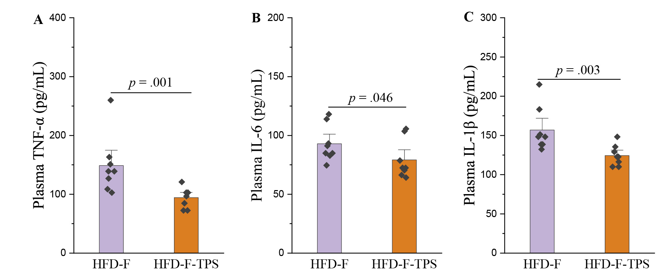
Fig. S13. Fuzhuan brick tea polysaccharides (TPS) abolish the fluoride-induced inflammation in HFD mice. (A-C) The plasma levels of TNF-α, IL-6, and IL-1β (n = 8). The results were expressed as means ± SEM. Difference in two groups was calculated using the Mann-Whitney test or Kruskal-Wallis test. A value of p < 0.05 was considered to be significant.

* Corresponding author. E-mail: zengxx@njau.edu.cn (X. Zeng); lark-liu@163.com (Z. Liu)

